Course | : | Design Patterns
Teacher | : | Sir Arsalan Qureshi
Assignment No | : | 4
Student | : | Farrukh Afzaal Kurd
Student ID | : | FA17 – MSCS – 0022

Observer Design Pattern
Intent
Define a one-to-many dependency between objects so that when one object changes state, all its dependents are notified and updated automatically.

Abstract Diagram
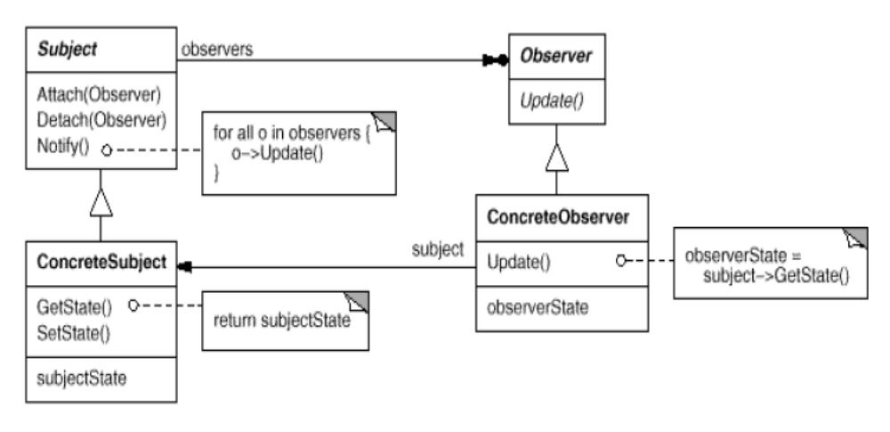
Cricket Application – Observer Pattern Example
Suppose we are building a cricket app that notifies viewers about the information such as current score, run rate etc. Suppose we have made two display elements CurrentScoreDisplay and AverageScoreDisplay. CricketData has all the data (runs, bowls etc.) and whenever data changes the display elements are notified with new data and they display the latest data accordingly.

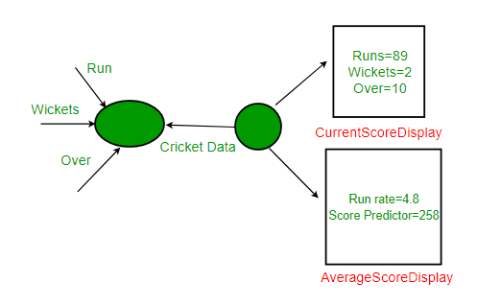
Class Diagram
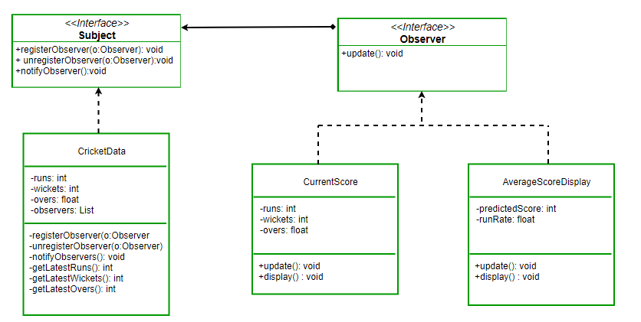

Java Code

// Java program to demonstrate working of
// onserver pattern
import java.util.ArrayList;
import java.util.Iterator;

// Implemented by Cricket data to communicate
// with observers
interface Subject
{
public void registerObserver(Observer o);
public void unregisterObserver(Observer o);
public void notifyObservers();
}

class CricketData implements Subject
{
int runs;
int wickets;
float overs;
ArrayList<Observer> observerList;

public CricketData() {
observerList = new ArrayList<Observer>();
}

@Override
public void registerObserver(Observer o) {
observerList.add(o);
}

@Override
public void unregisterObserver(Observer o) {
observerList.remove(observerList.indexOf(o));
}

@Override
public void notifyObservers()
{
for (Iterator<Observer> it =
observerList.iterator(); it.hasNext();)
{
Observer o = it.next();
o.update(runs,wickets,overs);
}
}

// get latest runs from stadium
private int getLatestRuns()
{
// return 90 for simplicity
return 90;
}

// get latest wickets from stadium
private int getLatestWickets()
{
// return 2 for simplicity
return 2;
}

// get latest overs from stadium
private float getLatestOvers()
{
// return 90 for simplicity
return (float)10.2;
}

// This method is used update displays
// when data changes
public void dataChanged()
{
//get latest data
runs = getLatestRuns();
wickets = getLatestWickets();
overs = getLatestOvers();

notifyObservers();
}
}

// This interface is implemented by all those
// classes that are to be updated whenever there
// is an update from CricketData
interface Observer
{
public void update(int runs, int wickets,
float overs);
}

class AverageScoreDisplay implements Observer
{
private float runRate;
private int predictedScore;

public void update(int runs, int wickets,
float overs)
{
this.runRate =(float)runs/overs;
this.predictedScore = (int)(this.runRate * 50);
display();
}

public void display()
{
System.out.println("\nAverage Score Display: \n"
+ "Run Rate: " + runRate +
"\nPredictedScore: " +
predictedScore);
}
}

class CurrentScoreDisplay implements Observer
{
private int runs, wickets;
private float overs;

public void update(int runs, int wickets,
float overs)
{
this.runs = runs;
this.wickets = wickets;
this.overs = overs;
display();
}

public void display()
{
System.out.println("\nCurrent Score Display:\n"
+ "Runs: " + runs +
"\nWickets:" + wickets +
"\nOvers: " + overs );
}
}

// Driver Class
class Main
{
public static void main(String args[])
{
// create objects for testing
AverageScoreDisplay averageScoreDisplay =
new AverageScoreDisplay();
CurrentScoreDisplay currentScoreDisplay =
new CurrentScoreDisplay();

// pass the displays to Cricket data
CricketData cricketData = new CricketData();

// register display elements
cricketData.registerObserver(averageScoreDisplay);
cricketData.registerObserver(currentScoreDisplay);

// in real app you would have some logic to
// call this function when data changes
cricketData.dataChanged();

//remove an observer
cricketData.unregisterObserver(averageScoreDisplay);

// now only currentScoreDisplay gets the
// notification
cricketData.dataChanged();
}
}

Output
Average Score Display:
Run Rate: 8.823529
PredictedScore: 441

Current Score Display:
Runs: 90
Wickets:2
Overs: 10.2

Current Score Display:
Runs: 90
Wickets:2
Overs: 10.2

