Course | : | Design Patterns
Teacher | : | Sir Arsalan Qureshi
Assignment No | : | 5
Student | : | Farrukh Afzaal Kurd
Student ID | : | FA17 – MSCS – 0022

ATM Machine Example – State Pattern
- State Machine
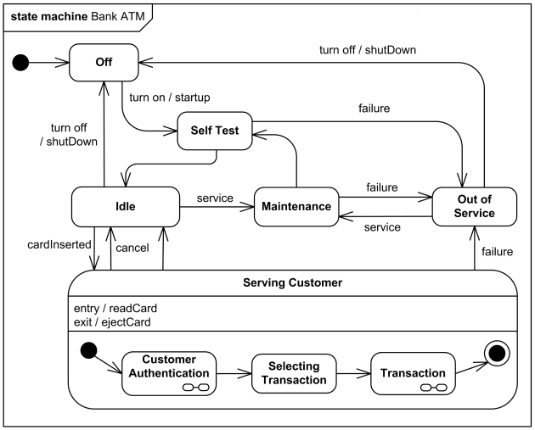

- Class Diagram
Client
+main( args : String [ ] ) : void
ATM Machine State
+ insertDebitCard ( ) : void
+ ejectDebitCard ( ): void
+ enterPinAndWithdrawMoney ( ) : void

NoDebitCardState
+ insertDebitCard ( ) : void
+ ejectDebitCard ( ): void
+ enterPinAndWithdrawMoney ( ) : void

NoDebitCardState
+ insertDebitCard ( ) : void
+ ejectDebitCard ( ): void
+ enterPinAndWithdrawMoney ( ) : void

AtmMachine
+ AtmMachine ( )
+ getAtmMachineState ( ) : AtmMachineSate
+ setAtmMachineState ( atmMachineState : AtmMachineState )
+ insertDebitCard ( ) : void
+ ejectDebitCard ( ) : void
+ enterPinAndWithdrawMoney ( ) : void

- atmMachineState : AtmMachineState

- State Diagram
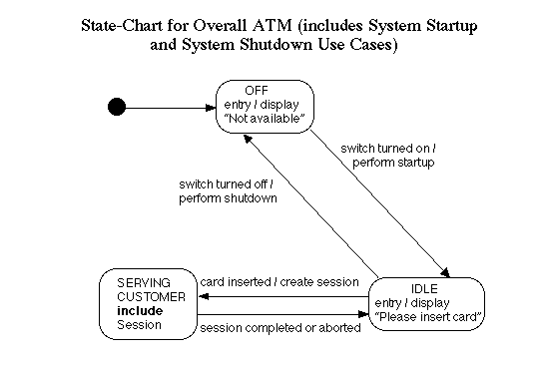

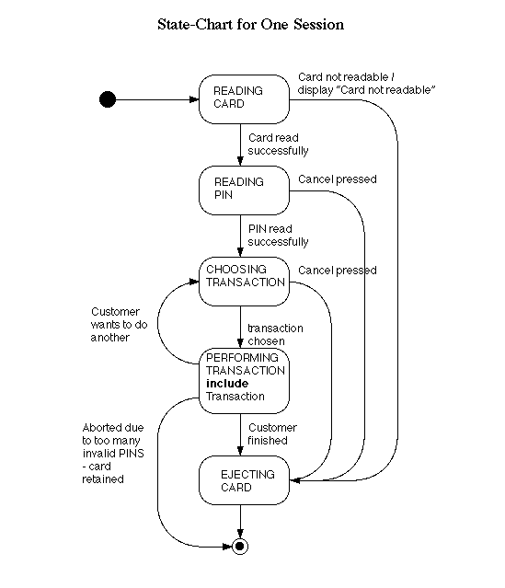

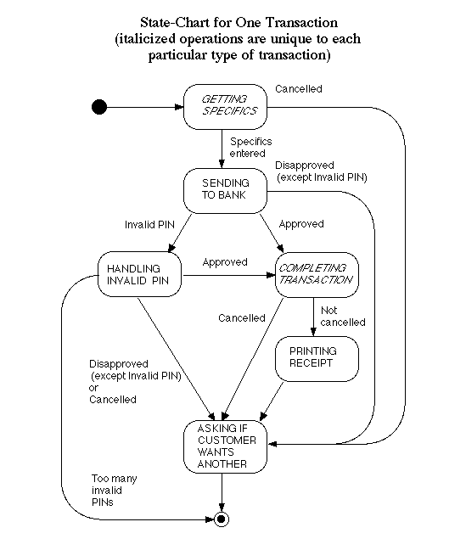

- State Action Matrix
CONDITION NO | 1 | 2 | 3 | 4 | 5 | 6 | 7
VALID CARD | NO | YES | YES | YES | YES | YES | YES
FIRST PIN CORRECT | - | NO | NO | YES | YES | NO | NO
3 INCORRECT PIN | - | NO | NO | NO | NO | YES | YES
1 – 2 WRONG PIN | - | YES | YES | NO | NO | NO | NO
MONEY AVAILABLE | - | NO | YES | NO | YES | NO | YES
OUTPUT / ACTION
REJECT CARD | YES | NO | NO | NO | NO | NO | NO
TRY AGAIN | NO | YES | YES | NO | NO | YES | YES
EAT CARD | NO | NO | NO | NO | NO | YES | YES
CASH OUT | NO | NO | YES | NO | YES | NO | NO

