DESCRIPTION OF SITE

# Header

The pages have a constant navigation bar. The navigation bar is white in colour, with an image on the left. Clicking on the image on the left, brings us in the home page. The heading of the page of the pages are Mauritius Attractions, The South. The navigation shows four pages namely Home, Places, About Us, Contact Us which are blue in colour. The writing for all pages is Georgia. After the navigation bar comes an image for all pages with width 100%. The home page has a Carousel after the navigation page.

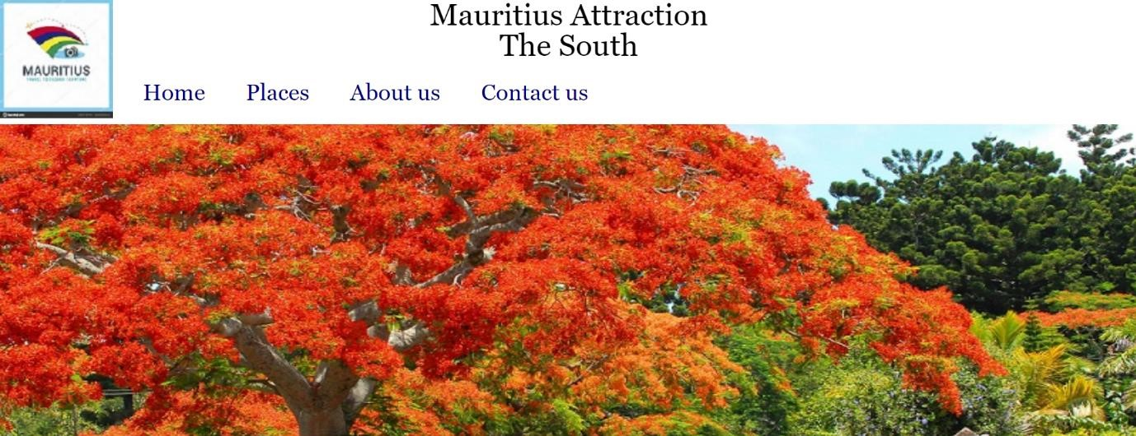

# Footer

The footer is grey is colour. It is divided into 3 columns. First Column has general information about developer, to subscribe to the website and feedback form. The second Column has pages that does not appear on the navigation bar which are Accommodation, Transport and Activities. The Third Column is Follow Us which is link to Facebook, Instagram, and YouTube is link to a video about Mauritius.

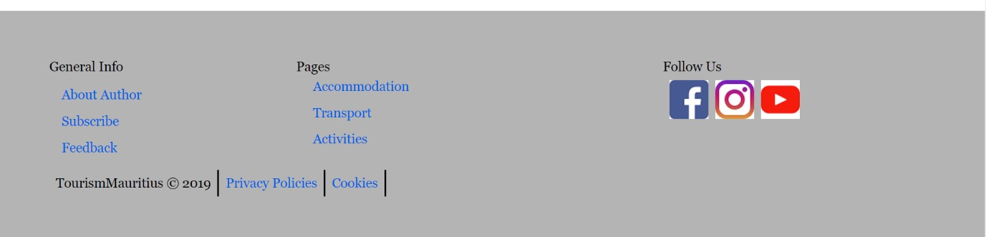

# Contents

Most of the pages have a selection of pictures that leads to different other pages. The pictures are arranged in three columns and several rows. The pictures have headings what is the picture about.

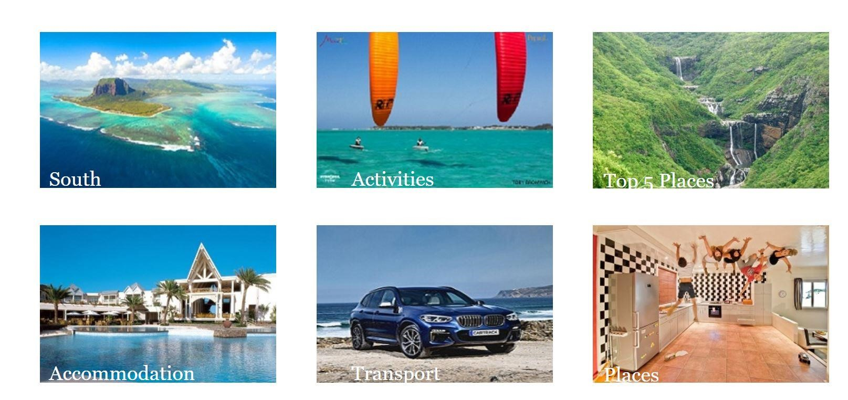

# Booking forms

The forms are all wrapped in a box with orange borders and the contents of the form are inside the box.

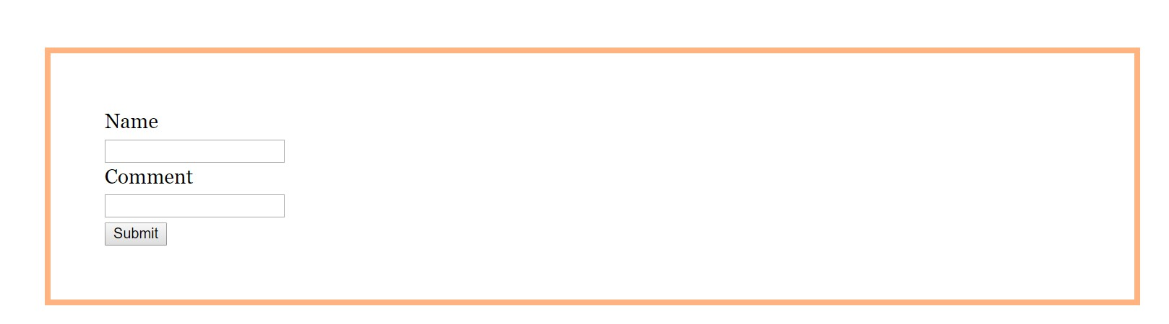

## General places

The general page has same layout for header and footer and the contents of the pages is as follows:

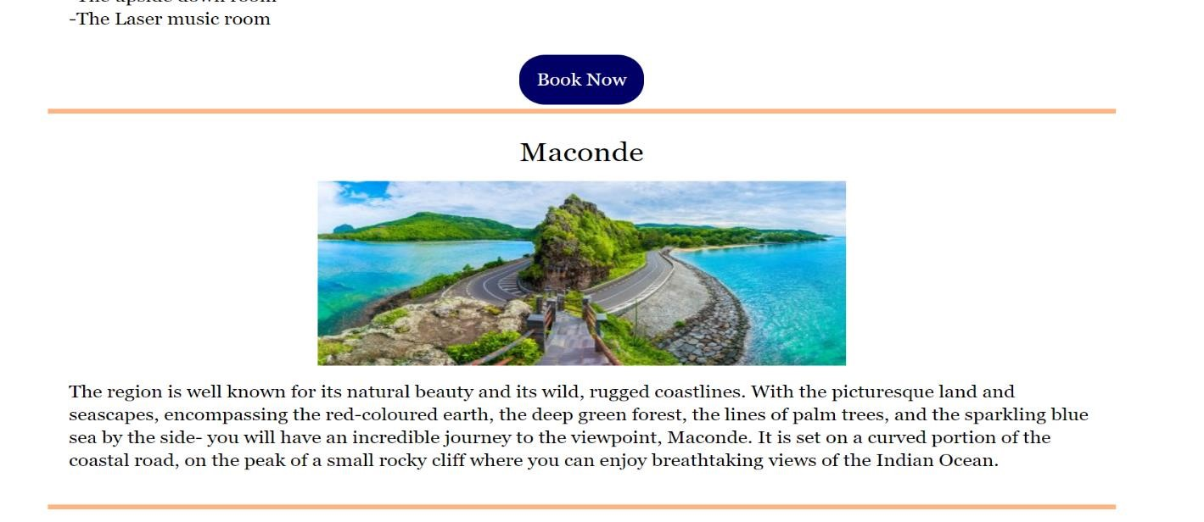

Each place is separated with an orange line. In between the lines, there is a heading, an image and a small piece of images.

## Responsive

The navigation bar goes hidden when size become less than 675px. A menu appears, when the menu is clicked the navigation bar appears as a block column.

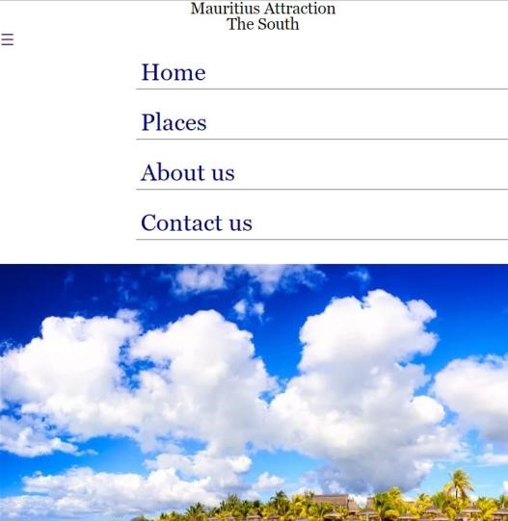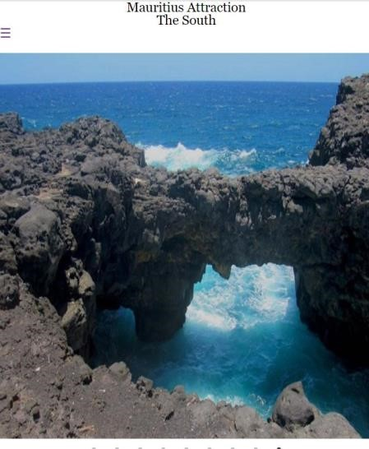

The content of the page all becomes in a column and is displayed.

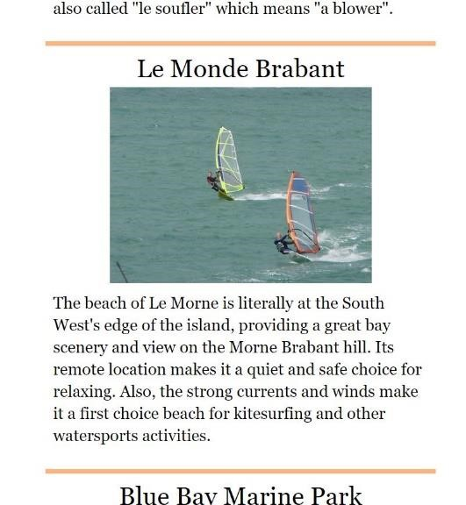

# RESEARCH

***Links:***

Tourism Mauritius -<https://www.tourism-mauritius.mu/en-int>

Diving in Mauritius -<https://www.sundiversmauritius.com/diving-in-mauritius/>

Mauritius Attractions -<http://mauritiusattractions.com/mauritius-catamaran-cruises-c-34.html>Interesting places - [https://www.indian-ocean.com/interesting-places-to-visit-on-the-westhttps://www.indian-ocean.com/interesting-places-to-visit-on-the-west-coast-of-mauritius/coast-of-mauritius/](https://www.indian-ocean.com/interesting-places-to-visit-on-the-west-coast-of-mauritius/)

***Inspirations:***

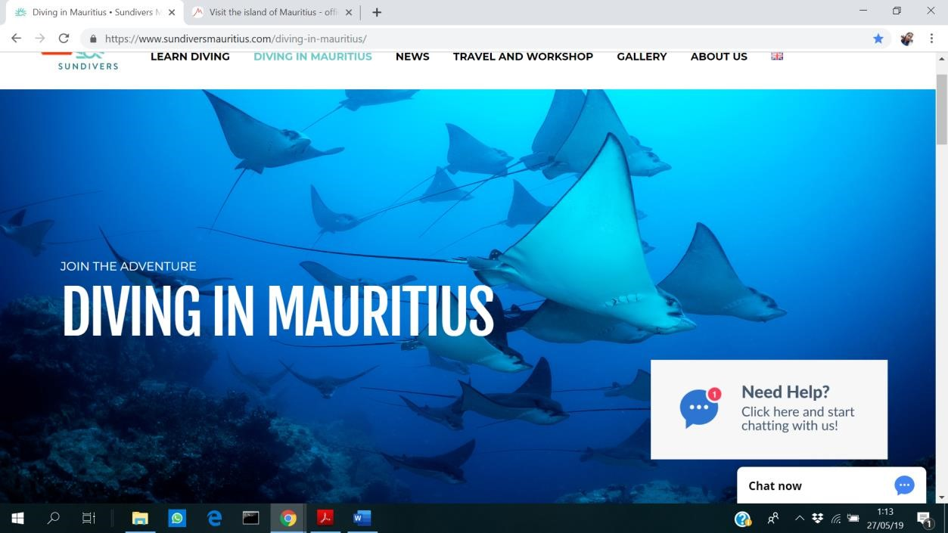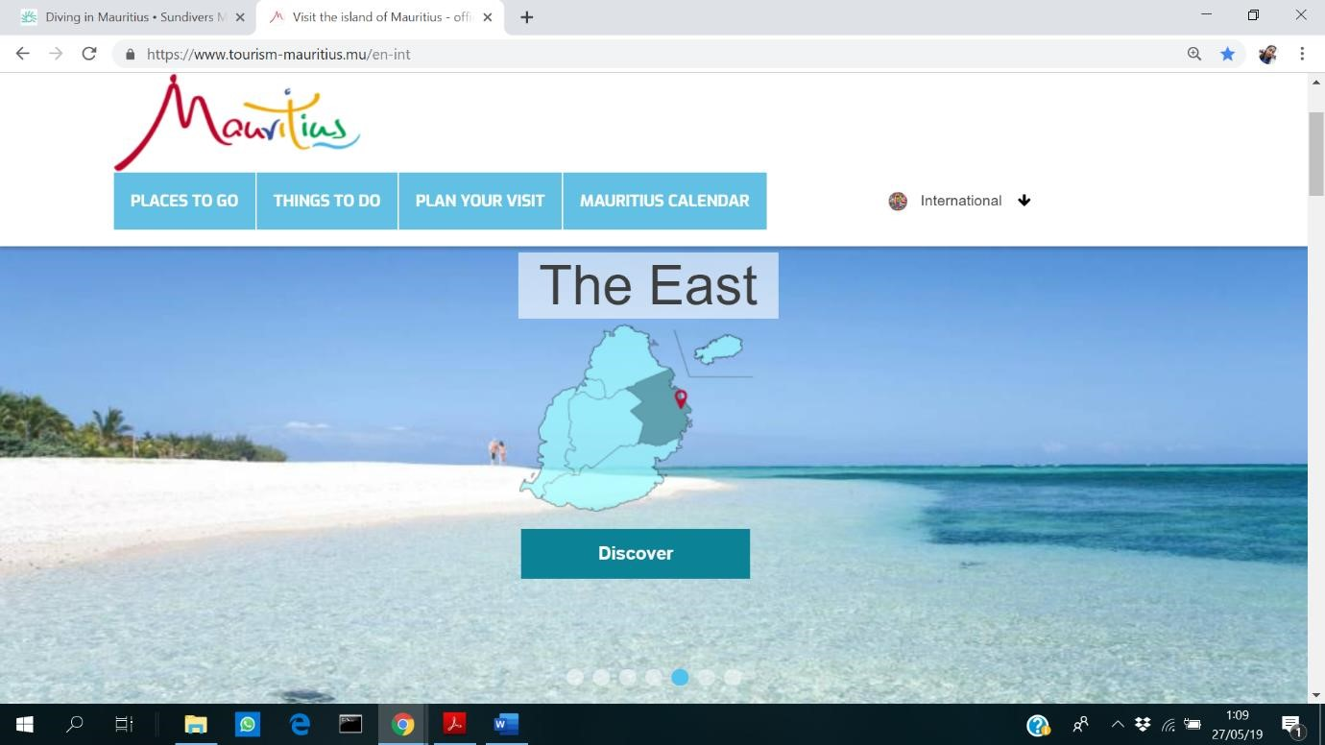

# SITE-MAP DIAGRAM

Pages

Home

Places

About Us

Contact us

South

Activities

Top 5 Places

Transport

Accommoda

tion

NewsForm

Feedback

Page

About

Developer

Navigation

Home

Places

About Us

Contact Us

Home

So

uth

Activities

Top 5 Pl

aces

Accommodation

Transportation

Places

Footer

About Author

NewsForm

Feedb

ack

Accom

modation

Tran

sport

Activities

WIREFRAMES

Home Page

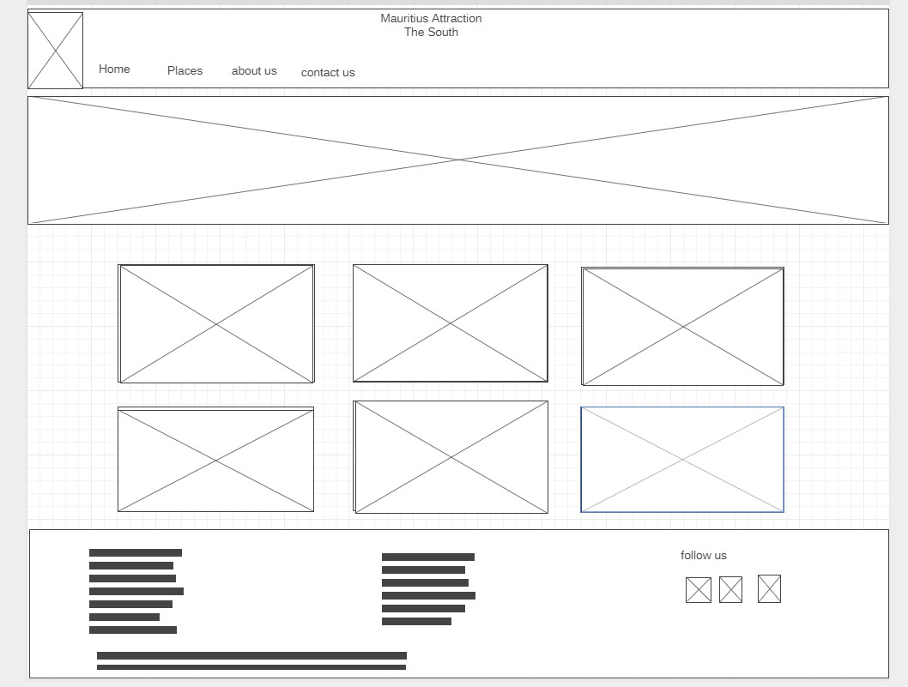

Places

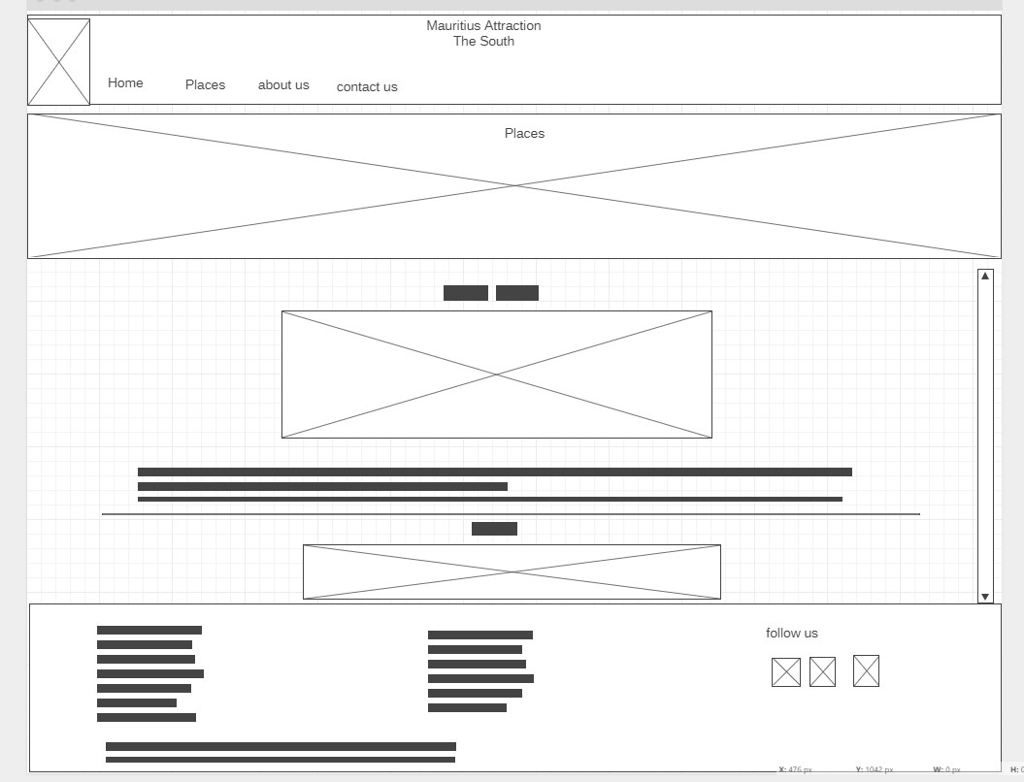

Responsive

Home page Places page

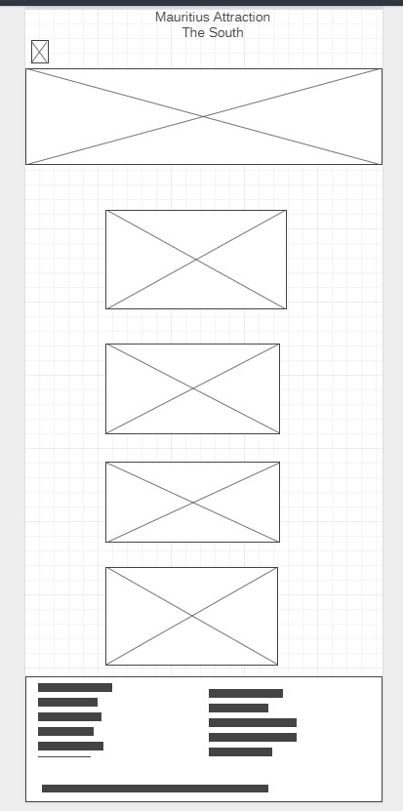 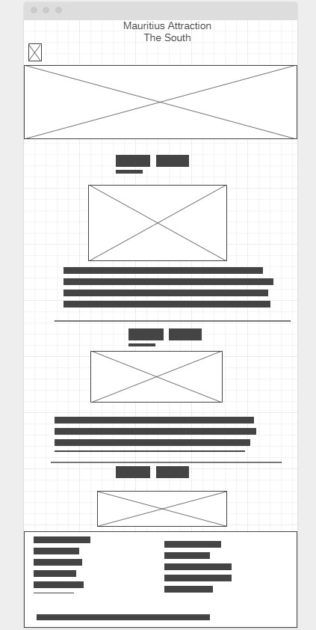

# REVIEW

We choose Mauritius as our Tourism site because it is a wonderful place for vacation.

Team work was definitely one of the most important aspects of our project. We would have been unable to accomplish anything if we had not worked together. Even though the design process was broken up into individual pieces, we always consulted with one another when we ran into difficulties with our work.

We decided how work should be allocated and how the designing of the page should be. We arranged for meetings as regular as possible so we can work the most parts together.