MASTER SERVICES AGREEMENT
MED-ALL AI / MED1.UZ Digital Healthcare Ecosystem
№ LGL-MASTER-2026-0001 • 22.05.2026
PARTIES
MED-ALL AI SYSTEM MCHJ LLC (hereinafter — the “Provider”), represented by Director Shernazarov Farrux (Taxpayer ID/INN: 312972027), acting under the Charter
And a natural or legal person who has accepted this Agreement electronically (hereinafter — the “Client”)
Article 1. Subject of the Agreement
1.1. The Provider delivers digital healthcare, SaaS (HMS/EMR), AI assistant, telemedicine, laboratory, pharmacy, and e-document services via MED1.UZ.
1.2. Full scope — see Appendix №1 (Tariffs).
Article 2. Legal Basis
2.1. Civil Code of Uzbekistan, Laws on Personal Data, Electronic Digital Signature, and E-commerce.
2.2. Ministry of Health digital and sanitary regulations.
Article 3. Rights and Obligations
3.1. Provider: service quality, SLA (99.5%), AES-256 + RLS data security.
3.2. Client: accurate data, timely payment, compliance with platform rules.
Article 4. Tariffs and Payment
4.1. Click, Payme, Uzcard, Humo, Visa/Mastercard, Stripe.
4.2. See Appendix №1. Prices may change with 30 days notice.
Article 5. Intellectual Property
5.1. All software, AI models, content, and trademarks belong to the Provider.
5.2. Client-entered data remains the Client's property.
Article 6. Data Protection
6.1. AES-256 encryption, RLS isolation, GDPR/HIPAA-aligned.
6.2. Breach notification within 72 hours.
Article 7. AI Services & Liability Limitation
7.1. AI services are informational and do not replace a doctor.
7.2. Medical responsibility rests with clinics and physicians.
Article 8. SLA
8.1. 24/7 availability. Guaranteed uptime — 99.5%.
8.2. Compensation per Appendix №2.
Article 9. Force Majeure
9.1. Natural disasters, war, cyberattacks, government restrictions release parties from liability.
Article 10. Confidentiality
10.1. Confidential information protected for 5 years after termination.
Article 11. Dispute Resolution
11.1. Negotiation → Economic Court of Tashkent.
Article 12. Termination
12.1. 30 days written notice.
Article 13. E-Signature & Acceptance
13.1. Registration + clicking “I Accept” = full acceptance.
13.2. OTP / canvas / EDS signatures = handwritten signature under the law.
Article 14. Updates
14.1. New versions published at med1.uz/legal.
Article 15. Final Provisions
15.1. Governed by the laws of Uzbekistan.
15.2. Concluded in electronic form.
Article 16. Party Details
PROVIDER: MED-ALL AI SYSTEM MCHJ
Director: Shernazarov Farrux
Taxpayer ID/INN: 312972027
Address: Tashkent, Uzbekistan
Web: https://med1.uz
Email: legal@med1.uz

APPENDIX №1 — TARIFFS
Free / Basic (490,000 UZS/mo) / Pro (1,290,000 UZS/mo) / Enterprise (custom).
APPENDIX №2 — SLA
Uptime 99.5%. Below 99.0% — 10% refund; below 95% — 30% refund.
APPENDIX №3 — AI DISCLAIMER
AI services are informational. Consult a licensed physician for diagnosis.

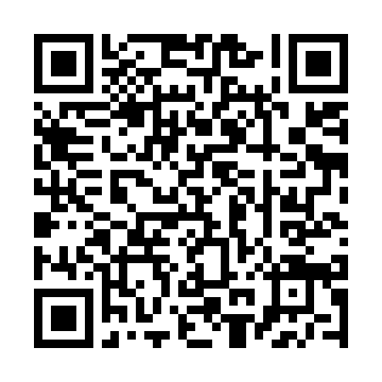
Verify contract authenticity via QR
Hash ID: 73cca99e9a75d03e4e462ba2fc0cd504
https://med1.uz/verify/contract/73cca99e9a75d03e4e462ba2fc0cd504
© 2018–2026 MED-ALL AI SYSTEM MCHJ | MED1.UZ | LGL-MASTER-2026-0001

