ASSIGNMENT

*SUBMITTED BY :FARSANA JASMIN*

*ROLL NO :37*

*SUBMITTED TO :MERIN MISS*

**1 . List all data from table deposite**

**COMMAND:** select * from DEPOSIT;

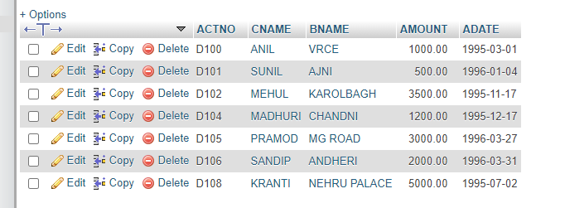

**2. List all data from borrow**

**COMMAND:** select * from BORROW;

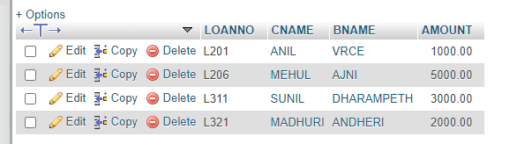

**3. List all data from customer**

**COMMAND:** select * from CUSTOMER;

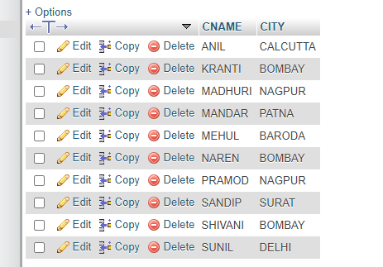

**4. List all data from branch**

**COMMAND:** select * from BRANCH;

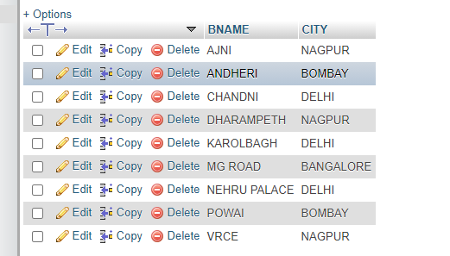

**5. Give account no and amount of deposite**

**COMMAND:** select ACTNO,AMOUNT from deposit;

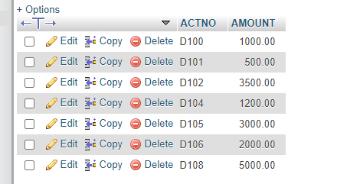

**6. Give customer name and account no of depositors**

**COMMAND:** select CNAME,ACTNO from deposit;

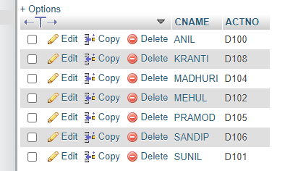

**7. Give name of customers**

**COMMAND:** select CNAME from customer;

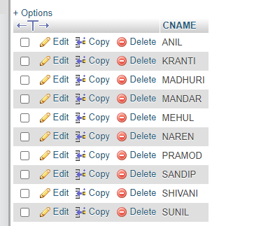

**8. Give name of branches**

**COMMAND:** select BNAME from branch;

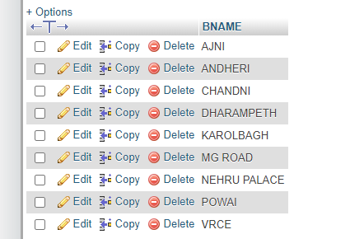

**9. Give name of borrows**

**COMMAND:** select CNAME from borrow;

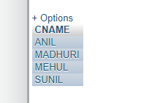

**10. Give names of customer living in city Nagpur**

**COMMAND:** select CNAME from customer where CITY="NAGPUR";

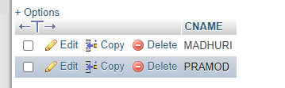

**11.  Give names of depositors having amount greater than 4000**

**COMMAND:** select CNAME from deposit where AMOUNT>4000;

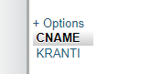

**12.  Give account date of Anil**

**COMMAND:** select ADATE from deposit where CNAME="ANIL";

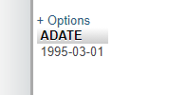

**13. Give name of all branches located in Bombay**

**COMMAND:** select BNAME from branch where CITY="BOMBAY";

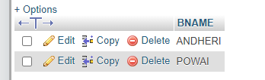

**14.  Give name of borrower having loan number l205**

**COMMAND:** select CNAME from borrow where LOANNO="L205";

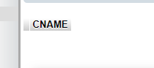

**15. Give names of depositors having account at VRCE**

**COMMAND:** select CNAME from deposit where BNAME="VRCE";

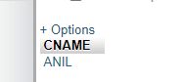

**16. Give names of all branched located in city Delhi**

**COMMAND:** select BNAME from BRANCH where CITY="DELHI";

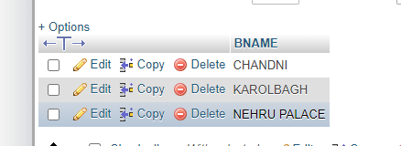

**17. Give name of the customers who opened account date ‘1-12-96’**

**COMMAND:** select CNAME from DEPOSITwhere ADATE=1996-12-01;

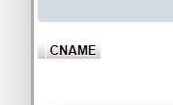

**18. Give account no and deposit amount of customers having account opened between dates     ‘1-12-96’  and  ‘1-5-96’**

**COMMAND:** select ACTNO,AMOUNT from deposit where ADATE between 1996-12-01 AND 1996-05-01;

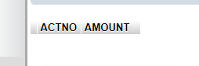

**19.  Give name of the city where branch KAROLBAGH is located**

**COMMAND:** select CITY from branch WHERE BNAME="KAROLBAGH";

