|  |
| --- |
| **Internal and Confidential**  **Specification for Proof-of-Delivery on Revenue Accounting Engine**  **PR 30174**  **Working Version**  **Changed on 01.22.2017** |

| **Users who have change authorization in the Working Version** | |
| --- | --- |
| Xin Fang | I042117 |
| *A list of all users and their roles can be found in the Appendix | |

**Document Versions**

| **Version** | **Status** | **Created By** | **Created On** | **Remark** |
| --- | --- | --- | --- | --- |
| [Work](https://ifp.wdf.sap.corp/sapspec?prefix=PR&id=00000000000000030174&version=work&sap-language=EN&sap-syscmd=nocookie) | Document Created | I042117 | 01.02.2017 | Print Preview of Working Version |

**Table of Contents**

1 Software Requirements 4

1.1 Functional Requirement to Sender component 4

Reference to specification: 4

1.2 Functional Requirements to Revenue Accounting Engine 4

2 Appendix (generated) 6

# Software Requirements

## Functional Requirement to Sender component

## Reference to specification:

\\dwdf213\CFP\30_FIN\30_ProductTeams\Financial_Accounting\30_RevenueRecognition\70 Solution Management\30_ProductBacklog\ProofOfDelivery\Specification_ProofOfDelivery_StockInTransit_V1.docx

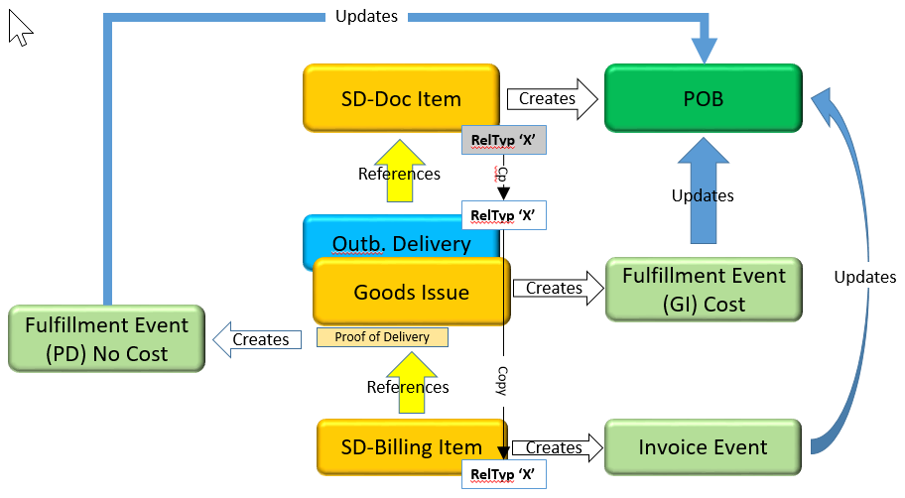

Notice:

Proof-of-Delivery is not a document in SD doc flow, on the other hand it is a ‘tab’(information) of Outbound delivery(Document). Therefore, the source doce id of Proof-of-Delivery is outbound delivery.

Key requirements:

* Sender component will create new fulfillment event type ‘PD’(Proof of Delivery).
* POB with event type ‘PD’ recognize revenue and cost at event PD
* The quantity of confirmed Proof of Delivery can be changed.
* Quantity difference shall adjust the quantity of performance obligation.

## Functional Requirements to Revenue Accounting Engine

**REQ #1: Engine shall have new event type 'PD'(Proof of Delivery).**

Event type ‘PD’ will be a new event type in customizing table FARR_C_EVNT_TY delivered by SAP.

**REQ #2: POB with event type 'PD' shall be possible to define as quantity relevant or value relevant.**

If POB with event type ‘PD’ is defined as quantity relevant, the quantity difference on each Proof-of-Delivery shall adjust the POB quantity.

If POB with event type of ‘PD’ is defined as value relevant (this means the POB has a billing plan), the quantity difference on the POD shall not adjust the quantity and amount of the POB at POD.

**REQ #3: POB with event type 'PD' shall post cost correction from Goods Issue which is sent to Engine using the amount carried by Goods Issue.**

**REQ #4: Engine shall recognize revenue at Proof of Delivery using the quantity on Proof of Delivery**

Once sender component sends 'PD' as a fulfillment RAI, Revenue Accounting with event type 'PD' shall recognize revenue using the Quantity on fulfillment entries

**REQ #5: Engine shall be able to adjust the fulfilled quantity and recognized revenue if the quantity of confirmed Proof-of-Delivery is changed.**

If sender component has changed the quantity of a confirmed Proof-of-Delivery, RAR shall adjust the recognized revenue base on the changed quantity.

**Boundary condition:**

* When the quantity of confirmed Proof of Delivery is changed, sender component (SD) always sends the latest total value instead of with a new fulfillment RAI with delta quantity.
* SD can only update the existing source doc id (Outbound delivery of the PoD)
* A new RAI shall be created with the same source doc id.
* RAIs must be processed in time in the period.
* There shall be a new fulfillment entry in FARR_D_FULFILLMENT as the change may happen at different period.
* This new fulfillment entry in FARR_D_FULFILLMENT shall contain the delta information.

**Delta handling of the fulfillment**

When the new RAI is created, and it leads to a creation of the new fulfillment RAIs, there are 2 options on delta handling of the changed PoD

**Option 1**: ARL create a new fulfillment RAI with delta quantity and Engine will also create a new entry in FARR_D_FULFILLMENT.

**Option 2**: ARL update existing fulfillment RAI with total quantity and Engine do the delta handling.

**Option 2 is preferred** because with this total quantity of the RAIs, it is possible to always get the latest quantity and adjust to the latest total quantity.

**Requirement related to option 2:**

* **Existing fulfillment RAI4 will be overwritten and changed based on the source doc id**
* **Revenue accounting engine shall calculate the delta and generate new entries in FARR_D_FULFILLMENT.**

With this option, the granularity of Fulfillment Source doc ID: Fulfillment RAI4: Fulfillment entries = 1:1: N.

Detail to be discussed to avoid reading mapping table unnecessarily. For example: hard code to some logic of PD and pass a flag via parameter.

**REQ #6: RAR shall recognize cost at Proof of Delivery based on the cost correction of the Goods Issue related to Proof of Delivery.**

RAR recognize cost with the formula:

*Total Recognized Cost = Total amount of Planned Cost * Fulfilled quantity/Total effective POB quantity (adjusted quantity by POD)*

The formula above is using the Percentage of Revenue Recognition to recognized cost because *PoC of revenue = Fulfilled Quantity/Total Effective POB quantity.*

RAR shall adjust the planned total cost if cost of each quantity on Goods Issue is different than the planned cost of each quantity

**Examples to be specified:**

1. **No planned cost adjustment**
2. **Planned cost is changed by goods issue**
3. **Over delivery scenario**

**REQ#7: Adjust quantity difference from PoD and Goods Issue.**

It is possible that the quantity confirmed by Proof of Delivery is different than the quantity of Goods Issue.

**RAR shall Adjust quantity difference at each Proof-of-Delivery**

* Sender component shall send additional on quantity difference.
* The quantity difference is the TOTAL difference.
* At Proof-of-Delivery, the sender component sends confirmed quantity on POD and quantity difference together.

**At POB completion, RAR shall set the POB quantity to delivered quantity from Proof-of-Delivery.**

The quantity difference in fulfillment table shall not be adjusted even the at POB completion the quantity difference <> Quantity from Goods Issue – Quantity on the POB.

**REQ #8: Requirement to RAI monitor**

* POD’s source doc id shall use outbound delivery number.
* In RAI monitor, it shall be able to navigate to outbound delivery by the source doc id using transaction for outbound delivery.
* New source doc type shall be created for outbound delivery because currently there is no source doc type for outbound delivery.

# Appendix (generated)

| **Assigned Users** | |
| --- | --- |
| **Role** | **Name** |
| SRS Admin | Xin Fang (I042117) |