CombCell
Summarize

Version <1.0>

Revision History
Date | Version | Description | Author
2009-07-29 | 1.0 | Structure | Jiachen Yang

Table of Contents
1. Introduction 4
1.1 Purpose 4
1.2 Scope 4
1.3 Definitions, Acronyms, and Abbreviations 4
1.4 References 4
2. Background Introduction 4
2.1 Advanced Objectives: 5
2.2 Additive Objectives 5
3. Design Guidelines 5
3.1 GUI Design Guidelines 5
3.1.1 Only clicking, no typing 6
3.1.2 Less Wondering 6
3.1.3 Animation and Blend 6
3.1.4 UI Automation Orientated 6
3.1.5 Keyboard shortcut access 7
3.2 Performance Guidelines 7

Summarize

Introduction
The purpose of this document is to summarize the development process of CombCell project.

Purpose
The purpose of this Summarize document is to summarize the development process of CombCell project. The summarize includes Background introduction, design guidelines, techniques, implements, experiences, extension and other topics about the development process of CombCell project.

Scope
This Summarize Document applies to the CombCell Project, which is developed by Jiachen Yang farseerfc@sjtu.edu.cn .

Definitions, Acronyms, and Abbreviations
Abbr. | Stands for…
Vision | Vision Document
SDP | Software development plan
SRS | Software Requirement Specification
SAD | Software Architecture Document
CC | CombCell, refer to the project
comb | Actually all ‘comb’ in this document stands for honeycomb
cell | All cells in this document refer to the cell on a honeycomb
CSV | Comma separated values, a kind of data format supported by Microsoft Excel
UI | User-interface, all UI in this document means graphic user interface
SVN | Subversion, refer to http://202.120.40.121/svn/ssp2009/07/5070379022
WPF | Windows Presentation Foundation, code name Avalon, a graphic library used in develop Windows Vista
UIA | UI Automation, a layer that ease to write other-process-driven UI, which helps the program interoperate with support utilities such as Screen Reader or GUI Test tools such as WinRunner

References
CombCell Software Request Specification
CombCell Software Development Plan
CombCell Software Architecture Document

Background Introduction
The project CombCell aims to accomplish an algorithm about calculating length between two cells on a comb. Providing a comb, the algorithm firstly marked each cell an index number. The first index cell (with index 1) is random selected. Other indexes are according to clockwise selection. A comb with 87 cells may look like:
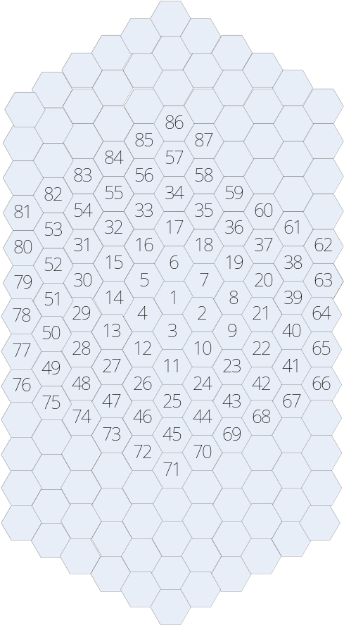
After marked all cells with indexes, the user can use a number to indicate each cell.
User select two cells by click, the algorithm will give a shortest path between these two cells. The length of a path is calculated by the number of cells the path passed through. For example, the path between 9 and 13 in above comb may be 9-2-3-4-13, the length of which is 4 moves.

Advanced Objectives:
- Compare several different algorithms to give a shortest path.
- Show the shortest path on the displayed comb.
- Provide a manually rotatable 3D view of the comb.

Additive Objectives
- Animated all displayed items, better control feedbacks. Smooth changing between 2D display and 3D display.
- Some of the cells are inaccessible.
- Some of the cell-walls are too thick to pass through.
- Several object cells, give a shortest Hamilton path or Hamilton circle.

Design Guidelines

GUI Design Guidelines
Designed as a game, CombCell is applied to provide a user-friendly modern graphic user interface. In order to achieve that, CombCell uses Windows Presentation Foundation as its graphic support library and a few design guidelines to form such a graphic user interface:
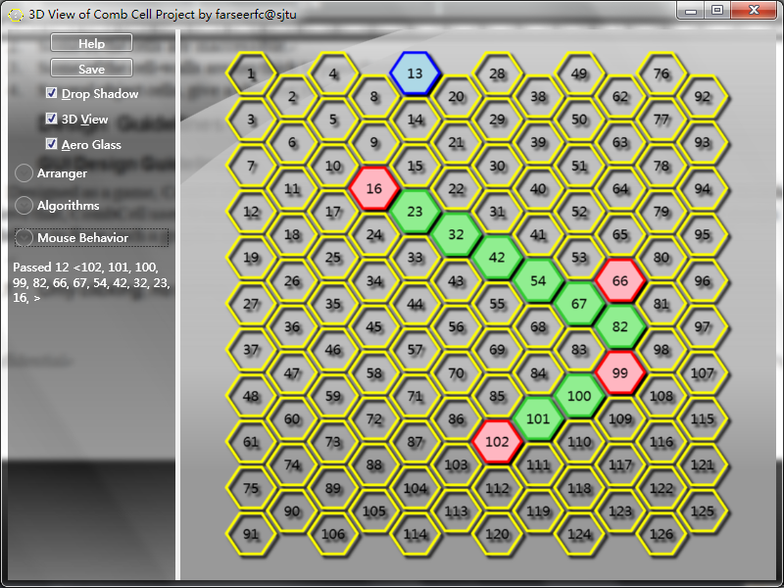

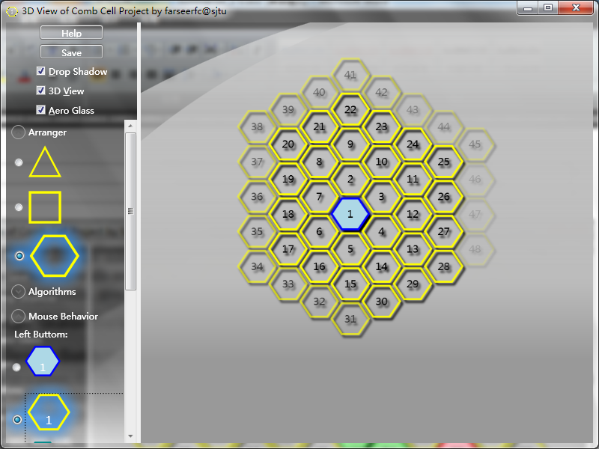
Only clicking, no typing
Throughout the main window of CombCell we can only find buttons, radio buttons, checkboxes and expenders. There are no textboxes or input areas on the screen so there is no need for user to type in required information.

Less Wondering
On start up, the program is ready to calculate the shortest path – which is the main task of the project. User does not need to have fully knowledge about CombCell by don’t touch the things he don’t familiar with.

Animation and Blend
Blend effects and animations are arming the main window of CombCell. They make the GUI looks much smarter, prettier.

Resizable
The main window is resizable, the sidebar is resizable. This needs much extra attentions to pay on arrange the controls on the windows such as provide a scrollbar when controls are in invisible area.

UI Automation Orientated
This feature may be less important to most users, but it is quite essential for GUI testers of the system. Every control on the screen is recognizable and accessible to UI Automation utilities, which means that other program that based on the UI Automation can control CombCell, including honeycomb cells that looks and arranged quite different as normal window components.

Keyboard shortcut access
Many of the controls has keyboard shortcut access, such as <F1> or <H> for help, <Ctrl> + <S> or <S> for save.

Performance Guidelines

Provide mechanisms, but not strategy
In other word, let user choose, not help user to choose.
In the CombCell, we provide 3D view and 2D view to user. The weakness for 3D view is only performance and resource cost. User can use 3D as default, and quickly shift to 2D when graphic performance is poor.
Other examples are whether to use drop shadow effect, whether to use Aero Glass effect, whether to load User Manual.

Provide alternatives to important but slow algorithm
CombCell provides two Hamilton algorithms, one is fast and another is accurate.

Architecture Guidelines

Separate core algorithms with graphic implements
In architecture, CombCell is separated into three

