CombCell
Master Test Plan

Version <1.0>

Revision History
Date | Version | Description | Author
2009-07-07 | 1.0 | Structure | Jiachen Yang

Table of Contents
1. Introduction 5
1.1 Purpose 5
1.2 Scope 5
1.3 Intended Audience 5
1.4 Document Terminology and Acronyms 5
1.5 References 6
1.6 Document Structure 6
2. Evaluation Mission and Test Motivation 6
2.1 Background 6
2.2 Evaluation Mission 6
2.3 Test Motivators 6
3. Target Test Items 6
4. Outline of Planned Tests 7
4.1 Outline of Test Inclusions 7
4.2 Outline of Other Candidates for Potential Inclusion 7
4.3 Outline of Test Exclusions 7
5. Test Approach 7
5.1 Initial Test-Idea Catalogs and Other Reference Sources 7
5.1.1 FxCop 7
5.1.2 Pex 7
5.1.3 Visual Studio Test Framework 7
5.1.4 UIAVerify 7
5.2 Testing Techniques and Types 7
5.2.1 Function Testing 7
5.2.2 User Interface Testing 8
5.2.3 Performance Profiling 8
5.2.4 Stress Testing 9
5.2.5 Volume Testing 9
6. Entry and Exit Criteria 9
6.1 Test Plan 9
6.1.1 Test Plan Entry Criteria 9
6.1.2 Test Plan Exit Criteria 9
6.1.3 Suspension and Resumption Criteria 9
6.2 Test Cycles 9
6.2.1 Test Cycle Entry Criteria 9
6.2.2 Test Cycle Exit Criteria 9
6.2.3 Test Cycle Abnormal Termination 9
7. Deliverables 9
7.1 Test Evaluation Summaries 10
7.2 Reporting on Test Coverage 10
7.3 Perceived Quality Reports 10
7.4 Incident Logs and Change Requests 10
8. Testing Workflow 10
9. Environmental Needs 10
9.1 Base System Hardware 10
9.2 Base Software Elements in the Test Environment 11
9.3 Productivity and Support Tools 11
10. Responsibilities, Staffing, and Training Needs 11
10.1 People and Roles 11
11. Management Process and Procedures 12
11.1 Measuring and Assessing the Extent of Testing 12
11.2 Assessing the Deliverables of this Test Plan 12
11.3 Problem Reporting, Escalation, and Issue Resolution 12
11.4 Traceability Strategies 12

Master Test Plan

Introduction

Purpose
The purpose of the Master Test Plan is to plan and control the test effort during the development of Project CombCell. It describes the approach to testing the software, and is the top-level plan generated and used by managers to direct the test effort.
This Test Plan for the CombCell supports the following objectives:
- Identifies the items that should be targeted by the tests.
- Identifies the motivation for and ideas behind the test areas to be covered.
- Outlines the testing approach that will be used.
- Identifies the required resources and provides an estimate of the test efforts.
- Lists the deliverable elements of the test project.

Scope
The levels of testing used in CombCell are Unit testing, Integration testing, System testing, Regression testing and Regular testing. Their relations are illustrated below.
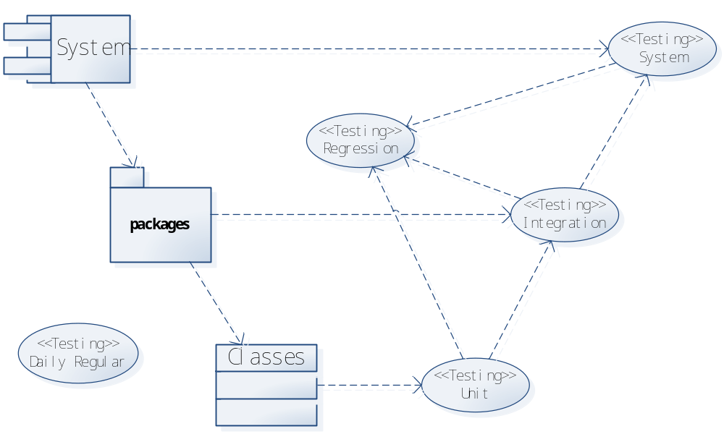
And also this plan will address the Functionality, Usability, Reliability, Performance and other requirements during the test of project CombCell.

Intended Audience
This testing plan is intended to be read by the Programmer, Architecture Designer, Tester, and also the Manager of the Project CombCell.
The Programmer and the Architecture Designer should design the system so that it can be tested according to this plan.
The Tester should execute this testing plan.
The manager should control the process of the testing.

Document Terminology and Acronyms
Abbr. | Stands for
SAD | Software Architecture Documents
SDP | Software Development Plan
SRS | Software Requirements Specification
WPF | Windows Presentation Foundation, a graphic user interface library used by this system
netfx | .net framework, programming framework used by this system
DP | Dependency property, kind of property in class defines that used by WPF
comb | All comb mentioned in this documents stands for honeycomb, not hair-comb
GUI | Graphic User Inerface
FPS | Frames per second, criteria for GUI performance

References
CombCell Software Architecture Document
CombCell Software Development Plan

Document Structure
The Master Test Plan contains an evaluation mission, the motivation of testing, outline of planned tests, the approach to test, the test entry and exit criteria, deliverables, workflow, environmental needs, staffs, milestones, and management of the testing process.

Evaluation Mission and Test Motivation

Background
The project is intended to develop a series algorithms about finding path on a comb. The details are described in SRS, SDP and SAD.

Evaluation Mission
The missions of testing include:
- Find as many bugs as possible
- Find important problems in implement and design of the system
- Certify to Microsoft FxCop standard with no errors and less than 10 warning per kilo-line.
- Verify to CombCell Code Convention
- Advise on GUI design of CombCell
- Advise on product quality

Test Motivators
Requirements described in SRS
Standard described in Code Convention
Advises from the end users

Target Test Items
The listing below identifies those test items⎯software, hardware, and supporting product elements ⎯that have been identified as targets for testing. This list represents what items will be tested.
- .Net Framework Core library used by the system
- Windows Presentation Foundation used by the system
- Algorithm implement
- Problem abstraction
- Graphic User Interface
- System Architecture

Outline of Planned Tests

Outline of Test Inclusions
- Algorithm Unit Test
- Model Unit Test
- Algorithm + Model Integration Test
- User Interface Control Test
- Algorithm + Model + User Interface Integration Test
- User Interface Alternating Unit Test
- User Interface Image Export Test
- User Interface Control + Alternating + Image Export Integration Test
- Model save/ load Unit Test
- Model + Save/Load Integration Test
- System Test

Outline of Other Candidates for Potential Inclusion
- View3D Test
- View3D switch with view2d Test
- Microsoft FxCop Standard certification Test
- Operating System Independency Test

Outline of Test Exclusions
Database test - No Databases involved

Test Approach
The Test Approach presents the recommended strategy for designing and implementing the required tests. Sections 3, Target Test Items, and 4, Outline of Planned Tests, identified what items will be tested and what types of tests would be performed. This section describes how the tests will be realized.

Initial Test-Idea Catalogs and Other Reference Sources

FxCop
FxCop is a tool to verify a .Net assembly ‘s convention with Microsoft FxCop Standard.

Pex
Pex is a testing tool to automatically generate unit test cases by analyzing the program logic and coverage indication and it will cooperate with Visual Studio Test.

Visual Studio Test Framework
A framework implement in Visual Studio IDE with basic ability to manage test cases.

UIAVerify
A GUI automatically test tool based on Microsoft UI Automation, with is the only GUI Automation support for (managed) WPF controls currently.

Testing Techniques and Types

Function Testing
Technique Objective: | Mark index on each cell, maps the comb/cell model to graph/vertex model, calc the shortest path, well-defined behavior of graph abstraction
Technique: | Simply create a comb and initial a random cell to be index 1. Verify each cells around it gets the valid index.
Oracles: | Indexing behavior that specified in SRS.
Required Tools: | Pex  Visual Studio Test Framework
Success Criteria: | All algorithm behavior specified in SRS achieved  Code coverage over 98%
Special Considerations: | DSAlgo part of the system defined in SAD should be tested separately and it should be covered 100%

User Interface Testing

Technique Objective: | Correct map between comb/cell with CombView/CellShape  Alternating View  View3D
Technique: | Run the program manually to experience the UI response  Use UIAVerify to test boundary conditions of compound UI operations  Create Pex test cases to test every compound of cells’ state.
Oracles: | UI experience specified in SRS
Required Tools: | UIAVerify  Pex  Visual Studio Test Framework
Success Criteria: | The technique supports the testing of each major screen or window that will be used extensively by the end user.
Special Considerations: | UIAVerify is not specially designed for WPF, so not all controls can be captured including user controls.  UIAVerify didn’t provide script based solution like WinRunner, all test cases must be organized as compiled IL assemblies.  UIAVerify can’t cooperate with Visual Studio Test Framework, report must be hand-collected or generate from Pex

Performance Profiling

Technique Objective: | Normal workload: 500 cells on the screen with 100 selected  Worst workload: 10000 cells on the screen with 1000 selected
Technique: | - Create a CombWindow and zoom out it to hold workload target cells  - Run Pex-based test case to select cells randomly and then calculate the shortest path  - Loop for 1000 times to profile the performance.
Oracles: | The graphic invocation of functions should be faster than 2 frame per second  The algorithm performance will be discussed later in User Reference Manual
Required Tools: | Pex  Visual Studio Test Framework  .Net Performance Profile
Success Criteria: | Fps: more than 50 in normal workload and 2 in worst workload
Special Considerations: | View3D part of performance is not considered in this plan, which may be more difficult to measure.  Release version will be used in the Test to reduce memory cost of the system.

Stress Testing
Technique Objective: | Gain the acceptable RAM limit of the system
Technique: | Create a memory-leak environment by running Visual PC (which will lock allocated memory block in physic RAM)  Run Performance Profiling
Oracles: | With worst workload defined above, the memory cost should be 15k per cell
Required Tools: | Microsoft Visual PC 2004 standard edition  .Net Performance Profile  Visual Studio Test Framework
Success Criteria: | The only stress condition of the system is the accessible memory. The system should be able to run worst workload profile with only 150MB memory cost.
Special Considerations: | Release version will be used in the Test to reduce memory cost of the system.

Volume Testing
Technique Objective: | Gain the maximum limit of cells of the system
Technique: | Use tests developed for Performance Profiling  No workload limit, log whenever adding the workload  Retest 20 times to gain a average limit
Oracles: | Currently none
Required Tools: | Pex  Visual Studio Test Framework  .Net Performance Profile
Success Criteria: | More than 20000 cells are supported
Special Considerations: | User usability should also be logged during the test

Entry and Exit Criteria

Test Plan

Test Plan Entry Criteria
When the code is ready run Unit Test or Integration Test or System Test

Test Plan Exit Criteria
When no more problem arose or Release Millstone is reached.

Suspension and Resumption Criteria
When a serious problem was found that may affect the further test, the test is suspended until the problem is solved.

Test Cycles

Test Cycle Entry Criteria
Whenever a coding cycle is ended

Test Cycle Exit Criteria
When next coding cycle is started

Test Cycle Abnormal Termination
When a serious problem was found that may affect the further test

Deliverables

Test Evaluation Summaries
All problems met during the test will be logged by Visual Studio Test Framework
The summaries must provide the cause and possible solution to each problem

Reporting on Test Coverage
This will be generated automatically by Visual Studio Test Framework

Perceived Quality Reports
Most part of the report will be generated automatically by Visual Studio Test Framework

Incident Logs and Change Requests
Most part of the logs will be generated automatically by Visual Studio Test Framework
The issues that need to be pay attentions are committed on Google Code Issue Tracking

Testing Workflow
Basic Testing workflow looks like:

Environmental Needs
This section presents the non-human resources required for the Test Plan.

Base System Hardware
The following table sets forth the system resources for the test effort presented in this Test Plan.

System Resources
Resource | Quantity | Name and Type
Client Test PCs | Intel Core2 T7300  DDR2 1GB*2 | PC
—Include special configuration requirements |  | PC
Test Development PCs | The same as above | PC

Base Software Elements in the Test Environment
The following base software elements are required in the test environment for this Test Plan.
Software Element Name | Version | Type and Other Notes
Windows Vista | 6.0 sp 2 (6002) | Operating System
.Net Framework | 3.5 sp1 | Framework
Windows 7 | 7.0 | Operating System
Internet Explorer | 7.0 | Browser (with support lib)

Productivity and Support Tools
The following tools will be employed to support the test process for this Test Plan.
Tool Category or Type | Tool Brand Name | Vendor or In-house | Version
Test Management | Visual Studio | Microsoft | 2008 Team Suite
Defect Tracking | Google Code Issue | Google
ASQ Tool for functional testing | Pex 2010 | Microsoft Research | 0.14.40610
ASQ Tool for performance testing | Pex 2010 | Microsoft Research | 0.14.40610
Test Coverage Monitor or Profiler | Pex 2010 | Microsoft Research | 0.14.40610
Project Management | Visual Studio | Microsoft | 2008 Team Suite

Responsibilities, Staffing, and Training Needs
This section presents the required resources to address the test effort outlined in the Test Plan—the main responsibilities, and the knowledge or skill sets required of those resources.

People and Roles
This table shows the staffing assumptions for the test effort.
Human Resources
Role | Minimum Resources Recommended  (number of full-time roles allocated) | Specific Responsibilities or Comments
Tester | 1 | Implements and executes the tests.  Responsibilities include:  - implement tests and test suites  - execute test suites  - log results  - analyze and recover from test failures  - document incidents

Management Process and Procedures

Measuring and Assessing the Extent of Testing
Pex and other automated test tools will be introduced during the test and they will take over the measuring and assessing the extent of testing.

Assessing the Deliverables of this Test Plan
Jiachen Yang < farseerfc@sjtu.edu.cn > is responsible for the deliverables of this Test Plan

Problem Reporting, Escalation, and Issue Resolution
Google Code Issue Tracking systems will be used in daily issue management.
Visual Studio Build-in Tasks will be used in issues during a day

