CombCell
Software Architecture Document

Version <1.0>

Revision History
Date | Version | Description | Author
<2009-7-2> | <1.0> | First edition | Jiachen Yang

Table of Contents
1. Introduction 4
1.1 Purpose 4
1.2 Scope 4
1.3 Definitions, Acronyms, and Abbreviations 4
1.4 References 4
1.5 Overview 4
2. Architectural Representation 4
3. Architectural Goals and Constraints 4
4. Use-Case View 4
4.1 Use-Case Realizations 5
5. Logical View 5
5.1 Overview 5
5.2 Architecturally Significant Design Packages 5
6. Process View 5
7. Deployment View 5
8. Implementation View 5
8.1 Overview 5
8.2 Layers 5
9. Data View (optional) 6
10. Size and Performance 6
11. Quality 6

Software Architecture Document

Introduction

Purpose
This document provides a comprehensive architectural overview of the CombCell project, using a number of different architectural views to depict different aspects of the system. It is intended to capture and convey the significant architectural decisions which have been made on the system.
This document is intended to be provided to system maintainers and developers, so many technical terms may be occurred in this document. The document will NOT be presented as part of user manual.

Scope
This document illustrates the architecture design of CombCell Project which will guide the development of the project. The program code will be organized according to the illustration in this document.

Definitions, Acronyms, and Abbreviations
Abbr. | Stands for
SAD | Software Architecture Documents, refer to this document
SRS | Software Requirements Specification
WPF | Windows Presentation Foundation, a graphic user interface library used by this system
netfx | .net framework, programming framework used by this system
DP | Dependency property, kind of property in class defines that used by WPF
GoF | Gang of four, author of Design Patterns
comb | All comb mentioned in this documents stands for honeycomb, not hair-comb

References
Design Patterns : Elements of Reusable Object-Oriented Software . By Erich Gamma, Richard Helm, Ralph Johnson, John Vlisssides, Pearson Education and Addison Wesley.

Overview
[This subsection describes what the rest of the Software Architecture Document contains and explains how the Software Architecture Document is organized.]

Architectural Representation
The architecture of the system is represented by 3 views:
- Use Case Views
- Analyze Views
- Design Views
Use case view contains use cases and their realizations, some important sequence diagrams and important activity diagrams. There is no process views and deployment views because the project will be run on a single machine and in a single process.

Architectural Goals and Constraints

Development Environment
Microsoft Visual Studio 2008
Microsoft Expression Blend 2
Microsoft Visio 2007

Portability
The System will be run on the following systems:
Windows XP with SP2 or higher and netfx 3.5
Windows Vista with netfx 3.5
Windows 7

Reusability
The algorithm part of the system should be flexible and reuse in other systems

Schedule
The detail schedule is presented in Software Development Plan and all other iteration plans.

Use-Case View
[This section lists use cases or scenarios from the use-case model if they represent some significant, central functionality of the final system, or if they have a large architectural coverage—they exercise many architectural elements or if they stress or illustrate a specific, delicate point of the architecture.]

Main Use Case
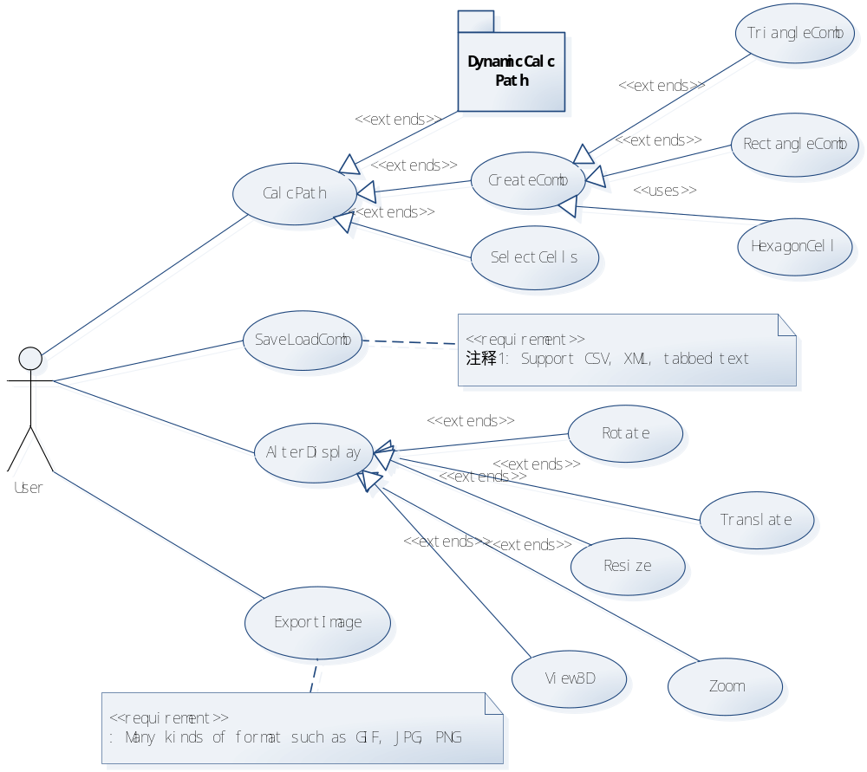
We can see only one user is considered in the system. The user can CalcPath, SaveLoadComb, AlterDisplay, and export image file.
The most important use case is CalcPath, so this use case is divided into 3 steps, CreateComb( including marking index onto the cells), select cells, and dynamic calc path.

Sequence diagram of CreateComb
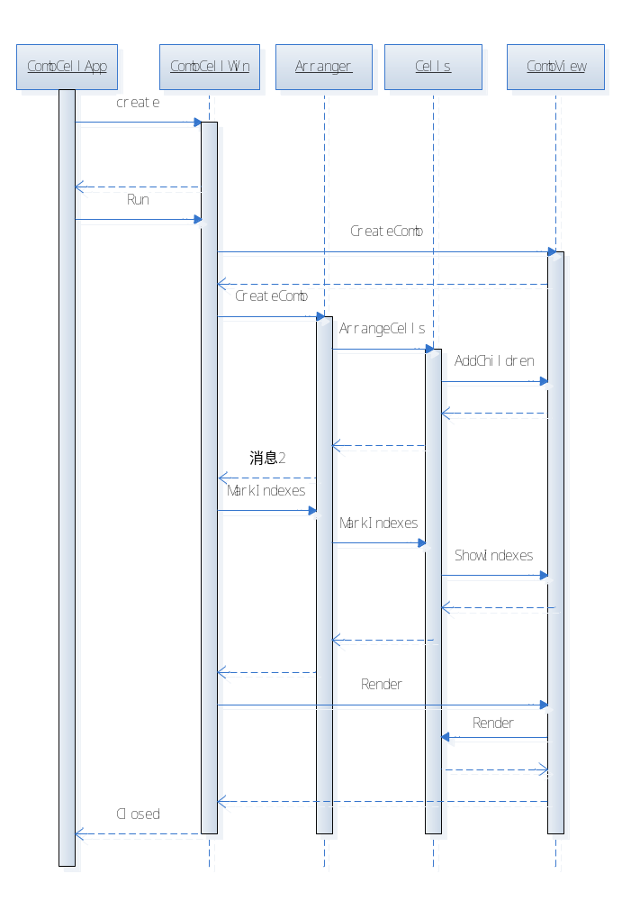
The first created object is the application object. This object will register and create the main window object, and then run into a message loop to drive the main window.
As soon as the main window is created, it will create all controls on it, among them the most important one is the CombView. The CombView object will provide a user-friendly interface facade and it also act as a container of cells.
After CombView is created, an arranger is created and called to arrange cells on comb. The inner comb and cells models will also be created at this time(not showed). Cells maps to CellShapes on the screen, which will be the children of CombView’s virtual tree.
And then, when the main window required mark indexes, this requirement will be passed to arranger. The arranger will provide each cell with an index number, and this number will be displayed.
Then the main window render the display of CombView, this will continue to render the CellShapes.

Activity Diagram of AlterDisplay
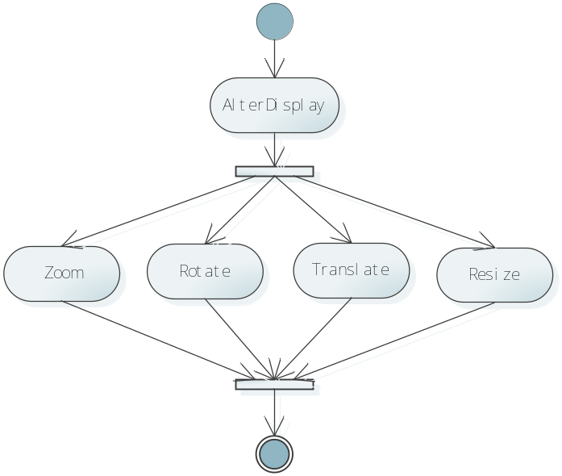
The AlterDisplay is one step operation including translate, rotate, zoom in and zoom out, and the resize of the displayed area.

Activity Diagram of ExportImage
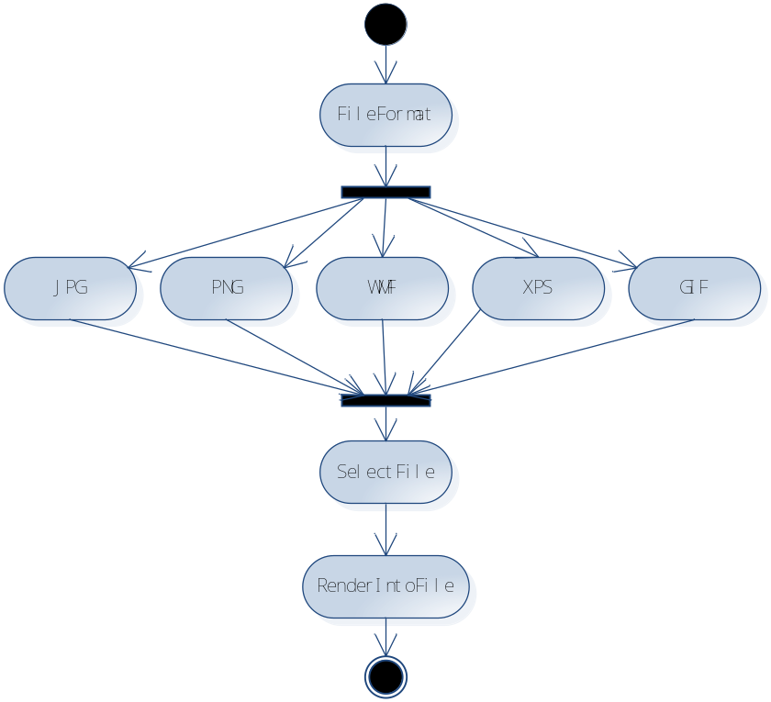
The ExportImage consist 2 user input steps, selecting file format and choose the filename.

Use case view of Dynamic Calc Path
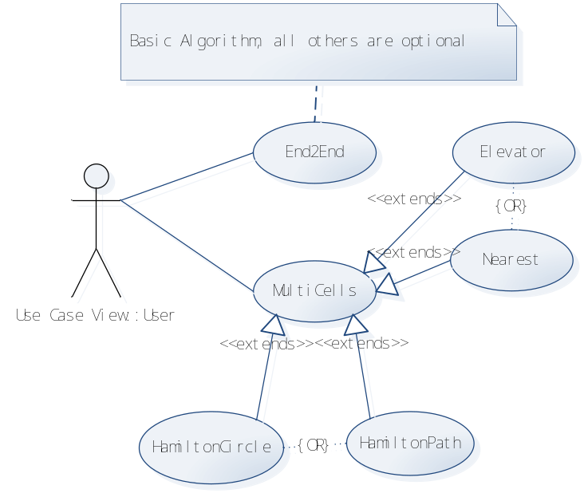
The basic requirement needs to calculate a path between 2 points. This is represented as End2End use case.
MultiCells are also supported by the system. By default, the system will calculate the nearest points to figure out a shortest Hamilton path. The user may also alter to figure out a circle.
When cell-access requirement is coming continually, the algorithm may be trapped in the center of the comb, i.e. the edge part of the comb may be hard to access. So the system will provide a kind of Elevator algorithm to solve this problem, which will ensure to access all cells and still consider the length of path. The result of the elevator algorithm may be not the shortest, so this is an option exposed to the user.

Activity diagram of CalcPath
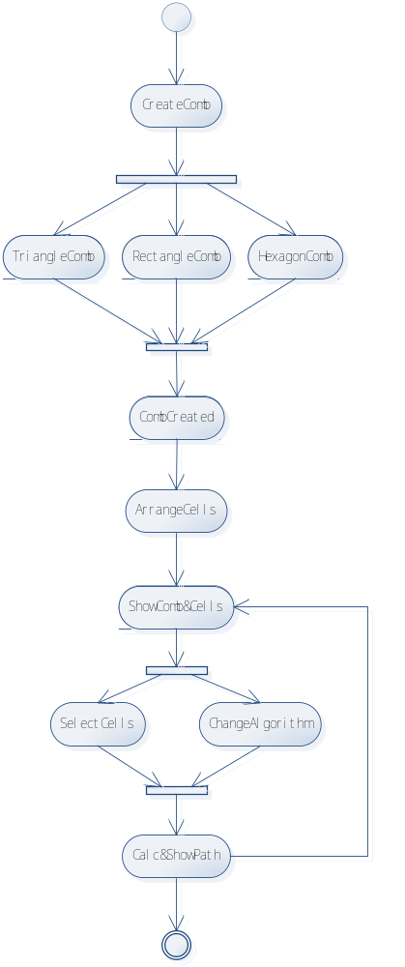

Use-Case Realizations
[This section illustrates how the software actually works by giving a few selected use-case (or scenario) realizations, and explains how the various design model elements contribute to their functionality.]

Logical View
[This section describes the architecturally significant parts of the design model, such as its decomposition into subsystems and packages. And for each significant package, its decomposition into classes and class utilities. You should introduce architecturally significant classes and describe their responsibilities, as well as a few very important relationships, operations, and attributes.]

Overview
[This subsection describes the overall decomposition of the design model in terms of its package hierarchy and layers.]

Architecturally Significant Design Packages
[For each significant package, include a subsection with its name, its brief description, and a diagram with all significant classes and packages contained within the package.
For each significant class in the package, include its name, brief description, and, optionally, a description of some of its major responsibilities, operations, and attributes.]

Process View
[This section describes the system's decomposition into lightweight processes (single threads of control) and heavyweight processes (groupings of lightweight processes). Organize the section by groups of processes that communicate or interact. Describe the main modes of communication between processes, such as message passing, interrupts, and rendezvous.]

Deployment View
[This section describes one or more physical network (hardware) configurations on which the software is deployed and run. It is a view of the Deployment Model. At a minimum for each configuration it should indicate the physical nodes (computers, CPUs) that execute the software and their interconnections (bus, LAN, point-to-point, and so on.) Also include a mapping of the processes of the Process View onto the physical nodes.]

Implementation View
[This section describes the overall structure of the implementation model, the decomposition of the software into layers and subsystems in the implementation model, and any architecturally significant components.]

Overview
[This subsection names and defines the various layers and their contents, the rules that govern the inclusion to a given layer, and the boundaries between layers. Include a component diagram that shows the relations between layers. ]

Layers
[For each layer, include a subsection with its name, an enumeration of the subsystems located in the layer, and a component diagram.]

Data View (optional)
[A description of the persistent data storage perspective of the system. This section is optional if there is little or no persistent data, or the translation between the Design Model and the Data Model is trivial.]

Size and Performance
[A description of the major dimensioning characteristics of the software that impact the architecture, as well as the target performance constraints.]

Quality
[A description of how the software architecture contributes to all capabilities (other than functionality) of the system: extensibility, reliability, portability, and so on. If these characteristics have special significance, such as safety, security or privacy implications, they must be clearly delineated.]

