CombCell
Software Requirements Specification
For CombCell

Version <1.3>

Revision History
Date | Version | Description | Author
<2009-6-26> | <1.0> | Introduction, overall, requirements | Jiachen Yang
<2009-6-29> | <1.1> | Fixed some problem, enriched the functionality specification | Jiachen Yang
<2009-7-1> | <1.2> | Change use case view from Visio to Rational Rose, add some details | Jiachen Yang
<2009-7-5> | <1.3> | Updated according to the Software Architectural Design | Jiachen Yang

Table of Contents
1. Introduction 4
1.1 Purpose 4
1.2 Scope 4
1.3 Definitions, Acronyms, and Abbreviations 4
1.4 References 4
1.5 Overview 4
2. Overall Description 4
2.1.1 Advanced Objectives: 5
2.1.2 Additive Objectives 5
3. Specific Requirements 5
3.1 Functionality 5
3.1.1 Create & show the graphic comb 7
3.1.2 Calculate & show the shortest path 8
3.1.3 Save / Load the comb 8
3.1.4 All the displayed elements should be animated (Optional) 9
3.1.5 Zoom and rotate the comb (Optional) 9
3.1.6 Some of the cells and walls may be unable to pass (Optional) 10
3.1.7 Several objectives and find the Hamilton path or circle (Optional) 10
3.1.8 3D display of the graphic comb (Optional) 10
3.2 Usability 10
3.2.1 Tasking time 10
3.2.2 Coding standards 10
3.3 Reliability 10
3.3.1 Availability 10
3.3.2 Mean Time between Failures 10
3.3.3 Maximum Bugs or Defect Rate 10
3.4 Performance 10
3.4.1 Response time 10
3.4.2 Resource utilization 11
3.5 Supportability 11
3.5.1 Coding Standards 11
3.5.2 Naming Conventions 11
3.5.3 Class libraries 11
3.6 Design Constraints 11
3.6.1 Development Language 11
3.6.2 Development Environment 11
3.6.3 Development Tools 12
3.7 On-line User Documentation and Help System Requirements 12
3.8 Interfaces 12
3.8.1 User Interfaces 12
3.8.2 Hardware Interfaces 12
3.8.3 Software Interfaces 12
3.8.4 Communications Interfaces 12
3.9 Licensing Requirements 12
3.10 Legal, Copyright, and Other Notices 12
3.11 Applicable Standards 12

Software Requirements Specification

Introduction

Purpose
This document describes the requirements of the project CombCell, consisted with main functions and features of the overall system.

Scope
The purpose of this document is to collect, analyze, and define high-level needs and features of the CombCell project. It focuses on the capabilities need by the stake holders and the target users, and why these needs exist. The details of how the CombCell project fulfills these needs are detailed in the use-case and supplementary specifications.

Definitions, Acronyms, and Abbreviations
Abbr. | Stands for…
Vision | Vision document of this project
SDP | Software development plan
SRS | Software Requirement Specification, refer to this document
CC | CombCell, refer to the project
comb | Actually all ‘comb’ in this document stands for honeycomb
cell | All cells in this document refer to the cell on a honeycomb
CSV | Comma separated values, a kind of data format supported by Microsoft Excel
UI | User-interface, all UI in this document means graphic user interface
SVN | Subversion, refer to http://202.120.40.121/svn/ssp2009/07/5070379022
FxCop | dotNet Framework Coding Standards addressed by Microsoft

References
CombCell Vision
CombCell Software development plan

Overview
This document describes the requirements of the project CombCell, including the overall description of the whole project, the functionality, usability, reliability, performance, supportability, design constraints and other specific requirements of the CombCell project.

Overall Description
The project CombCell aims to accomplish an algorithm about calculating length between two cells on a comb. Providing a comb, the algorithm firstly marked each cell an index number. The first index cell (with index 1) is random selected. Other indexes are according to clockwise selection. A comb with 87 cells may look like:
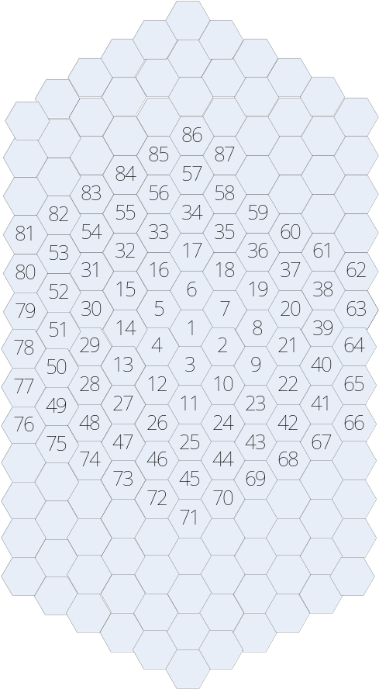
After marked all cells with indexes, the user can use a number to indicate each cell.
User select two cells by click, the algorithm will give a shortest path between these two cells. The length of a path is calculated by the number of cells the path passed through. For example, the path between 9 and 13 in above comb may be 9-2-3-4-13, the length of which is 4 moves.

Advanced Objectives:
- Compare several different algorithms to give a shortest path.
- Show the shortest path on the displayed comb.
- Provide a manually rotatable 3D view of the comb.

Additive Objectives
- Animated all displayed items, better control feedbacks. Smooth changing between 2D display and 3D display.
- Some of the cells are inaccessible.
- Some of the cell-walls are too thick to pass through.
- Several object cells, give a shortest Hamilton path or Hamilton circle.
- Import/export solution with different formats such as xml, csv. Export generated graph.
- CombCell should have capability with different kinds of operating systems, as Linux/Unix.

Specific Requirements

Functionality
The fully defined features will be provided during the Elaboration Iteration.
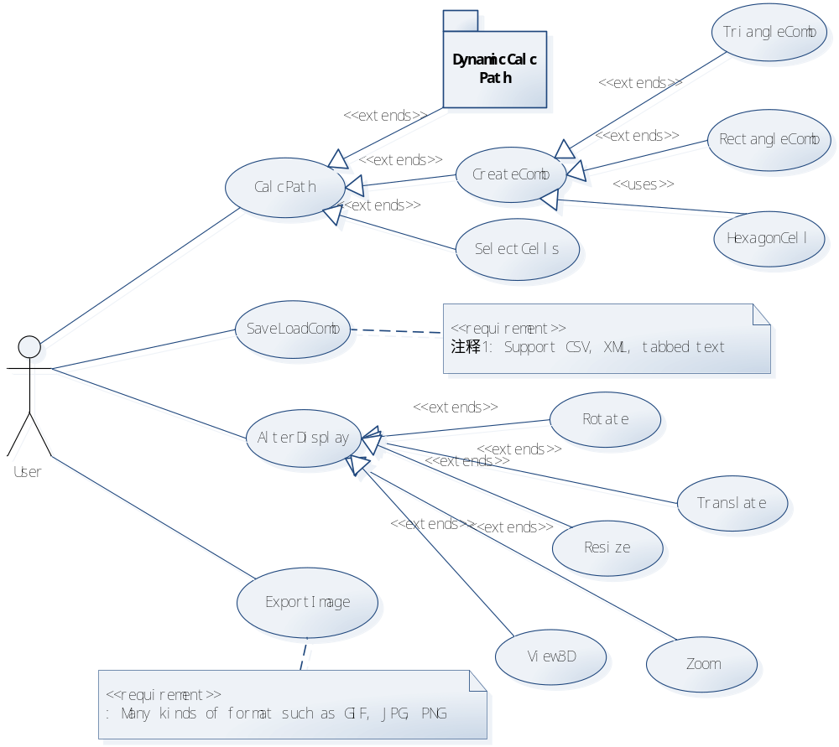
The most important part of this use case is Dynamic Calculate Path, which is described below:
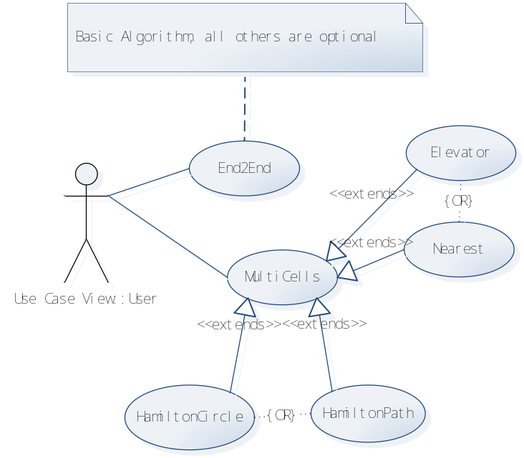

Create & show the graphic comb
The system will provide a graphic display of the comb with marked indexes in every cell. The cells will react to the user’s control such as when user put mouse cursor on one cell the cell will be displayed differently with other cells by color or other visible feature. Select or unselect a cell will also be displayed. The comb can be zoomed and rotated for all directions. This will enhance the sense of control of the system.
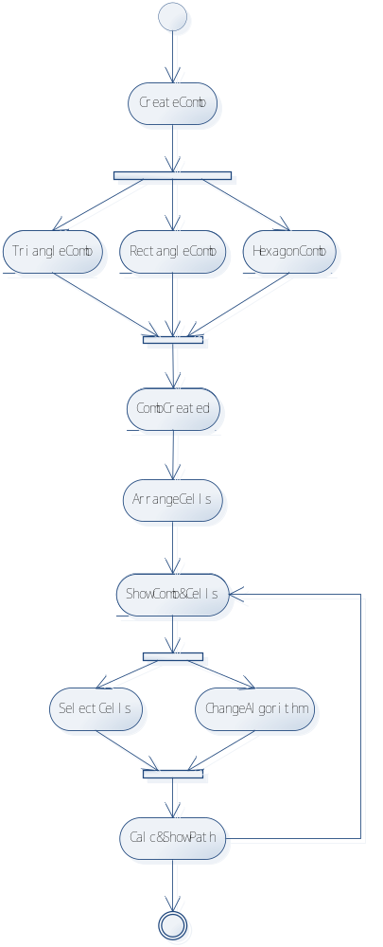

Calculate & show the shortest path
After selecting two cells on the comb, the system will calculate the shortest path and displayed it on the comb.
For a better sense of control, the user can change the cells that selected at any time and the system must re-calculate and redraw the shortest path according to user’s input.
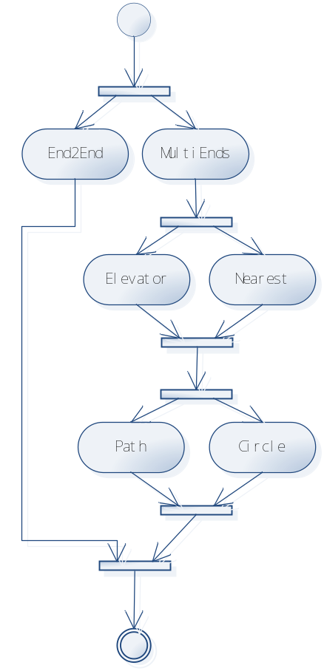

Save / Load the comb
The comb can be saved and loaded at any time by the will of the user. File format should be XML, CSV, tabled-text, or any other supported format.
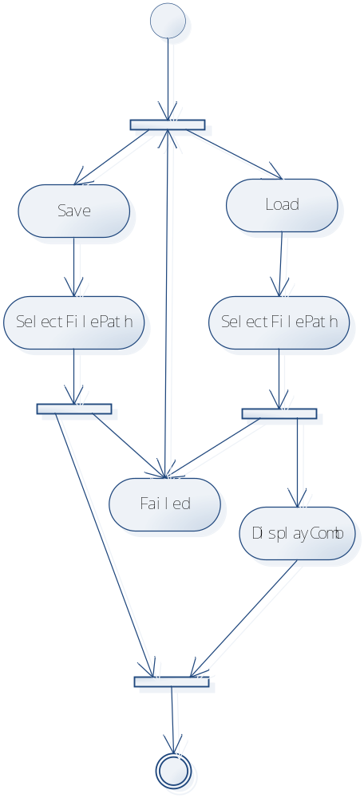

All the displayed elements should be animated (Optional)
This will enhance the sense of control of the system. Animation includes highlighting the cells that are selectable when cursor is above them, drawing the path of cells one by one.

Zoom and rotate the comb (Optional)
The comb could be zoomed in/out and rotate at all directions. This should be controlled by mouse input, and react directly when user is controlling.
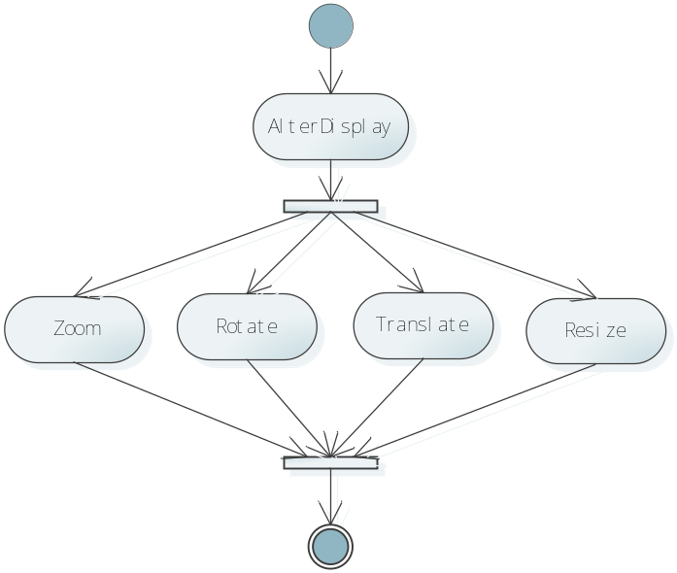

Some of the cells and walls may be unable to pass (Optional)
The algorithm is much smarter in choosing the shortest path. The algorithm should be suitable for a complex maze like comb and should be not to slow in solving complex maze-like comb.

Several objectives and find the Hamilton path or circle (Optional)
The algorithm can solve more complex circumstances. The standard Hamilton path algorithm should be a NP-Complete problem, so the algorithm realized in the program may be an approximate algorithm.

3D display of the graphic comb (Optional)
The system will be built on the modern graphic technology to provide better user experience. 3D view of the comb should provide the zoom / rotate operation that could substitute the 2D operations.

Usability

Tasking time
One minute should be ok for normal tasks.

Coding standards
Microsoft FxCop standards

Reliability

Availability
The system should be available at all time with percentage 99%

Mean Time between Failures
MTBF of the system should be over 10 hour.

Maximum Bugs or Defect Rate
MDR of the system should be no more than 1 defect in 1000 lines of code.

Performance

Response time
The system SHOULD NOT occur significant delay by the view of end user. So every operation or algorithm must carry out in 1 second.

Resource utilization
Memory: Limited in 100 MB
Disk occupation: Limited in 20 MB

Supportability

Coding Standards
Coding should be According to Microsoft FxCop Standards with less than 1 warning per 1000 lines of code.

Naming Conventions
All public class, functions, events, properties, variables should be in PascalCast defined in FxCop.
All parameters should be in camelCast defined in FxCop.
All private functions, events, properties, variables should be in camelCast defined in FxCop
All event argument class should be post-fixed by EventArgs
All event handler class should be the specification of EventHandler<EventArgs>
All public class should be put separately in a source file with the name equally to the class name

Class libraries
.Net framework class with next namespaces:
System
System.Date
System.IO
System.Collection.Generic
System.Threading
System.Xml
System.Xml.Serialization
System.Text.Regax
System.Windows (Optional)
System.Windows.Media (Optional)
System.Windows.Controls (Optional)
System.Windows.Drawing (Optional)
System.Windows.Media.Media2D (Optional)
System.Widnows.Forms (Optional)
System.Widnows.Forms.Controls (Optional)

Design Constraints

Development Language
C#

Development Environment
Windows Vista Home Premium sp1
Microsoft Visual Studio 2008 sp1
Microsoft Expression Blend 2

Ubuntu desktop 9.04
Wine 1.0
Mono project 2.0
MonoDevelop Studio 2.0

Microsoft Office 2007
Microsoft Office Visio 2007

Development Tools
Subversion
FxCop Check

On-line User Documentation and Help System Requirements
The online help system is consisted of:
- Popup tooltips of every GUI elements
- Basic guide for first game players
- All document elements included in user manual

Interfaces

User Interfaces
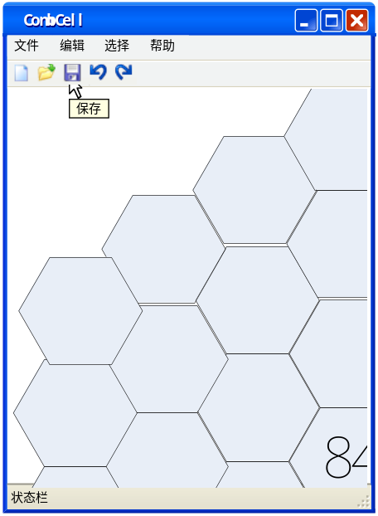

Hardware Interfaces
All the hardware interfaces that meet the needs of the supporting operating systems and library.

Software Interfaces
- Windows API
- Windows .Net Framework support
- MonoProject for Linux support

Communications Interfaces
N/A

Licensing Requirements
GNU General Public License version 3

Legal, Copyright, and Other Notices
According to the GNU copyright/ copyleft license

Applicable Standards
Microsoft FxCop Standards

