CombCell
Test Evaluation Summary

Version <1.0>

Revision History
Date | Version | Description | Author
<2009-07-27> | <1.0> | Introduction, test result summary | Jiachen Yang

Table of Contents
1. Introduction 4
1.1 Purpose 4
1.2 Scope 4
1.3 Definitions, Acronyms, and Abbreviations 4
1.4 References 4
1.5 Overview 5
2. Test Results Summary 5
2.1 Finished Workload 5
2.1.1 Total Test Case: 265 Test Methods, Passed 233 5
2.1.2 Test sub-project Files: 168 8
3. Requirements-based Test Coverage 8
4. Code-based Test Coverage 8
4.1 Overall Coverage 8
4.2 CombCell.DsAlgo 8
5. Suggested Actions 11
6. Diagrams 11

Test Evaluation Summary

Introduction

Purpose
This summary provides a overall summary to the test part of Project CombCell in order to evaluate the test.

Scope
The summary is associated with the test stuff of Project CombCell.
The test is guided by Test Plan and Software Requirement Specification of Project CombCell.
The levels of testing used in CombCell are Unit testing, Integration testing, System testing, Regression testing and Regular testing. Their relations are illustrated below.
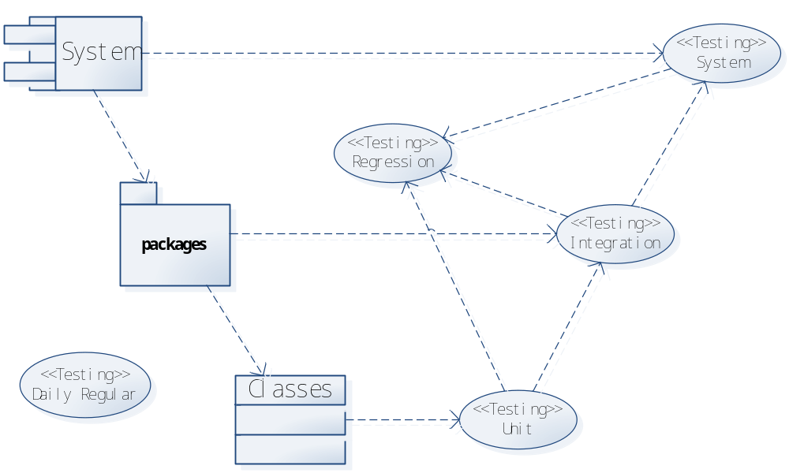

Definitions, Acronyms, and Abbreviations
Abbr. | Stands for
SAD | Software Architecture Documents
SDP | Software Development Plan
SRS | Software Requirements Specification
WPF | Windows Presentation Foundation, a graphic user interface library used by this system
netfx | .net framework, programming framework used by this system
DP | Dependency property, kind of property in class defines that used by WPF
comb | All comb mentioned in this documents stands for honeycomb, not hair-comb
GUI | Graphic User Inerface
FPS | Frames per second, criteria for GUI performance

References
CombCell Software Architecture Document
CombCell Software Development Plan
CombCell Test Plan

Overview
This summary includes the Test Results Summary, Test Coverage, Suggested Actions, Diagrams and the reference to the generated report of the test of Project CombCell.

Test Results Summary

Finished Workload

Total Test Case: 265 Test Methods, Passed 233

Refer to the test report generated by MSTest

通过 | AlgorithmGet01 | CombCell.Tests
通过 | Constructor01 | CombCell.Tests
通过 | ToString01 | CombCell.Tests
通过 | Arrange01 | CombCell.Tests
通过 | CombGetSet03 | CombCell.Tests
通过 | CombGetSet04 | CombCell.Tests
通过 | CombGetSet05 | CombCell.Tests
通过 | CombGetSet06 | CombCell.Tests
通过 | CreateCellShape01 | CombCell.Tests
通过 | FromPointToIndex06 | CombCell.Tests
通过 | FromPointToIndex07 | CombCell.Tests
通过 | FromPointToPair06 | CombCell.Tests
通过 | FromPointToPair07 | CombCell.Tests
未通过 | MarkIndex01 | CombCell.Tests
未通过 | MarkIndex03 | CombCell.Tests
通过 | NearBy04 | CombCell.Tests
通过 | NearBy05 | CombCell.Tests
通过 | NeedAddChild02 | CombCell.Tests
通过 | XCountGet02 | CombCell.Tests
通过 | YCountGet02 | CombCell.Tests
通过 | IndexGetSet01 | CombCell.Tests
通过 | IndexGetSet02 | CombCell.Tests
通过 | PositionGetSet01 | CombCell.Tests
通过 | PositionGetSet02 | CombCell.Tests
通过 | StateGetSet01 | CombCell.Tests
未通过 | Main01 | CombCell.Tests
未通过 | Main02 | CombCell.Tests
通过 | Constructor01 | CombCell.Tests
未通过 | Block02 | CombCell.Tests
未通过 | Block01 | CombCell.Tests
未通过 | ChoosedAlgorithmGetSet02 | CombCell.Tests
未通过 | ChoosedAlgorithmGetSet01 | CombCell.Tests
未通过 | Constructor01 | CombCell.Tests
未通过 | Constructor02 | CombCell.Tests
通过 | EnsureCells11 | CombCell.Tests
通过 | EnsureCells09 | CombCell.Tests
通过 | EnsureCells08 | CombCell.Tests
通过 | EnsureCells07 | CombCell.Tests
通过 | EnsureCells04 | CombCell.Tests
通过 | EnsureCells32 | CombCell.Tests
通过 | EnsureCells12 | CombCell.Tests
通过 | EnsureCells14 | CombCell.Tests
通过 | EnsureCells15 | CombCell.Tests
通过 | EnsureCells17 | CombCell.Tests
通过 | EnsureCells18 | CombCell.Tests
通过 | EnsureCells19 | CombCell.Tests
通过 | EnsureCells21 | CombCell.Tests
通过 | EnsureCells23 | CombCell.Tests
通过 | EnsureCells29 | CombCell.Tests
通过 | EnsureCells33 | CombCell.Tests
通过 | EnsureCells34 | CombCell.Tests
通过 | GraphPathGetSet03 | CombCell.Tests
通过 | GraphPathGetSet02 | CombCell.Tests
通过 | GraphPathGetSet01 | CombCell.Tests
通过 | ItemGet04 | CombCell.Tests
未通过 | ItemGet05 | CombCell.Tests
通过 | ItemGet06 | CombCell.Tests
通过 | ItemGet0103 | CombCell.Tests
未通过 | ItemGet0104 | CombCell.Tests
通过 | ItemGet0105 | CombCell.Tests
通过 | PathDescriptionGetSet03 | CombCell.Tests
通过 | PathDescriptionGetSet02 | CombCell.Tests
通过 | PathDescriptionGetSet01 | CombCell.Tests
未通过 | Select02 | CombCell.Tests
未通过 | Select01 | CombCell.Tests
通过 | StartMarkIndex02 | CombCell.Tests
通过 | StartMarkIndex01 | CombCell.Tests
未通过 | Unblock02 | CombCell.Tests
未通过 | Unblock01 | CombCell.Tests
未通过 | Unselect02 | CombCell.Tests
未通过 | Unselect01 | CombCell.Tests
通过 | Constructor01 | CombCell.Tests
通过 | Constructor02 | CombCell.Tests
通过 | Constructor03 | CombCell.Tests
通过 | Constructor04 | CombCell.Tests
通过 | Constructor0101 | CombCell.Tests
通过 | FromGetSet01 | CombCell.Tests
通过 | FromGetSet02 | CombCell.Tests
通过 | ToGetSet01 | CombCell.Tests
通过 | ToGetSet02 | CombCell.Tests
通过 | ToString01 | CombCell.Tests
通过 | ClearAccessed01 | CombCell.Tests
通过 | Constructor01 | CombCell.Tests
通过 | Constructor02 | CombCell.Tests
通过 | CreateEdge01 | CombCell.Tests
通过 | CreateEdge02 | CombCell.Tests
通过 | CreateEdge03 | CombCell.Tests
通过 | CreateEdge04 | CombCell.Tests
通过 | CreateEdge10 | CombCell.Tests
通过 | CreateVertex01 | CombCell.Tests
通过 | EdgesGet01 | CombCell.Tests
通过 | InfinitiveGet01 | CombCell.Tests
通过 | RemoveEdge01 | CombCell.Tests
通过 | RemoveEdge02 | CombCell.Tests
通过 | RemoveVertex01 | CombCell.Tests
通过 | RemoveVertex02 | CombCell.Tests
通过 | VertexesGet01 | CombCell.Tests
通过 | VertexMapGet01 | CombCell.Tests
通过 | Arrange01 | CombCell.Tests
通过 | CreateCellShape01 | CombCell.Tests
通过 | FromPointToPair02 | CombCell.Tests
通过 | FromPointToPair01 | CombCell.Tests
未通过 | MarkIndex01 | CombCell.Tests
未通过 | MarkIndex02 | CombCell.Tests
通过 | NearBy02 | CombCell.Tests
通过 | NearBy01 | CombCell.Tests
通过 | Add03 | CombCell.Tests
通过 | Add02 | CombCell.Tests
未通过 | Add01 | CombCell.Tests
通过 | CurrentGet01 | CombCell.Tests
通过 | ItemGetSet05 | CombCell.Tests
未通过 | ItemGetSet04 | CombCell.Tests
未通过 | ItemGetSet02 | CombCell.Tests
未通过 | ItemGetSet01 | CombCell.Tests
未通过 | ItemGetSet11 | CombCell.Tests
通过 | Constructor01 | CombCell.Tests
通过 | Equality02 | CombCell.Tests
通过 | Equality01 | CombCell.Tests
通过 | Equals04 | CombCell.Tests
通过 | Equals03 | CombCell.Tests
通过 | Equals02 | CombCell.Tests
通过 | Equals0102 | CombCell.Tests
通过 | Equals0101 | CombCell.Tests
通过 | GetHashCode01 | CombCell.Tests
通过 | Inequality02 | CombCell.Tests
通过 | Inequality01 | CombCell.Tests
通过 | ToString01 | CombCell.Tests
通过 | Arrange01 | CombCell.Tests
通过 | CreateCellShape01 | CombCell.Tests
通过 | FromPointToPair03 | CombCell.Tests
通过 | FromPointToPair02 | CombCell.Tests
通过 | FromPointToPair01 | CombCell.Tests
未通过 | MarkIndex01 | CombCell.Tests
未通过 | MarkIndex02 | CombCell.Tests
通过 | NearBy01 | CombCell.Tests
通过 | BrushGetSet02 | CombCell.Tests
通过 | BrushGetSet01 | CombCell.Tests
通过 | KeyGetSet03 | CombCell.Tests
通过 | KeyGetSet02 | CombCell.Tests
通过 | KeyGetSet01 | CombCell.Tests
通过 | PenGetSet04 | CombCell.Tests
通过 | PenGetSet03 | CombCell.Tests
通过 | PenGetSet02 | CombCell.Tests
通过 | PenGetSet01 | CombCell.Tests
通过 | Calc00101 | CombCell.Tests
通过 | Calc00102 | CombCell.Tests
通过 | Calc00103 | CombCell.Tests
通过 | Arrange01 | CombCell.Tests
通过 | CreateCellShape01 | CombCell.Tests
通过 | FromPointToPair05 | CombCell.Tests
通过 | FromPointToPair04 | CombCell.Tests
通过 | FromPointToPair03 | CombCell.Tests
通过 | FromPointToPair02 | CombCell.Tests
通过 | FromPointToPair01 | CombCell.Tests
未通过 | MarkIndex01 | CombCell.Tests
未通过 | MarkIndex02 | CombCell.Tests
通过 | NearBy03 | CombCell.Tests
通过 | NearBy02 | CombCell.Tests
通过 | NearBy01 | CombCell.Tests
通过 | Constructor01 | CombCell.DSAlgo.Tests
通过 | CountGet01 | CombCell.DSAlgo.Tests
通过 | CrossVertexesGetSet01 | CombCell.DSAlgo.Tests
通过 | KeyCountGet01 | CombCell.DSAlgo.Tests
通过 | KeyVertexesGetSet01 | CombCell.DSAlgo.Tests
通过 | PassedCountGet01 | CombCell.DSAlgo.Tests
通过 | PassedVertexesGetSet01 | CombCell.DSAlgo.Tests
通过 | CreateEdge05 | CombCell.DSAlgo.Tests
通过 | RemoveEdgeFc0102 | CombCell.DSAlgo.Tests
通过 | RemoveVertexFc0101 | CombCell.DSAlgo.Tests
通过 | CalcFc0101 | CombCell.DSAlgo.Tests
通过 | CalcFc0102 | CombCell.DSAlgo.Tests
通过 | CalcFc0106 | CombCell.DSAlgo.Tests
通过 | CalcFc0104 | CombCell.DSAlgo.Tests
通过 | Constructor01 | CombCell.DSAlgo.Tests
通过 | HasNextPermutation01 | CombCell.DSAlgo.Tests
通过 | HasNextPermutation02 | CombCell.DSAlgo.Tests
通过 | HasNextPermutation03 | CombCell.DSAlgo.Tests
通过 | HasNextPermutation04 | CombCell.DSAlgo.Tests
通过 | HasNextPermutation07 | CombCell.DSAlgo.Tests
通过 | HasNextPermutation10 | CombCell.DSAlgo.Tests
通过 | HasNextPermutation11 | CombCell.DSAlgo.Tests
通过 | HasNextPermutation15 | CombCell.DSAlgo.Tests
未通过 | HasNextPermutation0101 | CombCell.DSAlgo.Tests
通过 | HasNextPermutation0102 | CombCell.DSAlgo.Tests
通过 | HasNextPermutation0103 | CombCell.DSAlgo.Tests
未通过 | HasNextPermutation0108 | CombCell.DSAlgo.Tests
通过 | HasNextPermutation0109 | CombCell.DSAlgo.Tests
通过 | HasNextPermutation0114 | CombCell.DSAlgo.Tests
通过 | HasNextPermutation0104 | CombCell.DSAlgo.Tests
通过 | HasNextPermutation0105 | CombCell.DSAlgo.Tests
通过 | HasNextPermutation0106 | CombCell.DSAlgo.Tests
通过 | HasNextPermutation0107 | CombCell.DSAlgo.Tests
通过 | HasNextPermutation0110 | CombCell.DSAlgo.Tests
通过 | HasNextPermutation0115 | CombCell.DSAlgo.Tests
通过 | HasNextPermutation0124 | CombCell.DSAlgo.Tests
通过 | HasNextPermutation0125 | CombCell.DSAlgo.Tests
通过 | HasNextPermutation0127 | CombCell.DSAlgo.Tests
通过 | HasNextPermutation0128 | CombCell.DSAlgo.Tests
通过 | NextPermutation01 | CombCell.DSAlgo.Tests
通过 | NextPermutation02 | CombCell.DSAlgo.Tests
通过 | NextPermutation07 | CombCell.DSAlgo.Tests
通过 | NextPermutation08 | CombCell.DSAlgo.Tests
通过 | NextPermutation11 | CombCell.DSAlgo.Tests
通过 | NextPermutation13 | CombCell.DSAlgo.Tests
通过 | NextPermutation15 | CombCell.DSAlgo.Tests
通过 | NextPermutation17 | CombCell.DSAlgo.Tests
通过 | NextPermutation16 | CombCell.DSAlgo.Tests
通过 | NextPermutation19 | CombCell.DSAlgo.Tests
通过 | NextPermutation20 | CombCell.DSAlgo.Tests
通过 | NextPermutationFc01 | CombCell.DSAlgo.Tests
通过 | NextPermutationFc02 | CombCell.DSAlgo.Tests
通过 | CalcFc0101 | CombCell.DSAlgo.Tests
通过 | CalcFc0102 | CombCell.DSAlgo.Tests
通过 | CalcFc0103 | CombCell.DSAlgo.Tests
通过 | Constructor01 | CombCell.DSAlgo.Tests
通过 | Add0101 | CombCell.DSAlgo.Tests
通过 | Add02 | CombCell.DSAlgo.Tests
通过 | ChangePriority02 | CombCell.DSAlgo.Tests
通过 | Clear01 | CombCell.DSAlgo.Tests
通过 | Constructor0101 | CombCell.DSAlgo.Tests
通过 | Constructor02 | CombCell.DSAlgo.Tests
通过 | ContainsKey01 | CombCell.DSAlgo.Tests
通过 | Contains01 | CombCell.DSAlgo.Tests
通过 | CopyTo04 | CombCell.DSAlgo.Tests
通过 | CopyTo02 | CombCell.DSAlgo.Tests
通过 | CopyTo01 | CombCell.DSAlgo.Tests
通过 | CopyTo08 | CombCell.DSAlgo.Tests
通过 | CountGet01 | CombCell.DSAlgo.Tests
通过 | EmptyGet01 | CombCell.DSAlgo.Tests
通过 | GetEnumerator02 | CombCell.DSAlgo.Tests
通过 | Insert0101 | CombCell.DSAlgo.Tests
通过 | Insert02 | CombCell.DSAlgo.Tests
通过 | IsReadOnlyGet01 | CombCell.DSAlgo.Tests
通过 | ItemGetSet01 | CombCell.DSAlgo.Tests
通过 | KeysGet01 | CombCell.DSAlgo.Tests
通过 | Peek01 | CombCell.DSAlgo.Tests
通过 | Pop01 | CombCell.DSAlgo.Tests
通过 | Remove0101 | CombCell.DSAlgo.Tests
通过 | Remove02 | CombCell.DSAlgo.Tests
通过 | TryGetValue01 | CombCell.DSAlgo.Tests
通过 | ValuesGet01 | CombCell.DSAlgo.Tests
通过 | Calc01 | CombCell.DSAlgo.Tests
通过 | CanCalcGet01 | CombCell.DSAlgo.Tests
通过 | Constructor01 | CombCell.DSAlgo.Tests
通过 | DiscriptionGet01 | CombCell.DSAlgo.Tests
通过 | NameGet01 | CombCell.DSAlgo.Tests
通过 | Calc02 | CombCell.DSAlgo.Tests
通过 | Calc01 | CombCell.DSAlgo.Tests
未通过 | Calc04 | CombCell.DSAlgo.Tests
通过 | Calc03 | CombCell.DSAlgo.Tests
通过 | CalcFc0101 | CombCell.DSAlgo.Tests
通过 | CanCalcGet01 | CombCell.DSAlgo.Tests
通过 | CanCalcGet02 | CombCell.DSAlgo.Tests
通过 | Constructor01 | CombCell.DSAlgo.Tests
通过 | DiscriptionGet01 | CombCell.DSAlgo.Tests
通过 | NameGet01 | CombCell.DSAlgo.Tests
通过 | AccessedGetSet01 | CombCell.DSAlgo.Tests
通过 | AccessedGetSet02 | CombCell.DSAlgo.Tests
通过 | Constructor01 | CombCell.DSAlgo.Tests
通过 | EdgesGet01 | CombCell.DSAlgo.Tests
通过 | IsConnect01 | CombCell.DSAlgo.Tests
通过 | IsConnect02 | CombCell.DSAlgo.Tests
通过 | IsConnectFc0102 | CombCell.DSAlgo.Tests
通过 | KeyGetSet01 | CombCell.DSAlgo.Tests
通过 | ToString01 | CombCell.DSAlgo.Tests

Test sub-project Files: 168
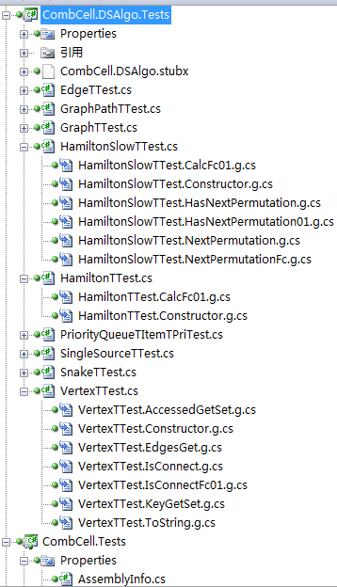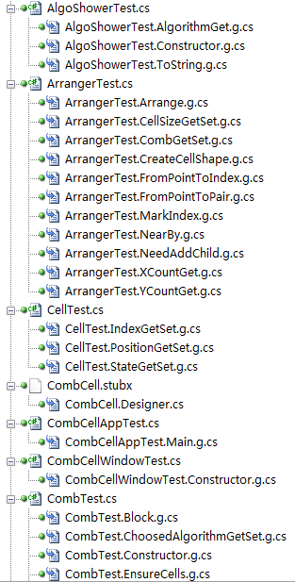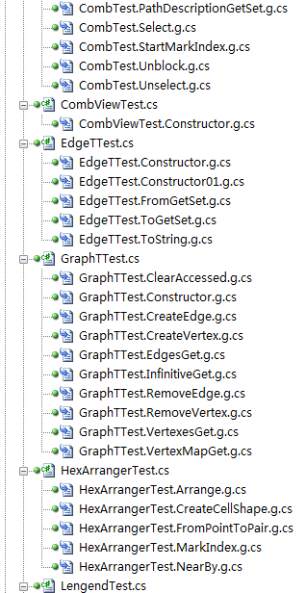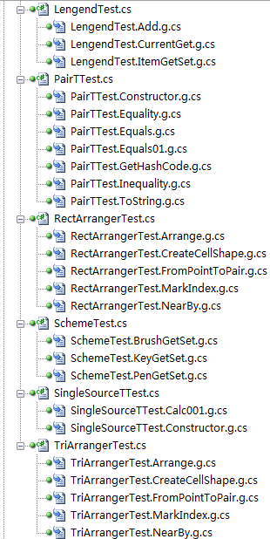
Test sub-project Code Count: 14004 (Total) 11043(Code) 2213(Comments)
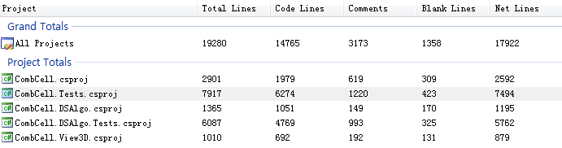

Requirements-based Test Coverage

Function Testing
All basic functions in DSAlgo namespace has been tested.

User Interface Testing
All user interface has been separately tested, some unnoticeable mistakes occurs in hit test in TriArranger, which may dual with double’s accuracy.

Performance Profiling
System was normal under 5000 cells, at this time the memory cost was more than 128MB. With more than 5000 cells and graphic drop-down-shadow effect, the system seems a bit low reaction, but after cancel the effect, the system still normal, with the memory cost over 200MB.

Code-based Test Coverage
Refer to code coverage generated by MSTest

Overall Coverage
Sub-project | Uncovered (Blocks) | Uncovered (Percentage) | Covered (Blocks) | Covered (Percentage)
CombCell.DSAlgo.Tests.dll | 471 | 37.32% | 791 | 62.68%
CombCell.DSAlgo.dll | 54 | 4.88% | 1052 | 95.12%
CombCell.Tests.dll | 112 | 9.03% | 1128 | 90.97%
CombCell.exe | 981 | 53.81% | 842 | 46.19%
We can see that the most covered part is CombCell.DSAlgo.Dll sub-project with over 95% coverage. Other projects are related with GUI logic which is hard to test with unit test cases.

CombCell.DSAlgo
The most uncovered blocks are throws statement, which is actually covered but cannot recorded by coverage tools.
A few uncovered blocks are branches that will never be triggered by upper layer of program, such as swap the same item in a list.
+ | Project, Class, Method | Uncovered (Blocks) | Uncovered (Percentage) | Covered (Blocks) | Covered (Percentage)
- | CombCell.DSAlgo | 54 | 4.88% | 1052 | 95.12%
- | Edge`1 | 0 | 0.00% | 27 | 100.00%
 | .ctor() | 0 | 0.00% | 2 | 100.00%
 | .ctor(class CombCell.DSAlgo.Vertex`1<!0>,class CombCell.DSAlgo.Vertex`1<!0>) | 0 | 0.00% | 8 | 100.00%
 | ToString() | 0 | 0.00% | 5 | 100.00%
 | get_From() | 0 | 0.00% | 2 | 100.00%
 | get_To() | 0 | 0.00% | 2 | 100.00%
 | set_From(class CombCell.DSAlgo.Vertex`1<!0>) | 0 | 0.00% | 4 | 100.00%
 | set_To(class CombCell.DSAlgo.Vertex`1<!0>) | 0 | 0.00% | 4 | 100.00%
- | GraphPath`1 | 0 | 0.00% | 23 | 100.00%
 | .ctor() | 0 | 0.00% | 5 | 100.00%
 | get_Count() | 0 | 0.00% | 3 | 100.00%
 | get_CrossVertexes() | 0 | 0.00% | 2 | 100.00%
 | get_KeyCount() | 0 | 0.00% | 3 | 100.00%
 | get_KeyVertexes() | 0 | 0.00% | 2 | 100.00%
 | get_PassedCount() | 0 | 0.00% | 3 | 100.00%
 | get_PassedVertexes() | 0 | 0.00% | 2 | 100.00%
 | set_CrossVertexes(class System.Collections.Generic.List`1<!0>) | 0 | 0.00% | 1 | 100.00%
 | set_KeyVertexes(class System.Collections.Generic.List`1<!0>) | 0 | 0.00% | 1 | 100.00%
 | set_PassedVertexes(class System.Collections.Generic.List`1<!0>) | 0 | 0.00% | 1 | 100.00%
- | Graph`1 | 0 | 0.00% | 89 | 100.00%
 | .ctor() | 0 | 0.00% | 5 | 100.00%
 | ClearAccessed() | 0 | 0.00% | 13 | 100.00%
 | CreateEdge(class CombCell.DSAlgo.Vertex`1<!0>,class CombCell.DSAlgo.Vertex`1<!0>) | 0 | 0.00% | 22 | 100.00%
 | CreateVertex(!0) | 0 | 0.00% | 8 | 100.00%
 | RemoveEdge(class CombCell.DSAlgo.Edge`1<!0>) | 0 | 0.00% | 12 | 100.00%
 | RemoveVertex(class CombCell.DSAlgo.Vertex`1<!0>) | 0 | 0.00% | 17 | 100.00%
 | get_Edges() | 0 | 0.00% | 2 | 100.00%
 | get_Infinitive() | 0 | 0.00% | 6 | 100.00%
 | get_VertexMap() | 0 | 0.00% | 2 | 100.00%
 | get_Vertexes() | 0 | 0.00% | 2 | 100.00%
- | HamiltonSlow`1 | 14 | 6.03% | 218 | 93.97%
 | Calc() | 0 | 0.00% | 34 | 100.00%
 | CalcDistance() | 6 | 10.00% | 54 | 90.00%
 | HasNextPermutation(class System.Collections.Generic.List`1<int32>,int32,int32) | 0 | 0.00% | 31 | 100.00%
 | NextPermutation(class System.Collections.Generic.List`1<int32>,int32,int32) | 0 | 0.00% | 50 | 100.00%
 | generatePath() | 0 | 0.00% | 49 | 100.00%
 | get_CanCalc() | 4 | 100.00% | 0 | 0.00%
 | get_Discription() | 2 | 100.00% | 0 | 0.00%
 | get_Name() | 2 | 100.00% | 0 | 0.00%
- | Hamilton`1 | 15 | 6.02% | 234 | 93.98%
 | Calc() | 0 | 0.00% | 5 | 100.00%
 | CalcDistance() | 6 | 10.00% | 54 | 90.00%
 | approxTravelingSalesman() | 1 | 2.33% | 42 | 97.67%
 | generatePath() | 0 | 0.00% | 49 | 100.00%
 | get_CanCalc() | 4 | 100.00% | 0 | 0.00%
 | get_Discription() | 2 | 100.00% | 0 | 0.00%
 | get_Name() | 2 | 100.00% | 0 | 0.00%
 | prim() | 0 | 0.00% | 84 | 100.00%
- | PathAlgorithm`1 | 0 | 0.00% | 15 | 100.00%
 | .ctor() | 0 | 0.00% | 6 | 100.00%
 | get_Graph() | 0 | 0.00% | 2 | 100.00%
 | get_Path() | 0 | 0.00% | 2 | 100.00%
 | get_Selected() | 0 | 0.00% | 2 | 100.00%
 | set_Graph(class CombCell.DSAlgo.Graph`1<!0>) | 0 | 0.00% | 1 | 100.00%
 | set_Path(class CombCell.DSAlgo.GraphPath`1<!0>) | 0 | 0.00% | 1 | 100.00%
 | set_Selected(class System.Collections.Generic.List`1<!0>) | 0 | 0.00% | 1 | 100.00%
- | PriorityQueue`2 | 20 | 9.39% | 193 | 90.61%
 | .ctor() | 0 | 0.00% | 4 | 100.00%
 | .ctor(class System.Collections.Generic.IComparer`1<!1>) | 0 | 0.00% | 6 | 100.00%
 | Add(!0,!1) | 0 | 0.00% | 2 | 100.00%
 | Add(valuetype System.Collections.Generic.KeyValuePair`2<!0,!1>) | 0 | 0.00% | 2 | 100.00%
 | ChangePriority(!0,!1) | 2 | 12.50% | 14 | 87.50%
 | Clear() | 0 | 0.00% | 3 | 100.00%
 | Contains(valuetype System.Collections.Generic.KeyValuePair`2<!0,!1>) | 0 | 0.00% | 3 | 100.00%
 | ContainsKey(!0) | 0 | 0.00% | 3 | 100.00%
 | CopyTo(valuetype System.Collections.Generic.KeyValuePair`2<!0,!1>[],int32) | 0 | 0.00% | 11 | 100.00%
 | GetEnumerator() | 0 | 0.00% | 3 | 100.00%
 | Insert(!0,!1) | 0 | 0.00% | 3 | 100.00%
 | Insert(valuetype System.Collections.Generic.KeyValuePair`2<!0,!1>) | 0 | 0.00% | 7 | 100.00%
 | Peek() | 3 | 42.86% | 4 | 57.14%
 | Pop() | 0 | 0.00% | 18 | 100.00%
 | Remove(!0) | 3 | 42.86% | 4 | 57.14%
 | Remove(valuetype System.Collections.Generic.KeyValuePair`2<!0,!1>) | 0 | 0.00% | 4 | 100.00%
 | System.Collections.IEnumerable.GetEnumerator() | 3 | 100.00% | 0 | 0.00%
 | TryGetValue(!0,!1&) | 2 | 33.33% | 4 | 66.67%
 | compare(int32,int32) | 0 | 0.00% | 7 | 100.00%
 | get_Count() | 0 | 0.00% | 3 | 100.00%
 | get_Empty() | 0 | 0.00% | 3 | 100.00%
 | get_IsReadOnly() | 0 | 0.00% | 2 | 100.00%
 | get_Item(!0) | 0 | 0.00% | 5 | 100.00%
 | get_Keys() | 0 | 0.00% | 3 | 100.00%
 | get_Values() | 4 | 26.67% | 11 | 73.33%
 | init() | 1 | 16.67% | 5 | 83.33%
 | left(int32) | 0 | 0.00% | 2 | 100.00%
 | parent(int32) | 0 | 0.00% | 2 | 100.00%
 | right(int32) | 0 | 0.00% | 2 | 100.00%
 | set_Item(!0,!1) | 0 | 0.00% | 7 | 100.00%
 | siftDown(int32) | 1 | 4.55% | 21 | 95.45%
 | siftUp(int32) | 0 | 0.00% | 12 | 100.00%
 | swap(int32,int32) | 1 | 7.14% | 13 | 92.86%
- | SingleSource`1 | 1 | 0.66% | 150 | 99.34%
 | Calc() | 0 | 0.00% | 9 | 100.00%
 | Dijkstra() | 0 | 0.00% | 24 | 100.00%
 | GeneratePath() | 1 | 1.61% | 61 | 98.39%
 | Initialize() | 0 | 0.00% | 38 | 100.00%
 | Relax(class CombCell.DSAlgo.Vertex`1<!0>,class CombCell.DSAlgo.Vertex`1<!0>) | 0 | 0.00% | 10 | 100.00%
 | get_CanCalc() | 0 | 0.00% | 4 | 100.00%
 | get_Discription() | 0 | 0.00% | 2 | 100.00%
 | get_Name() | 0 | 0.00% | 2 | 100.00%
- | Snake`1 | 1 | 1.47% | 67 | 98.53%
 | Calc() | 0 | 0.00% | 56 | 100.00%
 | get_CanCalc() | 1 | 12.50% | 7 | 87.50%
 | get_Discription() | 0 | 0.00% | 2 | 100.00%
 | get_Name() | 0 | 0.00% | 2 | 100.00%
- | Vertex`1 | 3 | 7.69% | 36 | 92.31%
 | .ctor() | 0 | 0.00% | 3 | 100.00%
 | IsConnect(class CombCell.DSAlgo.Vertex`1<!0>) | 1 | 4.76% | 20 | 95.24%
 | ToString() | 0 | 0.00% | 4 | 100.00%
 | get_Accessed() | 0 | 0.00% | 2 | 100.00%
 | get_Edges() | 0 | 0.00% | 2 | 100.00%
 | get_Key() | 0 | 0.00% | 2 | 100.00%
 | set_Accessed(bool) | 0 | 0.00% | 1 | 100.00%
 | set_Key(!0) | 2 | 50.00% | 2 | 50.00%

CombCell sub-project
All GUI related methods cannot be tested. They are:
- class CellShape, class CombView, class HexCell, class RectCell, class TriCell, class CombCellWindow
- method OnRender, OnRenderSizeChanged, ArrangeOverride, MeasureOverride, OnMouseOver
- method Block, Unblock, Select, Unselect, UpdatePath in Comb, because related CombView don't have a invalid size, which will be provided after CombView is shown on screen.
- Method RecalcCount in all 3 Arranger classes, because related CombView don't have a invalid size, which will be provided after CombView is shown on screen.
+ | Project, Class, Method | Uncovered (Blocks) | Uncovered (Percentage) | Covered (Blocks) | Covered (Percentage)
- | CombCell.exe | 981 | 53.81% | 842 | 46.19%
- | CombCell | 976 | 53.69% | 842 | 46.31%
+ | AlgoShower | 3 | 27.27% | 8 | 72.73%
- | Arranger | 6 | 10.17% | 53 | 89.83%
 | .cctor() | 0 | 0.00% | 22 | 100.00%
 | .ctor() | 0 | 0.00% | 4 | 100.00%
 | FromPointToIndex(valuetype System.Windows.Point) | 0 | 0.00% | 4 | 100.00%
 | NeedAddChild(valuetype System.Windows.Size) | 0 | 0.00% | 4 | 100.00%
 | get_CellSize() | 0 | 0.00% | 3 | 100.00%
 | get_Comb() | 0 | 0.00% | 3 | 100.00%
 | get_RenderSize() | 0 | 0.00% | 3 | 100.00%
 | get_XCount() | 0 | 0.00% | 3 | 100.00%
 | get_YCount() | 0 | 0.00% | 3 | 100.00%
 | set_CellSize(float64) | 2 | 100.00% | 0 | 0.00%
 | set_Comb(class CombCell.Comb) | 0 | 0.00% | 2 | 100.00%
 | set_RenderSize(valuetype System.Windows.Size) | 0 | 0.00% | 2 | 100.00%
 | set_XCount(int32) | 2 | 100.00% | 0 | 0.00%
 | set_YCount(int32) | 2 | 100.00% | 0 | 0.00%
- | Cell | 3 | 9.68% | 28 | 90.32%
 | .cctor() | 0 | 0.00% | 13 | 100.00%
 | CreateInstanceCore() | 3 | 100.00% | 0 | 0.00%
 | get_Index() | 0 | 0.00% | 3 | 100.00%
 | get_Position() | 0 | 0.00% | 3 | 100.00%
 | get_State() | 0 | 0.00% | 3 | 100.00%
 | set_Index(int32) | 0 | 0.00% | 2 | 100.00%
 | set_Position(valuetype CombCell.Pair`1<int32>) | 0 | 0.00% | 2 | 100.00%
 | set_State(valuetype CombCell.CellState) | 0 | 0.00% | 2 | 100.00%
+ | CellShape | 50 | 68.49% | 23 | 31.51%
- | Comb | 155 | 40.26% | 230 | 59.74%
 | .cctor() | 0 | 0.00% | 15 | 100.00%
 | .ctor(class CombCell.Arranger) | 0 | 0.00% | 6 | 100.00%
 | Block(valuetype CombCell.Pair`1<int32>) | 12 | 92.31% | 1 | 7.69%
 | CreateInstanceCore() | 3 | 100.00% | 0 | 0.00%
 | EnsureCells(int32,int32) | 0 | 0.00% | 47 | 100.00%
 | MarkIndex() | 1 | 0.81% | 122 | 99.19%
 | Select(valuetype CombCell.Pair`1<int32>) | 5 | 83.33% | 1 | 16.67%
 | StartMarkIndex(valuetype CombCell.Pair`1<int32>) | 0 | 0.00% | 2 | 100.00%
 | Unblock(valuetype CombCell.Pair`1<int32>) | 34 | 97.14% | 1 | 2.86%
 | Unselect(valuetype CombCell.Pair`1<int32>) | 5 | 83.33% | 1 | 16.67%
 | UpdatePath() | 84 | 86.60% | 13 | 13.40%
 | get_ChoosedAlgorithm() | 0 | 0.00% | 3 | 100.00%
 | get_GraphPath() | 0 | 0.00% | 3 | 100.00%
 | get_Item(int32,int32) | 8 | 61.54% | 5 | 38.46%
 | get_Item(valuetype CombCell.Pair`1<int32>) | 2 | 66.67% | 1 | 33.33%
 | get_PathDescription() | 0 | 0.00% | 3 | 100.00%
 | set_ChoosedAlgorithm(class CombCell.DSAlgo.PathAlgorithm`1<valuetype CombCell.Pair`1<int32>>) | 1 | 33.33% | 2 | 66.67%
 | set_GraphPath(class CombCell.DSAlgo.GraphPath`1<valuetype CombCell.Pair`1<int32>>) | 0 | 0.00% | 2 | 100.00%
 | set_PathDescription(string) | 0 | 0.00% | 2 | 100.00%
+ | CombCellWindow | 66 | 41.51% | 93 | 58.49%
+ | CombView | 401 | 80.36% | 98 | 19.64%
- | HexArranger | 18 | 18.37% | 80 | 81.63%
 | Arrange(int32,int32) | 0 | 0.00% | 9 | 100.00%
 | CreateCellShape() | 0 | 0.00% | 3 | 100.00%
 | CreateInstanceCore() | 3 | 100.00% | 0 | 0.00%
 | FromPointToPair(valuetype System.Windows.Point) | 0 | 0.00% | 20 | 100.00%
 | MarkIndex(int32,int32) | 9 | 81.82% | 2 | 18.18%
 | NearBy(int32,int32) | 0 | 0.00% | 30 | 100.00%
 | RecalcCount() | 6 | 27.27% | 16 | 72.73%
+ | HexCell | 51 | 100.00% | 0 | 0.00%
- | Lengend | 1 | 1.37% | 72 | 98.63%
 | .cctor() | 0 | 0.00% | 44 | 100.00%
 | Add(class CombCell.Scheme) | 0 | 0.00% | 13 | 100.00%
 | get_Current() | 1 | 20.00% | 4 | 80.00%
 | get_Item(string) | 0 | 0.00% | 6 | 100.00%
 | set_Item(string,class CombCell.Scheme) | 0 | 0.00% | 5 | 100.00%
- | Pair`1 | 0 | 0.00% | 26 | 100.00%
 | .ctor(!0,!0) | 0 | 0.00% | 1 | 100.00%
 | Equals(object) | 0 | 0.00% | 5 | 100.00%
 | Equals(valuetype CombCell.Pair`1<!0>) | 0 | 0.00% | 7 | 100.00%
 | GetHashCode() | 0 | 0.00% | 4 | 100.00%
 | ToString() | 0 | 0.00% | 3 | 100.00%
 | op_Equality(valuetype CombCell.Pair`1<!0>,valuetype CombCell.Pair`1<!0>) | 0 | 0.00% | 3 | 100.00%
 | op_Inequality(valuetype CombCell.Pair`1<!0>,valuetype CombCell.Pair`1<!0>) | 0 | 0.00% | 3 | 100.00%
- | RectArranger | 33 | 45.21% | 40 | 54.79%
 | Arrange(int32,int32) | 0 | 0.00% | 7 | 100.00%
 | CreateCellShape() | 0 | 0.00% | 3 | 100.00%
 | CreateInstanceCore() | 3 | 100.00% | 0 | 0.00%
 | FromPointToPair(valuetype System.Windows.Point) | 0 | 0.00% | 17 | 100.00%
 | MarkIndex(int32,int32) | 9 | 81.82% | 2 | 18.18%
 | NearBy(int32,int32) | 0 | 0.00% | 11 | 100.00%
 | RecalcCount() | 21 | 100.00% | 0 | 0.00%
+ | RectCell | 40 | 100.00% | 0 | 0.00%
- | Scheme | 3 | 10.71% | 25 | 89.29%
 | .cctor() | 0 | 0.00% | 10 | 100.00%
 | CreateInstanceCore() | 3 | 100.00% | 0 | 0.00%
 | get_Brush() | 0 | 0.00% | 3 | 100.00%
 | get_Key() | 0 | 0.00% | 3 | 100.00%
 | get_Pen() | 0 | 0.00% | 3 | 100.00%
 | set_Brush(class System.Windows.Media.Brush) | 0 | 0.00% | 2 | 100.00%
 | set_Key(string) | 0 | 0.00% | 2 | 100.00%
 | set_Pen(class System.Windows.Media.Pen) | 0 | 0.00% | 2 | 100.00%
- | TriArranger | 34 | 34.00% | 66 | 66.00%
 | Arrange(int32,int32) | 0 | 0.00% | 9 | 100.00%
 | CreateCellShape() | 0 | 0.00% | 3 | 100.00%
 | CreateInstanceCore() | 3 | 100.00% | 0 | 0.00%
 | FromPointToPair(valuetype System.Windows.Point) | 0 | 0.00% | 37 | 100.00%
 | MarkIndex(int32,int32) | 9 | 81.82% | 2 | 18.18%
 | NearBy(int32,int32) | 0 | 0.00% | 15 | 100.00%
 | RecalcCount() | 22 | 100.00% | 0 | 0.00%
+ | TriCell | 112 | 100.00% | 0 | 0.00%

Suggested Actions
[State any suggested actions based upon an evaluation of the test results and key measures of the test.]

