**N-BEATS (Neural Basis Expansion Analysis for Time Series)**

N-BEATS is [a type of neural network that was first described in a 2019 article by Oreshkin et al.](https://arxiv.org/abs/1905.10437)

They focus on solving the univariate times series point forecasting problem using deep learning. Actually, they propose a deep neural architecture based on backward and forward residual links and a very deep stack of fully-connected layers. The proposed architecture has a number of desirable properties, being interpretable, applicable without modification to a wide array of target domains, and fast to train.

The proposed methodology has three main components basic block, doubly residual stacking of blocks, and combining the stacks. We illustrate each one in the follows.

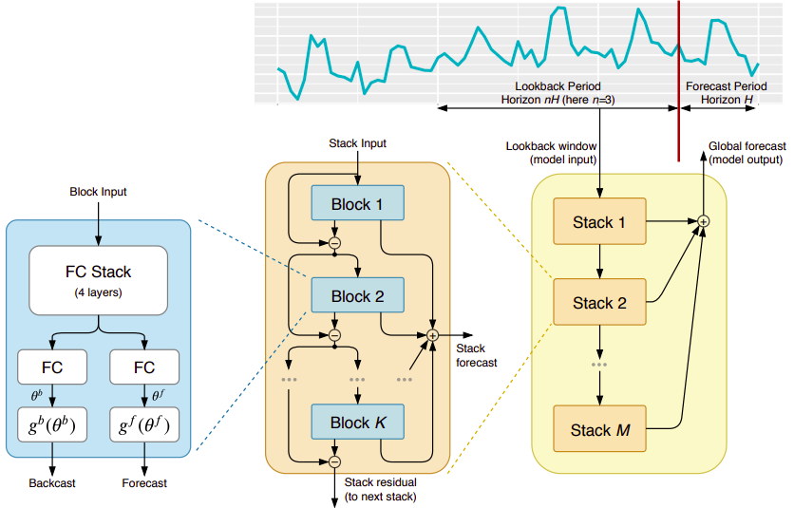

The main structure of NBEATS.

Firstly, imagine we have a time series data and want to predict next *H* step ahead. We call *H* as forecast period horizon. In addition to that we set the length of history lookback window as *nH* (the certain length ending with the last measured observation).

**i) Basic Block**

Each block receives an input (This input for the first block is the vector of history lookback with length *nH* and for the other is the subtraction of the backcast of previous block and input of that). Using this input 4 layers fully connected network are trained and based on them, two outputs are provided. The first one is the forecast with length *H* and the second one is the backcast with the length *nH*.

**ii) Doubly Residual Stacking Of Blocks:**

As mentioned before, each block provides two outputs: the forecast and the backcast. The subtraction of the block’s input and backcast is given to next block as input and called as residual. The residual of the last block of each stack is considered as the input of next stack. Also, the summation of blocks forecast are considered as the stack forecast.

**iii) Combining the Stacks**

Finally the summation of all stacks forecasts make the global forecast (model output).

**Learning trends and seasonality**

**Trend model.** A typical characteristic of trend is that most of the time it is a monotonic function, or at least a slowly varying function. In order to mimic this behavior the model proposes to constrain forecast and backcast of each block to be a polynomial of small degree p, a function slowly varying across forecast window:



**Seasonality model.** Typical characteristic of seasonality is that it is a regular, cyclical, recurring fluctuation. Therefore, to model seasonality, we propose to constrain backcast and forecast to belong to the class of periodic functions, i.e. $y_{t}=y_{t-Δ}$, where $Δ$ is a seasonality period. A natural choice for the basis to model periodic function is the Fourier series:

