Security Pitfalls in Lightweight RFID Authentication: Cryptanalysis and Robust Enhancements for EPC C1 G2 Standards
Farshad Abdolmaleki, Morteza Choubin*
Department of Electrical Engineering, Malayer University, Malayer, Iran
*Corresponding author: m.chobin@malayeru.ac.ir

ABSTRACT
Low-cost RFID systems that follow the EPC Class-1 Generation-2 (C1G2) air interface are widely deployed, yet their tags offer only a 16-bit PRNG, a CRC and a few thousand gates for security. This paper re-examines two recent authentication protocols designed for this setting, those of Cheng et al. (2019) and Caballero-Gil et al. (2022). Because both protocols feed 16-bit values to a public PRNG, the PRNG can be tabulated and inverted, and every eavesdropped session becomes a secret-recovery tool. Against Cheng et al., a passive adversary who knows no secret recovers the access-password fold N, the 16-bit EPC fold and the random number RT2 from one session with about 2¹⁶ PRNG evaluations (0.10 s in our implementation), links the tag through its next pseudonym with a 100% true-positive rate and a 0.01% false-positive rate, and fixes the EPC fold uniquely after two sessions. Against Caballero-Gil et al., a passive adversary recovers the pair (ID, SSK) and therefore the session key K = ID ⊕ SSK with the same effort (0.21 s; unique in 67% of single sessions at n = 16), and an active adversary links a tag in O(1) by repeating one Query. We then propose a hash-based replacement that removes every identifier from the air interface, binds both nonces into each message, evolves the key one-way and tolerates lost messages. A ProVerif analysis confirms secrecy of the key and server-side authentication; simulation and a cost comparison show that the redesign needs three hash evaluations and a 128-bit key on the tag, at the price of a linear-time key search on the server.
Keywords: RFID authentication; EPC C1G2; lightweight cryptography; cryptanalysis; Ouafi–Phan privacy; ProVerif; tracking

1. INTRODUCTION
Passive Radio Frequency Identification (RFID) systems have become essential components of large-scale identification infrastructures, particularly in logistics automation, healthcare monitoring, and access management applications [1]. Their low production cost and battery-free operation enable massive deployment; however, these advantages are accompanied by severe limitations in memory capacity, computational power, and energy availability. In EPC Class-1 Generation-2 (C1G2) systems, authentication protocols must operate within strict hardware constraints defined by the standard [2]. Typical Gen2 tags support only simple bitwise operations, lightweight pseudorandom number generators (PRNG), and CRC functions, while heavy cryptographic primitives are generally infeasible [5], [6]. Consequently, many lightweight authentication schemes rely primarily on XOR-based constructions and reduced internal state representations.
Several lightweight protocols have recently been proposed to meet these requirements while claiming resistance to tracking and disclosure attacks. Cheng et al. [8] introduced a PRNG-based mutual authentication protocol with pseudonym updates, and Caballero-Gil et al. [9] proposed an EPC Gen2-oriented design built on a nonlinear-filter LFSR generator. Both protocols compress the secrets that enter the PRNG into 16-bit words. This is natural for a 16-bit PRNG, but it has a consequence that is easy to overlook: whoever knows the PRNG algorithm can tabulate it over its whole 2¹⁶-element input space in a fraction of a second, and can then run it backwards. The security of XOR-composed 16-bit constructions therefore has to be assessed against attacks that are far cheaper than the nominal 2³² or 2⁹⁶ sizes of the secrets suggest.
The main contributions of this paper are as follows:
- A passive secret-disclosure attack on Cheng et al. [8] that needs no prior knowledge of any secret: one eavesdropped session yields the access-password fold N, the 16-bit EPC fold EPC16 and the session number RT2, and the recovered RT2 predicts the tag’s next pseudonym (Section 4).
- A passive attack on Caballero-Gil et al. [9] that recovers (ID, SSK) and the session key K = ID ⊕ SSK from one eavesdropped session by a table join, and an active, PRNG-independent linking attack that needs two Query messages (Section 5).
- Quantitative validation of all attacks in the Ouafi–Phan setting [10], including success rates, false-positive rates and run times, and an explicit discussion of what the complexity O(2¹⁶) means for a realistic adversary (Sections 4.5 and 5.5).
- A hash-based redesign for the C1G2 air interface, with a complete protocol description and flowchart, a ProVerif analysis, an informal security argument, and a comparison of computation, communication and storage costs with the two original protocols (Sections 6 and 7).
The remainder of this paper is organized as follows. Section 2 reviews related work. Section 3 states the system model, the Ouafi–Phan model and the notation. Sections 4 and 5 present the cryptanalysis of Cheng et al. [8] and Caballero-Gil et al. [9]. Section 6 introduces the proposed protocol, Section 7 evaluates it, and Section 8 concludes the paper.

2. RELATED WORK
Gen2-oriented authentication and its cryptanalysis. Ultralightweight protocols such as SASI [3] opened a long line of schemes that rely on XOR, rotations and modular addition, and most of them were subsequently broken or repaired. Representative analyses show secret disclosure and traceability flaws in recent EPC C1G2-compliant protocols [4], [6], [7], [11], and several works propose countermeasures to restore privacy [7], [12]. The same two failure modes recur: secrets that enter the transcript linearly, and state that is not refreshed with fresh randomness from both parties. The protocols studied here belong to this family.
The two protocols under study. Cheng et al. [8] present a mutual authentication scheme in which the tag answers a reader challenge with a pseudonym and PRNG-based values, and in which the access-password fold and the pseudonym are refreshed after every session. Caballero-Gil et al. [9] propose both a nonlinear-filter LFSR generator and a challenge–response protocol in which tag identification and key establishment are based on XORed PRNG outputs, with the tag state updated after each successful session. Both rely on a 16-bit PRNG, as required by the standard [2].
Recent lightweight authentication for IoT. Recent work follows a different direction and uses richer primitives on devices that can afford them. RePUF-IoT [13] relies on a reconfigurable physically unclonable function to authenticate devices in IoT-driven healthcare systems. SecTwin [14] secures vehicular digital twins with TinyJAMBU authenticated encryption and hash-based authentication. MedLap-IoT [15] addresses lightweight authentication with privacy preservation for constrained medical IoT environments, and BLAP-SHS [16] builds a lightweight authentication framework for connected medical IoT on authenticated encryption with associated data. These schemes target devices with a PUF, an AEAD primitive or a hash function and do not run over the C1G2 air interface; we therefore use them as reference points for the choice of primitive rather than as direct competitors. Their common lesson is that robust privacy in constrained settings is obtained by moving the secret into a primitive with a wide internal state. Our redesign (Section 6) follows this direction with the smallest possible step for a C1G2 tag, namely one lightweight hash function such as SPONGENT [17] or PHOTON [18], which have been reported at roughly 0.7–1.1 kGE.

3. TECHNICAL BACKGROUND AND THREAT MODEL
This section formalizes the system assumptions, adversarial capabilities, and operational constraints underlying our security analysis. The evaluation is conducted under the widely adopted privacy framework of Ouafi and Phan [10], while maintaining compliance with EPC Class-1 Generation-2 (C1G2) specifications [2], [6].

3.1 System Model and Notation
We consider a standard RFID architecture composed of three entities: a tag Tᵢ, a reader R, and a backend server S. The tag shares secret parameters with the backend server and communicates with the reader over an insecure wireless channel. All protocol executions occur in discrete sessions indexed by j. The adversary may observe, modify, replay, or inject messages transmitted over the channel. Throughout this paper, operations are performed over 16-bit words consistent with EPC C1G2 lightweight implementations. Bitwise XOR is denoted by ⊕, and PRNG(·) denotes the pseudo-random number generator implemented on the tag.
As in [8] and [9], the reader–server link is assumed secure and only the tag–reader channel is under adversarial control. The PRNG algorithm is public, in line with Kerckhoffs’ principle; only keys and states are secret.

3.2 Ouafi–Phan Privacy Model
We adopt the privacy model of Ouafi and Phan [10], which captures active adversarial capabilities in RFID systems. The adversary A interacts with protocol participants through the following oracle queries:
- Execute(R,T): passive eavesdropping of a legitimate protocol session.
- Send(U,m): active message injection to entity U (reader or tag) and receipt of the response.
- Corrupt(T): physical compromise of a tag revealing its internal secret state.
A protocol satisfies untraceability if no probabilistic polynomial-time adversary can distinguish whether two protocol transcripts originate from the same tag or from two different tags with non-negligible advantage over random guessing. In the experiments below, the advantage of a linking test is measured as its true-positive rate on pairs of transcripts of the same tag together with its false-positive rate on pairs of transcripts of different tags.
Besides linkability we consider secret disclosure: the adversary succeeds if it outputs a secret of the tag (or the session key) from the transcript of one eavesdropped session, without calling Corrupt.

3.3 EPC C1G2 Operational Constraints
EPC Class-1 Generation-2 passive tags operate under severe hardware limitations, typically providing only a few thousand logic gates for security functionality [5], [6]. Consequently, conventional cryptographic primitives such as SHA-256 or asymmetric encryption are infeasible in low-cost implementations. Lightweight authentication protocols therefore rely on ultra-lightweight operations including XOR, bitwise logic, cyclic shifts, and simple PRNG constructions (often LFSR-based). Caballero-Gil et al. [9] state that low-cost tags have roughly 5K–10K gates, of which only 400 to 4K are available for security.
The standard provides a 16-bit PRNG and a 16-bit CRC, a 32-bit access password and a 32-bit kill password [2]. Protocols that fold these values into 16-bit words, as the two studied protocols do, inherit a 16-bit input space for the PRNG.

3.4 Notation
The symbols used in the analysis of the two protocols are listed in Table 1; the symbols of the proposed protocol are given in Table 4.
Table 1. Symbols used in Sections 3–5.
Symbol | Description
P(·) | Public deterministic PRNG with a 16-bit input; P⁻¹(y) = {x : P(x) = y} is the (possibly empty or multi-element) set of preimages of y.
tail_n P(x) | Last n bits of the (16+n)-bit keystream produced by the PRNG seeded with x (Caballero-Gil et al. [9]).
⊕ | Bitwise XOR of 16-bit words.
EPC16 | 16-bit word obtained by XORing the six 16-bit parts of the 96-bit EPC (Cheng et al. [8]).
N | 16-bit fold (XOR of the two 16-bit halves) of the 32-bit access password of the tag.
IDS | 16-bit tag pseudonym.
RndR | 16-bit random number sent by the reader.
RT1, RT2 | 16-bit random numbers generated by the tag.
B, C, D | Authentication messages of Cheng et al., Eqs. (1)–(3).
ID, SSK | 16-bit secret identification number and 16-bit shared secret key of Caballero-Gil et al.
Query | 16-bit random number sent by the reader.
NONCE1 | 16-bit random number generated by the tag.
NONCE2, NONCE3 | n-bit authentication values of Caballero-Gil et al., Eqs. (6)–(7).
K | Session key K = ID ⊕ SSK.

3.5 Attack Methodology
All attacks are implemented in Python (Section 7.3) and are stated for an adversary that knows the PRNG algorithm. The PRNG of [8] is not specified in further detail, and the attacks below do not depend on a particular PRNG structure: they need only that P can be evaluated on all 2¹⁶ inputs. In the experiments P is modelled as a random function (a truncated SHA-256 value), which gives the protocol designer the best case with respect to algebraic structure; a PRNG with exploitable structure can only help the adversary. Because a random function is not injective, preimage tables can return several candidates, and all success rates below are reported with the resulting candidate-list sizes. Secret-disclosure analyses of this kind follow the methodology of [11].

4. CRYPTANALYSIS OF CHENG ET AL.’S EPC C1G2 PROTOCOL

4.1 Protocol Description
Cheng et al. [8] proposed a lightweight mutual authentication protocol compliant with EPC C1G2 constraints. It relies on XOR combinations and on the tag PRNG, and it is executed in three messages (Fig. 1). The reader first sends a random challenge RndR. The tag draws two random numbers RT1 and RT2 and answers with (IDS, RT1, B, C). The backend server identifies the tag by IDS, verifies B and returns D, which the tag verifies. Both sides then refresh N and IDS. With P denoting the PRNG, the messages are
B = P(N ⊕ RT1 ⊕ EPC16 ⊕ RndR) (1)
C = P(N ⊕ RndR) ⊕ RT2 (2)
D = P(N ⊕ RT2 ⊕ EPC16 ⊕ RndR) (3)
and the state is refreshed as
N_new = P(N ⊕ RndR), IDS_new = P(IDS ⊕ RT2) (4)
The values RndR, IDS, RT1, B, C and D are sent over the air; N and EPC16 are secret, and RT2 is hidden by Eq. (2). The equations are those of [8], as implemented in the reference code of this paper. The flag-controlled branch of [8] that handles desynchronisation does not affect the analysis and is omitted.
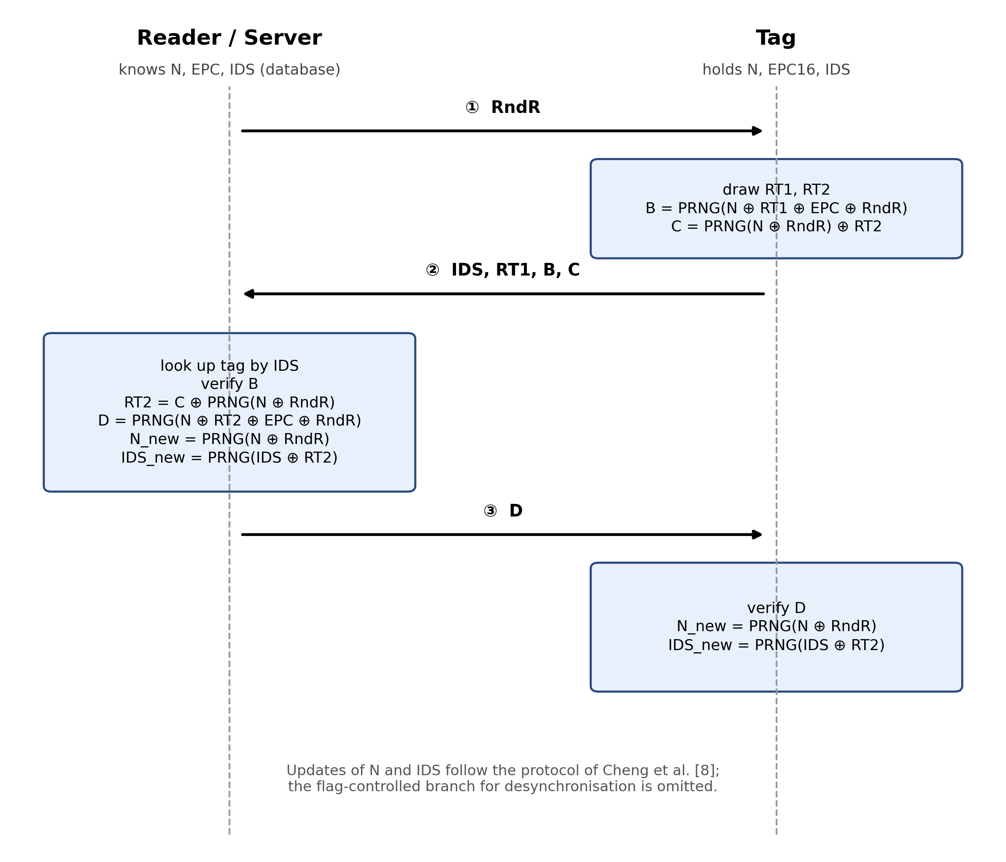
Fig. 1. Message flow and computations of the protocol of Cheng et al. [8].

4.2 Passive Secret Disclosure
Eqs. (1)–(3) contain three unknowns, N, EPC16 and RT2, and the adversary observes the three outputs B, C and D together with RT1 and RndR. Each output is a PRNG value of a 16-bit XOR combination, so each equation can be solved for its combination by one lookup in a table of P⁻¹. The three lookups chain (Fig. 2). Eq. (1) gives s = N ⊕ EPC16; Eq. (3) then gives RT2 from s; Eq. (2) gives N from RT2; and EPC16 = s ⊕ N. No secret needs to be known in advance.
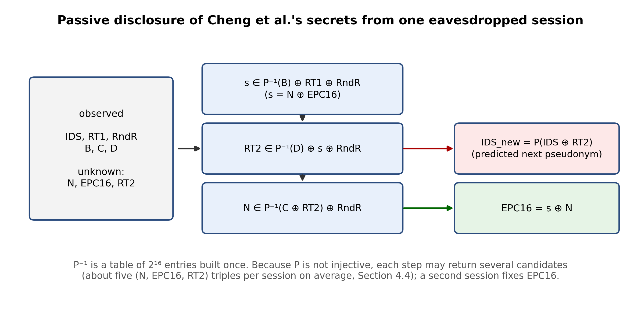
Fig. 2. Chain of table lookups that recovers N, EPC16 and RT2 from one eavesdropped session of Cheng et al.
Algorithm 1: Passive disclosure of N, EPC16 and RT2
Input: RndR, RT1, B, C, D from one observed session; table P⁻¹ of all 2¹⁶ PRNG values
Output: list of candidate triples (N, EPC16, RT2)
1: L ← ∅
2: for each u in P⁻¹(B): s ← u ⊕ RT1 ⊕ RndR
3: for each v in P⁻¹(D): RT2 ← v ⊕ s ⊕ RndR
4: for each w in P⁻¹(C ⊕ RT2): N ← w ⊕ RndR; add (N, s ⊕ N, RT2) to L
5: return L

Complexity. Building P⁻¹ costs 2¹⁶ PRNG evaluations and is done once for all sessions; each session then costs a few table lookups. The work is therefore O(2¹⁶), dominated by the table. Because the PRNG is not injective, the loops may return several candidates; the true triple is always among them. EPC16 never changes, so intersecting the EPC16 candidates of two sessions of the same tag leaves a single value. If N happens to be known (an insider scenario), steps 2–4 collapse to RT2 = C ⊕ P(N ⊕ RndR) and EPC16 ∈ P⁻¹(D) ⊕ N ⊕ RT2 ⊕ RndR.

4.3 Tag Tracking
The pseudonym is refreshed by Eq. (4), IDS_new = P(IDS ⊕ RT2). The adversary observes IDS (it is sent in clear) and recovers RT2 with Algorithm 1; it can therefore compute the pseudonym that the tag will use in its next session and recognise the tag when it appears again.
Algorithm 2: Tag tracking
Input: IDS and the candidate list L of Algorithm 1 for one session; IDS' observed in a later session
Output: true if IDS' belongs to the same tag
1: for each (N, EPC16, RT2) in L:
2: if IDS' = P(IDS ⊕ RT2) then return true
3: return false

4.4 Experimental Results
The attacks were implemented in Python (Section 7.3, Table 6). Table 2 gives the results. A single session returns on average 4.9 candidate triples (at most 35) and always contains the true one; two sessions of the same tag determine EPC16 uniquely in every trial. The tracking test has a true-positive rate of 100% and a false-positive rate of 0.010% over 20 000 pairs. For comparison, a brute-force search with known N that stops at the first match identifies the correct EPC16 in only 62.0% of single sessions, because a false match can precede the true one; the candidate-list formulation of Algorithm 1 removes this weakness.
Table 2. Experimental results for the attacks on Cheng et al. (PRNG modelled as a random function).
Quantity | Result | Trials
Building the table P⁻¹ (2¹⁶ evaluations) | 0.103 s | once
Candidate recovery per session (Algorithm 1) | 4.3 µs | 2 000
True (N, EPC16, RT2) contained in the list | 100% | 2 000
List has exactly one element (one session) | 10.4% | 2 000
Mean / maximum list size (one session) | 4.9 / 35 | 2 000
EPC16 unique and correct after two sessions | 100% | 1 000
Tracking (Algorithm 2): true-positive rate | 100% | 20 000
Tracking (Algorithm 2): false-positive rate | 0.010% | 20 000
Known-N brute force, first match only | 62.0% | 1 000

4.5 Practical Interpretation of the O(2¹⁶) Complexity
The complexity O(2¹⁶) is a statement about computation, and computation is not what limits this attack: the table is built in 0.10 s on one core of a commodity CPU, and the remaining work per session is a few microseconds. What limits the attack is the ability to capture one complete session, that is, the reader’s RndR and D and the tag’s answer. This requires a receiver for the backscatter link within the range of an ordinary Gen2 reader and no knowledge of any secret, no cooperation of the reader, and no interaction with the tag. The adversary therefore is a passive eavesdropper, which is a weaker requirement than the insider who knows N. After the session the adversary holds N and EPC16, can compute valid B and C values while those secrets are unchanged, and can follow the refresh of N and IDS because Eq. (4) uses only RndR, which is public, and RT2, which Algorithm 1 recovers in every observed session. A tag that is read once in range of such a receiver is thus exposed for the remainder of its life, and the expected total cost of the attack is below one second of computation per tag.

4.6 Root Cause
Three design choices combine: (i) every secret enters the transcript through a PRNG whose input is only 16 bits wide, so the PRNG can be inverted by table lookup; (ii) secrets are combined with public values by XOR only, so each equation can be solved for its secret combination independently; and (iii) the same secrets N and EPC16 appear in three equations, which lets the solutions chain.

5. CRYPTANALYSIS OF CABALLERO-GIL ET AL.’S PROTOCOL

5.1 Protocol Description
In the protocol of Caballero-Gil et al. [9] the tag holds a 16-bit secret identification number ID and a 16-bit shared secret key SSK, and the server holds the same pair for every tag. The PRNG is a nonlinear filter of a 16-bit LFSR with irregular decimation; the tag feeds it with a 16-bit value and uses the last n bits of the resulting (16+n)-bit keystream, written tail_n P(·) here. The protocol runs in five steps (Fig. 3): the reader sends a random Query; the tag draws NONCE1 and answers with NONCE1 and NONCE2; the server compares NONCE2 with the value it computes from every stored pair, and if exactly one pair matches, sends the session key K to the reader over the secure link and NONCE3 to the tag; the tag verifies NONCE3. After a successful session both sides replace (ID, SSK) by new values obtained with the PRNG. The values are
NONCE2 = tail_n P(ID ⊕ Query) ⊕ tail_n P(SSK ⊕ Query) (6)
NONCE3 = tail_n P(ID ⊕ NONCE1) ⊕ tail_n P(SSK ⊕ NONCE1) (7)
K = ID ⊕ SSK (8)
Query, NONCE1, NONCE2 and NONCE3 are transmitted over the air, whereas K is not. The key K initialises the stream cipher that encrypts the messages exchanged in the session [9]. The protocol description does not handle desynchronisation: the authors assume continuous connectivity between reader and server.
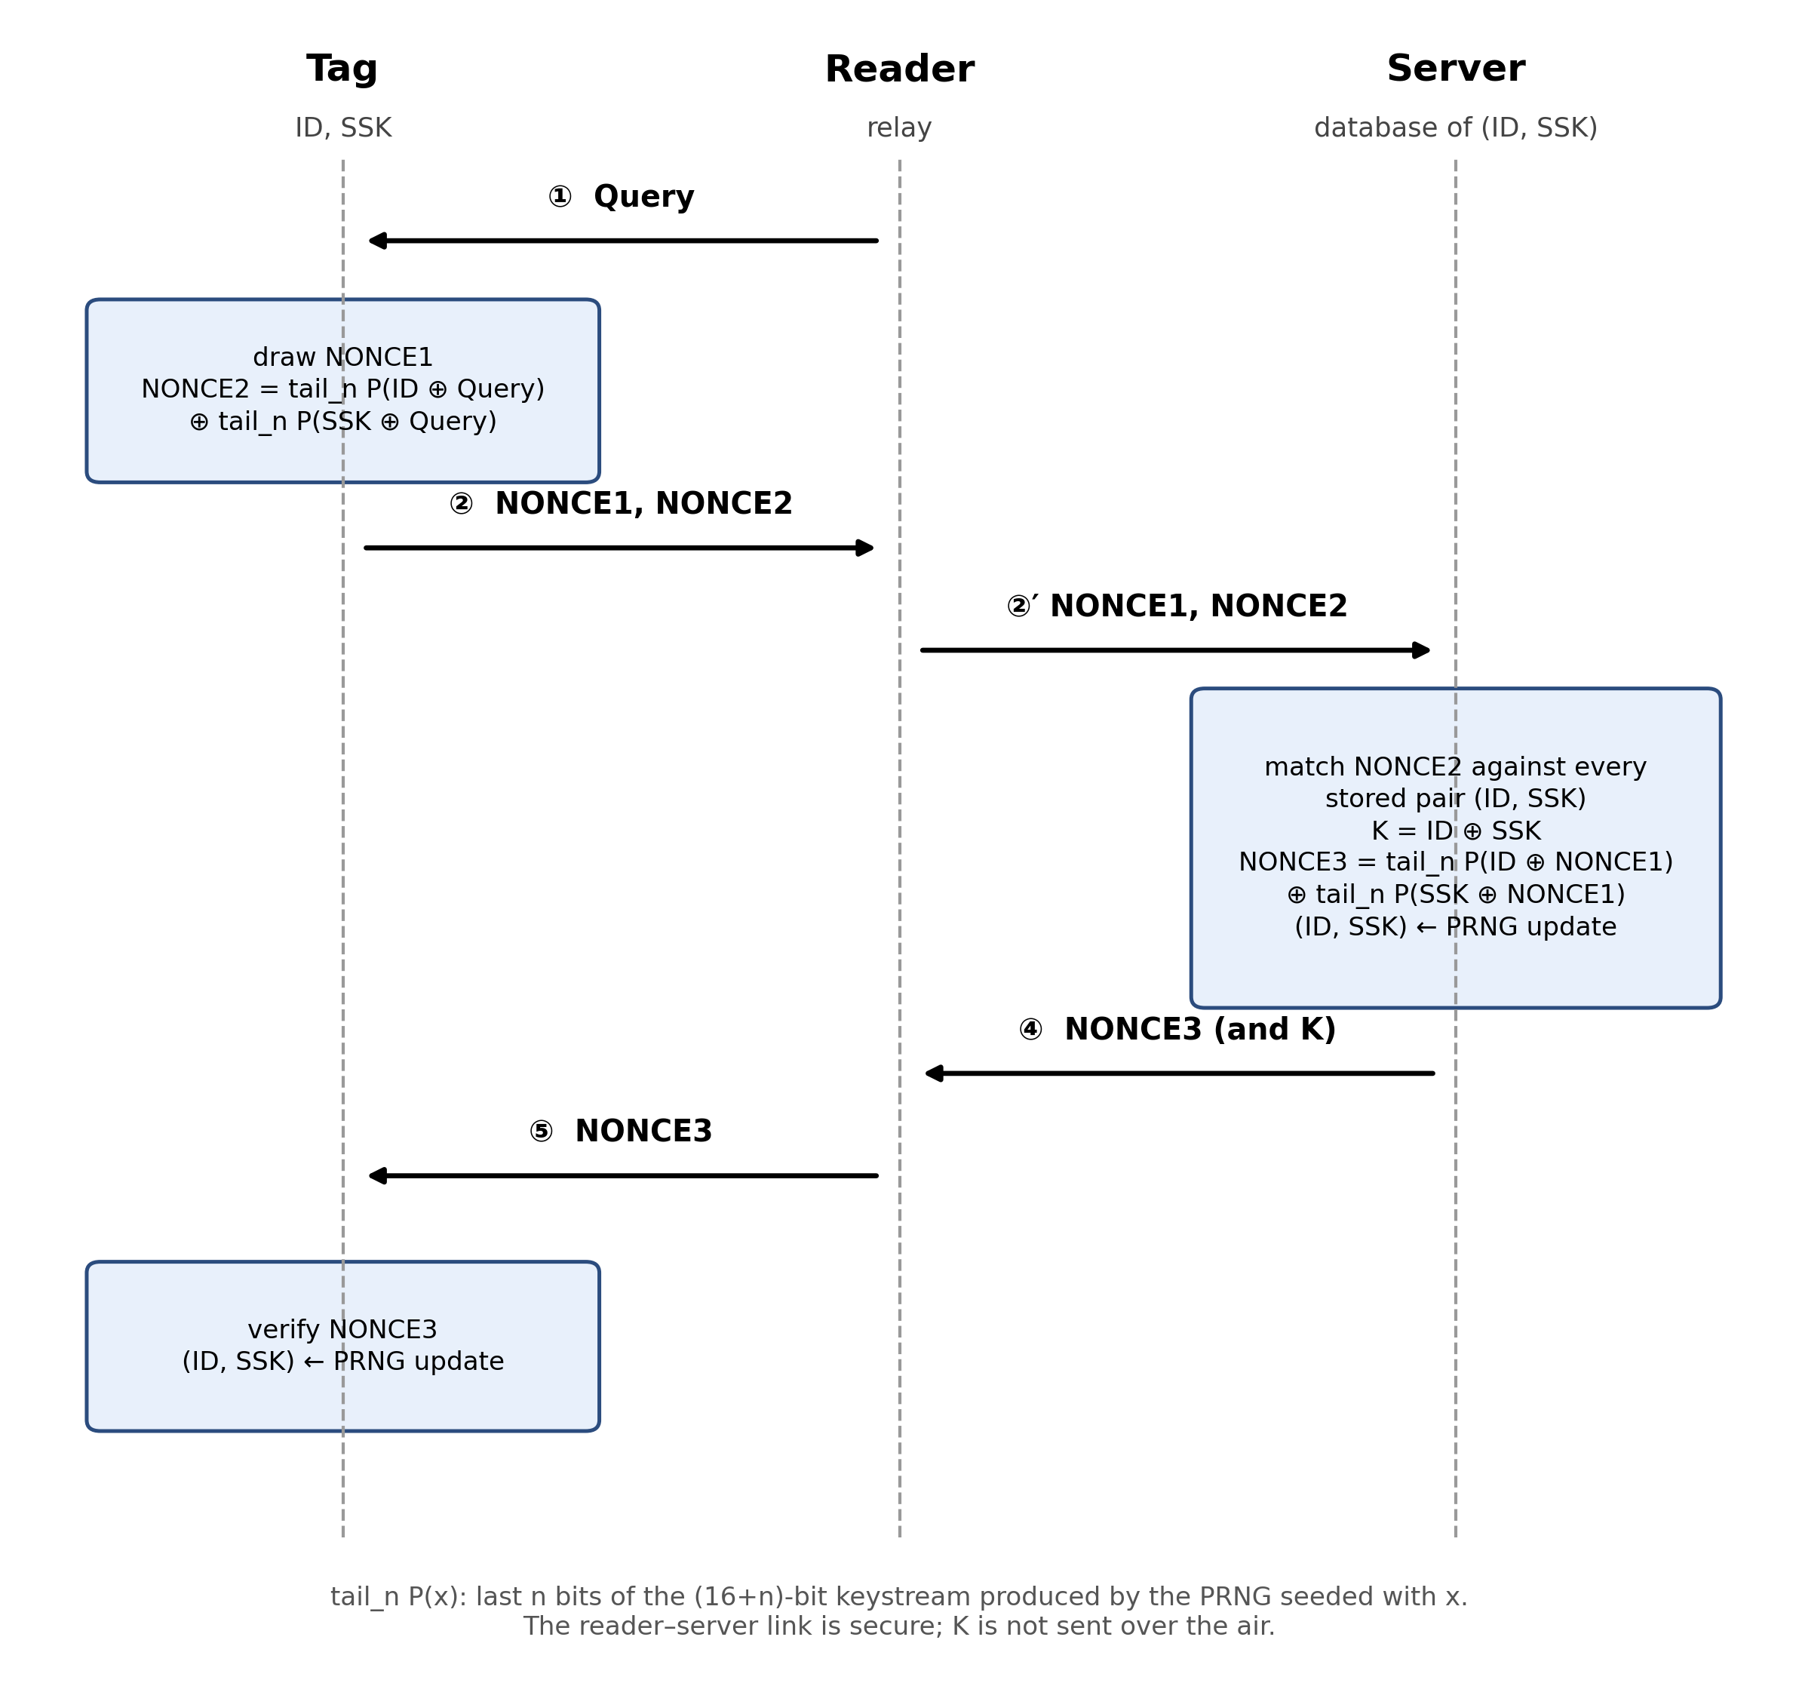
Fig. 3. Message flow of the protocol of Caballero-Gil et al. [9].
The attacks below do not rely on the PRNG being linear. [9] uses a nonlinear filter generator, and in the experiments P is modelled as a random function; a plain linear LFSR is included only as a comparison in Table 3.

5.2 Passive Disclosure of (ID, SSK) and K
Define the two tables T_Q(x) = tail_n P(x ⊕ Query) and T_1(x) = tail_n P(x ⊕ NONCE1) for all 16-bit x. Both are computable by the adversary from the public PRNG with 2¹⁷ evaluations in total. By Eqs. (6) and (7), the unknown pair {a, b} = {ID, SSK} satisfies T_Q(a) ⊕ T_Q(b) = NONCE2 and T_1(a) ⊕ T_1(b) = NONCE3. The pair is found by a hash join (Fig. 4): index T_Q by value, and for every a look up the b with T_Q(b) = T_Q(a) ⊕ NONCE2, then test the second equation. The equations are symmetric in ID and SSK, so the pair is recovered up to order, which is irrelevant because K = a ⊕ b.
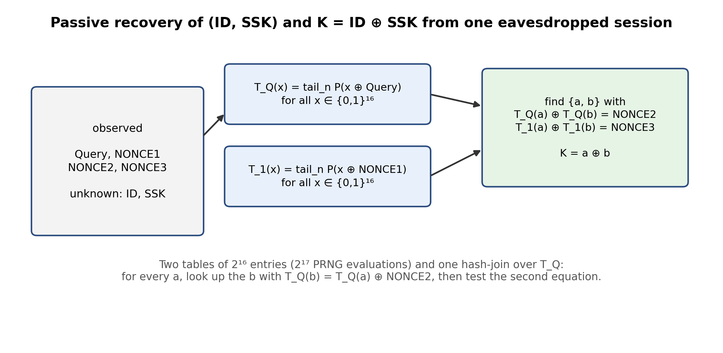
Fig. 4. Table join that recovers (ID, SSK) and K from one eavesdropped session of Caballero-Gil et al.
Algorithm 3: Passive disclosure of (ID, SSK) and K
Input: Query, NONCE1, NONCE2, NONCE3 from one observed session
Output: list of candidate pairs and the corresponding session keys
1: compute T_Q(x) and T_1(x) for all x in {0,1}¹⁶
2: build an index idx: value → {x : T_Q(x) = value}
3: for a = 0 to 65535:
4: for each b in idx[T_Q(a) ⊕ NONCE2] with b ≥ a:
5: if T_1(a) ⊕ T_1(b) = NONCE3 then output ({a, b}, K = a ⊕ b)

Complexity. 2¹⁷ PRNG evaluations and about 2¹⁶ lookups. The expected number of spurious unordered pairs is about 2³¹⁻²ⁿ, which is below one for n ≥ 16 and large for small n; the true pair is always in the list.
Consequence. The adversary learns the session key K, and thus can decrypt the stream-ciphered traffic of that session, together with the secret pair that was current during the session.

5.3 Linking by Query Replay
NONCE2 in Eq. (6) is a deterministic function of the tag state (ID, SSK) and of the Query chosen by the reader; the tag’s own randomness NONCE1 does not enter it. The tag changes its state only after a successful session, that is, after it has verified a valid NONCE3. A rogue reader can therefore send the same Query to a tag twice, or to two tags, and compare the NONCE2 values: equal values mean that the same tag, with unchanged state, answered. The attack uses only Send queries, needs two Query messages, and does not depend on the PRNG at all.
Algorithm 4: Linking by Query replay
Input: two tags (or one tag twice) that have not completed a session since the first query
Output: true if both responses come from the same tag
1: send the same Query q to the first tag; record NONCE2 ← NONCE2₁
2: send q to the second tag; record NONCE2 ← NONCE2₂
3: return (NONCE2₁ = NONCE2₂)

The window of the attack lasts until the tag completes its next authentication with a legitimate reader, after which its state, and hence NONCE2 for the same Query, changes. A tag that is not being read by a legitimate reader can be linked for as long as the adversary wishes. In the Ouafi–Phan game of Section 3.2 the adversary needs only Send, so the protocol does not satisfy untraceability.
The authors of [9] state that the response of the tag differs in every authentication request because its data are updated; the update, however, happens only at the end of a completed session, which an active adversary does not have to complete.

5.4 Experimental Results
Table 3 gives the results. For n = 16 the true pair is always in the list; the list has a single element in 66.7% of the single sessions and at most four elements in the 150 trials. For n = 24 and n = 32 the list is unique in all trials. For n = 12 the list has 128 elements on average and the attack alone does not isolate the pair. The linking attack succeeds in every trial for both PRNG models, with false-positive rates in line with the theoretical value 2⁻ⁿ = 0.0015%.
Table 3. Experimental results for the attacks on Caballero-Gil et al. (a) Algorithm 3; (b) Algorithm 4.
(a) n | Trials | True pair in list | List unique | Mean / max list | Time per session
12 | 20 | 100% | 0% | 128.3 / 159 | 0.25 s
16 | 150 | 100% | 66.7% | 1.41 / 4 | 0.21 s
24 | 40 | 100% | 100% | 1.00 / 1 | 0.18 s
32 | 40 | 100% | 100% | 1.00 / 1 | 0.19 s

(b) PRNG model | Pairs | True positive | False positives | False-positive rate
Random function, n = 16 | 200 000 | 100% | 5 | 0.0025%
Plain linear LFSR, n = 16 | 200 000 | 100% | 3 | 0.0015%
Theory | – | 100% | – | 0.0015%

5.5 Practical Interpretation
As for Cheng et al., computation is negligible: 0.2 s on one core. Algorithm 3 needs one complete eavesdropped session, including NONCE3, which is sent over the air by the reader. The recovered K breaks the confidentiality of that session; the recovered pair is the tag’s secret at that time. Algorithm 4 needs only an active reader within range of the tag, and its effect on privacy is independent of every choice made for the PRNG. Tracking and disclosure are therefore realistic for an adversary with a commodity reader.

5.6 Root Cause
The protocol has the same structural issues as the first one. A 16-bit seed lets the adversary tabulate the whole PRNG, so XORs of two PRNG outputs are not hiding the two seeds; and the response depends on state that does not change until the session is completed, with no fresh randomness from the tag in NONCE2.

6. PROPOSED ENHANCEMENT

6.1 Design Rationale
The attacks of Sections 4 and 5 share three root causes: (i) the secrets enter the transcript through a PRNG with a 16-bit input, which can be tabulated and inverted; (ii) the secrets are combined with public values by XOR only; and (iii) the tag state does not change until a session completes, so responses depend on a static state. Constructions made only of 16-bit words and a 16-bit PRNG keep exposing 16-bit unknowns to table attacks; chaining more PRNG calls raises the number of unknowns that must be guessed jointly, but we found no way to obtain a margin comparable to 2⁶⁴ or more without a wider primitive. To raise the cost of key recovery well beyond a table lookup, the secret should enter the transcript through a primitive with a wide internal state. We therefore relax the XOR/PRNG/CRC-only assumption by exactly one component, a lightweight hash function H on the tag, and follow three rules:
- No identifier on the air. The tag never transmits an identifier or an EPC-derived value. The server identifies the tag by testing candidate keys.
- Full-width keyed authentication with two-sided freshness. Each authentication value is a keyed hash over the whole key and over nonces of both the server and the tag, so a guess must cover the whole key and no value repeats across queries.
- One-way state evolution with recovery. The key is replaced after each successful session by a one-way function of the old key and both nonces, and the server keeps the previous key to survive lost messages.
The proposal is not meant for tags that can only run a PRNG and a CRC; it targets the C1G2 air interface with a small hash module on the tag. The hash is of the size reported for SPONGENT-128 (1060 GE) [17] and PHOTON (about 1120 GE for the 128-bit variant) [18], within the 400–4K gates that [9] reports as available for security.

6.2 Parameters and Notation
Table 4. Symbols of the proposed protocol.
Symbol | Description
k | 128-bit secret key shared by the tag and the server.
N_R | 32-bit fresh nonce chosen by the server and sent through the reader; valid for one pending session only.
N_T | 64-bit fresh nonce drawn by the tag (four RN16 outputs).
H(·) | Lightweight hash function with 128-bit output; ⌊H⌋₆₄ denotes truncation to 64 bits.
A, B | 64-bit authentication values of the tag and of the server.
(k_cur, k_old) | The two keys stored by the server for each tag.
‖ | Concatenation. The one-byte constants 01, 02, 03 separate the three uses of H.

6.3 Protocol Description
The protocol is shown in Fig. 5 and runs in three messages. The server first issues N_R and keeps it as a pending session. The tag draws N_T and answers with N_T and A = ⌊H(k ‖ N_R ‖ N_T ‖ 01)⌋₆₄. The server removes N_R from the pending sessions, searches its records for a key k_x ∈ {k_cur, k_old} with A = ⌊H(k_x ‖ N_R ‖ N_T ‖ 01)⌋₆₄, and rejects if there is none. Otherwise it replies with B = ⌊H(k_x ‖ N_T ‖ N_R ‖ 02)⌋₆₄ and updates its record. The tag verifies B and, if it is correct, replaces its key. Swapping the nonce order in B and using different constants prevents a message of one direction from being replayed in the other.
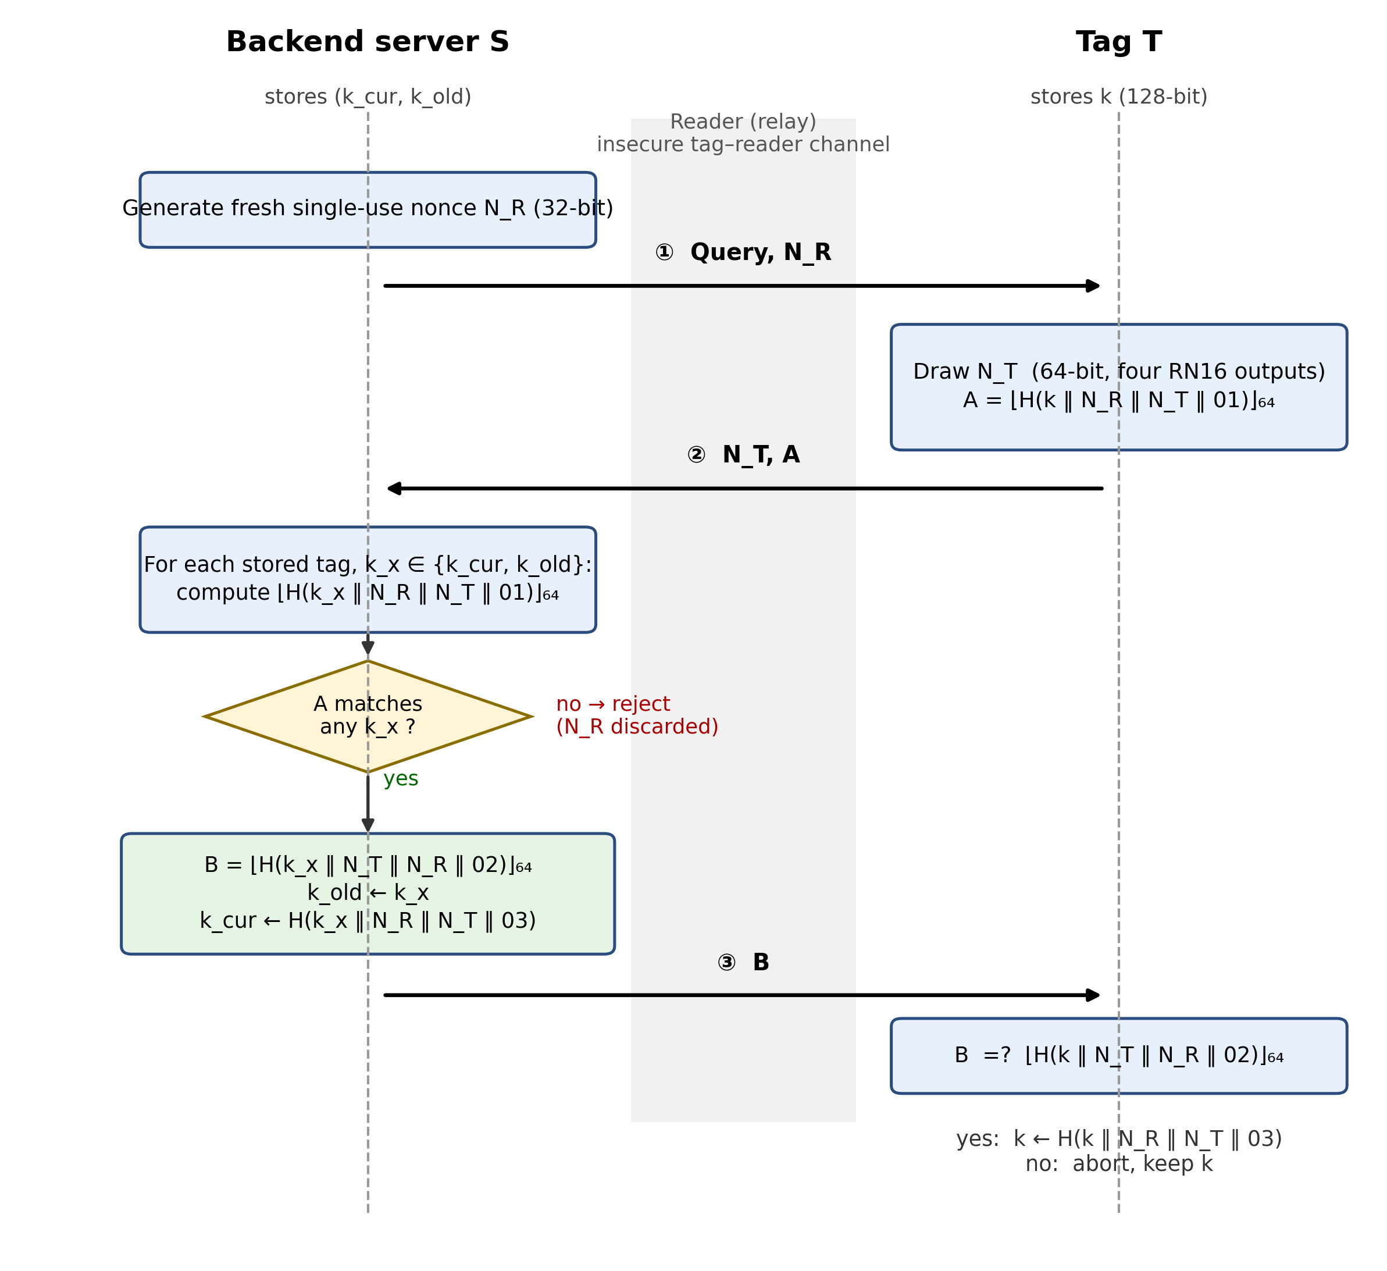
Fig. 5. Complete flowchart of the proposed protocol: message exchange, verification decisions and state updates on the server (k_cur, k_old) and on the tag (k).

6.4 State Update and Desynchronisation
After accepting A under key k_x, the server sets k_old ← k_x and k_cur ← H(k_x ‖ N_R ‖ N_T ‖ 03); after verifying B, the tag sets k ← H(k ‖ N_R ‖ N_T ‖ 03). If message B is lost, the tag keeps k_x, which the server still holds as k_old, so the next session is accepted. If the tag did update, its key equals k_cur. The old key is therefore never discarded before the tag has demonstrably moved on, and the server remains able to identify the tag after an adversary blocks message B, the desynchronisation scenario that [9] leaves open.

7. SECURITY ANALYSIS AND EVALUATION

7.1 Informal Security Analysis
Secret disclosure. No transmitted value is a function of fewer than the 128 key bits, and every transmitted value is a truncated hash. An eavesdropper that wants to recover k from a transcript has to evaluate H on candidate keys, about 2¹²⁸ evaluations under a preimage-resistance assumption. The tabulation and inversion of Sections 4 and 5 do not apply, because no 16-bit PRNG input is involved. No EPC-dependent value is ever sent.
Linkability. The only transmitted values are N_T and A, and A depends on the fresh 64-bit nonce N_T. A rogue reader that repeats the same N_R sees different values every time. The link test of Algorithm 4 therefore no longer works. A linking adversary can only hope for a repeated N_T, and thus a repeated A, among the answers of the same tag, since the tag changes its key only after a completed session. The birthday bound makes the size of N_T the relevant parameter (Table 5): with a 32-bit nonce, 2¹⁶ queries to one tag repeat a value with probability about 39%, while with 64 bits the probability is about 10⁻⁸ percent. We therefore use a 64-bit N_T.
Table 5. Probability that unauthenticated queries to one tag produce a repeated (N_T, A) pair (birthday bound).
N_T bits | Queries | Theory (%) | Simulation (%)
16 | 2^10 | 100.0 | 100.0
24 | 2^12 | 39.3 | 39.3
32 | 2^12 | 0.20 | 0.17
32 | 2^16 | 39.3 | 39.0
64 | 2^16 | 1.2e-8 | –

Replay and forgery. N_R is bound to a pending session at the server and discarded when used, so a recorded transcript is rejected. A random forgery of A or B succeeds with probability 2⁻⁶⁴ per attempt, and a forged B cannot be produced without k.
Desynchronisation. Handled by (k_cur, k_old) as described in Section 6.4.
Compromise. After Corrupt(T), the sessions of that tag after the compromise are linkable, since the adversary holds the current key. Sessions before the compromise stay unlinkable under the preimage-resistance of H, because the key update is one-way and the adversary cannot recompute the earlier key. This argument is informal and is not covered by the symbolic analysis below.
Denial of service. The server has to search the records for every A it receives, so the cost of a forged A is linear in the number of tags. We report this cost in Section 7.4.

7.2 Formal Verification with ProVerif
We model one authentication session of the protocol in the applied pi calculus and analyse it with ProVerif 2.x [20] under the Dolev–Yao adversary [19], who controls the tag–reader channel. The hash functions are modelled as free constructors H1 and H2 over the key and the two nonces, and the key k is a private free name. The model is given in Appendix A. We verified two properties: (i) secrecy of the key, the query attacker(k), and (ii) server-side authentication, the correspondence event(ServerAccepts(nr, nt)) ⇒ event(TagSends(nr, nt)). ProVerif proves both (“not attacker(k[]) is true” and “event(ServerAccepts(nr,nt)) ==> event(TagSends(nr,nt)) is true”). The corresponding property for the tag, that the tag accepts B only after the server has sent it, follows from the binding of B to both nonces and to the key as argued in Section 7.1.
The symbolic analysis has limits that matter here. It covers a single session without key update, so desynchronisation recovery and the evolution of the key are argued in Sections 6.4 and 7.1 instead of being proved. It also treats the hash as a perfect constructor, so it cannot express brute-force or birthday bounds; those are covered quantitatively in Section 7.1 and Table 5.

7.3 Simulation Environment and Reproducibility
Table 6. Experimental environment.
Item | Setting
Language and libraries | Python 3.12.3, standard library only (hashlib, random, os, time)
PRNG model (attacked protocols) | Random function: first bytes of SHA-256 of the seed, truncated to the required width; a plain linear LFSR is added as a comparison in Table 3(b)
Hash model (proposed protocol) | SHA-256 truncated to 128 bits as a stand-in for a lightweight hash such as SPONGENT or PHOTON; security arguments assume an ideal hash
Randomness | Seeded Python PRNG for the attack experiments (seed 20261023); os.urandom for keys and nonces of the proposed protocol
Hardware | One CPU core of a commodity x86-64 machine; all times are wall-clock times in Python and are indicative only
Trials | Table 2: 1 000–20 000; Table 3: 20–150 sessions and 200 000 pairs; proposed protocol: 5 000 sessions, 1 000 replays, 200 000 forgery attempts
Formal analysis | ProVerif 2.x, single-session model (Appendix A)
Code and data | rfid_experiments.py and results.json in the public repository (Data availability); one script produces every number reported in this paper

For the proposed protocol, 5 000 sessions among 100 tags were identified correctly in all cases (5000/5000); in about 20% of the sessions message B was dropped, and the tag was identified again in the following session through k_old. All 1 000 replayed transcripts were rejected, and none of 200 000 random forgeries was accepted. These runs check the logic of the protocol and are not a security proof.

7.4 Comparison of Security Properties and Costs
Table 7 compares the security properties established in this paper, and Table 8 compares computation, communication and storage. Operation counts of the original schemes are derived from their message equations (Eqs. (1)–(8)); the shared value P(N ⊕ RndR) in Cheng et al. is computed once. For Caballero-Gil et al. the state update by the PRNG is not specified in detail in [9] and is therefore not counted.
Table 7. Security properties of the three protocols as established in Sections 4–7.
Property | Cheng et al. [8] | Caballero-Gil et al. [9] | Proposed
Passive disclosure of secrets | Broken (N, EPC16, RT2; 2¹⁶) | Broken ((ID, SSK), K; 2¹⁷) | Not applicable (2¹²⁸ key search)
Linking of tags | Broken (next IDS predicted) | Broken (Query replay, O(1)) | No link test known; birthday-bounded
Identifier or fold sent in clear | IDS (16 bit) | None, but state-dependent NONCE2 | None
Desynchronisation recovery | Flag-controlled branch in [8] | Not provided | k_cur / k_old
Hash function on the tag | No | No | Yes

Table 8. Computation, communication and storage per session.
Metric | Cheng et al. [8] | Caballero-Gil et al. [9] (n = 16) | Proposed
Tag computation | 4 PRNG, 9 XOR, 2 random numbers | 4 tail_n P, 7 XOR, 1 random number (+ state update) | 3 hash evaluations, 64-bit random nonce
Tag → reader (bits) | 64 (IDS, RT1, B, C) | 32 (NONCE1, NONCE2) | 128 (N_T, A)
Reader → tag (bits) | 32 (RndR, D) | 32 (Query, NONCE3) | 96 (N_R, B)
Tag storage of secrets (bits) | 48 (EPC16, N, IDS) | 32 (ID, SSK) | 128 (k)
Server storage per tag (bits) | 48 | 32 | 256 (k_cur, k_old)
Server identification | O(1) by IDS | O(n), compares all pairs [9] | O(n), at most 2n hashes; measured worst case 1.8 ms (10³ tags), 29.7 ms (10⁴), 194 ms (10⁵)

The redesign therefore costs the tag one hash module and 128 bits of key storage and between 2.3 and 3.5 times the communication of the original schemes (224 bits per session against 96 and 64). The server pays a linear search per authentication, which is the same asymptotic cost as in [9] and the price of removing the identifier from the air interface. The three hash evaluations process inputs of at most 232 bits; the latency on a real tag depends on the hash implementation and the tag clock and has to be established on hardware.

7.5 Limitations
First, the descriptions of the two attacked protocols are taken from [8] and [9]; the attacks inherit any deviation between these descriptions and the deployed products. Second, the PRNG is modelled as a random function; because the attacks only need a public, tabulable PRNG, structure in the real generator can only make them easier, but the exact list sizes in Tables 2 and 3 depend on the model. Third, the proposal needs a hash function on the tag and is therefore not a drop-in replacement for tags that offer only a PRNG and a CRC. Fourth, the formal analysis covers a single session; key evolution and recovery are argued rather than proved. Fifth, no hardware implementation was made, and all run times are Python wall-clock times.

8. CONCLUSION
We showed that two recent lightweight EPC C1G2 authentication protocols are broken by attacks that need only the public PRNG and one eavesdropped session. Against Cheng et al., an adversary who knows no secret recovers N, EPC16 and RT2 with about 2¹⁶ PRNG evaluations, links the tag through its next pseudonym with a 100% true-positive rate, and fixes EPC16 uniquely with two sessions. Against Caballero-Gil et al., a passive adversary recovers (ID, SSK) and the session key with 2¹⁷ evaluations, and an active adversary links tags with two Query messages regardless of the PRNG. The common cause is that 16-bit PRNG inputs make the generator invertible by table lookup.
The proposed hash-based protocol removes identifiers from the air interface, binds two nonces into each message, evolves the key one-way and recovers from lost messages. ProVerif confirms secrecy of the key and server-side authentication in a single-session model, and simulation shows correct operation, replay rejection and no repeated values at the chosen nonce size. The price is a hash module on the tag, 128 bits of key storage and a linear key search on the server.
Future work includes a gate-level implementation of the tag side, a stateful symbolic analysis of key evolution and desynchronisation, and server-side indexing to avoid the linear search.
Funding: No funding was received for this research.
Data availability: The Python code and the results of all experiments reported in this paper, including the attacks of Sections 4 and 5, the simulation of the proposed protocol and the results file, are available in the GitHub repository at https://github.com/farshadabdolmaleki1998-bot/RFID-Security-Analysis.
Declarations. Ethics approval and consent to participate: not applicable. Competing interests: the authors declare that they have no conflicts of interest/competing interests associated with the publication of this article.

APPENDIX A: PROVERIF MODEL
The following model was analysed with ProVerif 2.x. The adversary controls the channel c; the key k is a private name.
type key. type nonce.
fun H1(key,nonce,nonce): bitstring. (* A = H(k || NR || NT || 01) *)
fun H2(key,nonce,nonce): bitstring. (* B = H(k || NT || NR || 02) *)
free c: channel.
free k: key [private].
event TagSends(nonce,nonce). event ServerAccepts(nonce,nonce).
event ServerSendsB(nonce,nonce). event TagAccepts(nonce,nonce).

query attacker(k).
query nr:nonce, nt:nonce;
event(ServerAccepts(nr,nt)) ==> event(TagSends(nr,nt)).

let Tag(k:key) =
in(c, nr:nonce); new nt:nonce; event TagSends(nr,nt);
out(c, (nt, H1(k,nr,nt))); in(c, b:bitstring);
if b = H2(k,nt,nr) then event TagAccepts(nr,nt).

let Server(k:key) =
new nr:nonce; out(c, nr); in(c, (nt:nonce, a:bitstring));
if a = H1(k,nr,nt) then
event ServerAccepts(nr,nt); event ServerSendsB(nr,nt); out(c, H2(k,nt,nr)).

process !Tag(k) | !Server(k)

APPENDIX B: REPRODUCING THE RESULTS
All numbers in Tables 2, 3, 5 and 6 and in Section 7.3 are produced by one script. Running python3 rfid_experiments.py with Python 3 and no third-party libraries executes the experiments in one to two minutes and writes results.json; the ProVerif model of Appendix A is in the file proverif/proposed_protocol.pv of the repository. The script contains the PRNG models, Algorithms 1–4, the simulation of the proposed protocol and the timing measurements. The seed is fixed, so repeated runs give the same counts; the timings vary with the machine.

REFERENCES
[1] Ahson, S.A., Ilyas, M.: ‘RFID handbook: applications, technology, security, and privacy’ (CRC Press, 2017)
[2] EPCglobal Inc.: ‘EPC Radio-Frequency Identity Protocols Class-1 Generation-2 UHF RFID Protocol for Communications at 860 MHz – 960 MHz, Version 1.2.0’, 2008
[3] Chien, H.-Y.: ‘SASI: A new ultralightweight RFID authentication protocol providing strong authentication and strong integrity’, IEEE Transactions on Dependable and Secure Computing, 2007, 4, (4), pp. 337–340
[4] Wang, S., Liu, S., Chen, D.: ‘Security analysis and improvement on two RFID authentication protocols’, Wireless Personal Communications, 2015, 82, (1), pp. 21–33
[5] Zavvari, A., Shakiba, M., Islam, M.T., Sundararajan, E., Singh, M.J.: ‘Computational cost analysis on securing RFID protocols conforming to EPC class-1 generation-2 standard’, Procedia Technology, 2013, 11, pp. 778–784
[6] Peris-Lopez, P., Hernandez-Castro, J.C., Tapiador, J.M., Van der Lubbe, J.C.: ‘Cryptanalysis of an EPC class-1 generation-2 standard compliant authentication protocol’, Engineering Applications of Artificial Intelligence, 2011, 24, (6), pp. 1061–1069
[7] Alavi, S.M., Baghery, K., Abdolmaleki, B.: ‘Security and privacy flaws in a recent authentication protocol for EPC C1 G2 RFID tags’, Advances in Computer Science: an International Journal, 2014, 3, (5), pp. 44–52
[8] Cheng, C.-Y., Huang, C.-T., Lin, I.-C., Hsu, H.-H.: ‘An efficient and secure RFID authentication scheme for C1G2 standard’, Journal of Internet Technology, 2019, 20, (3), pp. 963–973
[9] Caballero-Gil, P., Caballero-Gil, C., Molina-Gil, J.: ‘RFID authentication protocol based on a novel EPC Gen2 PRNG’, arXiv preprint arXiv:2208.05345, 2022
[10] Ouafi, K., Phan, R.C.-W.: ‘Privacy of recent RFID authentication protocols’, in ‘Information Security Practice and Experience (ISPEC 2008)’, LNCS 4991 (Springer, 2008), pp. 263–277
[11] Safkhani, M.: ‘Full secret disclosure attack against an EPC-C1 G2 compliant authentication protocol’, Journal of Computing and Security, 2019, 6, (1), pp. 13–23
[12] Baghery, K., Abdolmaleki, B., Akhbari, B., Aref, M.R.: ‘Enhancing privacy of recent authentication schemes for low-cost RFID systems’, The ISC International Journal of Information Security, 2015, 7, (2), pp. 135–149
[13] Tanveer, M., Alharbi, A.G., Aldossari, S.A.: ‘RePUF-IoT: Reconfigurable PUF-based authentication protocol for IoT-driven healthcare systems’, IEEE Internet of Things Journal, 2025, 12, (22), pp. 47575–47587
[14] Tanveer, M., Toor, K., Alharbi, A.G., Hassan, S.R.: ‘SecTwin: A secure and efficient authentication mechanism for vehicular digital twins’, Journal of Information Security and Applications, 2025, 95, p. 104292
[15] [MedLap-IoT: authors, title, journal, year, volume and pages to be completed by the authors]
[16] Tanveer, M., Chelloug, S.A., Alabdulhafith, M., Abd El-Latif, A.A.: ‘Lightweight authentication protocol for connected medical IoT through privacy-preserving access’, Egyptian Informatics Journal, 2024, 26, p. 100474
[17] Bogdanov, A., Knezevic, M., Leander, G., Toz, D., Varici, K., Verbauwhede, I.: ‘SPONGENT: A lightweight hash function’, in ‘Cryptographic Hardware and Embedded Systems – CHES 2011’, LNCS 6917 (Springer, 2011), pp. 312–325
[18] Guo, J., Peyrin, T., Poschmann, A.: ‘The PHOTON family of lightweight hash functions’, in ‘Advances in Cryptology – CRYPTO 2011’, LNCS 6841 (Springer, 2011), pp. 222–239
[19] Dolev, D., Yao, A.C.: ‘On the security of public key protocols’, IEEE Transactions on Information Theory, 1983, 29, (2), pp. 198–208
[20] Blanchet, B.: ‘An efficient cryptographic protocol verifier based on Prolog rules’, Proc. 14th IEEE Computer Security Foundations Workshop (CSFW-14), 2001, pp. 82–96

AUTHORS
 | Farshad Abdolmaleki received his M.Sc. degree in Electrical Engineering (Telecommunications) from Malayer University, Iran, in 2022. His research interests include RFID security, lightweight cryptography, and wireless communication systems.  E-mail: farshadabdolmaleki1998@gmail.com
 | Morteza Choubin received his Ph.D. in Electrical Engineering (Telecommunications) from Imam Khomeini International University, Iran, in 2019. He is currently an Assistant Professor with the Department of Electrical Engineering, Malayer University, Iran. His research interests include wireless communication systems, signal processing, image processing, and network security.  E-mail: m.chobin@malayeru.ac.ir

