**Lab1**

**Create a Repository: Computer-ScienceII**

**Screenshots:**

Here is a screenshot of the main repository of the course. The repository is available at: <https://github.com/farshadsafavi/Computer-ScienceII>

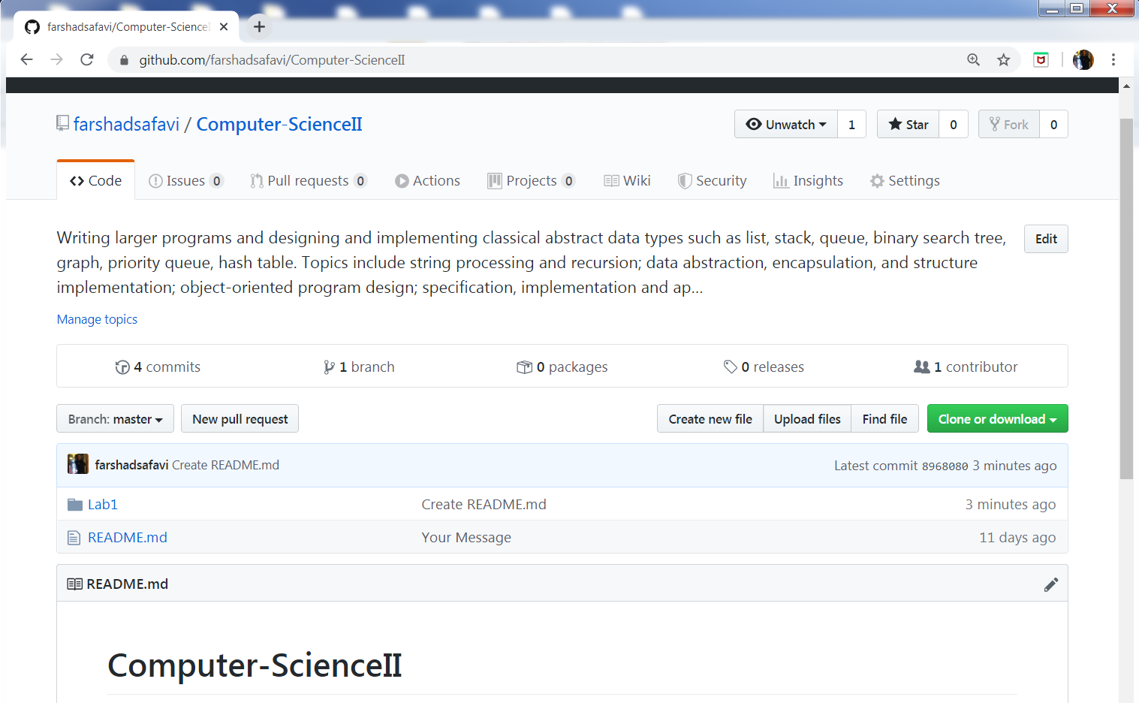

Here is a screenshot of **Lab1 folder** inside Computer-ScienceII repository. The Lab1 folder is available at: <https://github.com/farshadsafavi/Computer-ScienceII/tree/master/Lab1>

