Metal Trading Platform (MTP)
پلتفرم معاملات مواد اولیه فلزات
Software Architecture Document · Enterprise Grade · v2.0.0

Property | Value
Project Name | Metal Trading Platform (MTP)
Document Version | 2.0.0 (Final)
Date | 1405/02/05 (April 25, 2026)
Classification | CONFIDENTIAL – Internal Use Only
Document Type | Software Architecture Document (SAD) + Project Proposal
Standards | IEEE 1471-2000 | ISO/IEC 42010:2011 | TOGAF 9.2
Backend | ASP.NET Core 10 | C# 12 | Entity Framework Core 9
Database | Microsoft SQL Server 2022 | Redis 7 | Elasticsearch 8
Frontend | Next.js 14 | React 18 | TypeScript | Tailwind CSS
Cloud | Azure Kubernetes Service | Azure SQL | Service Bus

Change History
Version | Date | Author | Changes
1.0.0 | 1405/01/15 | Analysis Team | Initial document creation
1.5.0 | 1405/01/28 | Senior Architect | Architecture detail additions
2.0.0 | 1405/02/05 | Technical Team | Final version with complete detail

Chapter 1: Executive Summary (خلاصه اجرایی)

1.1 Project Overview
The Metal Trading Platform (MTP) is an enterprise-grade B2B e-commerce system designed to digitise and bring full transparency to metal raw-material trading across Iran and the wider Middle East. By connecting verified manufacturers, suppliers and industrial buyers on a single secure platform, MTP eliminates information asymmetry, reduces transaction cycles by up to 70 %, and creates an auditable, trust-based marketplace.
پلتفرم معاملات مواد اولیه فلزات (MTP) یک سامانه تجارت الکترونیک B2B در سطح سازمانی است که با هدف دیجیتالی‌سازی و شفاف‌سازی معاملات مواد اولیه فلزی طراحی شده و فرآیند معاملات بین تولیدکنندگان، تأمین‌کنندگان و خریداران صنعتی را متحول می‌سازد.

1.1.1 Strategic Vision
"Becoming the reference and trusted platform for metal raw-material trading in the Middle East – delivering integrated, secure, and intelligent services by 1410."

1.1.2 Mission Pillars
- Transparency – Real-time pricing and complete transaction history for all participants.
- Security – Multi-layer protection mechanisms safeguarding both buyer and seller interests.
- Efficiency – Dramatic reduction in time-to-close and total transaction cost.
- Trust – Comprehensive KYC, grading, and credit-scoring infrastructure.

1.2 Value Proposition

For Sellers (برای فروشندگان)
Value | Description | KPI
Broad market access | Network of 500+ verified buyers | +500 active buyers
Payment-risk reduction | Pre-payment & tiered grading system | 85% risk reduction
Price transparency | Real-time market analytics & LME integration | Live pricing data
One-stop services | Shipping, insurance, warehouse on a single platform | One-stop-shop

For Buyers (برای خریداران)
Value | Description | KPI
Quality guarantee | Inspection system and product warranty | 99 % quality satisfaction
Price competition | Access to multiple competing sellers | Avg. 5 % savings
Transaction security | KYC verification and seller grading | Zero fraud tolerance
Process simplicity | End-to-end digital from order to delivery | 70 % time reduction

1.3 Key Success Metrics (KPI Dashboard)
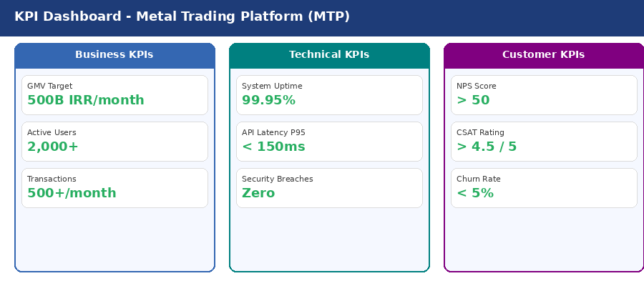
Figure: KPI Dashboard – Business, Technical & Customer Metrics

1.4 Competitive Positioning
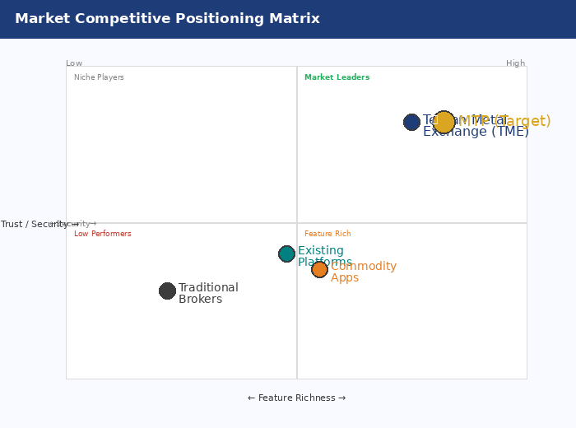
Figure: Market Competitive Positioning Matrix

Chapter 2: Business Analysis (تحلیل کسب‌وکار)

2.1 Market Analysis (تحلیل بازار)

2.1.1 Market Size
Indicator | Value | Source
Annual copper production – Iran | 400,000 tonnes | IME 1404
Annual aluminium production | 600,000 tonnes | IRALCO
Annual zinc production | 200,000 tonnes | IZMDC
Total Addressable Market (TAM) | 150,000 Billion IRR | Internal estimate
Serviceable Addressable Market (SAM) | 30,000 Billion IRR | 20 % of TAM
Serviceable Obtainable Market (SOM) | 3,000 Billion IRR | 10 % of SAM

2.1.2 SWOT Analysis
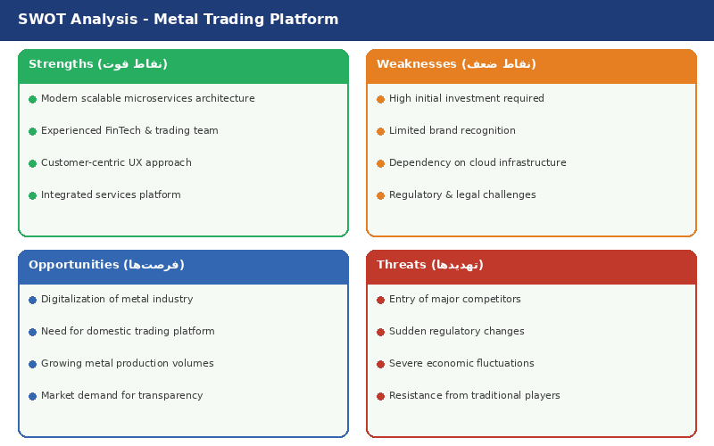
Figure: SWOT Analysis

2.2 Business Model Canvas
Component | Details
Key Partners | Shipping companies, Insurance firms, Inspection agencies, Banks & PSPs, Licensed warehouses
Key Activities | Platform development & maintenance, KYC/grading, Transaction management, Customer support, AI & analytics
Value Propositions | Secure & transparent B2B trading, Comprehensive grading, Integrated ancillary services, AI-driven market insights
Customer Segments | Metal manufacturers, Suppliers & intermediaries, Industrial buyers, Exporters & traders
Revenue Streams | Transaction commission (0.5 %), Premium subscription, API & data licensing, Partner service commissions
Key Resources | Technology platform & IP, Security infrastructure, Verified-user network, Proprietary market data
Cost Structure | R&D & engineering, Personnel, Azure cloud, Security & compliance, Sales & marketing

2.3 Revenue Model

2.3.1 Commission Structure
Commission Formula
Commission = 0.5 % x Transaction Value
Seller share: 40 % = 0.2 % of value
Buyer share: 60 % = 0.3 % of value
Example: 10 B IRR trade -> total 50 M IRR (seller 20 M | buyer 30 M)

2.3.2 Discount Tiers
Transaction # | Discount | Rationale
1st | 100 % | New-user acquisition
2nd | 66 % | Encourage continued activity
3rd onwards | 0 % | Full commission
Gold Member | 20 % always | Loyalty reward
Volume > 100 B IRR | 30 % | Volume incentive

2.3.3 5-Year Revenue Forecast
Year | GMV (B IRR) | Commission Revenue | Other Revenue | Total Revenue
Y1 | 500 | 2.5 B | 0.5 B | 3 B IRR
Y2 | 2,000 | 10 B | 3 B | 13 B IRR
Y3 | 5,000 | 25 B | 10 B | 35 B IRR
Y4 | 10,000 | 50 B | 25 B | 75 B IRR
Y5 | 20,000 | 100 B | 50 B | 150 B IRR

Chapter 3: System Requirements (نیازمندی‌های سیستم)

3.1 Functional Requirements (RTM)
Req ID | Category | Requirement | Priority | Module | Phase
FR-001 | Auth | Registration with mobile & OTP | Must | UserService | 1
FR-002 | Auth | Individual KYC verification | Must | UserService | 1
FR-003 | Auth | Corporate KYC verification | Must | UserService | 1
FR-004 | Auth | Face Match with National ID | Should | UserService | 1
FR-005 | Auth | Bank account IBAN verification | Must | UserService | 1
FR-006 | Auth | Two-Factor Auth (2FA) | Should | UserService | 1
FR-007 | Order | Create sell order | Must | OrderService | 1
FR-008 | Order | Create buy order | Must | OrderService | 1
FR-009 | Order | Edit order before match | Should | OrderService | 1
FR-010 | Order | Cancel order with conditions | Must | OrderService | 1
FR-012 | Trade | Real-time trading board | Must | MatchingService | 1
FR-013 | Trade | Place bid (price proposal) | Must | MatchingService | 1
FR-014 | Trade | Open Auction | Must | MatchingService | 1
FR-015 | Trade | Dark Auction | Should | MatchingService | 1
FR-016 | Trade | Manual match by seller | Must | MatchingService | 1
FR-017 | Trade | Automatic match at expiry | Must | MatchingService | 1
FR-018 | Trade | Partial match | Should | MatchingService | 1
FR-019 | Payment | Issue commission invoice | Must | PaymentService | 1
FR-020 | Payment | Online commission payment | Must | PaymentService | 1
FR-021 | Payment | Wallet & credit balance | Should | PaymentService | 2
FR-022 | Payment | Escrow for pre-payment | Could | PaymentService | 3
FR-023 | Grade | Calculate seller grade | Must | GradingService | 2
FR-024 | Grade | Calculate buyer grade | Must | GradingService | 2
FR-025 | Grade | Show grade to Gold Members | Must | GradingService | 2
FR-026 | Complaint | File complaint | Must | ComplaintService | 2
FR-027 | Complaint | Complaint resolution workflow | Must | ComplaintService | 2
FR-028 | Complaint | Grade impact of complaints | Must | GradingService | 2
FR-029 | Logistics | Inspection module | Should | LogisticsService | 3
FR-030 | Logistics | Shipping module | Should | LogisticsService | 3
FR-031 | Logistics | Insurance module | Should | LogisticsService | 3
FR-033 | Notify | Transaction SMS | Must | NotificationService | 1
FR-039 | AI | Price prediction | Could | AIService | 4
FR-040 | AI | Fraud detection | Should | AIService | 2

3.2 Key Use Cases

UC-007: Create Sell Order
Field | Detail
Use Case ID | UC-007
Primary Actor | Seller (KYC approved, Seller role active)
Pre-conditions | User logged in | KYC approved | Seller role active
Main Flow | 1→Select 'Create Sell Order' 2→Form shown 3→Select commodity 4→Select/create brand 5→Enter quantity & weight specs 6→Set delivery terms 7→Choose auction type & validity 8→System validates 9→Order registered & number issued 10→SMS to Gold buyers
Alternative 5a | Seller creates new brand → status 'pending approval' → order suspended
Alternative 7a | Credit sale: system checks if seller grade A+ or A; if not → error
Post-conditions | Order Active on trading board | SMS sent to eligible buyers
Business Rules | BR-001: Non-gold sellers have monthly tonnage limit | BR-002: Credit sales only for Grade A | BR-003: Pre-sales require guarantee | BR-004: Min validity 1 hour

UC-014: Execute Match
Field | Detail
Use Case ID | UC-014
Actors | Seller (manual) / System (automatic)
Pre-conditions | Active sell order with ≥1 active bid | In matching window (09:00–17:00 for manual)
Manual Flow | 1→Seller views bid list 2→Selects bid 3→Clicks Match 4→System validates (validity, not-blocked, quantity) 5→Match record created 6→Commission invoices issued 7→SMS to both parties
Auto Flow | 1→Order expires 2→System checks for bids ≥ base price 3→If found: selects highest-price/earliest 4→Creates match (same as manual step 5+) 5→If none: order expires
Business Rules | BR-010: Seller cannot cancel during 09–17 window | BR-012: Auto priority = highest price → earliest time | BR-013: Partial match only if qty ≥ min-qty

3.3 Non-Functional Requirements

3.3.1 Performance
NFR ID | Requirement | Target | Measurement
NFR-001 | API Response P50 | < 100 ms | APM Metrics
NFR-002 | API Response P95 | < 200 ms | APM Metrics
NFR-003 | API Response P99 | < 500 ms | APM Metrics
NFR-004 | Page Load Time | < 2 s | Lighthouse
NFR-006 | Concurrent Users | 10,000 | Load Test
NFR-007 | Transactions/sec | 1,000 TPS | Load Test
NFR-008 | WebSocket Connections | 50,000 | Stress Test
NFR-009 | DB Query P95 | < 50 ms | SQL Profiler

3.3.2 Availability
NFR ID | Requirement | Target | Strategy
NFR-020 | System Uptime | 99.95 % | Multi-AZ Deployment
NFR-021 | Planned Downtime | < 4 h/month | Blue-Green Deployment
NFR-022 | RTO | < 1 hour | Hot Standby
NFR-023 | RPO | < 15 minutes | Continuous Replication
NFR-024 | MTBF | > 720 hours | Fault Tolerance
NFR-025 | MTTR | < 30 minutes | Automated Recovery

3.3.3 Security
NFR ID | Category | Requirement | Implementation
NFR-030 | Auth | Multi-Factor Auth | OTP (mandatory) + TOTP (optional)
NFR-031 | Auth | Session timeout | 30 min inactive
NFR-034 | AuthZ | API authorization | JWT RS256 + Permission claims
NFR-035 | Encryption | Transit | TLS 1.3 external | mTLS internal
NFR-036 | Encryption | At rest | AES-256 via TDE
NFR-037 | Encryption | PII columns | Always Encrypted (column-level)
NFR-038 | Encryption | Passwords | Argon2id (64 MB, 3 iterations)
NFR-040 | Audit | Log retention | 7 years (regulatory)
NFR-044 | Protection | DDoS | Rate limiting + Azure WAF + AFD

3.3.4 Scalability Architecture
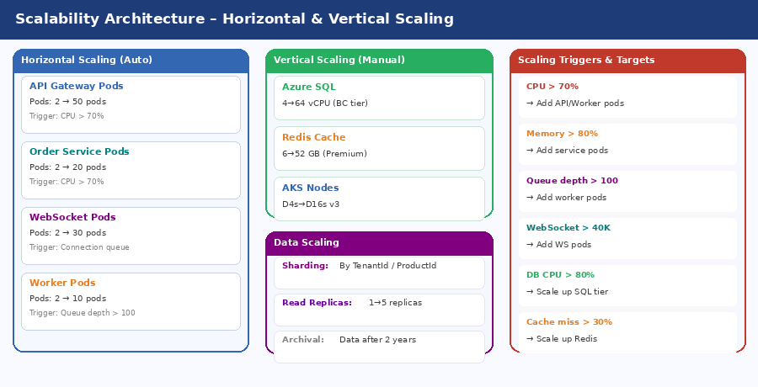
Figure: Scalability Architecture – Horizontal & Vertical Scaling

Chapter 4: System Architecture (معماری سیستم)
Architecture is documented using the C4 Model (Context → Container → Component → Code) aligned with ISO/IEC 42010:2011 and TOGAF 9.2 Architecture Views.

4.1 Technology Stack
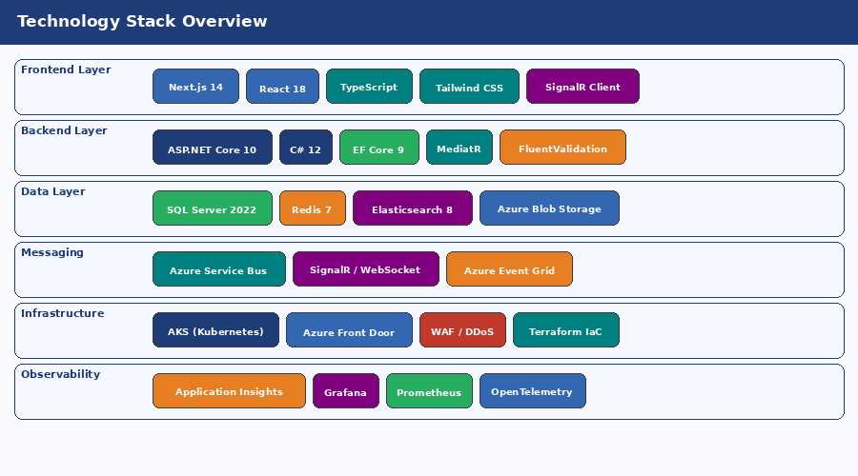
Figure: Technology Stack – All Layers

4.2 Context View (C4 Level 1)
All external actors and systems that interact with MTP are shown below:
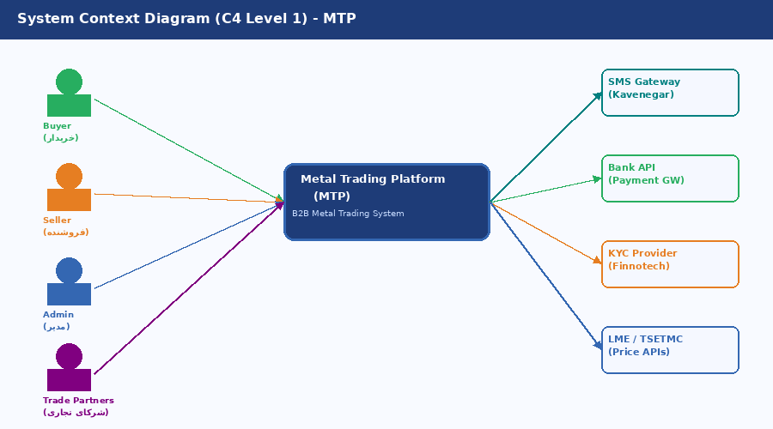
Figure: System Context Diagram (C4 Level 1)

4.3 Container View (C4 Level 2)
All deployable containers (services, data stores, messaging) within MTP:
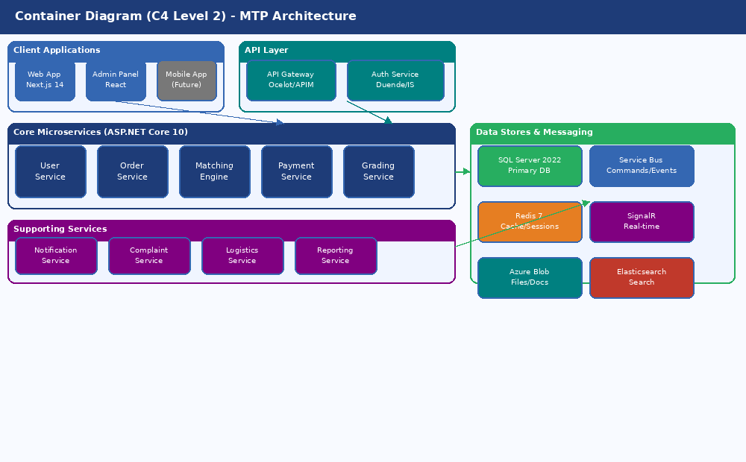
Figure: Container Diagram (C4 Level 2) – MTP Architecture

Service Catalogue
Service | Technology | Responsibility
API Gateway | Azure APIM / Ocelot | Routing, rate-limiting, auth, load-balancing
Auth Service | Duende IdentityServer 6 | OAuth 2.0/OIDC, JWT issuance, session management
User Service | ASP.NET Core 10 | User management, KYC, profiles, bank accounts
Order Service | ASP.NET Core 10 | Sell/buy orders, bids, order-book management
Matching Engine | ASP.NET Core 10 | Order matching algorithm, auction management, real-time updates
Payment Service | ASP.NET Core 10 | Commission invoicing, payment-gateway integration, wallet
Grading Service | ASP.NET Core 10 | Credit scoring, grade calculation, grade history
Notification Service | ASP.NET Core 10 | SMS, email, push notifications, WebSocket broadcast
Complaint Service | ASP.NET Core 10 | Dispute creation, resolution workflow, escalation
Reporting Service | ASP.NET Core 10 | Analytics, management dashboards, market data
Logistics Service | ASP.NET Core 10 | Inspection, shipping, insurance, warehouse (Phase 3)

4.4 Component View (C4 Level 3) – Order Service
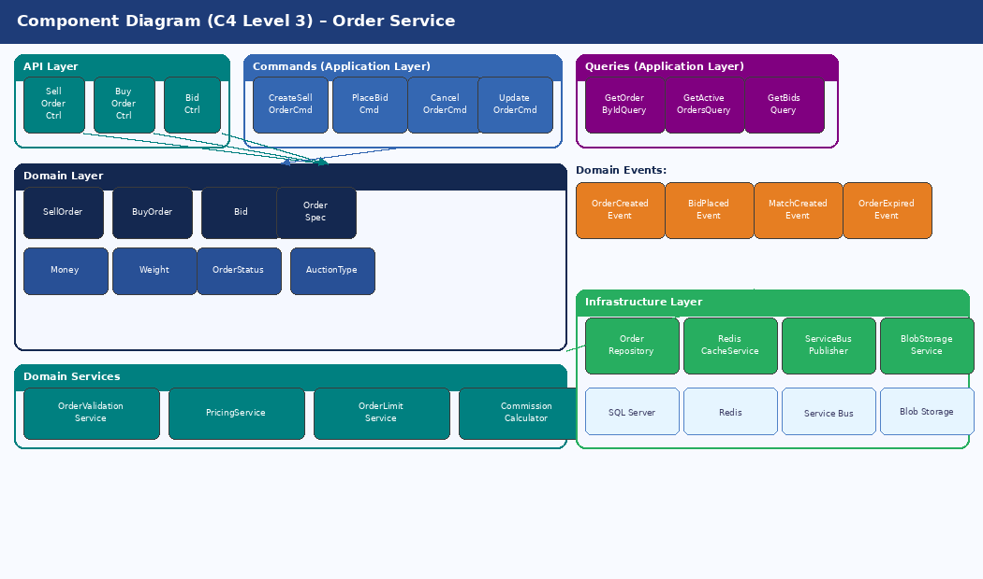
Figure: Component Diagram (C4 Level 3) – Order Service Internal

4.5 Deployment View (AKS on Azure)
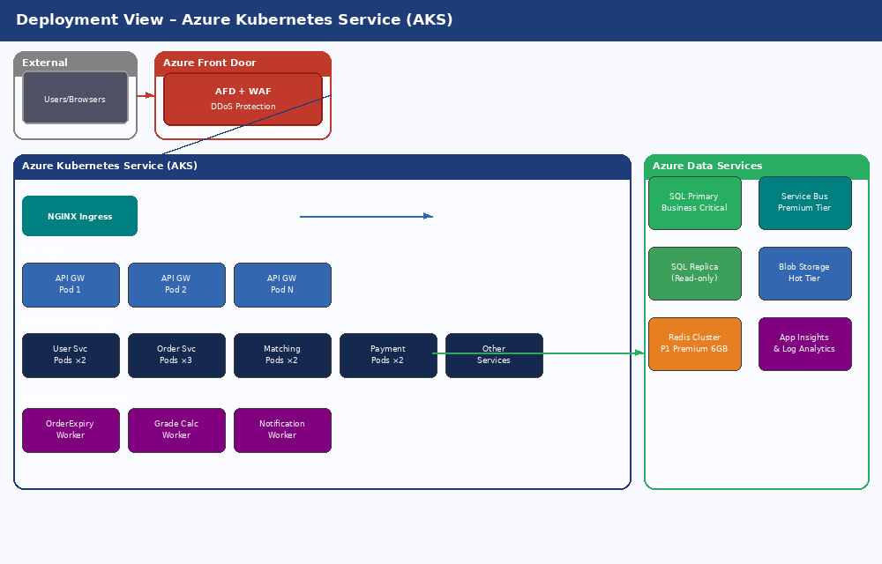
Figure: Deployment View – Azure Kubernetes Service

4.6 Architecture Patterns
Pattern | Applied In | Benefit
CQRS | All core services | Independent read/write scaling, optimised queries
Event Sourcing | Matching Engine, Audit | Full audit trail, temporal replay, event replay for reporting
Saga (Orchestration) | Match transaction flow | Consistency + rollback across microservices without 2PC
Circuit Breaker | All inter-service calls | Cascading-failure protection, fast fail, self-healing
Repository + Unit of Work | All data access | Testability, clean separation of concerns
Mediator (MediatR) | Command/query dispatch | Loose coupling, single responsibility, pipeline behaviours
Outbox Pattern | Event publishing | At-least-once delivery guarantee for domain events
API Gateway Pattern | All external traffic | Cross-cutting concerns: auth, CORS, rate-limit, routing

4.6.1 Saga Pattern – Match Transaction Flow
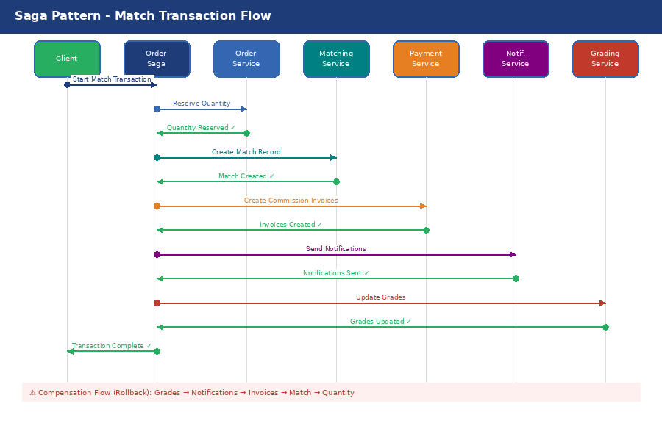
Figure: Saga Pattern – Distributed Transaction (Match Flow)

4.6.2 Circuit Breaker State Machine
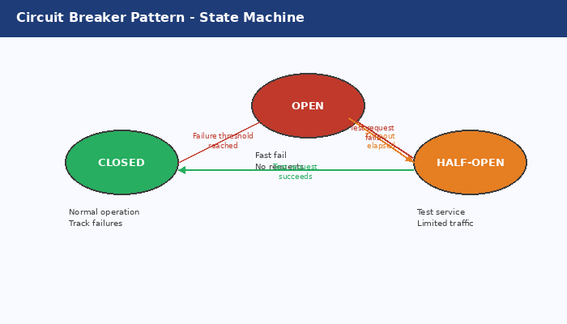
Figure: Circuit Breaker – State Transitions

4.7 Matching Engine Design

4.7.1 Internal Architecture
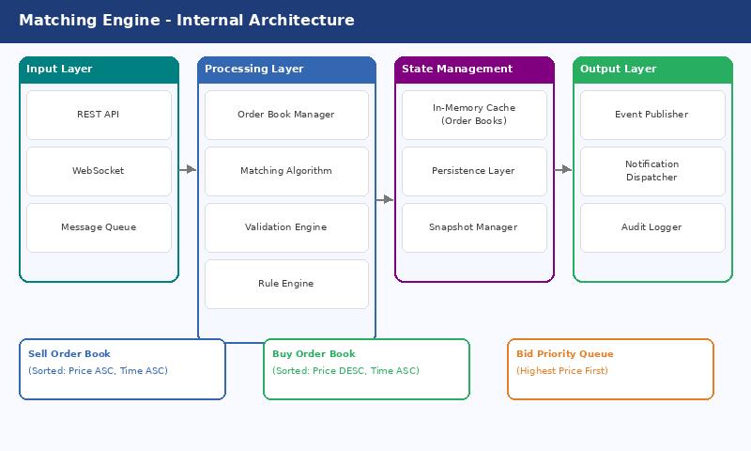
Figure: Matching Engine – Internal Architecture

4.7.2 Matching Algorithm
Algorithm: OrderMatching
Input : SellOrder, List<Bid>
Output: Match or None
1. VALIDATE order is Active and not Expired
2. VALIDATE current time is in matching window (09:00–17:00 for manual)
3. FILTER bids where:
bid.status = Active
bid.validUntil > now
bid.bidderId not blocked
bid.quantity >= order.minQuantity (or partial allowed)
4. IF auctionType = Open → SORT bids by Price DESC, CreatedAt ASC
IF auctionType = Dark → same sort but prices hidden from others
5. FOR manual match (seller selects):
- VALIDATE bid.price >= order.basePrice (if lockBelowBase = true)
- CREATE Match with selected bid
6. FOR automatic match (order expires):
- FILTER bids where bid.price >= order.basePrice
- IF no valid bids → EXPIRE order
- ELSE SELECT top bid (highest price; tie → earliest createdAt)
- CREATE Match
7. POST-MATCH:
- UPDATE order.remainingQuantity -= match.quantity
- UPDATE bid.status = Matched
- IF order.remainingQuantity = 0 → order.status = Completed
- ELSE order.status = PartiallyFilled
- PUBLISH MatchCreatedEvent (→ Service Bus)
- CREATE SellerCommissionInvoice + BuyerCommissionInvoice

4.8 Order Lifecycle State Machine
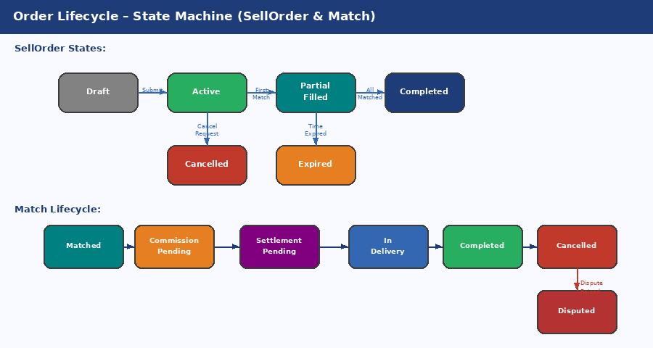
Figure: Order & Match Lifecycle – State Machines

4.9 Real-time Updates (SignalR)
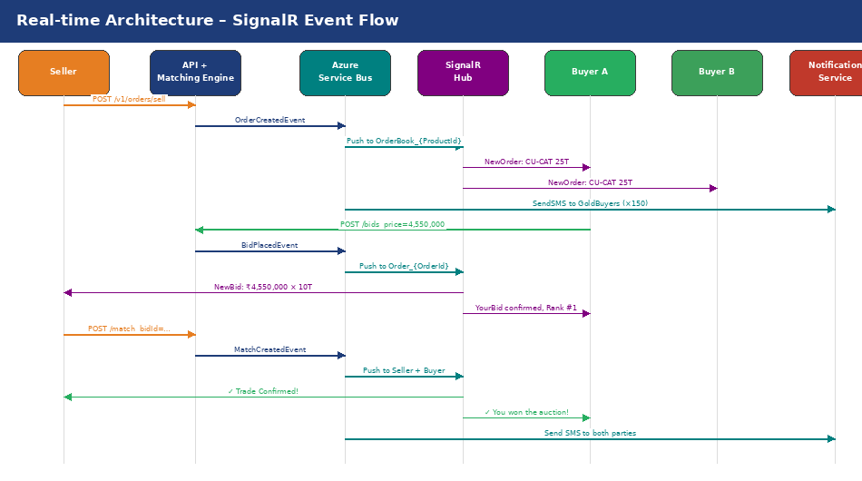
Figure: Real-time Event Flow – SignalR Architecture

Chapter 5: Database Design (طراحی پایگاه داده)

5.1 Data Classification
Classification | Description | Examples | Retention | Encryption
Critical | Business-critical records | Matches, Transactions | Forever | AES-256
Sensitive | PII & financial data | Users, BankAccounts | 10 years | Column-level
Operational | Transaction data | Orders, Bids | 5 years | TDE
Analytical | Reporting data | Reports, Logs | 3 years | TDE
Transient | Short-lived data | Sessions, OTP | 24 hours | In-memory

5.2 Database Topology (HA & DR)
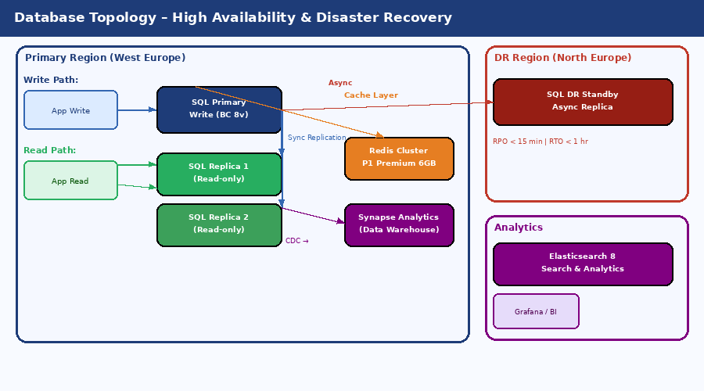
Figure: Database Topology – High Availability & Disaster Recovery

5.3 Entity Relationship Diagram
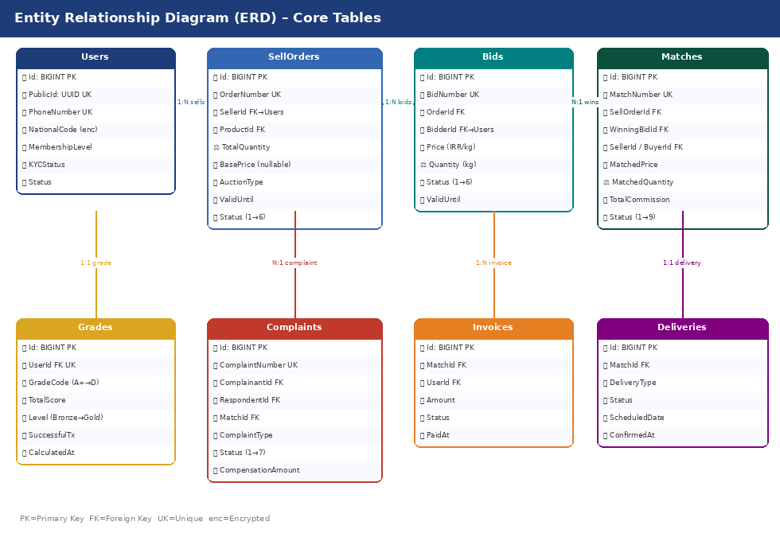
Figure: Entity Relationship Diagram – Core Tables

5.4 Key Table Schemas

5.4.1 Users
Column | Type | Notes
Id | BIGINT PK | Clustered primary key
PublicId | UNIQUEIDENTIFIER UK | Exposed to API consumers
PhoneNumber | NVARCHAR(20) UK | Masked: 0912***6789
NationalCode | NVARCHAR(10) UK | Always Encrypted (AES-256)
UserType | TINYINT | 1=Individual 2=Corporate
MembershipLevel | TINYINT | 1=Basic 2=Silver 3=Gold
KYCStatus | TINYINT | 0=None 1=Pending 2=Approved 3=Rejected
Status | TINYINT | 1=Active 2=Suspended 3=Blocked
TwoFactorEnabled | BIT | Whether TOTP is enrolled
FailedLoginAttempts | INT | Resets on success; triggers lock at 5
CreatedAt | DATETIME2 | UTC timestamp
UpdatedAt | DATETIME2 | Updated via trigger

5.4.2 SellOrders
Column | Type | Notes
Id | BIGINT PK
OrderNumber | NVARCHAR(20) UK | SO-YYYYMMDD-XXXX
SellerId | BIGINT FK | → Users.Id
ProductId | INT FK | → Products.Id
BrandId | INT FK | → Brands.Id
TotalQuantity | DECIMAL(18,3) | kg
RemainingQuantity | DECIMAL(18,3) | kg – decremented on partial match
MinQuantity | DECIMAL(18,3) | kg – minimum purchasable
WeightTolerancePercent | DECIMAL(5,2) | ± allowed variance
BasePrice | DECIMAL(18,2) | IRR/kg – nullable for open auction
LockBelowBasePrice | BIT | Reject bids below base
AuctionType | TINYINT | 1=Open 2=Dark
SaleType | TINYINT | 1=Ready 2=PreSale
PaymentTerms | TINYINT | 1=Cash 2=Check 3=LC 4=Mixed
DeliveryType | TINYINT | 1=ExWork 2=FOB 3=CIF
ValidFrom | DATETIME2 | Auction start
ValidUntil | DATETIME2 | Auction end / auto-match trigger
Status | TINYINT | 1=Draft→6=Expired

5.4.3 Matches
Column | Type | Notes
Id | BIGINT PK
MatchNumber | NVARCHAR(20) UK | MT-YYYYMMDD-XXXX
SellOrderId | BIGINT FK | → SellOrders.Id
WinningBidId | BIGINT FK | → Bids.Id
SellerId / BuyerId | BIGINT FK | Denormalized for query speed
MatchedPrice | DECIMAL(18,2) | IRR/kg
MatchedQuantity | DECIMAL(18,3) | kg
TotalValue | DECIMAL(18,2) | IRR – price × quantity
TotalCommission | DECIMAL(18,2) | 0.5 % of TotalValue
SellerCommission | DECIMAL(18,2) | 40 % of TotalCommission
BuyerCommission | DECIMAL(18,2) | 60 % of TotalCommission
CommissionRate | DECIMAL(5,4) | Effective rate (may differ for promotions)
MatchType | TINYINT | 1=Manual 2=Automatic
Status | TINYINT | 1=Matched → 9=Cancelled (full lifecycle)
MatchedAt | DATETIME2 | Immutable timestamp
CompletedAt | DATETIME2 | Set when delivery confirmed

5.5 Index Strategy
-- Trading-board covering index (supports GetActiveOrders query)
CREATE NONCLUSTERED INDEX IX_SellOrders_Board
ON SellOrders(Status, ProductId, ValidUntil DESC)
INCLUDE (PublicId,OrderNumber,SellerId,BrandId,
TotalQuantity,RemainingQuantity,MinQuantity,
BasePrice,AuctionType,SaleType,PaymentTerms,
DeliveryType,BidCount)
WHERE Status IN (2,3); -- Active, PartialFilled
-- Matching-algorithm index (price-sorted active bids per order)
CREATE NONCLUSTERED INDEX IX_Bids_Order_Status_Price
ON Bids(OrderId,OrderType,Status,Price DESC,CreatedAt ASC)
WHERE Status = 1;
-- Expiry-job index (minimal I/O scan)
CREATE NONCLUSTERED INDEX IX_SellOrders_Expiry
ON SellOrders(ValidUntil)
WHERE Status = 2;
-- User lookup by phone (login hotpath)
CREATE UNIQUE NONCLUSTERED INDEX IX_Users_Phone
ON Users(PhoneNumber) WHERE PhoneNumber IS NOT NULL;

5.6 Partitioning Strategy
High-volume tables (AuditLogs, Notifications) are range-partitioned monthly to keep query performance consistent as data grows.
CREATE PARTITION FUNCTION PF_Monthly (datetime2)
AS RANGE RIGHT FOR VALUES ('2026-01-01','2026-02-01', ... ,'2027-01-01');
CREATE PARTITION SCHEME PS_Monthly
AS PARTITION PF_Monthly ALL TO ([PRIMARY]);
-- Apply to AuditLogs and Notifications tables
-- Partition key = CreatedAt (enables fast date-range pruning)

Chapter 6: API Design (طراحی API)

6.1 Standards & Conventions
Standard | Value
Base URL | https://api.metaltrade.ir
Versioning | URI path /v1/ /v2/
Format | JSON (application/json) UTF-8
Date format | ISO 8601 – 2026-04-25T14:30:00Z
Pagination | Cursor-based for large result sets
Rate limiting | Token Bucket – 1,000 req/min per API key
Authentication | OAuth 2.0 + JWT (RS256)
API documentation | OpenAPI 3.0 / Swagger UI
Naming – resources | Plural nouns (orders, users, bids)
Naming – parameters | camelCase (pageSize, sortBy, productId)
Error format | RFC 7807 Problem Details JSON

HTTP Status Codes Used
Code | Meaning | When Used
200 | OK | Successful GET, PUT, PATCH
201 | Created | Successful POST that creates a resource
204 | No Content | Successful DELETE
400 | Bad Request | Input validation failure
401 | Unauthorized | Missing or invalid bearer token
403 | Forbidden | Authenticated but lacking permission
404 | Not Found | Resource does not exist
409 | Conflict | Business-rule violation
422 | Unprocessable Entity | Semantic error in payload
429 | Too Many Requests | Rate limit exceeded
500 | Internal Server Error | Unhandled server fault
503 | Service Unavailable | Maintenance / circuit open

6.2 API Response Envelope
// Success response
{
"success": true,
"data": { /* resource */ },
"meta": { "requestId": "...", "timestamp": "2026-04-25T14:30:00Z", "version": "1.0.0" },
"pagination": { "cursor": "eyJpZCI6MTAwfQ==", "hasMore": true, "totalCount": 1250 },
"errors": null
}
// Error response
{
"success": false,
"data": null,
"errors": [{ "code": "VALIDATION_ERROR", "field": "quantity",
"message": "Quantity must be greater than zero" }]
}

6.3 Key Endpoint Specifications
Endpoint | Method | Auth | Description
/v1/auth/register | POST | None | Register new user – triggers OTP
/v1/auth/verify-otp | POST | None | Verify OTP – returns JWT tokens
/v1/auth/refresh | POST | Refresh | Refresh access token
/v1/auth/logout | POST | Bearer | Revoke session
/v1/users/me | GET | Bearer | Current user profile + grade + wallet
/v1/users/me | PATCH | Bearer | Update profile fields
/v1/users/me/kyc | POST | Bearer | Submit KYC documents (multipart)
/v1/users/me/kyc/status | GET | Bearer | Poll KYC review status
/v1/users/me/bank-accounts | POST | Bearer | Add bank account (IBAN)
/v1/users/{id}/grade | GET | Bearer+Gold | View user grade (Gold Members only)
/v1/orders/sell | POST | Bearer+Seller | Create sell order
/v1/orders/sell | GET | Bearer | Trading board (paginated, filterable)
/v1/orders/sell/{id} | GET | Bearer | Full sell order detail
/v1/orders/sell/{id}/bids | POST | Bearer+Buyer | Place bid on sell order
/v1/orders/sell/{id}/match | POST | Bearer+Seller | Execute match (manual)
/v1/matches/{id} | GET | Bearer | Match detail + lifecycle status
/v1/matches/{id}/settlement | POST | Bearer | Confirm settlement (seller)
/v1/matches/{id}/delivery | POST | Bearer | Confirm delivery (buyer)
/v1/payments/commission | POST | Bearer | Pay commission invoice
/v1/complaints | POST | Bearer | File complaint against trade
/v1/complaints/{id} | GET | Bearer | Complaint status & messages

6.4 Sample Requests & Responses

POST /v1/orders/sell – Request
POST /v1/orders/sell
Authorization: Bearer <access_token>
{
"productId": 1,
"brandId": 5,
"quantity": { "total": 25000, "min": 5000, "tolerancePercent": 1.0 },
"pricing": { "basePrice": 4500000, "lockBelowBase": true },
"sale": { "type": "ready", "paymentTerms": "cash" },
"delivery": { "type": "exWork", "city": "Tehran", "expectedDays": 3 },
"auction": { "type": "open", "validUntil": "2026-04-26T17:00:00Z" }
}

POST /v1/orders/sell – Response (201 Created)
{
"success": true,
"data": {
"id": "ord_550e8400-e29b",
"orderNumber": "SO-20260425-0001",
"status": "active",
"product": { "name": "Copper Cathode (کاتد مس)", "code": "CU-CAT" },
"brand": { "name": "Sarcheshmeh (سرچشمه)" },
"quantity": { "total": 25000, "remaining": 25000, "unit": "kg" },
"pricing": { "basePrice": 4500000, "totalValue": 112500000000 },
"auction": { "type": "open", "validUntil": "2026-04-26T17:00:00Z",
"remainingTime": "31:30:00" },
"notifications": { "goldBuyers": 150, "smsSent": 150 }
}
}

POST /v1/orders/sell/{id}/match – Response (201 Created)
{
"success": true,
"data": {
"match": {
"id": "mtc_550e8400", "matchNumber": "MT-20260425-0001",
"matchedPrice": 4550000, "matchedQuantity": 10000,
"totalValue": 45500000000, "matchType": "manual"
},
"commission": { "total": 22750000, "seller": 9100000, "buyer": 13650000 },
"invoices": {
"seller": { "id": "inv_s_123", "amount": 9100000, "expiresIn": "1 hour" },
"buyer": { "id": "inv_b_456", "amount": 13650000, "expiresIn": "1 hour" }
},
"nextSteps": [
"1. Both parties pay commission within 1 hour",
"2. Seller issues pro-forma invoice",
"3. Settlement of goods payment",
"4. Physical delivery confirmation"
]
}
}

Chapter 7: Security Architecture (امنیت سیستم)

7.1 Defense in Depth (5 Layers)
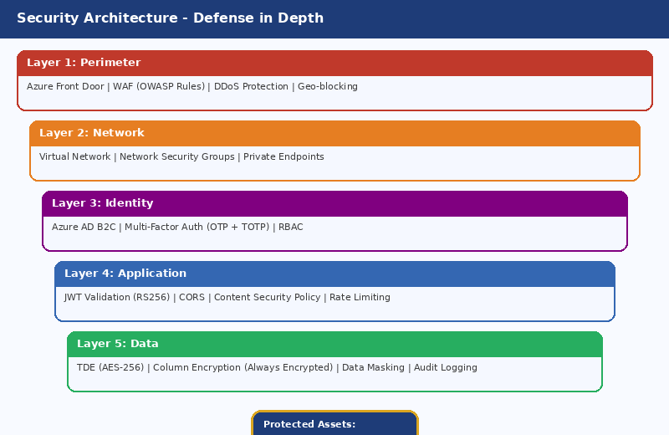
Figure: Security Architecture – Defense in Depth
Layer | Components | Purpose
1 – Perimeter | Azure Front Door, WAF (OWASP CRS 3.2), DDoS Standard, Geo-blocking | Stop known attacks at the network edge before reaching the application
2 – Network | Azure Virtual Network, NSGs, Private Endpoints, UDRs | Micro-segment services; no public IPs for data stores
3 – Identity | Azure AD B2C, OTP 2FA, TOTP, RBAC + Claims | Strongly authenticate and authorise every request
4 – Application | JWT RS256 validation, CORS, CSP headers, Rate limiting, Anti-CSRF | Block application-layer attacks and enforce business permissions
5 – Data | TDE (AES-256), Always Encrypted (PII), Data Masking, Audit Logging | Protect data at rest and ensure full traceability

7.2 Authentication Flow (OAuth 2.0 + JWT)
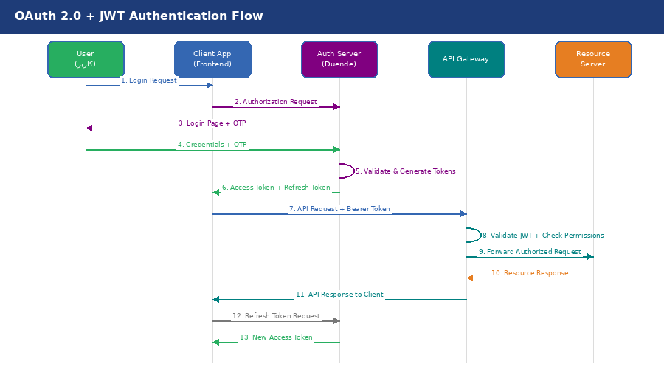
Figure: OAuth 2.0 + JWT Authentication Flow

7.3 JWT Token Structure
{
"header": { "alg": "RS256", "typ": "JWT", "kid": "key-2026-04" },
"payload": {
"iss": "https://auth.metaltrade.ir",
"sub": "550e8400-e29b-41d4-a716-446655440000",
"aud": ["api.metaltrade.ir"],
"exp": 1714056600, "iat": 1714053000,
"user": { "phone": "091*****89", "type": 1, "membershipLevel": 3, "kycStatus": 2 },
"roles": ["Buyer", "Seller", "GoldMember"],
"permissions": ["order:create","order:read","bid:create","match:execute",...],
"claims": { "seller_grade":"A", "buyer_grade":"B+", "monthly_limit":50000000000 },
"session": { "id": "sess_abc123", "ip": "x.x.x.x", "deviceId": "dev_xyz" }
}
}

7.4 Role-Permission Matrix
Role | Description | Key Permissions
Guest | Unauthenticated | public:read, prices:read, products:read
User | Registered, no KYC | user:read, user:update, kyc:submit
Buyer | KYC-verified buyer | order:read, bid:create, bid:cancel, payment:create, complaint:create
Seller | KYC-verified seller | order:create/update/cancel, match:execute, invoice:create, payment:create
GoldMember | Gold-tier member | All Buyer+Seller + grade:read:others, order:credit, analytics:read, priority:notif
Operator | Trading operations | match:monitor, complaint:respond, kyc:review, user:read:basic
Admin | System administrator | * (all) – except audit:delete (permanently forbidden)

7.5 Data Protection
Protection | Method | Details
Database (at rest) | TDE – AES-256 | Keys stored in Azure Key Vault; 90-day rotation
PII columns | Always Encrypted | NationalCode, IBAN, PasswordHash
External transit | TLS 1.3 | TLS_AES_256_GCM_SHA384; HSTS max-age=31536000
Internal transit | mTLS via Linkerd | Internal CA; certificate auto-rotation
Passwords | Argon2id | Memory=64 MB, Iterations=3, Salt=16 B, Hash=32 B
API keys | HMAC-SHA256 | 90-day rotation; stored hashed
Phone / NationalCode (display) | Dynamic Data Masking | 0912***6789 for non-privileged roles
Files (Blob) | Storage Service Encryption | AES-256; Microsoft-managed keys

7.6 Security Monitoring & Alerts
Alert | Condition | Severity | Auto-Action
BruteForce | ≥5 failed logins / 5 min / IP | High | Block IP 1 hr + notify security
SuspiciousLogin | New geo > 500 km in < 2 hrs | Medium | Step-up auth + notify user
PrivilegeEscalation | Unauthorised access to Admin/Financial resources | Critical | Block session + create incident
DataExfiltration | Download > 10 MB/hr (non-admin) | High | Throttle + review
SQLInjection | WAF pattern match | Critical | Block IP 24 hr + notify
HighErrorRate | 5xx > 1 % for 5 min | High | PagerDuty + auto-scale
CertExpiry | Certificate expires in < 30 days | Medium | Trigger renewal workflow

Chapter 8: DevOps & CI/CD

8.1 CI/CD Pipeline
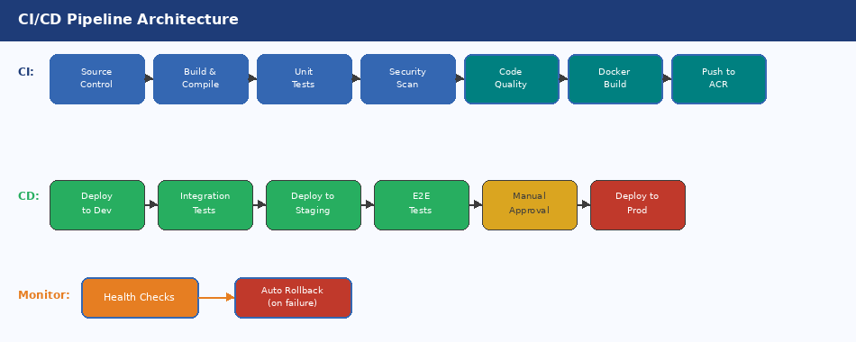
Figure: CI/CD Pipeline – Source to Production

8.2 Pipeline Stage Details
Stage | Tool | Gate Criteria | On Failure
Source Control | GitHub | PR requires 2 approvals; protected branches | PR blocked
Build & Compile | GitHub Actions | Zero build errors; warnings as errors | Pipeline fails
Unit Tests | xUnit + Jest | Coverage ≥ 80 %; zero failures | Pipeline fails
Security Scan | Snyk + SonarQube | No critical/high CVEs; SonarQuality ≥ B | Pipeline fails
Docker Build | Docker multi-stage | Image size < 500 MB; no root user | Pipeline fails
Push to ACR | Azure CR | Trivy scan – no critical vulns | Pipeline fails
Deploy Dev | Helm + AKS | All pods Running; health checks pass | Rollback
Integration Tests | Postman/Newman | 100 % API contract tests pass | Rollback
Deploy Staging | Helm Blue-Green | Zero-downtime switch; smoke tests pass | Rollback
E2E Tests | Playwright | All critical user journeys pass | Block promotion
Manual Approval | GitHub Environments | Required approver sign-off | Block
Deploy Production | Helm Rolling | Canary 5 % → 25 % → 100 % over 30 min | Auto rollback

8.3 Kubernetes & Auto-scaling
# Helm values.yaml – Order Service (Production)
replicaCount: 3
autoscaling:
enabled: true
minReplicas: 3
maxReplicas: 20
targetCPUUtilizationPercentage: 70
targetMemoryUtilizationPercentage: 80
resources:
limits: { cpu: 1000m, memory: 1Gi }
requests: { cpu: 250m, memory: 256Mi }
podDisruptionBudget:
minAvailable: 2
affinity:
podAntiAffinity:
topologyKey: topology.kubernetes.io/zone # Spread across AZs
livenessProbe: { httpGet: { path: /health/live, port: 80 }, initialDelaySeconds: 30 }
readinessProbe: { httpGet: { path: /health/ready, port: 80 }, initialDelaySeconds: 10 }

8.4 Infrastructure as Code (Terraform)
# Key Terraform resources (main.tf)
resource "azurerm_kubernetes_cluster" "main" {
kubernetes_version = "1.28"
default_node_pool {
vm_size = "Standard_D4s_v3"
enable_auto_scaling = true
min_count = 3; max_count = 10
availability_zones = ["1","2","3"]
}
}
resource "azurerm_mssql_database" "main" {
sku_name = "BC_Gen5_8" # Business Critical
zone_redundant = true
short_term_retention_policy { retention_days = 35 }
long_term_retention_policy { yearly_retention = "P5Y" }
}
resource "azurerm_redis_cache" "main" {
sku_name = "Premium"; capacity = 2; zones = ["1","2"]
}

Chapter 9: Monitoring & Observability (مانیتورینگ)

9.1 Observability Stack
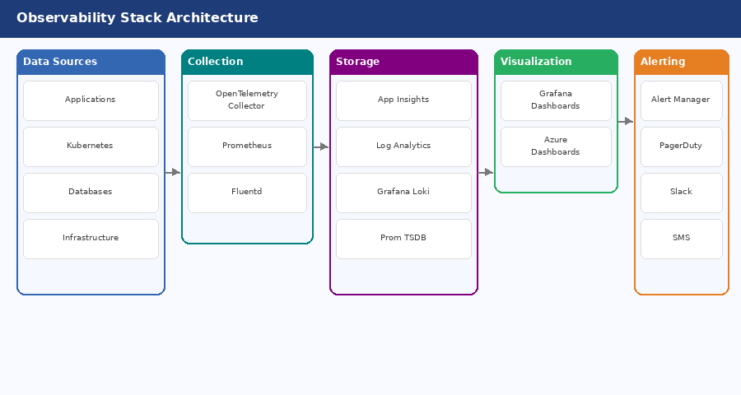
Figure: Observability Stack – End-to-End

9.2 SLIs / SLOs
Service | Availability SLO | Latency P95 | Error Rate | Special SLO
API Gateway | 99.95 % | < 200 ms | < 0.1 %
Matching Engine | 99.99 % | < 50 ms | < 0.01 % | Match accuracy 100 %
Order Service | 99.9 % | < 150 ms | < 0.1 % | Order processing < 5 s
Payment Service | 99.99 % | < 1,000 ms | < 0.5 % | Tx success > 99.5 %
Real-time (SignalR) | 99.9 % | < 100 ms | < 0.1 % | Delivery rate > 99.9 %
Auth Service | 99.99 % | < 200 ms | < 0.1 %
Grading Service | 99.9 % | < 500 ms | < 0.1 % | Grade accuracy 100 %
Error Budget: Monthly allowance = 0.05 % downtime = 21.6 min/month. Alert fires at 50 % consumed.

9.3 Key Dashboards & Alerts
Dashboard / Panel | Metric | Tool
Trading Board Health | Active orders, bids/min, match rate | Grafana
GMV & Revenue | Rolling GMV, commission earned, daily trend | Grafana + Azure
API Performance | P50/P95/P99 by service & endpoint | Application Insights
Error Rate Trend | 5xx rate over time by service | Application Insights
Kubernetes Cluster | Pod count, CPU/memory, HPA events | Grafana + Prometheus
Database Health | Query duration, lock waits, DTU % | Azure Monitor
Security Events | Failed logins, WAF blocks, suspicious IPs | Log Analytics
User Funnel | Registration → KYC → First trade | Grafana
SLO Burn Rate | Error-budget consumption over rolling window | Grafana + Prometheus

Chapter 10: Execution Plan & Budget (برنامه اجرایی و بودجه)

10.1 Project Phasing (Gantt)
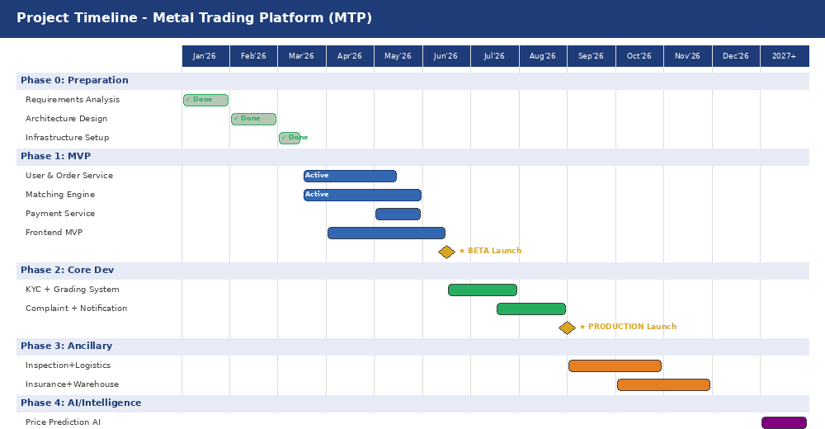
Figure: Project Timeline – Gantt Chart (2026-2027)
Phase | Period | Key Deliverables | Success Milestone
Phase 0 – Preparation | Q1 2026 ✓ | Requirements, architecture design, infrastructure baseline | Architecture approved
Phase 1 – MVP | Q2 2026 | User Service, Order Service, Matching Engine, Payment Service, Frontend MVP | Beta Launch
Phase 2 – Core Dev | Q3 2026 | Advanced KYC, Grading & Complaint systems, Push notifications | Production Launch
Phase 3 – Ancillary | Q4 2026 | Inspection, Logistics, Insurance, Warehouse modules | Full-featured platform
Phase 4 – Intelligence | 2027 | Price-prediction AI, Behaviour analytics, Advanced BI & reporting | Smart platform

10.2 Grading System Detail
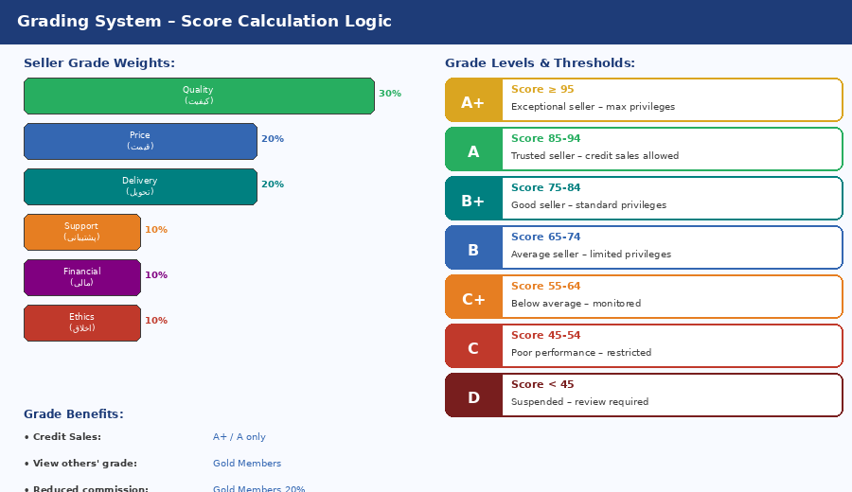
Figure: Grading System – Score Weights & Grade Levels

10.3 Team Structure
Role | # | Responsibility
Project Manager | 1 | Project delivery, stakeholder management, timeline & budget
Product Owner | 1 | Product vision, backlog prioritisation, business requirements
Solution Architect | 1 | Overall architecture design, governance, technical standards
Security Architect | 0.5 | Security review, threat modelling, penetration-test oversight
Tech Lead – Backend | 1 | Backend technical leadership, code reviews, standards enforcement
Senior .NET Developer | 3 | Core service development (Order, Matching, Payment)
Mid-level .NET Developer | 4 | Feature development, unit testing, bug fixing
Junior Developer | 2 | Supporting tasks, test coverage, documentation
Tech Lead – Frontend | 1 | Frontend architecture, design-system ownership
Senior React Developer | 2 | Complex UI, performance optimisation, state management
Mid-level React Developer | 3 | Standard UI components, form validation, API integration
DevOps Engineer | 2 | CI/CD pipelines, AKS, infrastructure as code, monitoring
Site Reliability Engineer | 1 | Production reliability, on-call rota, SLO management
QA Lead + QA Engineers | 4 | Test strategy, automation suite, regression, performance testing
Database Administrator | 1 | Schema design, query optimisation, backup & recovery
UI/UX Designer | 2 | User research, wireframes, design system, accessibility
Business Analyst | 2 | Requirements elicitation, process modelling, user stories
Total Headcount: 32 FTEs across all roles.

10.4 Budget (2-Year)
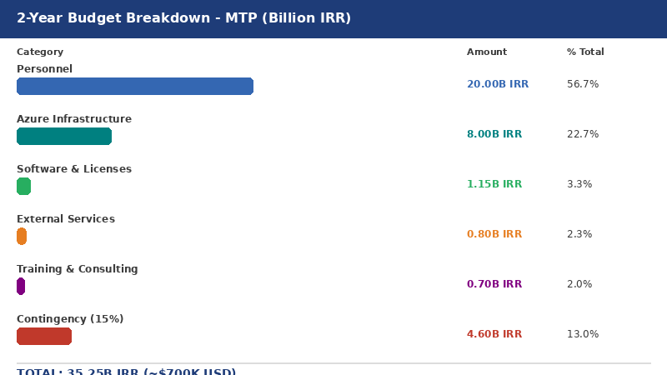
Figure: 2-Year Budget Breakdown
Category | Year 1 | Year 2 | 2-Year Total
Personnel (development, mgmt, support) | 10.0 B | 10.0 B | 20.0 B IRR
Azure Infrastructure | 3.0 B | 5.0 B | 8.0 B IRR
Software & Licenses | 0.6 B | 0.55 B | 1.15 B IRR
External Services (SMS, KYC) | 0.4 B | 0.4 B | 0.8 B IRR
Training & Consulting | 0.4 B | 0.3 B | 0.7 B IRR
Contingency (15 %) | 2.2 B | 2.4 B | 4.6 B IRR
TOTAL | 16.6 B IRR | 18.65 B IRR | 35.25 B IRR (~$700K USD)

10.5 Risk Register
ID | Category | Risk | Prob | Impact | Mitigation
R-001 | Technical | Matching Engine complexity exceeds estimates | Med | High | POC first; Algos from proven trading systems; expert consulting
R-002 | Security | Cyber attack or data breach | Low | Critical | Pen-test before launch; Bug Bounty; quarterly audits; IR plan
R-003 | Business | Market adoption failure / slow uptake | Med | High | Deep user research; MVP fast iteration; secure anchor sellers upfront
R-004 | Regulatory | Sudden regulatory changes | Med | Med | Ongoing legal counsel; flexible config-driven rules; regulator dialogue
R-005 | Resource | Key personnel attrition | Med | Med | Full documentation; knowledge-sharing; retention packages; cross-train
R-006 | Technical | Third-party service outages (SMS, KYC, Bank) | Med | Med | Multi-vendor strategy; local fallback; graceful degradation
R-007 | Financial | FX / inflation impact on IRR budget | High | Med | USD cost hedging; quarterly budget reviews; contingency buffer

Appendix A: Technical Glossary (واژه‌نامه فنی)
Term | Definition
Match | Completion of a trade – buyer bid accepted by seller (manual or automatic)
Bid | Price proposal submitted by a buyer against an active sell order
Order Book | Live registry of all Active and PartiallyFilled sell orders
Open Auction | Auction where all bid prices are visible to all participants
Dark Auction | Auction where bid prices are hidden from competing bidders
KYC | Know Your Customer – identity verification process
Grade | Credit/performance level (A+→D) assigned based on transaction history
Ex-Work | Incoterm: delivery at seller's premises; buyer bears all transport risk
FOB | Free On Board – delivery at origin port; buyer arranges onward shipping
CIF | Cost, Insurance, Freight – seller arranges and pays shipping & insurance
Tolerance | Allowed weight variance (%) between order spec and actual delivery
Commission | Platform fee: 0.5 % of transaction value (seller 40 %, buyer 60 %)
Escrow | Trust account holding funds until delivery is confirmed
CQRS | Command Query Responsibility Segregation
Saga | Distributed-transaction pattern with compensating transactions on failure
Circuit Breaker | Resilience pattern: open/close state protecting against cascades
TDE | Transparent Data Encryption – database-level encryption at rest
Always Encrypted | SQL Server column encryption – data protected even from DBAs
JWT | JSON Web Token – compact, signed bearer token for stateless auth
mTLS | Mutual TLS – bidirectional certificate authentication between services
HPA | Horizontal Pod Autoscaler – Kubernetes auto-scaling by CPU/memory
SLO | Service Level Objective – agreed availability/performance target
SLI | Service Level Indicator – measured metric backing an SLO
RTO | Recovery Time Objective – maximum tolerable downtime
RPO | Recovery Point Objective – maximum tolerable data loss
GMV | Gross Merchandise Value – total value of trades on the platform
TAM/SAM/SOM | Total/Serviceable/Obtainable Addressable Market
CDC | Change Data Capture – streaming DB changes to analytics pipeline

Appendix B: Production Readiness Checklist (چک‌لیست)

Security Checks
☐ Penetration test completed & sign-off received
☐ Security audit passed
☐ WAF rules configured and tested (OWASP CRS 3.2)
☐ DDoS Standard protection enabled on AFD
☐ SSL/TLS certificates installed & HSTS configured
☐ All secrets in Azure Key Vault – zero in code/config
☐ RBAC policies applied and peer-reviewed
☐ Data masking configured for PII fields
☐ Always Encrypted columns verified
☐ Log retention policy enforced (7 years)

Performance Checks
☐ Load test: 10,000 concurrent users – passed
☐ Stress test: 20,000 users – graceful degradation
☐ API P95 < 200 ms verified under load
☐ Auto-scaling HPA policies tested
☐ CDN configured and cache-hit ratio > 85 %
☐ DB query plans reviewed – no table scans on hot paths
☐ Covering indexes deployed and tested
☐ Connection pooling configured correctly

Reliability Checks
☐ Backup & point-in-time restore tested
☐ Disaster recovery drill completed (RTO < 1 hr, RPO < 15 min)
☐ Failover to DR region tested
☐ Health check endpoints verified on all services
☐ Circuit breakers configured and tested
☐ Dead-letter queue processing running
☐ Blue-green deployment tested – zero downtime confirmed

Monitoring Checks
☐ Application Insights SDK integrated in all services
☐ Log Analytics workspace configured
☐ Grafana dashboards live (Business + Technical + Security)
☐ Alert rules configured, tested, and routed to PagerDuty
☐ On-call rotation schedule established
☐ Runbooks created for all P1/P2 alert types
☐ SLO error-budget dashboards live
☐ Distributed tracing validated end-to-end

Documentation Checks
☐ OpenAPI 3.0 specification published
☐ Architecture documentation finalised (this document)
☐ Runbooks and incident playbooks created
☐ User guides and FAQ ready
☐ Deployment and rollback procedures documented
☐ Data dictionary and DB schema documented

Legal & Compliance Checks
☐ Terms of Service reviewed by legal and published
☐ Privacy Policy approved and published
☐ Data processing agreements signed with vendors
☐ KYC/AML compliance verified with legal counsel
☐ Regulatory approval obtained (if required)

Business Operations Checks
☐ Payment gateway end-to-end tested (real transactions)
☐ SMS gateway tested with failover to backup provider
☐ KYC provider integration tested (95 %+ pass rate)
☐ Support team trained and escalation matrix defined
☐ Executive stakeholder demo completed and approved
☐ Go/no-go review completed by leadership

Appendix C: Security Audit Log Schema
CREATE TABLE SecurityAuditLogs (
Id BIGINT IDENTITY(1,1) PRIMARY KEY,
EventId UNIQUEIDENTIFIER NOT NULL DEFAULT NEWID(),
EventType NVARCHAR(50) NOT NULL, -- Login, Logout, MatchExecuted ...
EventCategory NVARCHAR(50) NOT NULL, -- Authentication, Trading, Admin ...
Severity TINYINT NOT NULL, -- 1=Info 2=Warning 3=Error 4=Critical
UserId BIGINT NULL,
Username NVARCHAR(100) NULL,
SessionId NVARCHAR(100) NULL,
IpAddress NVARCHAR(45) NOT NULL,
UserAgent NVARCHAR(500) NULL,
RequestId UNIQUEIDENTIFIER NOT NULL,
Action NVARCHAR(100) NOT NULL,
Resource NVARCHAR(200) NULL,
ResourceId NVARCHAR(100) NULL,
Success BIT NOT NULL,
ErrorCode NVARCHAR(50) NULL,
OldValues NVARCHAR(MAX) NULL, -- JSON
NewValues NVARCHAR(MAX) NULL, -- JSON
CreatedAt DATETIME2 NOT NULL DEFAULT SYSUTCDATETIME(),
INDEX IX_Audit_EventType (EventType, CreatedAt DESC),
INDEX IX_Audit_UserId (UserId, CreatedAt DESC),
INDEX IX_Audit_IpAddress (IpAddress, CreatedAt DESC)
) ON PS_Monthly(CreatedAt); -- Range-partitioned monthly

— End of Document —
This document is CONFIDENTIAL and for internal use only.
Version 2.0.0 | 1405/02/05 (April 25, 2026) | Metal Trading Platform

