Raw Material Trading Platform
Software Requirements Specification (SRS), Software Design Document (SDD), and System Design Document

Field | Value
Project | Industrial raw-material marketplace and trading platform
Backend | .NET Core 10 Web API
Frontend | React.js
Database | SQL Server
Prepared By | Reza
Version | 0.01

Contents
Part A: Project Scope and Requirements
1. Problem Statement
2. General Overview Modelling
3. Requirements - Functional and Non-Functional
4. Domain Class Diagram
5. Entity Relationship Diagram
6. System Sequence Diagrams
7. Object State Machine Diagrams
8. Technologies
9. Project Management Gantt Chart
Part B: Software Design Architecture
1. Requirements Edits to Part A
2. Overview Model
3. Modularization
4. MVC Framework and Detailed Design
5. Data Layer
6. Gantt Chart Update
Part C: System Design Document
1. Corrections to Part B
2. Software Design Patterns
3. UI/UX Design
4. High-Level Component / Deployment Diagram
5. Gantt Chart Update for Part C

Part A: Project Scope and Requirements

Section 1: Problem Statement

1.1.a Problem Domain and Need
The project is a web-based industrial raw-material trading platform for metals and similar commodities. The system allows verified buyers and sellers to create buy and sell orders, submit offers, use auction-style matching, pay platform commissions, manage delivery and settlement steps, request optional services, and open complaints when quality, quantity, delivery, or payment problems occur.
The business need is to reduce trust problems in raw-material transactions. These transactions often involve high financial value, weight tolerance, product quality claims, credit or LC payment terms, delivery delays, and disputes over invoices, documents, or inspection reports. The platform solves these problems by adding KYC, seller and buyer grading, transaction logs, controlled messaging, operator supervision, digital workflows, and transparent rules.

1.1.b List of Capabilities and Benefits
Capability | Description
User registration and OTP | Individuals and companies register with mobile OTP and profile information.
KYC and role approval | Buyer and seller roles become active only after required verification and admin review.
Product catalogue and technical forms | Products such as copper cathode, copper wire, zinc ingot, aluminium ingot, brass sheet, scrap copper, and related items have product-specific forms.
Buy and sell order management | Approved buyers and sellers can create time-limited orders 24 hours a day.
Auction and offer management | Open auction, dark auction, base-price options, and price offers are supported.
Matching engine | The platform supports seller-initiated matching, buyer-initiated matching, and automatic matching based on rules.
Commission and invoices | System commission invoices, proforma invoices, advance payment links, and commission blocking rules are supported.
Optional services | Inspection, transportation, insurance, and warehousing service requests can be added to transactions.
Complaint management | Quality, quantity, delivery, document, fraud, and payment complaints are tracked through a formal workflow.
Grading system | Buyer and seller grades are calculated from KYC, quality, delivery, financial, support, and complaint metrics.
Analytics and AI | The website can show free prices, paid analysis, and AI-based price prediction using currency, global metal prices, previous trades, and demand.

Benefit | Explanation
Trust and safety | KYC, grading, and operator review reduce fake users and transaction fraud.
Pricing transparency | Users can view selected market data, historical deals, and auction activity based on their access level.
Operational control | Order validity, matching windows, cancellation rules, and penalty rules make the marketplace predictable.
Dispute reduction | Digital records, service partners, inspection reports, and complaint workflows support evidence-based decisions.
Business growth | Premium analysis, paid access, golden user benefits, and service commissions create revenue channels.

1.2 Stakeholders and Roles
Stakeholder | Role in the System
Buyer | Registers, completes KYC, creates buy orders, submits offers, pays commission, confirms settlement and delivery, submits complaints, and rates sellers.
Seller | Registers, completes KYC, creates sell orders, receives offers, matches transactions, issues proforma invoice, confirms delivery, and responds to complaints.
Admin / Operator | Approves KYC, approves brands, monitors trading board, helps with matching, handles claims, updates grades, and manages blocking/penalties.
Service Partner | Provides inspection, logistics, insurance, or warehousing support after buyer request.
Payment Gateway / Bank | Processes commission payments, payment links, deposits, and payment confirmations.
KYC Provider | Provides OCR, face match, national code, legal entity, and bank account matching services.
SMS Provider | Sends OTP, alerts, matching notifications, payment reminders, and complaint updates.
Developers and QA | Build, test, maintain, and deploy the React front end, .NET Core backend, and SQL Server database.

1.3 Subsystems / Functional Components
Subsystem | Main Responsibilities
Login and Registration | Account creation, OTP verification, login, logout, password reset, user profile.
KYC and Role Approval | Document upload, identity validation, legal entity verification, bank account matching, buyer/seller approval.
Product Catalogue | Product categories, brands, technical fields, packaging standards, and product-specific order forms.
Trading Board | Display active buy/sell orders, order validity, quantity, conditions, and status.
Offer and Auction | Open auction, dark auction, base price, credit/LC/presale visibility rules, and offer history.
Matching Engine | Manual match, auto-match, partial match, remaining quantity, cancellation and expiry rules.
Payment and Commission | Commission calculation, invoices, advance payment, payment link, blocking on unpaid commission.
Delivery and Settlement | Settlement confirmation, delivery weight, bill of lading, delivery delay handling, final invoice.
Complaint / Claim | Complaint form, evidence collection, operator assignment, service partner reports, resolution, penalties.
Grading and Risk | Buyer/seller scoring, golden user status, restriction logic, fraud flags, periodic review.
Analytics and AI | Price dashboards, analysis sales, AI price prediction, customer behavior analytics.
Admin Dashboard | Approval queues, monitoring, reports, penalties, user management, platform settings.

1.4 Intended Users of the SRS Documentation
- Software developers implementing .NET Core 10 backend APIs, React pages, SQL Server schema, and integrations.
- Project managers planning scope, timeline, and deliverables.
- Business owners and client representatives validating that requirements match the desired marketplace process.
- QA testers writing acceptance and integration tests.
- Legal and operations advisors reviewing platform rules, disclaimers, penalties, and complaint workflows.

Section 2: General Overview Modelling

2.1 Context Flow Diagram (CFD) - Raw Material Trading Platform
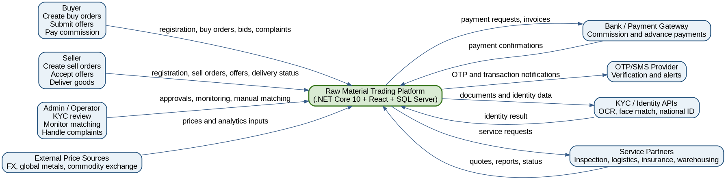
2.1 Context Flow Diagram (CFD) - Raw Material Trading Platform

2.2 Use Case Diagram - Main Platform Users
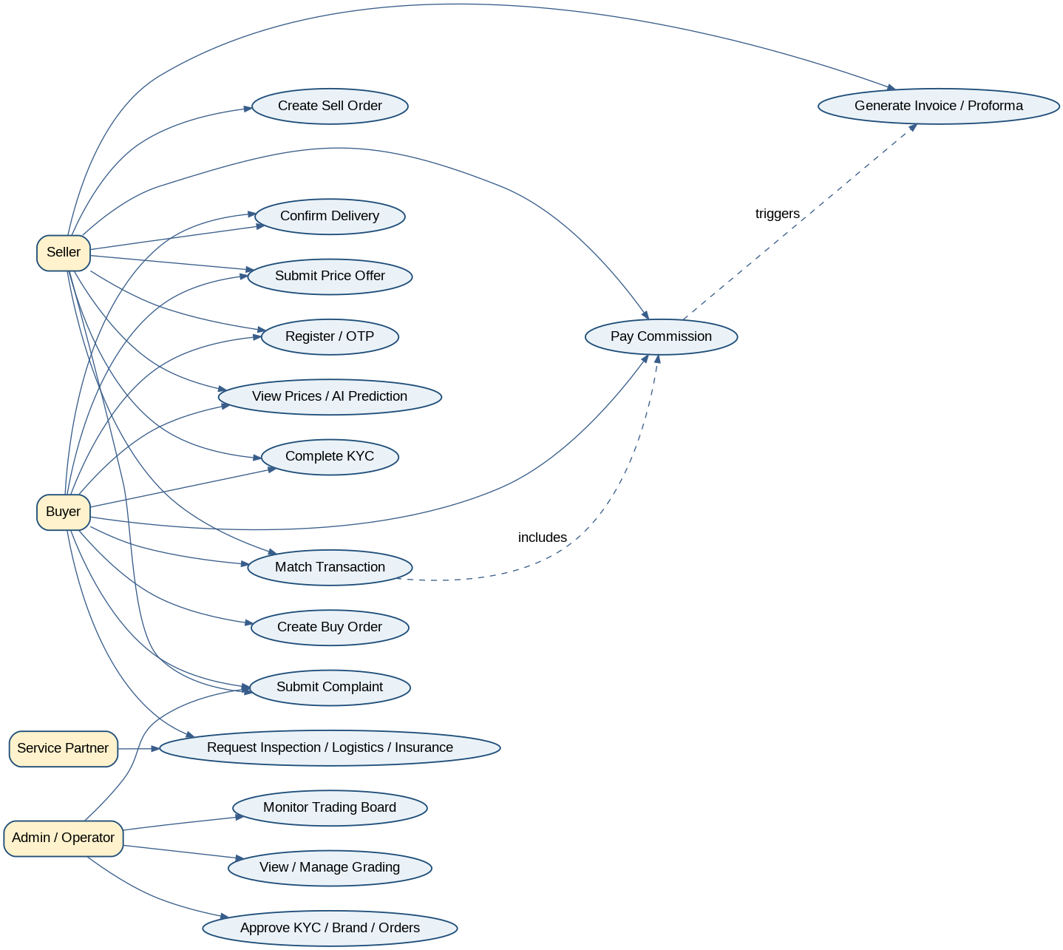
2.2 Use Case Diagram - Main Platform Users

Section 3: Requirements - Functional and Non-Functional

3.1 Non-Functional Requirements
NFR# | Name | Description
NFR001 | Performance | The trading board and order pages should load within 3 seconds under normal traffic. Matching operations should complete in near real time.
NFR002 | Security | All APIs must require HTTPS, JWT authentication, RBAC, server-side validation, and secure storage of sensitive data.
NFR003 | Confidentiality | KYC documents, bank details, identity data, and transaction details must be accessible only to authorized users.
NFR004 | Availability | The platform should be available 24/7 for order submission while matching windows can be business-rule limited.
NFR005 | Scalability | The architecture must support increasing users, products, orders, and notifications using scalable .NET services and SQL indexing.
NFR006 | Auditability | Important actions such as KYC approvals, offer submission, matching, payments, penalties, and complaint decisions must be logged.
NFR007 | Maintainability | The codebase should use layered architecture, DTOs, services, repositories, dependency injection, and unit tests.
NFR008 | Usability | React pages must be responsive, clear, and simple for buyers, sellers, admins, and operators.
NFR009 | Interoperability | The system must integrate with SMS, KYC APIs, payment gateways, analysis APIs, and future CRM systems.
NFR010 | Compliance and Legal Safety | The platform must show disclaimers, risk statements, prohibited chat content, and avoid conflict with commodity exchange obligations.

3.2.1 Login, Registration, and KYC Subsystem
FR# | Name / Goal Use Case | Role Player | Description
FR-KYC-01 | Create Individual Account | Visitor, System | Allow an individual user to register with name, family name, national code, mobile, optional email, address, and postal code.
FR-KYC-02 | Create Company Account | Visitor, System | Allow a legal entity to register with company name, national ID, company phone, mobile, address, activity type, and optional warehouse postal code.
FR-KYC-03 | Send and Verify OTP | System, SMS Provider | Send SMS OTP and validate the user mobile number before account activation.
FR-KYC-04 | Complete KYC | Buyer/Seller, System | Collect documents such as national card, selfie, company documents, representative authorization, and bank account details.
FR-KYC-05 | Approve Buyer or Seller Role | Admin, System | Allow admin to approve buyer role, seller role, or both. Seller approval may require operator contact and contract review.
FR-KYC-06 | Bank Account Verification | System, KYC Provider | Verify that bank card or IBAN owner name matches the verified user or company identity.
FR-KYC-07 | KYC Status Tracking | User, System | Show statuses: pending, needs correction, rejected, or approved. Provide reason when rejected or correction is needed.

User Stories and Acceptance Criteria
- As a visitor, I want to register using my mobile number, so I can enter the platform securely.
- Registration form accepts required fields.
- OTP is sent to mobile number.
- Account is created only after OTP verification.
- As a seller, I want to complete seller KYC, so I can publish sell orders.
- Seller role shows pending until admin approval.
- System stores uploaded documents.
- Admin can approve, reject, or request correction.

3.2.2 Trading and Order Subsystem
FR# | Name / Goal Use Case | Role Player | Description
FR-TRD-01 | Create Sell Order | Seller, System | Approved sellers can create sell orders 24/7 with product, brand, quantity, packaging, technical specs, sale type, delivery terms, payment terms, and validity time.
FR-TRD-02 | Create Buy Order | Buyer, System | Approved buyers can create buy orders with required product, quantity, payment terms, delivery terms, base target price, and validity time.
FR-TRD-03 | Product-Specific Forms | System | Open a product-specific technical and commercial form based on selected product category.
FR-TRD-04 | Brand Approval | Seller, Admin | If a brand is not listed, seller can request a new brand and the order remains pending until admin approval.
FR-TRD-05 | Trading Board Display | System | Publish valid orders to the trading board after checks and notify relevant users based on access level.
FR-TRD-06 | Order Edit and Cancel Rules | Seller/Buyer, System | Allow edits or cancellation based on role, golden grade, matching window, and order state rules.

User Stories and Acceptance Criteria
- As a seller, I want to create a detailed sell order, so buyers can trust the offer.
- Only approved sellers can access sell order form.
- Product-specific technical fields are shown.
- Order is published after validation.
- As a buyer, I want to create a buy order, so sellers can offer suitable material.
- Only approved buyers can create buy orders.
- Order appears on trading board.
- Relevant sellers receive notification.

3.2.3 Offer, Auction, and Matching Subsystem
FR# | Name / Goal Use Case | Role Player | Description
FR-MAT-01 | Submit Price Offer | Buyer/Seller, System | Users submit price, quantity, offer validity, requested quality guarantee, and special purchase/sale conditions.
FR-MAT-02 | Open Auction Visibility | System | In open auctions, golden or paid users can view competing prices based on access policy.
FR-MAT-03 | Dark Auction | System | Allow hidden bids where users cannot see other offers.
FR-MAT-04 | Manual Match | Buyer/Seller, System | Seller or buyer can manually match a suitable offer before validity ends.
FR-MAT-05 | Automatic Match | System | At expiry, match automatically if offer meets base price rule; earliest qualifying offer wins when prices are equal or above/below rule.
FR-MAT-06 | Partial Match | System | Allow partial quantity matching above minimum quantity and show remaining quantity on the board.
FR-MAT-07 | Cancellation Penalty | System | If a matched user cancels, apply guarantee, penalty, loss recovery, grade reduction, or trading ban based on rules.

User Stories and Acceptance Criteria
- As a seller, I want to match the best offer, so I can close a transaction quickly.
- Seller can view offers according to access rules.
- Clicking Match creates transaction.
- Both sides receive SMS or platform notification.

3.2.4 Payment, Commission, Invoice, and Settlement Subsystem
FR# | Name / Goal Use Case | Role Player | Description
FR-PAY-01 | Calculate Commission | System | Calculate total platform commission as 5 per thousand, split 40% seller and 60% buyer unless business policy changes.
FR-PAY-02 | Issue Commission Invoice | System | Generate system commission invoice and send it to both sides after matching.
FR-PAY-03 | Payment Link | Payment Gateway, System | Provide payment links for commission and advance payment where required.
FR-PAY-04 | Block on Unpaid Commission | System | Block or restrict accounts when commission is not paid based on policy.
FR-PAY-05 | Issue Proforma | Seller, System | After commission payment, seller issues system proforma invoice with terms, account number, and validity.
FR-PAY-06 | Settlement Confirmation | Buyer/Seller, System | Buyer confirms payment or credit/LC completion; seller confirms settlement as required.

User Stories and Acceptance Criteria
- As the platform, I want to issue commission invoices, so revenue is tracked correctly.
- Commission is calculated by rule.
- Invoices are generated for both sides.
- Unpaid commission can restrict account.

3.2.5 Delivery and Optional Services Subsystem
FR# | Name / Goal Use Case | Role Player | Description
FR-SRV-01 | Request Inspection | Buyer, System | Buyer can request quality guarantee or inspection at origin/destination with parameters and service cost.
FR-SRV-02 | Request Transportation | Buyer, System | Buyer can request logistics quote, pay cost, and receive vehicle and driver details.
FR-SRV-03 | Request Insurance | Buyer, System | Buyer can request insurance type, estimated cargo value, pay premium, and receive policy document.
FR-SRV-04 | Request Warehousing | Buyer, System | Buyer can request warehouse service, receive cost, pay fee, and receive warehouse address.
FR-SRV-05 | Delivery Confirmation | Seller/Buyer, System | Seller records exact weight and delivery status; system may require bill of lading or buyer confirmation.

User Stories and Acceptance Criteria
- As a buyer, I want optional inspection and logistics services, so I can reduce transaction risk.
- Buyer can select services.
- Operator receives service request.
- Cost and status are tracked in the platform.

3.2.6 Complaint, Claim, and Grading Subsystem
FR# | Name / Goal Use Case | Role Player | Description
FR-CLM-01 | Submit Complaint | Buyer/Seller, System | Users can submit complaints for quality, quantity, delivery, payment, document, fraud, or service issues.
FR-CLM-02 | One-Hour Response SLA | Operator, System | The complaint workflow should create an operator task and require first response within one hour where applicable.
FR-CLM-03 | Evidence Collection | System | Allow upload of documents, photos, invoices, inspection reports, weighbridge tickets, and messages.
FR-CLM-04 | Complaint Tracking | User, System | Show each complaint stage in the platform until closed.
FR-CLM-05 | Grade Impact | System | Confirmed complaints and violations must affect buyer or seller grade.
FR-GRD-01 | Seller Grading | System | Score sellers by KYC, quality, price, delivery, support, financial stability, history, and business ethics.
FR-GRD-02 | Buyer Grading | System | Score buyers by financial credit, timely payment, conduct, purchase potential, documentation, and communication.

User Stories and Acceptance Criteria
- As a buyer or seller, I want to submit a complaint, so disputes can be investigated fairly.
- Complaint form has category, transaction, explanation, and evidence upload.
- System shows complaint status.
- Confirmed complaint updates grade.

3.2.7 Website, Analytics, and AI Subsystem
FR# | Name / Goal Use Case | Role Player | Description
FR-WEB-01 | Free Website Content | System | Show weekly transaction quantities, FX price, global metal prices, commodity exchange prices, links, ads, membership, normal analysis, and trading time as free content.
FR-WEB-02 | Paid Analysis | System | Sell analysis, customer behavior analytics, historical prices, and AI price prediction to non-golden users.
FR-WEB-03 | AI Price Prediction | System | Predict prices using dollar rate, global metal prices, previous week trades, demand, and available market data.
FR-WEB-04 | Survey Link | System | Send survey links after matched and unmatched transactions for platform quality and user evaluation.

User Stories and Acceptance Criteria
- As a website visitor, I want to see free price information, so I can decide whether to register.
- Free market data is visible.
- Paid analysis is locked for non-golden users.
- AI prediction is available based on access policy.

Section 4: Domain Class Diagram

4.1 List of Classes
- User, Buyer, Seller, Admin, Operator
- KYCRecord, UploadedDocument, BankAccount
- Product, ProductCategory, Brand, ProductSpecification, PackagingStandard
- Order, BuyOrder, SellOrder, Offer, Auction, MatchingRule
- Transaction, Invoice, Payment, Commission, Settlement, Delivery
- Complaint, Evidence, ComplaintResolution, Penalty
- GradeScore, SellerGradeMetric, BuyerGradeMetric
- ServiceRequest, InspectionRequest, LogisticsRequest, InsuranceRequest, WarehouseRequest
- Notification, SmsMessage, AuditLog, SurveyResponse

4.2 Domain Class Diagram
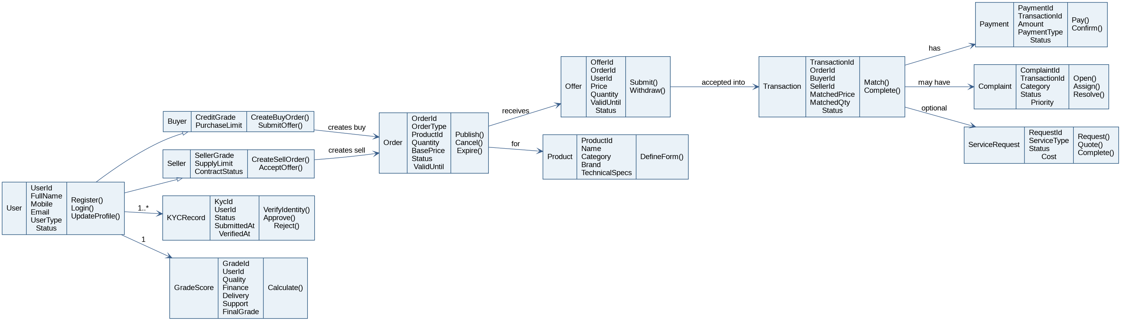
4.2 Domain Class Diagram

Section 5: Entity Relationship Diagram

5.1 Entity Relationship Diagram - SQL Server Database
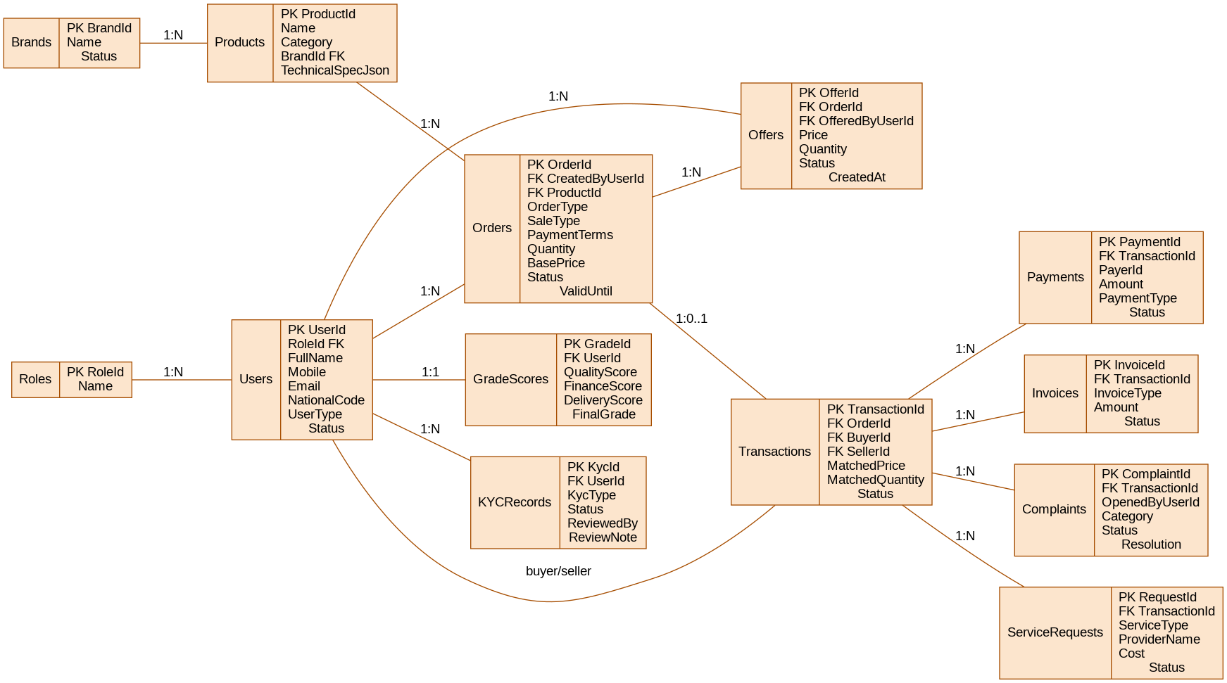
5.1 Entity Relationship Diagram - SQL Server Database

Section 6: System Sequence Diagrams

6.1 Registration and KYC Sequence Diagram
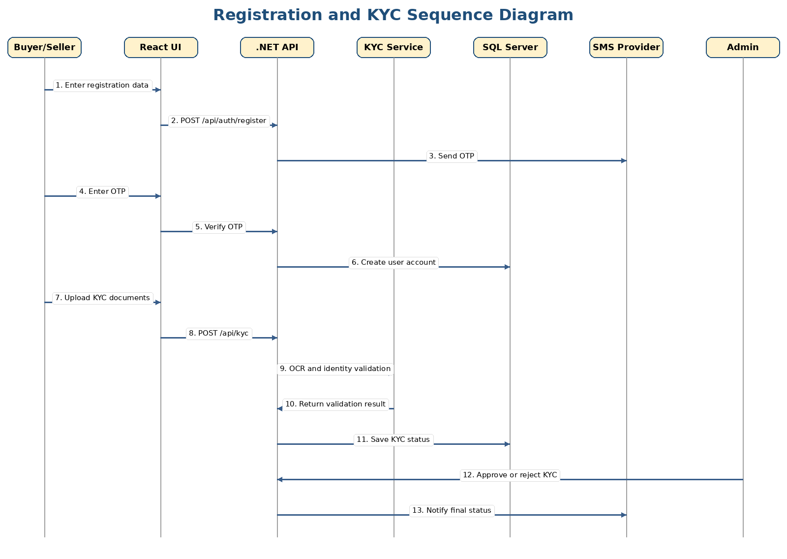
6.1 Registration and KYC Sequence Diagram

6.2 Create Sell Order and Matching Sequence Diagram
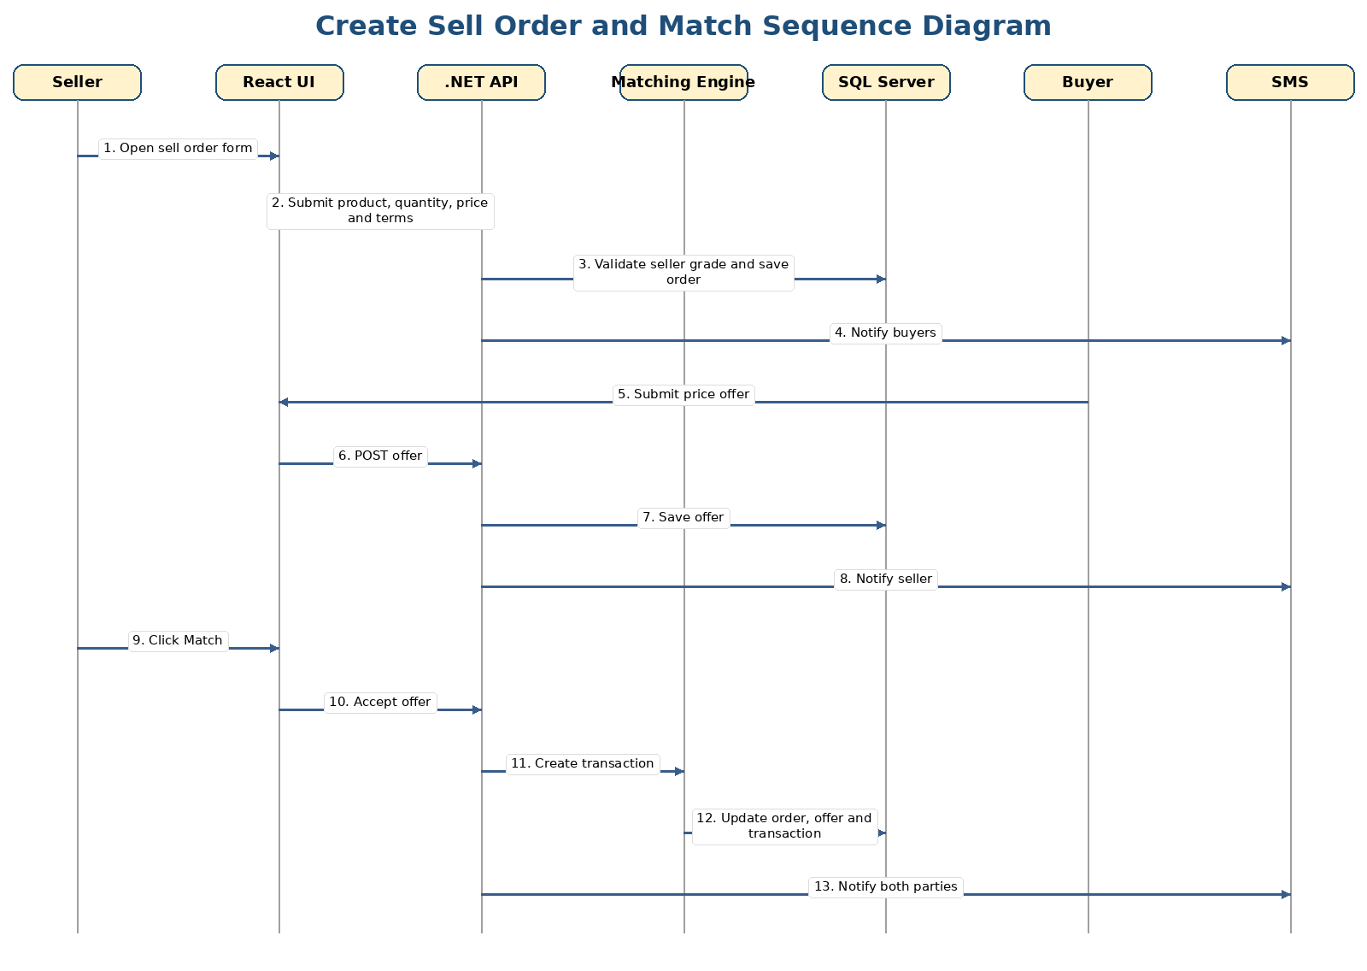
6.2 Create Sell Order and Matching Sequence Diagram

6.3 Commission, Invoice, and Delivery Sequence Diagram
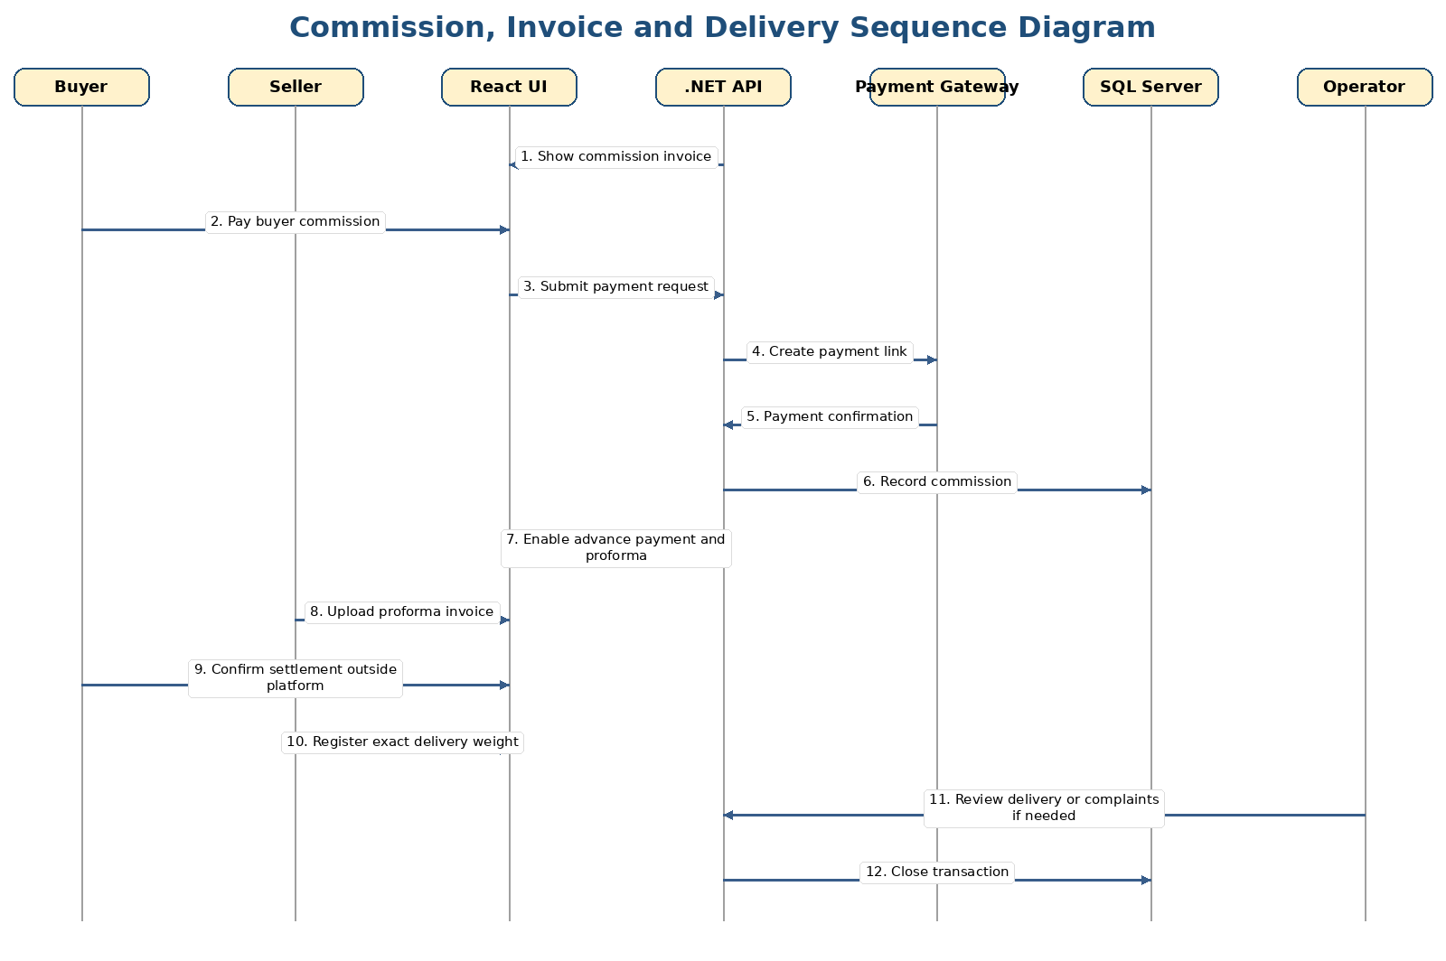
6.3 Commission, Invoice, and Delivery Sequence Diagram

Section 7: Object State Machine Diagrams

7.1 Order / Transaction State Machine
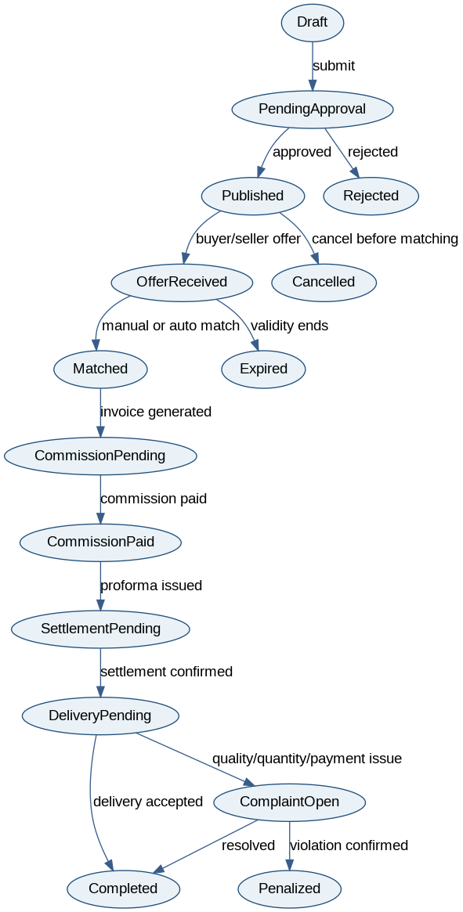
7.1 Order / Transaction State Machine

7.2 Complaint State Machine
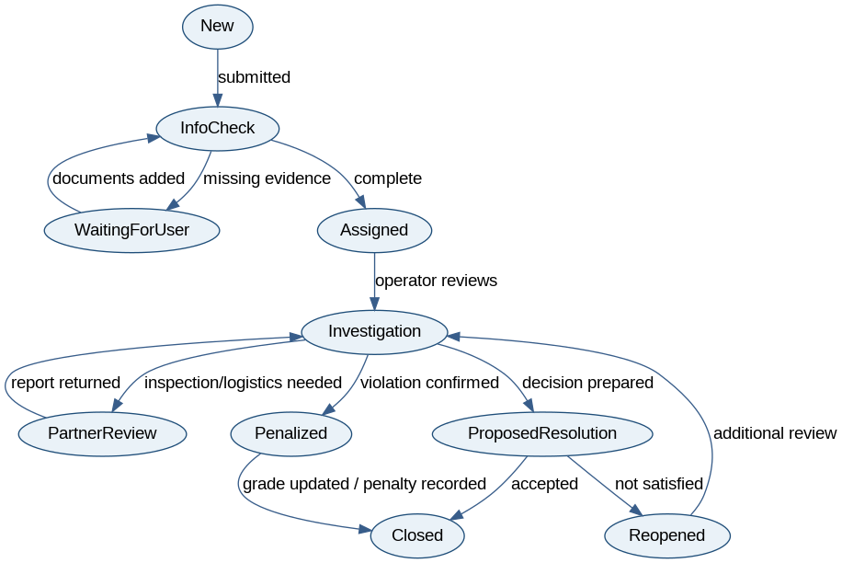
7.2 Complaint State Machine

Section 8: Technologies
Layer | Technology | Purpose
Client side | React.js, HTML, CSS, JavaScript/TypeScript | Responsive buyer, seller, admin portals and trading board.
Backend | ASP.NET Core 10 Web API | REST APIs, controllers, authentication, matching services, business rules.
Database | SQL Server | Relational transaction storage, reporting, audit logs, KYC metadata.
Authentication | JWT, refresh tokens, OTP SMS | Secure login and role-based access.
External Integrations | SMS, payment gateway, KYC APIs, market data APIs | Verification, notifications, payments, and price feeds.
AI / Analytics | Python or .NET ML service in later phase | Price prediction, behavior analytics, fraud signals.
DevOps | GitHub, CI/CD, Docker optional | Version control, automated builds, deployment.

Section 9: Project Management (Gantt Chart)
Task | Week 1 | Week 2 | Week 3 | Week 4 | Week 5 | Week 6 | Week 7 | Week 8
Requirements and client review | X | X
SRS Part A diagrams and use cases |  | X | X
Architecture and database design |  |  | X | X
Backend API setup |  |  |  | X | X
React UI setup |  |  |  | X | X
Trading and matching workflows |  |  |  |  | X | X
Payment, complaints, grading |  |  |  |  |  | X | X
Testing, final report, presentation |  |  |  |  |  |  | X | X

Part B: Software Design Architecture

Section 1: Requirements Edits to Part A
Area | Correction / Refinement
Class list | Added service requests, grade scores, notifications, audit logs, product specification, commission, settlement, and complaint evidence classes.
Domain diagram | Separated core marketplace concepts: User, Order, Offer, Transaction, Payment, Complaint, GradeScore, and ServiceRequest.
ERD | Updated database model for SQL Server with relational foreign keys and transaction-safe entities.
Technology stack | Updated stack from the sample to React frontend, .NET Core 10 backend, and SQL Server database.
Business rules | Added matching windows, role approval, golden-user access, commission split, penalties, and partial match rules.

Section 2: Overview Model

2.1 Intended Users of the SDD Document
- Developers who need design classes, controllers, services, database entities, and sequence flows.
- Project managers who need modular scope, milestones, and dependencies.
- QA testers who need testable flows and state transitions.
- Admins and operations team members who need to understand transaction monitoring and complaint handling.
- Client representatives who need confirmation that the software design supports the desired business workflow.

2.2.1 Context Flow Diagram (Updated)

2.2.1 Context Flow Diagram (Updated)

2.2.2 Architectural Context Diagram (ACD)
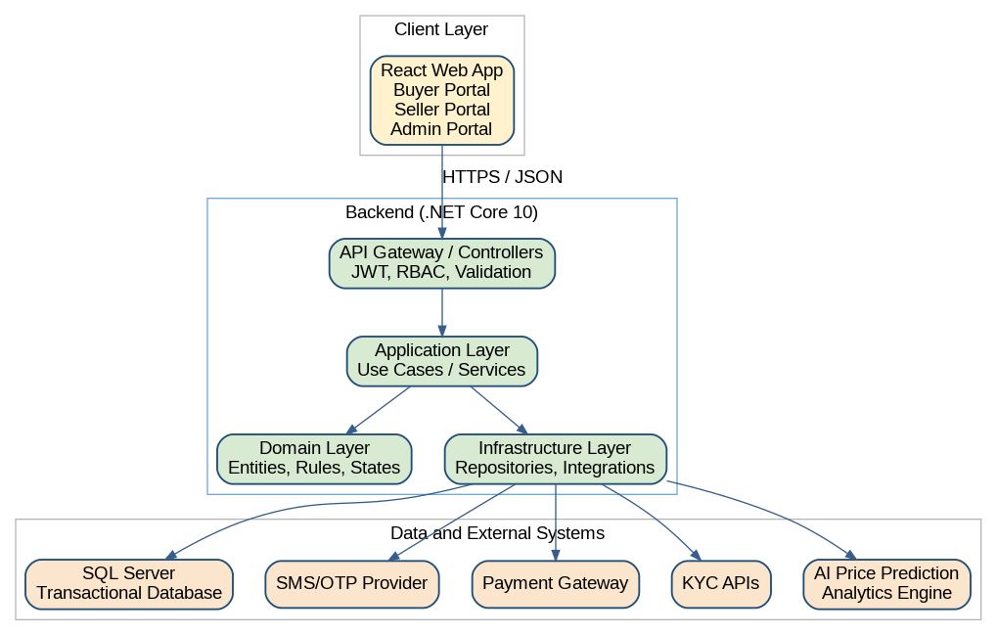
2.2.2 Architectural Context Diagram (ACD)

Section 3: Modularization

3.1 Login, Registration, and KYC Subsystem

Partition of Analysis Model
- Login interface
- Registration interface
- OTP service
- KYC upload interface
- KYC review interface
- User
- KYCRecord
- BankAccount
- Admin

Class Responsibility Collaboration (CRC) Cards
Class | Responsibility | Collaborators
User | Stores registered individual/company information | KYCRecord, BankAccount, Role
KYCRecord | Tracks identity documents, validation result, and approval status | User, Admin, KYC Provider
AuthController | Receives login, register, OTP, and password requests | AuthService, UserRepository
KycController | Receives KYC upload and review requests | KycService, DocumentStorage, Admin

Design Class Diagram

3.1 Login, Registration, and KYC Subsystem - MVC / Design View
3.1 Login, Registration, and KYC Subsystem - MVC / Design View

3.2 Trading and Matching Subsystem

Partition of Analysis Model
- Trading board
- Sell order form
- Buy order form
- Offer form
- Matching service
- Order
- Offer
- Transaction
- Notification

Class Responsibility Collaboration (CRC) Cards
Class | Responsibility | Collaborators
Order | Stores buy or sell demand with product, quantity, price, and terms | Product, Offer, Transaction
Offer | Stores buyer/seller submitted price and quantity | Order, User
MatchingService | Applies manual match, auto-match, partial match, and expiry rules | Order, Offer, Transaction
TradingController | Exposes order, offer, board, and match APIs | TradingService, MatchingService

Design Class Diagram

3.2 Trading and Matching Subsystem - MVC / Design View
3.2 Trading and Matching Subsystem - MVC / Design View

3.3 Payment, Commission, and Invoice Subsystem

Partition of Analysis Model
- Commission invoice view
- Payment link
- Payment confirmation webhook
- Proforma invoice
- Settlement status

Class Responsibility Collaboration (CRC) Cards
Class | Responsibility | Collaborators
CommissionService | Calculates platform fee and payer split | Transaction, Payment
Payment | Tracks payment type, amount, status, and gateway reference | Transaction, User
Invoice | Stores commission invoice and proforma invoice data | Transaction, Payment
PaymentGatewayAdapter | Converts platform payment calls into gateway-specific API calls | Payment Gateway

Design Class Diagram

3.3 Payment, Commission, and Invoice Subsystem - MVC / Design View
3.3 Payment, Commission, and Invoice Subsystem - MVC / Design View

3.4 Complaint and Grading Subsystem

Partition of Analysis Model
- Complaint form
- Complaint dashboard
- Evidence upload
- Grade calculator
- Penalty rules

Class Responsibility Collaboration (CRC) Cards
Class | Responsibility | Collaborators
Complaint | Tracks category, evidence, status, assignment, and resolution | Transaction, User, Evidence
GradeScore | Stores buyer/seller scoring dimensions and final grade | User, Complaint, Transaction
ComplaintService | Manages complaint workflow and first response SLA | Complaint, Operator, Partner
GradeService | Calculates manual and automatic grade scores | GradeScore, Transaction, Complaint

Design Class Diagram

Complaint State and Grade Design View

Complaint State and Grade Design View

Section 4: Framework Model-View-Controller (MVC)

4.1 MVC Pattern Diagrams

4.1.1 Login and KYC Subsystem MVC
4.1.1 Login and KYC Subsystem MVC

4.1.2 Trading and Matching Subsystem MVC
4.1.2 Trading and Matching Subsystem MVC

4.1.3 Payment and Commission Subsystem MVC
4.1.3 Payment and Commission Subsystem MVC

4.2 Full Sequence Diagrams

4.2.1 Full KYC Approval Sequence

4.2.1 Full KYC Approval Sequence

4.2.2 Full Trading Match Sequence

4.2.2 Full Trading Match Sequence

4.2.3 Full Payment and Delivery Sequence

4.2.3 Full Payment and Delivery Sequence

4.3 State Machine Diagrams

4.3.1 Order and Transaction State Machine

4.3.1 Order and Transaction State Machine

4.3.2 Complaint State Machine


4.3.2 Complaint State Machine

Section 5: Data Layer

5.1 Database Schema

Database Schema ERD

Database Schema ERD
Table | Important Columns | Notes
Users | UserId, RoleId, FullName, Mobile, Email, NationalCode, UserType, Status | Main identity table for individuals and companies.
KYCRecords | KycId, UserId, KycType, Status, ReviewedBy, ReviewNote | Tracks KYC workflow and review result.
Products | ProductId, CategoryId, BrandId, TechnicalSpecJson | Supports product-specific forms and technical data.
Orders | OrderId, CreatedByUserId, ProductId, OrderType, Quantity, BasePrice, ValidUntil, Status | Core buy/sell order record.
Offers | OfferId, OrderId, OfferedByUserId, Price, Quantity, Status | Submitted bids/offers.
Transactions | TransactionId, OrderId, BuyerId, SellerId, MatchedPrice, MatchedQuantity, Status | Created after match.
Payments | PaymentId, TransactionId, PayerId, Amount, PaymentType, Status | Commission and advance payments.
Complaints | ComplaintId, TransactionId, OpenedByUserId, Category, Status, Resolution | Claim workflow.
GradeScores | GradeId, UserId, QualityScore, FinanceScore, DeliveryScore, FinalGrade | Buyer and seller grade model.
AuditLogs | AuditLogId, UserId, Action, EntityName, EntityId, CreatedAt | Traceability and security.

5.2 Technology List Update
Original Sample Area | Updated Technology for This Project
Client side | React.js, TypeScript optional, HTML, CSS, responsive components.
Business logic | ASP.NET Core 10 Web API, C#, dependency injection, layered architecture.
Data side | SQL Server, Entity Framework Core, migrations, indexed relational tables.
Security | JWT, refresh token, OTP, RBAC, audit logging, secure file storage.
Integrations | Payment gateway adapter, SMS provider, KYC API adapter, market data API adapter.

Section 6: Gantt Chart Update
Part B Task | Week 3 | Week 4 | Week 5 | Week 6 | Week 7 | Week 8
Update Part A requirements |  | X
Create architecture context diagram |  | X
Design modules and CRC cards |  | X | X
Design MVC diagrams |  |  | X
Create full sequence/state diagrams |  |  | X | X
Design database schema |  |  | X | X
Review and correction |  |  |  | X | X

Part C: System Design Document

Section 1: Corrections to Design Specifications Part B
Correction | Description
MVC controllers | Controllers should only receive requests, validate authorization, call application services, and return DTOs. Business rules stay in services/domain.
Payment module | Added adapter boundary so payment gateway can change without changing domain logic.
Order state | Added explicit states for draft, approval, published, offer received, matched, commission pending, delivery pending, complaint open, completed, and penalized.
Complaint flow | Added evidence collection, partner review, SLA response, reopen, and penalty states.
Data layer | Added audit logs, service requests, and grade score tables for operational traceability.

Section 2: Software Design Patterns

2.1 State Pattern
Item | Description
Name | State Pattern
Problem | Order lifecycle and complaint lifecycle contain many states and transitions. If implemented using many if/else conditions, code becomes difficult to maintain.
Solution | Create separate state logic for order and complaint statuses. The service changes allowed actions based on current state.
Benefits | Clear lifecycle rules, easier testing, safer transitions.
Consequences | More classes and mappings are required.

2.2 Adapter Pattern
Item | Description
Name | Adapter Pattern
Problem | Payment gateways, SMS providers, KYC APIs, and market data APIs may have different interfaces. Direct dependency makes future changes expensive.
Solution | Create adapters such as IPaymentGatewayAdapter, ISmsProviderAdapter, IKycProviderAdapter, and IMarketDataAdapter.
Benefits | External services can be replaced with minimal business logic changes.
Consequences | Adds an extra abstraction layer.

2.3 Repository Pattern
Item | Description
Name | Repository Pattern
Problem | The application should not depend directly on Entity Framework queries everywhere.
Solution | Create repositories or query services for Users, Orders, Offers, Transactions, Payments, Complaints, and Grades.
Benefits | Improves testability and separates persistence concerns.
Consequences | Can be unnecessary for very simple CRUD if overused.

2.4 Strategy Pattern
Item | Description
Name | Strategy Pattern
Problem | Different auction types and matching rules are required: open auction, dark auction, base price, no-base-price, partial match, and golden-user rules.
Solution | Create matching strategies implementing a common interface and select the correct strategy based on order type.
Benefits | New auction rules can be added without changing the whole matching engine.
Consequences | Requires careful selection and configuration of strategies.

Section 3: UI/UX Design
Screen | Main Elements | Purpose
Login and Registration | Login form, register form, OTP input, password reset | Secure account entry and first registration.
KYC Upload | Identity/company fields, document upload, bank account, status tracker | Complete verification before trading.
Buyer Dashboard | Trading board, buy orders, offers, price analysis, service requests | Buyer workflow control.
Seller Dashboard | Sell order form, product technical form, offers received, match button | Seller workflow control.
Trading Board | Filters, product list, quantity, price range, auction type, validity countdown | Central market view.
Commission / Invoice | Commission invoice, payment link, proforma, payment status | Financial workflow after match.
Complaint Panel | Complaint category, evidence upload, status timeline, operator messages | Dispute handling and transparency.
Admin Dashboard | KYC queue, brand approval, order monitoring, complaint queue, user grades | Operational control.
Analytics Page | Free prices, paid analysis, AI prediction, historical prices | Inform users and create premium revenue.

3.1 UI Wireframe Descriptions
- Login and registration should be simple: mobile number, OTP verification, and clear user type selection.
- KYC pages should show progress steps: basic profile, documents, bank account, submitted, under review, approved or rejected.
- Trading board should show status labels, validity countdown, product filters, and role-based action buttons.
- Order forms should be dynamic: selecting product opens the correct technical and commercial fields.
- Complaint panel should show timeline view to reduce support calls and increase trust.

Section 4: High-Level Component / Deployment Diagram

4.1 High-Level Component / Deployment Diagram
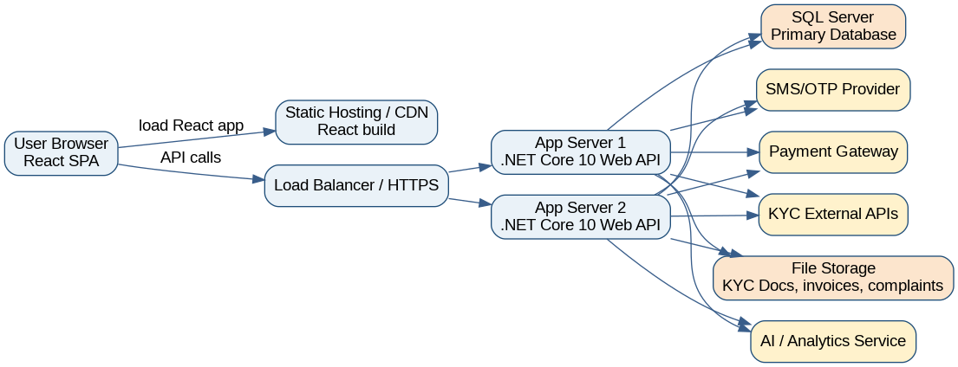
4.1 High-Level Component / Deployment Diagram

Section 5: Update the Gantt Chart to Include Part C Tasks
Part C Task | Week 6 | Week 7 | Week 8 | Week 9 | Week 10
Design pattern documentation | X | X
UI/UX screen descriptions |  | X | X
Deployment diagram |  | X | X
Database correction and final review |  |  | X | X
Final formatting and submission |  |  |  | X | X

Appendix A: Important Business Rules from Client Requirements

Rule Area | Business Rule
Matching window | Matching operates during defined business hours such as 9:00 to 17:00. Orders may be submitted 24/7.
Seller cancellation | Seller cannot cancel during matching window except based on configured grade and penalty rules.
Golden users | Golden buyers/sellers have extra visibility and flexibility; non-golden users may pay for premium access.
Presale | Presale may require buyer grade 1 or additional guarantee and has delivery time and tonnage limits.
Credit sale | Credit/LC sales are visible or available only to qualified or golden buyers.
Commission | Default commission is 5 per thousand, split 40% seller and 60% buyer.
Unpaid commission | Unpaid commission can block or restrict the user account.
Partial match | If accepted quantity is less than total but above minimum, remaining quantity is shown or cancelled based on rules.
Tolerance | Weight tolerance should be clearly defined. Higher disagreement can trigger third-party weighing and complaint process.
Disintermediation | Users attempting behind-the-scenes transactions outside the platform can be blocked or penalized.
Chat restrictions | Chat should block phone numbers and prohibited contact-sharing content.
Disclaimer | Platform is not responsible for quality, storage, insurance, or logistics unless a specific service contract is active.

Appendix B: Suggested API Endpoints

Area | Endpoint | Description
Auth | POST /api/auth/register | Create account and send OTP.
Auth | POST /api/auth/login | Login and return JWT.
KYC | POST /api/kyc | Submit KYC profile and documents.
Admin | PUT /api/admin/kyc/{id}/approve | Approve or reject KYC.
Orders | POST /api/orders/sell | Create sell order.
Orders | POST /api/orders/buy | Create buy order.
Trading | GET /api/trading-board | List visible orders based on role/access.
Offers | POST /api/orders/{id}/offers | Submit offer.
Matching | POST /api/orders/{id}/match/{offerId} | Manually match an offer.
Payments | POST /api/payments/commission | Create commission payment.
Complaints | POST /api/complaints | Open complaint.
Grades | GET /api/grades/{userId} | View user grade based on access rules.
Analytics | GET /api/analytics/price-prediction | Return AI price prediction for selected product.

