━━━━━━━━━━━━━━━━━━━━━━━━━━━━━━━━━━━━━━━━━━━━━━━━━━━━━━━━━━━━━━━━━━━━
RAWNEX
Raw Materials Trading Platform

──────────────────────────────────────────────────

ENTERPRISE PROJECT PROPOSAL
SOFTWARE SYSTEM ARCHITECTURE
& FULL SYSTEM DESIGN DOCUMENT

Project Name | Rawnex – B2B Raw Materials Trading Platform
Platform Name | Rawnex (رانکس)
Document Version | v1.0 – Enterprise Edition
Prepared Date | April 25, 2026
Classification | CONFIDENTIAL – Internal Use Only

━━━━━━━━━━━━━━━━━━━━━━━━━━━━━━━━━━━━━━━━━━━━━━━━━━━━━━━━━━━━━━━━━━━━

1. EXECUTIVE SUMMARY
Rawnex is a sophisticated, enterprise-grade B2B digital trading platform specifically engineered for the raw materials industry. The platform serves as an intelligent intermediary connecting verified buyers and sellers of industrial commodities — including copper, aluminum, zinc, brass, lead, and other primary metals — in a fully regulated, transparent, and secure digital marketplace.
The platform is built using cutting-edge technology — ASP.NET Core 10 backend with Clean Architecture and Domain-Driven Design principles, a Next.js 16 frontend with React 19, a Microsoft SQL Server persistence layer with Entity Framework Core 10, and a robust infrastructure stack including Redis, SignalR, Hangfire, Stripe, and multiple external compliance APIs.
Rawnex addresses a critical gap in traditional commodity trading by digitalizing and automating the complete trade lifecycle: from user KYC/KYB onboarding and product listing through price discovery (auctions and RFQ), order matching, escrow-protected payments, logistics coordination, quality inspection, dispute resolution, and user grading — all within a single unified platform.
1.1 Key Value Propositions
- AI-powered smart matching of buyers and sellers based on product specs, price history, and trade behavior
- Multi-layer KYC/KYB compliance with biometric verification, OCR document processing, and OFAC sanction screening
- Escrow-protected milestone-based payment system eliminating counterparty risk
- Real-time trading board with open/dark auction support, RFQ system, and price matching engine
- Full logistics integration: shipment tracking, freight quoting, bill of lading, warehouse management
- Dynamic user grading system (Bronze/Silver/Gold/Platinum) driving platform trust and privilege levels
- Complete transparency with audit trails, digital signatures, and contract management
- Enterprise-grade security: JWT + MFA, permission-based authorization, fraud scoring, velocity checks
1.2 Platform Statistics (Target at Scale)
Metric | Target Value | Description
Annual Trade Volume | $4.8 Billion+ | Total GMV processed through the platform
Verified Companies | 12,000+ | KYC/KYB verified buyer and seller entities
Countries Served | 180+ | Global reach with multi-currency support
Platform Uptime | 99.97% | High-availability SLA commitment
Product Categories | 50+ | Metal commodities and raw material types
API Endpoints | 150+ | REST + GraphQL endpoints exposed
Domain Entities | 70+ | Core domain models in the system
Background Jobs | 9 Recurring | Automated jobs running on schedule

2. BUSINESS CONTEXT & PROBLEM STATEMENT
The raw materials trading market — particularly in metals such as copper, aluminum, zinc, and brass — has traditionally operated through informal networks, telephone-based negotiations, and paper contracts. This creates significant inefficiencies, opacity, and risk for all market participants.
2.1 Market Challenges Addressed
Challenge | Business Impact
Price Opacity | Buyers cannot compare real-time prices from multiple sellers, leading to suboptimal purchasing decisions and price exploitation.
Counterparty Risk | Without verified identities and financial guarantees, fraudulent transactions, non-delivery, and payment defaults are common.
Manual Processes | Order placement, negotiation, invoicing, and logistics coordination are handled via phone/email, causing delays and errors.
Quality Disputes | No standardized inspection or lab testing workflow makes quality dispute resolution time-consuming and costly.
Lack of Trust Metrics | No objective grading system exists to evaluate buyer/seller reliability, leading to repeated due diligence costs.
Settlement Risk | Large transactions without escrow protection expose both parties to significant financial risk.
Logistics Fragmentation | Sourcing transport, insurance, and warehousing requires engaging multiple separate vendors.
Compliance Gaps | International sanctions screening and KYC for commodity trading is often neglected, creating regulatory risk.

2.2 Target Market Segments
Rawnex serves the following distinct user segments within the B2B commodity trading ecosystem:
User Segment | Role Description
Industrial Buyers | Manufacturing companies requiring consistent supply of copper, aluminum, zinc etc.
Metal Traders / Brokers | Intermediaries who buy and resell commodities for profit
Primary Producers | Mines, smelters, and refineries listing their output for direct sale
Secondary Producers | Recyclers and scrap processors selling processed metal
Financial Institutions | Banks and factoring companies offering trade finance products
Logistics Providers | Freight forwarders, warehouses, and insurance companies offering value-added services
Inspectors / Labs | Third-party quality inspectors and analytical laboratories
Platform Operators | Rawnex internal team for administration, monitoring, and support

2.3 Regulatory & Compliance Framework
Rawnex operates as a regulated marketplace with explicit legal boundaries designed to avoid conflict with existing commodity exchange regulations. All activities are defined outside the scope of formal commodity exchanges (e.g., Iran Commodity Exchange) in terms of volume, conditions, and applicable laws.
- Full KYC (Know Your Customer) for individual users with NID verification and biometric face matching
- Full KYB (Know Your Business) for corporate entities with official gazette, UBO records, and tax ID
- OFAC and international sanction screening for all registered entities via OFAC-API
- Digital contract generation with legally-binding clause management and electronic signatures
- Transparent commission invoicing compliant with Iranian tax authority (Moadian System) requirements
- Platform disclaimer clearly defines liability scope: Rawnex is not responsible for physical quality, storage, or logistics execution

3. SOFTWARE SYSTEM ARCHITECTURE
Rawnex is built on a layered, modular architecture following Clean Architecture principles combined with Domain-Driven Design (DDD). The system is designed for high throughput, horizontal scalability, multi-tenancy, and enterprise-level security and auditability.
3.1 High-Level System Architecture Overview
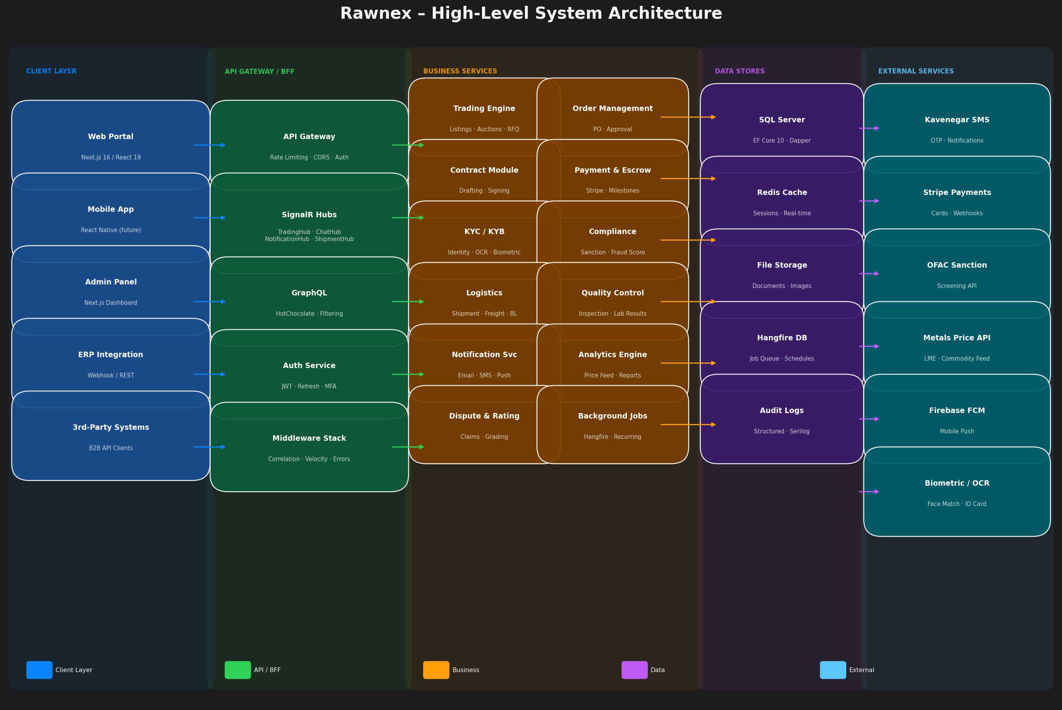
Figure: Rawnex High-Level System Architecture – 5-Tier Design
The system is organized into five distinct architectural tiers: (1) Client Layer — web portals and API clients; (2) API Gateway / BFF Layer — authentication, rate limiting, and routing; (3) Business Services Layer — domain-specific application services; (4) Data Stores Layer — SQL Server, Redis, and file storage; and (5) External Services Layer — third-party integrations.
3.2 Clean Architecture Layers
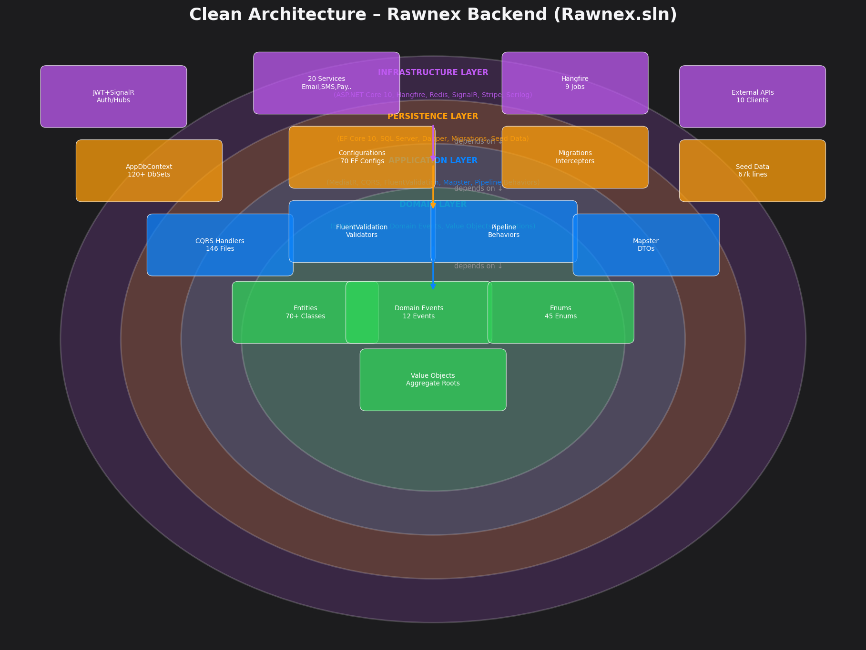
Figure: Clean Architecture Dependency Diagram – Backend (Rawnex.sln)
3.2.1 Domain Layer (Innermost)
The Domain layer contains the core business logic and is completely independent of external concerns. It contains:
Component | Count | Description
Domain Entities | 70+ | Core business entities with properties, navigation, and domain events
Domain Events | 12 | Events fired on business operations (BidPlaced, OrderChanged, etc.)
Enumerations | 45+ | Type-safe enums for all status, type, and category fields
Value Objects | 5 | Immutable objects like Money, Address encapsulating domain concepts
Base Classes | 4 | BaseEntity, BaseAuditableEntity, BaseDomainEvent, IAggregateRoot
Exceptions | 1 | DomainException base for all business rule violations
Interfaces | 3 | IAggregateRoot, ISoftDeletable, ITenantEntity cross-cutting contracts

3.2.2 Application Layer
The Application layer implements the CQRS (Command Query Responsibility Segregation) pattern using MediatR. All business use cases are implemented as Commands (write operations) and Queries (read operations) with associated validators and handlers.
Feature Module | Commands | Queries | Description
Auth | 4 | 2 | Login, Register, RefreshToken, MFA
Products | 5 | 4 | CRUD + Variants + Certifications
Listings | 4 | 3 | Create, Update, Expire, Search
Auctions | 5 | 3 | Create, Bid, End, Cancel, Start
RFQ | 5 | 3 | Publish, Respond, Accept, Invite
Negotiations | 4 | 2 | Propose, Counter, Accept, Reject
Orders | 6 | 4 | Confirm, Ship, Deliver, Cancel
Payments | 6 | 3 | Escrow Fund/Release, Stripe, Invoice
Contracts | 4 | 2 | Draft, Sign, Terminate
Shipments | 5 | 3 | Create, Track, Complete, Dispute
Quality | 4 | 3 | Schedule, Report, Lab Test
Disputes | 4 | 2 | File, Evidence, Resolve
Verification | 4 | 2 | KYC Submit/Approve, KYB Submit/Approve
Admin | 6 | 4 | User Mgmt, Flags, Reports
Notifications | 3 | 2 | Mark Read, Preferences, Send
Ratings | 2 | 2 | Submit, List
Webhooks | 4 | 2 | Subscribe, Test, List
Chat | 3 | 2 | Send Message, Get Thread
Workflows | 4 | 2 | Create, Step, Complete
Permissions | 4 | 3 | Assign, Revoke, List

3.2.3 Infrastructure Layer
The Infrastructure layer provides implementations of all application interfaces. It contains 20 concrete service implementations, 4 SignalR real-time hubs, JWT authentication, permission authorization, and Hangfire background job registration.
Service | Interface | Purpose
JwtTokenService | IJwtTokenService | Generate / validate / revoke JWT access and refresh tokens
CurrentUserService | ICurrentUserService | Expose authenticated user context from HttpContext
AuditService | IAuditService | Write structured audit log entries
PermissionService | IPermissionService | Dynamic RBAC permission resolution
FileStorageService | IFileStorageService | Local file storage with planned cloud migration
EmailService | IEmailService | SMTP email delivery via Gmail/Sendgrid
SmsService | ISmsService | OTP and transactional SMS via Kavenegar API
PushNotificationService | IPushNotificationService | Firebase FCM mobile push notifications
NotificationService | INotificationService | Unified multi-channel notification dispatch
RealTimeNotifier | IRealTimeNotifier | SignalR push to connected clients
BackgroundJobService | IBackgroundJobService | Hangfire job scheduling and management
CacheService | ICacheService | Redis distributed cache with memory fallback
FraudScoringService | IFraudScoringService | ML-based fraud risk scoring engine
WebhookDispatcher | IWebhookDispatcher | HTTP webhook delivery with retry logic
StripePaymentService | IPaymentGatewayService | Stripe payment intents and webhooks
ErpConnectorService | IErpConnectorService | ERP system integration via REST/webhook
CommodityPriceFeedService | ICommodityPriceFeedService | Live LME and metals price feed
SanctionScreeningService | ISanctionScreeningService | OFAC API sanction and PEP screening
BiometricVerificationService | IBiometricVerificationService | Face match and liveness detection
OcrDocumentService | IOcrDocumentService | ID card OCR data extraction
BillOfLadingService | IBillOfLadingService | Bill of lading generation (QuestPDF)
CarrierApiService | ICarrierApiService | Carrier booking and tracking APIs

3.2.4 SignalR Real-Time Hubs
Hub | Endpoint | Purpose
TradingHub | /hubs/trading | Live auction bids, price updates, listing board
NotificationHub | /hubs/notifications | Push user notifications in real-time
ShipmentTrackingHub | /hubs/shipment-tracking | Live shipment GPS / status updates
ChatHub | /hubs/chat | Buyer-seller secure messaging within the platform

3.2.5 Hangfire Background Jobs
Job Name | Schedule | Purpose
expire-listings | Hourly | Mark expired listings as closed
expire-rfqs | Hourly | Close RFQs past their validity window
end-auctions | Every Min | End auctions at scheduled end time
start-scheduled-auctions | Every Min | Activate scheduled auctions on time
overdue-invoices | Daily | Send reminders for unpaid invoices
cleanup-tokens | Daily | Remove expired JWT refresh tokens
expire-negotiations | Hourly | Close timed-out negotiation threads
seller-re-audit | Weekly | Periodic seller compliance re-audit
detect-off-platform-payments | Daily | Flag suspicious off-platform transactions

3.3 Persistence Layer
The Persistence layer uses Entity Framework Core 10 with SQL Server as the primary database. Dapper is used for complex read queries requiring high performance. The ApplicationDbContext contains 120+ DbSets organized into logical groups.
Domain Group | Tables | Key Entities
Identity & Auth | 8 | Users, Roles, Permissions, RefreshTokens, Sessions, AuditLogs
Tenancy | 2 | Tenants, TenantSettings
Organization | 6 | Companies, Departments, CompanyDocuments, UboRecords, CompanyMembers
Product Catalog | 9 | ProductCategories, Products, Variants, Attributes, Certifications
Trading | 11 | Listings, Rfqs, Auctions, AuctionBids, Negotiations, Orders, OrderItems
Contracts | 3 | Contracts, ContractClauses, DigitalSignatures
Payments | 5 | EscrowAccounts, EscrowMilestones, Payments, Invoices, InvoiceItems
Logistics | 6 | Shipments, ShipmentTrackings, FreightQuotes, Warehouses, Inventory, Batches
Quality | 3 | QualityInspections, QualityReports, LabTestResults
Dispute & Rating | 3 | Disputes, DisputeEvidences, Ratings
Notifications | 2 | Notifications, NotificationPreferences
Compliance | 4 | FraudScores, SanctionChecks, KycVerifications, KybVerifications
Platform Config | 4 | CommissionRules, PlatformBillings, FeatureFlags, EsgScores
Chat | 3 | ChatConversations, ChatParticipants, ChatMessages
Webhooks | 2 | WebhookSubscriptions, WebhookDeliveries

3.4 Domain Entity Relationship Diagram
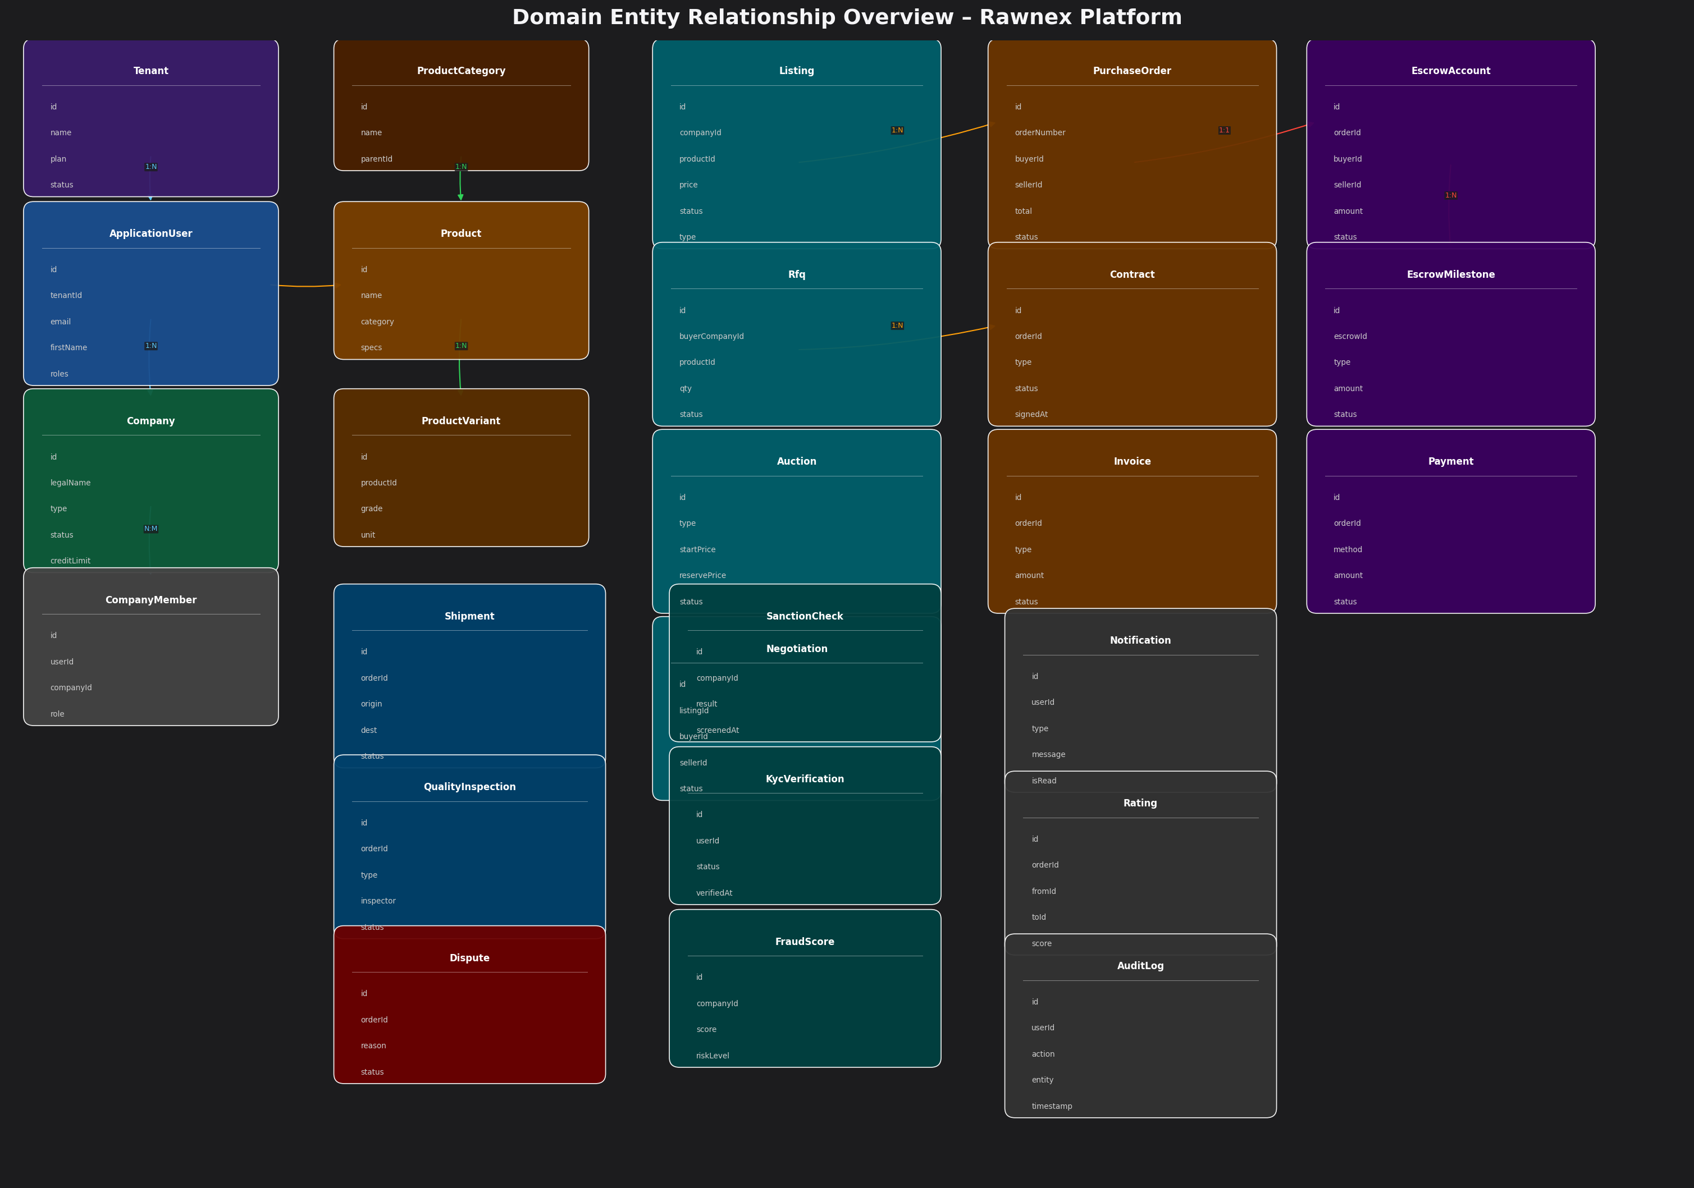
Figure: Domain Entity Relationship Overview – Core Aggregates and Associations
The ERD illustrates the relationships between the major domain aggregates. Key relationships include: Tenant (1:N) Users, Company (N:M) Users via CompanyMember, Product (1:N) Listings, PurchaseOrder (1:1) EscrowAccount, EscrowAccount (1:N) EscrowMilestones, Order (1:N) Shipments, Order (1:N) QualityInspections, Order (1:N) Disputes.

4. CQRS & EVENT-DRIVEN DESIGN
Rawnex implements the CQRS (Command Query Responsibility Segregation) pattern using the MediatR library. All operations are expressed as either Commands (state-changing) or Queries (read-only). A MediatR pipeline processes every request through logging and validation behaviors before execution.
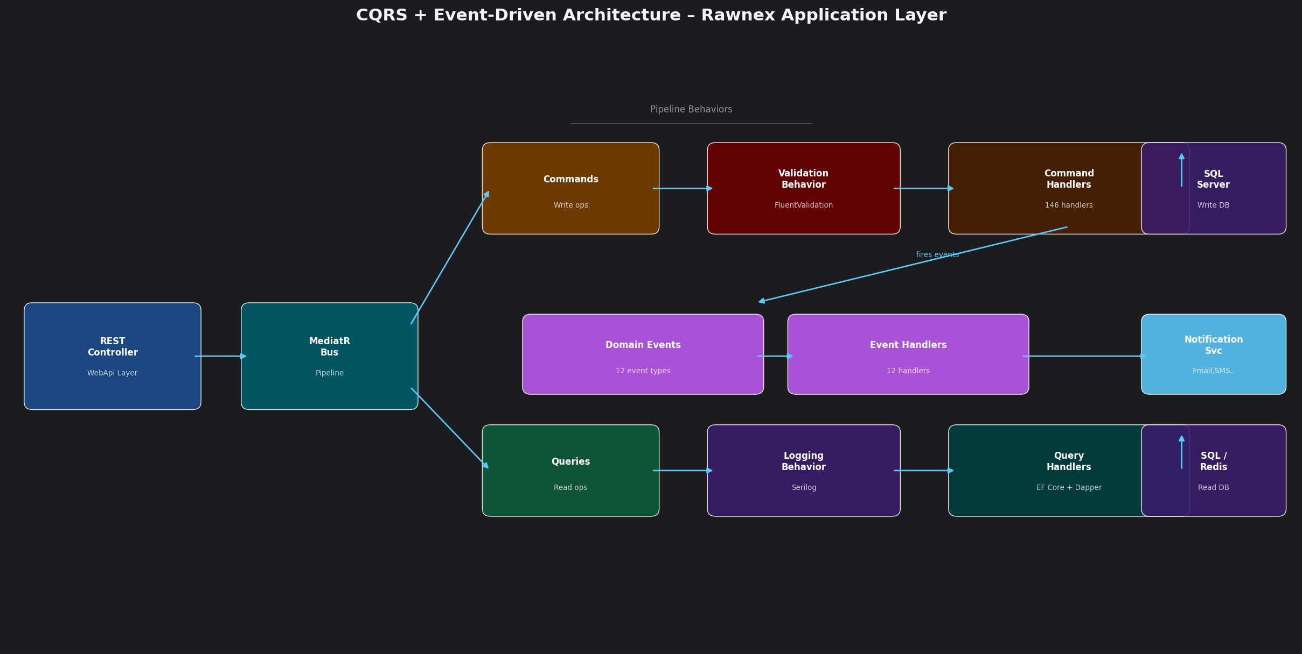
Figure: CQRS + Event-Driven Architecture – Application Layer Pattern
4.1 Pipeline Behaviors
Every command and query passes through the MediatR pipeline in this order:
Pipeline Stage | Behavior Class | Purpose
1st | LoggingBehavior<,> | Log request name, parameters, and execution time via Serilog
2nd | ValidationBehavior<,> | Run all FluentValidation validators; throw on failure
3rd | Handler Execution | Execute the actual Command or Query handler logic

4.2 Domain Events & Event Handlers
Domain events are fired by aggregate roots (entities) during state changes and dispatched after SaveChanges via EF Core interceptors. Event handlers execute cross-cutting side-effects decoupled from the main business logic.
Domain Event | Triggered When | Handler Actions
UserRegisteredEvent | New user registers | Send welcome email, provision defaults
UserLoggedInEvent | Successful login | Update session, log security event
TokenReuseDetectedEvent | Refresh token reused after use | Revoke all tokens, send security alert
BidPlacedEvent | Auction bid submitted | Notify seller, update live board via SignalR
RfqPublishedEvent | RFQ goes live | Notify matched suppliers, send SMS
OrderStatusChangedEvent | Order state transitions | Notify parties, trigger next workflow step
EscrowFundedEvent | Buyer funds escrow account | Notify seller, reveal contact details
EscrowMilestoneCompletedEvent | Milestone marked complete | Release partial escrow, update payment
ShipmentStatusChangedEvent | Shipment tracking update | Push real-time location via SignalR
CompanyVerifiedEvent | KYB verification approved | Enable selling privileges, notify user
DisputeFiledEvent | Dispute ticket created | Notify counterparty, assign operator
FraudDetectedEvent | High fraud score detected | Flag account, suspend trading, alert admin

5. CORE TRADING PROCESSES
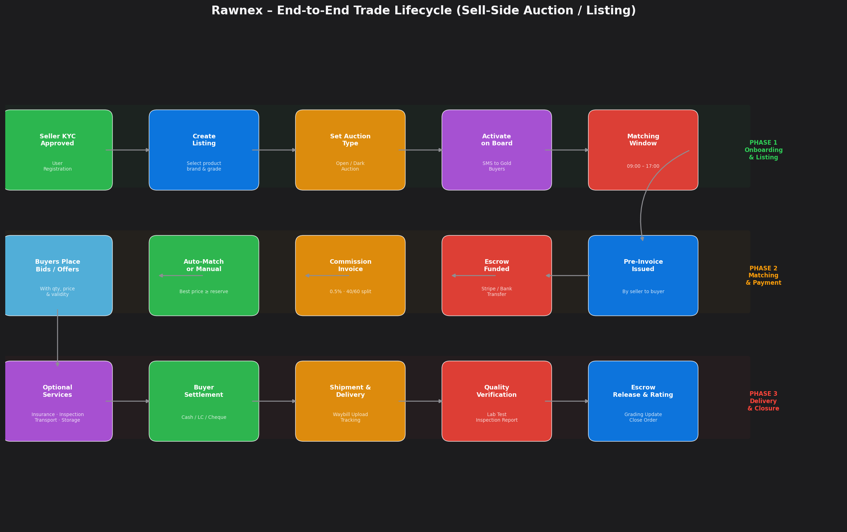
Figure: End-to-End Trade Lifecycle – Rawnex Sell-Side Auction Flow
5.1 Sell-Side Listing Process
Verified sellers (with approved KYC/KYB and active seller role) may create product listings 24 hours a day. The listing process follows a structured workflow:
Stage | Description
Step 1 – Seller Verification | Seller must have completed KYC/KYB. Role 'Seller' must be approved. Initial sellers are contacted offline and a selling contract is executed.
Step 2 – Product Selection | Seller selects from defined commodity catalog (Copper Cathode, Copper Wire, Copper Busbar, Zinc Ingot, Aluminum Ingot, Lead Ingot, Brass Sections, etc.)
Step 3 – Brand Selection | Seller selects a known brand. If brand is missing, seller creates a new brand request pending admin approval.
Step 4 – Product Form | A commodity-specific form is completed covering: quantity (with tolerance), packaging type, unit weight, net/gross weight, pallet weight, delivery terms, minimum order quantity.
Step 5 – Pricing & Auction Type | Seller sets base price (optional), auction type (Open/Dark), validity window, and optional price lock (reject bids below base).
Step 6 – Sale Type | Choice of Ready Stock (immediate), Forward Sale (with delivery date), or Pre-Sale (with down payment % and guaranteed buyer grades).
Step 7 – Payment Conditions | Cash (with penalty for late payment), Credit (L/C or Cheque), or hybrid. Seller specifies settlement timeline.
Step 8 – Activation | Listing goes live on the trading board. SMS notification sent to Gold-tier buyers immediately, others receive notification according to subscription.

5.2 Matching & Price Discovery
The price matching engine operates during the trading window (09:00 – 17:00). The following rules govern price discovery:
- Buyers submit price proposals with quantity, bid price, and validity period
- In Open Auctions, Gold buyers can see all competing bids and adjust without restriction
- In Dark Auctions, bid visibility is restricted; only the seller sees all offers
- The seller may manually click 'Match' on any acceptable offer at any time during the session
- If a bid equals or exceeds the reserve price and no manual match occurs before session end, the system auto-matches the highest/earliest bid
- Partial fills: if buyer bids cover less than full quantity but more than minimum order, a partial match is executed; remaining quantity stays on the board
- Session lock: seller cannot cancel an active order during trading hours (09:00 – 17:00), only before or after
- Post-match cancellation by seller requires a penalty deposit and penalty payment for any previous loss
- Gold sellers may edit validity and certain listing parameters during the session with restrictions
5.3 Buy-Side RFQ Process
Buyers may submit Request for Quotation (RFQ) requests. The RFQ process is symmetrical to the sell-side listing and follows these steps:
- Verified buyer submits RFQ with desired product, quantity, specifications, payment terms, and delivery location
- RFQ is published on the trading board; SMS notification sent to relevant Gold sellers
- Sellers submit price proposals against the RFQ
- Buyer may manually accept the best offer or auto-match triggers if offer meets the stated maximum price
- Seller visibility of competing seller prices in Open auction requires Gold subscription or payment
5.4 Commission & Billing Model
Rawnex charges a platform commission of 0.5% (5 per thousand) of the total matched trade value. The commission is split 40% from seller and 60% from buyer.
Commission Rule | Detail
Total Commission | 0.5% of matched trade value
Seller Share | 40% of commission (0.2% of value)
Buyer Share | 60% of commission (0.3% of value)
First Trade Discount | 100% commission waived on first trade
Second Trade Discount | 66.7% discount on second trade commission
Third Trade Onwards | Full commission applies from third trade
Non-payment Penalty | Account blocked until commission is settled
Buyer Deposit (Future) | Pre-funded commission account required before matching (Gold exempt)
Commission Invoice | System-generated, delivered to both parties immediately after match
Counterparty Reveal | Buyer identity is revealed to seller only after commission payment is confirmed

6. KYC / KYB COMPLIANCE SYSTEM
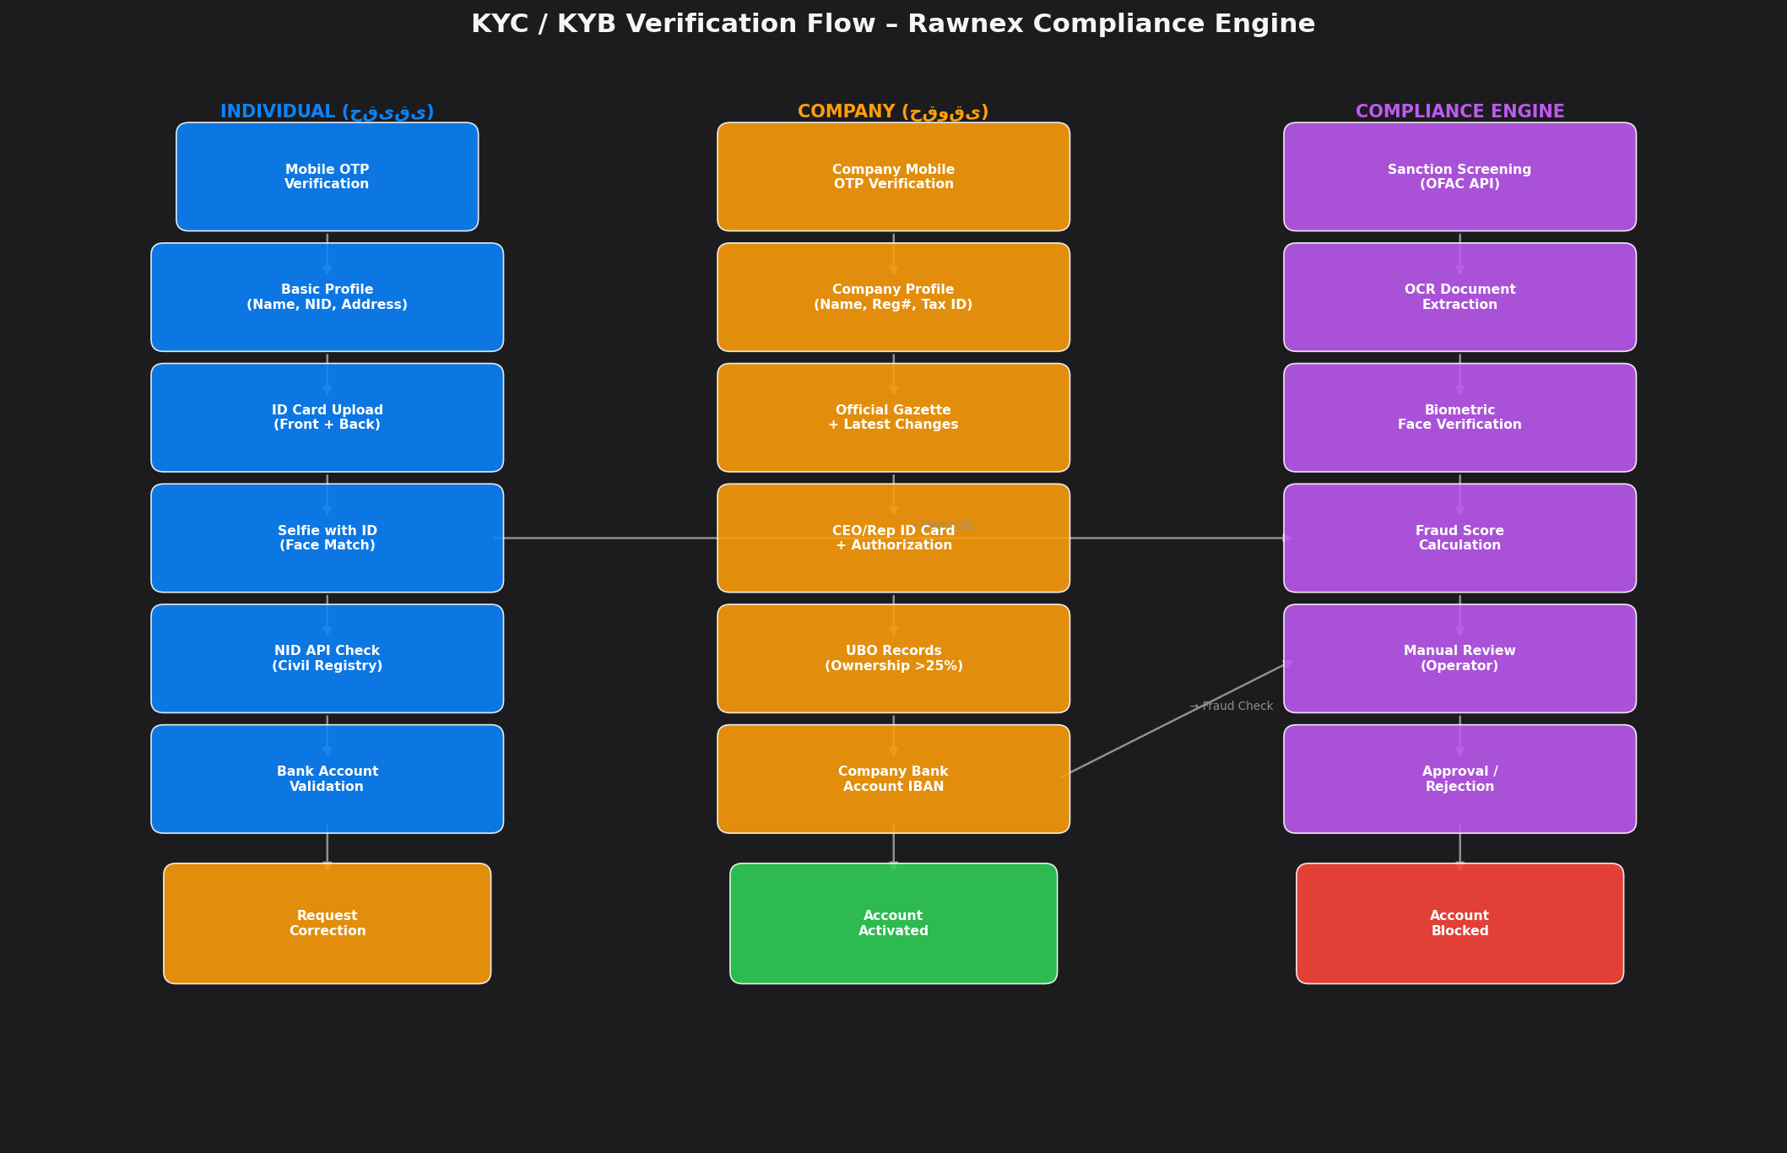
Figure: KYC / KYB Verification Flow – Compliance Engine
6.1 Individual (Haqiqi) KYC Process
Step | Action | Data Collected / Verified
1 | Mobile OTP Verification | Personal mobile number, OTP 4/6 digit code
2 | Basic Profile | Full name, National ID (NID), date of birth, email, address, postal code
3 | National ID Card Upload | Front and back images of the national identity card
4 | Selfie with ID (Face Match) | Live selfie photograph matched against ID card using biometric AI
5 | NID Registry API Check | Name matched against Civil Registration System via API
6 | Bank Account Validation | IBAN or card number; account holder name matched to verified identity
7 | Manual / Automated Review | Document quality check, sanction screening, fraud risk assessment
8 | Account Activation | Green: Trading enabled | Orange: Correction needed | Red: Rejected

6.2 Corporate (Hoqooqi) KYB Process
Step | Action | Data Collected / Verified
1 | Company Representative Mobile OTP | Mobile of CEO / authorized representative, OTP verification
2 | Company Profile | Legal company name, National Identification (Shenase Melli), registration number, tax ID
3 | Official Gazette (Roozname Rasmi) | Official gazette document + most recent amendments uploaded
4 | CEO/Rep ID Card | Identity card of CEO or authorized representative + power of attorney
5 | UBO (Ultimate Beneficial Owner) | Ownership records for shareholders with >25% ownership
6 | Company Bank Account | Corporate IBAN verified against company name
7 | Sanction Screening | All directors and UBOs screened against OFAC/PEP lists
8 | Manual Review & Approval | Compliance officer review; contract execution for sellers

6.3 Compliance Technology Stack
Service | Technology | Purpose
Biometric Face Match | BiometricVerificationService | Compare selfie with ID card photo using AI
OCR Extraction | OcrDocumentService | Extract text data from ID cards, gazettes
Sanction Screening | SanctionScreeningService | OFAC API v4 real-time screening
Fraud Scoring | FraudScoringService | Multi-factor risk score (IP, behavior, doc)
Token Security | JwtTokenService | Detect and block refresh token reuse attacks
Account Lockout | ASP.NET Identity | 5 failed attempts → 15-minute lockout

7. PAYMENT, ESCROW & FINANCIAL FLOWS
Rawnex implements a milestone-based escrow system to protect all trading parties. The payment flow is designed to eliminate settlement risk while providing maximum flexibility in payment methods for buyers and sellers in the Iranian and international market.
7.1 Escrow Account Lifecycle
Milestone | Trigger Event | Action
Escrow Creation | Order is matched and commission paid | EscrowAccount created; funds reserved
Funding | Buyer transfers 200M IRR advance payment | EscrowFundedEvent fired; seller identity revealed
Pre-Invoice | Seller issues pre-invoice with bank details | Invoice created; buyer settlement timeline starts
Settlement | Buyer completes full payment (cash/L/C/cheque) | Payment recorded; shipment authorized
Delivery | Seller uploads waybill or bill of lading | Milestone completed; inspection triggered if requested
Quality Approval | Buyer or inspector approves goods | EscrowMilestoneCompletedEvent; funds released
Final Release | All milestones complete, no disputes pending | EscrowAccount fully released to seller
Dispute Hold | Buyer files quality/quantity claim | Funds frozen pending dispute resolution
Refund | Dispute resolved in buyer's favour | Partial or full escrow refunded

7.2 Payment Methods Supported
Method | Details | Grade Restriction
Cash | Immediate bank transfer; penalty for late payment applies | All grades
Cheque | Post-dated cheque submitted to seller; risk on seller | Gold+ buyers
Letter of Credit (L/C) | Documentary L/C; seller risk managed by issuing bank | Gold+ buyers
Pre-Sale Down Payment | Partial advance; balance on delivery | Gold buyers only (or with guarantee)

7.3 Invoice Lifecycle
Three types of invoices are generated by the system:
- Commission Invoice: Auto-generated by Rawnex for platform fee collection immediately after match
- Pre-Invoice (Pish Factor): Issued by seller to buyer with payment terms, bank details, and validity
- Final Invoice: Issued by seller after delivery and weight confirmation; may be auto-generated or uploaded
7.4 Stripe Payment Integration
For international payments, the StripePaymentService wraps the Stripe API to process payment intents, handle webhook events (payment_intent.succeeded, payment_intent.payment_failed), and manage refunds through the dispute resolution process.

8. LOGISTICS, QUALITY & VALUE-ADDED SERVICES
Rawnex offers integrated value-added services that buyers can optionally select post-match. These services are initially coordinated by the Rawnex operations team and will be progressively automated with dedicated online forms and third-party contracts.
8.1 Available Value-Added Services
Service | Process Flow | Future
Quality Inspection | 1) Buyer requests inspection  2) Form submitted with parameters  3) Fee collected  4) Inspector dispatched  5) Report delivered | Online booking + inspector marketplace
Freight / Transport | 1) Buyer requests freight  2) Form submitted  3) Carrier selected  4) Fee collected  5) Driver details shared | Carrier API integration (CarrierApiService)
Cargo Insurance | 1) Buyer requests insurance  2) Cargo value declared  3) Insurer quoted  4) Fee collected  5) Policy issued | Insurance marketplace
Warehousing | 1) Buyer requests storage  2) Form submitted  3) Fee quoted  4) Payment received  5) Warehouse address provided | Warehouse management system

8.2 Shipment Tracking System
After seller confirms dispatch and uploads the waybill, real-time shipment tracking is enabled via the ShipmentTrackingHub (SignalR). The system supports multiple transport modes:
- Road Transport (Truck): License plate tracking, driver contact shared with buyer
- Rail Transport: Train carriage number and estimated schedule
- Sea Freight: Container number, vessel name, port ETD/ETA via CarrierApiService
- Air Freight: AWB number and airline tracking
Weight discrepancy tolerance is ±1% without claim. Beyond 1%, a third-party scale verification process is triggered.
8.3 Quality Inspection Workflow
Phase | Action | Responsible
Pre-shipment | Inspector visits seller premises; parameters verified | Third-party Inspector
At-destination | Inspector present at buyer location; goods verified | Third-party Inspector
Lab Testing | Material samples sent to certified laboratory | Certified Lab
Report | Quality report uploaded to platform with findings | Inspector / Lab
Outcome | Accept, Accept with deduction, or Reject + Dispute | Buyer + Platform

9. DISPUTE RESOLUTION & CLAIM MANAGEMENT
Rawnex implements a structured multi-tier dispute resolution system that handles all categories of trade claims. The system is designed to provide a first automated response within 1 hour and escalate to human operators for complex cases.
9.1 Dispute Categories
Category | Sub-types | Resolution SLA
Quality / Quantity Claims | Grade mismatch, weight shortage, damage, adulteration | 5 business days
Delivery Disputes | Late delivery, non-delivery, wrong address, improper loading | 3 business days
Financial Disputes | Non-payment, cheque dishonour, late settlement, VAT disputes | 7 business days
Documentation Disputes | Missing analysis certificate, missing gazette, false COA | 3 business days
Fraud / Misconduct | Fake products, counterfeit analysis, false waybill, scam | Immediate suspension

9.2 Dispute Process Flow
Step | Action | System Response
1 | Dispute form submitted by claimant | AI chatbot provides instant FAQ response; ticket created
2 | Counterparty notified automatically | DisputeFiledEvent triggers SMS + email + SignalR push
3 | Evidence upload period (24h) | Both parties upload photos, documents, lab reports
4 | Operator review and assessment | Rawnex compliance team reviews within 1 business day
5 | Third-party verification (if needed) | Inspector dispatched or lab test ordered
6 | Resolution decision | Accept, Partial Accept, Reject, or Escalate
7 | Grade impact | Any confirmed dispute negatively affects losing party's grade
8 | Escrow adjustment | Funds released, withheld, or refunded per decision

9.3 Grade Impact of Disputes
Every confirmed dispute outcome affects the grading score of the responsible party. Repeated violations trigger automatic account suspension and blacklisting from future trades.
- First confirmed dispute: 10% grade deduction
- Second confirmed dispute: 25% grade deduction + 30-day trading restriction
- Fraud or scam confirmed: Immediate permanent ban + legal escalation notification
- Withdrawn claim (claimant error): No grade impact on either party

10. USER GRADING & TRUST SCORING SYSTEM
Rawnex implements a sophisticated multi-dimensional grading system that assigns Trust Levels to both buyers and sellers. Grading starts as a manual process performed by the operations team and progressively becomes automated as behavioral data accumulates.
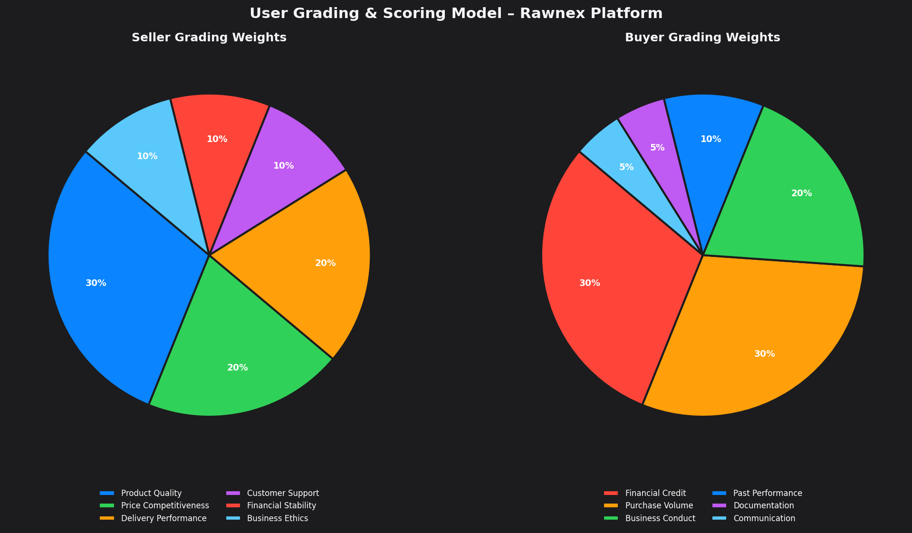
Figure: Buyer & Seller Grading Weight Distribution
10.1 Seller Grading Criteria
Criterion | Weight | Sub-metrics
Product Quality | 30% | Compliance with declared specs, purity grade, defect rate, consistency
Price Competitiveness | 20% | Price vs. market average, reserve price acceptance rate, payment flexibility
Delivery Performance | 20% | On-time delivery rate, quantity accuracy, packaging quality, logistics coordination
Customer Support | 10% | Response speed, professional communication, post-sale cooperation
Financial Stability | 10% | Liquidity assessment, no bounced cheques, high-volume capability
Business Ethics | 10% | No fraud history, complaint resolution rate, compliance with platform rules

10.2 Buyer Grading Criteria
Criterion | Weight | Sub-metrics
Financial Credit | 30% | On-time payment, no bounced cheques, bank credit rating, commission pre-funding
Purchase Volume & Potential | 30% | Total volume purchased, purchasing consistency, multi-category engagement
Business Conduct | 20% | Honoring commitments, no abrupt cancellations, honest information
Past Performance | 10% | Timely collection, no unreasonable disputes, stable purchasing pattern
Documentation | 5% | Complete legal docs, transparent invoicing, tax system compliance
Communication | 5% | Responsive, professional, follows platform communication guidelines

10.3 Grade Tiers & Privileges
Grade Tier | Criteria | Buyer Privileges | Seller Privileges
Bronze | New / Basic KYC complete | View board; cash-only; limited | Limited listing volume
Silver | 2+ completed trades, 70+ score | Standard trading; SMS for listings | Standard listing volume
Gold | 10+ trades, 85+ score, no disputes | All features; credit trading; see grade of sellers | All features; SMS priority; advance settlement
Platinum | 50+ trades, 95+ score, platform partner | API access; analytics; partner benefits | Premium placement; contract guarantee; ERP sync

11. ENTERPRISE SECURITY ARCHITECTURE
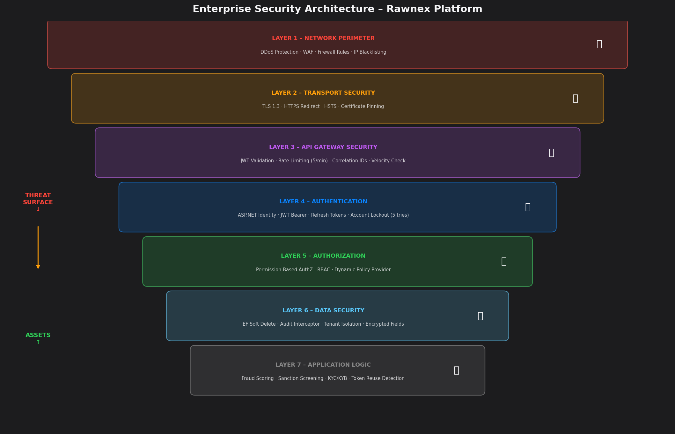
Figure: Enterprise Security Layers – Defense in Depth Model
11.1 Authentication & Authorization
Security Mechanism | Implementation | Detail
JWT Authentication | Microsoft.AspNetCore.Authentication.JwtBearer | 15-min access token, 7-day refresh token
Refresh Token Rotation | RefreshToken Entity + JwtTokenService | Single-use; reuse detection fires security event
Token Reuse Detection | TokenReuseDetectedEventHandler | All tokens revoked; security alert sent
Account Lockout | ASP.NET Identity | 5 failed attempts → 15-minute lockout
Multi-Factor Auth (MFA) | MfaCommandHandlers | TOTP-based second factor support
Permission-Based AuthZ | PermissionAuthorizationPolicyProvider | Dynamic policy generation from DB permissions
Role-Based Access | ASP.NET Roles + Custom Permissions | Admin, Seller, Buyer, Operator, Auditor roles

11.2 API Security Controls
Control | Configuration | Coverage
IP Rate Limiting | Login: 5/min | Register: 3/min | Global: 30/sec | All endpoints
Velocity Check | VelocityCheckMiddleware | Unusual request patterns
CORS Policy | Explicit allowed origins only + credentials | Frontend-origin restricted
Security Headers | X-Content-Type-Options, X-Frame-Options, CSP | All responses
HTTPS Redirect | Enforced in production environment | All HTTP traffic
Swagger | Development only; JWT bearer scheme defined | API documentation secure

11.3 Data Security
- Soft Delete: Data is never physically removed; IsDeleted flag preserves audit trail
- Audit Interceptor: AuditableEntityInterceptor auto-populates CreatedBy, CreatedAt, LastModifiedBy, LastModifiedAt
- Tenant Isolation: Every entity carrying TenantId is filtered at the application layer to prevent cross-tenant data leakage
- Password Policy: min 8 chars, upper + lower + digit + special required via ASP.NET Identity
- Correlation IDs: Every request tagged with a unique correlation ID for distributed tracing
- Fraud Scoring: FraudScoringService calculates multi-factor risk score on user registration and transaction events

12. FRONTEND ARCHITECTURE
The Rawnex frontend is built with Next.js 16 (App Router) and React 19 (Concurrent Mode). It is a server-side rendered / statically generated application with RTL (right-to-left) support for the Persian (Farsi) language using Vazirmatn font.
12.1 Application Routes
Route | Module | Description
/ | Landing Page | Public marketing page with features, stats, CTA, and footer
/auth/login | Authentication | Login form with JWT-based session management
/auth/register | Authentication | Multi-step registration form with validation
/dashboard | Dashboard | Main authenticated home with KPIs and summary
/marketplace | Marketplace | Live trading board — listings, RFQs, auctions
/listings | Listings | Seller's own listings management
/auctions | Auctions | Live and scheduled auction management
/rfq | RFQ | Request for quotation management
/negotiations | Negotiations | Active negotiation threads
/orders | Orders | Purchase order management and tracking
/payments | Payments | Invoice, escrow, and payment history
/contracts | Contracts | Contract library and digital signatures
/logistics | Logistics | Shipment tracking, freight, and warehousing
/quality | Quality | Inspection requests and lab reports
/companies | Companies | Company profile and member management
/analytics | Analytics | Price history, market trends, and reports
/notifications | Notifications | All in-app notification management
/settings | Settings | User and company settings, preferences
/team | Team | Internal team and department management
/admin | Admin Panel | Platform administration (admin role only)

12.2 Frontend Technology Stack
Technology | Version | Purpose
Next.js | 16.2.4 | Full-stack React framework with App Router and SSR
React | 19.2.4 | UI library with Concurrent Features
TypeScript | 5.x | Type-safe development
Zustand | 5.0.12 | Lightweight global state management
React Hook Form | 7.73.1 | High-performance form management
Zod | 4.3.6 | Schema-based validation integrated with forms
Framer Motion | 12.38 | Production-grade animations and transitions
Recharts | 3.8.1 | Composable charting library for analytics
Lucide React | 1.8.0 | Consistent icon system
Axios | 1.15.2 | HTTP client for API communication
SASS / CSS Modules | 1.99 | Scoped styling with design system variables
date-fns | 4.1.0 | Date manipulation and formatting
react-hot-toast | 2.6.0 | Non-intrusive notification toasts

13. DEPLOYMENT & INFRASTRUCTURE ARCHITECTURE
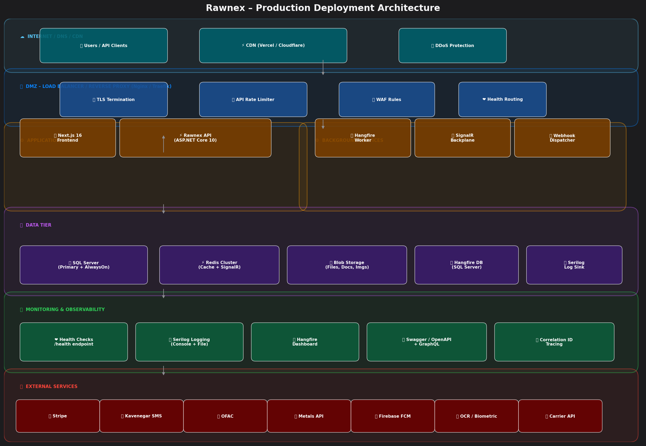
Figure: Production Deployment Architecture – Rawnex Platform
13.1 Infrastructure Components
Component | Technology | Role
Web Server | Nginx / Traefik | Reverse proxy, TLS termination, load balancing
Application Server | ASP.NET Core 10 (Kestrel) | Main API + SignalR + GraphQL server
Frontend CDN | Vercel / Cloudflare | Next.js static + SSR delivery
Primary Database | Microsoft SQL Server | Main relational data store with AlwaysOn HA
Cache Layer | Redis Cluster | Distributed cache and SignalR backplane
File Storage | Local Blob / Azure Blob | Documents, images, reports storage
Job Scheduler | Hangfire + SQL Server | Background job persistence and execution
Logging | Serilog (Console + File) | Structured logging with rolling daily files
Health Monitoring | ASP.NET Health Checks | SQL Server health probe at /health endpoint
API Documentation | Swagger / OpenAPI | Interactive API docs (dev only)
GraphQL | HotChocolate 14 | Alternative query interface for complex reads

13.2 High Availability & Scalability
- SQL Server AlwaysOn availability group for primary database failover
- Redis Cluster for distributed caching — eliminates single-node failure risk
- SignalR configured with Redis backplane for multi-instance real-time message distribution
- Horizontal API scaling: multiple ASP.NET Core instances behind load balancer
- Hangfire uses SQL Server for distributed job queue — survives server restarts
- Rate limiting configuration: 30 req/sec global, 5/min login, 3/min registration
13.3 Configuration & Environment Management
Configuration Area | Mechanism | Settings
Database | appsettings.json | SQL Server connection string
JWT | appsettings.json | Secret key, issuer, audience, token expiry
Email (SMTP) | appsettings.json | Gmail SMTP, port 587, TLS
SMS | appsettings.json | Kavenegar API key
Payment | appsettings.json | Stripe secret key, webhook secret
External APIs | appsettings.json | OFAC, Metals-API, OCR, Biometric, Carrier, ERP
Rate Limiting | appsettings.json | Endpoint rules per minute/second
CORS | appsettings.json | Allowed frontend origins
Logging | appsettings.json | Serilog minimum levels per namespace
Redis | appsettings.json | Connection string (optional, falls back to memory)

14. COMPLETE TECHNOLOGY STACK
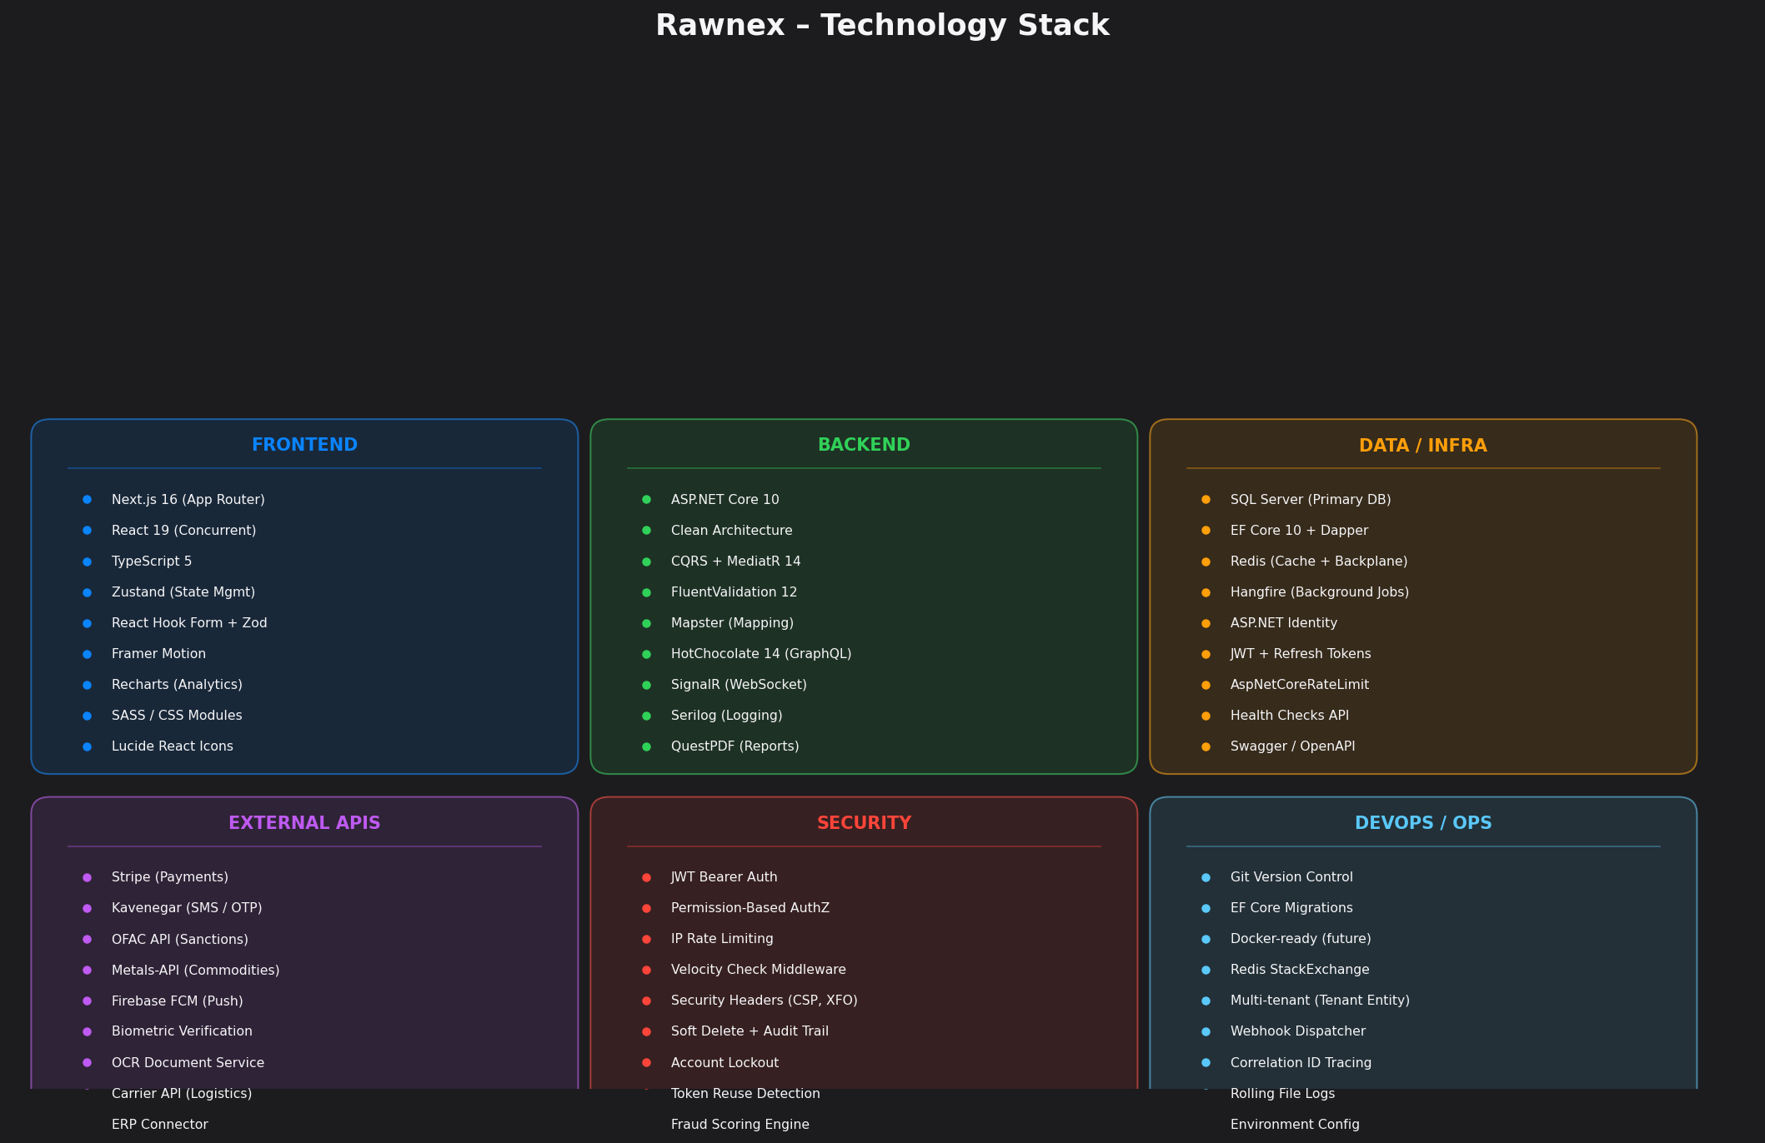
Figure: Complete Technology Stack – All Six Dimensions

15. REVENUE MODEL & SUBSCRIPTION STRATEGY
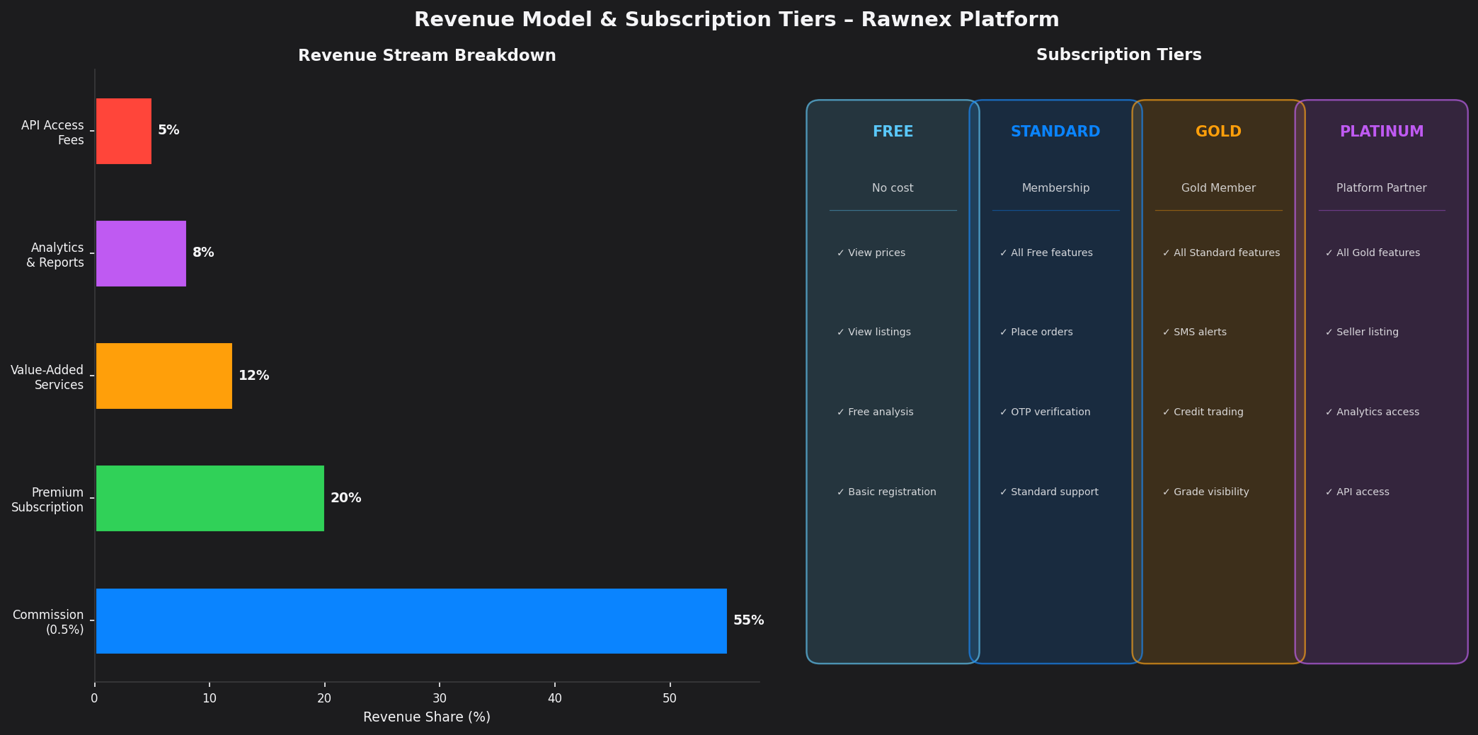
Figure: Revenue Stream Breakdown & Subscription Tier Model
15.1 Revenue Streams
Stream | Share | Model | Description
Transaction Commission | 55% | 0.5% per trade | Primary revenue from every matched trade
Premium Subscription | 20% | Monthly / Annual | Gold and Platinum tier membership fees
Value-Added Services | 12% | Per-transaction fee | Inspection, transport, insurance, storage commissions
Analytics & Reports | 8% | Subscription / Pay-per-use | Market intelligence, price predictions, behavioral analytics
API Access | 5% | Usage-based | API access for ERP integrations and B2B partners

15.2 Pricing Philosophy
- First two trades subsidized (100% and 66% commission discount) to drive adoption
- Gold subscription unlocks credit trading, advanced analytics, and priority SMS alerts
- Platinum tier designed for strategic partners and high-volume traders with custom pricing
- Analytics sold as premium subscription to non-Gold members — AI price predictions, behavioral data
- Value-added services operate on margin: Rawnex negotiates bulk rates with service providers and earns spread

16. IMPLEMENTATION ROADMAP
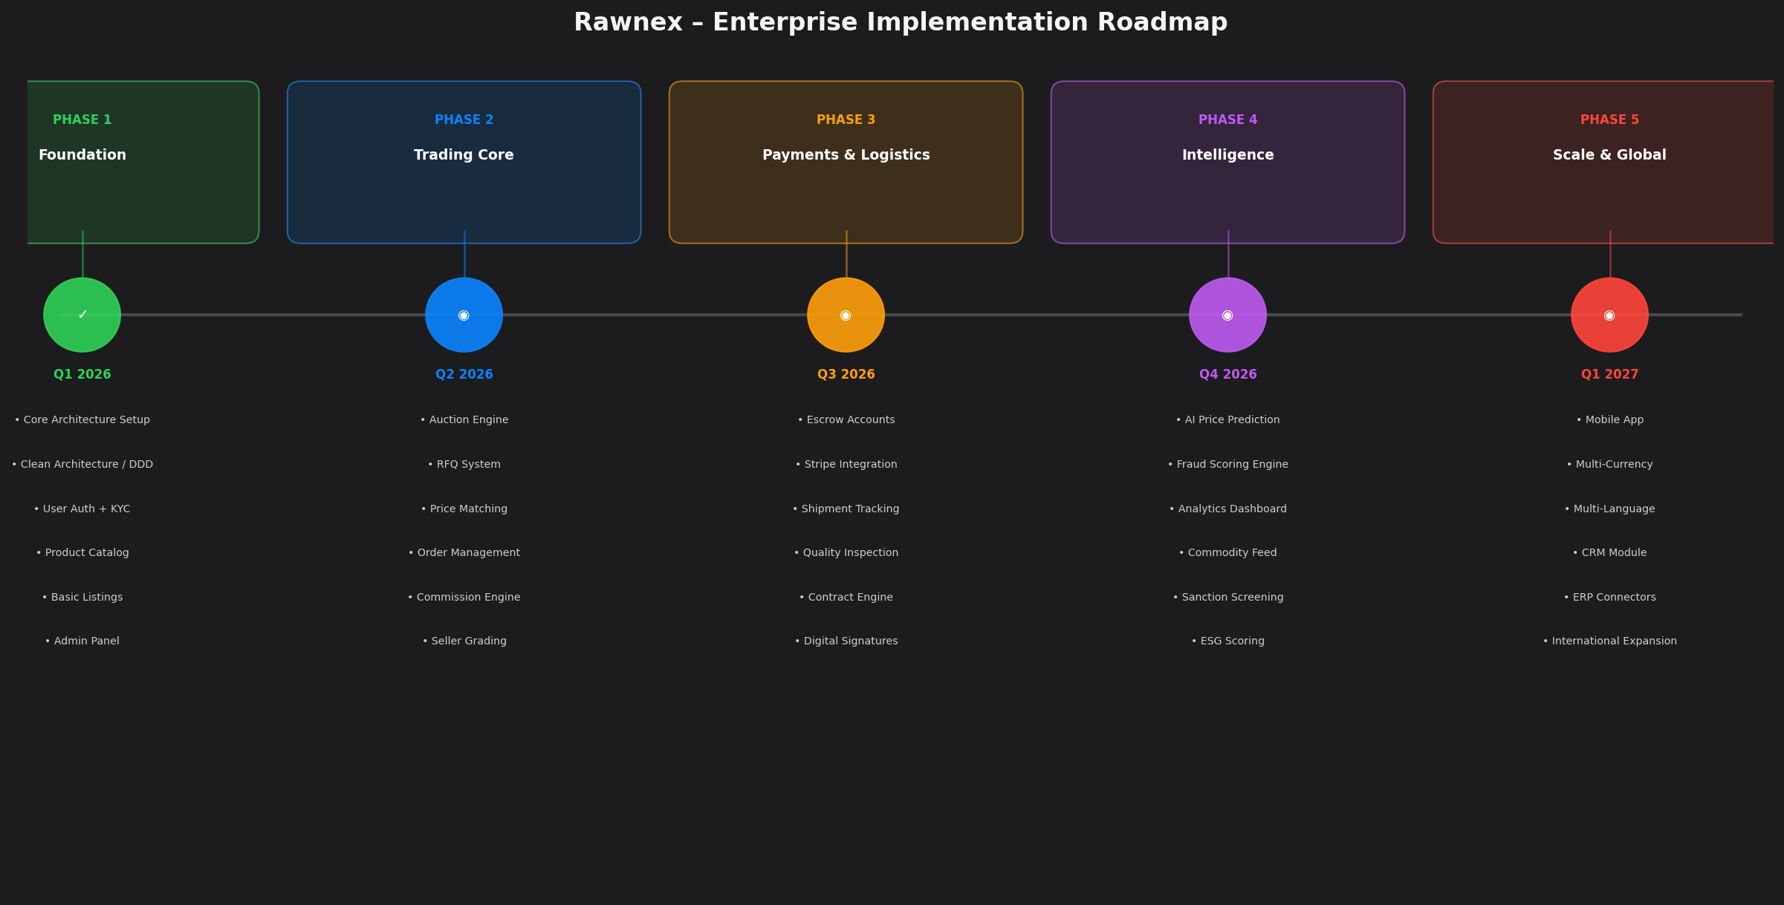
Figure: 5-Phase Enterprise Implementation Roadmap – 2026–2027
16.1 Phase Details
Phase 1 – Foundation (Q1 2026)
- Clean Architecture scaffold (Domain/Application/Persistence/Infrastructure/WebApi)
- ASP.NET Core 10 + EF Core 10 + SQL Server setup
- JWT authentication with refresh tokens, MFA, account lockout
- KYC/KYB module with document upload and basic verification
- Product catalog with categories, variants, and certifications
- Basic listing creation and management
- Admin panel with user management
- Seed data with demo companies, users, products, and listings
Phase 2 – Trading Core (Q2 2026)
- Full auction engine (Open/Dark) with real-time SignalR bidding
- RFQ (Request for Quotation) system with invitation and response tracking
- Price matching engine with auto-match and manual match
- Order management with approval workflow
- Commission calculation engine (0.5%, 40/60 split)
- Seller grading system (initial manual, then automated)
- SMS notification integration (Kavenegar) for trade alerts
- Hangfire background jobs for auction management and expiry
Phase 3 – Payments & Logistics (Q3 2026)
- Escrow account system with milestone-based releases
- Stripe payment gateway integration
- Pre-invoice and final invoice generation (QuestPDF)
- Shipment tracking with SignalR real-time updates
- Bill of lading generation and management
- Quality inspection workflow with lab test integration
- Freight quoting via CarrierApiService
- Dispute management module with evidence upload
Phase 4 – Intelligence (Q4 2026)
- AI-based commodity price prediction using LME + historical data
- Fraud scoring engine with multi-factor risk assessment
- Analytics dashboard (premium) with market intelligence
- Sanction screening automation (OFAC API) for all entities
- ESG scoring module for sustainability compliance
- Full webhook system for ERP and third-party integrations
- Advanced reporting with QuestPDF export
- Biometric and OCR automation for KYC processing
Phase 5 – Scale & Global (Q1 2027)
- React Native mobile application
- Multi-currency support with live FX rates
- Multi-language platform (Persian, Arabic, English)
- CRM module for relationship management
- Full ERP connector marketplace (SAP, Oracle, etc.)
- International market expansion beyond Iran
- Escrow account with regulated financial institution
- ISO 27001 security certification

17. NON-FUNCTIONAL REQUIREMENTS
17.1 Performance Requirements
Requirement | Target SLA | Implementation
API Response Time (p95) | < 200ms | Redis caching, Dapper for complex reads
API Response Time (p99) | < 500ms | Indexed queries, pagination
Auction Bid Latency | < 100ms | SignalR + Redis backplane
Platform Uptime | 99.97% | AlwaysOn HA + load balancer failover
Concurrent Users | 10,000+ | Horizontal scaling + Redis session
Database Query Time | < 50ms avg | EF Core 10 + indexed SQL Server
File Upload | < 5 sec | Async streaming, background processing
Background Job Latency | < 1 min | Hangfire poll interval: near-realtime

17.2 Security Requirements
Requirement | Implementation
Data Encryption at Rest | SQL Server TDE (Transparent Data Encryption)
Data Encryption in Transit | TLS 1.3 for all HTTP communication
Authentication Standard | JWT Bearer + Refresh Tokens (IETF RFC 6749)
Password Standard | Min 8 chars, complexity rules, hashed with ASP.NET Identity (PBKDF2)
Session Management | HttpOnly cookies + server-side session tracking
Audit Logging | All entity mutations logged with actor, timestamp, and before/after state
Compliance | GDPR-compatible soft delete and data retention policies
Penetration Testing | Planned for Phase 3 before payment go-live

17.3 Scalability & Reliability
Dimension | Design Decision
Stateless API | JWT tokens carry all session state; API instances are horizontally scalable
Database Scaling | Read replicas via AlwaysOn; write to primary only
Cache Scaling | Redis Cluster with automatic sharding
Job Distribution | Hangfire SQL Server ensures distributed job execution
Multi-tenancy | Tenant isolation at application layer via TenantId on all entities
Feature Flags | FeatureFlag entity enables runtime feature toggling without deployment
Backward Compatibility | Versioned API; no breaking changes to v1 contracts

18. RISK REGISTER & MITIGATION STRATEGIES
# | Risk | Probability | Impact | Mitigation Strategy
1 | Regulatory conflict with commodity exchange | High | High | Legal review; platform explicitly operates outside exchange scope
2 | Counterparty fraud | Medium | High | Multi-layer KYC + sanction screening + escrow protection
3 | Payment default by buyer | Medium | High | Escrow-first model; account blocked on non-payment
4 | Seller non-delivery after match | Medium | High | Penalty deposit required; grade reduction; legal contract
5 | Data breach / security incident | Low | Critical | Defense-in-depth; WAF; rate limiting; audit logs; pen test
6 | Platform downtime during trading | Low | High | AlwaysOn HA; health checks; automated failover
7 | Off-platform transactions | High | High | Daily fraud job; account monitoring; contract prohibition
8 | Poor adoption by sellers | Medium | High | On-site support team; contract incentives; first-trade free
9 | Quality dispute spike | Medium | Medium | Standardized inspection workflow; clear packaging standards
10 | Redis / cache failure | Low | Medium | In-memory fallback configured; graceful degradation
11 | Third-party API failure (SMS/Stripe/OFAC) | Medium | Medium | Circuit breaker pattern; retry policies; manual fallback
12 | Regulatory changes (fintech/commodity) | Medium | High | Legal counsel engaged; compliance monitoring team

19. DATA GOVERNANCE & COMPLIANCE
19.1 Data Classification
Classification | Examples | Controls
Top Secret | Private keys, passwords, API credentials | Never stored in plaintext; environment variables only
Confidential | NID, bank account, biometric data, contracts | Encrypted at rest; access audit logged; limited to authorized roles
Restricted | Trade details, prices, company financials | Role-based access; tenant isolation; HTTPS only
Internal | User profiles, product catalog, notifications | Authenticated access; soft delete; audit trail
Public | Market prices, product categories, news | Unauthenticated read; CDN cacheable

19.2 Audit Trail
The AuditableEntityInterceptor automatically captures every EF Core SaveChanges operation and records: Entity Type, Entity ID, Action (Create/Update/Delete), Actor (user ID), Timestamp (UTC), Old Values (JSON), and New Values (JSON) into the AuditLogs table.
19.3 Data Retention Policies
Data Type | Retention Period | Deletion Method
Audit Logs | 7 years | Physical delete after retention
Trade Records | 10 years | Archive after 3 years; soft delete only
User Personal Data | Duration + 2 years | GDPR right-to-erasure: anonymize on request
KYC Documents | 5 years | Encrypted storage with restricted access
Session / JWT Logs | 90 days | Automated cleanup via daily Hangfire job
Chat Messages | 3 years | Soft delete; user can request removal

20. API DESIGN & INTEGRATION INTERFACES
20.1 REST API Controllers
Controller | Base Path | Key Endpoints
AuthController | /api/auth | login, register, refresh, logout, mfa-setup
ProductsController | /api/products | CRUD + categories + variants + certifications
ListingsController | /api/listings | Create, update, expire, search, get-by-id
AuctionsController | /api/auctions | Create, bid, get-bids, cancel, schedule
RfqsController | /api/rfqs | Publish, respond, invite, accept, close
NegotiationsController | /api/negotiations | Start, counter-offer, accept, reject
OrdersController | /api/orders | Confirm, approve, ship, deliver, cancel
PaymentsController | /api/payments | Escrow fund/release, invoices, Stripe intents
ContractsController | /api/contracts | Draft, sign, terminate, get-clauses
ShipmentsController | /api/shipments | Create, track, update-status, freight quotes
QualityController | /api/quality | Schedule inspection, submit report, lab results
DisputesController | /api/disputes | File, add-evidence, resolve, list
CompaniesController | /api/companies | Profile, members, documents, KYB, verification
VerificationController | /api/verification | KYC submit/approve, KYB submit/approve
NotificationsController | /api/notifications | List, mark-read, preferences
RatingsController | /api/ratings | Submit, list-by-company
AdminController | /api/admin | Users, flags, platform metrics, approvals
ChatController | /api/chat | Conversations, messages, participants
WebhooksController | /api/webhooks | Subscribe, unsubscribe, test, list deliveries
WorkflowsController | /api/workflows | Create, advance-step, complete, list
PermissionsController | /api/permissions | List, assign, revoke, check

20.2 GraphQL Interface
A GraphQL endpoint is exposed at /graphql using HotChocolate 14 with support for filtering, sorting, and pagination. Currently exposes the Query type with entity read operations, designed for complex joined queries that would otherwise require multiple REST calls.
20.3 Webhook System
Third-party integrations (ERP systems, partner platforms) can subscribe to platform events via the webhook system. The WebhookDispatcher sends HTTP POST requests to registered URLs with event payloads and tracks delivery success in WebhookDelivery records.
Event Type | Trigger
order.matched | Price match confirmed between buyer and seller
order.status_changed | Purchase order status changes
payment.received | Payment confirmed in escrow
shipment.dispatched | Seller marks goods as shipped
shipment.delivered | Buyer confirms delivery
dispute.filed | Dispute ticket opened
dispute.resolved | Dispute closed with resolution
kyc.approved | User KYC verification approved
kyb.approved | Company KYB verification approved
invoice.issued | Invoice generated and delivered

21. PLATFORM WEBSITE FEATURES & SUBSCRIPTION TIERS
# | Feature | Access Level
1 | Last week's trade data (volume only) | Free
2 | Currency exchange rates (real-time) | Free
3 | Global metals prices (LME, CME, SHFE) | Free
4 | Iran Commodity Exchange prices | Free
5 | Industry and financial links directory | Free
6 | Company and website advertising slots | Free (paid placement)
7 | Telegram and social channel ads | Free (paid placement)
8 | Platform registration | Free
9 | Trading board access (listings, RFQ, auctions) | Registered users only
10 | Premium market analysis and commentary | Gold subscribers
11 | Basic price analysis | Free (limited)
12 | Trading session schedule | Free
13 | AI price prediction (USD + LME + demand model) | Gold subscribers
14 | Customer behavioral analytics | Gold subscribers
15 | Full trade history and price archive | Gold subscribers
16 | API access for ERP integrations | Platinum subscribers
17 | Digital document management | Registered users
18 | Credit trading (L/C and cheque settlement) | Gold buyers only
19 | Seller profile and listing creation | Verified sellers only
20 | Dispute filing and claim management | All registered users

22. SURVEY, FEEDBACK & USER SATISFACTION SYSTEM
Rawnex implements a comprehensive feedback system triggered after every trade event — whether the trade is successfully completed or cancelled. The goal is to continuously improve platform quality and gather grading data for the scoring engine.
22.1 Survey Triggers
Event | Survey Sent To | Content
Trade Completed | Buyer + Seller | Platform quality (1-5), counterparty rating (1-5), service rating, open feedback
Trade Cancelled | All parties | Platform quality, reason for cancellation, what could be improved
Dispute Resolved | All parties | Resolution satisfaction, operator quality, would recommend
KYC Completed | User | Onboarding experience, document upload difficulty, wait time
First Trade | User | NPS score (0-10), feature satisfaction, suggestions

22.2 Satisfaction Dimensions Measured
- Platform usability and ease of use (1-5 scale)
- System speed and performance (1-5 scale)
- Price transparency and information clarity (1-5 scale)
- Security and trust perception (1-5 scale)
- Order registration process satisfaction (1-5 scale)
- Customer support responsiveness (1-5 scale)
- Analytics and dashboard tool quality (1-5 scale)
- Net Promoter Score (NPS) — 0 to 10 recommendation likelihood

23. GLOSSARY OF TERMS
Term | Definition
KYC | Know Your Customer – identity verification for individual users
KYB | Know Your Business – identity and legitimacy verification for corporate entities
CQRS | Command Query Responsibility Segregation – architectural pattern separating reads from writes
DDD | Domain-Driven Design – software design approach centered on the business domain
MediatR | In-process messaging library implementing the mediator pattern for CQRS in .NET
RFQ | Request for Quotation – structured procurement request from buyer to multiple sellers
Escrow | Neutral third-party holding funds until contractual conditions are met
Incoterm | International commercial terms defining delivery and risk transfer points
LME | London Metal Exchange – primary global exchange for base metals pricing
OFAC | Office of Foreign Assets Control – US Treasury sanctions screening authority
UBO | Ultimate Beneficial Owner – natural person(s) who ultimately own/control a company
JWT | JSON Web Token – compact, URL-safe token for authentication and authorization
SignalR | ASP.NET Core library for real-time web communication via WebSockets
Hangfire | Background job processing library for .NET with persistence and scheduling
EF Core | Entity Framework Core – ORM (Object-Relational Mapper) for .NET
Dapper | Lightweight micro-ORM for .NET for high-performance raw SQL queries
OCR | Optical Character Recognition – automated text extraction from document images
ESG | Environmental, Social, and Governance – sustainability scoring framework
BL / BOL | Bill of Lading – legal shipment document issued by carrier to shipper
L/C | Letter of Credit – bank-guaranteed payment instrument for trade
NPS | Net Promoter Score – customer loyalty metric from 0 (detractor) to 10 (promoter)
Dark Auction | Sealed-bid auction where bidders cannot see competing bids
Open Auction | Transparent auction where all bids are visible (with Gold access or payment)
Haqiqi | Persian legal term for natural/individual person
Hoqooqi | Persian legal term for legal/corporate entity
Moadian | Iranian Tax Authority system for B2B invoice registration

APPENDIX – Document Structure Reference
Section | Title | Page
1 | Executive Summary | 3
2 | Business Context & Problem Statement | 5
3 | Software System Architecture | 7
4 | CQRS & Event-Driven Design | 14
5 | Core Trading Processes | 15
6 | KYC / KYB Compliance System | 18
7 | Payment, Escrow & Financial Flows | 20
8 | Logistics, Quality & Value-Added Services | 22
9 | Dispute Resolution & Claim Management | 24
10 | User Grading & Trust Scoring System | 25
11 | Enterprise Security Architecture | 27
12 | Frontend Architecture | 29
13 | Deployment & Infrastructure Architecture | 30
14 | Complete Technology Stack | 32
15 | Revenue Model & Subscription Strategy | 33
16 | Implementation Roadmap | 34
17 | Non-Functional Requirements | 36
18 | Risk Register & Mitigation Strategies | 37
19 | Data Governance & Compliance | 38
20 | API Design & Integration Interfaces | 39
21 | Platform Website Features | 41
22 | Survey & Feedback System | 42
23 | Glossary of Terms | 43

━━━━━━━━━━━━━━━━━━━━━━━━━━━━━━━━━━━━━━━━━━━━━━━━━━━━━━━━━━━━
© 2026 Rawnex Technologies
CONFIDENTIAL – For internal and executive review only.
Unauthorized distribution is strictly prohibited.

