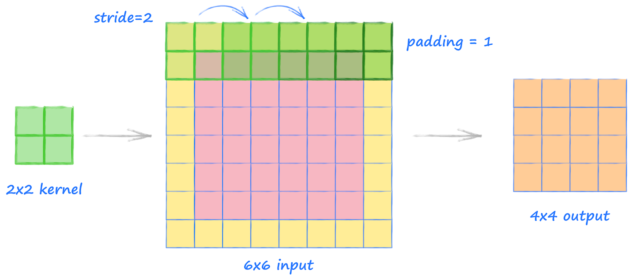
1. After each stride-2 conv, why do we double the number of filters?
In convolutional neural networks (CNNs), after a stride-2 convolution, doubling the number of filters is a common practice. This is because stride-2 convolutions reduce the spatial dimensions of the feature maps by half, leading to a decrease in the amount of spatial information. To compensate for this loss, the network increases the depth of the feature maps by doubling the number of filters. This helps in maintaining the network's capacity to learn complex features by allowing it to capture more detailed information in the deeper layers despite the reduction in spatial resolution.
2. Why do we use a larger kernel with MNIST (with simple cnn) in the first conv?
In simpler models or datasets like MNIST, which consists of small (28x28 pixels) grayscale images of handwritten digits, using a larger kernel in the first convolution layer can be beneficial. Larger kernels cover more of the image in the initial convolution, allowing the model to capture more global features of the digits (such as shape and connectivity) early on. This can be particularly useful for simpler datasets where the primary features to learn are relatively large and straightforward compared to the finer details required in more complex image datasets.
3. What data is saved by ActivationStats for each layer?
ActivationStats typically refers to a callback or a tool used in deep learning frameworks that tracks and saves the statistics of activations (the outputs of layers) across the model during training. It usually records metrics such as the mean, standard deviation, and sometimes the histogram of activations for each layer. This data is invaluable for analyzing and understanding the behavior of the model, such as detecting vanishing or exploding gradients, assessing the effectiveness of the activation functions, or identifying layers that are not learning effectively.
4. How do we get a learner&#39;s callback after they&#39;ve completed training?
In many deep learning frameworks, callbacks are functions or methods that are called at certain stages of training (e.g., at the start/end of an epoch, before/after a batch, etc.). To access a learner's callback after training, you typically need to refer to the documentation of the specific framework you are using. Usually, there is a list or a log of callbacks that can be accessed via the learner object. For example, in fastai, you can access the callback history of a learner through its callbacks attribute or a specific callback's data through methods provided by the callback class itself.
5. What are the drawbacks of activations above zero?
Having activations that are strictly above zero, such as those produced by the ReLU (Rectified Linear Unit) activation function, can lead to a few drawbacks:
- Dead neurons: If a neuron's activation is constantly zero due to negative input (ReLU outputs zero for any negative input), it can stop learning entirely, a phenomenon often referred to as "dying ReLUs."
- Unbounded activations: Without any negative values, the range of activations can become unbounded, potentially leading to issues with gradient scaling during backpropagation, such as exploding gradients.
6. Draw up the benefits and drawbacks of practicing in larger batches?
- Benefits:
  - Efficient use of hardware: Larger batches make better use of the parallel processing capabilities of GPUs, leading to faster training.
  - Stability: Larger batches can lead to more stable gradient estimates, which can help with the convergence of the model.
- Drawbacks:
- Memory constraints: Larger batches require more memory, which can limit the size of the model or the maximum batch size that can be used.
- Generalization: Training with very large batches can sometimes lead to poorer generalization to unseen data, as the model may overfit to the training set.
7. Why should we avoid starting training with a high learning rate?
Starting training with a high learning rate can be problematic because it can lead to overshooting the minima of the loss function. This can cause the model parameters to oscillate or diverge, significantly hampering the learning process. A high learning rate at the start does not allow the model to settle into smaller, potentially more optimal, regions of the loss landscape, leading to poor convergence properties.
8. What are the pros of studying with a high rate of learning?
- Faster convergence: A higher learning rate can lead to faster convergence in the initial stages of training, as larger steps are taken in the parameter space.
- Overcoming local minima: A sufficiently high learning rate can help the model escape shallow local minima, potentially leading to better overall solutions.

9. Why do we want to end the training with a low learning rate?
Ending the training with a low learning rate is a common practice known as learning rate annealing or decay. This approach allows the model to make smaller adjustments to the weights, enabling fine-tuning of the model parameters. As the training progresses and the model gets closer to the optimal solution, a lower learning rate helps in carefully navigating the loss landscape to find a more precise minimum, improving the model's performance and stability.

