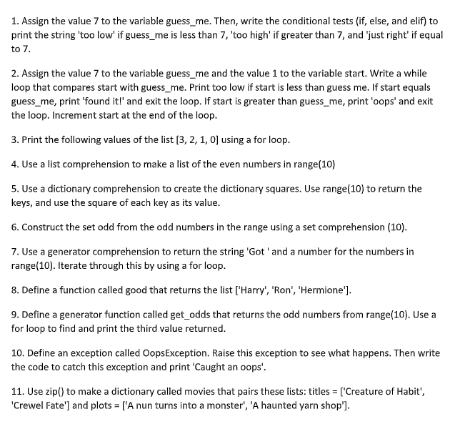
# Task 1
guess_me = 7
if guess_me < 7:
print('too low')
elif guess_me > 7:
print('too high')
else:
print('just right')

# Task 2
guess_me = 7
start = 1
while True:
if start < guess_me:
print('too low')
elif start == guess_me:
print('found it!')
break
else:
print('oops')
break
start += 1

# Task 3
for value in [3, 2, 1, 0]:
print(value)

# Task 4
even_numbers = [num for num in range(10) if num % 2 == 0]
print(even_numbers)

# Task 5
squares = {num: num ** 2 for num in range(10)}
print(squares)

# Task 6
odd = {num for num in range(10) if num % 2 != 0}
print(odd)

# Task 7
gen = ('Got ' + str(num) for num in range(10))
for item in gen:
print(item)

# Task 8
def good():
return ['Harry', 'Ron', 'Hermione']
print(good())

# Task 9
def get_odds():
for number in range(1, 10, 2):
yield number

third_odd = None
for i, odd in enumerate(get_odds()):
if i == 2:
third_odd = odd
break
print(third_odd)

# Task 10
class OopsException(Exception):
pass

try:
raise OopsException()
except OopsException:
print('Caught an oops')

# Task 11
titles = ['Creature of Habit', 'Crewel Fate']
plots = ['A nun turns into a monster', 'A haunted yarn shop']
movies = dict(zip(titles, plots))
print(movies)
```

