1. Using a graph to illustrate slope and intercept, define basic linear regression.
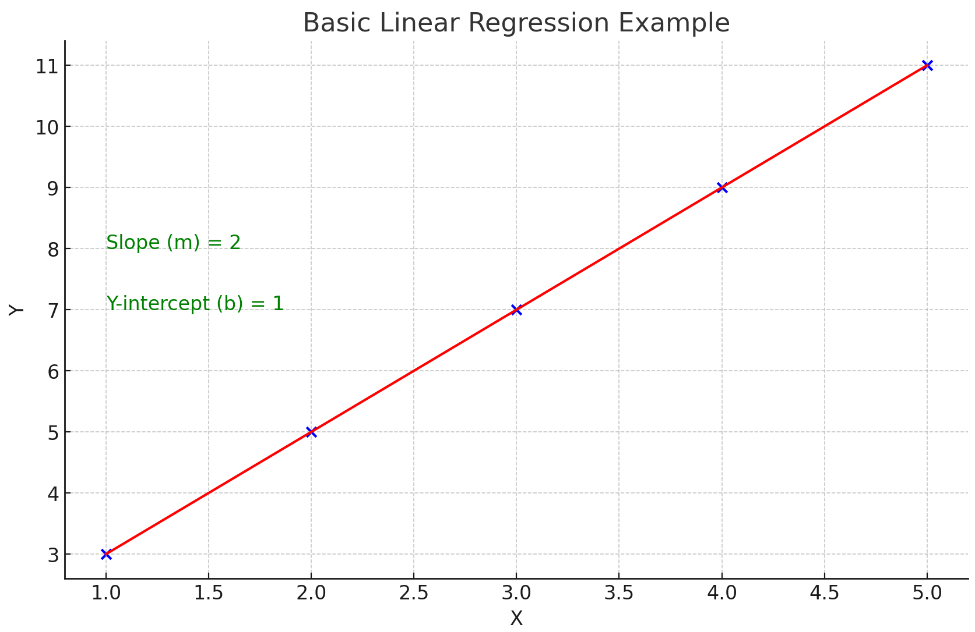
In this graph, we illustrate a basic linear regression using a simple linear equation: y = mx + b, where m is the slope, and b is the y-intercept.
- Slope (m): This is the rate at which the dependent variable y changes with respect to the independent variable x . In our example, the slope is 2, meaning for every unit increase in x, y increases by 2 units.
- Y-intercept (b): This is the value of y when x is 0. In our example, the y-intercept is 1, which is the point where the line intersects the y-axis.
The blue points represent data points, and the red line is the "line of best fit," which shows the linear relationship between x and y. This line is determined using the linear regression technique to minimize the distance between the data points and the line itself, ideally capturing the underlying trend of the data.
Code:
import matplotlib.pyplot as plt
import numpy as np
# Create a simple linear regression example
x = np.array([1, 2, 3, 4, 5])
y = 2 * x + 1 # y = mx + b, where m (slope) = 2 and b (y-intercept) = 1
# Plot the points
plt.scatter(x, y, color='blue')
# Plot the line of best fit
plt.plot(x, y, color='red')
# Annotations for slope and y-intercept
plt.text(1, 8, 'Slope (m) = 2', fontsize=12, color='green')
plt.text(1, 7, 'Y-intercept (b) = 1', fontsize=12, color='green')
# Labels and title
plt.xlabel('X')
plt.ylabel('Y')
plt.title('Basic Linear Regression Example')

# Show the plot
plt.grid(True)
plt.show()
2. In a graph, explain the terms rise, run, and slope.
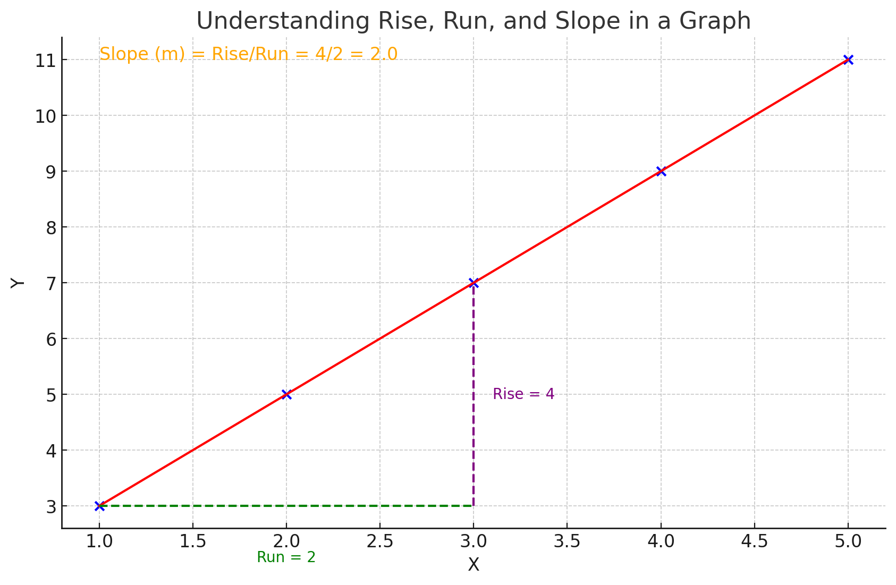
The concepts of rise, run, and slope are illustrated using a linear equation y = 2x + 1.
1. Rise: Refers to the vertical change between two points on a line. In the graph, the rise is shown in purple and calculated between the points x = 1 and x = 3.
It's the difference in the y -values of these points.
2. Run: Represents the horizontal change between the same two points. The run, shown in green, is the difference in the x -values.
3. Slope: Defined as the ratio of the rise to the run. It's a measure of how steep a line is. The slope (m) of the line is calculated as rise /run, which in this case is 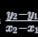 . For the given line, the slope is 2.
The slope is a key aspect of linear regression, indicating how much (y) changes for a unit change in (x)
Code:
# Creating a graph to explain the terms rise, run, and slope
# Using the same linear equation as before: y = 2x + 1
x = np.array([1, 2, 3, 4, 5])
y = 2 * x + 1
# Selecting two points to calculate rise and run
x1, x2 = 1, 3
y1, y2 = 2*x1 + 1, 2*x2 + 1
# Calculating rise and run
rise = y2 - y1
run = x2 - x1

# Plot the points and the line
plt.scatter(x, y, color='blue')
plt.plot(x, y, color='red')
# Plotting the "rise" and "run"
plt.plot([x1, x2], [y1, y1], color='green', linestyle='--') # run (horizontal)
plt.plot([x2, x2], [y1, y2], color='purple', linestyle='--') # rise (vertical)
# Annotating the rise, run, and slope
plt.text((x1 + x2) / 2, y1 - 1, f'Run = {run}', horizontalalignment='center', color='green')
plt.text(x2 + 0.1, (y1 + y2) / 2, f'Rise = {rise}', verticalalignment='center', color='purple')
plt.text(1, 11, f'Slope (m) = Rise/Run = {rise}/{run} = {rise/run}', fontsize=12, color='orange')
# Labels and title
plt.xlabel('X')
plt.ylabel('Y')
plt.title('Understanding Rise, Run, and Slope in a Graph')
# Show the plot with grid
plt.grid(True)
plt.show()
3. Use a graph to demonstrate slope, linear positive slope, and linear negative slope, as well as the different conditions that contribute to the slope.
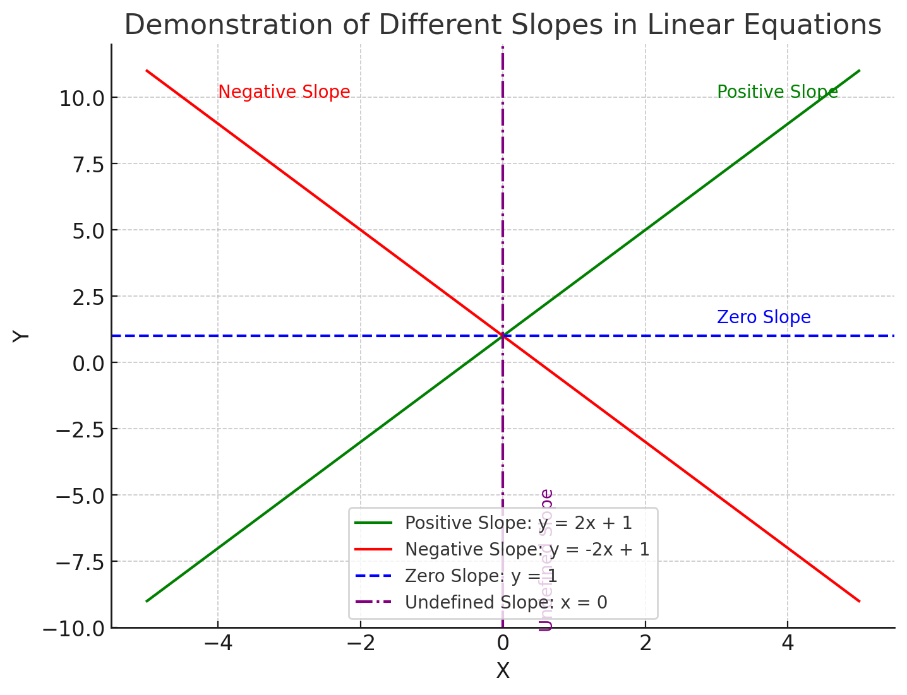
Different types of slopes in linear equations are demonstrated:

1. Positive Slope (Green Line): This is represented by the equation y = 2x + 1 . Here, as x increases, y also increases. The line slopes upwards from left to right, indicating a positive relationship between x and y .
2. Negative Slope (Red Line): Shown by the equation y = -2x + 1 , this line slopes downwards from left to right. In this case, as x increases, y decreases, indicating a negative relationship.
3. Zero Slope (Blue Dashed Line): Represented by y = 1 , this is a horizontal line. It demonstrates a situation where there is no change in y as x changes, resulting in a slope of zero.
4. Undefined Slope (Purple Dotted Line): Illustrated by a vertical line at x = 0 . This represents a situation where the slope is undefined because the run (change in x ) is zero, and dividing by zero is undefined in mathematics.
These different slopes are fundamental in understanding the nature of the relationship between two variables in linear equations and linear regression.
Code:
# Creating a graph to demonstrate slope, linear positive slope, and linear negative slope
# Different linear equations
x = np.linspace(-5, 5, 100)
y_positive = 2 * x + 1 # positive slope
y_negative = -2 * x + 1 # negative slope
y_zero = 0 * x + 1 # zero slope (horizontal line)
y_undefined = x # undefined slope (vertical line)
# Plot the lines
plt.figure(figsize=(8, 6))
plt.plot(x, y_positive, label='Positive Slope: y = 2x + 1', color='green')
plt.plot(x, y_negative, label='Negative Slope: y = -2x + 1', color='red')
plt.axhline(y=1, color='blue', linestyle='--', label='Zero Slope: y = 1')
plt.axvline(x=0, color='purple', linestyle='-.', label='Undefined Slope: x = 0')
# Annotating the different slopes
plt.text(3, 10, 'Positive Slope', color='green')
plt.text(-4, 10, 'Negative Slope', color='red')
plt.text(3, 1.5, 'Zero Slope', color='blue')
plt.text(0.5, -10, 'Undefined Slope', color='purple', rotation='vertical')
# Labels and title
plt.xlabel('X')
plt.ylabel('Y')
plt.title('Demonstration of Different Slopes in Linear Equations')
plt.legend()

# Show the plot with grid
plt.grid(True)
plt.show()
4. Use a graph to demonstrate curve linear negative slope and curve linear positive slope.
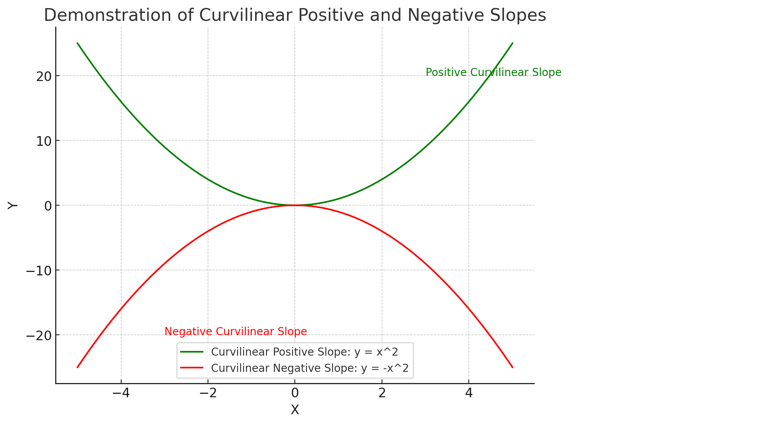
In this graph, we demonstrate curvilinear positive and negative slopes:
1. Curvilinear Positive Slope (Green Line): Represented by the equation y = x^2 , this is a parabolic curve opening upwards. As x moves away from 0 in either direction, y increases. This is characteristic of a positive curvilinear slope, where the rate of increase in y accelerates as x increases.
2. Curvilinear Negative Slope (Red Line): Shown by the equation y = -x^2 , this parabola opens downwards. Here, as x moves away from 0, y decreases more sharply. This represents a negative curvilinear slope, where the rate of decrease in y accelerates as x increases.
These types of slopes are important in understanding more complex relationships between variables where the change is not constant and can vary in magnitude depending on the value of x .
Code:
import matplotlib.pyplot as plt
import numpy as np
# Creating a graph to demonstrate curvilinear negative and positive slopes
# Generating data for curvilinear slopes
x = np.linspace(-5, 5, 100)
y_positive_curve = x**2 # curvilinear positive slope (parabola opening upwards)
y_negative_curve = -x**2 # curvilinear negative slope (parabola opening downwards)
# Plotting the curves
plt.figure(figsize=(8, 6))
plt.plot(x, y_positive_curve, label='Curvilinear Positive Slope: y = x^2', color='green')
plt.plot(x, y_negative_curve, label='Curvilinear Negative Slope: y = -x^2', color='red')
# Annotations for positive and negative curvilinear slopes
plt.text(3, 20, 'Positive Curvilinear Slope', color='green')
plt.text(-3, -20, 'Negative Curvilinear Slope', color='red')
# Labels and title
plt.xlabel('X')
plt.ylabel('Y')
plt.title('Demonstration of Curvilinear Positive and Negative Slopes')
plt.legend()
# Show the plot with grid
plt.grid(True)
plt.show()
5. Use a graph to show the maximum and low points of curves.
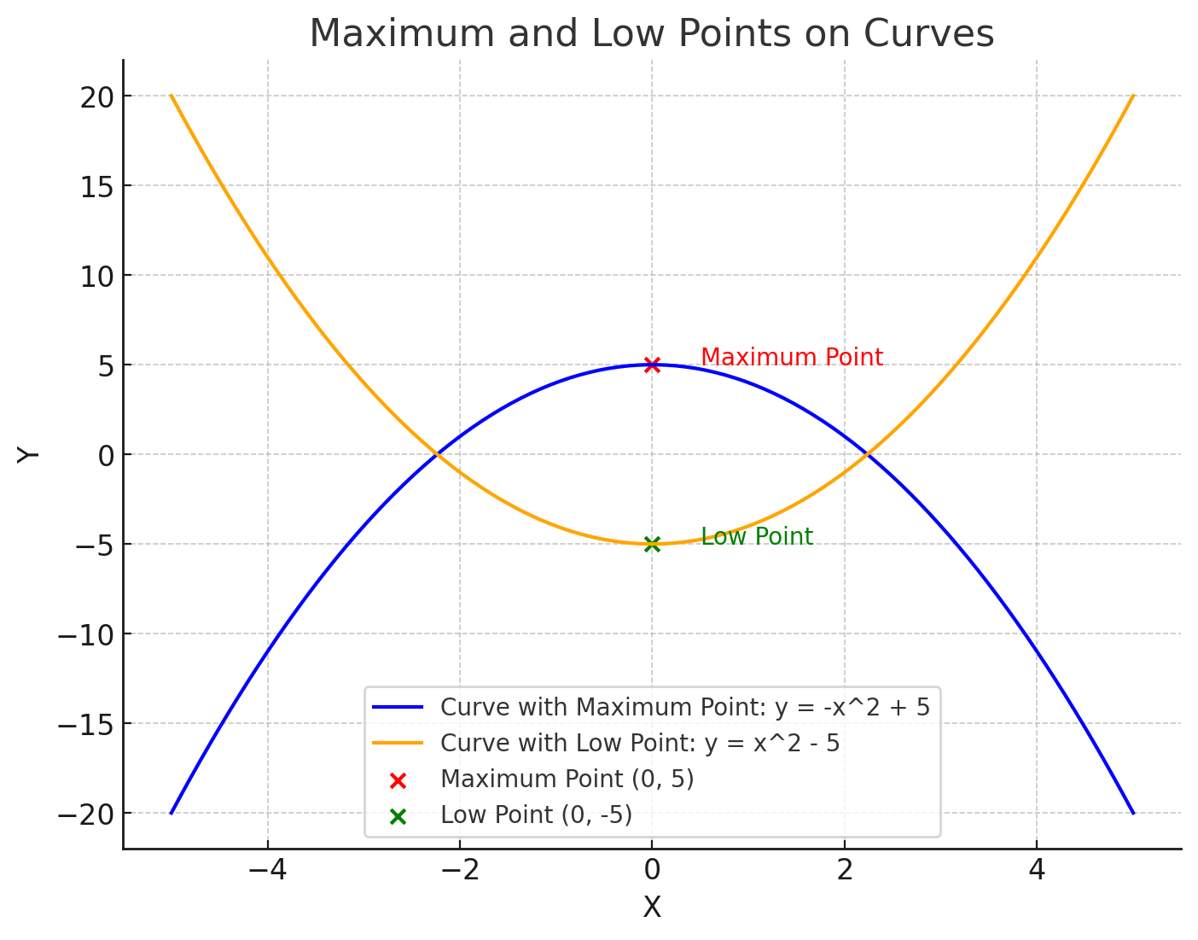
The concepts of maximum and low points on curves are demonstrated:
1. Curve with a Maximum Point (Blue Line): Represented by the equation y = -x^2 + 5 , this parabola opens downwards. The highest point on this curve is the maximum point, marked in red. It occurs at x = 0 , y = 5 , indicating the highest value that y reaches on this curve.
2. Curve with a Low Point (Orange Line): Shown by the equation y = x^2 - 5 , this parabola opens upwards. The lowest point on the curve, marked in green, is the low point. It is located at x = 0 , y = -5 , representing the lowest value of y on the curve.
These points are critical in the analysis of curves, as they represent the extremities in the values that the function can take. In various fields, identifying these points helps in understanding the behavior of different phenomena modeled by these curves.
Code:
import matplotlib.pyplot as plt
import numpy as np

# Creating a graph to show the maximum and low points of curves

# Generating data for curves
x = np.linspace(-5, 5, 100)
y_max_point_curve = -x**2 + 5 # Parabola with maximum point
y_low_point_curve = x**2 - 5 # Parabola with low point
# Finding the maximum and low points
max_point = (0, 5) # Maximum at x = 0, y = 5
low_point = (0, -5) # Low point at x = 0, y = -5
# Plotting the curves
plt.figure(figsize=(8, 6))
plt.plot(x, y_max_point_curve, label='Curve with Maximum Point: y = -x^2 + 5', color='blue')
plt.plot(x, y_low_point_curve, label='Curve with Low Point: y = x^2 - 5', color='orange')
# Marking the maximum and low points
plt.scatter(*max_point, color='red', label='Maximum Point (0, 5)')
plt.scatter(*low_point, color='green', label='Low Point (0, -5)')
# Annotations for maximum and low points
plt.text(max_point[0] + 0.5, max_point[1], 'Maximum Point', color='red')
plt.text(low_point[0] + 0.5, low_point[1], 'Low Point', color='green')
# Labels and title
plt.xlabel('X')
plt.ylabel('Y')
plt.title('Maximum and Low Points on Curves')
plt.legend()
# Show the plot with grid
plt.grid(True)
plt.show()
6. Use the formulas for a and b to explain ordinary least squares.
Ordinary Least Squares (OLS) is a method commonly used in linear regression for estimating the unknown parameters in a linear regression model. The linear regression model predicts the dependent variable, (Y), as a linear function of the independent variables, (X), plus an error term. The model can be expressed as:
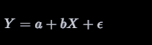
Where:
- Y is the dependent variable.
- a is the y-intercept of the regression line (the value of Y when X = 0 ).
- b is the slope of the regression line (the change in Y for a one-unit change in X ).
- ϵ represents the error term (the difference between the observed values and the values predicted by the model).
In OLS, the best-fitting line is found by minimizing the sum of the squares of the vertical distances of the points from the line. These distances are called "residuals."
The formulas for calculating the slope (b ) and y-intercept (a ) in a simple linear regression are:
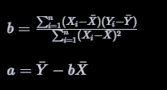
Where:
- Xi and Yi are the individual sample points.
- Xˉ and ˉY are the means of the X and Y data sets, respectively.
- n is the number of data points.
Interpretation:
- Slope (b ): Represents the estimated change in the dependent variable (Y ) for a one-unit change in the independent variable
(X ).
A positive b indicates a positive relationship, while a negative b indicates a negative relationship.
- Y-Intercept (a): Represents the estimated value of Y when X is 0. It is the point where the regression line crosses the Y-axis.
OLS aims to find the line that minimizes the total squared difference between the observed values and the values predicted by the linear model. This method is widely used due to its simplicity, interpretability, and for having good properties under a wide range of situations.
7. Provide a step-by-step explanation of the OLS algorithm.
Certainly! Ordinary Least Squares (OLS) is a fundamental algorithm in statistical modeling, particularly in linear regression. The goal of OLS is to find the best-fitting line through a set of data points that minimizes the sum of the squared differences (residuals) between the observed values and the values predicted by the model. Here's a step-by-step explanation of how the OLS algorithm works:
Step 1: Define the Model
The linear regression model is defined as Y=a+bX+ϵ , where:
- Y is the dependent variable.
- X is the independent variable.
- a is the y-intercept of the regression line.
- b is the slope of the regression line.
- is the error term.
Step 2: Calculate the Means
Calculate the mean (average) of the X values (Xˉ) and the Y values (Yˉ)
Step 3: Calculate the Slope (b)
The slope of the regression line (b) is calculated using the formula:
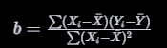
where Xi and Yi are the individual sample points.
Step 4: Calculate the Y-Intercept (a )
After calculating the slope, compute the y-intercept of the line using the formula:
Step 5: Form the Regression Equation
With the slope and y-intercept, form the regression equation as Y=a+bX. This equation can now be used to predict Y given values of X.
Step 6: Compute the Residuals
For each data point, calculate the residual, which is the difference between the observed Y value and the Y value predicted by the model.
Step 7: Calculate the Sum of Squared Residuals
Sum up the squares of these residuals. The goal of OLS is to minimize this sum.
Step 8: Assess the Model
Finally, assess the fit of the model. This can include looking at R-squared values, residual plots, or conducting hypothesis tests. R-squared, for example, indicates how much of the variance in Y is explained by the model.
Conclusion
OLS is a powerful yet simple method for linear regression. It's effective when the relationship between the variables is linear and the data do not exhibit severe multicollinearity, heteroscedasticity, or other anomalies. The simplicity of the model and its interpretability makes OLS a widely used technique in statistics and data analysis.
8. What is the regression's standard error? To represent the same, make a graph.
The standard error of the regression (often denoted as SE ) is a measure that provides an estimate of the average distance that the observed values fall from the regression line. Essentially, it's a measure of the accuracy of predictions made with a regression analysis. The standard error gives an idea of the variability of the regression coefficients, indicating how precisely the regression line represents the data.
Mathematically, the standard error of the regression is calculated as:
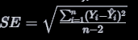
where:
- Yi are the observed values.
- Y^i​ are the predicted values by the regression.
- n is the number of observations.
The denominator, n - 2, accounts for the degrees of freedom in the model (subtracting 2 accounts for the two estimated parameters: slope and intercept).
### Creating a Graph to Represent Regression Standard Error
To illustrate the standard error in a graph, we can plot the regression line through a set of data points and add bands that represent the standard error around this line. These bands can give a visual representation of where we expect the true regression line to fall with a certain level of confidence.

Let's create a simple linear regression plot with standard error bands.
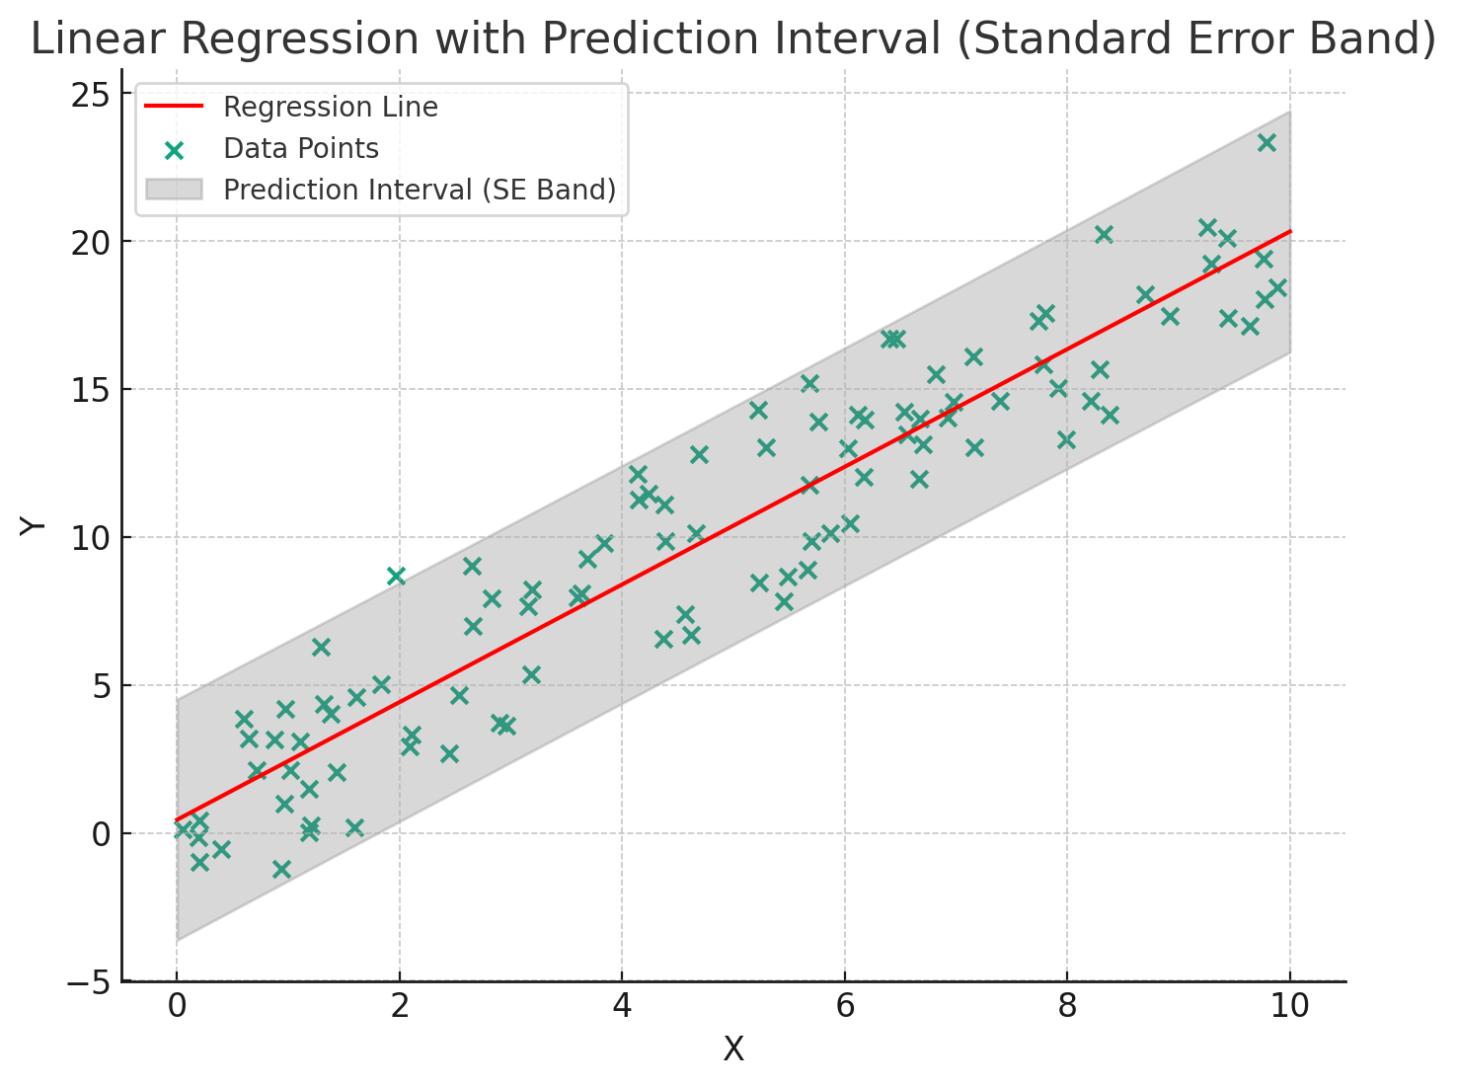
In the graph above, we have:
- Data Points: Represented by the individual dots. These are the observed values in the dataset.
- Regression Line (Red Line): This is the best fit line obtained from the linear regression. It represents the predicted values \hat{Y} for given X values.
- Standard Error Bands (Gray Area): These bands around the regression line represent the standard error. They provide a visual indication of the variability of the regression estimate. Specifically, the bands show where we expect the true regression line to fall with a certain level of confidence.
The width of the standard error bands indicates the level of certainty or uncertainty in the regression estimates. Wider bands imply greater uncertainty or variability in the regression estimate, whereas narrower bands imply more precise estimates. In this case, the bands are created using 2 times the standard error, which commonly corresponds to a 95% confidence interval for the regression estimate.
9. Provide an example of multiple linear regression.
Certainly! Multiple linear regression is an extension of simple linear regression where more than one independent variable is used to predict the dependent variable. Let's consider a hypothetical example to illustrate this:
### Example: Predicting House Prices
Objective: To predict the price of a house based on various features.
Dependent Variable (Y):
- House Price (in thousands of dollars)
Independent Variables (X):
1. House Size (Square feet)
2. Number of Bedrooms
3. Age of the House (Years)
4. Distance to the City Center (Miles)
5. Average Income of the Neighborhood (in thousands of dollars)

### The Multiple Linear Regression Model
The model can be represented as:
House Price=a+b1​(House Size)+b2​(Number of Bedrooms)+b3​(Age of House)+b4​(Distance to City Center)+b5​(Average Income)+ϵ
Where:
- a is the y-intercept.
- b1​,b2​,b3​,b4​, and b5 are the coefficients for each independent variable, representing the estimated change in the house price for a one-unit change in the respective variable, holding all other variables constant.
- ϵ is the error term.
### Hypothetical Data:
Suppose we have a dataset with the following values for 5 houses:
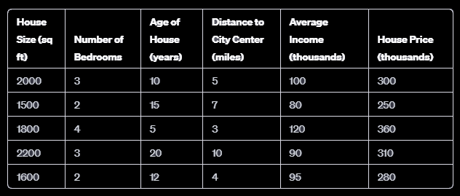
### Analysis:
Through multiple linear regression analysis, we would estimate the coefficients b1​,b2​,b3​,b4​, , and b5​, and the intercept a . These coefficients give us insights into how each factor influences the house price. For instance, if b1is positive and large, it indicates that house size has a significant positive impact on the house price.
### Conclusion:
Multiple linear regression is particularly useful in scenarios where multiple factors influence the outcome. It allows for a more comprehensive analysis compared to simple linear regression, which only considers one independent variable.
10. Describe the regression analysis assumptions and the BLUE principle.
Regression analysis, particularly linear regression, operates under a set of assumptions. When these assumptions are met, the regression estimates are considered to be the Best Linear Unbiased Estimators (BLUE). The BLUE principle comes from the Gauss-Markov theorem, which states that in a linear regression model where the errors have expectation zero, are uncorrelated, and have equal variances, the best linear unbiased estimator of the coefficients is given by the ordinary least squares (OLS) estimator.
Assumptions of Regression Analysis:
1. Linearity: The relationship between the independent variables and the dependent variable is linear. This can be checked using scatter plots.
2. Independence: Observations are independent of each other. This assumption is crucial for the model as correlated data can lead to unreliable and unstable estimates. Independence is often assumed in time series data, where this assumption might be violated.
3. Homoscedasticity: This means that the residuals (differences between the observed and predicted values) have constant variance at every level of the independent variable(s). When the variance of residuals changes across levels of an independent variable, the condition is known as heteroscedasticity.
4. Normal Distribution of Errors: The regression model assumes that the errors are normally distributed. This is particularly important for making inferences about the regression coefficients or conducting hypothesis tests.
5. No or Little Multicollinearity: In multiple regression, this assumption states that the independent variables are not highly correlated with each other. High multicollinearity can lead to coefficients being poorly estimated and can affect the interpretation of the model.
The BLUE Principle:
- Best: This refers to the smallest variance or the most precise estimate.
- Linear: The model is linear in the parameters (coefficients).
- Unbiased: On average, the estimate equals the true value. It means that the expected value of the estimates equals the true value of the coefficients.
- Estimator: Refers to the formula or procedure that is used to estimate the parameters of the model.
When these assumptions are met, the OLS estimators of the coefficients in the linear regression model have the smallest variance among all unbiased linear estimators. This makes them the best (in the sense of having the lowest sampling variability) and most reliable for inference and prediction within the scope of the linear model.
In practice, however, these assumptions are not always perfectly met. Part of the regression analysis involves checking these assumptions and applying various techniques to mitigate issues when assumptions are violated.
11. Describe two major issues with regression analysis.
Two major issues that can arise in regression analysis are multicollinearity and overfitting. Both of these issues can significantly impact the reliability and interpretability of the regression model.
1. Multicollinearity
Multicollinearity occurs when two or more independent variables in a regression model are highly correlated with each other. This correlation makes it difficult to isolate the individual effect of each independent variable on the dependent variable.
Implications:
- Coefficient Instability: The regression coefficients can become unstable and highly sensitive to changes in the model, such as including or excluding variables.
- Inflated Standard Errors: It can lead to inflated standard errors for the coefficients, which in turn can result in coefficients being statistically insignificant even if they are theoretically important.
- Difficult Interpretation: The interpretation of the coefficients becomes problematic because it's hard to discern the effect of each variable independently.
Solutions:
- Remove highly correlated predictors from the model.
- Use Principal Component Analysis (PCA) or Partial Least Squares Regression (PLSR) to reduce the feature space.
- Regularization methods like Ridge or Lasso regression can also be used.

2. Overfitting
Overfitting occurs when a model is too complex, capturing the noise in the data as if it were part of the underlying relationship. This usually happens when the model has too many parameters relative to the number of observations.
Implications:
- Poor Generalization: While an overfitted model may perform exceptionally well on training data, it often performs poorly on unseen data (test data).
- Lack of Simplicity: Overfitting goes against the principle of Occam's razor, which states that among competing hypotheses that predict equally well, the one with the fewest assumptions should be selected.
Solutions:
- Simplify the model by reducing the number of variables or parameters.
- Use cross-validation techniques to detect overfitting.
- Employ regularization methods that penalize overly complex models.
- Gathering more data can sometimes help to reduce overfitting.
Conclusion
Both multicollinearity and overfitting can severely undermine the effectiveness and interpretability of a regression model. Recognizing and addressing these issues is crucial for conducting robust and reliable regression analysis.
12. How can the linear regression model's accuracy be improved?
Improving the accuracy of a linear regression model involves several steps, focusing on data quality, feature selection, model tuning, and addressing any underlying assumptions and issues. Here are some strategies:
1. Feature Engineering
- Selecting Relevant Variables: Use domain knowledge to select the most relevant features for the regression. Irrelevant variables can reduce model accuracy.
- Creating Interaction Terms: Sometimes, the effect of one variable on the dependent variable depends on another variable. Creating interaction terms can capture these effects.
- Polynomial Features: For non-linear relationships, consider polynomial or transformed variables (like log, square, square root).
2. Data Quality
- Outlier Removal: Outliers can skew the results of a linear regression model. Investigate and possibly remove outliers that do not represent the data well.
- Handling Missing Data: Appropriately handle missing data through imputation or removal, as missing data can lead to biased estimates.
- Data Scaling: Though not always necessary for linear regression, scaling features (like with standardization or normalization) can be beneficial, especially in regularized models.
3. Addressing Multicollinearity
- Use Variance Inflation Factor (VIF) to detect multicollinearity. If found, you may need to remove highly correlated variables.
- Regularization techniques like Lasso or Ridge regression can also help in dealing with multicollinearity.
4. Model Complexity
- Avoid Overfitting: Overfitting leads to poor generalization to new data. Techniques like cross-validation can help in determining if the model is overfitting.

- Regularization: Techniques like Lasso (L1 regularization) and Ridge (L2 regularization) can penalize the magnitude of coefficients and help in reducing overfitting.
5. Model Assessment
- Residual Analysis: Analyze the residuals to ensure that they are randomly distributed and have constant variance (homoscedasticity).
- Cross-Validation: Use cross-validation techniques to assess the model’s performance on unseen data.
6. Advanced Techniques
- Ensemble Methods: Combining the predictions of several models (like in bagging or boosting) can improve prediction accuracy.
- Non-linear Models: If the relationship between the independent and dependent variables is non-linear, consider using non-linear models or transform variables to capture the non-linear relationships.
7. Domain Knowledge
- Incorporating domain-specific knowledge into the feature selection, model design, and interpretation can significantly improve the model's relevance and accuracy.
Conclusion
Improving a linear regression model's accuracy is not just about tweaking the model; it also involves a thorough understanding of the data, the underlying assumptions of the model, and applying appropriate statistical and machine learning techniques. Each dataset and problem might require a different combination of these strategies.

13. using an example, describe the polynomial regression model in detail.
Polynomial regression is a form of regression analysis in which the relationship between the independent variable X and the dependent variable Y is modeled as an nth degree polynomial. Polynomial regression fits a nonlinear relationship between the value of X and the corresponding conditional mean of Y, denoted E(Y∣X).
Example: Predicting Fuel Efficiency
Let's consider an example where we want to predict the fuel efficiency (miles per gallon, MPG) of a car based on its engine size.
Objective: To model and predict the relationship between 'Engine Size' (in liters) and 'Fuel Efficiency' (MPG).
Data:
Suppose we have the following data points:

Polynomial Regression Model:
Unlike linear regression, where the model is Y=a+bX+ϵ, the polynomial regression model can be expressed as:
Y=a+b1​X+b2​X2+b3​X3+...+bn​Xn+ϵ
where:
- Y is the dependent variable (Fuel Efficiency).
- X is the independent variable (Engine Size).
- a,b1​,b2​,...,bn​ are the coefficients.
- n is the degree of the polynomial.
- ϵ, is the error term.
Fitting the Model:
For our example, let's fit a second-degree polynomial (quadratic model):
MPG=a+b1​(Engine Size)+b2​(Engine Size)^2
We would use statistical software or programming libraries to find the best estimates for a , b1, and b2 that minimize the sum of squared residuals.
Why Polynomial Regression?
- Captures Non-Linearity: Polynomial regression can model the curvilinear relationship that a simple linear regression cannot.
- Flexibility: You can choose the degree of the polynomial based on the relationship's complexity. However, higher degrees can lead to overfitting.
Visualization:
The plot of the regression would show a curve rather than a straight line, indicating how MPG changes nonlinearly with engine size.
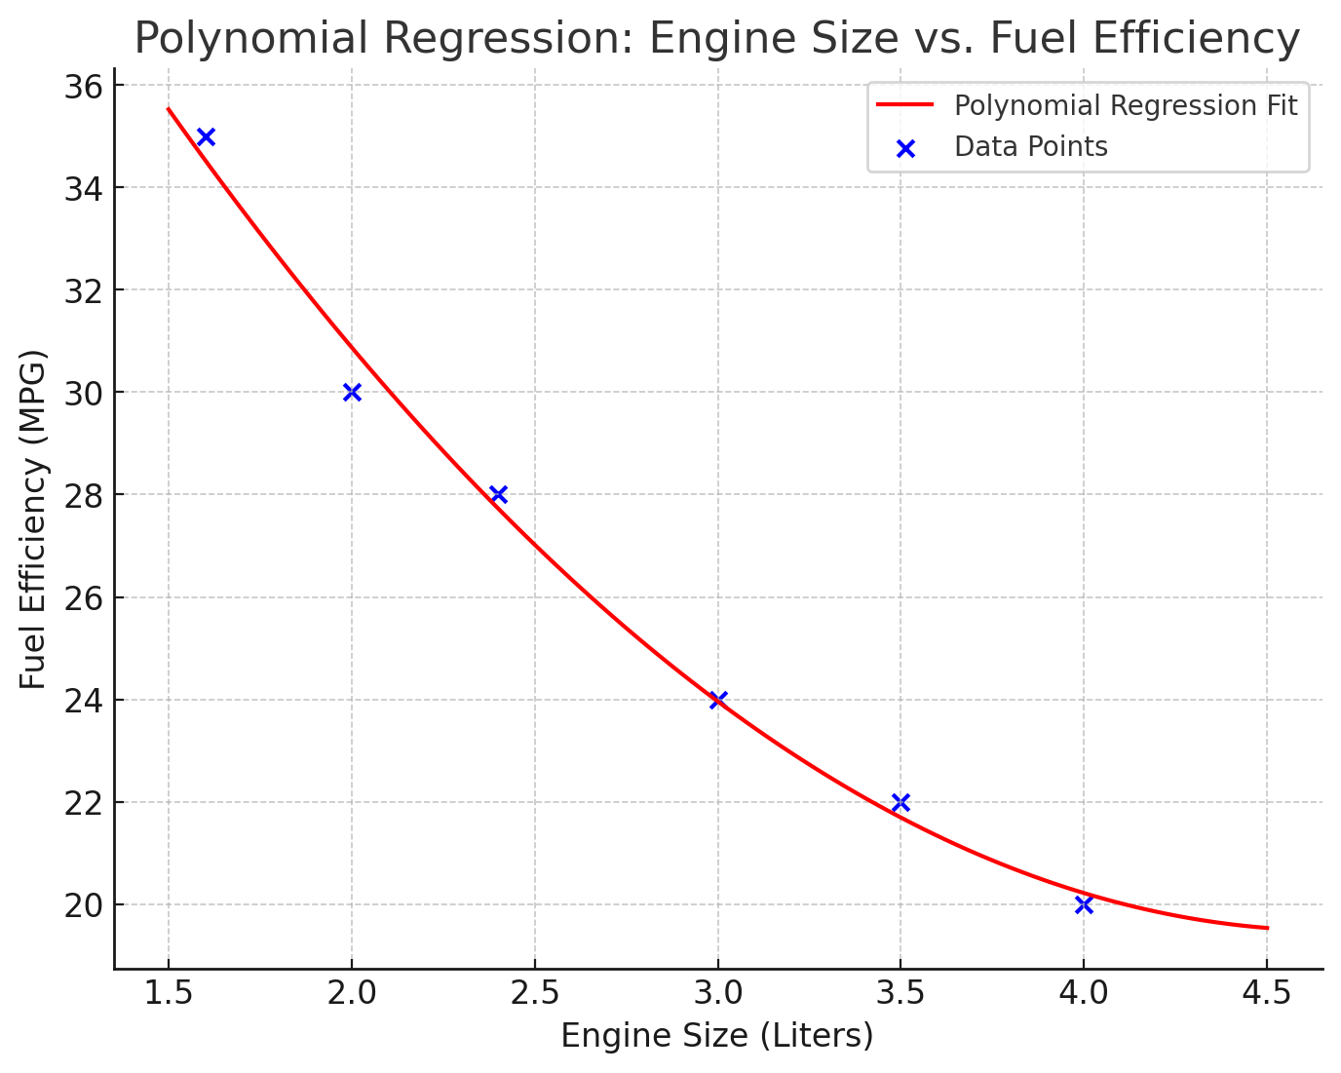
Conclusion:
Polynomial regression is useful in cases where the relationship between variables is not well-represented by a straight line. However, care must be taken to avoid overfitting, especially with higher-degree polynomials. It provides a good balance between the simplicity of linear regression and the flexibility to fit a wider range of data.

14. Provide a detailed explanation of logistic regression.
Logistic Regression is a statistical method used for binary classification problems — it predicts the probability that a given instance belongs to a particular class. Unlike linear regression, which predicts a continuous outcome, logistic regression is used when the outcome is categorical. It's particularly useful in situations where you need to predict the presence or absence of a characteristic or outcome, based on values of a set of predictor variables.
The Logistic Function:
The core of logistic regression is the logistic function, also known as the sigmoid function, which is an S-shaped curve. It can take any real-valued number and map it into a value between 0 and 1, but not exactly at the boundaries. The logistic function is defined as:
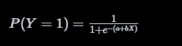
Where:
- P(Y=1) is the probability that the dependent variable Y is equal to 1.
- e is the base of the natural logarithm.
- a is the intercept and b represents the coefficient for the predictor variable X .
Understanding Logistic Regression:
- Binary Outcome: Logistic regression deals with scenarios where the outcome is binary (such as "Yes" or "No", "Success" or "Failure").
- Odds and Logit Function: The logistic regression model is based on the odds of the event occurring, and it uses the logit function (the logarithm of the odds) as the dependent variable.
- Coefficient Interpretation: The coefficients in logistic regression represent the change in the log odds of the dependent variable for a one-unit change in the independent variable.
Model Estimation:
Logistic regression estimates the probability that a certain event occurs. For example, in medical fields, it might be used to predict whether or not a patient has a certain disease (binary outcome) based on various characteristics of the patient (predictor variables).
Assumptions:
Similar to linear regression, logistic regression assumes:
- No high multicollinearity among the independent variables.
- A linear relationship between the logit of the outcome and each predictor variables.
- The observations should be independent of one another.
Use Cases:
- Medical fields: Predicting the likelihood of a patient having a disease.
- Finance: Predicting whether an individual will default on a loan.
- Marketing: Predicting customer churn.
Model Evaluation:
The evaluation of a logistic regression model involves checking the accuracy, precision, recall, F1 score, ROC curve, and AUC (Area Under the Curve) score. These metrics help determine how well the model is classifying the outcomes.
Conclusion:
Logistic regression is a powerful and widely used statistical method for binary classification problems. Its ability to provide probabilities and classify new samples using continuous and categorical data makes it a valuable tool for many areas, including social sciences, medical fields, and business.
15. What are the logistic regression assumptions?
Logistic regression, a popular method used for binary classification problems, operates effectively under several key assumptions. While some of these assumptions are similar to those in linear regression, others are specific to the logistic regression model. Understanding and validating these assumptions is crucial for the proper application of logistic regression and for ensuring reliable results.
1. Binary Outcome
The dependent variable should be binary in nature (e.g., 0/1, Yes/No, True/False). Logistic regression is meant for binary classification problems, although it can be extended to multiclass classification through techniques like one-vs-rest (OvR).
2. Linearity of Logit
Although logistic regression does not assume a linear relationship between the dependent and independent variables, it assumes a linear relationship between the logit of the outcome and each predictor variable. The logit function is the natural log of the odds ratio (log-odds).
3. No Multicollinearity
The independent variables should not be highly correlated with each other. Multicollinearity among the predictor variables can impact the model's estimates and make them unstable and difficult to interpret.
4. Independence of Observations
The observations should be independent of each other. This assumption is important in time-series models or clustered samples where the independence of observations might be violated.
5. No Significant Outliers
Logistic regression is sensitive to the presence of outliers. Significant outliers can distort the outcome and accuracy of the model and should be addressed during the data pre-processing phase.
6. Large Sample Size
Like many other statistical models, logistic regression requires a sufficiently large sample size to ensure reliable results. The general rule of thumb is that the dataset should include at least 10 cases per predictor variable.
7. Homoscedasticity of Error Terms
The error terms (residuals) should be homoscedastic, meaning they have constant variance across all levels of the independent variables.
Conclusion
Fulfilling these assumptions ensures that logistic regression provides a reliable, accurate, and interpretable model for binary classification. In practice, data scientists often perform various diagnostic tests and checks to validate these assumptions before fully relying on the model's outcomes. In cases where assumptions are violated, alternative methods or adjustments may be necessary.
16. Go through the details of maximum likelihood estimation.
Maximum Likelihood Estimation (MLE) is a method used in statistics to estimate the parameters of a statistical model. It is widely used in various statistical models, including logistic regression. MLE is based on the principle of maximizing the likelihood function, which measures how likely it is that the model at hand would produce the observed data.

Concept of Likelihood:
- Likelihood: In the context of MLE, the likelihood is a function of the parameters of a statistical model given the observed data. It is different from probability as it treats the observed data as fixed and the parameters as variable.
- Likelihood Function: It's a function of the parameters that measures how likely the observed data are under different parameter values. For a given set of data and a statistical model, the likelihood function evaluates the probability of obtaining the observed data as a function of the parameters of the model.
The Process of MLE:
1. Model Specification: Specify the statistical model and its associated likelihood function.
2. Likelihood Function Construction: Based on the model and observed data, construct the likelihood function.
3. Maximization: Find the parameter values that maximize the likelihood function. This typically involves taking the derivative of the likelihood function, setting it equal to zero, and solving for the parameters.
4. Optimization: In many cases, especially in complex models, the maximization step requires numerical optimization techniques, as analytical solutions may not be feasible.
Logistic Regression and MLE:
In logistic regression, MLE is used to find the best-fitting model to describe the relationship between the dependent binary variable and one or more independent variables. The process involves:
- Estimating the probability of each observed outcome under different values of the parameters.
- Maximizing the product of these probabilities, which is the likelihood of the observed data under the model.
- The parameter values that maximize this likelihood are considered the best estimates for the model.
Properties of MLE:
- Consistency: As the sample size increases, the MLE tends to converge to the true parameter value.
- Efficiency: MLE makes the most efficient use of the data provided, assuming that the model is correct.
- Asymptotically Normal: As the sample size increases, the distribution of MLE tends to be normal.
Challenges with MLE:
- In complex models, finding the maximum likelihood estimates can be computationally intensive.
- MLE assumes that the model is correctly specified, i.e., the form of the model and the distribution of the error terms are known and correctly modeled.
- MLE can be sensitive to outliers in the data.
Conclusion:
MLE is a fundamental concept in statistical inference, providing a principled framework for estimating the parameters of a statistical model. Its widespread use in various statistical and machine learning models is attributed to its desirable properties, although care must be taken in its application, especially in complex or poorly specified models.

