1.What is the difference between supervised and unsupervised learning? Give some examples to illustrate your point.
Supervised learning and unsupervised learning are two main categories of machine learning techniques, each with distinct approaches and applications.
Supervised Learning
Definition: In supervised learning, the algorithm is trained on a labeled dataset. This means that each instance in the training dataset is composed of input data (features) and an expected output (label). The goal of supervised learning is to learn a mapping from inputs to outputs, enabling predictions for unseen data.
Key Characteristics:
- Requires labeled data for training.
- Used for regression and classification tasks.
- The model's performance can be evaluated against known outputs.
Examples:
1. Classification: An email spam filter is a classic example of a classification task. The algorithm is trained on a dataset containing emails with labels as 'spam' or 'not spam' and learns to classify new emails into these categories.
2. Regression: Predicting house prices based on features like size, location, and number of bedrooms. The training data includes examples of houses with known selling prices.
Unsupervised Learning
Definition: Unsupervised learning involves training an algorithm on data without labeled responses. The goal is to explore the data and find some structure within. It's about discovering hidden patterns or data groupings without the need for human intervention.
Key Characteristics:
- Works with unlabeled data.
- Used for clustering, association, and dimensionality reduction tasks.
- There's no straightforward way to evaluate the model's performance due to the absence of true labels.
Examples:
1. Clustering: Grouping customers into segments for market analysis. The algorithm finds customers with similar purchasing behaviors or preferences without prior knowledge of these groupings.
2. Dimensionality Reduction: Reducing the number of features in a dataset while retaining its essential information. A common application is in image processing where reducing the number of features can help in noise reduction and compression.
Conclusion
The main difference between supervised and unsupervised learning lies in the nature of the data used for training. Supervised learning relies on labeled data to train a model that can make predictions or classifications. In contrast, unsupervised learning works with unlabeled data to find structure and patterns, often used for exploratory data analysis, clustering, and association. Both approaches have their unique applications and are valuable tools in the field of machine learning and data science.
2. Mention a few unsupervised learning applications.
Unsupervised learning, a type of machine learning where algorithms infer patterns from a dataset without reference to known or labeled outcomes, is used in a variety of applications.
1. Clustering: This is perhaps the most common application of unsupervised learning. It involves grouping data points with similar characteristics. Examples include customer segmentation in marketing, grouping genes with similar expression patterns in biology, or organizing news articles that cover the same story.

2. Anomaly Detection: Unsupervised learning can be used to identify unusual data points in a dataset. This is particularly useful in fields like fraud detection in banking, identifying network intrusions in cybersecurity, or monitoring industrial machines for unusual behavior that might indicate a fault.
3. Dimensionality Reduction: Techniques like Principal Component Analysis (PCA) reduce the number of variables under consideration, helping in simplifying models, visualizing high-dimensional data, and removing noise from data. This is widely used in fields like genomics for analyzing gene expression data, or in image processing.
4. Association Rule Learning: This is used to discover interesting relationships between variables in large databases. A common example is market basket analysis in retail, where it's used to find products that are frequently bought together.
5. Natural Language Processing (NLP): Unsupervised learning methods like topic modeling and word embeddings are used to understand and process human language, helping in tasks like sentiment analysis, topic extraction, and language translation.
6. Recommendation Systems: Unsupervised learning algorithms can help in recommending products to customers based on their browsing and purchasing history, as seen in online retail or streaming services.
These applications demonstrate the versatility and power of unsupervised learning in extracting insights and patterns from data without the need for explicit programming or labeled datasets.
3. What are the three main types of clustering methods? Briefly describe the characteristics of each.
The three main types of clustering methods are:
1. Centroid-based Clustering: This method represents each cluster by a single mean vector. The most common example is the K-means algorithm. In centroid-based clustering, objects are assigned to the nearest cluster center according to some distance metric (usually Euclidean distance), and the centroids are recalculated until they no longer change significantly. This method is efficient but can be sensitive to the initial choice of centroids and may not work well with non-spherical cluster shapes or clusters of different sizes and densities.
2. Density-based Clustering: Unlike centroid-based clustering, density-based methods consider clusters as areas of high density separated by areas of low density. A well-known example is DBSCAN (Density-Based Spatial Clustering of Applications with Noise). In this approach, clusters are defined as areas where the number of data points per unit space exceeds some threshold. Density-based clustering is good at separating clusters of arbitrary shapes and can handle noise and outliers well. However, it can struggle with clusters of varying densities and requires selecting appropriate parameters for density thresholds.
3. Hierarchical Clustering: This method builds a hierarchy of clusters either in a bottom-up (agglomerative) or top-down (divisive) manner. Agglomerative algorithms begin with each element as a separate cluster and merge them into progressively larger clusters, while divisive algorithms start with the entire dataset as one cluster and divide it into smaller clusters. The result is a tree-based representation of the objects, known as a dendrogram, which shows how the clusters are related. Hierarchical clustering doesn’t require pre-specifying the number of clusters but can be computationally expensive, especially for large datasets. It's particularly useful for understanding the data structure and is applicable in various domains, including biology and social sciences.
4. Explain how the k-means algorithm determines the consistency of clustering.
The K-means algorithm, a popular centroid-based clustering method, determines the consistency of clustering primarily through an iterative process that aims to minimize the variance within each cluster.
1. Initialization: The process begins by selecting 'k' initial centroids. The selection of these initial points can be random or based on a specific heuristic. The choice of initial centroids can significantly affect the final clusters.
2. Assignment Step: Each data point in the dataset is assigned to the nearest centroid. The "nearest" is usually defined in terms of Euclidean distance, though other distance metrics can be used. This step partitions the data into 'k' clusters based on the current centroids.
3. Update Step: After all data points have been assigned to clusters, the centroids of these clusters are recalculated. This is typically done by taking the mean of all points assigned to each cluster. The centroids then move to these new mean positions.

4. Iteration: Steps 2 and 3 are repeated iteratively. In each iteration, data points may shift between clusters as the centroids move. The algorithm continues this process of assignment and update until a stopping criterion is met. Common stopping criteria include a situation where centroids no longer move significantly, the changes in the sum of the squared distances (within-cluster variance) fall below a certain threshold, or a predefined number of iterations is reached.
5. Convergence and Consistency: The algorithm is said to have converged when the assignments no longer change. At this point, it's assumed that the algorithm has found a local optimum. However, because K-means relies on initial random seed points for centroids, different runs of the algorithm can result in different clusterings. This is where the consistency of clustering is often questioned in K-means.
To check for consistency, K-means is often run multiple times with different initializations, and the clustering result (such as the sum of squared distances from points to their respective centroids) is compared across these runs. The more consistent the results across different runs, the more reliable the clustering is considered. However, it's important to note that K-means can still converge to local optima, and therefore, the consistency doesn't necessarily imply that the clustering result is the global best in terms of minimizing within-cluster variances.
5. With a simple illustration, explain the key difference between the k-means and k-medoids algorithms.
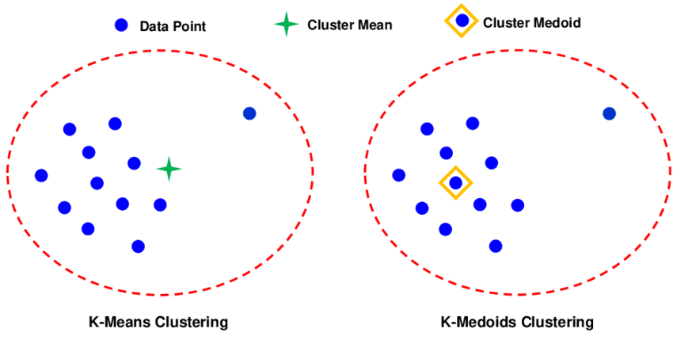
The key difference between the k-means and k-medoids algorithms lies in how they determine the central point (centroid) of each cluster:
1. K-Means: This algorithm calculates the mean (average) of the data points in each cluster to determine its centroid. The mean represents the central point in a cluster, and it may not necessarily be one of the actual data points in the dataset. The k-means algorithm iteratively adjusts the cluster centroids (the means) to minimize the total variance within each cluster.
2. K-Medoids: In contrast, k-medoids selects actual data points as the centroids. The algorithm chooses the most centrally located point in each cluster, known as the medoid. The medoid is an actual data point from the dataset that minimizes the sum of the dissimilarities between itself and all the other points in the cluster. This approach can be more robust to noise and outliers compared to k-means.
While k-means uses the mean of the points in a cluster as the central point, k-medoids uses the most centrally located actual data point in the cluster. This distinction can lead to different clustering results, especially in the presence of noise and outliers.

6. What is a dendrogram, and how does it work? Explain how to do it.
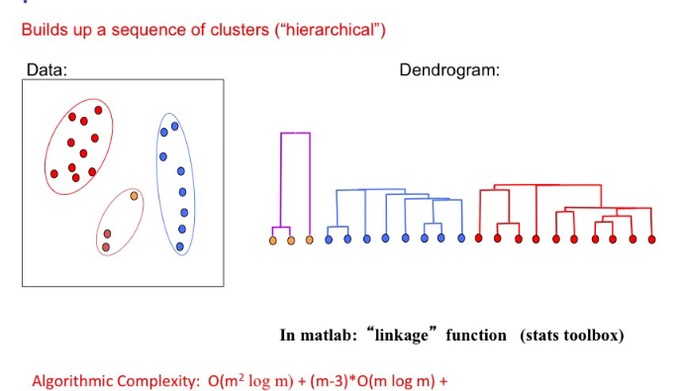
A dendrogram is a diagram that shows the arrangement of the clusters produced by hierarchical clustering. It's often used in data analysis to illustrate the grouping of elements into clusters based on their similarity.
How a Dendrogram Works:
1. Representation: In a dendrogram, each element is typically represented by a leaf, and clusters are represented by branches that link these leaves. The root of the dendrogram represents the single cluster that contains all the data points.
2. Distance or Similarity: The vertical axis of a dendrogram represents the distance or dissimilarity between clusters. The height at which two clusters are joined together in the dendrogram indicates the distance at which these clusters are merged. In some contexts, this might instead reflect similarity, where a lower height indicates more similarity.
3. Hierarchical Structure: A key feature of a dendrogram is its ability to illustrate the hierarchy of clusters. You can see how individual elements are grouped into clusters, and how these clusters are further combined into larger clusters, and so on, up to the root.
Creating a Dendrogram:
1. Start with Individual Elements: Initially, treat each data point as a separate cluster.
2. Compute Distances: Calculate the distances (or dissimilarities) between all pairs of clusters. Various metrics (like Euclidean distance) and methods (like single linkage, complete linkage, average linkage) can be used for this.
3. Merge Clusters: Find the two clusters that are closest to each other and merge them into a single cluster.
4. Update Distance Matrix: Recalculate the distances between the new cluster and all the old clusters.
5. Repeat: Continue merging the closest clusters and updating the distance matrix until all elements are merged into a single cluster.
6. Draw the Dendrogram: Each time a merge occurs, draw a link between the clusters at a height corresponding to their distance. Continue until the final link forms the root of the dendrogram.
Reading a Dendrogram:
- Cluster Identification: By drawing a horizontal line at different heights, you can identify clusters. The number of vertical lines the horizontal line intersects corresponds to the number of clusters at that distance threshold.

- Understanding Groupings: The dendrogram shows how each cluster is composed, allowing you to understand the grouping and proximity of different elements and clusters.
Dendrograms are particularly useful in exploratory data analysis, allowing for a visual understanding of the clustering process and the relationships between data points. They are widely used in various fields, such as biology (for phylogenetic trees), social sciences, and market research.

7. What exactly is SSE? What role does it play in the k-means algorithm?
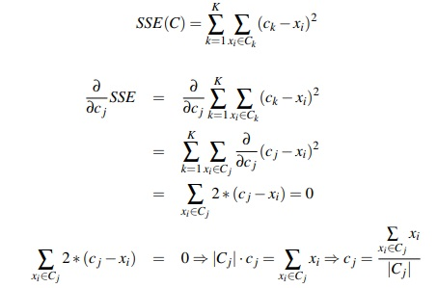
Proof a formula:
The image you uploaded depicts a mathematical derivation related to the optimal placement of centroids in K-means clustering, which is an algorithm used for partitioning a dataset into K distinct, non-overlapping clusters. Here's a detailed explanation of the proof shown in the image:
1. Sum of Squared Errors (SSE) Definition:
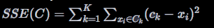
This equation defines the SSE for a set of clusters, where C represents the entire set of clusters, K is the number of clusters, Ck is the set of points in the k-th cluster, ck is the centroid of the k-th cluster, and xi represents each data point in Ck.
2. Derivative of SSE with Respect to a Centroid Cj :
To minimize SSE, we take the partial derivative of the SSE with respect to the centroid Cj of a specific cluster j :
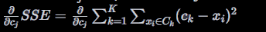
Since the differentiation is with respect to Cj , only the terms where k = j will contribute to the derivative. Terms where k ≠ j will have a derivative of zero.
3. Simplifying the Derivative:
The derivative simplifies to:
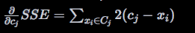
This simplification comes from applying the power rule of derivatives, where the derivative of
(Cj - x_i)^2 with respect to Cj is 2(Cj - x_i) .
4. Setting the Derivative to Zero for Minimization:
To find the minimum SSE, we set the derivative equal to zero:
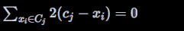
Dividing by 2 and rearranging terms, we get:
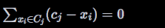
Which simplifies to:
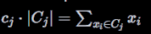
Here, |Cj| denotes the number of elements in cluster j .
5. Solving for the Centroid Cj :
Finally, we solve for Cj , the position of the centroid:
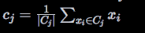
This equation states that the optimal position for the centroid Cj of cluster j is the mean (average) of all the points x_i in cluster j .
The proof shows that the optimal position of the centroid Cj for any cluster j in K-means clustering is the arithmetic mean of all the data points in that cluster. This is the condition that minimizes the SSE, which is the objective function for the K-means algorithm.
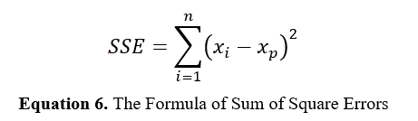

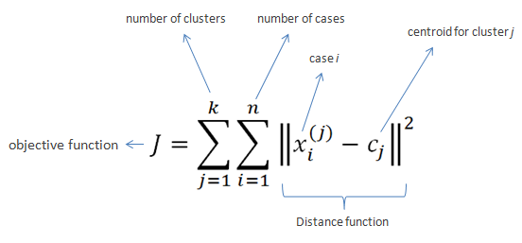
SSE stands for Sum of Squared Errors, and it plays a crucial role in the k-means clustering algorithm.
Definition of SSE:
- Sum of Squared Errors (SSE): In the context of k-means, SSE is a measure of the total variance within the clusters. It is calculated as the sum of the squared distances between each data point and the centroid of its assigned cluster.

Calculation of SSE:
- For each data point, calculate the distance (usually Euclidean distance) between the point and the centroid of the cluster it belongs to.
- Square this distance.
- Sum these squared distances across all data points in the dataset.
Role of SSE in K-Means:
1. Determining Cluster Cohesion: SSE is a measure of how close the data points in a cluster are to the cluster’s centroid. A lower SSE indicates that data points are closer to their centroids, signifying more cohesive clusters.
2. Evaluating Cluster Quality: It is used as a criterion to assess the quality of the clustering. Lower SSE values generally indicate better clustering because they suggest less scatter within the clusters.
3. Algorithm Optimization: During the iterative process of the k-means algorithm, the objective is to minimize the SSE. The algorithm assigns data points to the cluster whose centroid is closest to the point, then recalculates the centroids based on the current cluster memberships, aiming to reduce SSE in each iteration.

4. Convergence Criterion: The k-means algorithm stops iterating when the change in SSE between successive iterations falls below a threshold, indicating that the clusters have become stable.
5. Choosing 'K': SSE can also help in determining the optimal number of clusters (K). As K increases, SSE tends to decrease because there are more centroids, so data points are likely to be closer to centroids. However, the rate of decrease in SSE diminishes at some point, indicating a diminishing return in cluster quality. This point, often identified using methods like the "elbow method," can be a good choice for K.
SSE is a key metric in the k-means algorithm, providing a quantifiable measure of clustering quality and informing both the optimization process and the selection of the number of clusters.
8. With a step-by-step algorithm, explain the k-means procedure.
The k-means algorithm is a widely used method in machine learning for clustering data into a specified number of groups (or clusters) based on their features. Here's a detailed step-by-step explanation of the k-means procedure:
Step 1: Choose the Number of Clusters, K)
- Initialization: Decide the number of clusters, K ). The choice of K ) is critical and can significantly influence the outcome. It's often determined based on domain knowledge or using methods like the Elbow Method to find an appropriate number.
Step 2: Select Initial Cluster Centroids
- Random Selection: Randomly select K ) data points from the dataset as the initial centroids. These points represent the initial centers of the clusters. The selection of initial centroids can affect the algorithm's convergence and results.
Step 3: Assign Data Points to the Nearest Centroid
- Cluster Assignment: For each data point in the dataset, compute its distance to each of the K ) centroids and assign the point to the nearest centroid's cluster. The distance is typically measured using the Euclidean distance, although other distance metrics can be used.
Step 4: Recompute Centroids
- Centroid Update: After all data points are assigned to clusters, recalculate the centroids of each cluster. The new centroid is the mean of all points in the cluster. This step adjusts the position of each centroid to better represent the members of its cluster.
Step 5: Iterate Until Convergence
- Iterative Optimization: Repeat steps 3 and 4 until a stopping criterion is met. Common stopping criteria include:
- No (or minimal) change in centroid positions between iterations, indicating convergence.
- No (or minimal) change in points' cluster assignments.
- A predefined number of iterations is reached.
Step 6: Final Cluster Output
- Result: Once the algorithm stops, the final cluster assignments and centroid positions are returned as the output. Each data point in the dataset is now assigned to one of the K ) clusters.
Additional Considerations
1. Convergence: K-means typically converges to a local optimum, which may not be the global optimum. Therefore, it's common practice to run the algorithm multiple times with different initial centroid selections.
2. Distance Metric: While Euclidean distance is standard, other metrics can be used depending on the nature of the data.
3. Feature Scaling: It's important to scale features before applying k-means, as the algorithm is sensitive to the scale of the data.
4. Handling Different Shapes and Sizes: K-means assumes clusters of roughly equal sizes and spherical shapes, which may not always be appropriate for the data at hand.
K-means is popular due to its simplicity and efficiency, but these steps highlight the importance of understanding its assumptions and limitations when applying it to real-world data.
9. In the sense of hierarchical clustering, define the terms single link and complete link.
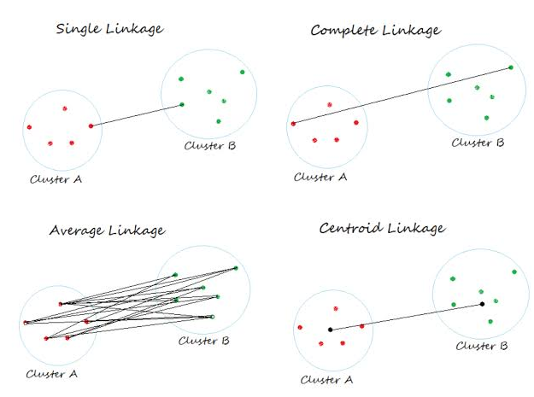
In hierarchical clustering, a method used for grouping data points into a tree of clusters, two common approaches are the single-link and complete-link strategies. These strategies define how the similarity (or distance) between clusters is measured and therefore influence the shape of the clusters formed.
1. Single Link (or Single Linkage):
- In single-link clustering, the similarity between two clusters is defined as the similarity (or distance) between their closest members.
- This method focuses on the minimum distance. For any two clusters, you find the pair of elements (one from each cluster) that are closest to each other, and use the distance between these elements as the distance between the clusters.
- It tends to produce clusters that can be quite elongated or straggly, as a single close pair of points can result in linking two otherwise distant clusters.

- Single link clustering is particularly sensitive to outliers, as an outlier close to another cluster can distort the shape of the clusters.
2. Complete Link (or Complete Linkage):
- In complete-link clustering, the similarity between two clusters is defined as the similarity (or distance) between their most distant members.
- This method focuses on the maximum distance. For any two clusters, you examine all pairs of elements (one from each cluster) and use the distance between the farthest pair as the distance between the clusters.
- Complete link tends to produce more compact, evenly sized clusters compared to single link. It is less susceptible to noise and outliers, as it considers the furthest points in each cluster.
- However, it can sometimes split large clusters prematurely, leading to a greater number of smaller clusters.
3. Average Linkage (also known as average group linkage):
In average linkage clustering, the distance between two clusters is defined as the average distance between all pairs of points in the two clusters. That is, for every point in one cluster, calculate its distance to every point in the other cluster, and then take the average of all these distances. This method balances between the sensitivity to outliers seen in single link and complete link methods, potentially providing clusters that are somewhat compact but also capable of capturing the natural structure of the data if it is not globular.
4. Centroid Linkage:
In centroid linkage clustering, the distance between two clusters is calculated based on the distance between their centroids. The centroid of a cluster is the mean position of all the points in the cluster. Thus, the distance between two clusters is the distance between their centroids. This method can result in clusters where elements within each cluster are closer on average to their centroid than to elements in other clusters. However, centroid linkage can be affected by the presence of outliers, which can shift the centroid of a cluster.
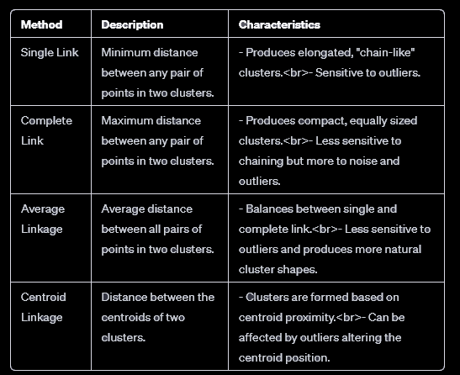
This comparison highlights how each method approaches the measurement of distance between clusters, impacting the shape, size, and composition of the resulting clusters. The choice of method depends on the specific characteristics of the data and the desired outcomes of the clustering process.

10. How does the apriori concept aid in the reduction of measurement overhead in a business basket analysis? Give an example to demonstrate your point.
The Apriori algorithm is a classic algorithm used in data mining for finding frequent itemsets and relevant association rules in large databases of transactions. In the context of market basket analysis, which involves analyzing items frequently purchased together, the Apriori concept helps in reducing the measurement overhead by efficiently narrowing down the search space for frequent itemsets, thereby optimizing the process of identifying associations between items. Here's how it aids in reduction:
Principle of Apriori Algorithm
The core principle of the Apriori algorithm is based on the concept that "all subsets of a frequent itemset must also be frequent." This principle helps in reducing the search space significantly by eliminating itemsets that are unlikely to be frequent early in the process. Here's a step-by-step breakdown of how it aids in reduction:
1. Identify Single Items' Frequency: Initially, the frequency of each item in the dataset is counted, and items not meeting a minimum support threshold (a user-defined parameter) are pruned away. This step ensures that only items that are potentially part of frequent itemsets are considered in further analyses.
2. Build Itemsets Iteratively: Starting with the frequent individual items identified in the first step, the algorithm iteratively combines them to form larger itemsets. At each iteration, the algorithm constructs new candidate itemsets by combining the frequent itemsets from the previous iteration.
3. Prune Non-Frequent Subsets Early: Before counting the occurrence of each new candidate itemset in the dataset, the algorithm applies the Apriori principle to prune away candidates that have any subset not identified as frequent in previous iterations. This step is crucial because it prevents the costly computation of support for itemsets that are guaranteed not to meet the minimum support threshold, as one of their subsets is already known to be infrequent.
Example
Imagine a supermarket wants to perform a basket analysis to find combinations of items frequently bought together. The dataset comprises thousands of transactions, each containing a set of items purchased.
Step 1: The algorithm first counts the frequency of each item. Suppose the minimum support threshold is set at 3%. Items like "milk" and "bread" meet this threshold, but "gourmet cheese" does not and is therefore pruned.

Step 2: Next, it looks at pairs of items that might be bought together (e.g., "milk" and "bread"). Only those pairs where both items have passed the initial frequency threshold are considered.
Step 3: When moving to triplets (e.g., "milk," "bread," and "eggs"), the algorithm checks all subsets of the triplet (all pairs in this case) to ensure they were frequent in the previous iteration. If any subset wasn't frequent, the triplet is not considered further.
Reduction in Measurement Overhead:
- Efficiency: By focusing only on the combinations of items that have a chance of being frequently bought together (based on the principle that all subsets of a frequent itemset must also be frequent), the algorithm significantly reduces the number of itemsets that need to be evaluated.
- Scalability: This efficiency allows businesses to analyze large datasets and derive meaningful association rules without expending unnecessary computational resources on evaluating unlikely or infrequent item combinations.
The Apriori algorithm, through its iterative approach of building and pruning itemsets based on the frequency of their subsets, allows businesses to conduct market basket analyses more effectively. By focusing computational resources on evaluating the

most promising item combinations, companies can uncover actionable insights into customer purchasing patterns with reduced overhead, leading to more informed decision-making regarding product placement, promotions, and inventory management.

