1. Explain the basic architecture of RNN cell.
A Recurrent Neural Network (RNN) cell is a type of artificial neuron designed to recognize patterns in sequences of data by incorporating the concept of memory. Each RNN cell takes two inputs: the current input x t and the previous hidden state h (t−1). It produces an output o (t) and updates its hidden state h (t) , which is passed to the next time step. The basic formula for an RNN cell is:
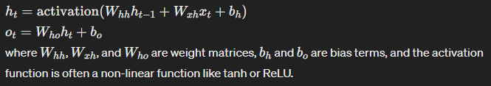
2. Explain Backpropagation through time (BPTT)
Backpropagation through Time (BPTT) is the process of training RNNs by unrolling them across time steps and applying the backpropagation algorithm. Since RNNs share parameters across time, BPTT involves calculating the gradients of the loss function with respect to these parameters at each time step and summing these gradients before making a parameter update. This allows the model to learn long-term dependencies.
3. Explain Vanishing and exploding gradients
- Vanishing Gradients: Occur when gradients of the loss function become increasingly small as they are propagated back through time, causing early layers to learn very slowly or not at all. This makes it difficult for RNNs to capture long-term dependencies.
- Exploding Gradients: Happen when gradients become excessively large, leading to unstable training processes and wildly fluctuating model parameters. This often results in a failure to converge or to model divergence.
4. Explain Long short-term memory (LSTM)
LSTM is a type of RNN designed to overcome the vanishing gradient problem and better capture long-term dependencies. It introduces a memory cell and three gates (input, forget, and output gates) to regulate the flow of information. These gates determine what information is stored, updated, or discarded, allowing the network to maintain a more stable gradient over time and learn from long-distance elements in the data sequence.
5. Explain Gated recurrent unit (GRU)
The Gated Recurrent Unit (GRU) is a variant of the LSTM designed to be simpler and more efficient. It combines the forget and input gates into a single "update gate" and merges the cell state and hidden state, resulting in a model that is easier to compute and achieves similar performance to LSTM on many tasks. GRUs are particularly effective in tasks where the LSTM’s complexity doesn’t offer a clear advantage.
6. Explain Peephole LSTM
Peephole LSTM is a variation of the standard LSTM that allows the gate layers to look at the cell state directly, rather than just the input and previous hidden state. This is achieved by adding "peephole connections" from the cell state to the gate units, which can improve the model's ability to learn precise timing of the outputs.
7. Bidirectional RNNs
Bidirectional RNNs (BiRNNs) process data in both forward and backward directions. This means they have two sets of RNN cells, one for processing the input sequence as it is and another for processing it in reverse. By combining the information from both directions, BiRNNs can capture context from both the past and the future, improving performance on tasks like sequence tagging and anomaly detection.

8. Explain the gates of LSTM with equations.
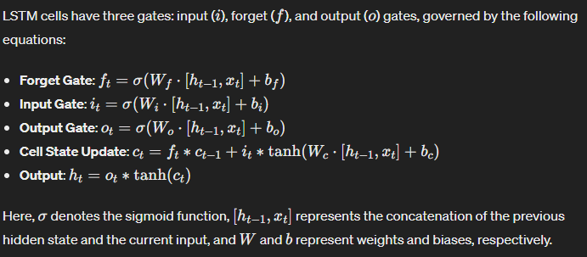
9. Explain BiLSTM
BiLSTM, or Bidirectional Long Short-Term Memory, combines the LSTM architecture with bidirectional processing. It has two LSTM layers running in opposite directions, enabling it to capture information from both the past and the future context. This makes BiLSTMs particularly powerful for tasks involving sequences where context from both directions is crucial for understanding.
10. Explain BiGRU
BiGRU, or Bidirectional Gated Recurrent Unit, applies the bidirectional approach to GRUs. Like BiLSTMs, BiGRUs process data in both forward and backward directions with two GRU layers. This enables the model to leverage information from both past and future, offering advantages in tasks where understanding the full context of a sequence is necessary for accurate predictions.

