Education Board Management System

1. Examiner Assignment

**Information System Design**

**CSE-308**

**1/18/2014**

1.Mohammad ullah Farsid – 1005093  
2.Md. Mostafizur Rahman – 1005100  
3.Abu Naweem Khan – 1005116  
4.Md. Nazmul Huq – 1005117  
5.Muhammad Ahadul Alam-1005118  
6.B.M. Kamruzzaman - 0905101

# 1.1 Use Case Diagram:

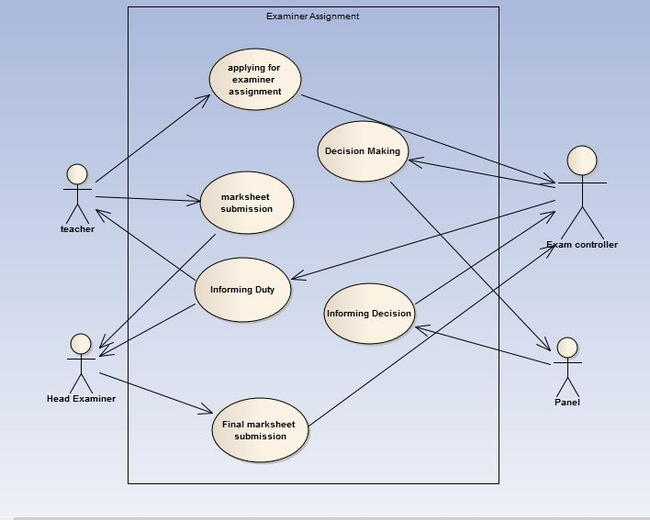

# 1.2 Use Case Glossary:

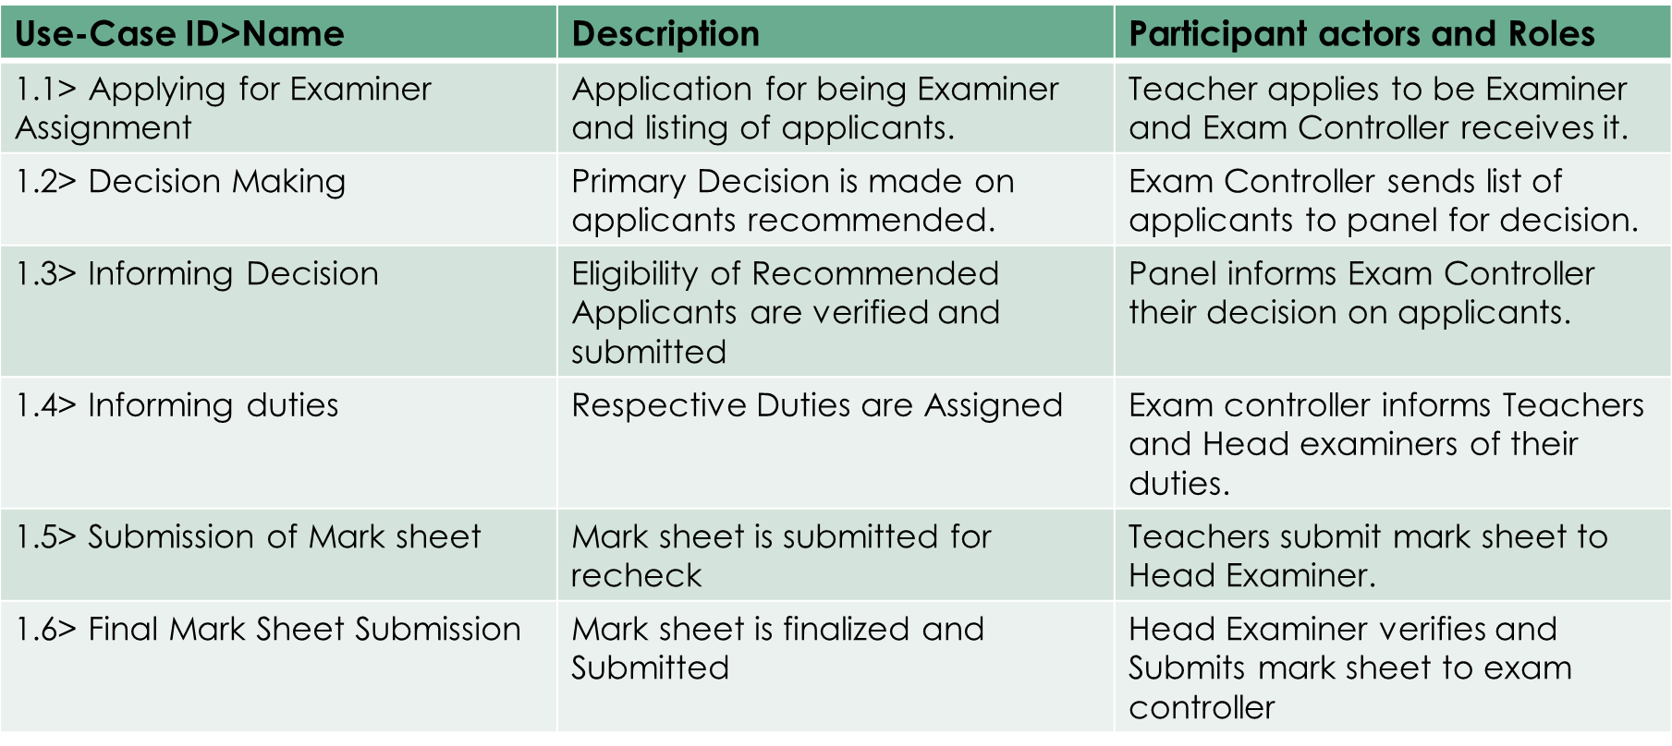

2. Corrections and Applications

# 2.1 Use Case Diagram:

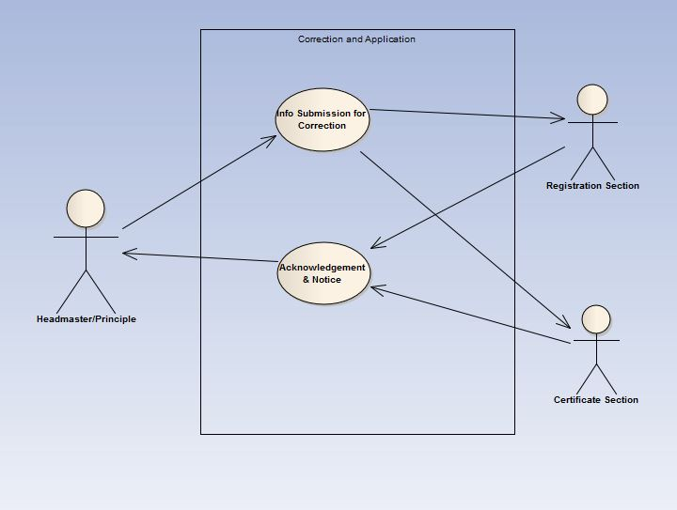

# 2.2 Use Case Glossary:

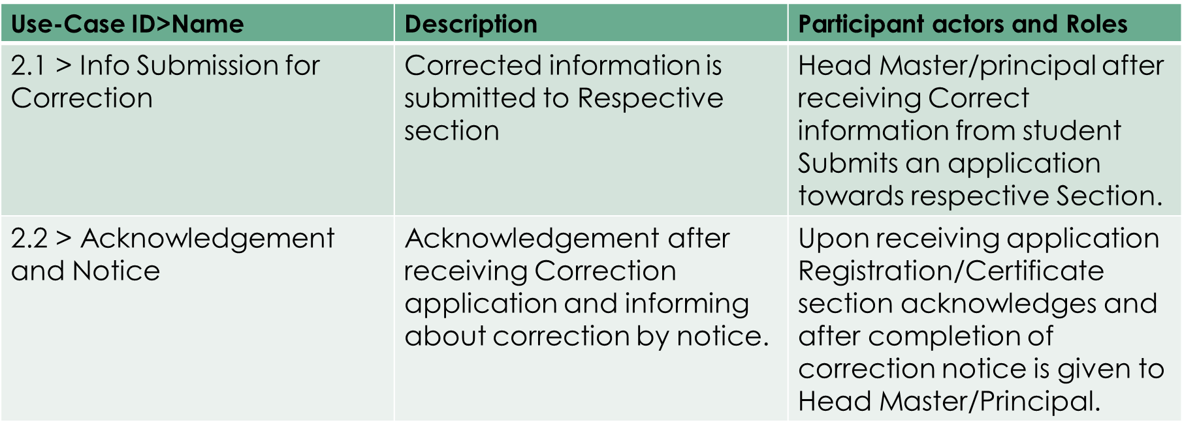

3. Board Exam Question Making And Moderator Assignment

# 3.1 Use Case Diagram:

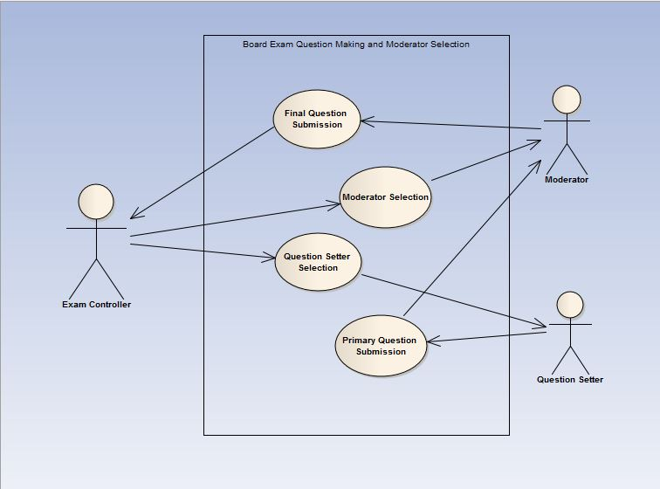

# 3.2 Use Case Glossary:

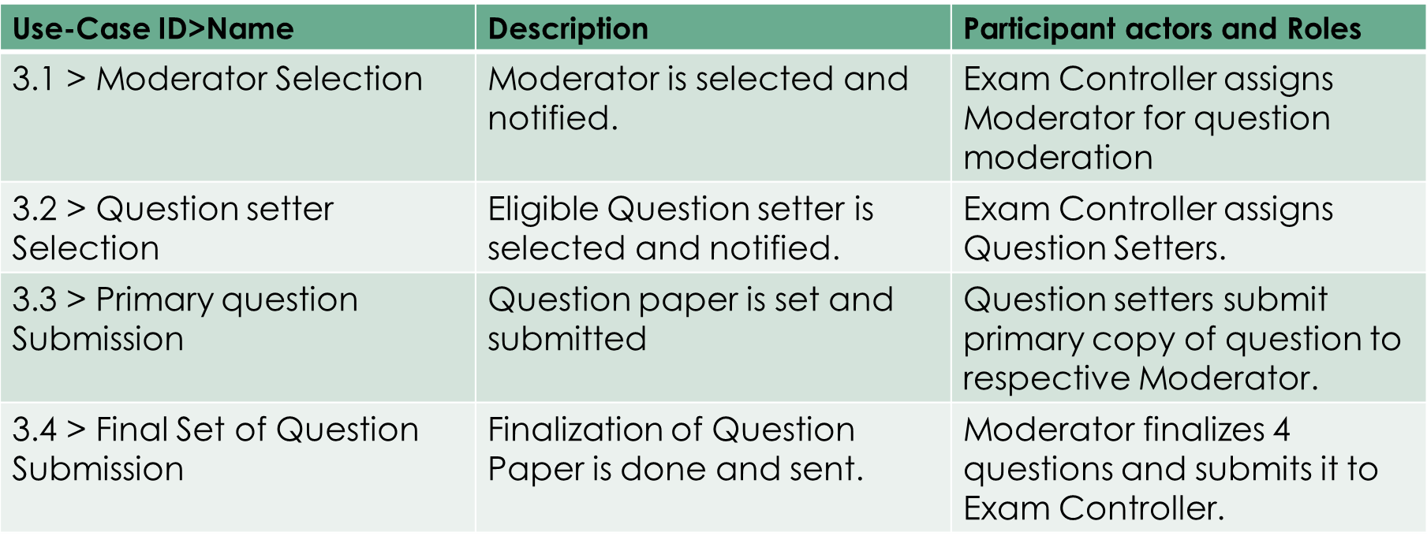

4. Student Transfer

# 4.1 Use Case Diagram:

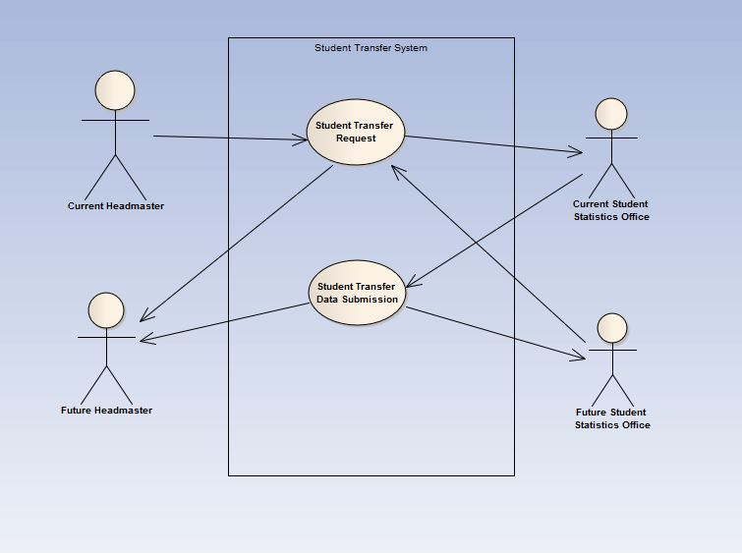

# 4.2 Use Case Glossary:

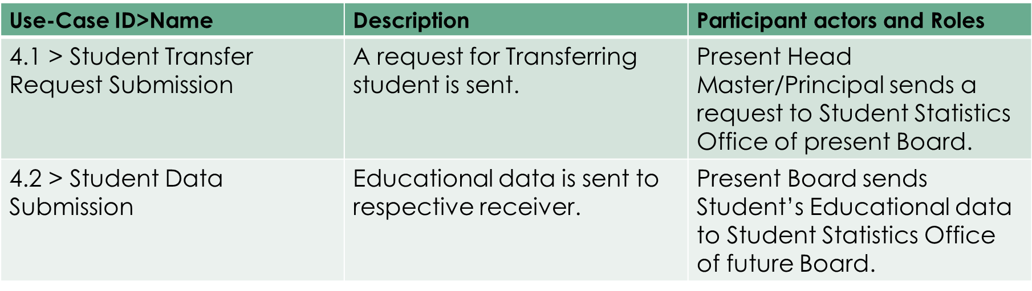

5. Teacher Info subsystem

# 5.1 Use Case Diagram:

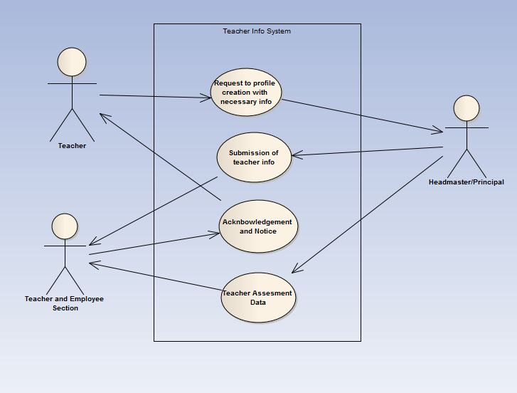

# 5.2 Use Case Glossary:

