Education Board Management System

1. Examiner Assignment

**Information System Design**

**CSE-308**

**1/25/2014**

1.Mohammad ullah Farsid – 1005093  
2.Md. Mostafizur Rahman – 1005100  
3.Abu Naweem Khan – 1005116  
4.Md. Nazmul Huq – 1005117  
5.Muhammad Ahadul Alam-1005118  
6.B.M. Kamruzzaman - 0905101

# 1.1 Data Flow Diagram:



# 1.2 Fish-Bone Diagram:

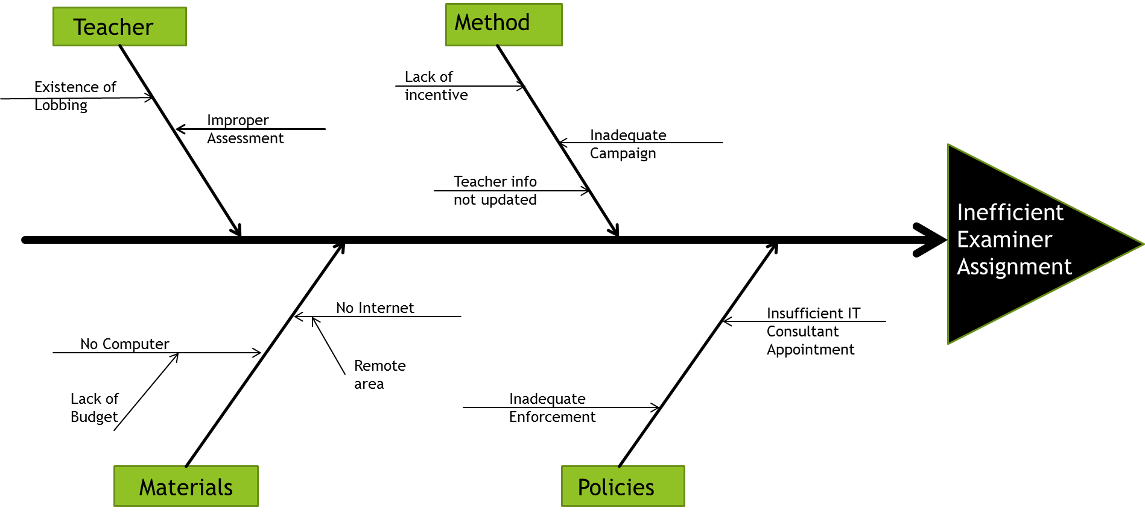

2. Corrections and Applications

# 2.1 Data Flow Diagram:



# 2.2 Fish-Bone Diagram:

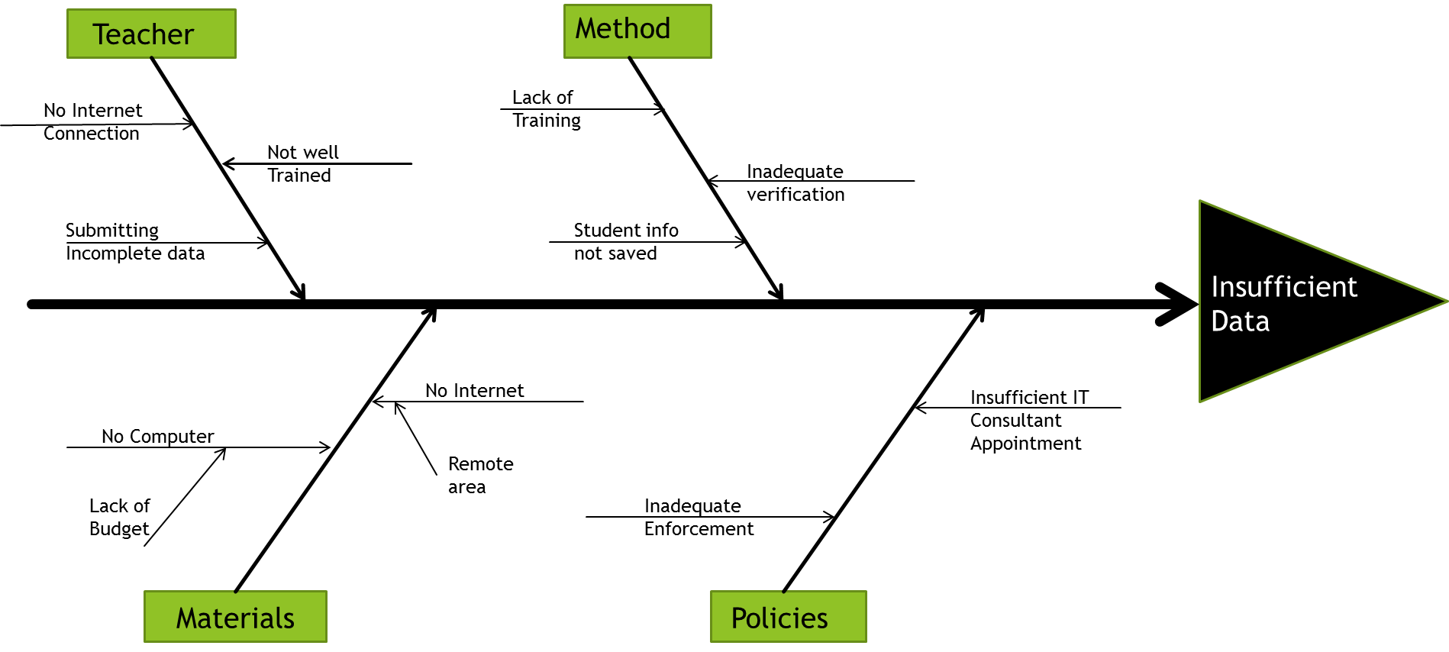

3. Board Exam Question Making And Moderator Assignment

# 3.1 Data Flow Diagram:



# 3.2 Fish-Bone Diagram:

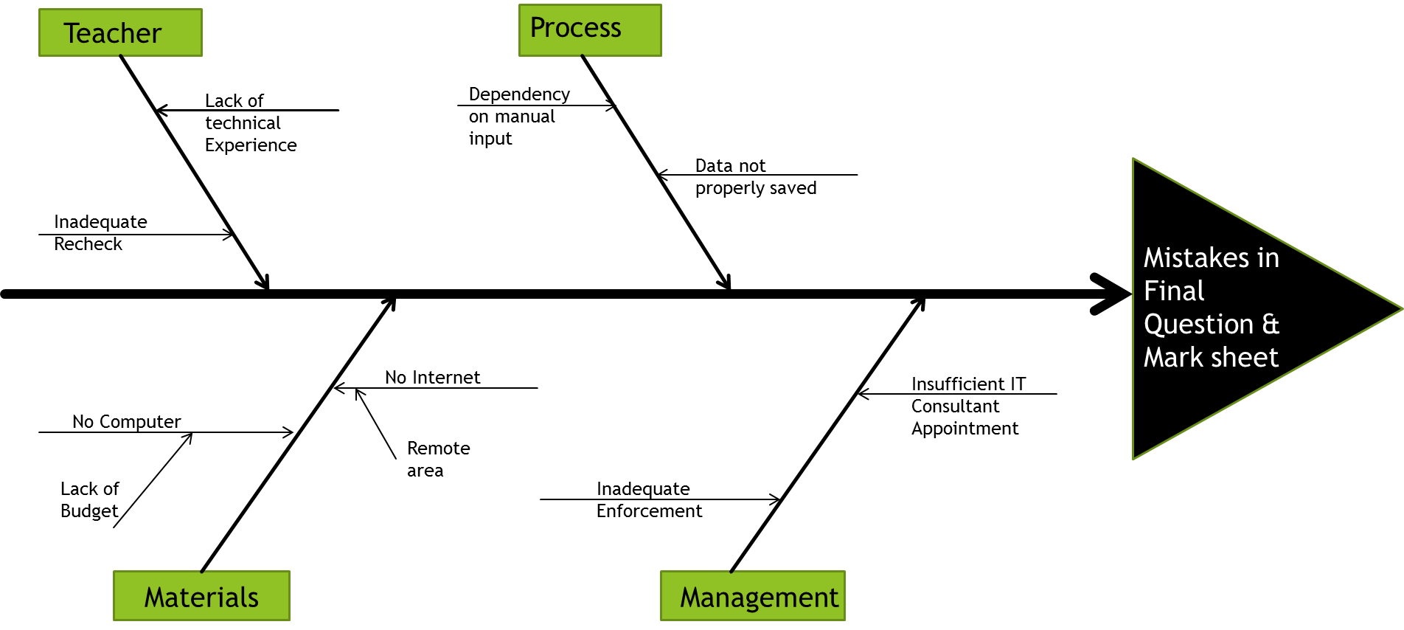

4. Student Transfer

# 4.1 Data Flow Diagram:



# 4.2 Fish-Bone Diagram:

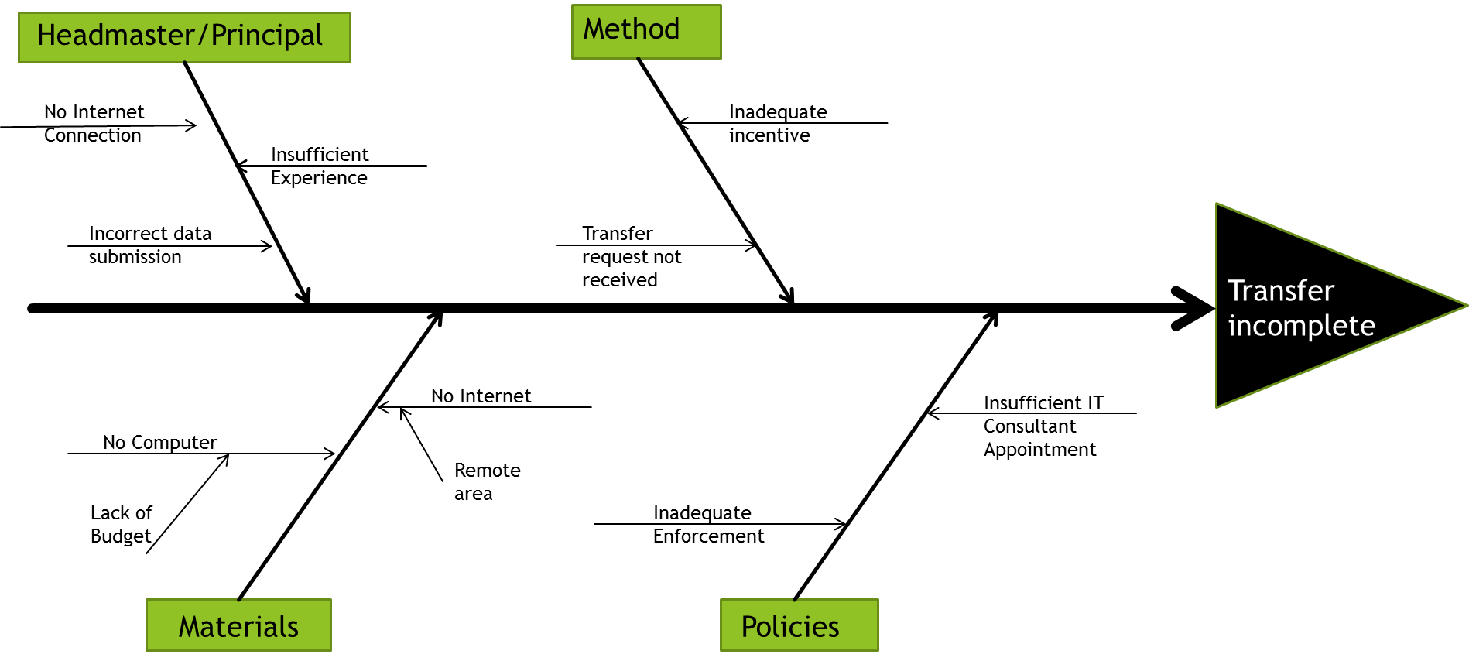

5. Teacher Info subsystem

# 5.1 Data Flow Diagram:



# 5.2 Fish-Bone Diagram:

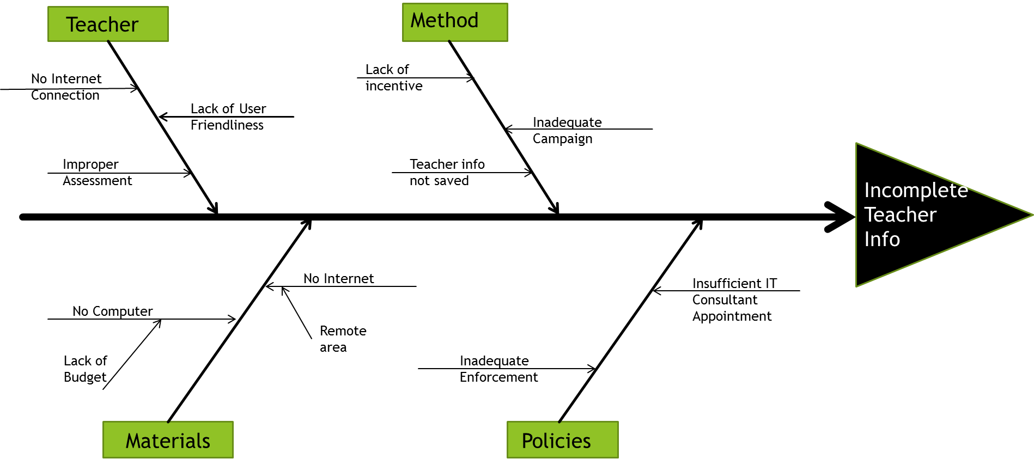

6. Feasibility Study

# 6.1 Operational Feasibility:

Operation related issues:

|  |  |  |  |  |
| --- | --- | --- | --- | --- |
|  |  | Low Potential (0) | Moderate Potential (+1) | High Potential (+2) |
| 1. | Number of Participants | Few | Many | Few |
| 2. | Stage of Project life cycle | Maturity phase | Growth phase | Emergence phase |
| 3. | Growth rate of Project | Little growth | Moderate growth | Strong growth |
| 4. | Importance of Project’s services to Participants | “Ambivalent” | “Would like to have” | “Must have” |
|  |  |  |  |  |

During maturity phase the potential of our project remains almost zero. At this time few people of Moderate potential and High potential will be involved. As a result the operational Feasibility during development phase remains within a range of 0 to 5.

During Growth phase the potential of our project is higher than that of maturity phase. At this time many participants of moderate potential is likely to be involved in our project. Due to increase in participants the operational feasibility increases and potential becomes 4 to almost 6.

During Emergence phase the operational feasibility becomes much higher and reaches to a potential of 8.

# 6.2 Cultural Feasibility:

Cultural Feasibility issues:

|  |  |  |  |  |
| --- | --- | --- | --- | --- |
|  | Issues | Initial Stage (Maturity phase) | Intermediate Stage (Growth phase) | Final Stage (Strong growth) |
| 1. | Technical impact | High | Medium | Few |
| 2. | Acceptance To Participants. | Low | Medium | Normal |
| 3. | Comfort Level | Low | Medium | High |
| 4. | Participation Level | Low | Medium | High |
|  |  |  |  |  |

During initial Stage due to Issues such as technical impact on participants and also due to discomfort with a new system the feasibility remains low on an average. But as the project grows and number of participants increases the likelihood of feasibility of the project to be implemented.

# 6.3 Technical Feasibility:

This section of the feasibility study explains any considerations the involved offices must make with regards to technology. Many new initiatives rely on technology to manage or monitor various process of the system.

The table below assigns Feasibility potential according to Growth of the project.

|  |  |  |  |  |
| --- | --- | --- | --- | --- |
|  | Issues | Initial Stage (Maturity phase) | Intermediate Stage (Growth phase) | Final Stage (Strong growth) |
| 1. | Extent to which the idea:   * Takes advantage of an existing trend * Addresses an unfilled gap in the Technology | Weak  Weak | Weak  Moderate | Weak  Strong |
| 2. | System Implementation Delay | Not timely | Moderately timely | Timely |
| 3. | Cost of new IT establishment | Moderate | Low | None |
| 4. | Expenses for technical maintenance | Needs subsidy | Needs Budget plan | Only maintenance cost |
| 5. | Degree to which the idea requires Participants to change their basic practices or behaviors | Substantial IT changes required | Moderate IT changes required | Small to no IT changes required |

# 6.4 Economic Benefits:

The system brings economic benefits in various criteria that can mobilize current educational lifestyle. The table below describes how it reduce expenses:

|  |  |  |  |  |  |
| --- | --- | --- | --- | --- | --- |
|  | Issues | Initial Stage (Maturity phase) | Intermediate Stage (Growth phase) | | Final Stage (Strong growth) |
| 1. | Initial capital investment | High | Moderate | | Low |
| 2. | Involvement of Corruption | Moderate | | Low | Low |
| 3. | Financial performance of similar activity | Weak | Modest | | Strong |
| 4. | Training expenses | High | Moderate | | Low |

7. Tangible and Intangible Benefits of EBMS Initiative:

Our project improves the activities of Education Board which will automatically see the direct advantage of it in terms of profitability. Below are few ways through which the EBMS benefits the Education board with the above goal in mind.

7.1 Reduction of Corruption:

It is known to all that our Education Boards are highly associated with corruption. So our system is a means to reduce it. If we can automate the entire education board we can reduce the corruption associated with education board to a significant amount.

7.2 Facilitates Communication:

Automated system reduces the difficulties of communication. Since internet is currently the easiest medium of communication, our system facilitates the activities of our education board to a large extent.

# 7.3 Reduces time consumption:

The existing system in our education board is very time consuming. Our system if implemented will reduce waste of time, money, labour manifold.