Education Board Management System

1. Examiner Assignment

**Information System Design**

**CSE-308**

1.Mohammad ullah Farsid – 1005093  
2.Md. Mostafizur Rahman – 1005100  
3.Abu Naweem Khan – 1005116  
4.Md. Nazmul Huq – 1005117  
5.Muhammad Ahadul Alam-1005118  
6.B.M. Kamruzzaman - 0905101

# 1.1 Class Diagrams:



 

# I:\ExaminerAssignmtApp.jpg1.2 Collaboration Diagrams:

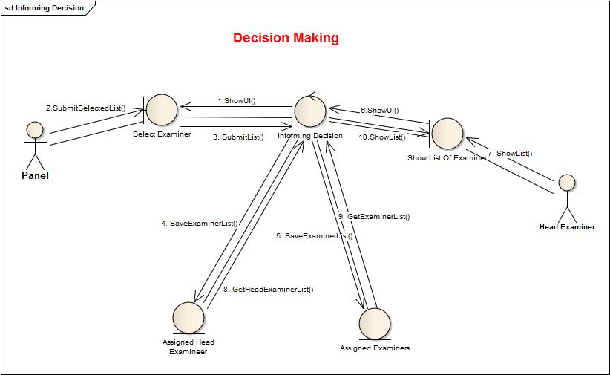

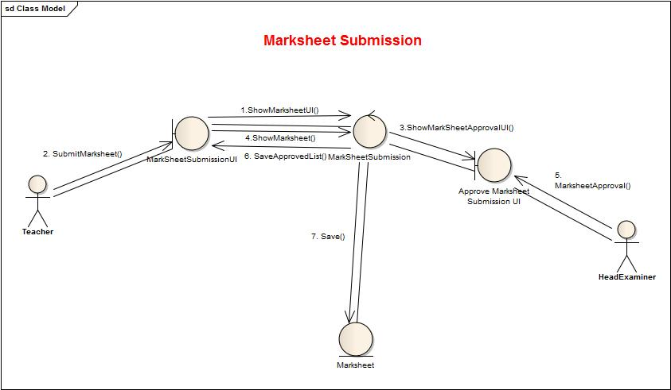 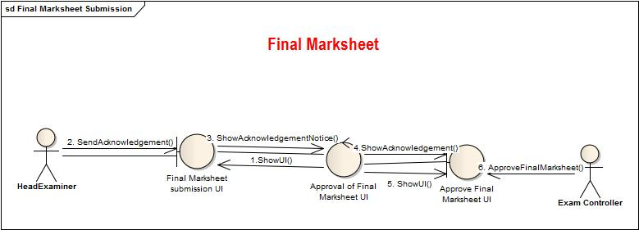

2. Corrections and Applications

# 2.1 Class Diagrams:





# 2.2 Collaboration Diagrams:

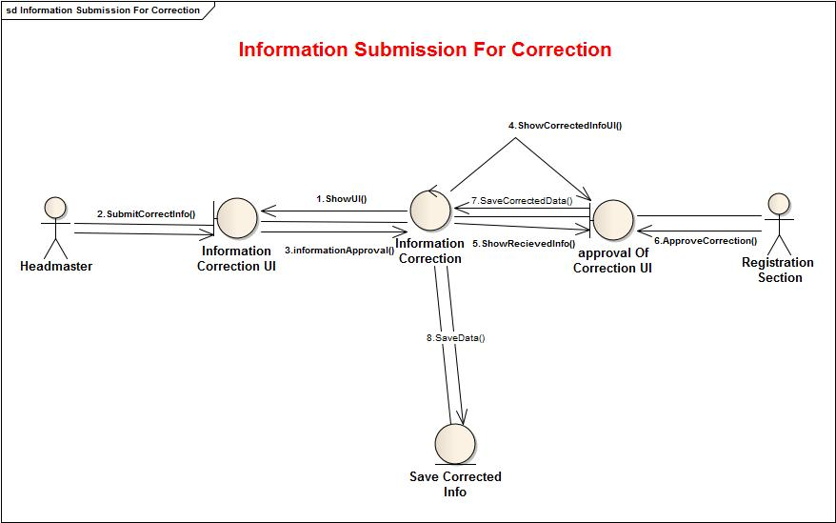

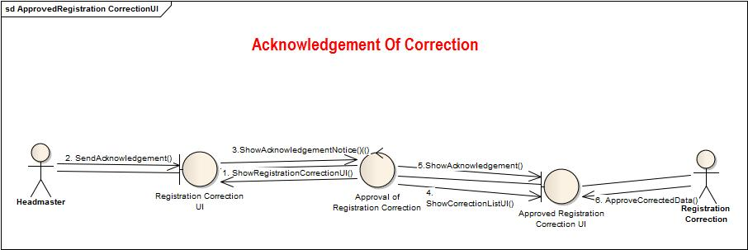

3. Board Exam Question Making and Moderator Assignment

# 3.1 Class Diagrams:



# 3.2 Collaboration Diagrams:

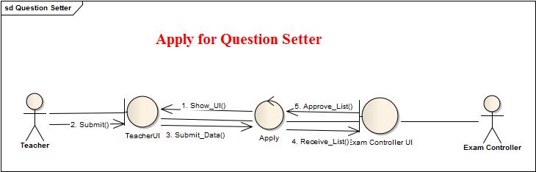

4. Student Transfer

# 4.1 Class Diagrams:

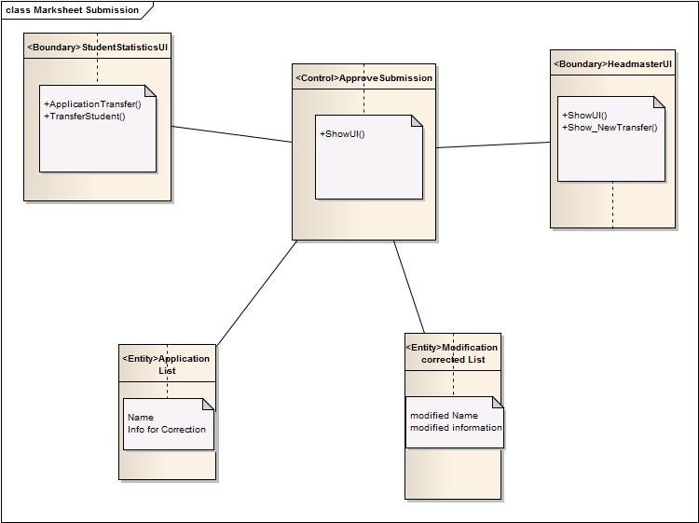



# 4.2 Collaboration Diagrams:

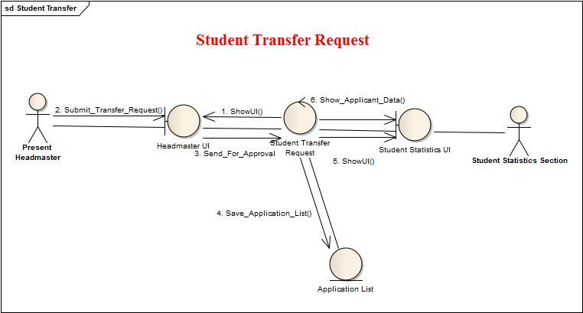

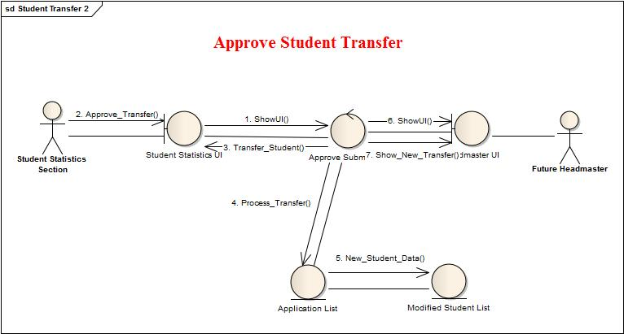

5. Teacher Info subsystem

# 5.1 Class Diagrams:

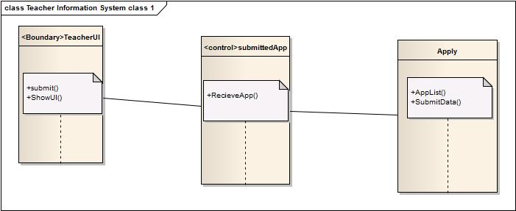



# 5.2 Collaboration Diagrams:

