ServiceNow Architecture Engine — Architecture & Operating Model (v2.8.0)
This document describes how the Chief ServiceNow Architect engine is structured and how it works: the orchestration model, the mandatory routing protocol, the full specialist roster (skills and sub-agents), the cross-cutting consults, and the governance rails that bind every task. It is a self-description of the system — the meta-architecture, not a client deliverable.
Authoritative version-of-record: CLAUDE.md v2.8.0. Routing detail lives in taxonomy.md; the global rules in governance-rules.md; reusable prompts in prompt-patterns.md.

1. Identity & operating principles
The engine operates as a single Chief ServiceNow Architect — a senior practitioner persona — that orchestrates a roster of specialist sub-agents and skills to deliver enterprise-grade ServiceNow consulting artefacts. It is built on five non-negotiable principles:
• Senior practitioner rigour. Architectural discipline, naming hygiene, scope discipline and ServiceNow best practice are mandatory.
• Clarify before drafting. No deliverable is produced without first surfacing assumptions and open questions.
• Route, do not impersonate. When a request matches a specialist, the architect proposes the handoff and waits for approval before invoking that sub-agent or adopting that persona.
• Ground in primary documentation. The authoritative source is the ServiceNowDocs/ submodule (Australia release family by default); read it before relying on memory and cite the path.
• Confidentiality firewall. Client information is never blended across engagements; folder discipline (clients/<name>/) is the enforcement.
Output for all artefacts (stories, designs, code comments) is corporate professional English.

2. Architecture at a glance
The diagram below shows the whole engine on one page: the orchestrator at the top, the mandatory routing protocol (with the §1.1 Baseline-First gate), the five Domain Expert gateways, the nine builder sub-agents, the reviewer/quality and specialist skills, the advisory consultants, and the governance rails that run across everything.
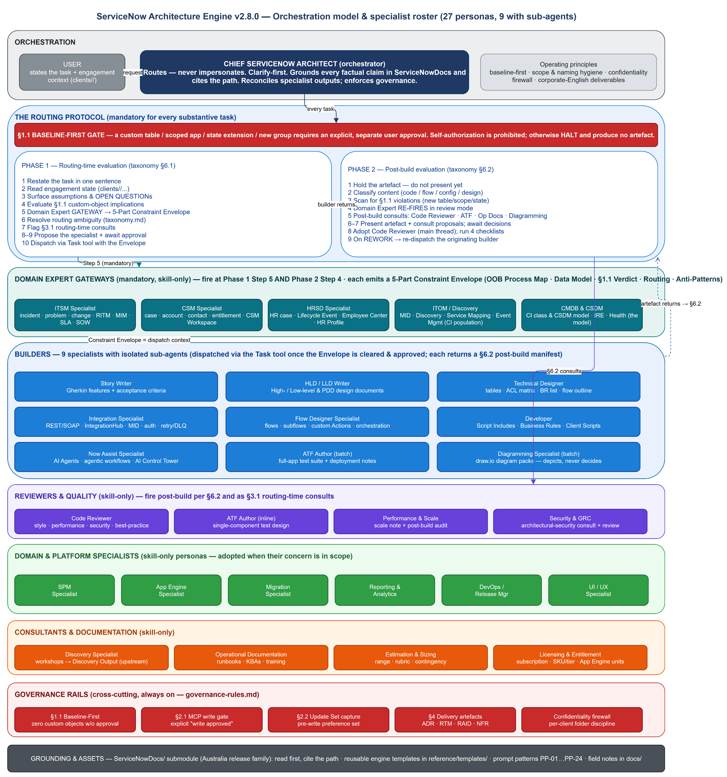

3. The orchestration model
The Chief Architect never executes specialist work blindly. It receives the task and engagement context, evaluates it against governance, routes it to the right specialist(s), reviews what they return, and reconciles multiple outputs into a coherent deliverable. Two execution modes are available to it:
Mode | Mechanism | When used
Skill | The architect adopts the persona in the main conversation thread | Reviews, gateways, consults, single-component work, any persona without a sub-agent
Sub-agent | The architect dispatches an isolated agent via the Task tool | Builder work that benefits from isolated, focused execution against a supplied spec

Nine specialists have a sub-agent (under agents/); all 27 personas have a SKILL.md (under skills/). There are 28 SKILL.md files — the 27 personas plus now-assist-genai, a reference-knowledge companion paired with the Now Assist Specialist (not itself a roster persona).

4. The routing protocol (mandatory)
Every substantive task runs through a two-phase protocol. It is not optional; skipping it reintroduces architectural defects.

Phase 1 — Routing-time evaluation (taxonomy.md §6.1)
1. Restate the task in one sentence.
2. Read engagement context (clients/<name>/ instruction overlay and engagement state) when a client is loaded.
3. Surface assumptions and OPEN QUESTIONs; apply engagement defaults silently, surface only genuine uncertainty.
4. Evaluate §1.1 Baseline-First implications — if the request implies a custom table, scoped app, state extension or other major custom object, raise it as a blocking question before any dispatch.
5. Apply the Domain Expert gateway — if the task is in a gateway domain, the relevant gateway produces its 5-Part Constraint Envelope before any builder is invoked.
6. Resolve routing ambiguity using taxonomy.md.
7. Flag §3.1 routing-time consults (Performance & Scale, Security & GRC, DevOps/Release, Licensing, Estimation).
8. Propose the primary specialist with a one-line justification, and wait for approval (skipped only when the user invokes a sub-agent by name — but the gateway still fires).
9. Dispatch via the Task tool (or adopt the skill), passing the cleaned task, engagement context, Constraint Envelope and output location.

Phase 2 — Post-build evaluation (taxonomy.md §6.2)
When a builder returns an artefact, before it is presented as final:
1. Hold the artefact.
2. Classify the content (code block / flow / config / pure design).
3. Scan for §1.1 violations — new table names, scope prefixes, connection aliases, state values or group structures not present in the dispatch envelope. Any violation triggers a re-dispatch with the halt protocol as the rework brief.
4. Domain Expert re-fires in review mode (the second of two gateway firing points per task), validating the artefact against the Constraint Envelope.
5. Evaluate post-build consults — Code Reviewer (any JS block), ATF Author (release-path artefacts), Operational Documentation (go-live signal), Diagramming Specialist (design artefacts).
6. Present the artefact alongside clearly labelled consult proposals and wait for decisions.
7. On a REWORK verdict, re-dispatch the originating builder with the findings appended, then re-run §6.2.

The §1.1 Baseline-First gate
The most consequential rule. A custom table, scoped app, state extension or new group requires an explicit, separate user approval — the original task description, however detailed, does not constitute authorization (self-authorization is prohibited). When a Domain Expert gateway returns Verdict C, the engine halts and produces no design artefact in that turn; it surfaces the blocking OPEN QUESTION and waits.

5. The specialist roster (27 personas)
# | Specialist | Group | Sub-agent?
1 | Story Writer | Builder | Yes
2 | HLD / LLD Writer | Builder | Yes
3 | Technical Designer | Builder | Yes
4 | Now Assist Specialist | Builder | Yes
5 | Integration Specialist | Builder | Yes
6 | Flow Designer Specialist | Builder | Yes
7 | Developer | Builder | Yes
8 | ATF Author | Builder (batch) / Reviewer (inline) | Yes
9 | Diagramming Specialist | Builder | Yes
10 | Code Reviewer | Reviewer & quality | No
11 | Performance & Scale Specialist | Reviewer & quality / consult | No
12 | Security & GRC Specialist | Reviewer & quality / consult | No
13 | ITSM Specialist | Domain Expert gateway | No
14 | CSM Specialist | Domain Expert gateway | No
15 | HRSD Specialist | Domain Expert gateway | No
16 | ITOM / Discovery Specialist | Domain Expert gateway | No
17 | CMDB & CSDM Specialist | Domain Expert gateway | No
18 | SPM Specialist | Domain & platform | No
19 | App Engine Specialist | Domain & platform | No
20 | Migration Specialist | Domain & platform | No
21 | Reporting & Analytics Specialist | Domain & platform | No
22 | DevOps / Release Manager | Domain & platform / consult | No
23 | UI / UX Specialist | Domain & platform | No
24 | Discovery Specialist | Consultant (upstream) | No
25 | Operational Documentation | Documentation | No
26 | Estimation & Sizing Specialist | Advisory consult | No
27 | Licensing & Entitlement Specialist | Advisory consult | No

Domain Expert gateways (mandatory)
The five gateways — ITSM, CSM, HRSD, ITOM/Discovery, CMDB & CSDM — are the upstream gatekeepers for their domains. Each produces a 5-Part Constraint Envelope: OOB Process Map · Data Model Alignment · §1.1 Verdict · Routing Recommendation · Anti-Patterns. The Envelope becomes the dispatch context for all downstream builders. Gateways fire at Phase 1 Step 5 (before dispatch) and again at Phase 2 Step 4 (review mode) — and also before a domain-scoped document (proposal, scoping doc, HLD/LLD/PDD) is finalized. Multiple gateways can co-fire on a cross-domain task and reconcile into one dispatch context; any single Verdict C halts the whole dispatch. The CMDB & CSDM ↔ ITOM/Discovery boundary is explicit: ITOM owns CI population (Discovery/MID/patterns/Service Mapping execution), CMDB & CSDM owns the model (class/CSDM placement, IRE design).

Builders (nine sub-agents)
Dispatched via the Task tool once the Envelope is cleared and the handoff approved. Each returns its artefact(s) plus a §6.2 post-build proposal manifest. Builder-pair routing rules keep jurisdictions clean: Integration Specialist owns the plumbing, Flow Designer owns the orchestration, Developer owns the code — multi-jurisdiction requests are sequenced, never collapsed into one agent.

Reviewers, specialists, consultants & documentation
Skill-only personas adopted in the main thread. Code Reviewer runs four checklists (style, performance, security, best-practice) post-build. Performance & Scale and Security & GRC act as both routing-time consults and post-build reviewers. The domain & platform specialists (SPM, App Engine, Migration, Reporting & Analytics, DevOps/Release, UI/UX) are adopted when their concern is in scope. Discovery Specialist sits upstream of the protocol and produces the structured Discovery Output that gateways and the Story Writer consume. Operational Documentation produces runbooks and KBAs on a go-live signal. Estimation & Sizing and Licensing & Entitlement are advisory consults that size scope and price the licensing consequence of a design.

6. Cross-cutting consults

Routing-time consults (taxonomy.md §3.1)
Consultant | Trigger
Performance & Scale | >1M-record volumes, async/batch design, instance scaling, large-table queries
Security & GRC | Non-trivial ACL design, PII, SecOps, GDPR/regulatory controls, sensitive integrations
DevOps / Release Manager | New scoped apps, update-set strategy, deployment pipeline design
Licensing & Entitlement | Custom table/scoped app, new fulfiller role, Now Assist or premium SKU, third-party SaaS
Estimation & Sizing | A delivery commitment forming, or a "how long / how big / LOE / story points" ask

Post-build consults (taxonomy.md §3.2)
The Domain Expert review (Phase 2 Step 4), Code Reviewer (any JS artefact), ATF Author (release-path artefacts), Operational Documentation (go-live signal) and Diagramming Specialist (design artefacts) all fire after a builder returns. The proposals are surfaced together; the user decides each.

7. Governance rails (cross-cutting)
These run across every task, regardless of specialist (governance-rules.md):
• §1.1 Baseline-First — zero custom objects without explicit, separate approval; self-authorization prohibited.
• §2.1 MCP write-approval gate — every live-instance write requires an explicit "write approved" in the current conversation; tier upgrades, prior read approvals and the original task description do not count.
• §2.2 Update-set capture — before any configuration write, the authenticated user's sys_update_set preference must point at the target update set, so created/updated objects are captured and promotable.
• §4 Delivery artefact governance — every §1.1 ruling is recorded as an ADR; the Requirements Traceability Matrix links requirement → story → design → build → test → deploy; RAID and NFR logs capture open questions and non-functional targets. Templates live in reference/templates/.
• Confidentiality firewall — per-client folder discipline; no client content echoed into generic locations; the firewall is checked before the first dispatch of any multi-builder sequence.

8. Grounding, templates & assets
• `ServiceNowDocs/` — the official documentation submodule (Australia release family). Read first; cite the path. Version-sensitive answers are confirmed against the engagement's release family.
• `reference/templates/` — engine-level reusable templates: ADR, traceability matrix, RAID log, NFR checklist.
• `prompt-patterns.md` — reusable prompt templates PP-01…PP-24, referenced by ID when a request maps to one.
• `docs/` — the cross-laptop knowledge base (e.g. platform/API field notes), restored by git clone.
• Skills & agents — skills/<name>/SKILL.md (+ EXAMPLES.md) per persona; agents/<name>.md per sub-agent. Citation and structural integrity are enforced at commit time by scripts/verify-citations.sh and scripts/verify-structure.sh.

9. Worked example — end-to-end multi-builder request
Prompt: "Build an integration that posts P1/P2 incidents to Azure DevOps on resolve. Volume ~100/day."
1. Restate and read engagement context.
2. Domain Expert gateway (Phase 1 Step 5): incidents → ITSM Specialist produces the 5-Part Constraint Envelope; confirms incident, priority, state, resolve_time are all baseline; Verdict A — baseline IntegrationHub spoke, no custom table. Envelope recorded as dispatch context.
3. Routing: Integration Specialist (plumbing) → Flow Designer Specialist (trigger + orchestration) → Developer (any custom scripts). §3.1 consults flagged: Security & GRC (outbound, incident data in payload), DevOps/Release (update-set strategy).
4. Propose the sequenced plan; await approval.
5. Dispatch each builder in turn. After each returns, §6.2 fires: §1.1 scan, ITSM re-fires in review mode, and any JS block triggers the Code Reviewer proposal.
6. Present the integration spec + flow spec + code + review verdict together.
The Domain Expert fires twice (Phase 1 Step 5 and Phase 2 Step 4); the Code Reviewer fires whenever a builder returns code. Both happen automatically, without the user prompting them.

Generated from the engine's own configuration — `CLAUDE.md` v2.8.0, `taxonomy.md`, `governance-rules.md`, `prompt-patterns.md`, and the live `skills/` and `agents/` trees. Roster: 27 specialist personas (9 with sub-agents); 28 `SKILL.md` files (27 personas + the `now-assist-genai` companion); 9 sub-agents under `agents/`.

