users:1 million+

tb:data volume

perf:microseconds

req rate:millions

access:mobilr,iot,devices,

scale:up-out-in

economics:pay as u go

low latency

high concurency

manage data in memory

yum update

sudo amazon-linux-extras install redis4.0

yum install redis4.0

redis-cli -h bismillah.nx10db.ng.0001.aps1.cache.amazonaws.com

ZADD leaderboard 132 Robert

ZADD leaderboard 231 Sandra

ZADD leaderboard 32 June

ZADD leaderboard 381 Adam

ZREVRANGEBYSCORE leaderboard +inf -inf

1) Adam

2) Sandra

3) Robert

4) June

ZADD leaderboard 232 June

ZREVRANGEBYSCORE leaderboard +inf -inf

1) Adam

2) June

3) Sandra

4) Robert

stackoverflow…datastore no.7 redis

step1 add a security group

one for REdis with Custom TCP and port 6379 and source of another

SG Webserver with its groupid as source...

Step2

Go to Elasticache service

Click on cache subnet groups->create cache subnet group

Step3

Elasticache dashboard

Click on redis->disable replica(in real ul enable)

Type t2->cache subnet grp(select the created one)->no pref

->vpc security the redis one

->no pref->disable sns->next review

**ElastiCache for Redis**

Amazon ElastiCache is a web service that makes it easy to deploy, operate, and scale an in-memory data store or cache in the cloud. The service improves the performance of web applications by allowing you to retrieve information from fast, managed, in-memory data stores, instead of relying entirely on slower disk-based databases.

The basic building block of Amazon ElastiCache is the node. Nodes are configured singularly or in groupings to form clusters. When determining the node type to use for your cluster, take the cluster’s node configuration and the amount of data you have to store into consideration.

Amazon ElastiCache for Redis is a blazing fast in-memory data store that provides sub-millisecond latency to power internet-scale real-time applications. Built on open-source Redis and compatible with the Redis APIs, ElastiCache for Redis works with your Redis clients and uses the open Redis data format to store your data.

**Steps:**

* Search for ElastiCache using search bar

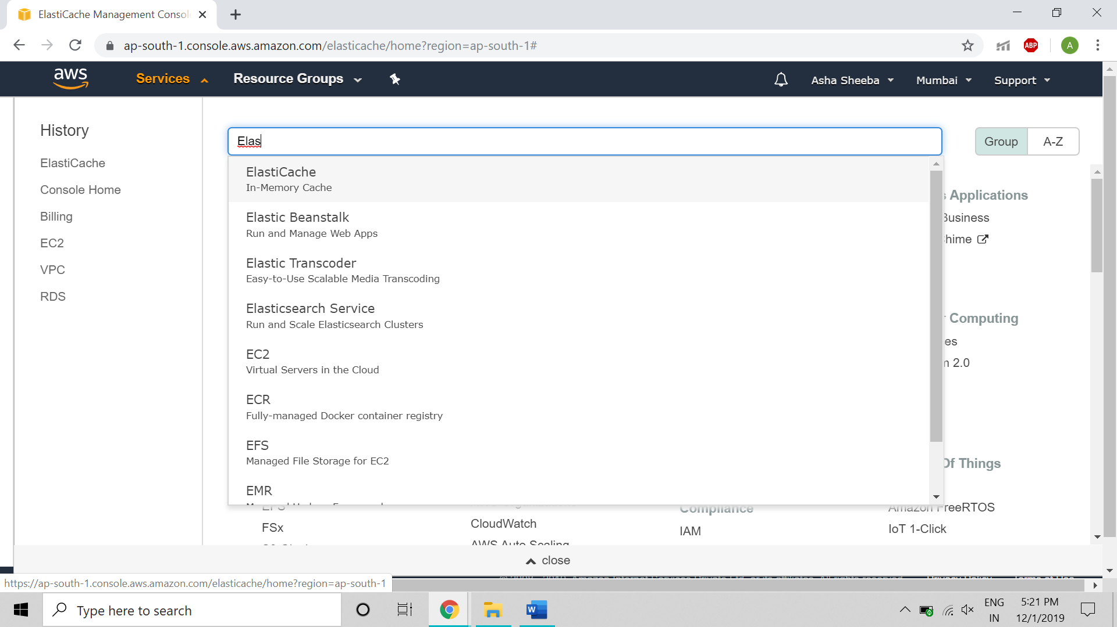

* Click on Redis which is to the left panel

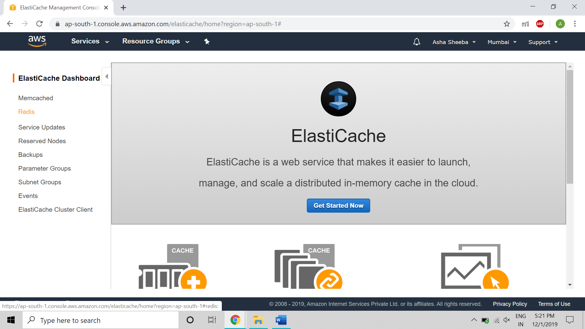

* By default Redis will be selected,if needed enable(in real-type enabling is used) or disable clustering and then by configuring we input the name here as REDIS1,Description,the capability of the version will be given by default

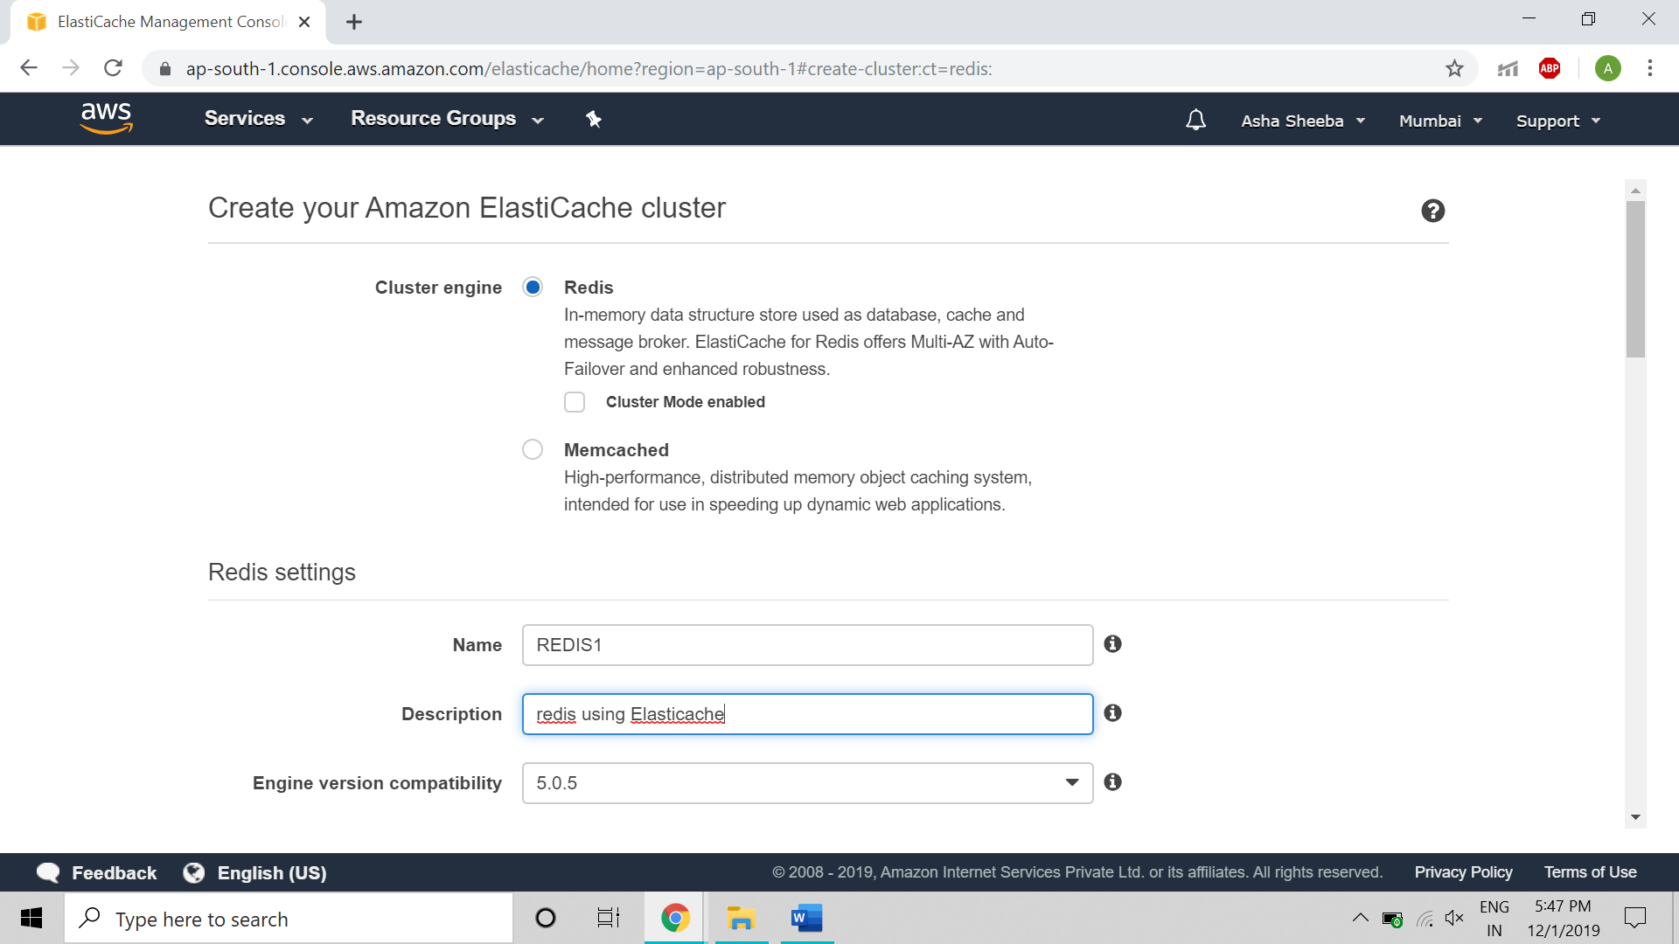

* The port number for redis is 6379, parameter group is by default present, node type is important, as this is a demo and it is chargeable here we use is a t2 with least memory,also replicas in number here I have given 2.

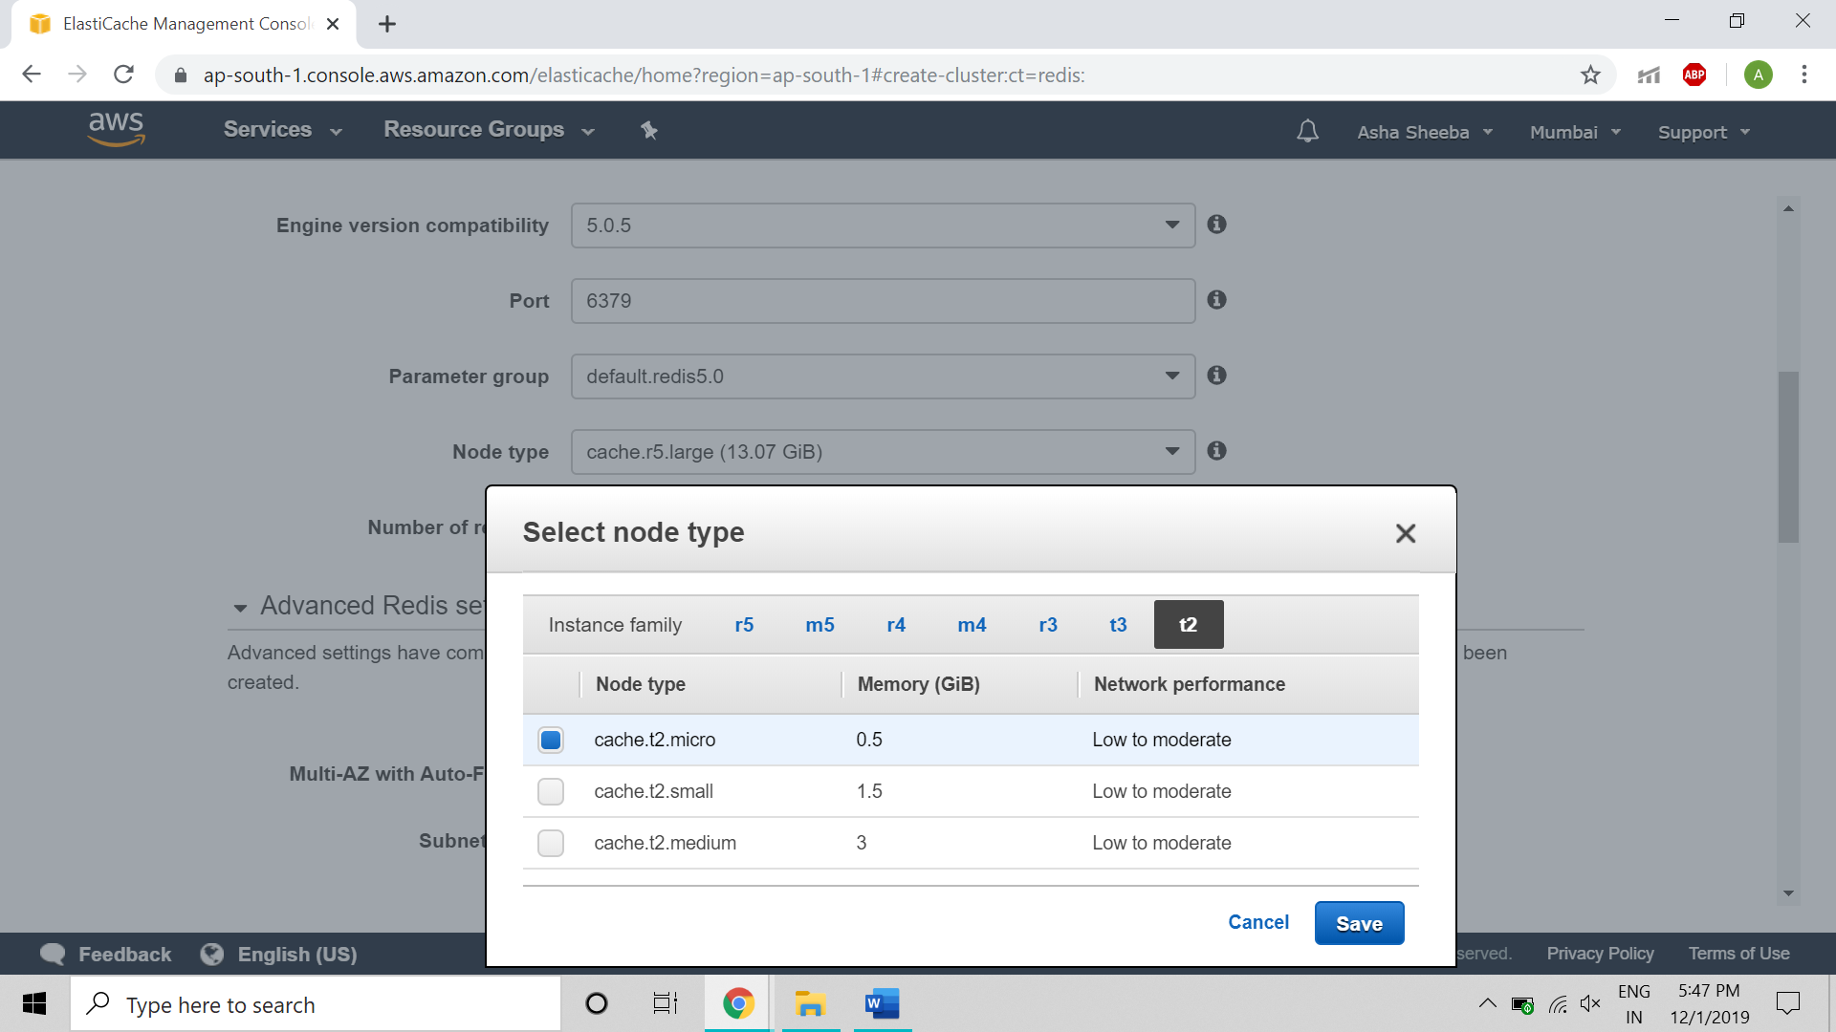

* Moving forward we input by selecting subnet group and availability zones if needed.

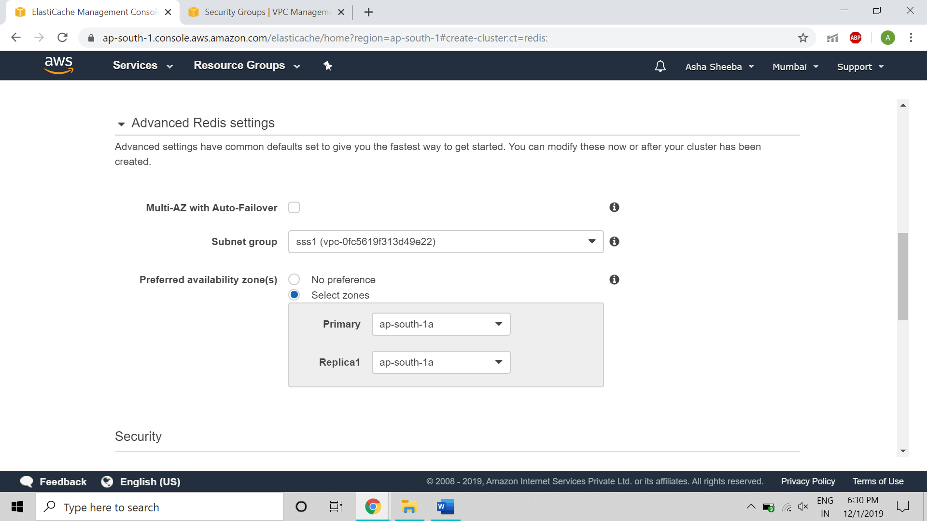

* For security group add Custom TCP with port of redis 6739 during creation and select it as shown in below figure,disable encryption but in real you will be needing it.

If any data to be given can be imported using S3 bucket.Backup option should be enabled for use in real.

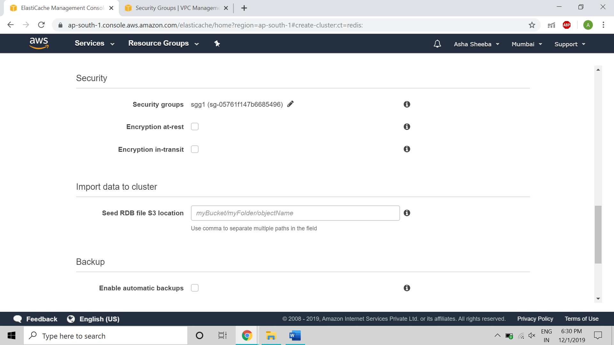

* Just click on create for an redis single cluster

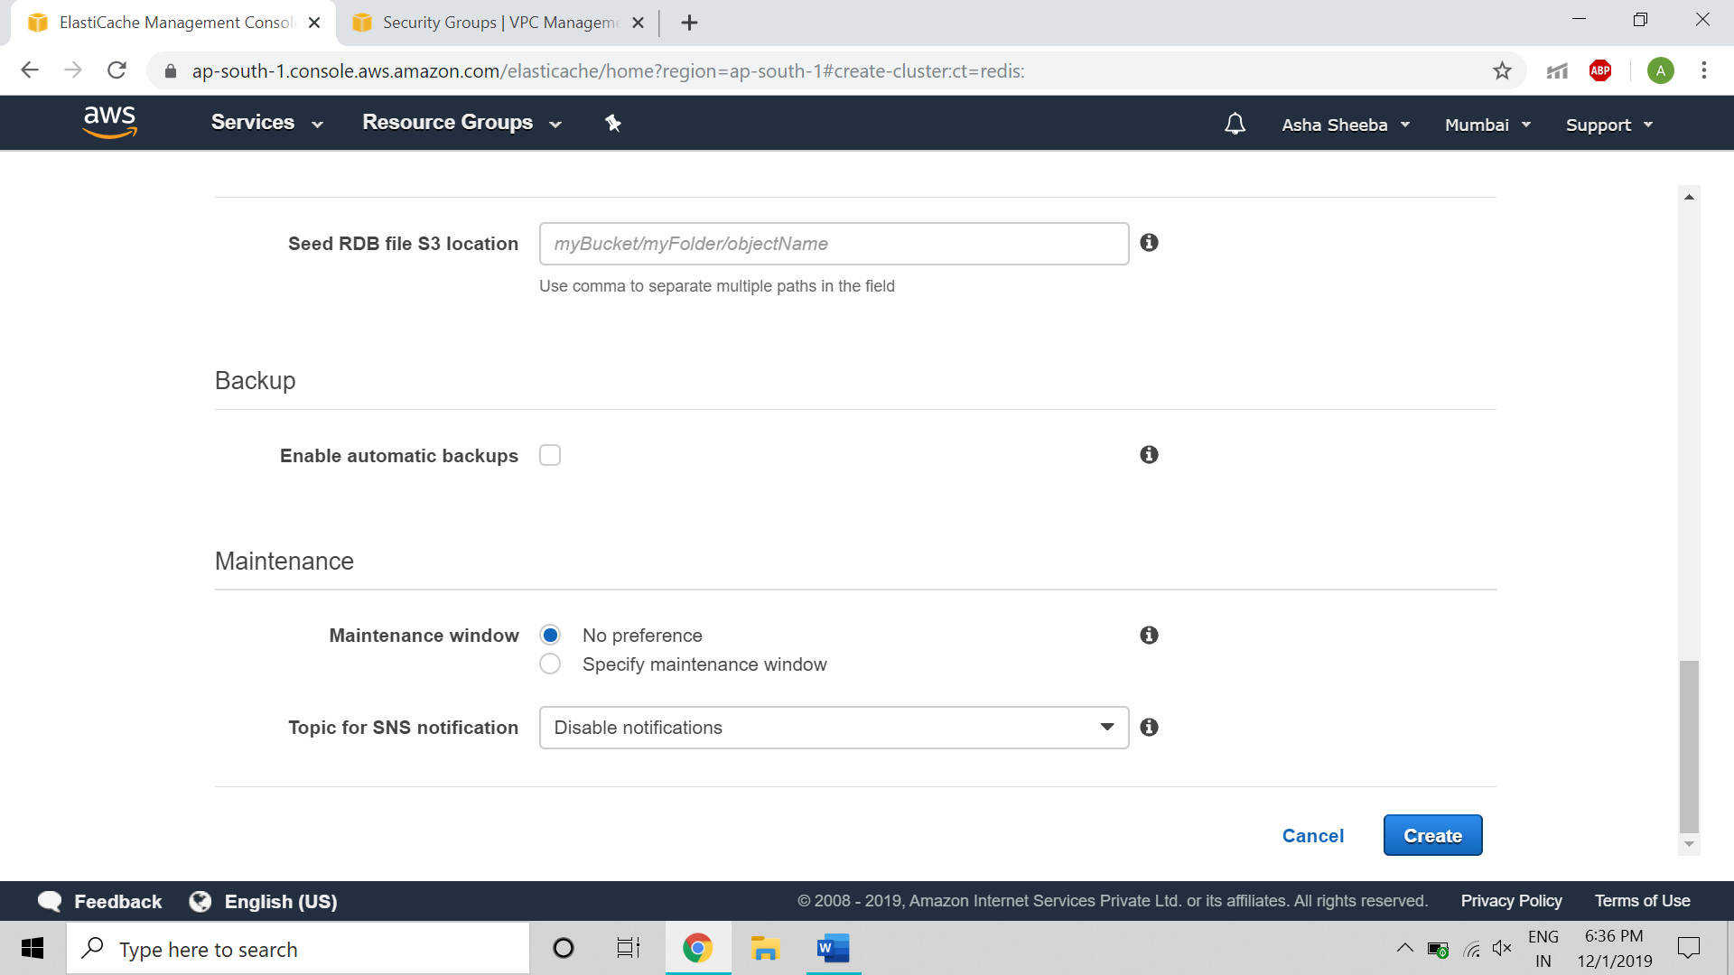

* We can see the below picture that the redis instance is been created with its information and End points

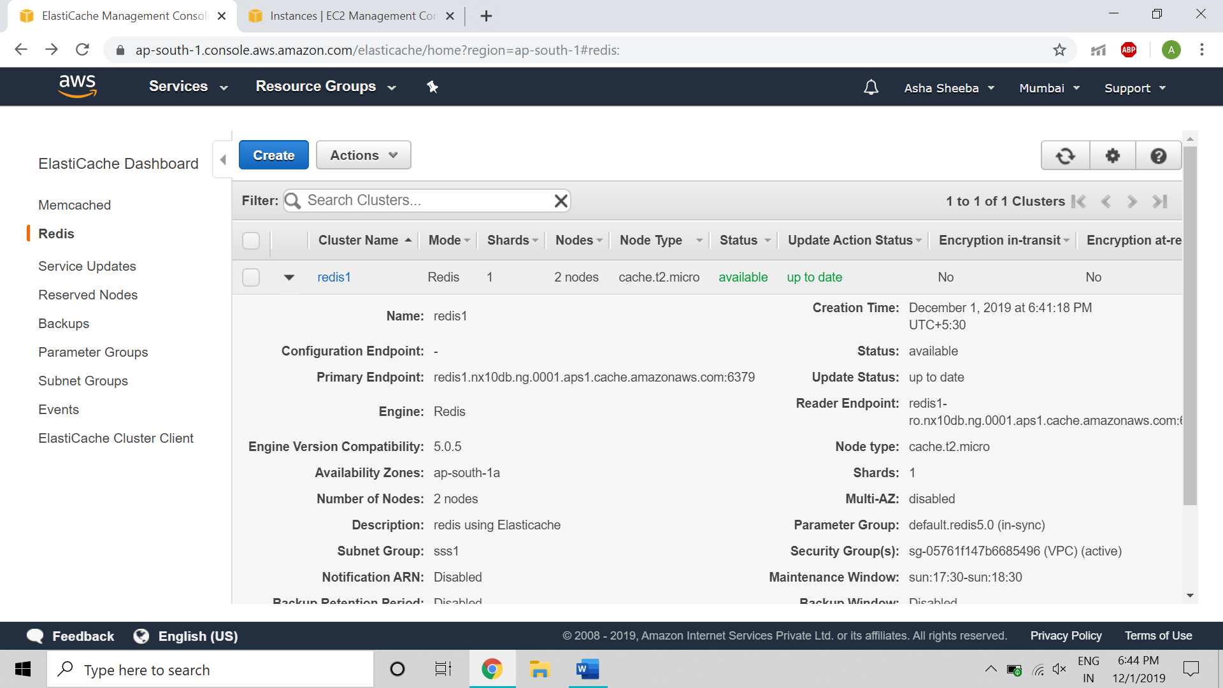

* The picture below is the instances created one is the primary original and another is the replica. The operations will work fine without replica but not without primary one.

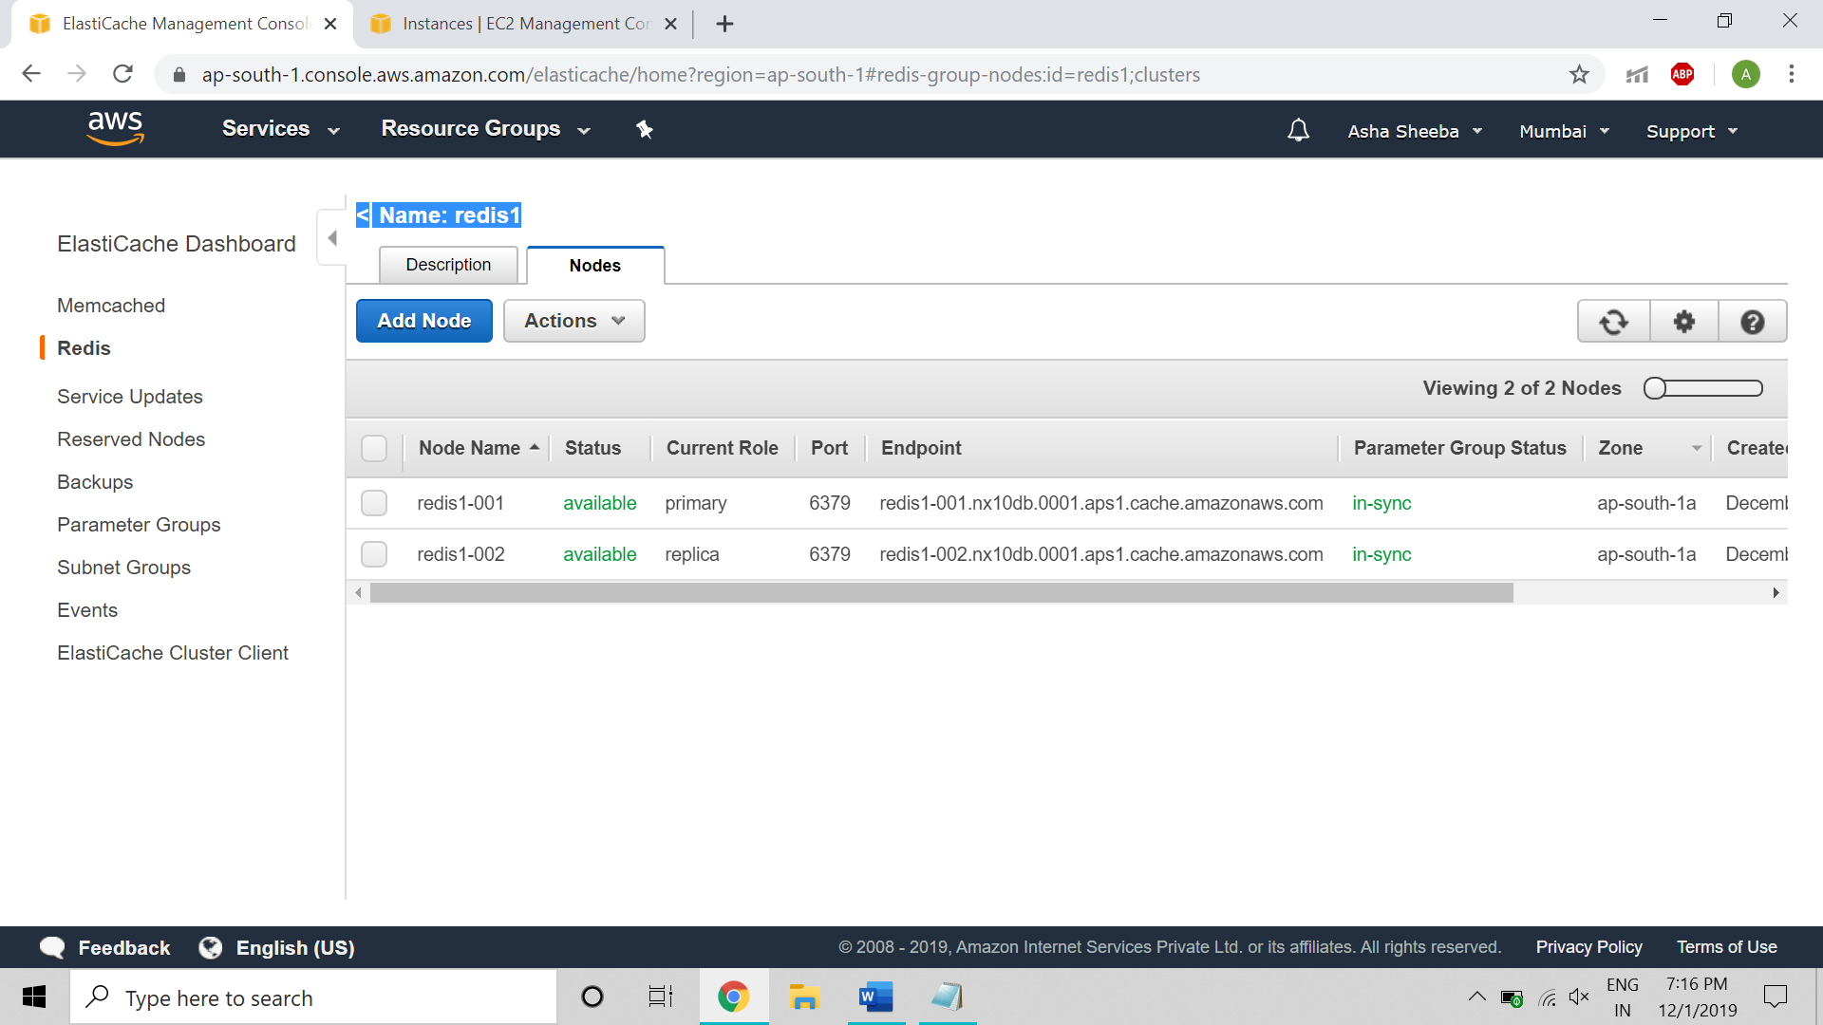

* Using EC2 create an Linux Instance Free tier

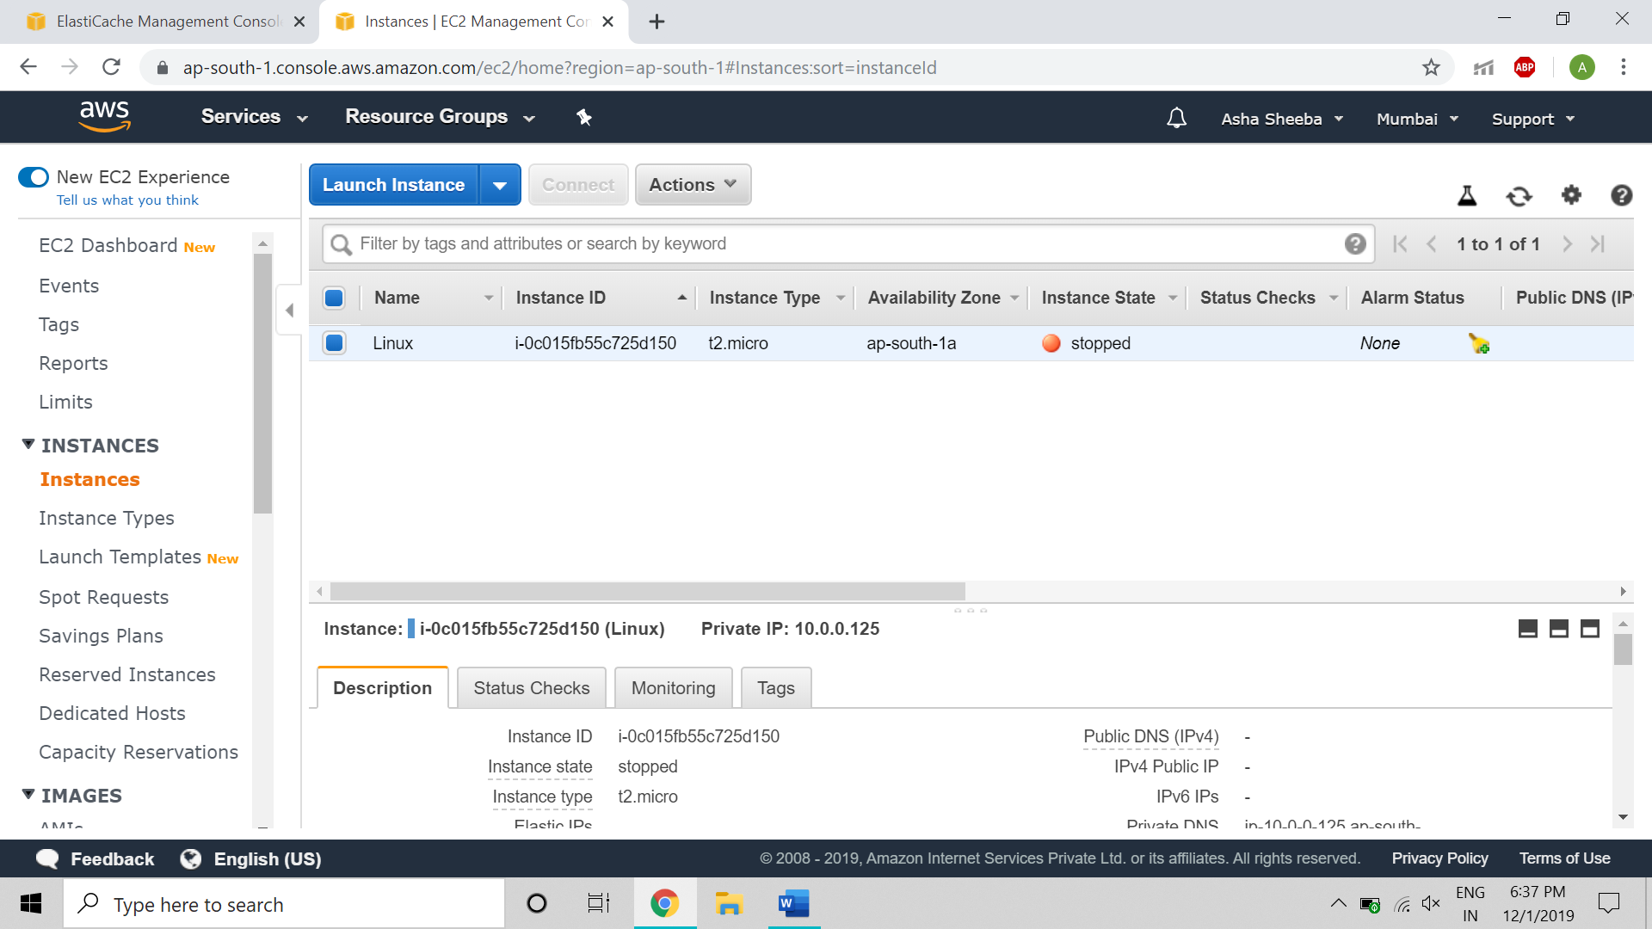

* Connect the Linux instance to putty

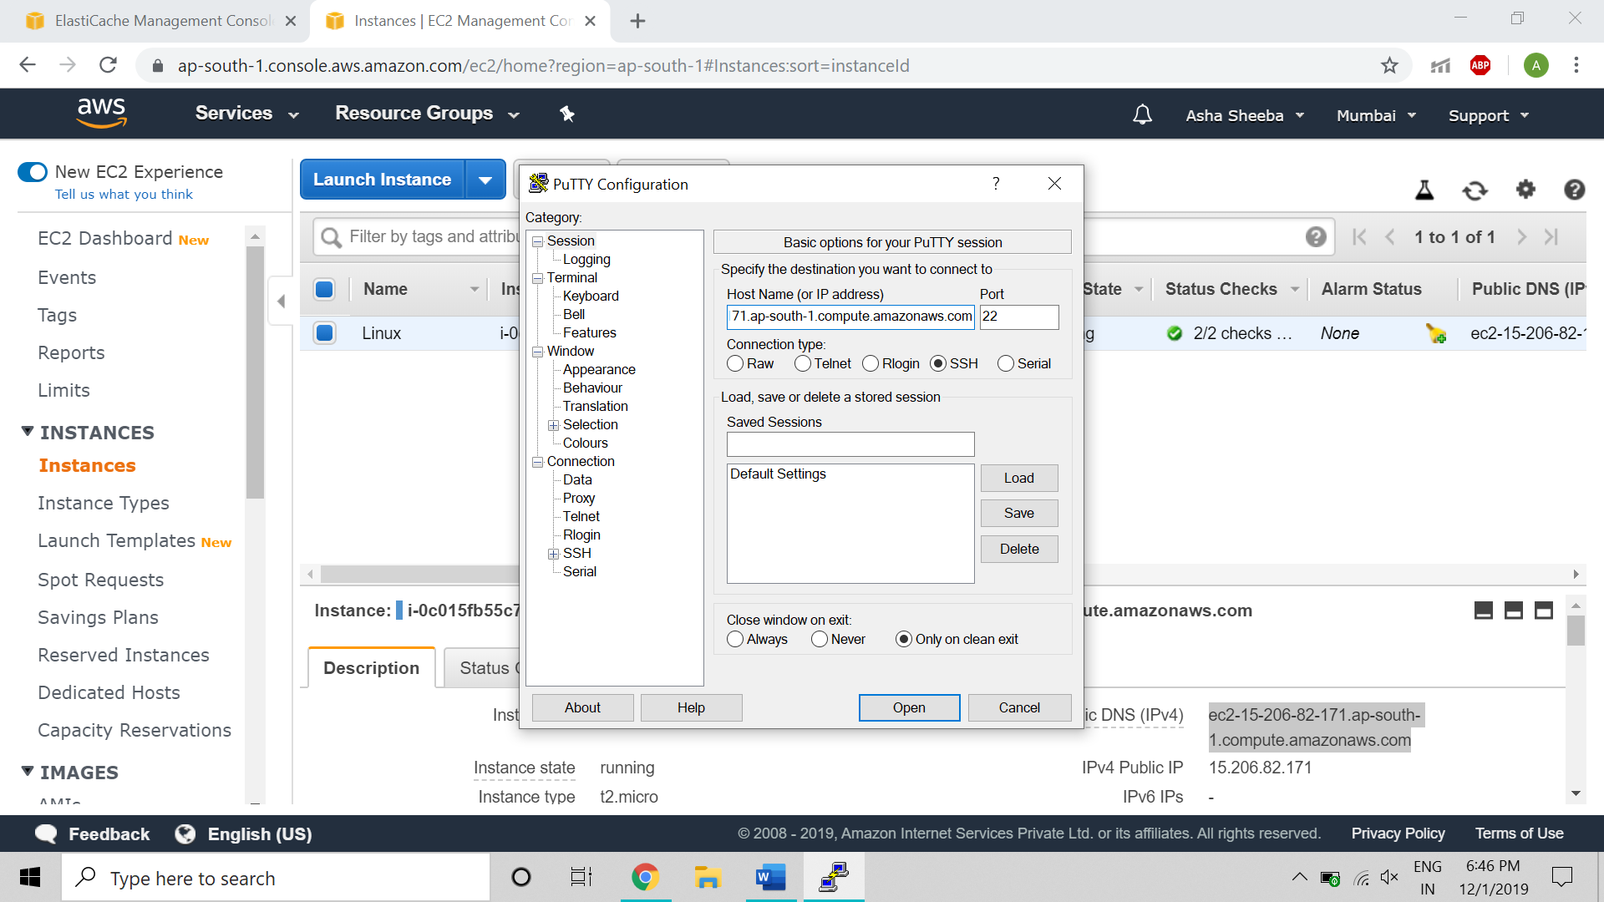

* Use the key that is created using linux instance

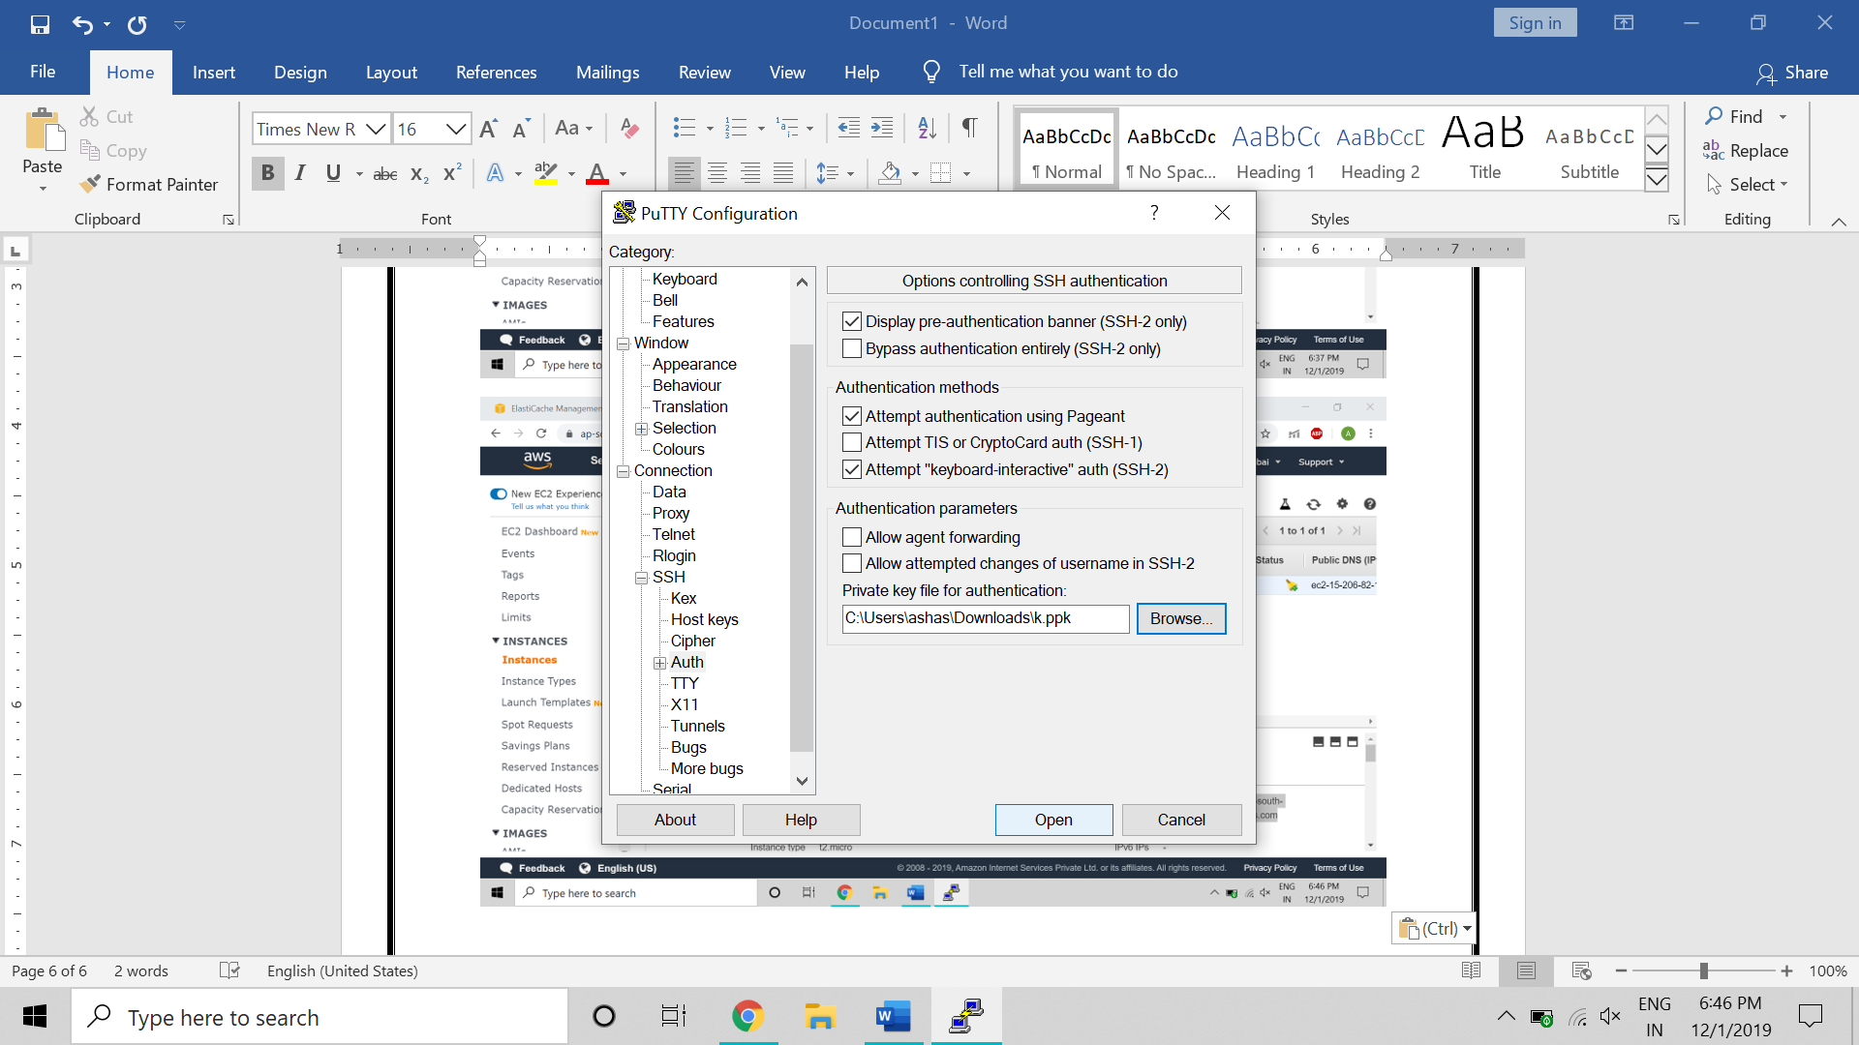

* Login as:ec2-user

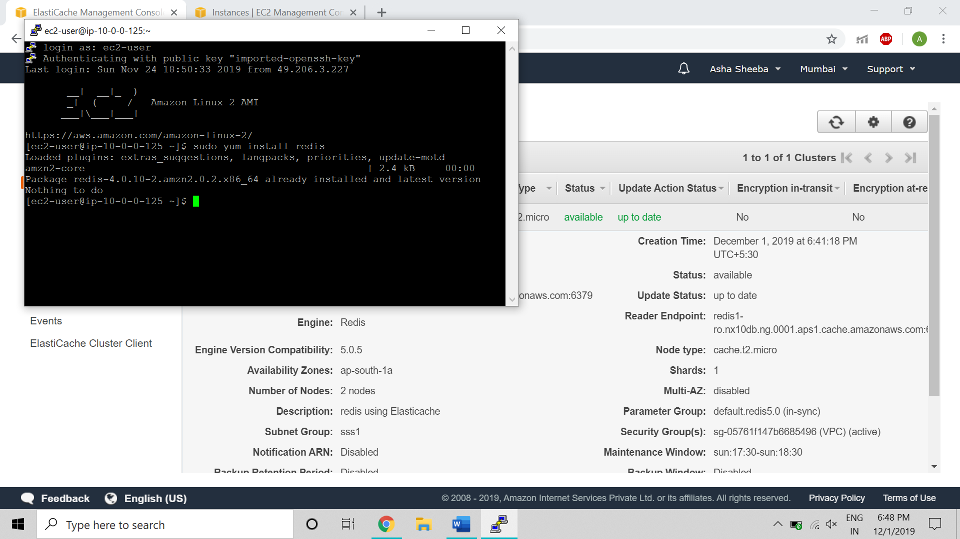

* Use the commands below to connect to Redis using Linux Instance
* yum update
* sudo amazon-linux-extras install redis4.0y
* yum install redis0.4
* Redis Endpoint: redis-cli -h kk1.nx10db.ng.0001.aps1.cache.amazonaws.com

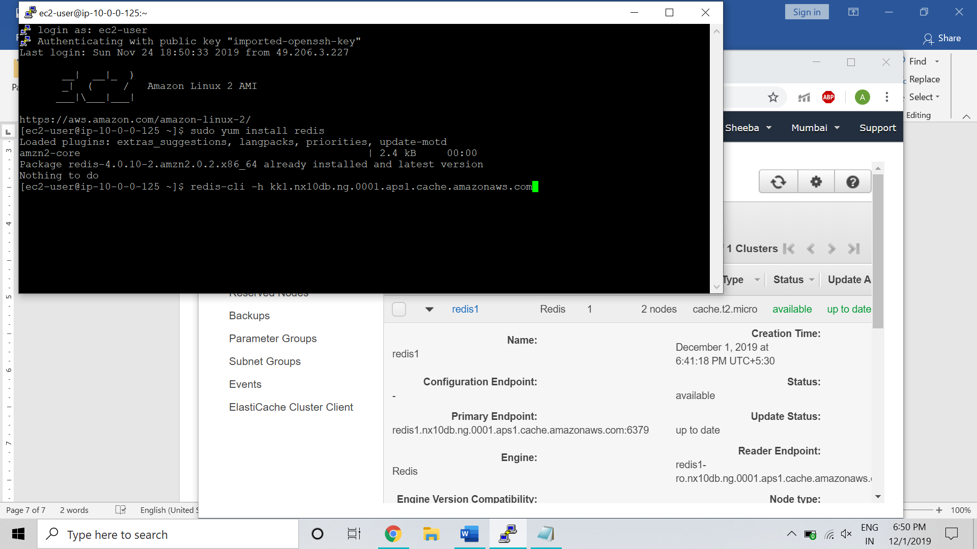

* Now to work on redis there are commands as we Redis is a Key value pair storage

1. To set the key value pair

Command: SET KEY VALUE

Ex: SET College MSRIT

Output: OK

1. To get the value

Command: GET KEY

Ex: GET College

Output: MSRIT

1. To know all the keys

Command: keys *

Output: all the keys that is been set

We can also use incr and decr to increment and decrement the value of key if needed.

* Redis one of usage is score board

**A small example to add scores on leaderboard:**

ZADD leaderboard 132 Robert

ZADD leaderboard 231 Sandra

ZADD leaderboard 32 June

ZADD leaderboard 381 Adam

* To arrange the score

ZREVRANGEBYSCORE leaderboard +inf -inf

Output:

1) Adam

2) Sandra

3) Robert

4) June

* To update

ZADD leaderboard 232 June

ZREVRANGEBYSCORE leaderboard +inf -inf

Output: Changes after updation and sorting

1) Adam

2) June

3) Sandra

4) Robert

* Below figure Demonstrates these commands

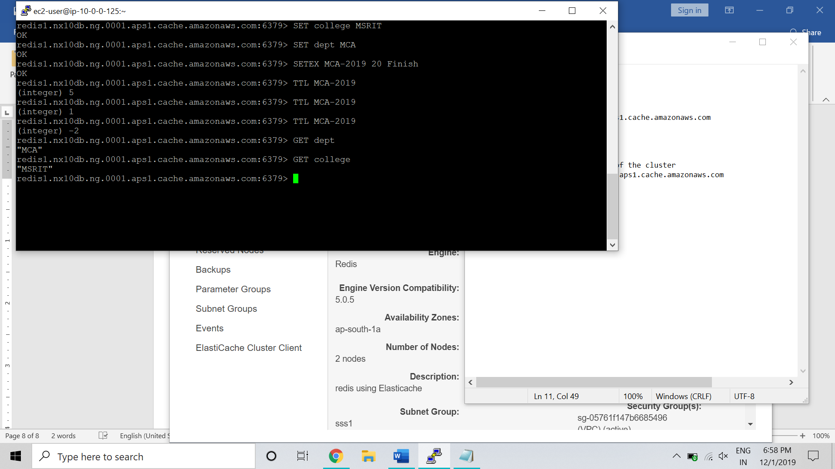

* Logout and login still u get the data stored

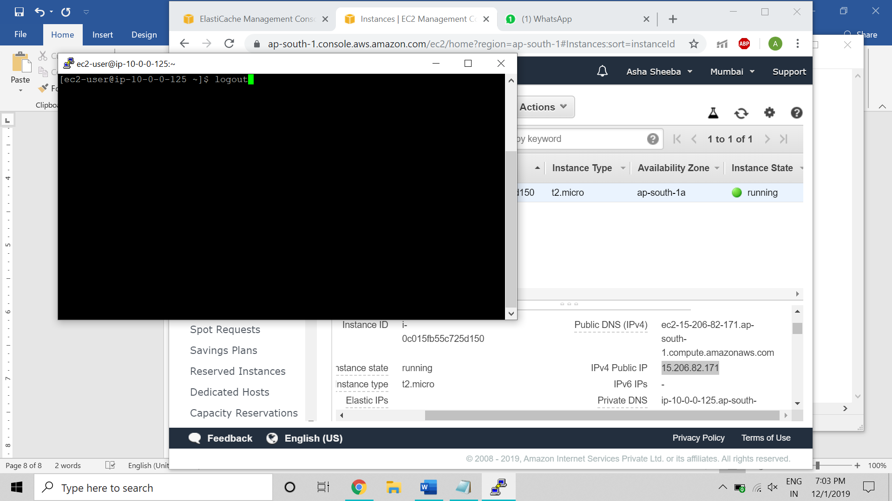

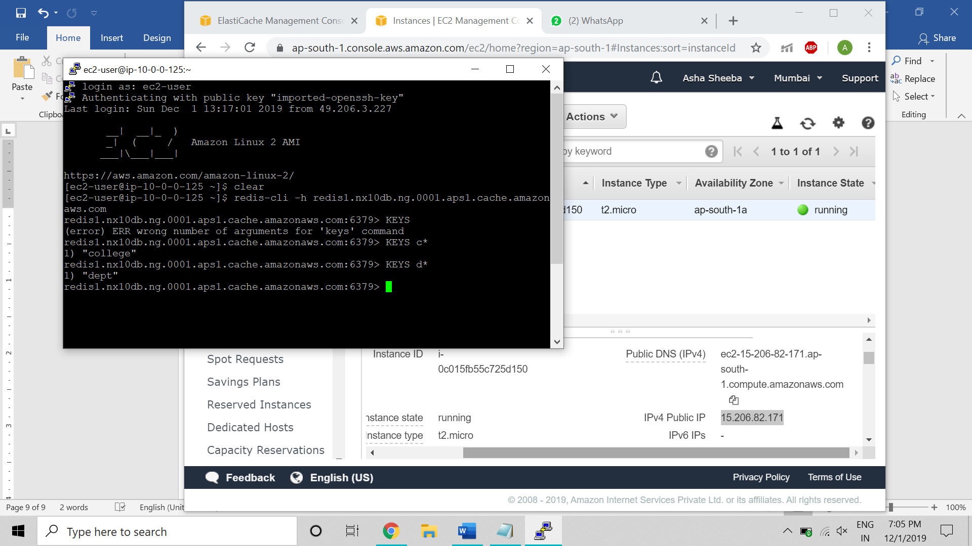

* To delete the instance select and on action click delete

