Schematic

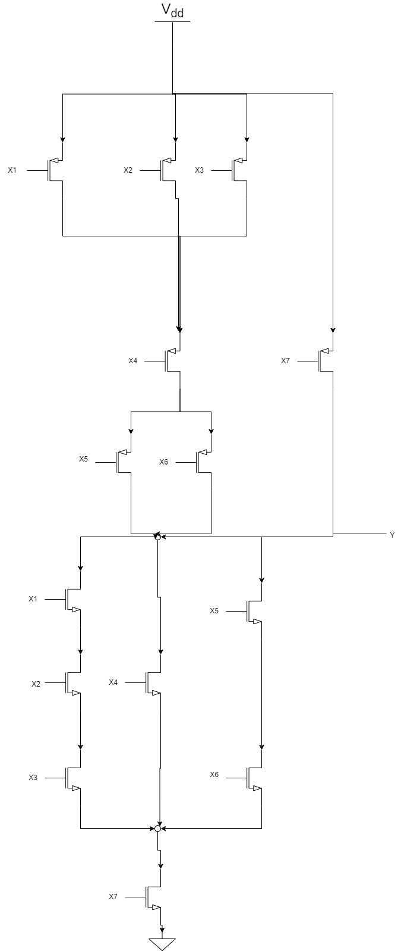

Euler’s Path

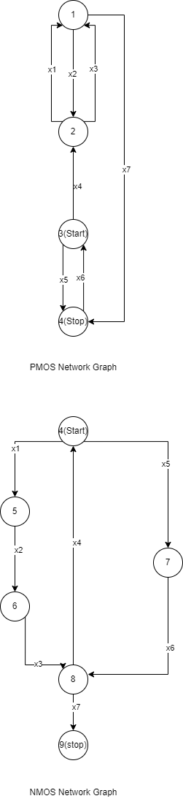

Stick Diagram

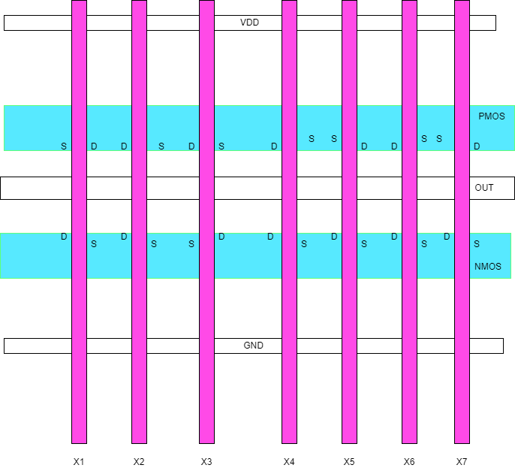

Ömer Faruk SERT

708241011