**Pass Logic**

**Shannon Expansion**

S = Cin . (~A.~B + A.B ) + ~Cin . (~A.B + A.~B)

Cout = Cin . (A.1 + ~A.B ) + ~Cin.(A.B+~A.0)

**Transmission Gates S and Cout**

**S Cout**

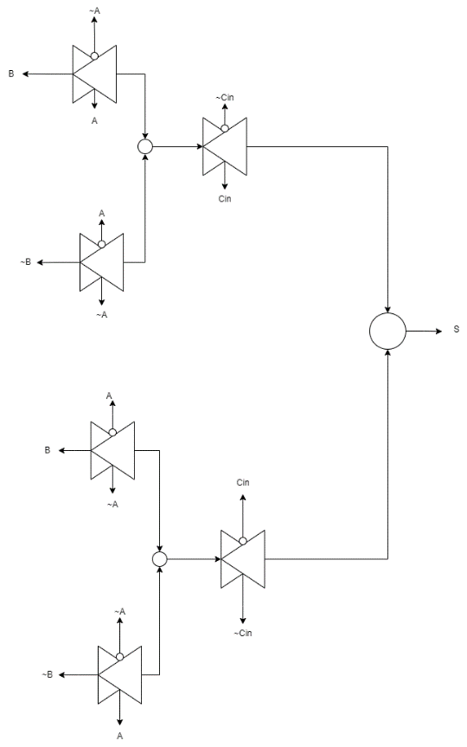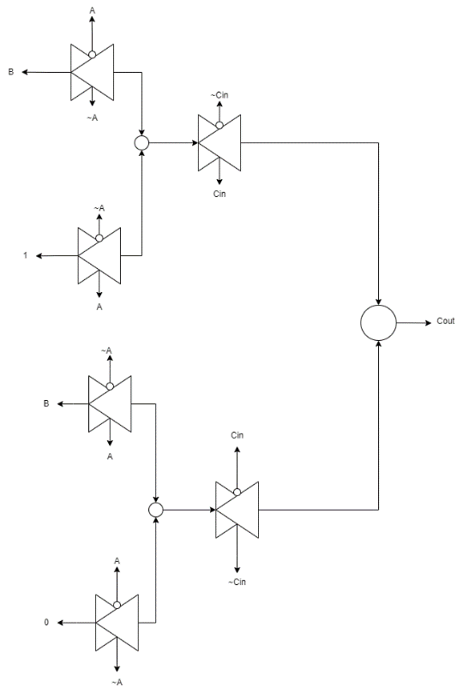

Ömer Faruk Sert

708241011