Midterm

Ömer Faruk Birgül

504242202

# Q1

## a)

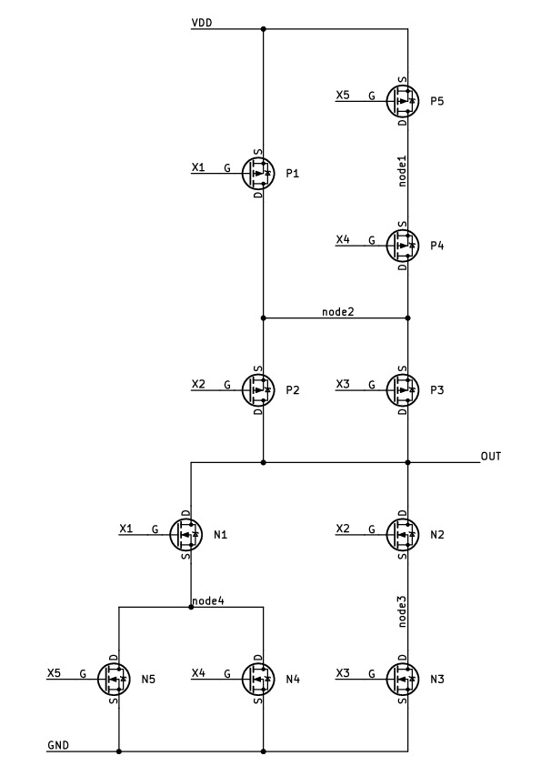

Schematic of the five input function.

## b)

Output function is $\overline{\left[\left(X4+X5\right).X1+X2.X3\right]}$

## c)

Nodes are name in the code below.

.incl tsmc18.sp  
.param wp=0.3u  
.param wn=0.3u  
  
vdd vdd 0 dc 1.8  
Vx1 x1 0 PULSE(0 1.8 0n 1n 1n 5n 10n)  
Vx2 x2 0 PULSE(0 1.8 0n 1n 1n 10n 20n)  
Vx3 x3 0 PULSE(0 1.8 0n 1n 1n 20n 40n)  
Vx4 x4 0 PULSE(0 1.8 0n 1n 1n 40n 80n)  
Vx5 x5 0 PULSE(0 1.8 0n 1n 1n 80n 160n)  
  
MP1 node2 X1 VDD VDD CMOSP W=0.5u L=0.2u  
MP2 OUT X2 node2 VDD CMOSP W=0.5u L=0.2u  
MP3 OUT X3 node2 VDD CMOSP W=0.5u L=0.2u  
MP4 node2 X4 node1 VDD CMOSP W=0.5u L=0.2u  
MP5 node1 X5 VDD VDD CMOSP W=0.5u L=0.2u  
  
MN1 OUT X1 node4 0 CMOSN W=0.5u L=0.2u  
MN2 OUT X2 node3 0 CMOSN W=0.5u L=0.2u  
MN3 node3 X3 0 0 CMOSN W=0.5u L=0.2u  
MN4 node4 X4 0 0 CMOSN W=0.5u L=0.2u  
MN5 node4 X5 0 0 CMOSN W=0.5u L=0.2u  
  
.control  
tran 0.5n 160n  
plot v(x1) v(x2)+2 v(x3)+4 v(x4)+6 v(x5)+8 v(y)+10  
.endc  
.end

# Q2

Before starting calculations, I determine all necessary values are shown in below table, units are given in square brackets. $C_{L}$, $W_{N\left(1\right)}$, $J_{N\left(max\right)}$, $J_{P\left(max\right)}$, and $L_{min}$ given in the tech file. $CGSO$ is a value from mosfet model. $C_{OX}$ can be calculated usign $\frac{ϵ_{ox}}{t_{ox}}$ where $ϵ_{ox}$ is approximately $3.453\text{e-}13\left[F/cm^{2}\right]$, and $t_{ox}$ is from the mosfet model.

$$\begin{matrix}C_{L} & =5.00\text{e-}12\left[F\right] \\ J_{N\left(max\right)} & =508\left[A/m\right] \\ J_{P\left(max\right)} & =224\left[A/m\right] \\ L_{min} & =2.00\text{e-}7\left[m\right] \\ C_{OX} & =8.41\text{e-}3\left[F/m^{2}\right] \\ CGSO & =7.19\text{e-}10\left[F/m\right] \\ W_{N\left(1\right)} & =5.00\text{e-}7\left[m\right]\end{matrix}$$

## Calculation of chain number

Since n is given as 3, I will use it as 3.

## Calculation of tapering factor

Then I need to calculate $m$ which is calculated by following formula.

$$m={\left[\frac{C_{L}}{\left(1+\sqrt{\frac{J_{N\left(max\right)}}{J_{P\left(max\right)}}}\right)⋅\left(L_{min}.C_{OX}+2⋅CGSO\right)⋅W_{N\left(1\right)}}\right]}^{\frac{1}{n}}$$

And when I put the values to formula:

$$m={\left[\frac{1.00\text{e-}12\left[F\right]}{\left(1+\sqrt{\frac{508\left[A/m\right]}{224\left[A/m\right]}}\right)⋅\left(2.00\text{e-}7\left[m\right]⋅8.41\text{e-}3\left[F/m^{2}\right]+2⋅7.19\text{e-}10\left[F/m\right]\right)⋅5.00\text{e-}7\left[m\right]}\right]}^{\frac{1}{3}}$$

And results is $10.85487625$. So $m≈10.85$.

## a)

| Inverter | Wn | Wp |
| --- | --- | --- |
| 1 | 500n | 750n |
| 2 | 5425n | 8137n |
| 3 | 58861n | 88291n |

## b)

I need to calculate $L$ which is calculated by following formula.

$$L=\frac{1}{4}⋅{\left(\frac{1}{\sqrt{J_{N\left(max\right)}}}+\frac{1}{\sqrt{J_{P\left(max\right)}}}\right)}^{2}⋅\left(L_{min}⋅C_{OX}+2⋅CSGO\right)⋅V_{DD}⋅m⋅n$$

And when I put the values to formula:

$$L=\frac{1}{4}⋅{\left(\frac{1}{\sqrt{508\left[A/m\right]}}+\frac{1}{\sqrt{224\left[A/m\right]}}\right)}^{2}⋅\left(2.00\text{e-}7\left[m\right]⋅8.41\text{e-}3\left[F/m^{2}\right]+2⋅7.19\text{e-}10\left[F/m\right]\right)⋅1.8\left[V\right]⋅10.85⋅3$$

And results is $5.64931\text{e-}10$. So $L≈564ps$

## c)

According to simulation, $T_{PHL}=733\left[ps\right]$, and $T_{PLH}=864\left[ps\right]$ and it creates 798.5[ps] delay.

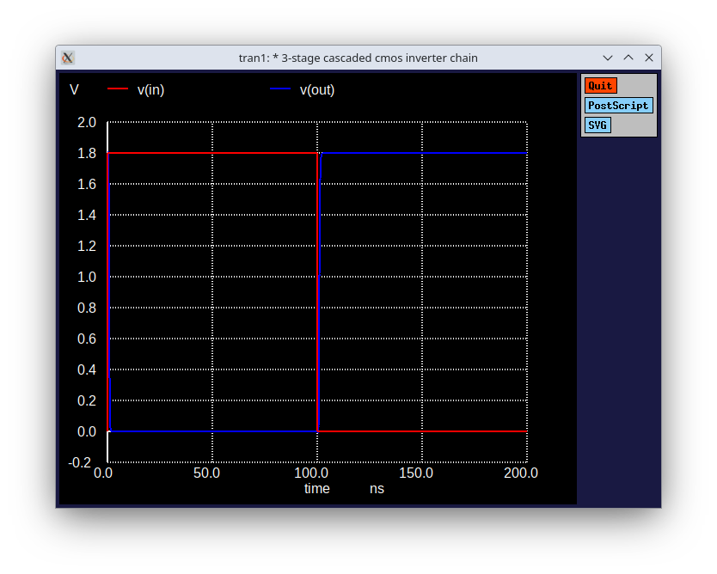

Output waveform of Vin and Vout for 3stage cascaded inverter.

# Q3

## a)

Let’s write $t_{PLH}$ $t_{PHL}$ for inverter, 3 input NAND and 3 input NOR gates in general form.  
Assume that $R_{n}=R$ and $R_{p}=2R$ beacuse we are using minimum dimensions.  
Assume that $C_{load}=C$.  
N is 3 for NAND and NOR.

### Delay of Inverter

$$\begin{matrix}t_{PLH} & ≈0,7.R_{p}.C_{load}=0,7.2R.C & =1,4RC \\ t_{PHL} & ≈0,7.R_{n}.C_{load}=0,7.R.C & =0,7RC \\ t_{PD} & =\frac{t_{PLH}+t_{PHL}}{2}=\frac{1,4RC+0,7RC}{2} & =1,05RC\end{matrix}$$

### Delay of NAND

$$\begin{matrix}t_{PLH} & ≈0,7.\frac{R_{p}}{N}.C_{load}=0,7.\frac{2R}{3}.C & ≈0,47RC \\ t_{PHL} & ≈0,7.N.R_{n}.C_{load}=0,7.3.R.C & =2,1RC \\ t_{PD} & =\frac{t_{PLH}+t_{PHL}}{2}=\frac{0,47RC+2,1RC}{2} & =1,285RC\end{matrix}$$

### Delay of NOR

$$\begin{matrix}t_{PLH} & ≈0,7.N.R_{p}.C_{load}=0,7.3.2R.C & =4,2RC \\ t_{PHL} & ≈0,7.\frac{R_{n}}{N}.C_{load}=0,7.\frac{R}{3}.C & ≈0,23RC \\ t_{PD} & =\frac{t_{PLH}+t_{PHL}}{2}=\frac{4,2RC+0,23RC}{2} & =2,215RC\end{matrix}$$

### Delay of NOR + Inverter

$$\begin{matrix}t_{PD}=2,215RC+1,05RC=3,265RC\end{matrix}$$

### Delay of Inverters + NAND

$$\begin{matrix}t_{PD}=1,05RC+1,285RC=2,335RC\end{matrix}$$

## b)

Results of simulation in terms of $t_{PLH}$ and $t_{PHL}$

|  |  |  |  |
| --- | --- | --- | --- |
| Start Point | End Point | Delay Type | Value |
| X1 | NOR Circuit | $$T_{PHL}$$ | 35.34 ps |
| X1 | NOR Circuit | $$T_{PLH}$$ | 4.97 ps |
| X2 | NOR Circuit | $$T_{PHL}$$ | 35.34 ps |
| X2 | NOR Circuit | $$T_{PLH}$$ | 9.97 ps |
| X3 | NOR Circuit | $$T_{PHL}$$ | 35.34 ps |
| X3 | NOR Circuit | $$T_{PLH}$$ | 19.97 ps |
| X1 | NAND Circuit | $$T_{PHL}$$ | 35.10 ps |
| X1 | NAND Circuit | $$T_{PLH}$$ | 4.96 ps |
| X2 | NAND Circuit | $$T_{PHL}$$ | 35.10 ps |
| X2 | NAND Circuit | $$T_{PLH}$$ | 9.96 ps |
| X3 | NAND Circuit | $$T_{PHL}$$ | 35.10 ps |
| X3 | NAND Circuit | $$T_{PLH}$$ | 19.96 ps |

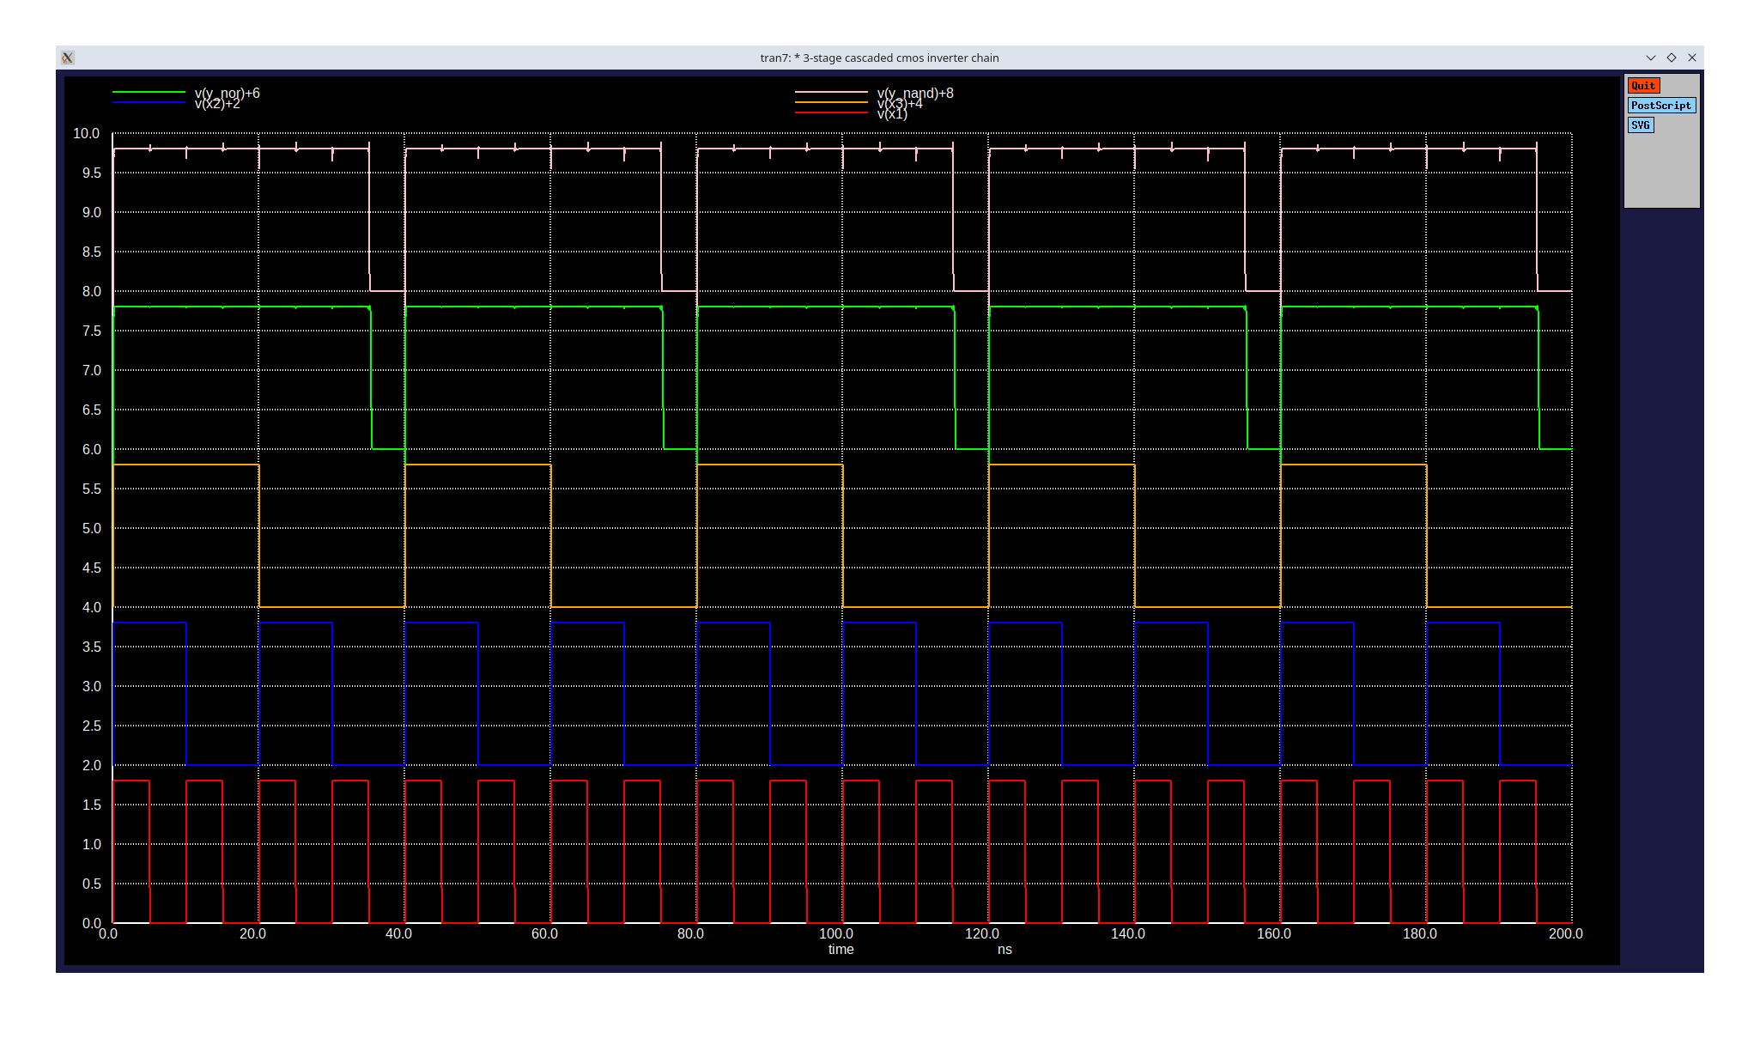

Waveform of all inputs and both outputs.

* 3-Stage Cascaded CMOS Inverter Chain  
  
.incl tsmc18.sp  
  
* Parameters  
.param Wp=0.3u  
.param Lp=0.2u  
.param Ln=0.2u  
.param Wn=0.3u  
  
* Power supply  
VDD vdd 0 1.8  
  
* Input pulse  
Vx1 x1 0 PULSE(0 1.8 100p 10p 10p 5n 10n)  
Vx2 x2 0 PULSE(0 1.8 100p 10p 10p 10n 20n)  
Vx3 x3 0 PULSE(0 1.8 100p 10p 10p 20n 40n)  
  
  
* Inverter 1  
M1_1 n1 in vdd vdd cmosp W='Wp' L='Lp' ad='Wp*0.55u' as='Wp*0.55u' pd='2*(Wp+0.55u)' ps='2*(Wp+0.55u)'  
M2_1 n1 in 0 0 cmosn w='wn' l=0.2u ad='wn*0.55u' as='wn*0.55u' pd='2*(wn+0.55u)' ps='2*(wn+0.55u)'  
  
M1 n1 x1 vdd vdd cmosp W='Wp' L='Lp' ad='Wp*0.55u' as='Wp*0.55u' pd='2*(Wp+0.55u)' ps='2*(Wp+0.55u)'  
M2 n2 x2 n1 n1 cmosp W='Wp' L='Lp' ad='Wp*0.55u' as='Wp*0.55u' pd='2*(Wp+0.55u)' ps='2*(Wp+0.55u)'  
M3 n3 x3 n2 n2 cmosp W='Wp' L='Lp' ad='Wp*0.55u' as='Wp*0.55u' pd='2*(Wp+0.55u)' ps='2*(Wp+0.55u)'  
  
M4 n3 x1 0 0 cmosn w='wn' l=0.2u ad='wn*0.55u' as='wn*0.55u' pd='2*(wn+0.55u)' ps='2*(wn+0.55u)'  
M5 n3 x2 0 0 cmosn w='wn' l=0.2u ad='wn*0.55u' as='wn*0.55u' pd='2*(wn+0.55u)' ps='2*(wn+0.55u)'  
M6 n3 x3 0 0 cmosn w='wn' l=0.2u ad='wn*0.55u' as='wn*0.55u' pd='2*(wn+0.55u)' ps='2*(wn+0.55u)'  
  
M7 Y_nor n3 vdd vdd cmosp W='Wp' L='Lp' ad='Wp*0.55u' as='Wp*0.55u' pd='2*(Wp+0.55u)' ps='2*(Wp+0.55u)'  
M8 Y_nor n3 0 0 cmosn w='wn' l=0.2u ad='wn*0.55u' as='wn*0.55u' pd='2*(wn+0.55u)' ps='2*(wn+0.55u)'  
  
  
M9 x1_not x1 vdd vdd cmosp W='Wp' L='Lp' ad='Wp*0.55u' as='Wp*0.55u' pd='2*(Wp+0.55u)' ps='2*(Wp+0.55u)'  
M10 x1_not x1 0 0 cmosn w='wn' l=0.2u ad='wn*0.55u' as='wn*0.55u' pd='2*(wn+0.55u)' ps='2*(wn+0.55u)'  
  
M11 x2_not x2 vdd vdd cmosp W='Wp' L='Lp' ad='Wp*0.55u' as='Wp*0.55u' pd='2*(Wp+0.55u)' ps='2*(Wp+0.55u)'  
M12 x2_not x2 0 0 cmosn w='wn' l=0.2u ad='wn*0.55u' as='wn*0.55u' pd='2*(wn+0.55u)' ps='2*(wn+0.55u)'  
  
M13 x3_not x3 vdd vdd cmosp W='Wp' L='Lp' ad='Wp*0.55u' as='Wp*0.55u' pd='2*(Wp+0.55u)' ps='2*(Wp+0.55u)'  
M14 x3_not x3 0 0 cmosn w='wn' l=0.2u ad='wn*0.55u' as='wn*0.55u' pd='2*(wn+0.55u)' ps='2*(wn+0.55u)'  
  
M15 Y_nand x1_not vdd vdd cmosp W='Wp' L='Lp' ad='Wp*0.55u' as='Wp*0.55u' pd='2*(Wp+0.55u)' ps='2*(Wp+0.55u)'  
M16 Y_nand x2_not vdd vdd cmosp W='Wp' L='Lp' ad='Wp*0.55u' as='Wp*0.55u' pd='2*(Wp+0.55u)' ps='2*(Wp+0.55u)'  
M17 Y_nand x3_not vdd vdd cmosp W='Wp' L='Lp' ad='Wp*0.55u' as='Wp*0.55u' pd='2*(Wp+0.55u)' ps='2*(Wp+0.55u)'  
  
M18 Y_nand x1_not n4 n4 cmosn w='wn' l=0.2u ad='wn*0.55u' as='wn*0.55u' pd='2*(wn+0.55u)' ps='2*(wn+0.55u)'  
M19 n4 x2_not n5 n5 cmosn w='wn' l=0.2u ad='wn*0.55u' as='wn*0.55u' pd='2*(wn+0.55u)' ps='2*(wn+0.55u)'  
M20 n5 x3_not 0 0 cmosn w='wn' l=0.2u ad='wn*0.55u' as='wn*0.55u' pd='2*(wn+0.55u)' ps='2*(wn+0.55u)'  
  
  
.control  
tran 5p 200n  
* plot v(in) v(out)  
plot v(x1) v(x2)+2 v(x3)+4 v(Y_nor)+6 v(Y_nand)+8  
  
meas tran tphl TRIG v(x1) VAL=0.9 RISE=1 TARG v(Y_nor) VAL=0.9 FALL=1  
meas tran tplh TRIG v(x1) VAL=0.9 FALL=1 TARG v(Y_nor) VAL=0.9 RISE=1  
  
meas tran tphl TRIG v(x2) VAL=0.9 RISE=1 TARG v(Y_nor) VAL=0.9 FALL=1  
meas tran tplh TRIG v(x2) VAL=0.9 FALL=1 TARG v(Y_nor) VAL=0.9 RISE=1  
  
meas tran tphl TRIG v(x3) VAL=0.9 RISE=1 TARG v(Y_nor) VAL=0.9 FALL=1  
meas tran tplh TRIG v(x3) VAL=0.9 FALL=1 TARG v(Y_nor) VAL=0.9 RISE=1  
  
meas tran tphl TRIG v(x1) VAL=0.9 RISE=1 TARG v(Y_nand) VAL=0.9 FALL=1  
meas tran tplh TRIG v(x1) VAL=0.9 FALL=1 TARG v(Y_nand) VAL=0.9 RISE=1  
  
meas tran tphl TRIG v(x2) VAL=0.9 RISE=1 TARG v(Y_nand) VAL=0.9 FALL=1  
meas tran tplh TRIG v(x2) VAL=0.9 FALL=1 TARG v(Y_nand) VAL=0.9 RISE=1  
  
meas tran tphl TRIG v(x3) VAL=0.9 RISE=1 TARG v(Y_nand) VAL=0.9 FALL=1  
meas tran tplh TRIG v(x3) VAL=0.9 FALL=1 TARG v(Y_nand) VAL=0.9 RISE=1  
  
.endc  
.end