Lab No | : | 11
Name of the Lab | : | Implementation of FIFO page replacement algorithm
ID | : | IT-17035
Objective | : | (1) What is FIFO page replacement Algorithm?  (2) How to implementation in C?

(1) What is FIFO page replacement algorithm ?
Ans :
This is the simplest page replacement algorithm. In a page replacement algorithm we decide when a page replacement occures then which frames are to be replaced. For evaluating an algorithm we take a particular string of memory references ,called reference string.
In FIFO page replacement algorithm- for each page we track the time when it was brought into the memory and when any replacement request comes then oldest page is chosen. If we choose a queue to hold all pages in memory then its more easy to understand and implement rather than tracking time of all pages.

(2) How to implementation in C?
Ans :
Source code :
#include<stdio.h>
int main()
{
int i,j,n,a[50],frame[10],no,k,avail,count=0;
printf("Enter the number of Pages: ");
scanf("%d",&n);
printf("Enter the page number : ");
for(i=1; i<=n; i++)
scanf("%d",&a[i]);
printf("Enter the number of FRAMES : ");
scanf("%d",&no);
for(i=0; i<no; i++)
frame[i]= -1;
j=0;
printf("\n");
printf("tref string\t page frames\n");

for(i=1; i<=n; i++)
{
printf("%d\t\t",a[i]);
avail=0;
for(k=0; k<no; k++)
if(frame[k]==a[i])
avail=1;

if (avail==0)
{
frame[j]=a[i];
j=(j+1)%no;
count++;
for(k=0; k<no; k++)
printf("%d\t",frame[k]);
}
printf("\n");
}

printf("Page Fault is: %d\n",count);
int cc =count;
printf("Page Hit is : %d\n",n-cc);
return 0;
}

Output :

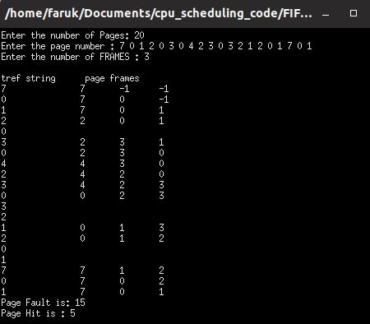

Conclusion :
By doing this lab, I have implemented FIFO page replacement algorithm.
First of all, I face some problem,when I do this.But later I solve these problem by seeing
tutorial on internet.

