Lab No | : | 04
Name of the Lab | : | File Operation and Permission
ID | : | IT-17035
Objective | : | 1. Learn about File Operation and Permission&  2. Implementation of File Operation and Permission

Question – 1 : What is File Operation and File Permission in Linux Operating System?
Answer :
File Operation : A file is an abstract data type. For defining a file properly, we need to consider the operations that can be performed on files. The operating system can provide system calls to create, write, read, reposition, delete, and truncate files. There are six basic file operations within an Operating system. These are:
- Creating a file
- Writing a file
- Reading a file
- Repositioning inside a file
- Deleting a file
- Truncating a file

File Permissions : Linux is a multi-user operating system, so it has security to prevent people from accessing each other’s confidential files. Every file and directory in your UNIX/Linux system has following 3 permissions.
- Read: This permission give you the authority to open and read a file. Read permission on a directory gives you the ability to lists its content.
- Write: The write permission gives you the authority to modify the contents of a file. The write permission on a directory gives you the authority to add, remove and rename files stored in the directory. Consider a scenario where you have to write permission on file but do not have write permission on the directory where the file is stored. You will be able to modify the file contents. But you will not be able to rename, move or remove the file from the directory.
- Execute: In Windows, an executable program usually has an extension ".exe" and which you can easily run. In Unix/Linux, you cannot run a program unless the execute permission is set. If the execute permission is not set, you might still be able to see/modify the program code(provided read & write permissions are set), but not run it.

Question -2 : Implementation of File operation and permission :
Answer:
File operations :
- List directories and Files: $ ls

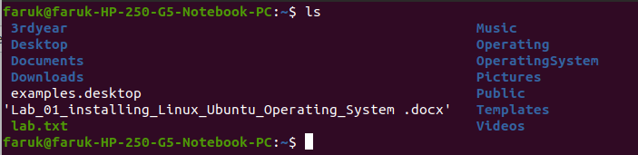
(b) List hidden files and directories : $ ls -a

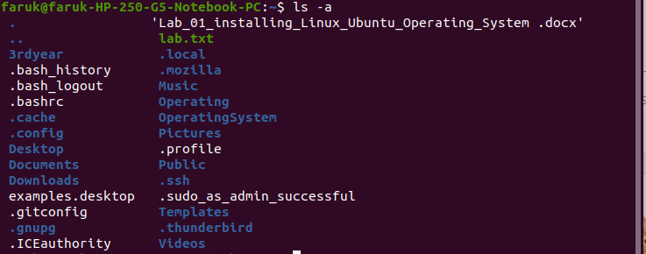
(c)List files and folders recursively : $ ls -R
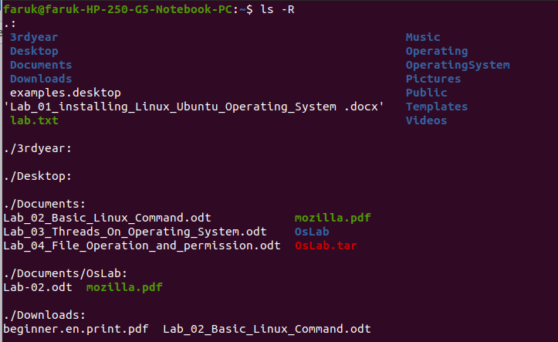
(d)Change Directory : $ cd can be used to change to the different directories.
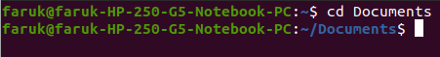

(e)Go User Home Directory : $ cd ~

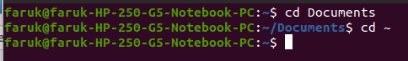

(f) Go upper and Parent directory : $ cd ..

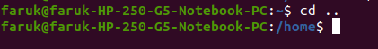

(g)Go given Path : We can go to the log directory $ cd /var/log

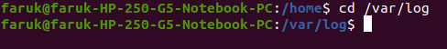

(h)Delete file and Directory : $ rmdir foldername (empty file delete) and rm -r foldername (for forcing delete)

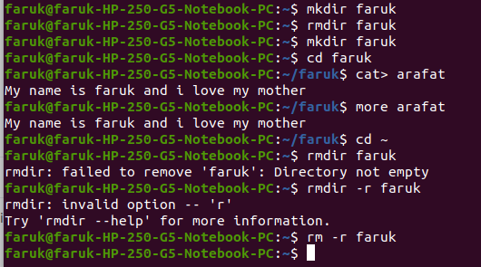
(I) move files and directories : $ mv
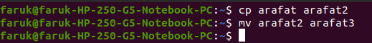

File Permissions : Linux is a multi-user operating system, so it has security to prevent people from accessing each other’s confidential files.

Understanding the security permissions :
First, you must think of those nine characters as three sets of three characters (see the box at the bottom). Each of the three “rwx” characters refers to a different operation you can perform on the file.

--- --- ---
rwx rwx rwx
user group other
The characters are easy to remember :
r = read permissions
w=write permission
x =execute permission
- = no permission
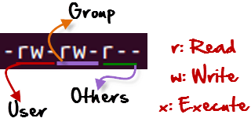

Let's see the chmod command in action.
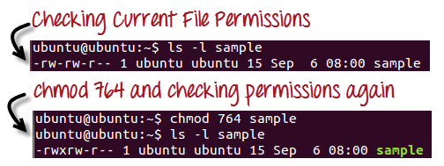
In the above-given terminal window, we have changed the permissions of the file 'sample to '764'.
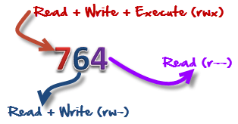
'764' absolute code says the following:
- Owner can read, write and execute
- Usergroup can read and write
- World can only read

Let's look into an example

Adding permission:

