Lab No | : | 08
Name of the Lab | : | Implementation of SJF scheduling algorithm
ID | : | IT-17035
Objective | : | (1) What is SJF scheduling Algorithm?  (2) How to implementation in C?

(1) What is SJF scheduling Algorithm?
Ans:
Shortest Job First scheduling works on the process with the shortest burst time or duration first.
- This is the best approach to minimize waiting time.
- This is used in Batch
- It is of two types:
  - Non Pre-emptive
  - Pre-emptive
- To successfully implement it, the burst time/duration time of the processes should be known to the processor in advance, which is practically not feasible all the time.
- This scheduling algorithm is optimal if all the jobs/processes are available at the same time. (either Arrival time is 0 for all, or Arrival time is same for all)

(2) How to implementation in C?
Ans :
Source Code:
#include<stdio.h>
int main()
{
int bt[20],p[20],wt[20],tat[20],i,j,n,total=0,pos,temp;
float avg_wt,avg_tat;
printf("\n\nEnter number of process: ");
scanf("%d",&n);

for(i=0; i<n; i++)
{
printf("Enter burst time for process %d: ",i+1);
scanf("%d",&bt[i]);
p[i]=i+1;
}

for(i=0; i<n; i++)
{
pos=i;
for(j=i+1; j<n; j++)
{
if(bt[j]<bt[pos])
pos=j;
}

temp=bt[i];
bt[i]=bt[pos];
bt[pos]=temp;

temp=p[i];
p[i]=p[pos];
p[pos]=temp;
}

wt[0]=0;
for(i=1; i<n; i++)
{
wt[i]=0;
for(j=0; j<i; j++)
wt[i]+=bt[j];

total+=wt[i];
}

avg_wt=(float)total/n;
total=0;

printf("\nProcess\t Burst Time \tWaiting Time\tTurnaround Time");
for(i=0; i<n; i++)
{
tat[i]=bt[i]+wt[i];
total+=tat[i];
printf("\nprocess %d\t %d\t\t %d\t\t\t%d",p[i],bt[i],wt[i],tat[i]);
}

avg_tat=(float)total/n;
printf("\n\nAverage Waiting Time=%f",avg_wt);
printf("\nAverage Turnaround Time=%f\n",avg_tat);
}

Output :
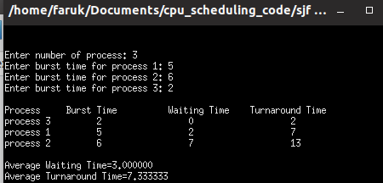

Conclusion :
By doing this lab, I have implemented SJF scheduling algorithm . When I do this lab , I face some problems, but I solve these problem later .

