Lab No | : | 02
Name of the Lab | : | Basic Command of Linux Operating System
ID | : | IT-17035
Objective | : | 1. Learn about Linux Command &  2. Operation of Basic Linux Command

Basic Command of Linux Operating System

i) What is Linux command?

Ans : Linux is an open-source operating system. It is like Windows, Mac, Android, etc. Linux is a Unix-Like operating system. All the Linux/Unix commands are run in the terminal provided by the Linux system. This terminal is just like command prompt of Windows OS. Linux/Unix commands are case-sensitive. The terminal can be used to accomplish all Administrative tasks. This includes package installation, file manipulation, and user management. Linux terminal is user-interactive. The terminal outputs the results of commands which are specified by the user itself.

ii) Write 15 commands in Linux operating system.

Ans : 15 commands of Linux Operating System are :

- ls
- pwd
- cd
- chmod
- df
- free
- mkdir
- passwd
- shutdown
- history
- echo
- tar
- whoami
- cat
- exit

iii) Describe the operation of Linux basic command.(Screenshot) .

Ans: Describing the operation of Linux basic command :

- ls : This might be the first command the majority of Linux users meet . It lists the files and folders in the directory you specify .

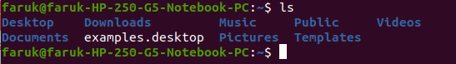

2. pwd : The pwd command prints the working directory (the current directory) from
the root/directory .

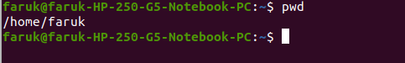

3. cd : The cd command changes your current directoy . In other words , it moves
you to a new place in the file filesystem .
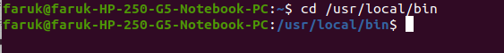

4 .chmod : The chmod commands sets the file permissions flags on a file or folder .The
flag define who can read,write or to execute the file .

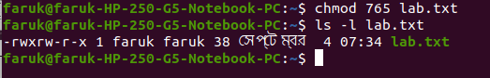

5. df : The df command shows the sized , used space and available space on the
mounted filesystems of your computer .

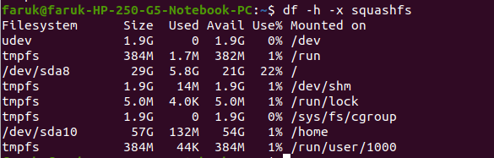

6 . free : The free command gives you a summary of the memory usage with your
computer . It does this for both the Random Access Memory(RAM) and swap
memory .

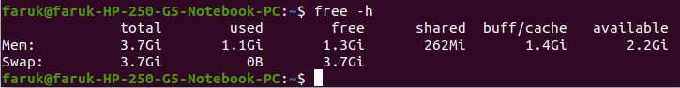

7. mkdir : The mkdir command allows you to create new directories in the filesystem .
You must provide the name of the new directory to mkdir .

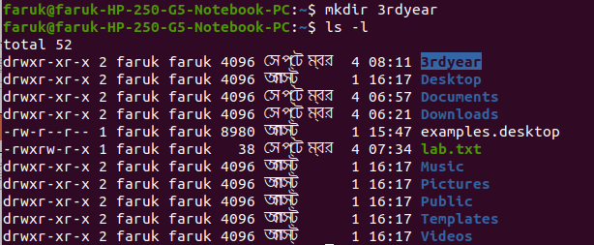

8 . passwd : The passwd command lets you change a password for a user . Just type
passwd to change your own password .

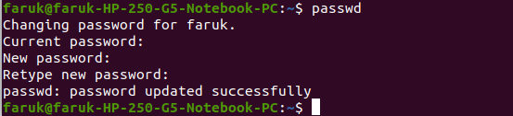

9 . shutdown : The shutdown commands lets you shut down or reboot your linux
system .

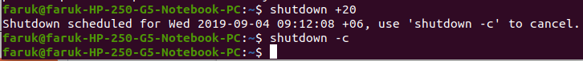

10 . history : The history command lists the commands you have previously issued on
the command line.

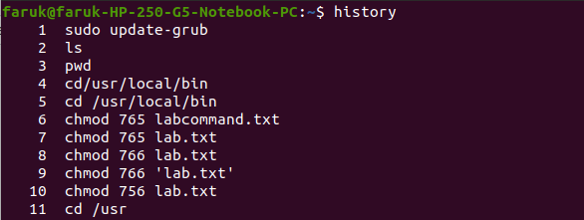

11 . echo : The echo command prints a string of text to the terminal window . The echo
command can show the value of environment variables , or example , the $USER ,
$HOME , and $PATH environment variables.

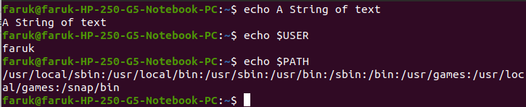

12. tar : With the tar command, you can create an archive file (also called a tarball) that
can contain many other files . This makes it much more convenient to distribute a
collection of files . You can also use tar to extract the files from an archive file .

13 . whoami : whoami is used to find out who you are logged in as or who is logged
into an unmanned Linux terminal.

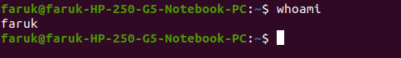

14 . cat : The cat command lists the contents of filles to the terminal window . This is
faster than opening the file in an editor, and there’s no chance you can accidentally
alter the file .

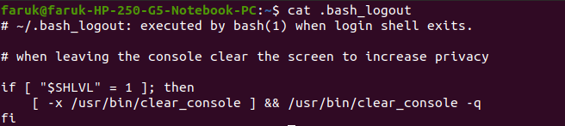

15. exit : The exit command will close a terminal window, end the execution of a shell
script , or log you out of an SSH remote access session .

Conclusion : Linux helps us to control all things using commands . So I think Linux is
very user-friendly . Using Linux Command , I have learn many things like shutdown schedule and making tar file using command . Hence it is fairly easy to work from the terminal and that is why most people prefer the Linux terminal .

