Lab No | : | 09
Name of the Lab | : | Implementation of Priority Scheduling Algorithm
ID | : | IT-17035
Objective | : | (1) What is Priority Scheduling Algorithm?  (2) How to implementation in C?

(1) What is Priority Scheduling Algorithm?

Ans : Priority Scheduling Algorithm :

- Priority scheduling is a non-preemptive algorithm and one of the most common scheduling algorithms in batch systems.
- Each process is assigned a priority. Process with highest priority is to be executed first and so on.
- Processes with same priority are executed on first come first served basis.
- Priority can be decided based on memory requirements, time requirements or any other resource requirement.
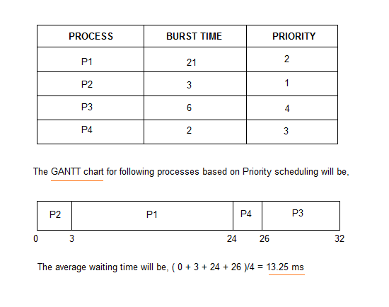

(2) How to implementation in C?
Ans:Source code :

#include<stdio.h>
int main()
{
int bt[20], p[20], wt[20], tat[20], pr[20],i,j,n,total=0,pos,temp,avg_wt,avg_tat;
printf("Enter Total Number of Process:");
scanf("%d",&n);

printf("\nEnter Burst Time and Priority\n");
for(i=0; i<n; i++)
{
printf("\nP[%d]\n",i+1);
printf("Burst Time:");
scanf("%d",&bt[i]);
printf("Priority:");
scanf("%d",&pr[i]);
p[i]=i+1; //contains process number
}

for(i=0; i<n; i++)
{
pos=i;
for(j=i+1; j<n; j++)
{
if(pr[j]<pr[pos])
pos=j;
}

temp=pr[i];
pr[i]=pr[pos];
pr[pos]=temp;

temp=bt[i];
bt[i]=bt[pos];
bt[pos]=temp;

temp=p[i];
p[i]=p[pos];
p[pos]=temp;
}

wt[0]=0; //waiting time for first process is zero

//calculate waiting time
for(i=1; i<n; i++)
{
wt[i]=0;
for(j=0; j<i; j++)
wt[i]+=bt[j];

total+=wt[i];
}

avg_wt=total/n; //average waiting time
total=0;

printf("\nProcess\t Burst Time \tWaiting Time\tTurnaround Time");
for(i=0; i<n; i++)
{
tat[i]=bt[i]+wt[i]; //calculate turnaround time
total+=tat[i];
printf("\nP[%d]\t\t %d\t\t %d\t\t\t%d",p[i],bt[i],wt[i],tat[i]);
}

avg_tat=total/n; //average turnaround time
printf("\n\nAverage Waiting Time=%d",avg_wt);
printf("\nAverage Turnaround Time=%d\n",avg_tat);
printf("\n");
return 0;
}

Output :
