Virtual Museum Project - Technical Report
Team 8
Team Members:
• Ömer Faruk Dinçoğlu – 2021556025
• Hüsnü Önder Kabadayı – 2021556039
• Ertuğrul Tetik – 2021556063

1. Introduction
The Virtual Museum Project aims to create an interactive 3D museum environment that digitally reconstructs selected artifacts from the Adana Museum. Using modern graphics and simulation technologies, the system allows users to explore the museum and interact with historical items via a simulated mobile robot.

Related Work
Several virtual museum applications have emerged in recent years, leveraging technologies like Unity or Unreal Engine. Projects such as 'Virtual Smithsonian' or 'The British Museum VR' offer immersive educational experiences. Unlike these, our project uses OpenGL with C++ to provide low-level rendering control and hands-on understanding of graphics pipelines. Additionally, robot interaction for scanning and UI-triggered artifact exploration introduces a unique blend of robotics simulation and virtual exhibition.

Original Contribution
- Full implementation using native C++ and OpenGL (no high-level engines)
- Custom scanning robot and artifact recognition system
- Manually modeled historical artifacts based on real exhibits
- Lightweight and educationally focused design

2. System Overview
Our system is composed of five main modules:
- Scene Rendering and Environment Setup
- Artifact Loading and Display
- Robot Simulation and Navigation
- User Interface (UI) and Interaction
- Integration and Performance Testing

Team Commitments

Student 1: Ömer Faruk Dinçoğlu
- Lead development of OpenGL rendering pipeline
- Lead system integration effortts
- Create shader programs for realistic rendering
- Develop material system for objects
- Assist with scene integration
- Design and implement user interface using ImGui
- Design Museum Scene Architecture
- Fullscreen mode feature
- Performance Optimization

Student 2: Hüsnü Önder Kabadayı
- Model all five museum artifacts in Blender
- Create textures and materials for artifacts
- Camera system
- Develop an information display system for artifacts
- Assist with scene design and aesthetic elements

Student 3: Ertuğrul Tetik
- Design and implement mobile robot mechanics
- Develop robot arm kinematics and control systems
- Implement scanning mechanism and artifact recognition
- Implement lighting systems (main light and spotlights)
- Museum artifacts pop up information

Each team member will program significant components using both C++ and OpenGL, ensuring equal participation in the core technical aspects of the project.

3. Features and Objectives
1. Immersive Museum Environment
- Realistic 3D room with lighting
- Adjustable spotlights and global illumination
2. Detailed Artifact Representation
- Five accurately modeled artifacts
- High-resolution textures and material maps
3. Interactive Mobile Robot
- Keyboard-controlled movement (Arrow keys + Q/E/R)
- Articulated scanning arm (mouse-controlled)
4. Educational Information System
- Info pop-ups appear when robot scans an artifact
- Data includes name, period, material, and description
5. Usability-Focused UI
- ImGui-based control panels
- Adjustable lighting, camera views, and debug options
BONUS FEATURES:
- F11 for Fullscreen:
You can press F11 to switch to fullscreen mode anytime while using the app. It gives a better view of the museum.
- FPS Display:
There is an FPS counter that shows how many frames per second the app is running. This helps us check performance.
- Cluster Optimization:
We used clustering techniques to improve the frame rate. This way, the app runs faster even when many models are loaded.
- Cross-platform Support:
The project works on both Windows and Linux. We tested it on both systems to make sure it's stable and runs smoothly.
- Error Checking at Every Step:
Our project checks for errors at each stage, like loading models, shaders, or setting up the robot. If something goes wrong, we show a message in the console so it’s easier to fix.
- Supports Multiple Model Formats (.glb and .obj):
The app can load 3D models in both .glb and .obj formats. This makes it easier to add different types of artifacts,robots or models to the museum scene.

4. Technologies Used
- Programming Language: C++
- Graphics API: OpenGL 3.3+
- Libraries: GLFW, GLAD, GLM, Assimp, stb_image, ImGui
- Modeling Software: Blender
- IDE and Build System: Visual Studio 2022
- Version Control: Git (GitHub repository)

5. Architecture and Diagrams
You can find the diagrams here:
https://github.com/yuemco/virtual-adana-museum-v2-team-8/tree/main/Docs/Diagrams

6. Implementation Details
- SceneManager manages all scene objects, lighting, and drawing logic.
- MuseumObject loads models and textures using Assimp and stb_image.
- Robot class handles movement and interaction logic.
- InputManager maps keys and mouse to robot, camera, and light controls.
- ImGuiManager displays UI, artifact info, and debug settings.

Sample Code Snippet:
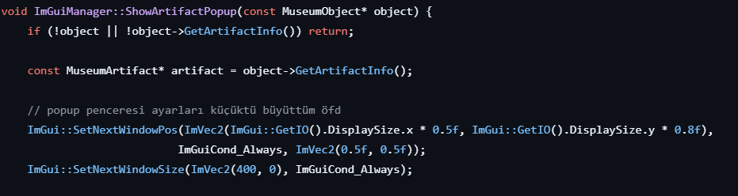

7. Usability and Performance Testing

Usability Testing
Performed tests with 6 users
- Tasks: Moving robot, robot arm movement, show pop up with robot, scanning artifact, adjusting light.
- Result: All users completed tasks within 2 minutes on average
- Feedback: The robot arm could move a little more freely, scanning animation could be done, textures and structures could be more resolved
-The command line panel displays various runtime information, such as which objects have been loaded, which ones have been initialized, and the user's GPU model.
-The application is cross-platform and runs smoothly on both Linux and Windows systems, ensuring broad compatibility for different user environments.

Performance Testing
Metric | Result
Average FPS: Due to the VSync feature, the frame rate is capped to match the screen's refresh rate. In our tests with an RTX 3060 and a 180Hz display, the application consistently achieved 180 FPS. | 180 (RTX 3060)
Memory Usage | < 350 MB
Scene Load Time (Windows) | ~30-35 seconds
Scene Load Time (Ubuntu) | ~12-13 seconds
SSD-HDD Space | ~150 MB

8. Timeline and Milestones
Date Range | Milestone
Mar 25 - Apr 7 | Museum environment, lighting
Apr 8 - Apr 21 | Artifact modeling, integration
Apr 22 - May 5 | Robot mechanics and control
May 6 - May 19 | Integration, testing
May 20 - Jun 2 | Documentation, final polish
June 13 | Final submission

9. Conclusion
As a team, we had the chance to work together on a real project where we used C++ and OpenGL. Throughout this process, we got more comfortable with writing organized code using object-oriented programming concepts like encapsulation and polymorphism. It was helpful to learn them not just in theory but also by using them in actual code.
We also learned how to model objects in Blender. We created things like sarcophagi and statues, added bones and joints to our robot, and figured out how to make it move naturally. Using GitHub for version control was new to some of us, but it helped us understand how to manage files and work as a group.
There were times when big 3D models caused the program to crash or run slowly on some of our computers. To fix this, we made changes to the models and improved how the code loads and draws them. While doing this, we also learned how important optimization is for performance.
The project also taught us about teamwork. We realized that talking openly and solving problems together is just as important as writing good code. Sometimes we got tired or frustrated, but working through those moments helped us become more patient and better at handling stress.
We also showed our project to others and asked for feedback. That helped us spot bugs we hadn’t noticed, like missing parts of a model or something not loading right.
In the end, this project gave us a lot. We didn’t just improve our technical skills, but also learned how to communicate better, work under pressure, and stay organized. It was a good example of how many different skills come together when building a real program.

10. Appendix
For Windows=https://www.youtube.com/watch?v=B3McXQTyJMo
For Linux=https://www.youtube.com/watch?v=2UTruvvfl34
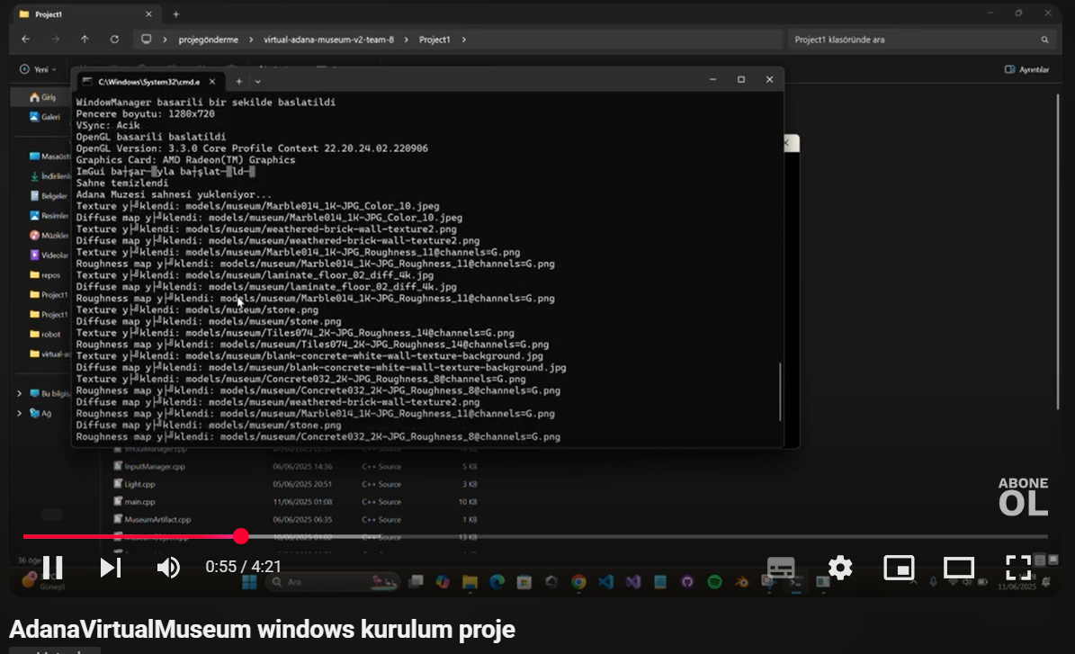
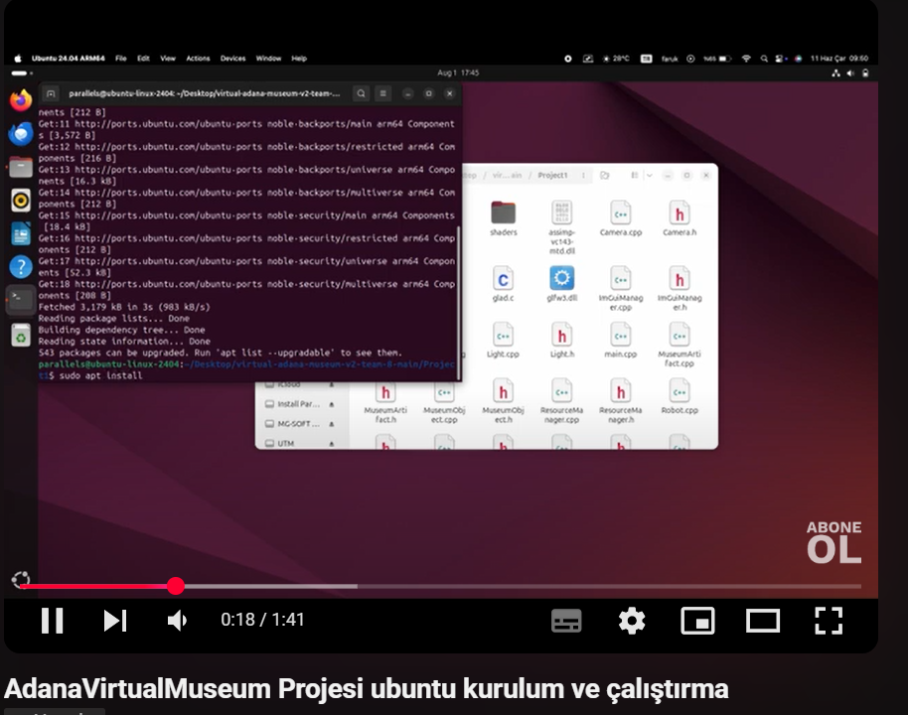

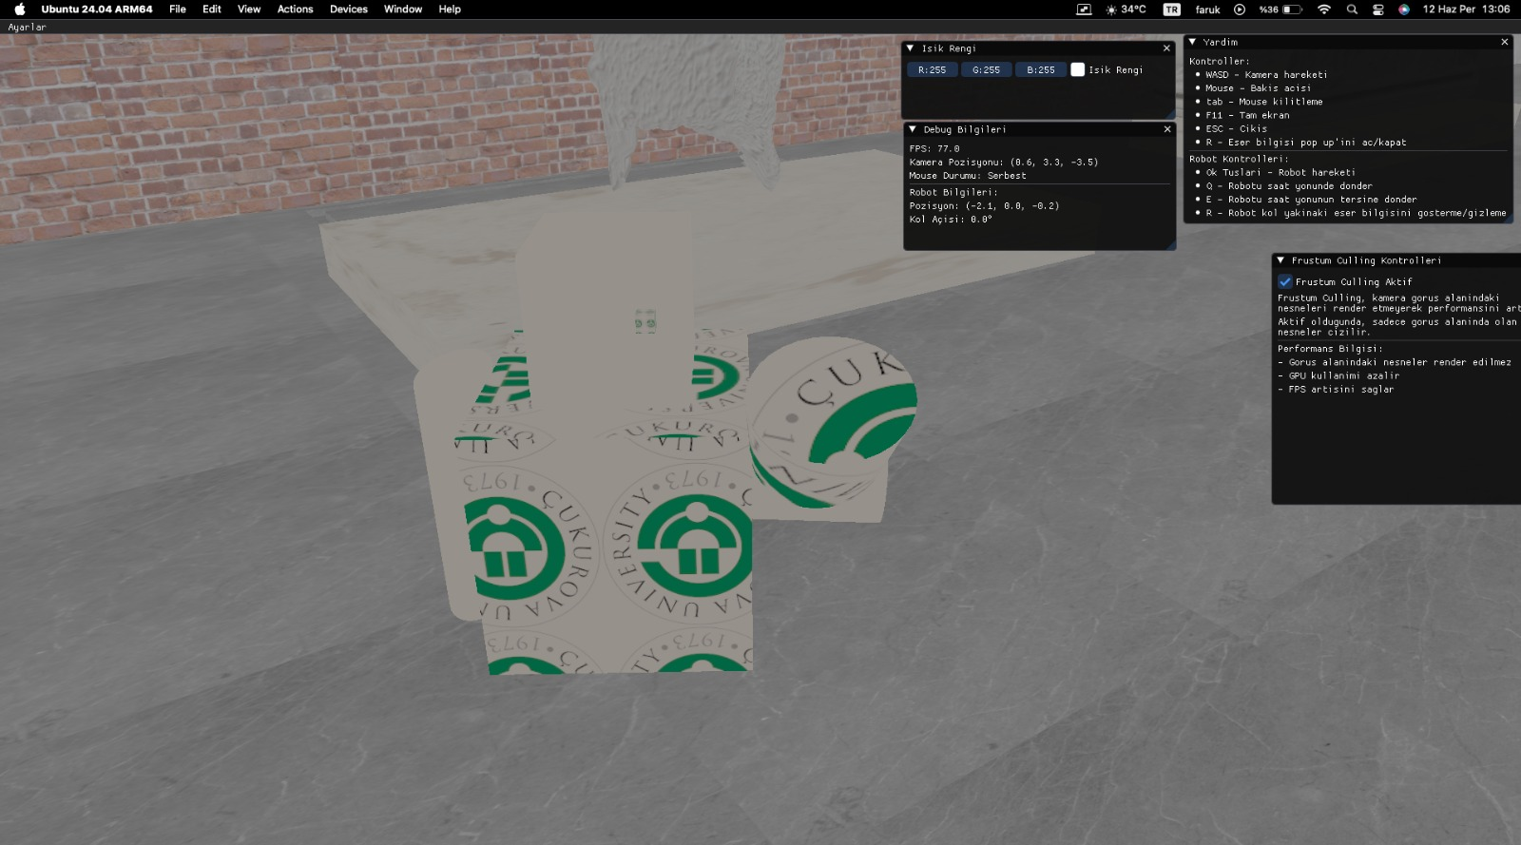
ROBOT:

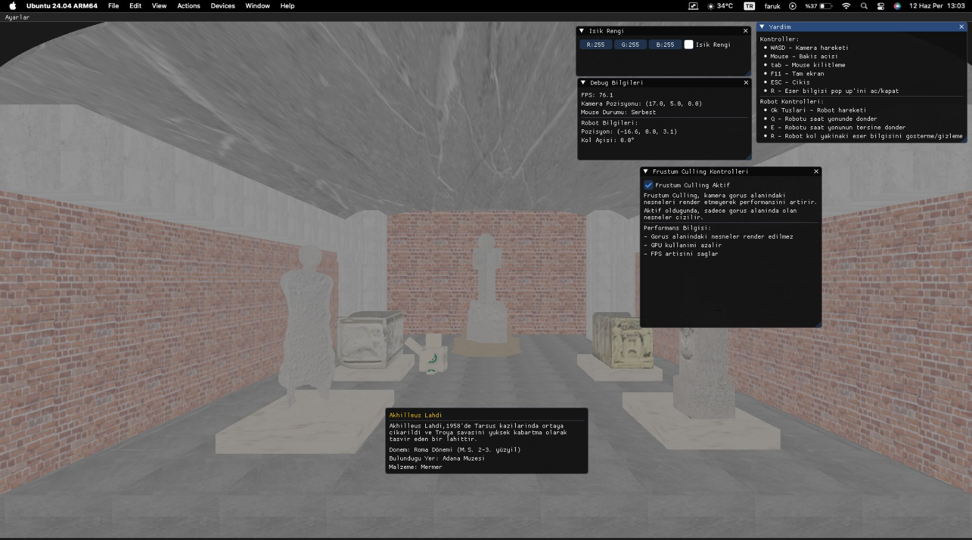
SCENE:

