

CSE 3033 - OPERATING SYSTEM

Programming Assignment 3

|  |  |  |
| --- | --- | --- |
| **Name** | **Surname** | **Student ID** |
| Faruk | Akdemir | 150119012 |
|  |  |  |

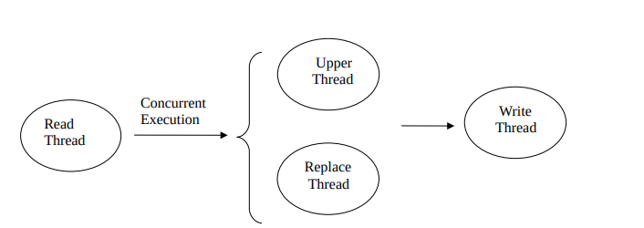

1. Basic Algorithm
2. MainThread : create read thread, upper thread, replace thread, write thread
3. Readthread : create N-input threads
4. Upperthread : create N-input threads
5. Replacethread : create N-input threads
6. Writethread : create N-input threads

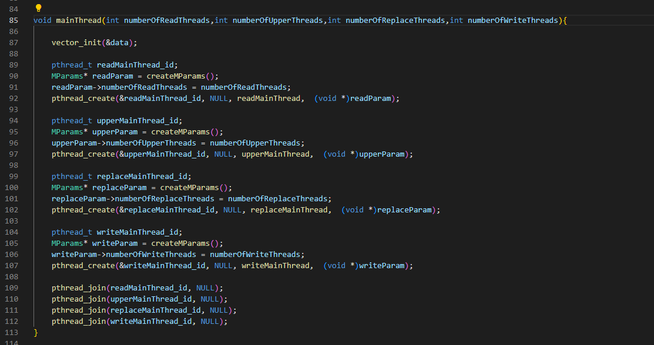

1. Read
2. Open file
3. Create N-input threads
4. Each threads read line by line-index
5. Wait till N-input threads finish
6. Repeat step 2 still read all lines
7. Close file

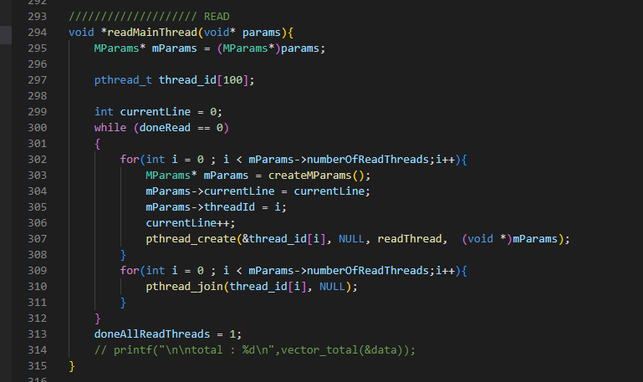

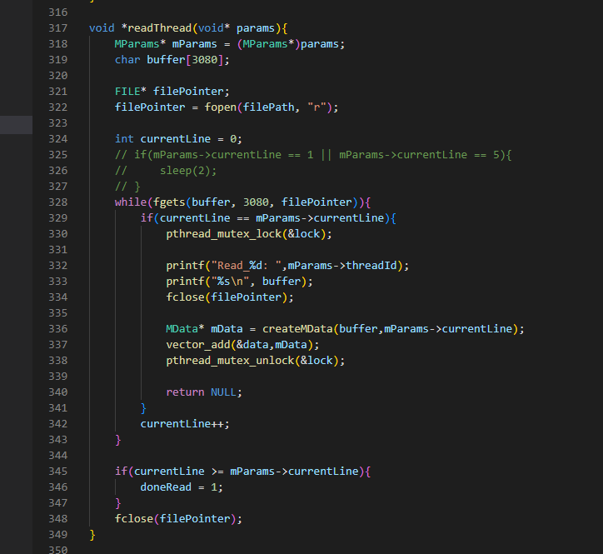

1. Upper
2. Create N-input threads
3. Each thread:
   1. Wait still current line-index readed in array
   2. Upper all character
4. Wait till N-input threads done
5. Check finish all lines, if not repeat step1

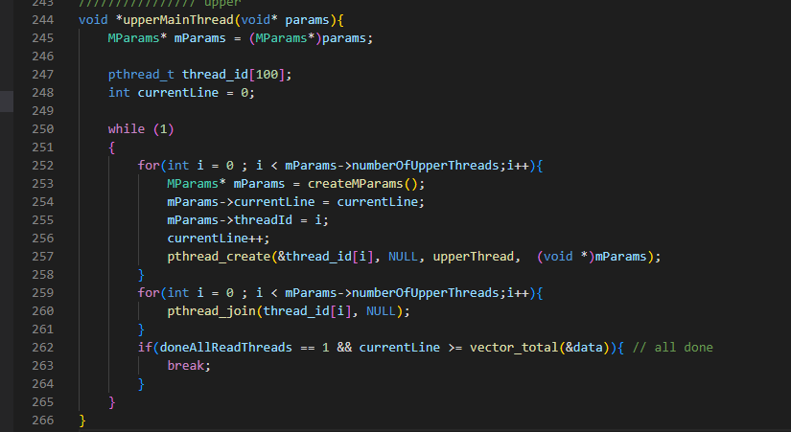

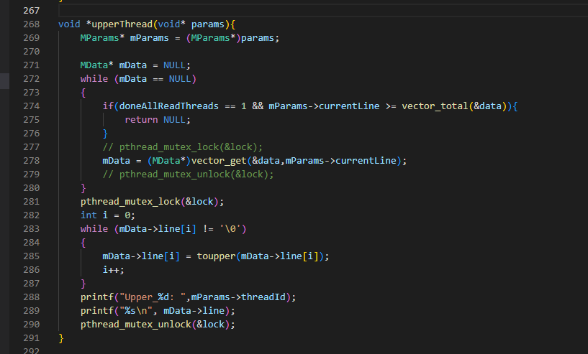

1. Replace
   1. Create N-input threads
   2. Each thread:
      1. Wait still current line-index readed in array
      2. Replace all character ‘ ‘ to ‘_’
   3. Wait till N-input threads done
   4. Check finish all lines, if not repeat step1

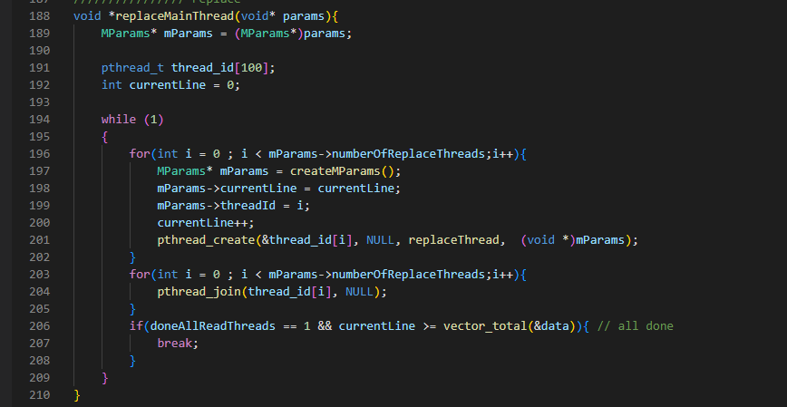

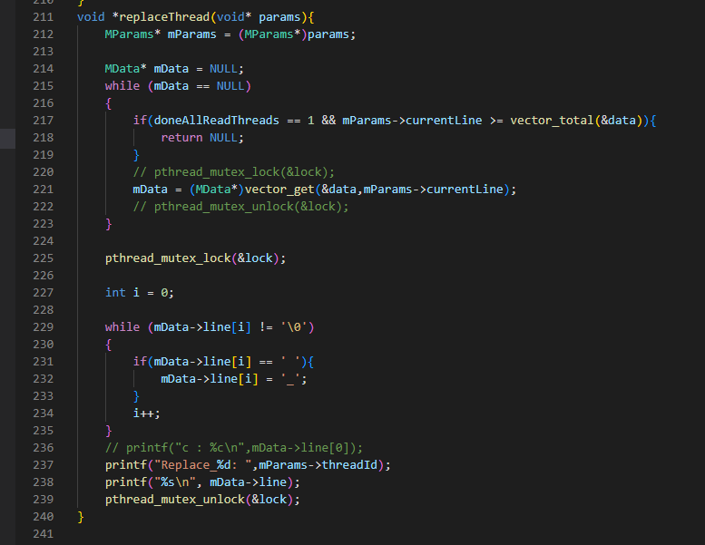

1. Write
   1. Create N-input threads
   2. Each thread:
      1. Wait still current line-index readed in array
      2. Wait still current line-index is done in both replace and upper
      3. Replace the old line in file to the new line
   3. Wait till N-input threads done
   4. Check finish all lines, if not repeat step1

