

**T.C.**

**MARMARA UNIVERSITY**

**FACULTY OF ENGINEERING**

**COMPUTER ENGINEERING DEPARTMENT**

**CSE4057 Information Systems Security**

**Homework 1 Report**

April 25th, 2024

|  |  |
| --- | --- |
| Faruk Akdemir | 150119012 |
| Yasin Sefa Kırman | 150119034 |

Q1-)

A Part

KA+

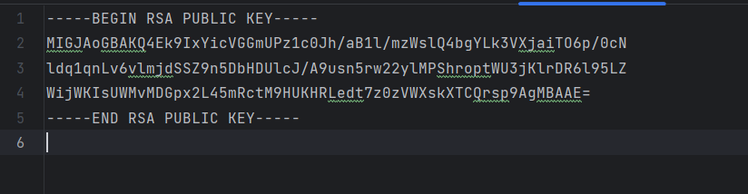

KA-

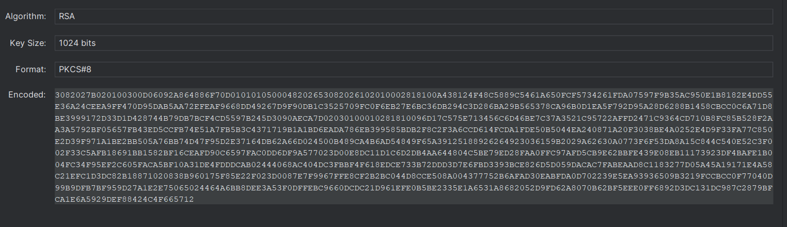

B Part

KB+

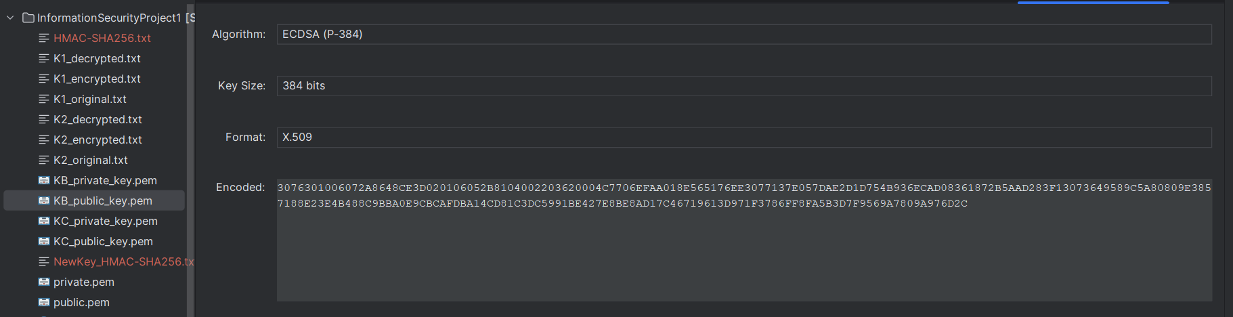

KB-

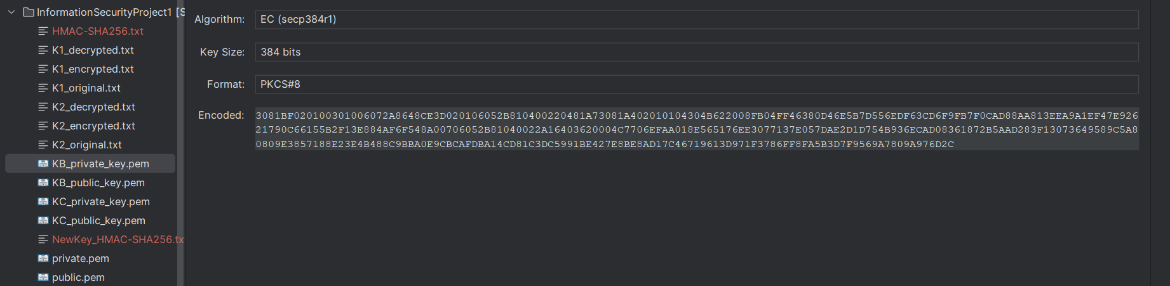

KC+  
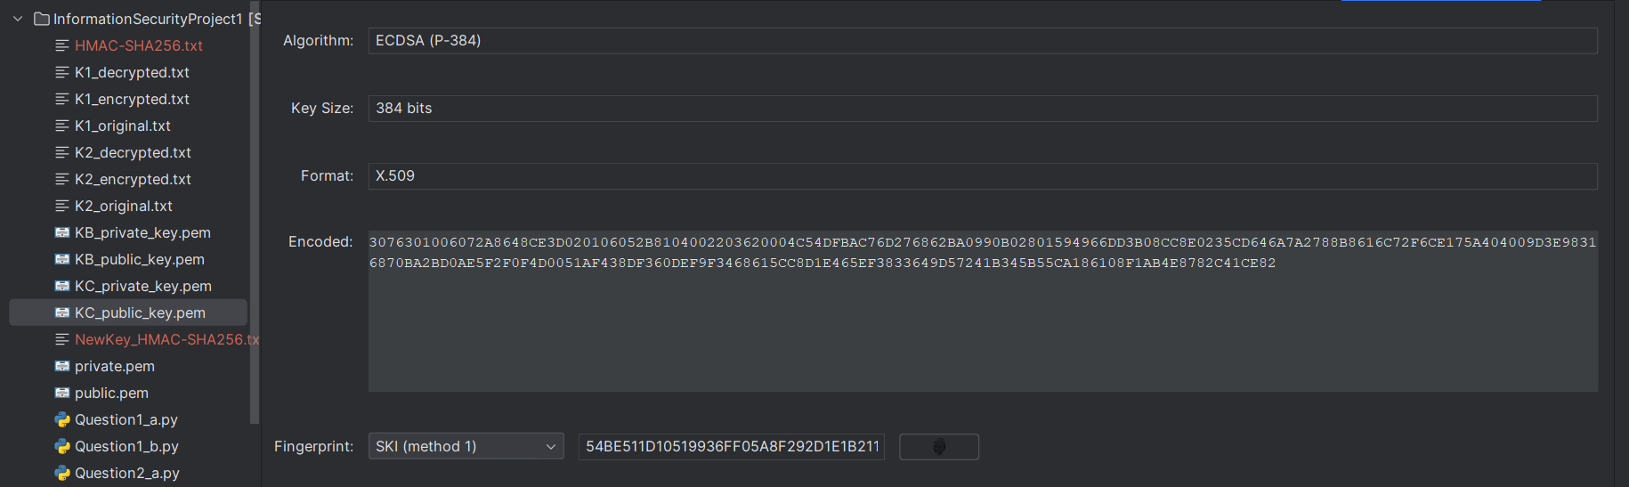

KC-

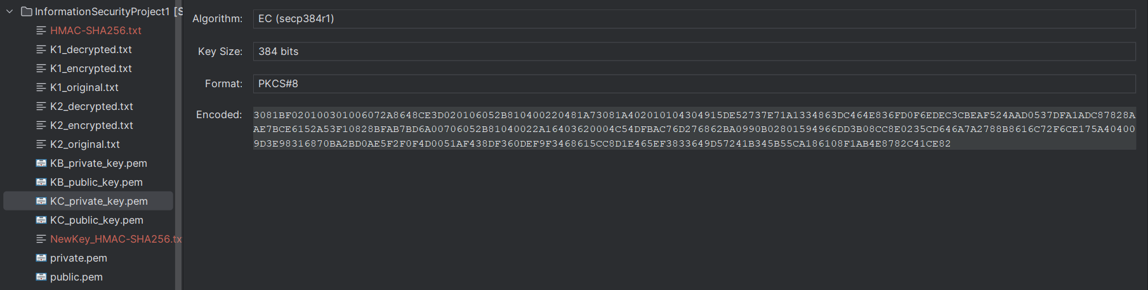

Q2-)

A Part

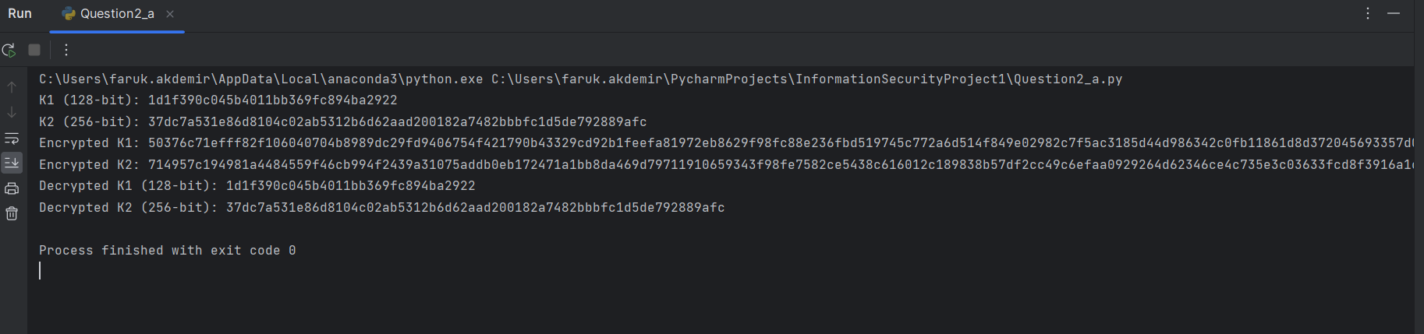

B Part

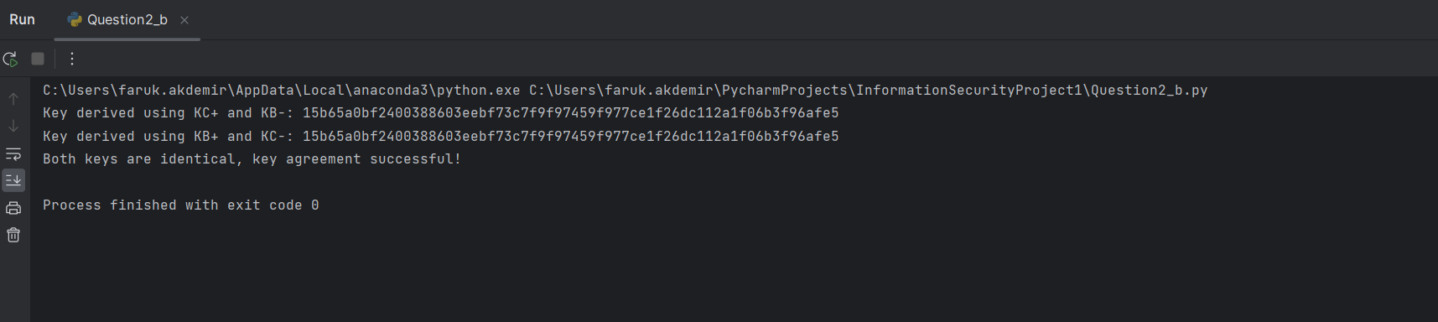

Q3-)

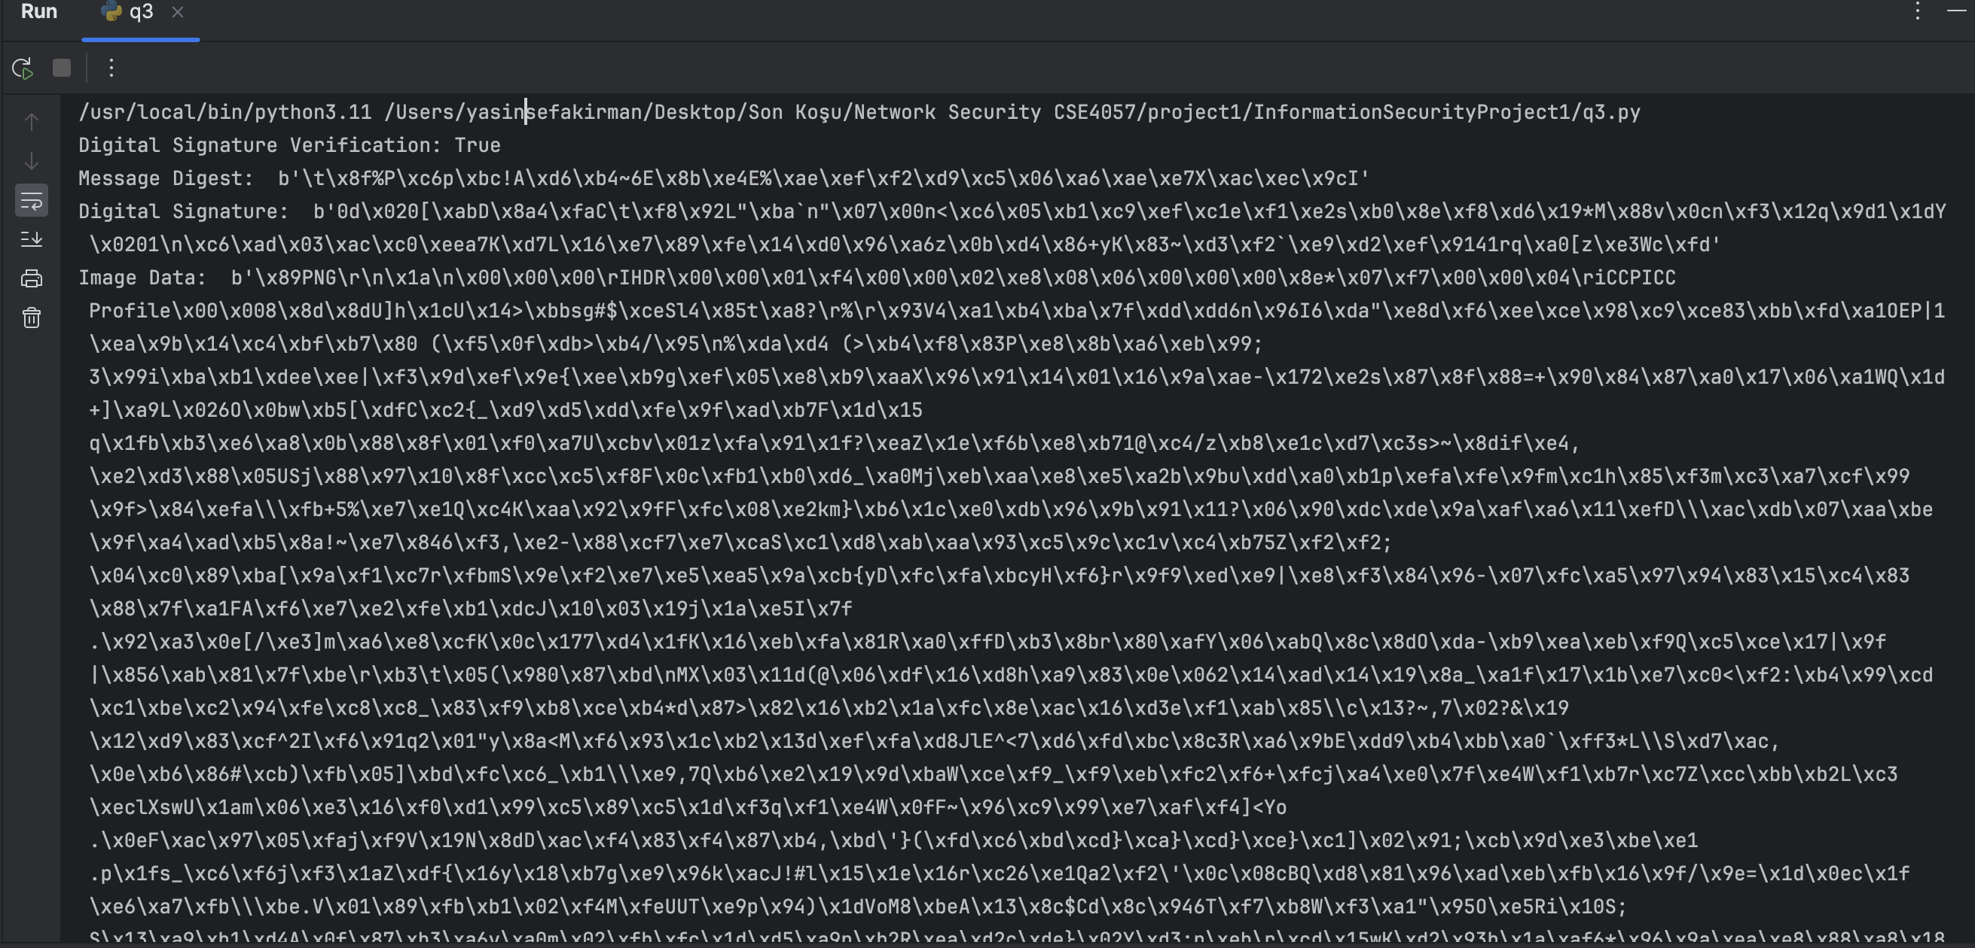

Image data too long to capture in a snapshot.

Q4-)

Console output:

All the outputs printed under the subdirectory q4_materials:

Q5-)

A Part

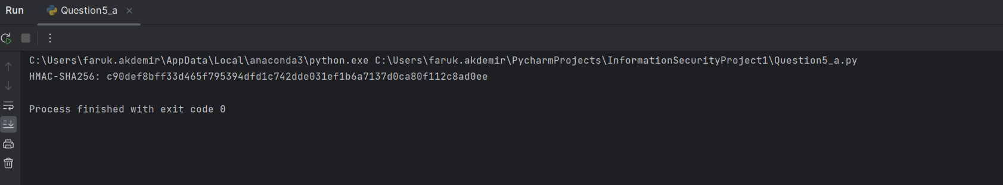

B Part

