ENGLISH QUESTION

Answer all the questions below Total marks 100

1. Circle ‘D’ and ‘d’ 10 marks

a. D o o r b. d u b

c. B a d d. D o g

e. D u c k f. G o o d

g. d h a k a h. b e d

i. D o w n j. D e e p

2. Write the missing letters from A to Q 10 marks

A __ C D __ __ __ G __ I __ __ L __ N __ __ Q

3. Fill in the blanks with the correct letters 20 marks

a. C __ T __

b. A__P P L __

c. M __ N __ O

d. N __ S __

e. B __ N A __ A

f. D__ L __

g. G __ __ D

h. B __ __ L

i. B __ __ T

j. G __ A P __ S

4. Match the capital letters to their small letters 10 marks

B p

D q

Q b

J j

P c

C d

G a

I h

A g

H i

5. Rewrite the words using small letters 20 marks

a. C O L O U R

Ans: ___________

b. D A N G E R

Ans: ___________

c. R E D

Ans: ___________

d. O R A N G E

Ans: ___________

e. P E N

Ans: ___________

f. B L A C K

Ans: ___________

g. P O T A T O

Ans: ___________

h. C A R

Ans: ___________

i. C Y C L E

Ans: ___________

j. M O N K E Y

Ans: ___________

6. Write in small letters from a to t 20 marks

Ans.______________________________________________________

__________________________________________________________

__________________________________________________________

__________________________________________________________

7. Match the pictures with words 10 marks

i. BAT 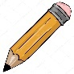

ii. TREE 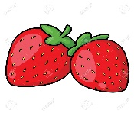

iii. PENCIL

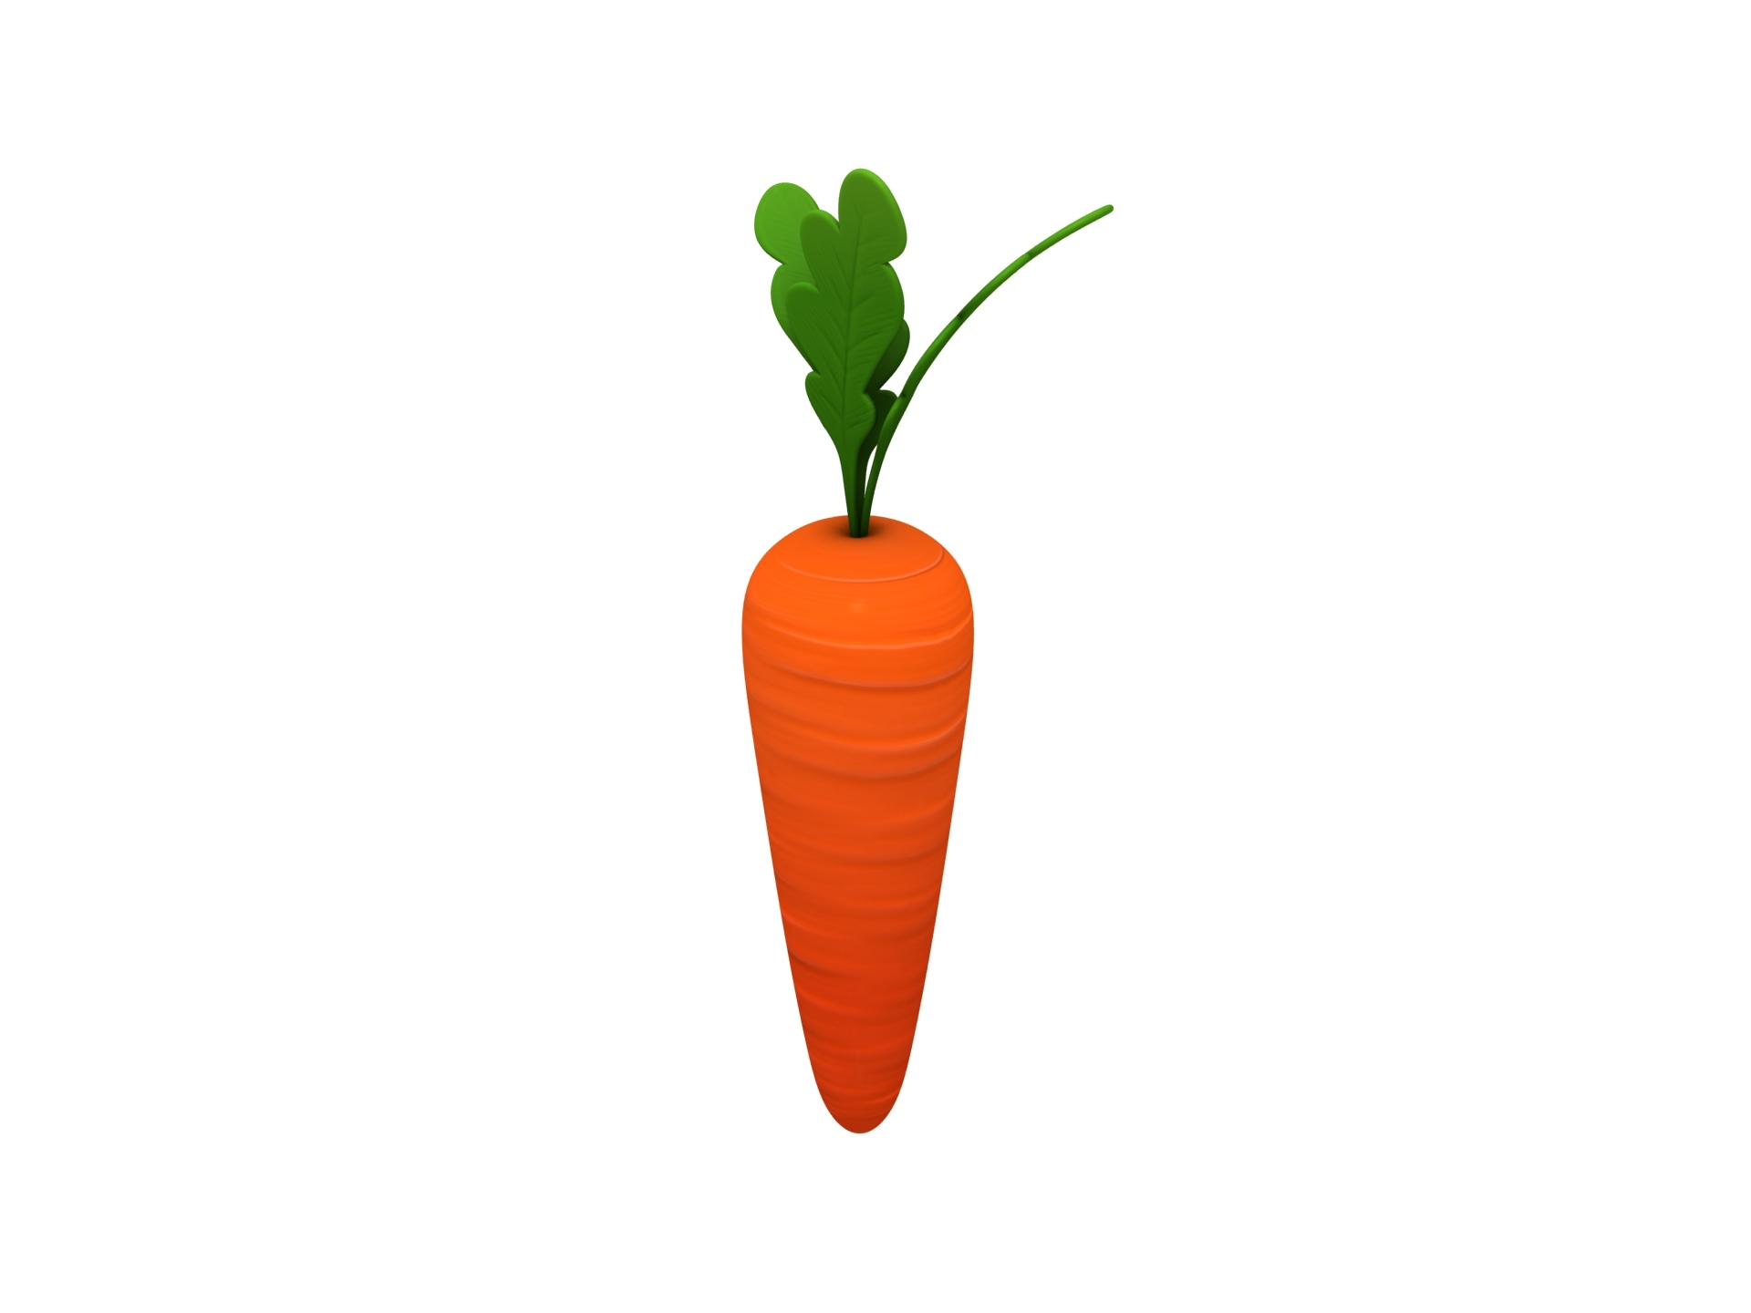

iv. CARROT

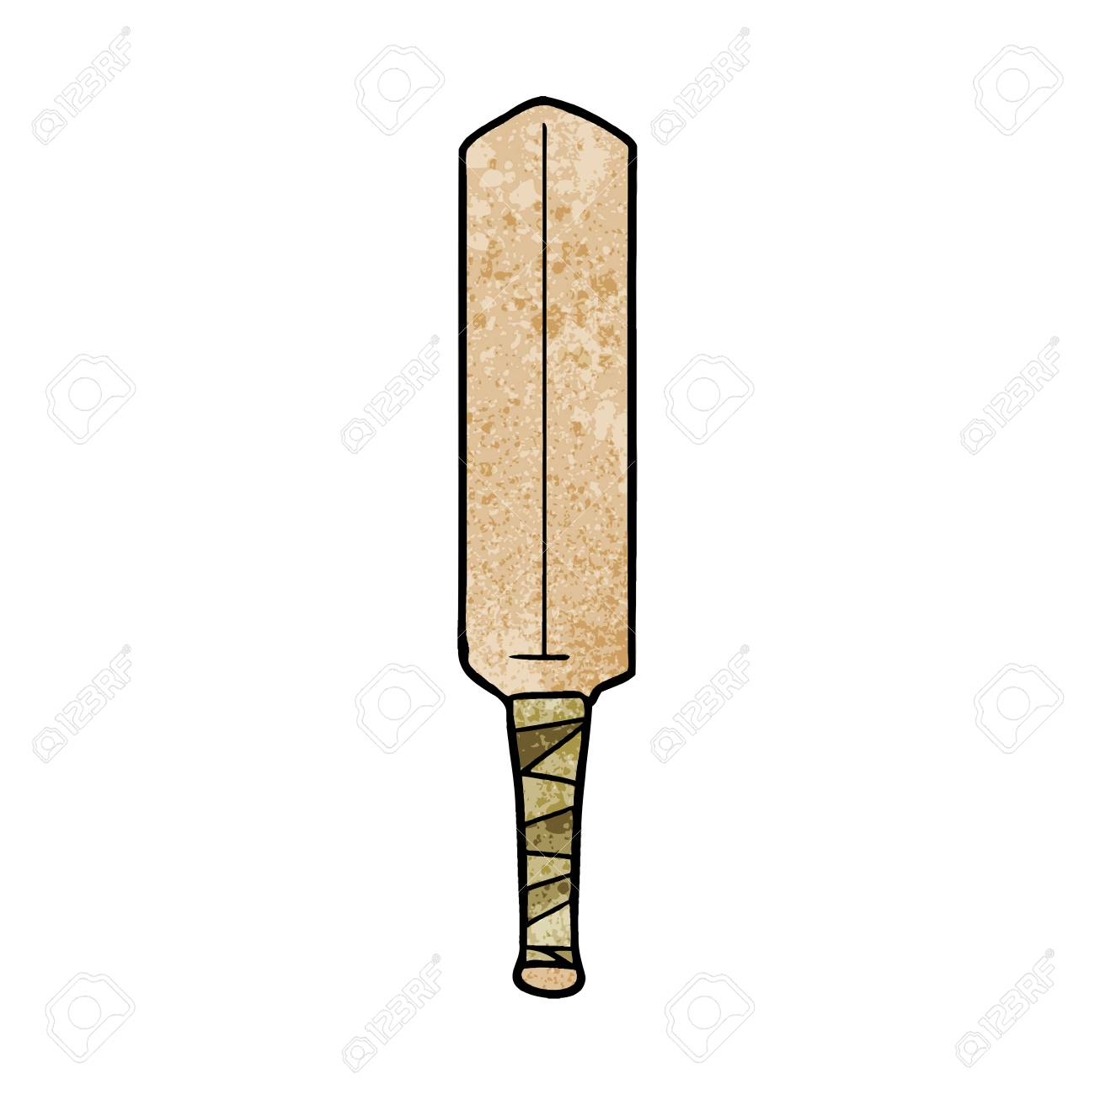

v. STRAWBERRY

