Bilkent University
Department of Computer Engineering

CS 478/564 COMPUTATIONAL GEOMETRY
HOMEWORK 1

Instructor: Uğur Güdükbay
Due date: Friday, February 25, 2022 (23.55)

In doing the assignments, you are on the honour system, meaning that any submitted assignment is solely the work of the submitter. You are free to discuss the questions with your friends, but you should submit your own work.

You must use a Word Processor to prepare your answers. Handwritten homeworks will not be graded.

- Given a circular linked list of points and a point P that is not included in the list, give an algorithm to check if the list of points is in counterclockwise order according to P. HEAD is the first node of the circular linked list, and for each node N, N.P refers to the point with x and y coordinates, and N.NEXT refers to the next node. Note that, if we draw line segments between P and each point in the list, these lines are not intersecting.
- Given Doubly Connected Edge List representation of a Planar Straight-Line Graph, give an algorithm to check if we can color all the faces using two colors, such that no two adjacent faces share the same color.
- You are given N rectangles with fixed x coordinates. Each rectangle has constant unit height, but can have different width. What is the height of the shortest tower we can build using N rectangles? Think of it as we view the tower from its side, as in the figure below. Maximum rectangle width is a constant number W, and the tower should sit on a line that is W wide. You have to use all the rectangles to build the tower, y coordinates of the rectangles can be changed, in other words, you can change the vertical arrangement of the rectangles as long as x coordinates remain the same. Describe an approach to calculate the solution utilizing sweeping algorithmic technique.
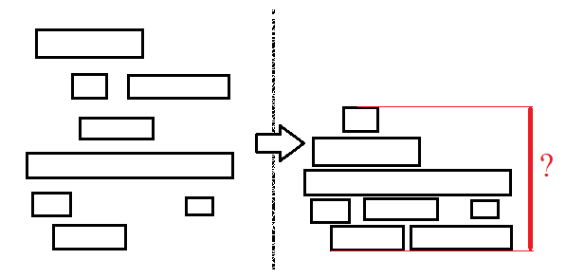
- Given Doubly Connected Edge List representation of a Planar Straight-Line Graph and a face F, give an algorithm to expand F such that it covers all the neighbors of F (you are going to calculate union of F with all the neighbor faces of F). You need to modify the graph, you can use DeleteEdge(int i) function to remove an edge.
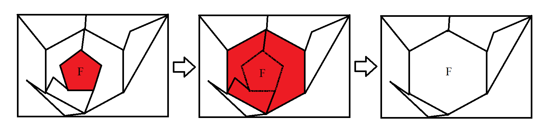
- Using Euler’s formula as a starting point, prove the following inequalities for a Planar Straight-Line Graph with the additional property that each vertex has degree greater than or equal to 3
v <= 2/3 e e <= 3v – 6
e <= 3f – 6 f <= 2/3 e
v <= 2f – 4 f <= 2v – 4

Also prove that if a Planar Straight-Line Graph is triangulated (that is every face is a triangle) then e = 3v – 6. Note that in this case some vertices may have degree less than 3.

