Bilkent University
Department of Computer Engineering

CS 478/564 COMPUTATIONAL GEOMETRY
HOMEWORK 2

Instructor: Uğur Güdükbay
Due date: Tuesday, March 22nd, 2022 (23.55)

In doing the assignments, you are on the honour system, meaning that any submitted assignment is solely the work of the submitter. You are free to discuss the questions with your friends, but you should submit your own work.

You must use a Word Processor to prepare your answers. Handwritten homework will not be graded.

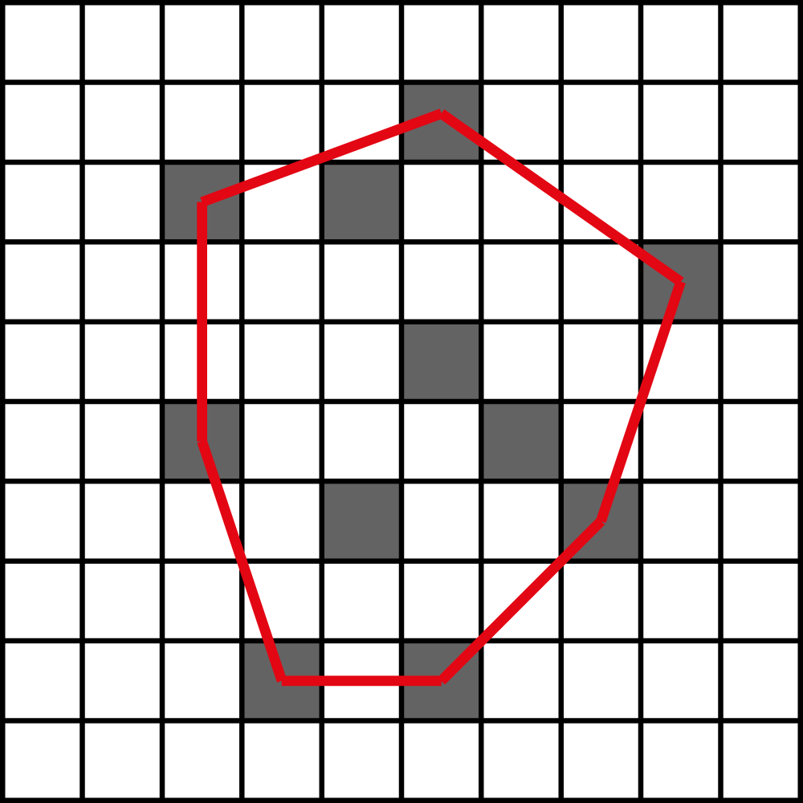

- A set of points are represented as a 2D matrix M. M[i][j] is true if there is a point in the center of the grid cell (i, j), where i is in range [0,X], and j is in range [0,Y]. Describe an approach to find the cells that contribute to the convex hull of the points of M in O(XY) utilizing the matrix structure. The cells may or may not be in order.
- We want to maintain the convex hull of a set of points S. Describe how to add new points to S and remove points from S so that the convex hull is updated accordingly. While updating you may utilize the existing convex hull. Suppose S has N points and the convex hull is made of H points, give a complexity analysis of your approach in terms of N and H. Consider the cases where the point is outside or inside the convex hull.
- We want to simulate a 2D rigid body system of a huge number of objects. For each object O; O.V gives the current speed and O.P gives the current position. CheckCollision(Object[] objects) can be used for checking the collision of an array of objects, this function also updates the speeds of the colliding objects accordingly. This function runs in O(N²) where N is the length of the given objects. The current algorithm is as follows:
Initialize Objects[] allObjects
While(true):
CheckCollision(allObjects)
For every object o in allObjects:
o.p = o.p + o.v
We realize this approach is very slow as we use CheckCollision for all of the objects. Write a faster algorithm utilizing a computational geometry structure used for range searching (you can include any modifications to the structure and use high level functions defined for that structure) which will use CheckCollision for a subset of allObjects so that average running time is improved. Suppose maximum speed for an object in each dimension is V_{max}. Ignore any object outside [(-X,-Y), (X, Y)] range where X and Y are very big numbers compared to V_{max}. Assume objects are uniformly distributed at the beginning.
- Modify the graph weight balancing algorithm (Preparata, page 51) given in the lecture slides so that it constructs a monotone complete set of chains from the given Planar Straight Line Graph. You should modify the second pass to construct the monotone complete set of chains.
- Let p₁ = (x₁, y₁) and p₂ = (x₂, y₂) be two points in the plane. We say that point p₁ dominates point p₂ if x₁ ≥ x₂ and y₁ ≥ y₂. Let S be a set of points in the plane. A point p∈ S is a maximal element if p is not dominated by any other point in S. Solve the following problem: Given a set of n points in the plane, let k denote the number of maximal elements in this set. Design a divide-and-conquer algorithm of time O(n log n) (or better) for finding these maximal elements. Prove the correctness of your algorithm.

