Taxi Game Report

Table of Contents
- Project Overview
- Technical Architecture
- Game Features and Mechanics
- User Interface Design
- Implementation Details
- Game Manual
- Conclusion

1. Project Overview

1.1 Introduction
- Project Type: Taxi simulation game
- Language: x86 assembly (Irvine32 library)
- Goal: Pick up passengers, avoid obstacles, deliver to destinations
- Focus: Score maximization and strategic navigation

1.2 Project Objectives
- Show x86 assembly programming skills
- Create complex game logic with AI cars
- Build fun user experience with multiple modes
- Add save/load features
- Include sound effects and music

1.3 Development Environment
- Language: x86 Assembly (MASM)
- Library: Irvine32.inc
- Audio: winmm.lib
- Platform: Windows
- Grid: 20x20 cells
- Graphics: ASCII art with colors

2. Technical Architecture

2.1 Memory Organization
Main Data Storage:
- Grid array: 400 bytes (20×20 cells)
- Player data: position, color, score, timers
- Passenger arrays: 5 passengers max with positions
- NPC cars: 5 AI vehicles with directions and colors
- Game state: mode, difficulty, timers, lives, level

2.2 Core Data Structures
Grid Symbols:
- . = Empty space
- C = Player taxi
- P = Passenger
- D = Destination
- H = House obstacle
- T = Tree obstacle
- X = Hurdle obstacle
- R = Rock obstacle
- O = NPC car
- $ = Coin

2.3 Key Algorithms
Pathfinding (BFS):
- Checks if passenger can reach destination
- Ensures game is solvable
- Validates all placements
Collision Detection:
- Real-time checking for all movements
- Different damage based on taxi color
- Handles all obstacle types
AI Movement:
- NPC cars follow straight paths
- Reverse direction when blocked
- Avoid obstacles automatically
Level Generation:
- Random house blocks (3-6 cells)
- Passengers placed 5+ cells apart
- All items reachable (BFS verified)

3. Game Features and Mechanics

3.1 Game Modes
Standard Mode:
- Classic gameplay
- Focus on high score
- Choose difficulty level
Career Mode:
- 10 progressive levels
- Level 1 target: 50 points
- Each level adds 50 points to target
- Difficulty increases each level
- Complete all 10 to win
Time Attack Mode:
- Race against clock
- Options: 30s / 60s / 120s
- Score as much as possible
- Quick decisions needed
Endless Mode:
- Start with 3 lives
- Each collision = lose 1 life
- Survive as long as possible
- Game ends at 0 lives

3.2 Taxi Color System
Red Taxi:
- Speed: Slower (500ms between moves)
- Defense: Takes 50% less damage
- Best For: Defensive play, many obstacles
Yellow Taxi:
- Speed: Faster (100ms between moves)
- Defense: Normal damage
- Best For: Aggressive play, coin collecting

3.3 Difficulty Levels
Easy:
- Coins: 8-10
- Passengers: 2-5
- Obstacles: Few (2-3 hurdles, 1-2 trees)
- NPC speed: Slow (1500ms)
Standard:
- Coins: 5-7
- Passengers: 2-5
- Obstacles: Medium (3-5 hurdles, 1-3 trees)
- NPC speed: Medium (1000ms)
Hard:
- Coins: 3-5
- Passengers: 3-4
- Obstacles: Many (5-7 hurdles, 3-5 trees)
- NPC speed: Fast (700ms)

3.4 Scoring System
Earn Points:
- Drop off passenger: +10
- Collect coin: +10
Lose Points (damage varies by taxi):
- Hit passenger: -5
- Hit hurdle: -4 (yellow) / -2 (red)
- Hit tree: -4 (yellow) / -2 (red)
- Hit house: -3
- Hit NPC car: -2 (yellow) / -3 (red)
- Hit rock: -2

3.5 Dynamic Difficulty
- Every 2 passengers dropped = NPCs speed up
- Speed increases by 100ms
- Minimum speed: 300ms
- Creates challenge within single game

4. User Interface Design

4.1 Main Menu Screen
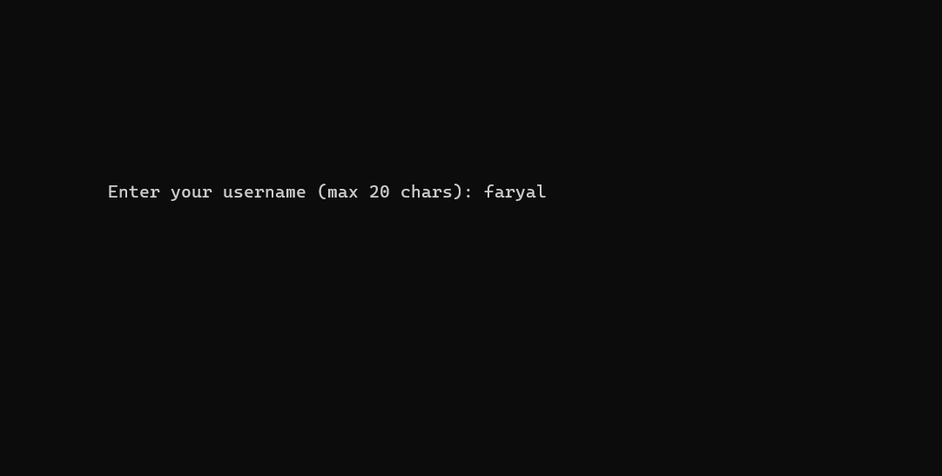
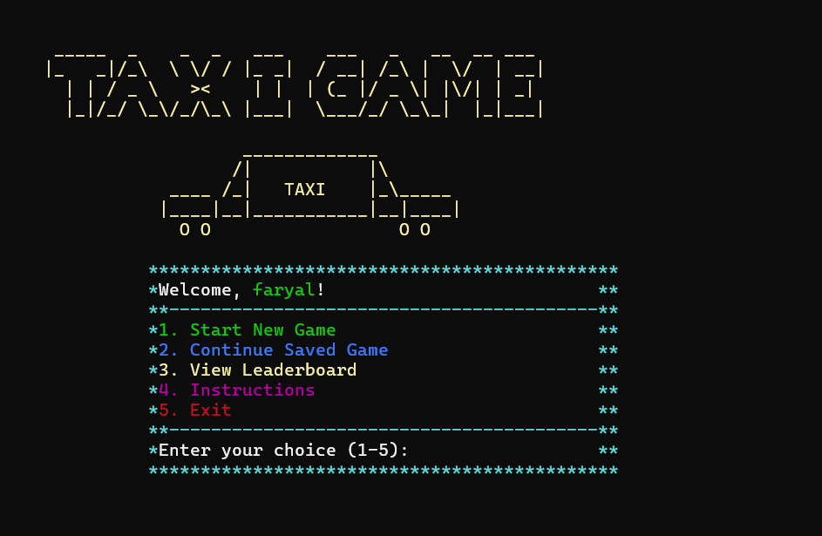

4.2 Game Board Display
Cell System: 9×9 characters per grid cell
Visual Elements:
- Borders: Blue with +, |, -
- Player: Red/yellow car art
- Passengers: Cyan stick figures
- Destinations: Green background
- Trees: Green
- Rocks: Gray
- Houses: White
- Hurdles: Magenta
- Coins: Yellow $
- NPCs: Various colors
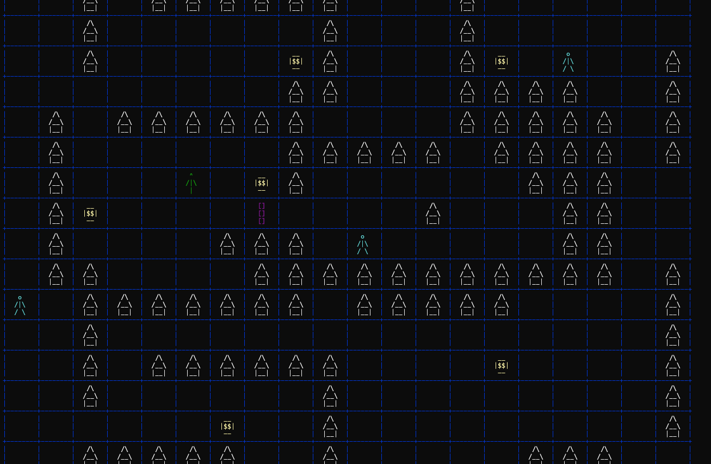

4.3 HUD Elements
Standard Display:
Score: 150 | Passenger in taxi: YES
Mode-Specific Info:
- Career: Level: 3 | Target: 150 | Passengers: 4
- Time: Time: 1:45
- Endless: Lives: 2

4.4 Pause Screen
=== GAME PAUSED ===

Press 'P' to resume
Press 'C' to save and exit

4.5 Leaderboard
=== TOP 10 ===

1. PlayerOne - Score: 450
2. Player2 - Score: 380
3. Player2 - Score: 325

5. Implementation Details

5.1 Sound System
Audio Files Used:
- click.wav - Menu clicks
- pickup.wav - Pick up passenger
- drop.wav - Drop off passenger
- crash.wav - Hit obstacle
- coin.wav - Collect coin
- pause.wav - Pause/resume
- endgame.wav - Game over
- background.wav - Music (loops)
Technology: Windows PlaySoundA API (winmm.lib)

5.2 Save System
File Name: username_save.txt
Saved Data (one value per line):
- Game mode
- Level info
- Player position & color
- Score & passenger status
- All passenger locations
- All NPC car data
- Full grid state (400 values)
Features:
- One save per username
- Load anytime from menu
- Full game state restored

5.3 Leaderboard System
File: highscores.txt Capacity: Top 10 scores Format: Username + Score per line
Features:
- Auto-saves after game completion
- Keeps highest score per player
- Sorted by score
- Persistent across sessions
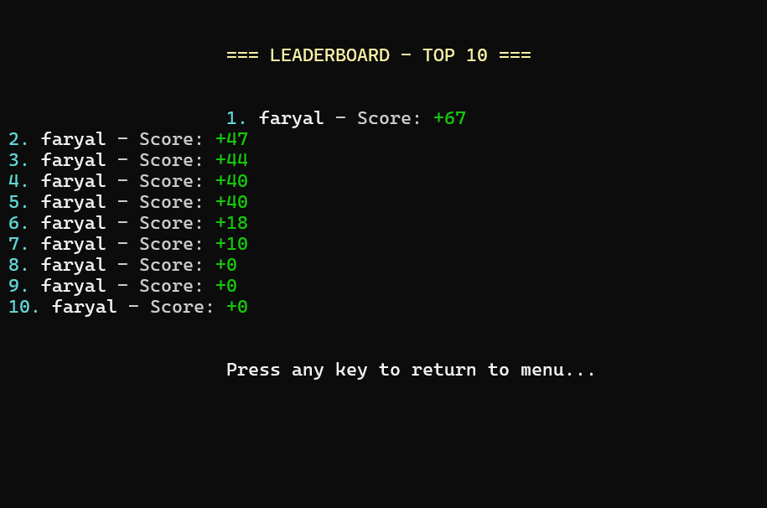

5.4 Key Procedures
draw_fullgrid:
- Renders all 400 cells
- Called on start/unpause
- Shows complete game state
draw_cell:
- Updates single cell
- Used for movement
- Efficient rendering
move_other_cars:
- AI car movement
- Direction changes on collision
- Boundary detection
check_adj_psngr:
- Finds passengers nearby
- Checks 4 adjacent cells
- Enables pickup
IsReachable:
- BFS pathfinding
- Verifies game solvable
- Used in generation
check_career_progress:
- Monitors level completion
- Handles progression
- Shows victory screen

5.5 Input Controls
Movement Keys:
- Arrow Up/Down/Left/Right
- Scan codes: 48h, 50h, 4Bh, 4Dh
Action Keys:
- Space: Pickup/dropoff
- P: Pause
- C: Save & exit
- X: Exit (no save)
Features:
- Timing system prevents spam
- Speed based on taxi color
- Responsive controls

6. Game Manual

6.1 Getting Started
First Time:
- Enter username (max 20 chars)
- View instructions (option 4)
- Start new game
New Game Setup:
- Pick game mode
- Choose taxi color
- Select difficulty
- Press any key to start

6.2 Controls Quick Reference
Key | Action
↑ | Move Up
↓ | Move Down
← | Move Left
→ | Move Right
Space | Pickup/Dropoff
P | Pause
C | Save & Exit
X | Exit (no save)

6.3 How to Play
Basic Steps:
- Find passenger (cyan person)
- Move adjacent to them
- Press Space to pickup
- Green destination appears
- Navigate to destination
- Press Space to dropoff (+10 pts)
- Collect coins (+10 pts)
- Avoid obstacles (lose points)
Important Rules:
- Must be adjacent to pickup/dropoff
- Can carry only 1 passenger at a time
- Obstacles cause damage
- NPCs get faster over time

6.4 Strategy Tips
General:
- Plan routes before moving
- Red taxi = better for obstacles
- Yellow taxi = better for speed
- Watch NPC car patterns
By Mode:
- Standard: Get all passengers & coins
- Career: Focus on target score first
- Time: Skip hard passengers, grab coins
- Endless: Defensive play, preserve lives

6.5 Obstacle Guide
Damage & Strategy:
- Houses (White): -3 pts, block paths
- Trees (Green): -4/-2 pts, scattered placement
- Hurdles (Magenta): -4/-2 pts, construction zones
- Rocks (Gray): -2 pts, minor obstacles
- NPCs (Colors): -2/-3 pts, moving threats
- Passengers (Cyan): -5 if hit, careful approach
Tip: Red taxi takes half damage from trees/hurdles

6.6 Save & Load
Saving:
- No auto-save
- Must pause (P) then press C
- Returns to menu after save
- File: username_save.txt
Loading:
- Main menu option 2
- Restores exact game state
- One save per player
Warning: New save overwrites old save

6.7 Leaderboard
How It Works:
- Top 10 scores saved
- Displayed in main menu
- Shows rank, name, score
- Updated after each game
Getting On Board:
- Complete any game
- System checks if score qualifies
- Auto-saves if top 10
- Special message for new high score

7. Conclusion

7.1 What Was Achieved
Technical Features:
- Complex game in assembly language
- AI-controlled NPC vehicles
- ASCII art graphics system
- Save/load functionality
- Sound effects & music
- 4 different game modes
- Random level generation
- Pathfinding algorithm

7.2 Problems Solved
Key Challenges:
- Memory management with registers
- Collision detection all directions
- BFS pathfinding in assembly
- Multiple timing systems
- File I/O for complex data
- NPC movement AI
- Procedural level generation

7.3 Skills Learned
Main Takeaways:
- x86 assembly language mastery
- Low-level game development
- Algorithm implementation
- Windows API integration
- Software design in assembly
- Debugging complex code

7.4 Future Ideas
Possible Additions:
- Better AI (A* algorithm)
- Animation system
- Daily challenges

7.5 Video Link
C__Users_v o s t r o_source_repos_Project7_Debug_Project7.exe 2025-12-03 20-47-57.mp4

