Bash commands

1] to create a file

***Use gedit filename.sh***

In below example I created a file a1 and wrote the data, to print the data we need to give the permission so use command ***chmod*** to give permissions and finally execute using .***/filename.sh***

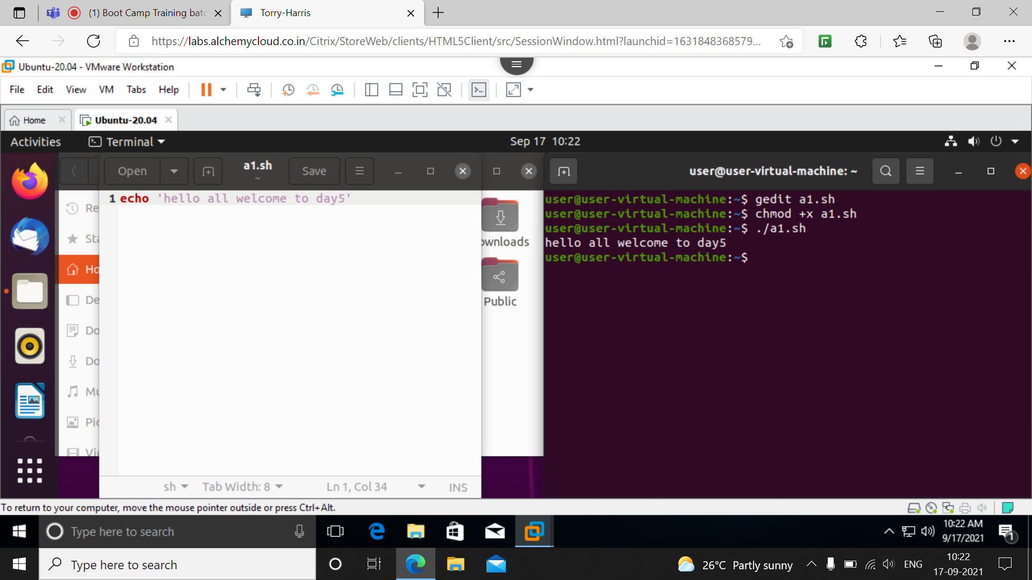

2] To create new folder and new folder inside that

Use command ***gedi***t to create a file inside file give command ***mkdir*** to make new folder

Echo to print given data we can add new folder inside that by giving path ***day5/1***

And the data represented by ***#*** wont be displayed here. We can use as comment

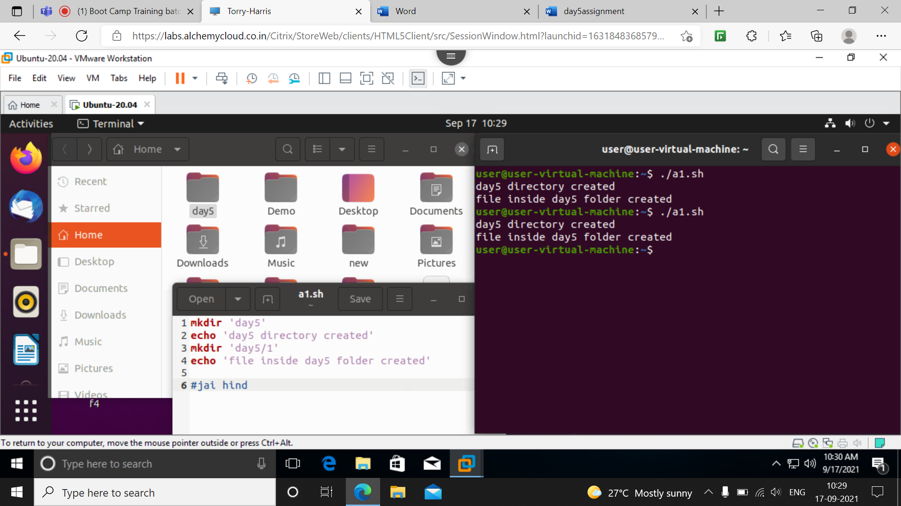

3] to remove created folder or file

Similar as above for removing we use ***rm*** command

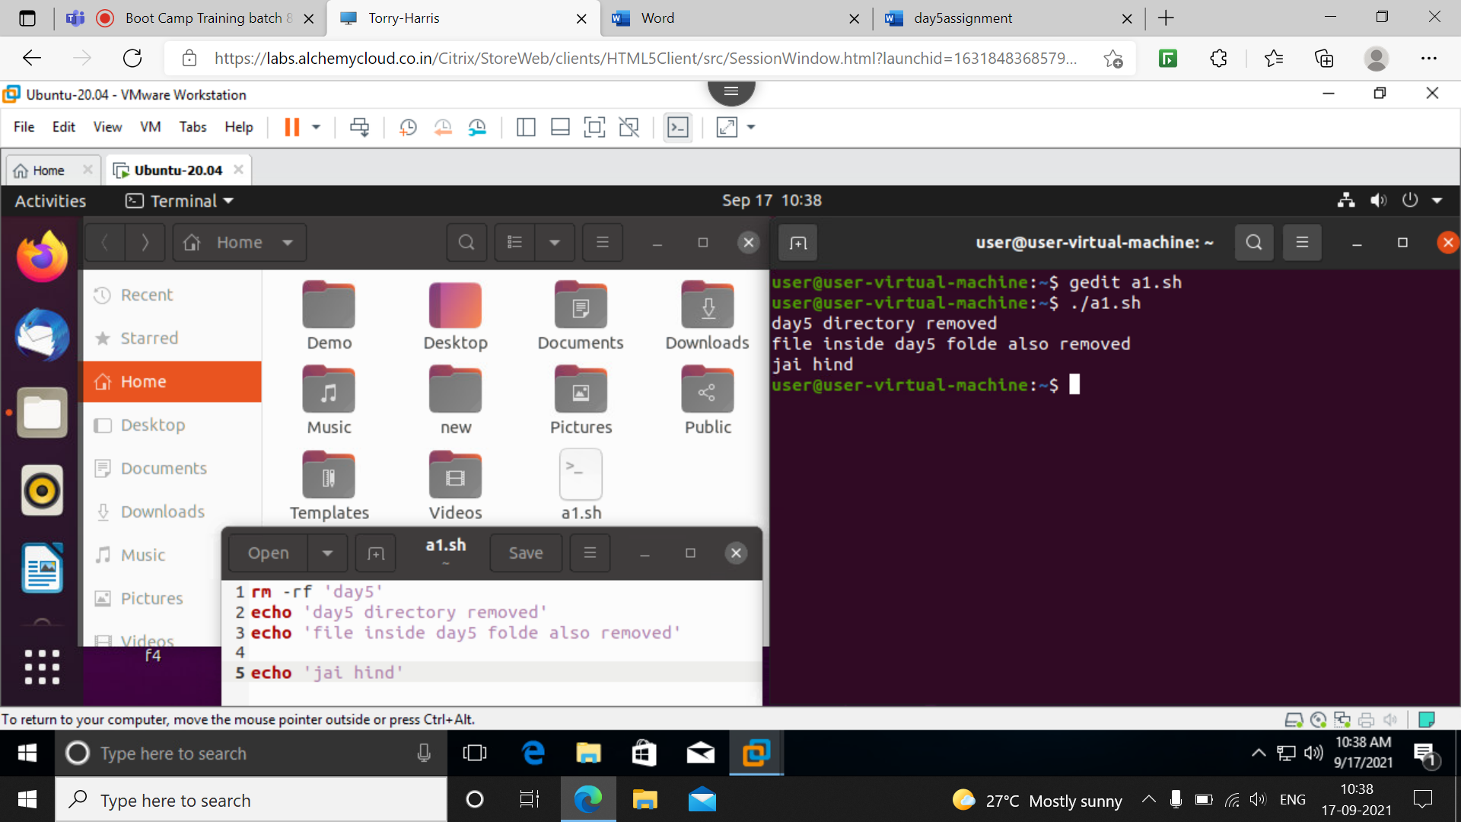

4] to create folder and create a file inside it

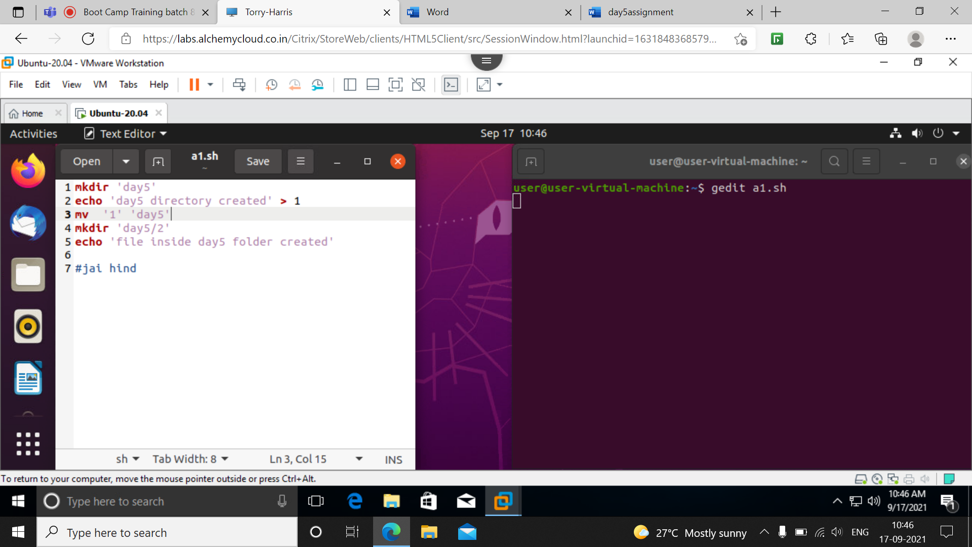

Python program to print SI after calculting in ubuntu screensho

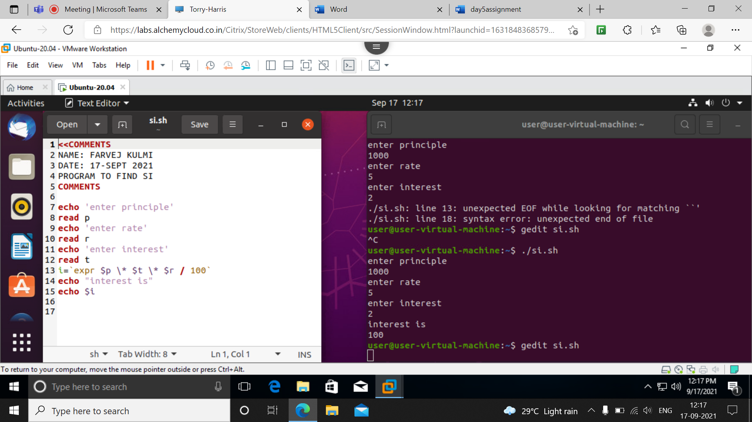

**File test operator:**

We hav eto specify a file as file=’filenmae’

Then we have to check for different test cases like read access, write, execute, type of file etc as given below

