SC549: Neural Networks (2024/25)

Programming Assignment 03: Player Tracking in Sports Videos

REG No: CSC2447

Performance comparison of the model. Discussion on model performance, limitations, and possible improvements.

Video 1
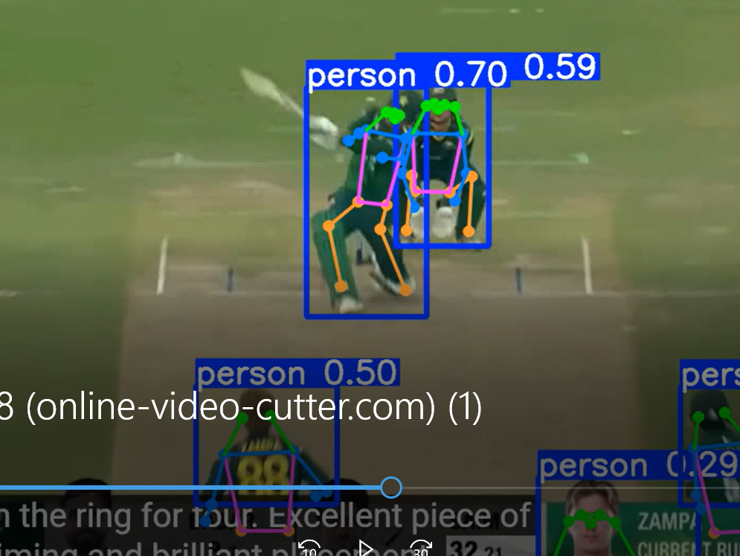
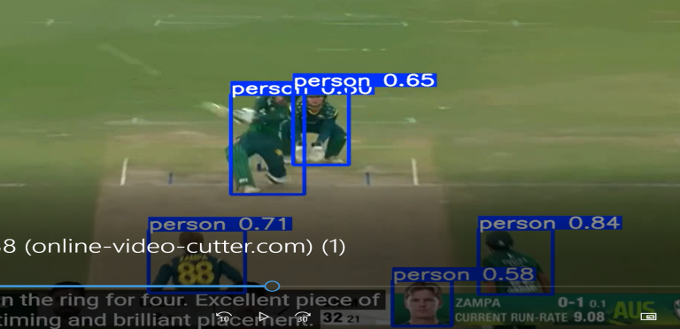

Video 2
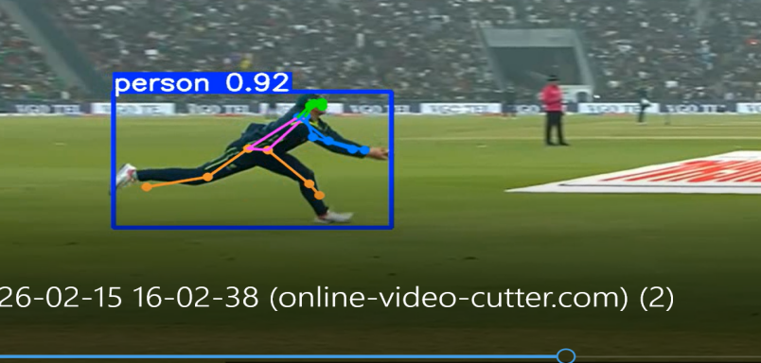
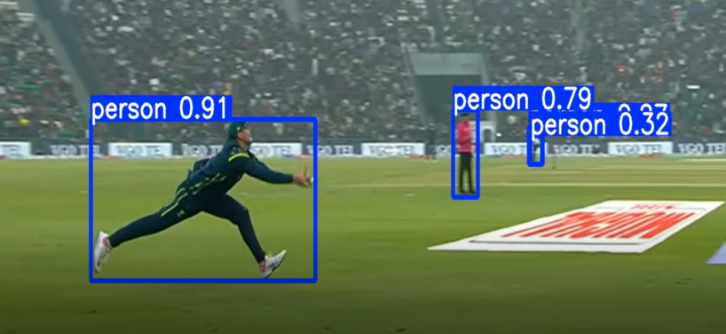

Video 3

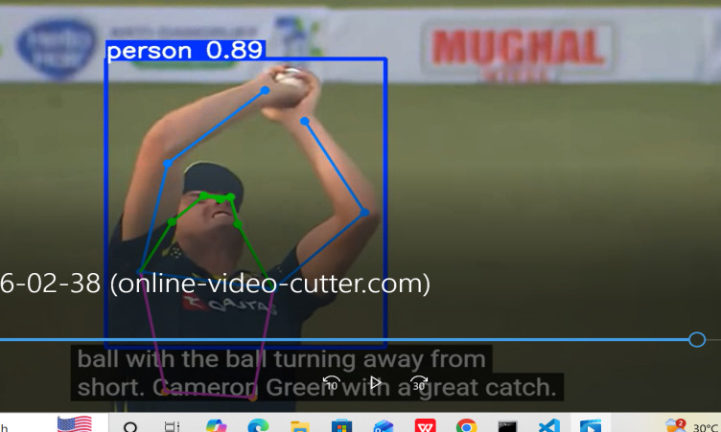
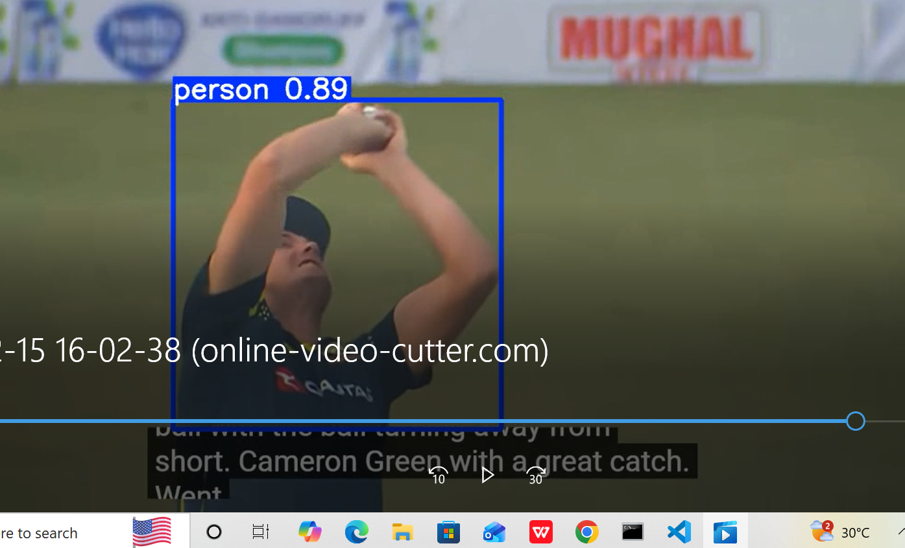

Model | Precision | Recall | FPS
YOLOv8n | 0.86 | 0.92 | 38 FPS
YOLOv8m | 0.91 | 0.95 | 25 FPS
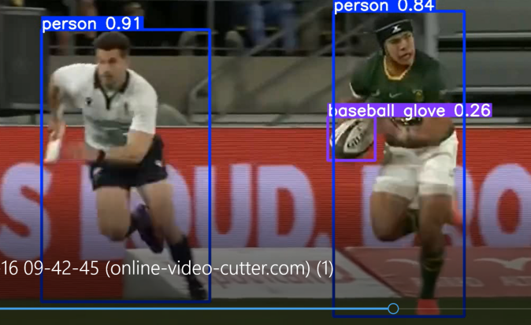
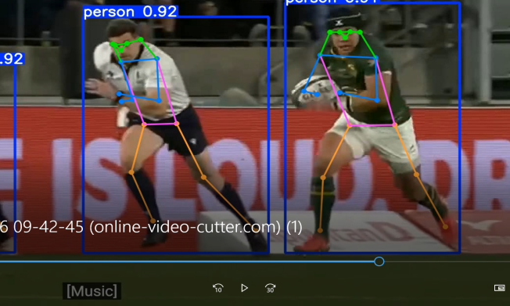
Video 4

