Preparing Data

The fundamental purpose of performing simple Power BI operations is to transform raw, unstructured data into meaningful, insightful information that can drive strategic decision-making. This starts with preparing data for analysis, where data is extracted from various sources, cleaned, and transformed into a structured format. This process sets the foundation for accurate and efficient analysis further down the line.

Loading Data

The next step involves loading the data into Power BI. This stage is crucial as it determines how efficiently you can access and work with your data. Whether importing large datasets or establishing queries to access only certain data, the goal is to make the data accessible and ready for analysis.

Datasets

First, download the CSV files that contain data on selling products in an online store. The files can be either uploaded to Power BI independently or initially uploaded to a database and then to Power BI.

* SaleID - Unique record identifier (PK)
* CustomerID - Unique identifier of DimCustomer table (FK)
* ProductID - Unique identifier of DimProduct table (FK)
* Quantity - Quantity of goods sold
* SaleDate - Date of sale

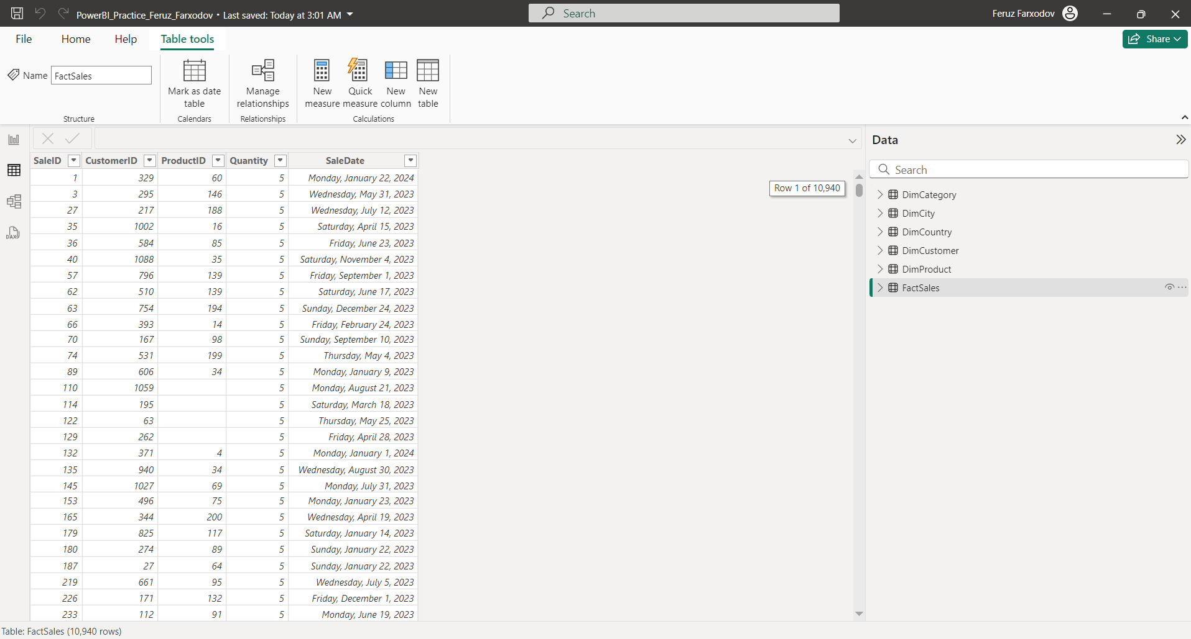

* CustomerID - Unique record identifier (PK)
* FirstName - Customer's name
* LastName - Customer's last name
* Gender - Customer's gender
* BirthDate - Customer's date of birth
* CityID - Unique identifier of DimCity table (FK)

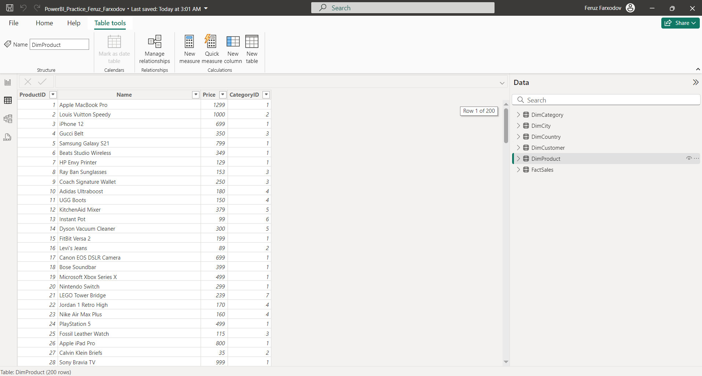

* CityID - Unique record identifier (PK)
* Name - City name
* CountryID - Unique identifier of DimCountry table (FK)

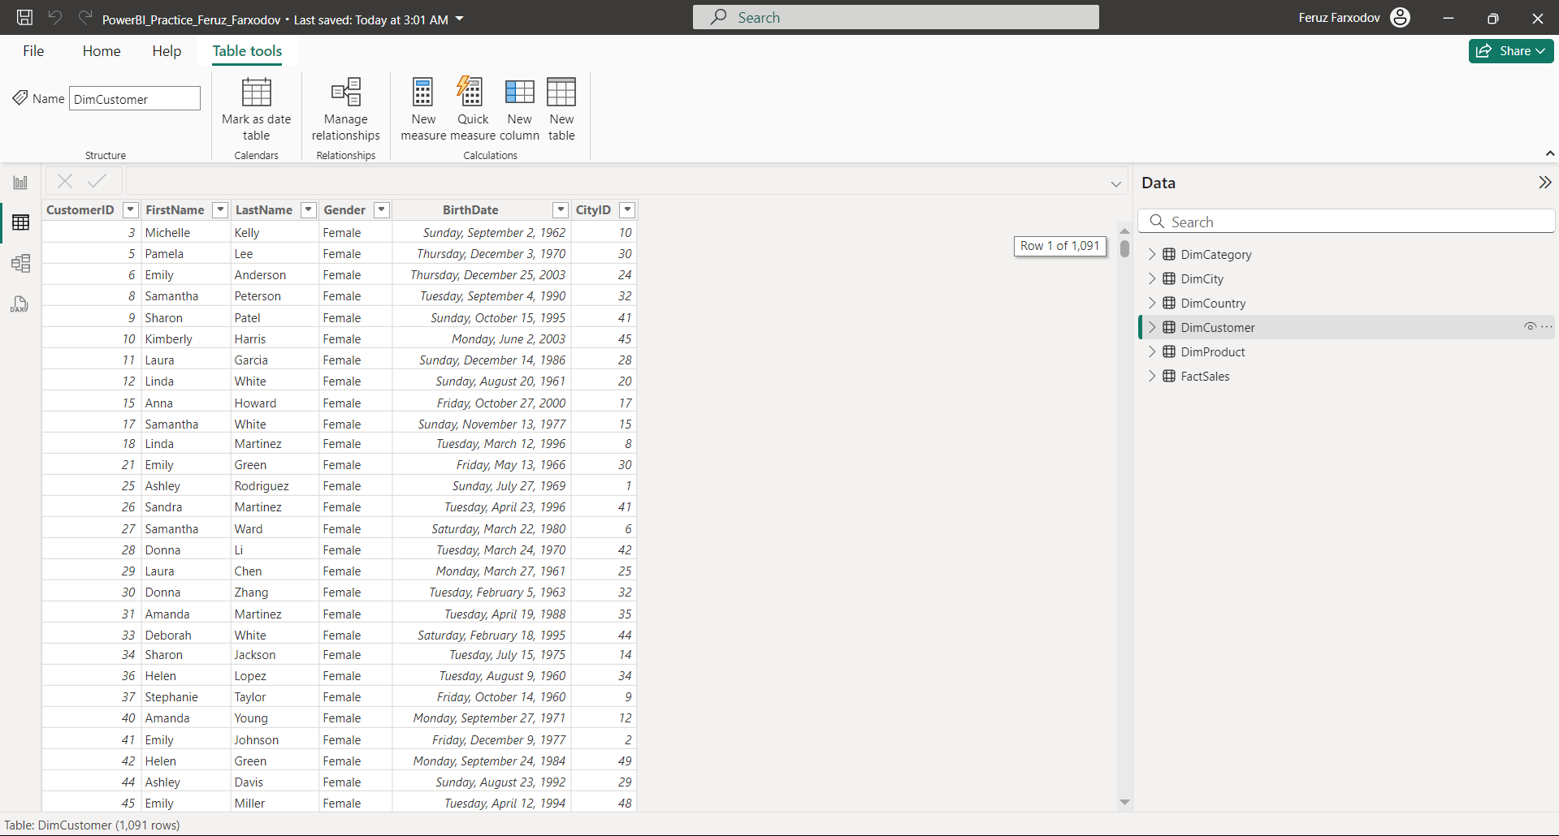

* CountryID - Unique record identifier (PK)
* Name - Country name

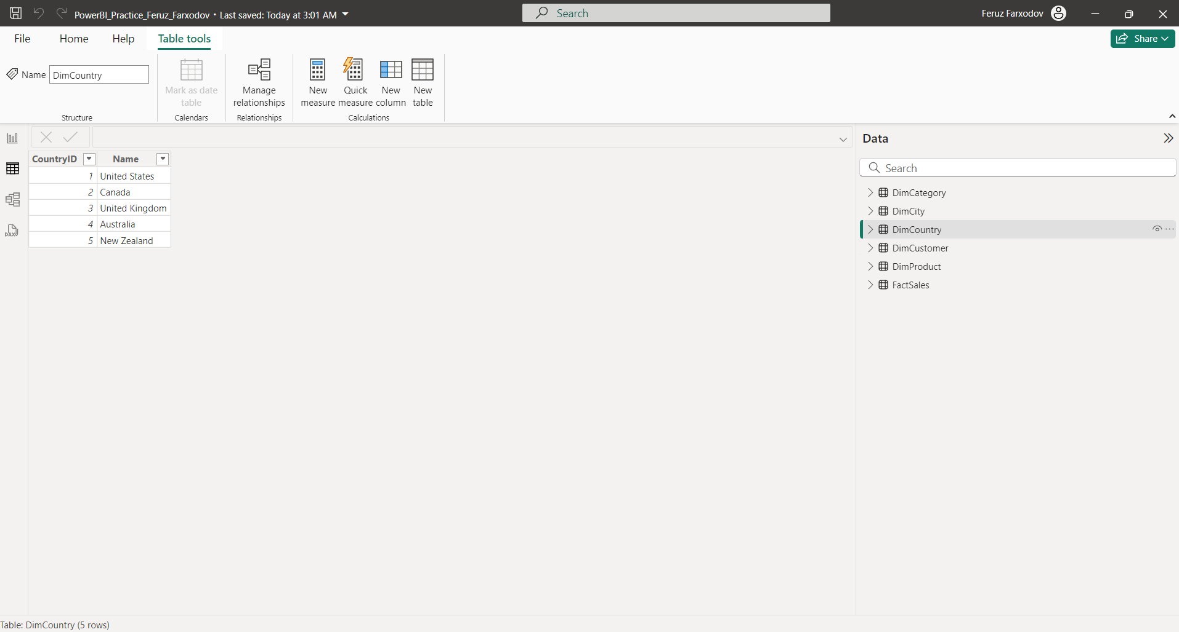

* ProductID - Unique record identifier (PK)
* Name - Product name
* Price - Price per unit
* CategoryID - Unique identifier of DimCategory table (FK)

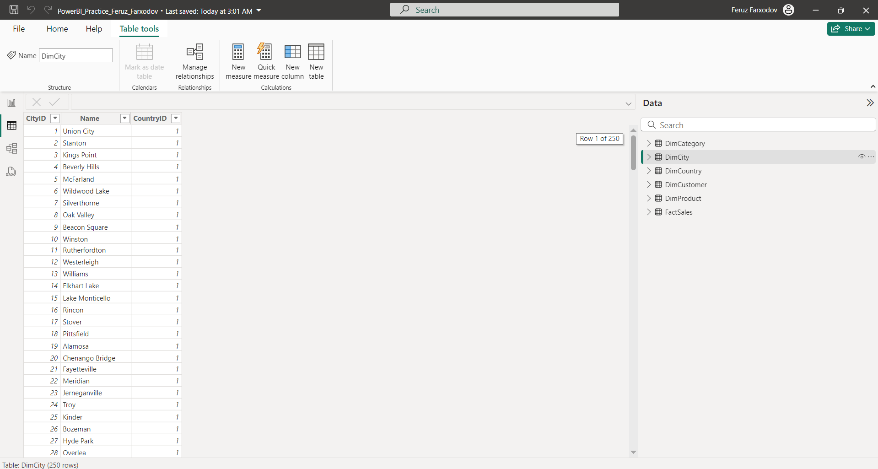

* CategoryID - Unique record identifier (PK)
* Name - Category name

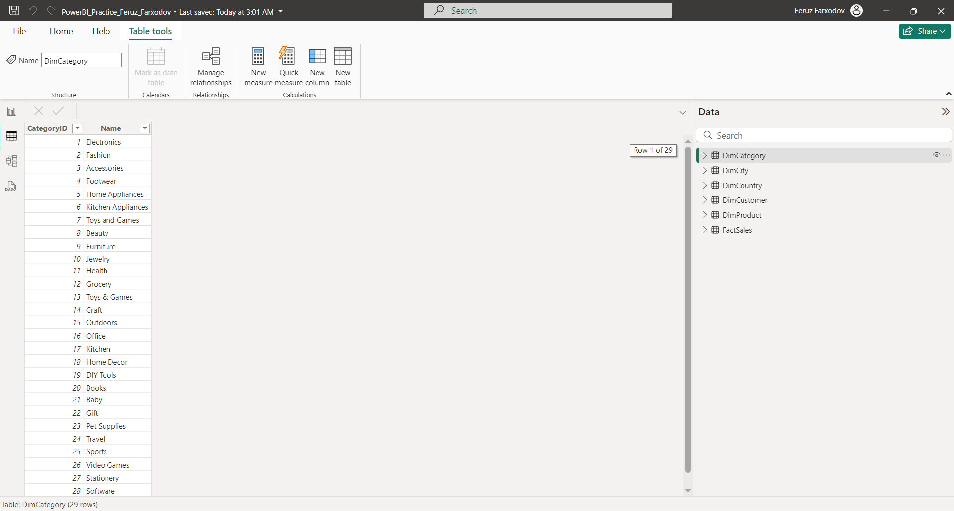

Modeling Data

Once the data is loaded, modeling is the next step. In Power BI, data modeling allows you to establish relationships between different datasets. By defining these connections, a logical data model is created, enabling smooth navigation and providing a coherent, consolidated view of the entire dataset.

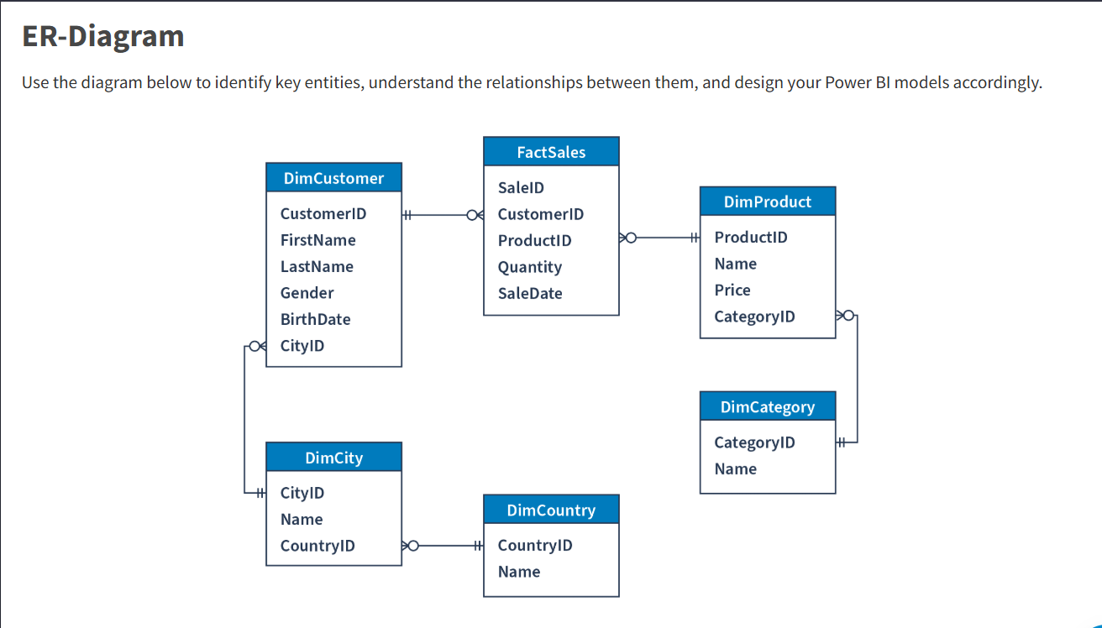

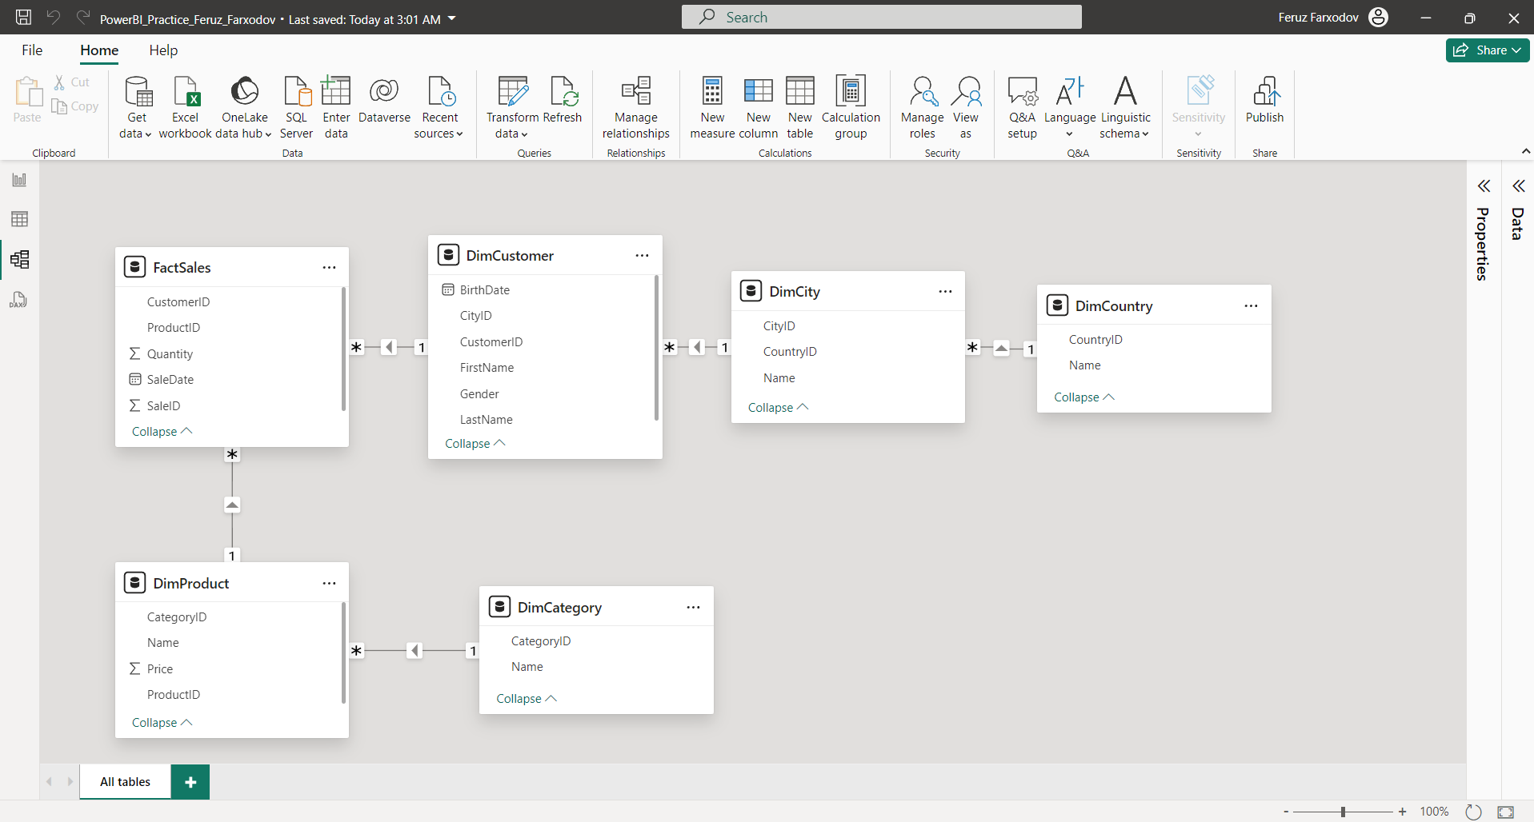

Visualizing Data

The final task involves using Power BI to build visual representations. This step turns raw data into interactive charts, graphs, and reports that are easy to understand. These visuals simplify the process of analyzing data, uncovering trends, anomalies, and insights that can inform decision-making processes and business strategies.

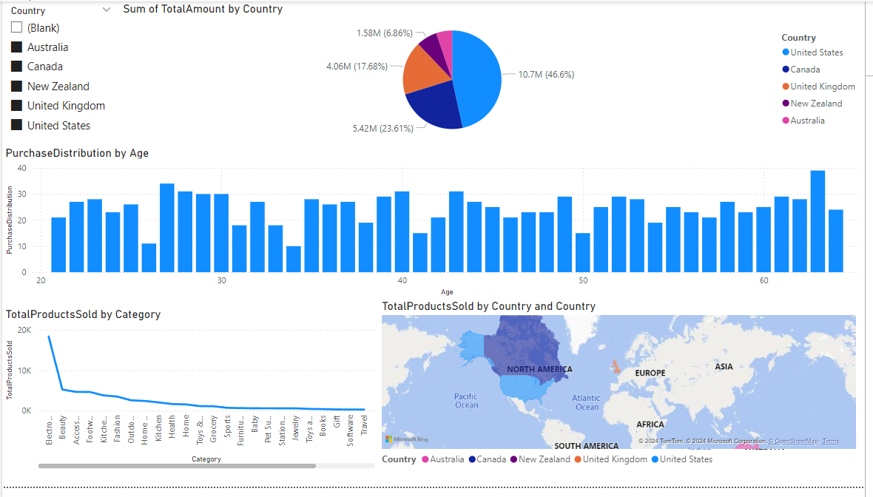

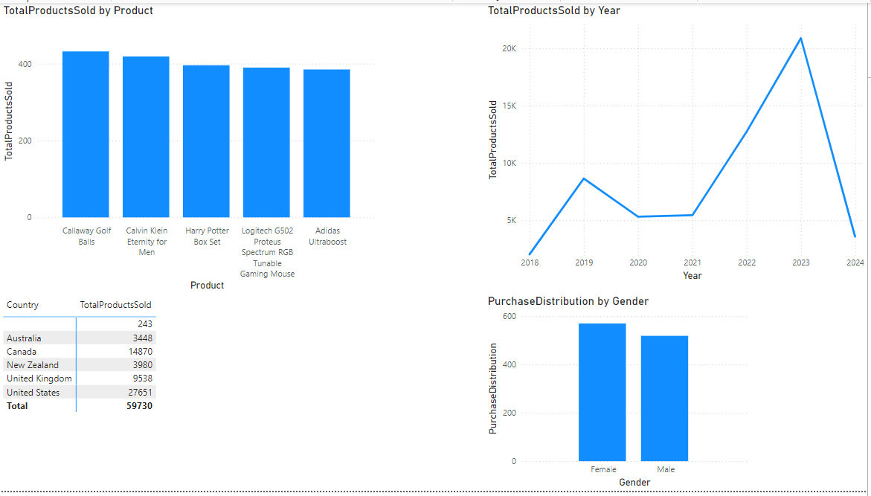

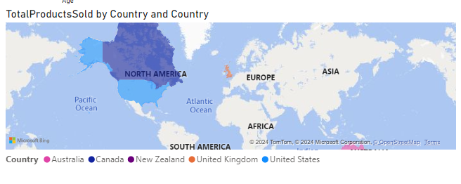

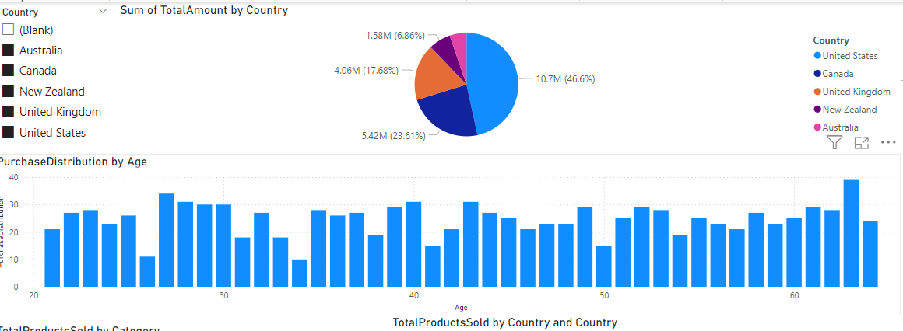

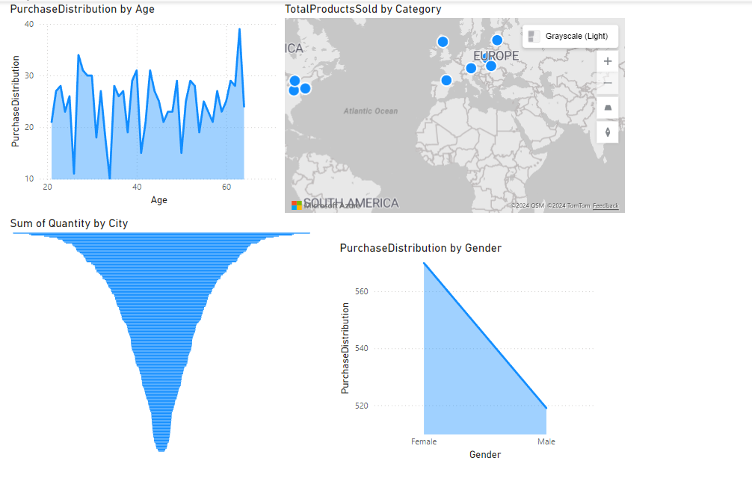

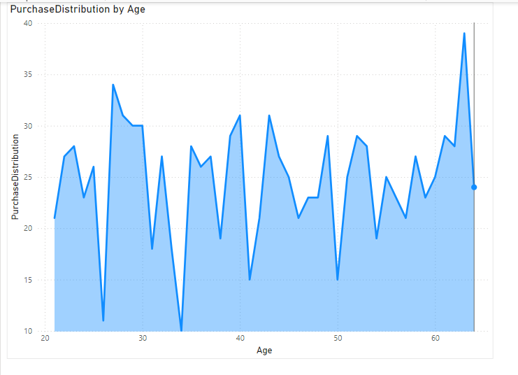

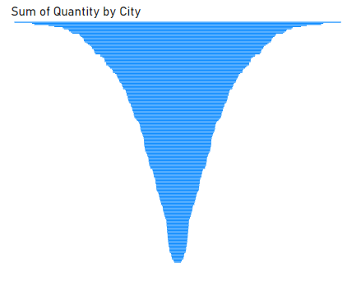

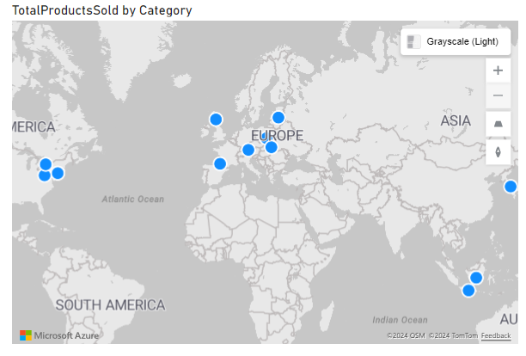

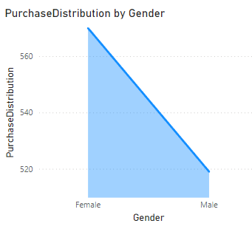

EXAMPLE DATA AFTER FIXING

