Arch Technologies - Internship and Training Program (Batch 1st August to 30th September 2026)

Information | Details
Full Name | Faryal
Internship Domain | Generative AI (Gen AI)
Project Title | Streamlit Interface for Locally Hosted LLM
LLM Platform | Ollama
Language Model | Llama 3.2 3B
Email Address | faryalf073@gmail.com
Phone Number | 03121574442

Task 1:
Build a Streamlit Interface for Inference of a Locally Hosted LLM
1. Introduction
This project focuses on developing a simple and interactive web-based interface for communicating with a locally hosted Large Language Model (LLM). The system uses Ollama to run the LLM locally and Streamlit to provide a user-friendly web interface.
The main purpose of the project is to allow users to enter questions or instructions through a web interface and receive responses generated by the locally hosted model. The application also provides conversation history and a reset option to improve usability.
2. Project Objectives
The main objectives of this project are:
- To install and configure Ollama for local LLM execution.
- To download and run a suitable local language model.
- To establish communication between Python and Ollama.
- To create a Streamlit-based web interface.
- To provide a text input area for user queries.
- To display responses generated by the LLM.
- To maintain conversation history during a session.
- To provide a reset button for starting a new conversation.
- To test the complete communication between the frontend and local LLM backend.
3. Software and Tools Used
The following tools and technologies were used:
Tool | Purpose
Python | Main programming language
Anaconda | Python environment management
Jupyter Notebook | Testing and development
Ollama | Local LLM runtime
Llama 3.2 3B | Locally hosted language model
Streamlit | Web interface development
Requests | Communication with the Ollama API
Web Browser | Accessing the Streamlit application
The Ollama version used in this project is 0.33.2.
4. System Requirements
Before starting the project, the computer should have:
- Windows operating system
- Anaconda installed
- Python environment available
- Sufficient free storage for the LLM
- Internet connection for the initial model download
- Ollama installed
- Streamlit installed
After the model is downloaded, the LLM can operate locally without sending the user's questions to a cloud-based AI service.
5. Project Structure
The project consists of two main components:
Frontend
The frontend is developed using Streamlit. It provides the interface through which the user interacts with the LLM.
Backend
Ollama acts as the local backend. It manages and runs the Llama language model and processes user requests.
The overall structure is:
User → Streamlit Interface → Ollama API → Llama 3.2 3B → Response → Streamlit Interface
6. Step 1 — Verify Anaconda and Python
The first step is to ensure that the Python environment is working correctly.
Anaconda Prompt is opened and the Python environment is checked. This environment is used to install the required packages and run the application.
A working Python environment is necessary because Streamlit and the communication libraries depend on Python.
Screenshot to add:
Take a screenshot showing the working Anaconda Prompt/Python environment.
7. Step 2 — Install Ollama
Ollama is installed on the Windows computer to provide a local environment for running the Large Language Model.
Ollama allows the model to run directly on the computer rather than relying on an online AI service.
After installation, the Ollama version is checked to confirm that the installation was successful.
In this project, the installed Ollama version is:
Ollama 0.33.2
Screenshot to add:
Add a screenshot showing the Ollama version.
8. Step 3 — Download the Llama Model
After installing Ollama, a suitable language model is downloaded.
For this project, Llama 3.2 3B is used because it is relatively lightweight and suitable for running on a local computer.
The model is downloaded through Ollama and stored locally on the computer.
Once the download is completed, the installed models are checked to verify that Llama 3.2 3B is available.
9. Step 4 — Test the Local LLM
Before developing the Streamlit interface, the downloaded model is tested directly through Ollama.
The model is started and a simple question is entered.
For example, a question about Artificial Intelligence can be used for testing.
The model generates a response, confirming that the local LLM is functioning correctly.
This step is important because it verifies the model before connecting it to the Streamlit application.
10. Step 5 — Install Required Python Libraries
The Python environment is prepared for Streamlit development.
The required libraries include:
- Streamlit for creating the web interface.
- Requests for sending requests to the Ollama API.
- Ollama's Python support for communicating with the local model when required.
The installation ensures that the Python environment contains the necessary components for developing and running the application.
11. Step 6 — Test Python and Ollama Communication
After installing the required libraries, communication between Python and Ollama is tested.
Python sends a sample question to the locally running Llama model.
Ollama receives the request, passes it to the model, and returns the generated response.
This confirms that Python can communicate successfully with the local LLM.
The communication process is:
Python → Ollama → Llama 3.2 3B → Ollama → Python
12. Step 7 — Test the Ollama API
Ollama provides a local API that allows applications to communicate with the locally hosted model.
The local API is tested to make sure that it is accessible from Python.
The API operates through a local endpoint on the computer. This allows the Streamlit application to send user queries to Ollama and receive model-generated responses.
This step confirms that the backend communication required by the final application is working properly.
13. Step 8 — Create the Streamlit Application
After successfully testing Ollama and its API, the Streamlit application is created.
The application is stored as a Python file named:
app.py
This file contains the structure and functionality of the web interface.
The Streamlit application acts as the frontend of the project and communicates with Ollama in the background.
14. Step 9 — Design the User Interface
The Streamlit interface is designed to be simple and easy to use.
The main page contains a title and a chat area where users can enter their questions.
The interface provides a clear separation between user messages and AI-generated responses.
The design allows users to interact with the local LLM without needing to use the Command Prompt or directly interact with Ollama.
15. Step 10 — Add User Input
A chat input area is provided at the bottom of the application.
The user can enter a question, instruction, or other text into this input area.
After submitting the query, the application sends the user's message to the local Ollama backend.
This provides the primary interaction mechanism between the user and the LLM.
16. Step 11 — Generate the LLM Response
When the user submits a query, Streamlit sends the request to the Ollama local API.
Ollama processes the request using the Llama 3.2 3B model.
The generated response is then returned to the Streamlit application and displayed on the webpage.
The complete process is:
User Query
↓
Streamlit
↓
Ollama Local API
↓
Llama 3.2 3B
↓
Generated Response
↓
Streamlit Display
17. Step 12 — Display Conversation
The application stores the messages exchanged between the user and the AI during the current session.
Both user questions and AI responses are displayed in the chat interface.
This makes the application behave like a basic conversational AI system rather than a single-question interface.
The conversation history also allows the model to receive previous messages as context when generating subsequent responses.
18. Step 13 — Add Conversation History Panel
A conversation history panel is added to the sidebar of the application.
The panel displays previous user queries and corresponding AI responses.
This feature allows the user to review the current conversation easily.
It also improves the usability of the application by keeping previous interactions visible.
19. Step 14 — Add Reset Button
A reset button is added to the sidebar.
The purpose of the reset button is to clear the current conversation and allow the user to start a new interaction.
When the reset option is selected, the stored conversation history is removed from the current session.
This provides a convenient way to start a fresh conversation without restarting the entire application.
20. Step 15 — Run the Streamlit Application
After completing the application, Streamlit is started from the project directory.
Streamlit launches a local web server and provides a local address through which the application can be accessed.
The application is then opened in a web browser.
The browser acts as the user interface, while Streamlit communicates with the local Ollama backend.
21. Step 16 — Test the Application
The completed application is tested using different questions.
A simple question is first entered to verify that the model generates a response.
A second related question is then entered to verify that conversation context is maintained.
The conversation history panel is checked to ensure that previous messages are displayed correctly.
Finally, the reset button is tested to verify that the conversation can be cleared.

22. Step 17 — Functional Testing
The following functions are tested:
Function | Expected Result
Application startup | Streamlit interface opens successfully
User input | User can enter a question
LLM response | Llama generates an answer
API communication | Streamlit communicates with Ollama
Conversation history | Previous messages remain visible
Follow-up question | Previous conversation can provide context
Reset button | Conversation is cleared
Local execution | Model operates through the local Ollama setup

23. Step 18 — Final Working System
After successful testing, the complete system consists of:
Frontend: Streamlit
Backend: Ollama
Language Model: Llama 3.2 3B
Communication: Local Ollama API
User Interface: Web browser
The system allows users to interact with the locally hosted LLM through a simple web interface.
24. Results
The project successfully provides a functional web-based interface for interacting with a locally hosted Large Language Model.
The Streamlit frontend accepts user queries and sends them to the Ollama backend. Ollama processes the queries using the Llama 3.2 3B model and returns the generated responses to the interface.

Part 1 — Check Ollama
Cell 1 — Import libraries
Cell 2 — Check Ollama version
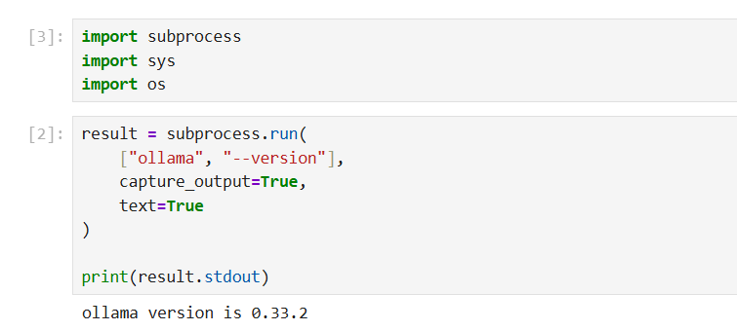
Part 2 — Check the Local Model
Cell 3 — Check installed Ollama models
Cell 4 — Download Llama 3.2 3B
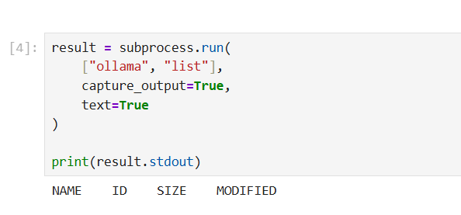
Part 3 — Install Required Python Libraries
Cell 5 — Install Streamlit and Ollama Python package
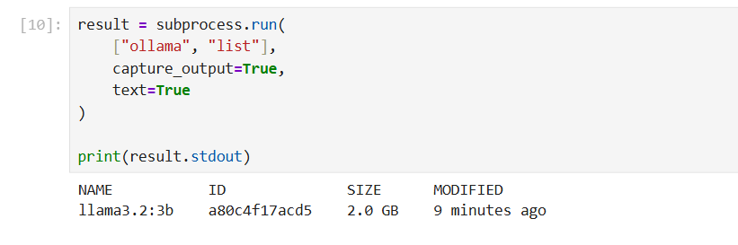
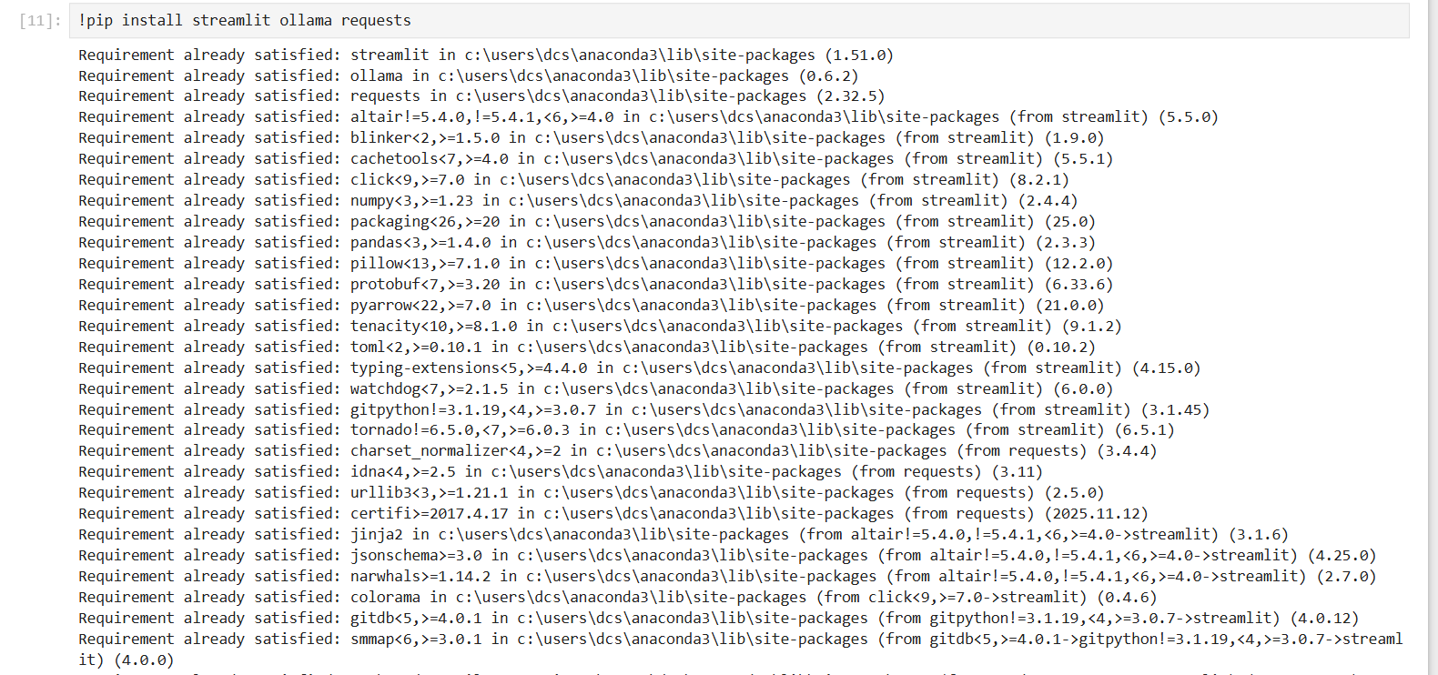
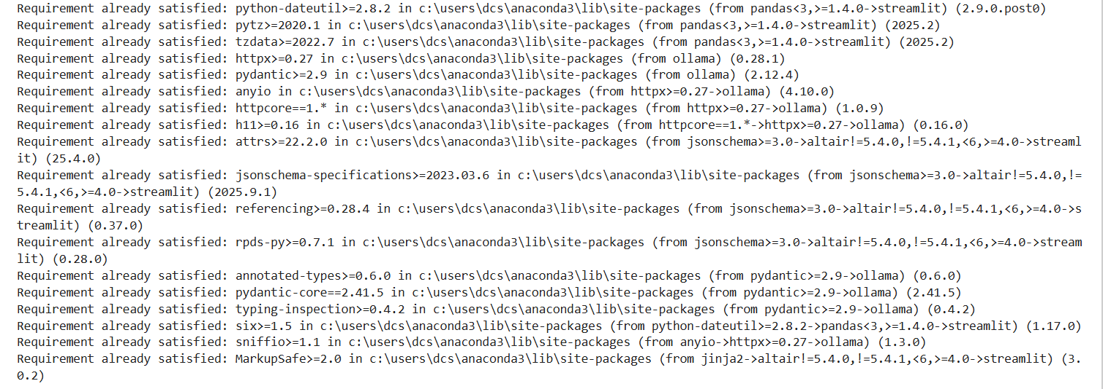
Part 4 — Test the Ollama Python Package
Cell 7 — Import Ollama
Cell 8 — Test Llama through Python
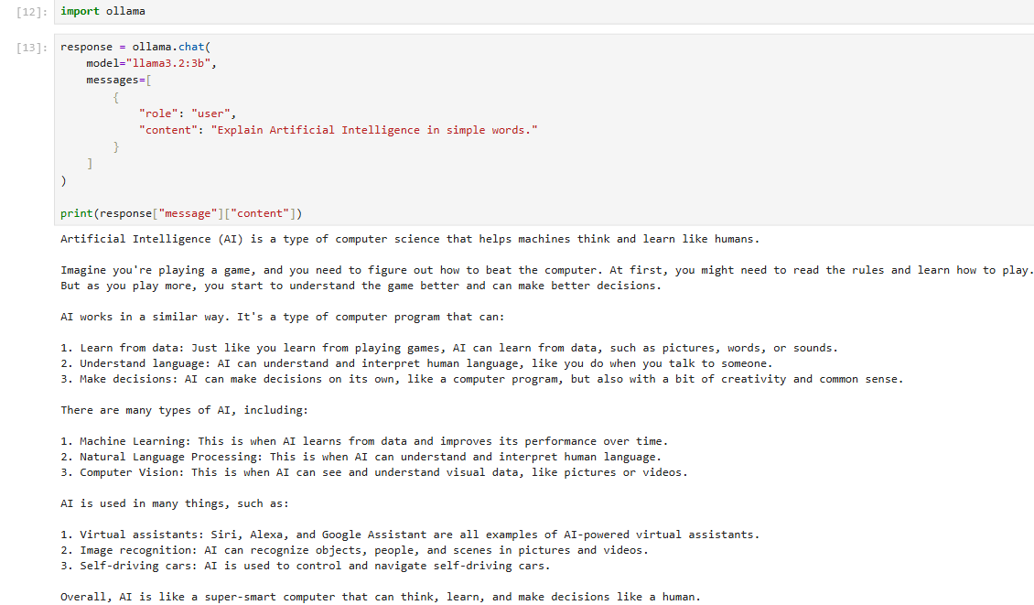
Part 5 — Test the Ollama API
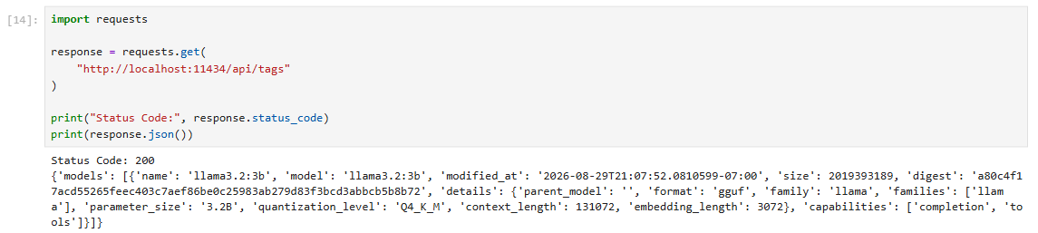
Part 6 — Test Chat API
Cell 10 — Send a question through Ollama API
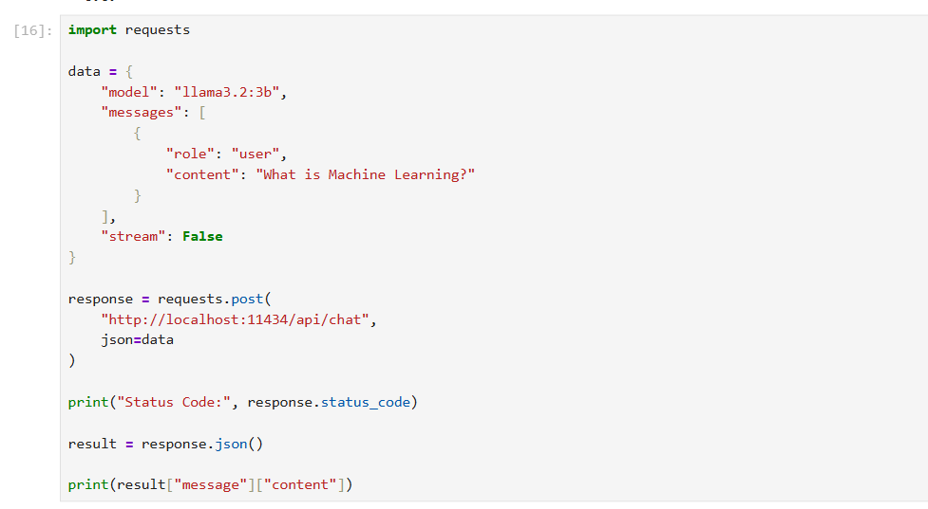
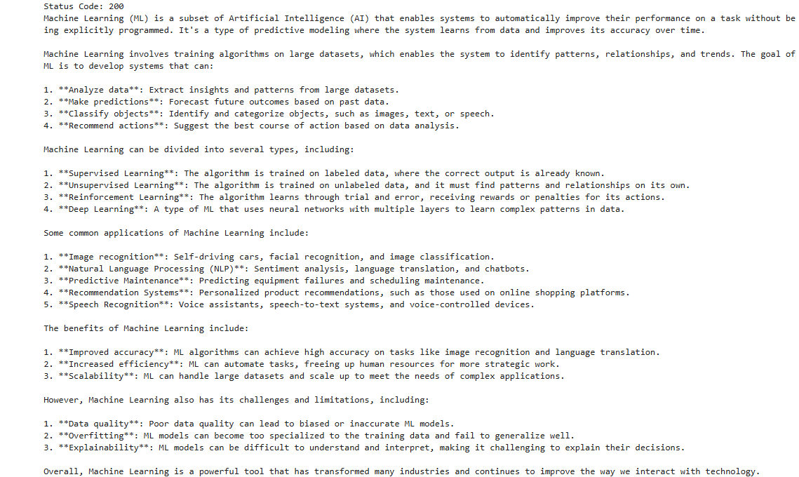
Part 7 — Create the Streamlit Application
Now we create the actual application required by your task.
The Streamlit application will contain:
- Application title
- Model selection
- Chat input b
- AI response
- Conversation history
- Reset button
- Error handling

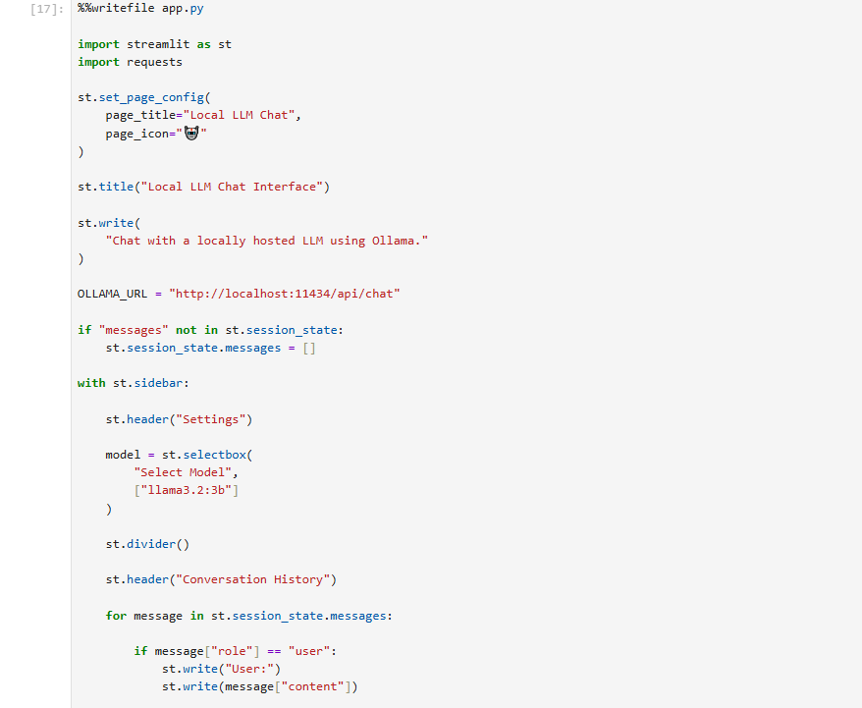
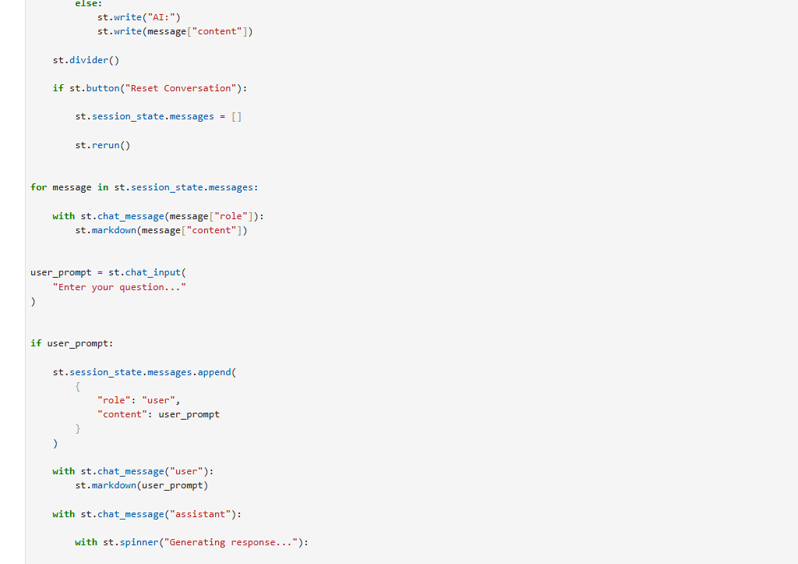
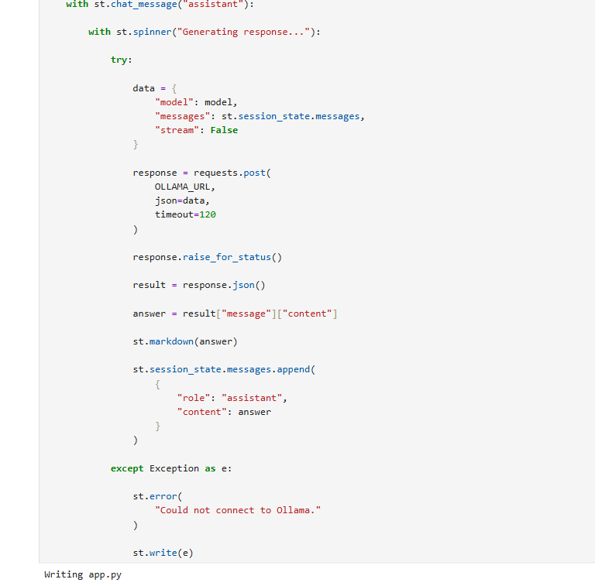
Part 8 — Check the App File
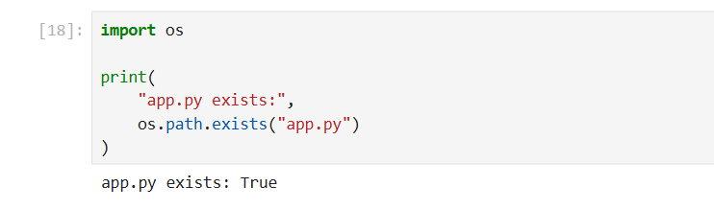

Create Streamlit application

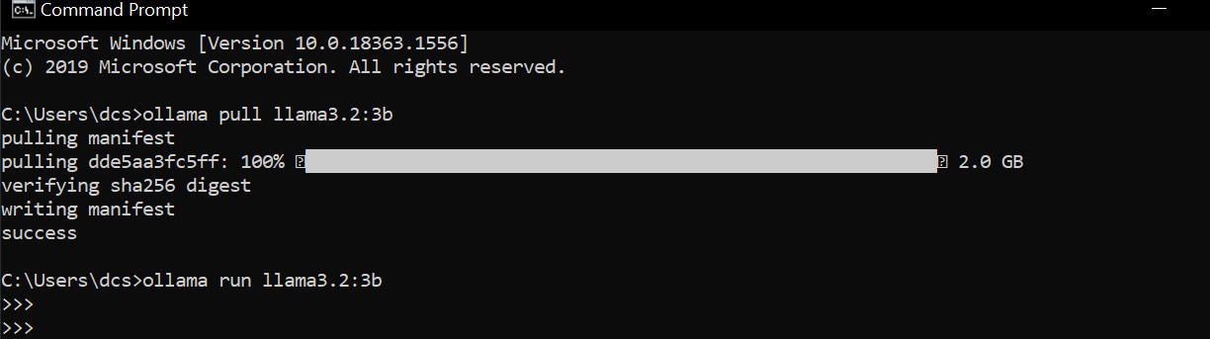
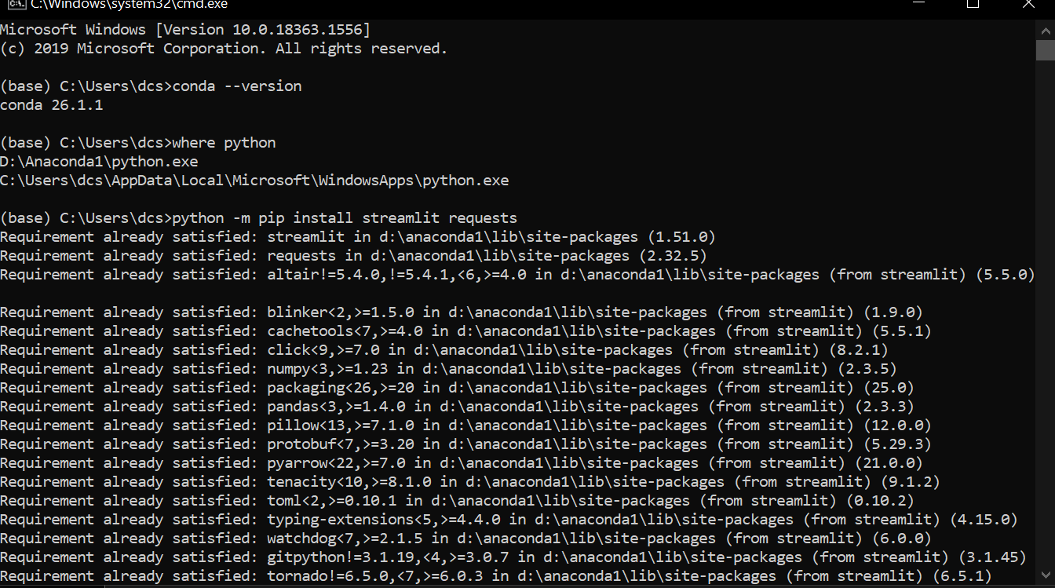
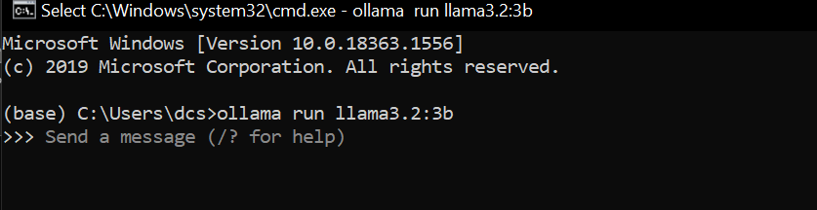
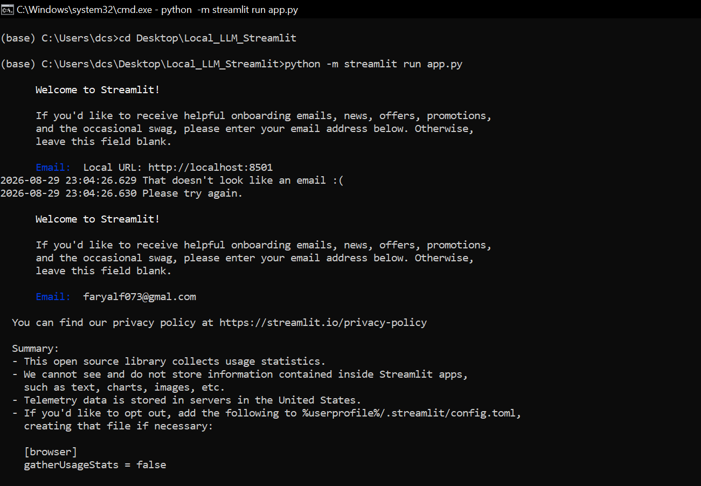
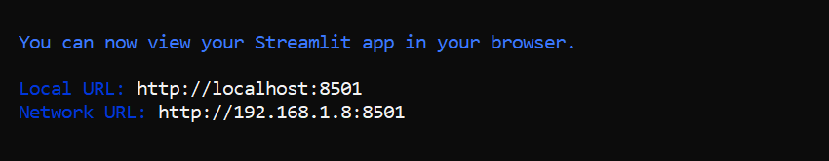

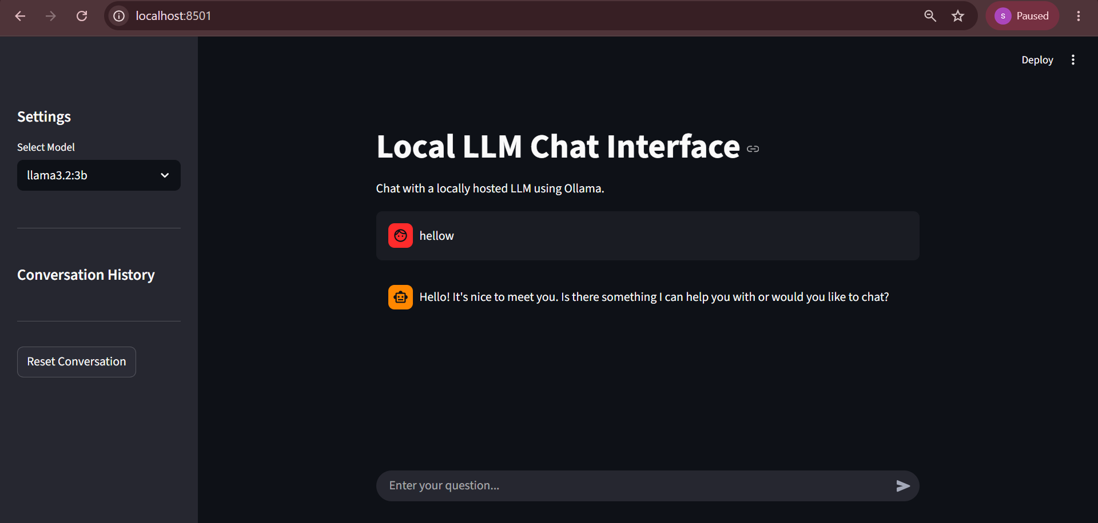

Task 2
Medical Fine-tuning With Quantization and Low Rank Adaptation via Unsloth In Colab
1. Project Objective
The objective of this project is to fine-tune a medical language model using QLoRA and Unsloth. The model is adapted to answer medical questions efficiently while reducing GPU memory usage through 4-bit quantization and LoRA adapters.
2. Environment Setup
The project was implemented in Google Colab using a Tesla T4 GPU.
Tools and libraries used:
- Google Colab
- Python
- PyTorch
- Unsloth
- Hugging Face Datasets
- Transformers
- TRL
- PEFT
- BitsAndBytes
3. GPU Verification
CUDA availability was checked before training.
GPU used:
Tesla T4
CUDA was successfully detected and the GPU was available for model training.
4. Dataset
A medical question-answer dataset was used for fine-tuning.
Dataset:
MedQuAD Medical Q&A
Total available examples:
16,407
The dataset contained medical questions and corresponding answers.
5. Data Preprocessing
The dataset was checked for missing questions and answers.
Empty records were removed.
For efficient training:
- 3,000 examples were selected.
- 2,700 examples were used for training.
- 300 examples were used for validation.
The questions and answers were converted into an instruction-based text format.
6. Base Model
The base model used was:
Llama 3.2 3B Instruct
The model was loaded using Unsloth with 4-bit quantization to reduce GPU memory requirements.
7. QLoRA Configuration
LoRA adapters were added to selected transformer layers.
Main configuration:
- LoRA rank: 16
- LoRA alpha: 16
- 4-bit quantization
- Gradient checkpointing
- 8-bit optimizer
Only a small portion of the model parameters was trained.
Trainable parameters:
24,313,856
Trainable percentage:
0.7511%
8. Model Training
The model was fine-tuned for 1 epoch using the medical Q&A dataset.
Training examples:
2,700
Validation examples:
300
Final training loss:
1.12184
9. GPU Memory Monitoring
GPU memory was monitored before and after training.
GPU:
Tesla T4
Peak GPU memory:
3.50 GB
The low memory usage demonstrates the benefit of 4-bit quantization and LoRA-based parameter-efficient fine-tuning.
10. Adapter Saving
After training, the LoRA adapter was saved separately.
Adapter folder:
medical_qlora_adapter
The saved adapter can be used with the base model for future inference.
11. Model Testing
The fine-tuned model was tested using new medical questions such as:
- What are the common symptoms of iron deficiency anemia?
- What is hypertension?
- What are the symptoms of dehydration?
- What is the difference between bacterial and viral infections?
- What are common causes of headaches?
The model generated medical responses based on its fine-tuned knowledge.
12. Conclusion
The project successfully demonstrated medical-domain fine-tuning using QLoRA and Unsloth. 4-bit quantization and LoRA significantly reduced the number of trainable parameters and GPU memory requirements while allowing the Llama 3.2 3B model to be adapted to medical question-answering tasks.
Note: The fine-tuned model is intended for educational and research purposes and should not be used as a substitute for professional medical advice.
13. Code Implementation
The code was implemented step-by-step in a Google Colab Jupyter Notebook. First, the GPU and CUDA environment were verified and the required libraries were installed. The medical dataset was then loaded, cleaned, divided into training and validation sets, and converted into an instruction-based format.
Next, the Llama 3.2 3B model was loaded in 4-bit quantized form using Unsloth. LoRA adapters were added to selected model layers, allowing only a small portion of the model parameters to be trained. The model was then fine-tuned using the prepared medical Q&A data.
After training, GPU memory usage and training loss were recorded. The trained LoRA adapter was saved separately, and the fine-tuned model was tested on new medical questions to evaluate its responses.

Code Execution and Results
Result | Value
Base model | Llama 3.2 3B
Quantization | 4-bit
Fine-tuning | QLoRA
Training data | 2,700
Validation data | 300
Epochs | 1
Trainable parameters | 24,313,856
Trainable percentage | 0.7511%
Final training loss | 1.12184
GPU | Tesla T4
Peak GPU memory | 3.50 GB



