Project title: Voting System

Group members:
Syeda Dua shah and Faryal

Project Proposal + Source Code + Output Screenshots

1. Project Proposal
Project Title:
COAL Voting System using 8086 Assembly Language
Introduction:
The COAL Voting System is a console-based electronic voting application developed in 8086 Assembly Language. The purpose of this project is to demonstrate the practical implementation of low-level programming concepts using Assembly Language. The system simulates a basic election environment where users can register as voters, securely log in, cast votes, and view election results. The project is designed for educational purposes and highlights how Assembly Language can be used to build real-world management systems.
Objectives:
• To understand the concepts of Assembly Language programming.
• To implement loops, arrays, procedures, and conditional statements in 8086 Assembly.
• To create a secure voting mechanism with login authentication.
• To develop a menu-driven console application.
• To perform vote counting and winner calculation using Assembly instructions.
System Features:
• Voter Registration System
• Automatic Voter ID Generation
• PIN-based Secure Login
• One Person One Vote Validation
• Live Vote Counting
• Winner Announcement
• Admin Panel Access
• Error Handling and Input Validation
Tools and Technologies Used:
• 8086 Assembly Language
• Microsoft Macro Assembler (MASM)
• DOSBox Emulator
• DOS Interrupts (INT 21H)
• Microsoft Word for Documentation
Working Methodology:
1. The system first displays a welcome screen and list of election candidates.
2. A new user can register by entering a 4-digit PIN.
3. The system automatically assigns a unique voter ID.
4. Registered users can log in using their voter ID and PIN.
5. After successful authentication, the voter can cast a vote.
6. The system ensures that a voter can vote only once.
7. Vote counts are stored and displayed in real time.
8. The admin panel allows monitoring of total votes and voter activity.
9. At the end, the system announces the winner based on maximum votes.
Advantages of the System:
• Secure voting process
• Prevents duplicate voting
• Simple and user-friendly interface
• Efficient vote counting
• Demonstrates low-level memory handling
Conclusion:
This project successfully demonstrates the implementation of a voting management system using 8086 Assembly Language. It provides practical understanding of Assembly programming concepts such as memory management, arithmetic operations, loops, procedures, arrays, and interrupt handling. The project also enhances problem-solving skills and demonstrates how low-level languages can be used to create complete functional applications.

2. Source Code
.model small
.stack 100h

.data

; ===================== WELCOME / BRANDING =====================
welcome db "================================================",13,10
db " WELCOME TO VOTING SYSTEM ",13,10
db "================================================",13,10,"$"

; ===================== MAIN MENU =====================
menu db 13,10,"============= MAIN MENU ================",13,10
db "1. Register as Voter",13,10
db "2. Login & Cast Vote",13,10
db "3. View Live Vote Count",13,10
db "4. Announce Winner",13,10
db "5. Admin Panel",13,10
db "6. Exit",13,10
db "Enter choice: $"

; ===================== CANDIDATES =====================
cand_header db 13,10,"======== CANDIDATES ON BALLOT ==========",13,10,"$"
cand1_msg db " [1] Ali Raza - Party: PML",13,10,"$"
cand2_msg db " [2] Sara Khan - Party: PTI",13,10,"$"
cand3_msg db " [3] Usman Tariq - Party: PPP",13,10,"$"
cand4_msg db " [4] Nadia Iqbal - Party: MQM",13,10,"$"
cand_footer db "========================================",13,10,"$"

votes dw 0,0,0,0

; ===================== VOTER DATA =====================
voters dw 10 dup(0)
voter_pins dw 10 dup(0)
has_voted db 10 dup(0)

voter_count db 0
currentVoter dw ?

; ===================== MESSAGES =====================
invalid_msg db 13,10,"Invalid choice! Try again.$"
full_msg db 13,10,"Voter registration full!$"
reg_ok db 13,10,"Voter registered successfully!$"

enter_pin db 13,10,"Enter your 4-digit PIN: $"
enter_vid db 13,10,"Enter your Voter ID: $"

wrong_pin db 13,10,"Wrong PIN!$"
not_found db 13,10,"Voter not found!$"

login_ok db 13,10,"Login successful!$"

already_msg db 13,10,"You already voted!$"

vote_prompt db 13,10,"Enter candidate number (1-4): $"

vote_ok db 13,10,"Vote cast successfully!$"

bad_cand db 13,10,"Invalid candidate!$"

count_hdr db 13,10,"========= LIVE VOTE COUNT =========",13,10,"$"

cname1 db "Ali Raza : $"
cname2 db "Sara Khan : $"
cname3 db "Usman Tariq : $"
cname4 db "Nadia Iqbal : $"

votes_txt db " votes",13,10,"$"

winner_hdr db 13,10,"========= WINNER =========",13,10,"$"

winner_msg db "Winner is: $"

tie_msg db 13,10,"Election Result: TIE!$"

no_votes_msg db 13,10,"No votes cast yet!$"

goodbye db 13,10,"Thank you for using Voting System!",13,10,"$"

newline db 13,10,"$"

; ===================== ADMIN =====================
admin_prompt db 13,10,"Enter Admin Password: $"

admin_pass dw 9999

admin_deny db 13,10,"Wrong admin password!$"

your_id_msg db 13,10,"Your Voter ID is: $"

; ===================== VOTE MENU =====================
vote_menu db 13,10
db "1. Cast Vote",13,10
db "2. Logout",13,10
db "Enter choice: $"

.code

; ==========================================================
main proc

mov ax,@data
mov ds,ax

mov ah,9
lea dx,welcome
int 21h

call show_candidates

; ==========================================================
main_menu:

mov ah,9
lea dx,menu
int 21h

mov ah,1
int 21h

cmp al,'1'
jne chk2
jmp register_voter

chk2:
cmp al,'2'
jne chk3
jmp login_voter

chk3:
cmp al,'3'
jne chk4
jmp view_count

chk4:
cmp al,'4'
jne chk5
jmp announce_winner

chk5:
cmp al,'5'
jne chk6
jmp admin_panel

chk6:
cmp al,'6'
jne invalid_option
jmp end_program

invalid_option:
mov ah,9
lea dx,invalid_msg
int 21h
jmp main_menu

; ==========================================================
; REGISTER VOTER
; ==========================================================

register_voter:

mov al,voter_count
cmp al,10
jge reg_full

xor ax,ax
mov al,voter_count

mov si,ax
shl si,1

add ax,2001

mov voters[si],ax

mov ah,9
lea dx,your_id_msg
int 21h

mov ax,voters[si]
call print_number

mov ah,9
lea dx,enter_pin
int 21h

call read_4digit

mov voter_pins[si],cx

xor ax,ax
mov al,voter_count

mov di,ax
mov has_voted[di],0

inc voter_count

mov ah,9
lea dx,reg_ok
int 21h

jmp main_menu

reg_full:
mov ah,9
lea dx,full_msg
int 21h

jmp main_menu

; ==========================================================
; LOGIN
; ==========================================================

login_voter:

cmp voter_count,0
je voter_not_found

mov ah,9
lea dx,enter_vid
int 21h

call read_4digit

mov bx,cx

mov si,0

xor cx,cx
mov cl,voter_count

search_loop:

mov ax,voters[si]

cmp ax,bx
je voter_found

add si,2

dec cl
jnz search_loop

voter_not_found:

mov ah,9
lea dx,not_found
int 21h

jmp main_menu

voter_found:

mov ah,9
lea dx,enter_pin
int 21h

call read_4digit

mov bx,cx

mov ax,voter_pins[si]

cmp ax,bx
jne wrong_password

mov currentVoter,si

mov ah,9
lea dx,login_ok
int 21h

; ==========================================================
voter_menu:

mov ah,9
lea dx,vote_menu
int 21h

mov ah,1
int 21h

cmp al,'1'
jne vm2
jmp cast_vote

vm2:
cmp al,'2'
jne voter_menu
jmp logout_user

wrong_password:

mov ah,9
lea dx,wrong_pin
int 21h

jmp main_menu

; ==========================================================
; CAST VOTE
; ==========================================================

cast_vote:

mov si,currentVoter

mov ax,si
shr ax,1

mov di,ax

cmp has_voted[di],1
je already_voted

call show_candidates

mov ah,9
lea dx,vote_prompt
int 21h

mov ah,1
int 21h

cmp al,'1'
jne vc2
jmp vote1

vc2:
cmp al,'2'
jne vc3
jmp vote2

vc3:
cmp al,'3'
jne vc4
jmp vote3

vc4:
cmp al,'4'
jne bad_candidate
jmp vote4

vote1:
inc votes[0]
jmp finish_vote

vote2:
inc votes[2]
jmp finish_vote

vote3:
inc votes[4]
jmp finish_vote

vote4:
inc votes[6]
jmp finish_vote

bad_candidate:

mov ah,9
lea dx,bad_cand
int 21h

jmp voter_menu

finish_vote:

mov si,currentVoter

mov ax,si
shr ax,1

mov di,ax

mov has_voted[di],1

mov ah,9
lea dx,vote_ok
int 21h

jmp voter_menu

already_voted:

mov ah,9
lea dx,already_msg
int 21h

jmp voter_menu

logout_user:
jmp main_menu

; ==========================================================
; VIEW COUNT
; ==========================================================

view_count:

mov ah,9
lea dx,count_hdr
int 21h

; Candidate 1
mov ah,9
lea dx,cname1
int 21h

mov ax,votes[0]
call print_number

mov ah,9
lea dx,votes_txt
int 21h

; Candidate 2
mov ah,9
lea dx,cname2
int 21h

mov ax,votes[2]
call print_number

mov ah,9
lea dx,votes_txt
int 21h

; Candidate 3
mov ah,9
lea dx,cname3
int 21h

mov ax,votes[4]
call print_number

mov ah,9
lea dx,votes_txt
int 21h

; Candidate 4
mov ah,9
lea dx,cname4
int 21h

mov ax,votes[6]
call print_number

mov ah,9
lea dx,votes_txt
int 21h

jmp main_menu

; ==========================================================
; WINNER
; ==========================================================

announce_winner:

mov ax,votes[0]
add ax,votes[2]
add ax,votes[4]
add ax,votes[6]

cmp ax,0
je no_votes

mov ah,9
lea dx,winner_hdr
int 21h

mov ax,votes[0]
mov bx,0

cmp votes[2],ax
jbe next3
mov ax,votes[2]
mov bx,2

next3:
cmp votes[4],ax
jbe next4
mov ax,votes[4]
mov bx,4

next4:
cmp votes[6],ax
jbe show_winner
mov ax,votes[6]
mov bx,6

show_winner:

mov ah,9
lea dx,winner_msg
int 21h

cmp bx,0
jne wc2

lea dx,cname1
jmp print_winner

wc2:
cmp bx,2
jne wc3

lea dx,cname2
jmp print_winner

wc3:
cmp bx,4
jne wc4

lea dx,cname3
jmp print_winner

wc4:
lea dx,cname4

print_winner:

mov ah,9
int 21h

jmp main_menu

no_votes:

mov ah,9
lea dx,no_votes_msg
int 21h

jmp main_menu

; ==========================================================
; ADMIN PANEL
; ==========================================================

admin_panel:

mov ah,9
lea dx,admin_prompt
int 21h

call read_4digit

cmp cx,admin_pass
jne admin_wrong

jmp view_count

admin_wrong:

mov ah,9
lea dx,admin_deny
int 21h

jmp main_menu

; ==========================================================
; EXIT
; ==========================================================

end_program:

mov ah,9
lea dx,goodbye
int 21h

mov ah,4Ch
int 21h

main endp

; ==========================================================
; SHOW CANDIDATES
; ==========================================================

show_candidates proc

mov ah,9

lea dx,cand_header
int 21h

lea dx,cand1_msg
int 21h

lea dx,cand2_msg
int 21h

lea dx,cand3_msg
int 21h

lea dx,cand4_msg
int 21h

lea dx,cand_footer
int 21h

ret

show_candidates endp

; ==========================================================
; PRINT NUMBER
; ==========================================================

print_number proc

mov bx,10
mov cx,0

pn1:
mov dx,0
div bx

push dx

inc cx

cmp ax,0
jne pn1

pn2:
pop dx

add dl,48

mov ah,2
int 21h

loop pn2

ret

print_number endp

; ==========================================================
; READ 4 DIGITS
; ==========================================================

read_4digit proc

; digit 1
mov ah,1
int 21h

sub al,48

mov ah,0

mov bx,1000
mul bx

mov cx,ax

; digit 2
mov ah,1
int 21h

sub al,48

mov ah,0

mov bx,100
mul bx

add cx,ax

; digit 3
mov ah,1
int 21h

sub al,48

mov ah,0

mov bx,10
mul bx

add cx,ax

; digit 4
mov ah,1
int 21h

sub al,48

mov ah,0

add cx,ax

ret

read_4digit endp

end main

3. Output Screenshots
Screenshot 1: 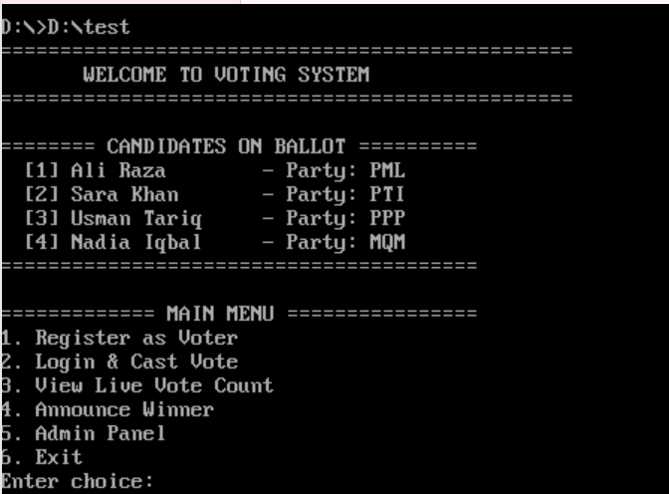
Screenshot 2: 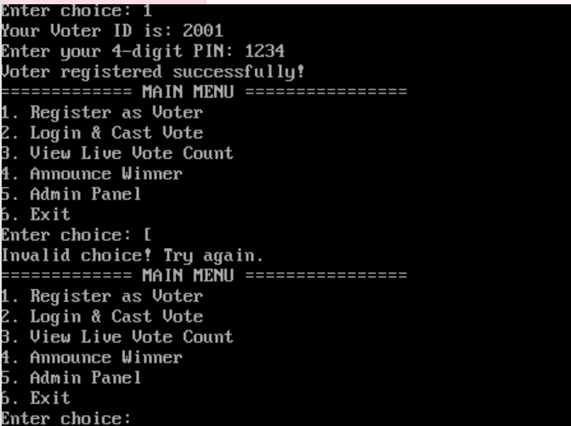
Screenshot 3: 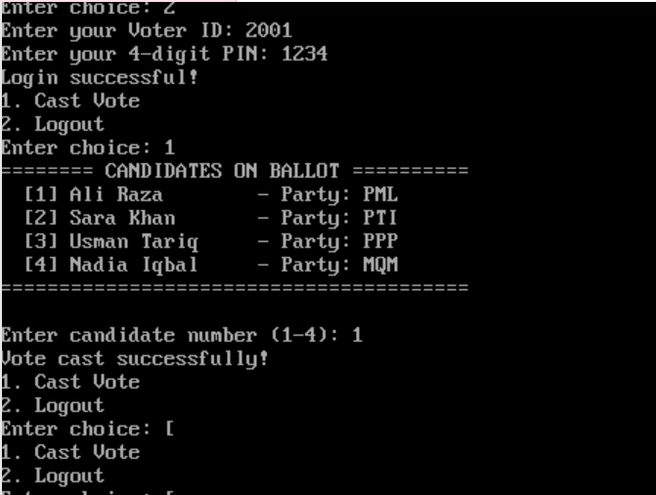
Screenshot 4: 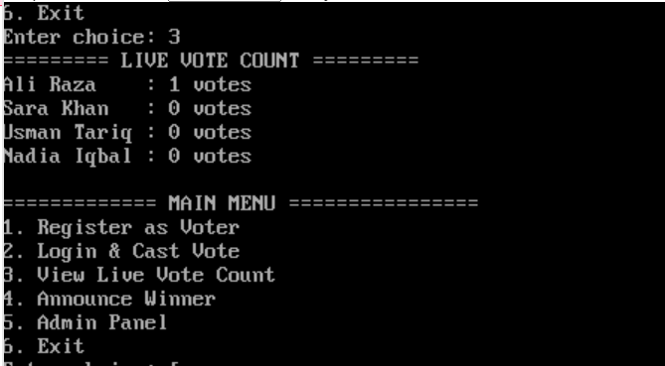
Screenshot 5: 