Exploring knitr functionality through Star wars and tidy-verse

Faryal Usman

10 February, 2020

# Initial setup

# Knitr options include:  
 # include = TRUE  
 # warning = FALSE  
 # echo = TRUE  
 # message = FALSE   
knitr::opts_chunk$set(echo = TRUE)  
knitr::read_chunk("external-chunk.r")  
source("external-chunk.r")

# Loading relevant libraries

library(tidyverse)  
library(ggplot2)  
library(bookdown)

# A plot of starwars data

starwars %>%   
 filter(species == "Human") %>%   
ggplot() +  
 aes(x = eye_color,   
 y = height, color = eye_color) +  
 geom_point() + ggtitle("Heights of humans by eye color in the Star Wars universe") +   
 theme(plot.title = element_text(size = 8, face = "bold"))

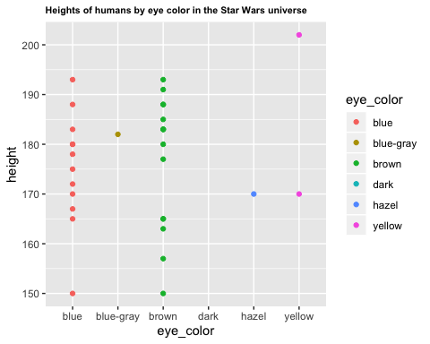

Figure 1: A ggplot of starwars data

# A table of star wars data

starwars %>%   
 filter(species == "Human") %>%   
 select(name,   
 height,   
 eye_color) %>%   
 knitr::kable(caption = "A knitr kable table of starwars humans eye color ")

Table 1: A knitr kable table of starwars humans eye color

|  |  |  |
| --- | --- | --- |
| name | height | eye_color |
| Luke Skywalker | 172 | blue |
| Darth Vader | 202 | yellow |
| Leia Organa | 150 | brown |
| Owen Lars | 178 | blue |
| Beru Whitesun lars | 165 | blue |
| Biggs Darklighter | 183 | brown |
| Obi-Wan Kenobi | 182 | blue-gray |
| Anakin Skywalker | 188 | blue |
| Wilhuff Tarkin | 180 | blue |
| Han Solo | 180 | brown |
| Wedge Antilles | 170 | hazel |
| Jek Tono Porkins | 180 | blue |
| Palpatine | 170 | yellow |
| Boba Fett | 183 | brown |
| Lando Calrissian | 177 | brown |
| Lobot | 175 | blue |
| Mon Mothma | 150 | blue |
| Arvel Crynyd | NA | brown |
| Qui-Gon Jinn | 193 | blue |
| Finis Valorum | 170 | blue |
| Shmi Skywalker | 163 | brown |
| Mace Windu | 188 | brown |
| Gregar Typho | 185 | brown |
| Cordé | 157 | brown |
| Cliegg Lars | 183 | blue |
| Dormé | 165 | brown |
| Dooku | 193 | brown |
| Bail Prestor Organa | 191 | brown |
| Jango Fett | 183 | brown |
| Jocasta Nu | 167 | blue |
| Raymus Antilles | 188 | brown |
| Finn | NA | dark |
| Rey | NA | hazel |
| Poe Dameron | NA | brown |
| Padmé Amidala | 165 | brown |

# Code from an external source

# Finding the cube of some number through an external chunk   
y <- cube_function(5)  
y

## [1] 125

# Finding the square of some number through an external chunk   
x <- square_function(3)  
x

## [1] 9

# Cached code

exponential_func <- function(reps) {  
 result_list <- c(rep(NA,reps))  
 for (i in 1:reps){  
 if (i %% 2 == 0) {  
 result_list[i] <- square_function(i)  
 } else {  
 result_list[i] <- cube_function(i)  
 }  
 }  
 q <- max(result_list)  
}

start.time <- Sys.time()  
first <- exponential_func(1e4)  
first

## [1] 9.997e+11

end.time <- Sys.time()  
time_taken = end.time - start.time   
time_taken

## Time difference of 0.07572508 secs

# Citations

In Xie (2017), a book written by one of the authors of knitr, the author explores the applications of R to scientific discpline such as epidemiology, finance, biology and the social sciences as well as the variety of models that can be used.

In Xie (2013), the same author explores some of the more technical functionalities of knitr.

Xie, Yihui. 2013. “Knitr: A General-Purpose Tool for Dynamic Report Generation in R.” *R Package Version* 1 (1).

———. 2017. *Dynamic Documents with R and Knitr*. Chapman; Hall/CRC.