**Solution to Problem – 1 (A)**

1. We can delete the META DATA of the image, which will reduce the size of the image.

* Image data which is not related pixel details, which not reduce the quality of the image.

1. If the image is not in JPEG format, then we can use JPEG compression algorithm.

* For example, image is in .png/bmp/gif etc format we can export images into JPEG format which will give us the good resolution image along with the good compression ratio.
* I have explained the algorithm below.

1. If the image is already into JPEG format, we can reduce the resolution of the image accordingly to the targeted image resolution.

* If the image is in 1000X1000 pixels and the desired resolution is 250X250 pixels, then we can compress the image to the desired resolution.

**Solution to Problem – 1 (B)**

* As said, the person id and the name of the image is same.
  + Remove the overhead of storing person id.
  + As the Image name and the person id is same. Fetch the file name split the name with “.” and we get the person id and the Image file too.
  + This way in one pass we get the image as well as the person id, to which the image is associated with.

JPEG COMPRESSION ALGROTHIM

**Image compression**

Image compression is the method of data compression on digital images. The main objective in the image compression is:

* Store data in an efficient form
* Transmit data in an efficient form

Image compression can be lossy or lossless.

**JPEG compression**

JPEG stands for Joint photographic experts group. It is the first international standard in image compression. It is widely used today. It could be lossy as well as lossless. But the technique we are going to discuss here today is lossy compression technique.

**How jpeg compression works:**

First step is to divide an image into blocks with each having dimensions of 8 x8.

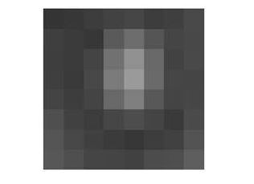



Let’s for the record, say that this 8x8 image contains the following values.

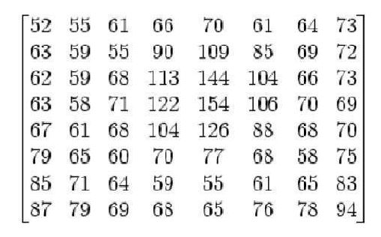

The range of the pixels intensities now are from 0 to 255. We will change the range from -128 to 127.

Subtracting 128 from each pixel value yields pixel value from -128 to 127. After subtracting 128 from each of the pixel value, we got the following results.

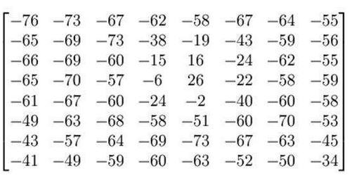



Now we will compute using this formula.

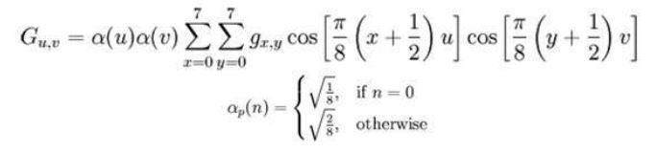

The result comes from this is stored in let’s say A*j*, *k* matrix. There is a standard matrix that is used for computing JPEG compression, which is given by a matrix called as Luminance matrix.

This matrix is given below

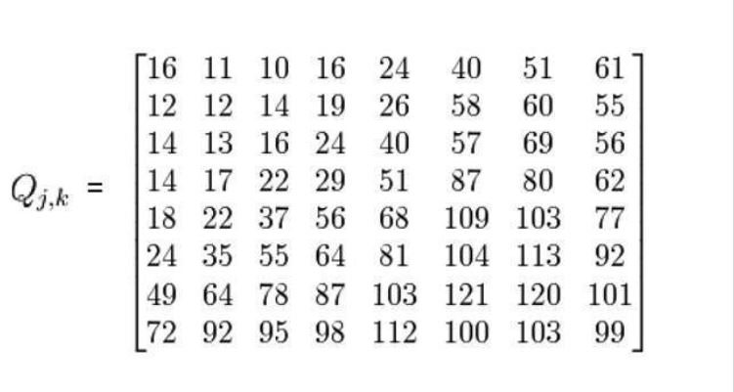

Applying the following formula

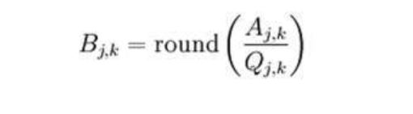

We got this result after applying.

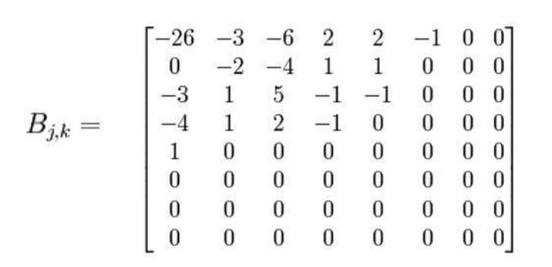

Now we will perform the real trick which is done in JPEG compression which is ZIG-ZAG movement. The zig zag sequence for the above matrix is shown below. You have to perform zig zag until you find all zeroes ahead. Hence our image is now compressed.

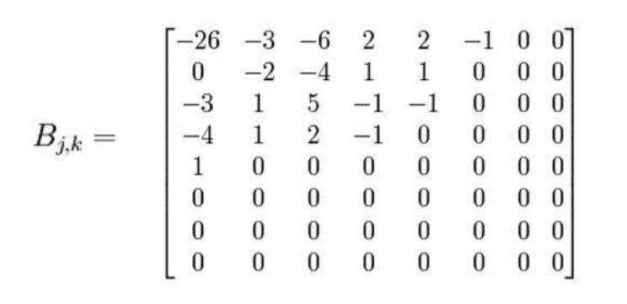

**Summarizing JPEG compression**

The first step is to convert an image to Y’CbCr and just pick the Y’ channel and break into 8 x 8 blocks. Then starting from the first block, map the range from -128 to 127. After that you have to find the discrete fourier transform of the matrix. The result of this should be quantized. The last

step is to apply encoding in the zig zag manner and do it till you find all zero.

Save this one-dimensional array and you are done.

*Note. You have to repeat this procedure for all the block of 8 x 8.*