

**”CSE Alumni Management System”**

**A PROJECT REPORT**

*Submitted By*

**Farzana Sultana Soma**

ID No. 12108024

Session 2020-2021

***In partial fulfillment for the award of the degree***

***of***

**BACHELOR OF ENGINEERING**

***in***

**COMPUTER SCIENCE AND ENGINEERING**

**COMILLA UNIVERSITY :: CUMILLA-3506**

**19th March 2025**

**COMILLA UNIVERSITY:: COMILLA-3506**

**BONAFIDE CERTIFICATE**

This is to certify that the major project report entitled, **”CSE Alumni Management System””** and submitted by **“Farzana Sultana Soma”** is the bonafide work completed under my super-vision and guidance in partial fulfillment for the award of Bachelor of Engineering (Computer Science and Engineering) of Khairun Nahar,Assistant Professor, Dept. of CSE..The system has been developed with great precision, integrating key functionalities required for alumni net-working and management.

**MAHMUDA KHATUN** **KHAIRUN NAHAR**

**CHAIRMAN, EXAM COMMITTEE** **SUPERVISOR**

Assistant Professor, Assistant Professor,

Department of Computer Science and Department of Computer Science and

Engineering Engineering

Comilla University, Cumilla Comilla University, Cumilla

i

**Abstract**

The Alumni Management System is designed to create a structured and interactive platform for alumni of the CSE Department, Comilla University. This web-based system helps alumni stay connected with their peers, receive updates about university events, and explore career oppor-tunities. By offering features such as profile management, networking, and event coordination, the system ensures seamless engagement between the university and its alumni. Additionally, it simplifies administrative tasks by maintaining an organized database of alumni records and communication logs. The system aims to strengthen the bond between the institution and its graduates, fostering long-term relationships and professional growth.

**Acknowledgements**

First and foremost, we thank to Almighty Allah for his blessings on the completion of our endeavor. Without mentioning the individuals whose persistent collaboration made it possible, whose constant direction and support crown all efforts with success, the pleasure that comes with the blooming accomplishment of any work would be curtailed.We extend our heartfelt gratitude to our esteemed supervisor, **Khairun Nahar**, Assistant Professor, Department of Computer Science and Engineering, for providing us with guidance advice, motivation and constructive recommendations throughout the development of this project. We are also grateful to all faculty members of our department and our families for their unwavering support.

iii

**Contents**

|  |  |  |  |  |
| --- | --- | --- | --- | --- |
| **Certificate** | | |  | **i** |
| **Abstract** | |  |  | **ii** |
| **Acknowledgements** | | | | **iii** |
| **Contents** | | |  | **iv** |
| **List of Figures** | | |  | **vi** |
| **Abbreviations** | | |  | **vii** |
| **1** | **Introduction** | |  | **1** |
|  | 1.1 | Motivation . . . . . . . . . . . . . . . . . . . . . . . . . . . . . . . . . . . . . | | 1 |
|  | 1.2 | Aims and Objectives . . . . . . . . . . . . . . . . . . . . . . . . . . . . . . . | | 2 |
|  | 1.3 | Software and Hardware Requirements . . . . . . . . . . . . . . . . . . . . . . | | 2 |
|  |  | 1.3.1 | Hardware Requirements . . . . . . . . . . . . . . . . . . . . . . . . . | 2 |
|  |  | 1.3.2 | Software Requirements . . . . . . . . . . . . . . . . . . . . . . . . . . | 2 |
|  | 1.4 | Scope . . . . . . . . . . . . . . . . . . . . . . . . . . . . . . . . . . . . . . . | | 3 |
| **2** | **Literature Review** | | | **4** |
|  | 2.1 | Feasibility Study . . . . . . . . . . . . . . . . . . . . . . . . . . . . . . . . . | | 6 |
|  |  | 2.1.1 | Technical Feasibility . . . . . . . . . . . . . . . . . . . . . . . . . . . | 6 |
|  |  | 2.1.2 | Economic Feasibility . . . . . . . . . . . . . . . . . . . . . . . . . . . | 6 |
|  |  | 2.1.3 | Behavioral Feasibility . . . . . . . . . . . . . . . . . . . . . . . . . . | 6 |
| **3** | **Analysis and Design** | | | **7** |
|  | 3.1 | Front-end Design and Database Model . . . . . . . . . . . . . . . . . . . . . . | | 7 |
|  | 3.2 | Requirements Analysis . . . . . . . . . . . . . . . . . . . . . . . . . . . . . . | | 8 |
|  | 3.3 | System Architecture . . . . . . . . . . . . . . . . . . . . . . . . . . . . . . . . | | 8 |
|  |  | 3.3.1 | Flowchart . . . . . . . . . . . . . . . . . . . . . . . . . . . . . . . . . | 8 |

iv

|  |  |  |  |
| --- | --- | --- | --- |
| *Contents* |  |  | v |
| **4 Implementation and Result** | | | **10** |
| 4.1 | Architectural Pattern . . . . . . . . . . . . . . . . . . . . . . . . . . . . . . . | | 10 |
| 4.2 | Used Tools and Technology . . . . . . . . . . . . . . . . . . . . . . . . . . . . | | 10 |
| 4.3 | Implementation Results . . . . . . . . . . . . . . . . . . . . . . . . . . . . . . | | 11 |
|  | 4.3.1 | Home . . . . . . . . . . . . . . . . . . . . . . . . . . . . . . . . . . . | 11 |
|  | 4.3.2 | Sign Up Page . . . . . . . . . . . . . . . . . . . . . . . . . . . . . . . | 11 |
|  | 4.3.3 | Navigation Bar . . . . . . . . . . . . . . . . . . . . . . . . . . . . . . | 11 |
|  | 4.3.4 | Event Page . . . . . . . . . . . . . . . . . . . . . . . . . . . . . . . . | 11 |
|  | 4.3.5 | Interface for MySQL Database . . . . . . . . . . . . . . . . . . . . . . | 14 |
|  |  | 4.3.5.1 MySQL Database . . . . . . . . . . . . . . . . . . . . . . . | 14 |
| **5 Conclusion and Future Directions** | | | **15** |
| 5.1 | Limitations . . . . . . . . . . . . . . . . . . . . . . . . . . . . . . . . . . . . | | 15 |
| 5.2 | Future Work . . . . . . . . . . . . . . . . . . . . . . . . . . . . . . . . . . . . | | 15 |

**List of Figures**

|  |  |  |
| --- | --- | --- |
| 3.1 | System’s Operational Flow chart . . . . . . . . . . . . . . . . . . . . . . . . . | 9 |
| 4.1 | Home Page . . . . . . . . . . . . . . . . . . . . . . . . . . . . . . . . . . . . | 12 |
| 4.2 | User Sign up . . . . . . . . . . . . . . . . . . . . . . . . . . . . . . . . . . . | 13 |
| 4.3 | Navigation Bar . . . . . . . . . . . . . . . . . . . . . . . . . . . . . . . . . . | 13 |
| 4.4 | Navigation Bar . . . . . . . . . . . . . . . . . . . . . . . . . . . . . . . . . . | 13 |
| 4.5 | Navigation Bar . . . . . . . . . . . . . . . . . . . . . . . . . . . . . . . . . . | 13 |
| 4.6 | MySQL Data table . . . . . . . . . . . . . . . . . . . . . . . . . . . . . . . . | 14 |

vi

**Abbreviations**

**DFD D**ata **F**low **D**iagram

**ER** **E**ntity **R**elationship

**DB** **D**ata **B**ase

**IDE** **I**ntegrated **D**evelopment **E**nvironment

vii

**Chapter 1**

**Introduction**

The Alumni Management System is a web-based platform designed to maintain connections between alumni and the institution. It enables alumni to register, update their profiles, engage in discussions, share job opportunities, and stay informed about events. The system streamlines communication and fosters a strong alumni network.

**1.1 Motivation**

The motivation behind the **CSE Alumni Management System** is to create a robust platform that fosters a strong connection between alumni and current students of the CSE Department at Comilla University. Alumni networks are invaluable resources for professional development, job opportunities, mentorship, and knowledge sharing. However, maintaining a structured and organized alumni database has always been a challenge.

This project aims to bridge that gap by providing a digital platform where alumni can stay connected with the department, participate in events, and offer career guidance to students. The system also enables job postings, event management, and networking opportunities that benefit both alumni and current students.

1

|  |  |
| --- | --- |
| Chapter 1. *Introduction* | 2 |

**1.2 Aims and Objectives**

The aim of this project is to develop a web-based solution for connecting department ex-students and alumni. The objectives of the project are as follows:

* Establish a **communication platform** between alumni and students.
* Maintain a database of alumni records with **updated contact information.**
* Provide **job and internship** postings for students from alumni and recruiters.
* Organize alumni events and manage **registrations online.**
* Ensure **secure authentication and access control.**

**1.3 Software and Hardware Requirements**

**1.3.1** **Hardware Requirements**

* Hard-disk
* Keyboard and Mouse
* Monitor
* Printer
* Internet connection for hosting and database access.

**1.3.2** **Software Requirements**

* Operating System: Windows 10
* Frontend: HTML, CSS, JavaScript
* Backend: Python (Flask)
* Database: MySQL

|  |  |
| --- | --- |
| Chapter 1. *Introduction* | 3 |

**1.4 Scope**

The **CSE Alumni Management System** is designed to establish a structured communication platform between alumni and students, ensuring seamless interaction and networking.

**Project Outline:**

This project will be structured as follows:

Chapter 2 introduces the Literature Review containing background knowledge and related works in this field.

In Chapter 3, We have presented an overall interpretation of the methodology and design of the thesis work.

In Chapter 4, We have discussed the implementation and results.

Finally, in Chapter 5, We have concluded this project with the future objectives for our system and an overall epilogue.

**Chapter 2**

**Literature Review**

Alumni websites are becoming increasingly popular as a way for educational institutions to connect with their alumni and current students. These websites provide numerous benefits, including:

* **Improved Communication and Engagement:** Alumni websites serve as a platform for institutions to stay connected with their graduates and keep them informed about news, events, and opportunities.
* **Increased Alumni Support:** Engaging alumni through a dedicated platform fosters a sense of belonging, leading to greater participation in fundraising and mentorship pro-grams.
* **Enhanced Student Recruitment and Retention:** Prospective and current students ben-efit from networking opportunities and career guidance provided by alumni.

4

|  |  |
| --- | --- |
| Chapter 2. *Literature Review* | 5 |

**Examples of Successful Alumni Websites**

To further understand the significance of alumni networks, here are some well-established alumni websites that have set a benchmark for engagement and community building:

* Harvard University Alumni Network
* Stanford University Alumni Association
* Yale Alumni Association
* University of California, Berkeley Alumni Association

These institutions have effectively utilized alumni networks to maintain strong connections with their graduates, encourage active participation, and foster career growth through mentorship pro-grams and networking opportunities. These websites offer a variety of features to their members, including:

* Alumni directories
* Job boards
* Career Resources
* News and events
* Social media groups
* Alumni benefit

|  |  |
| --- | --- |
| Chapter 2. *Literature Review* | 6 |

**2.1 Feasibility Study**

**2.1.1** **Technical Feasibility**

* Technology – Uses Flask, MySQL, and JavaScript.
* Scalability – Can handle increasing alumni and student interactions.
* Security – Implements authentication and encryption.
* Device Compatibility – Works on all devices and browsers.

**2.1.2** **Economic Feasibility**

* Developed using open-source tools, reducing costs.
* Requires minimal investment for hosting and maintenance.
* Long-term benefits include alumni networking and fundraising.

**2.1.3** **Behavioral Feasibility**

* User-Friendly – Simple and intuitive design.
* Easy Navigation – Quick access to jobs, blogs, and events.
* Responsive Design – Works smoothly on all devices.
* Fast Performance – Optimized for speed and efficiency.

This analysis confirms that the **CSE Alumni Association Management System** is feasible in all aspects.

**Chapter 3**

**Analysis and Design**

In this chapter, We have presented an overall interpretation of the design, methodology, and analysis of my proposed system.

**3.1 Front-end Design and Database Model**

The development of the **CSE Alumni Association Management System** follows an incremen-tal approach, where functionalities are implemented and tested in stages to ensure seamless integration. This methodology allows for iterative enhancements, ensuring that the design re-mains user-centric and adaptable to feedback. The front-end is developed using HTML, CSS, and JavaScript to provide a responsive and visually appealing interface, while Flask manages the backend logic and MySQL handles database storage. The structured database model supports efficient querying, enabling smooth access to alumni records, job postings, and event details. Regular testing ensures that new features function as expected while maintaining overall sys-tem stability.

7

|  |  |
| --- | --- |
| Chapter 3. *Analysis and Design* | 8 |

**3.2 Requirements Analysis**

The system is designed to provide a comprehensive alumni directory that allows users to search based on various criteria such as name, batch, industry, and job position. Additionally, the plat-form includes an event management module that enables alumni to register for reunions and professional networking events. The job board allows alumni and recruiters to post job oppor-tunities, helping current students and fellow alumni find relevant career prospects. To enhance alumni-student engagement, a mentorship program is integrated, facilitating career guidance and knowledge-sharing.

**3.3 System Architecture**

The architecture of the **CSE Alumni Association Management System** is designed as a **three-tier structure**, ensuring efficient data flow and management:

* **Presentation Layer:** Developed using HTML, CSS, JavaScript, and Bootstrap, provid-ing a visually appealing and responsive user interface.
* **Business Logic Layer:** Powered by Flask, managing system functionalities, authentica-tion, data validation, and server-side operations.
* **Database Layer:** MySQL serves as the primary database, storing alumni records, job postings, events, and mentorship program details.

**3.3.1** **Flowchart**

A flowchart is a structured diagram that visually represents the steps and interactions within the CSE Alumni Association Management System. It illustrates key processes such as alumni registration, login authentication, job posting, event participation, and mentorship engagement. Swimlane flowcharts are used to define the interaction between different system entities— alumni, students, and administrators—ensuring clarity in system workflow. Figure 3.1 presents a structured representation of the system’s operational flow, showcasing data interactions and process transitions.

|  |  |
| --- | --- |
| Chapter 3. *Analysis and Design* | 9 |

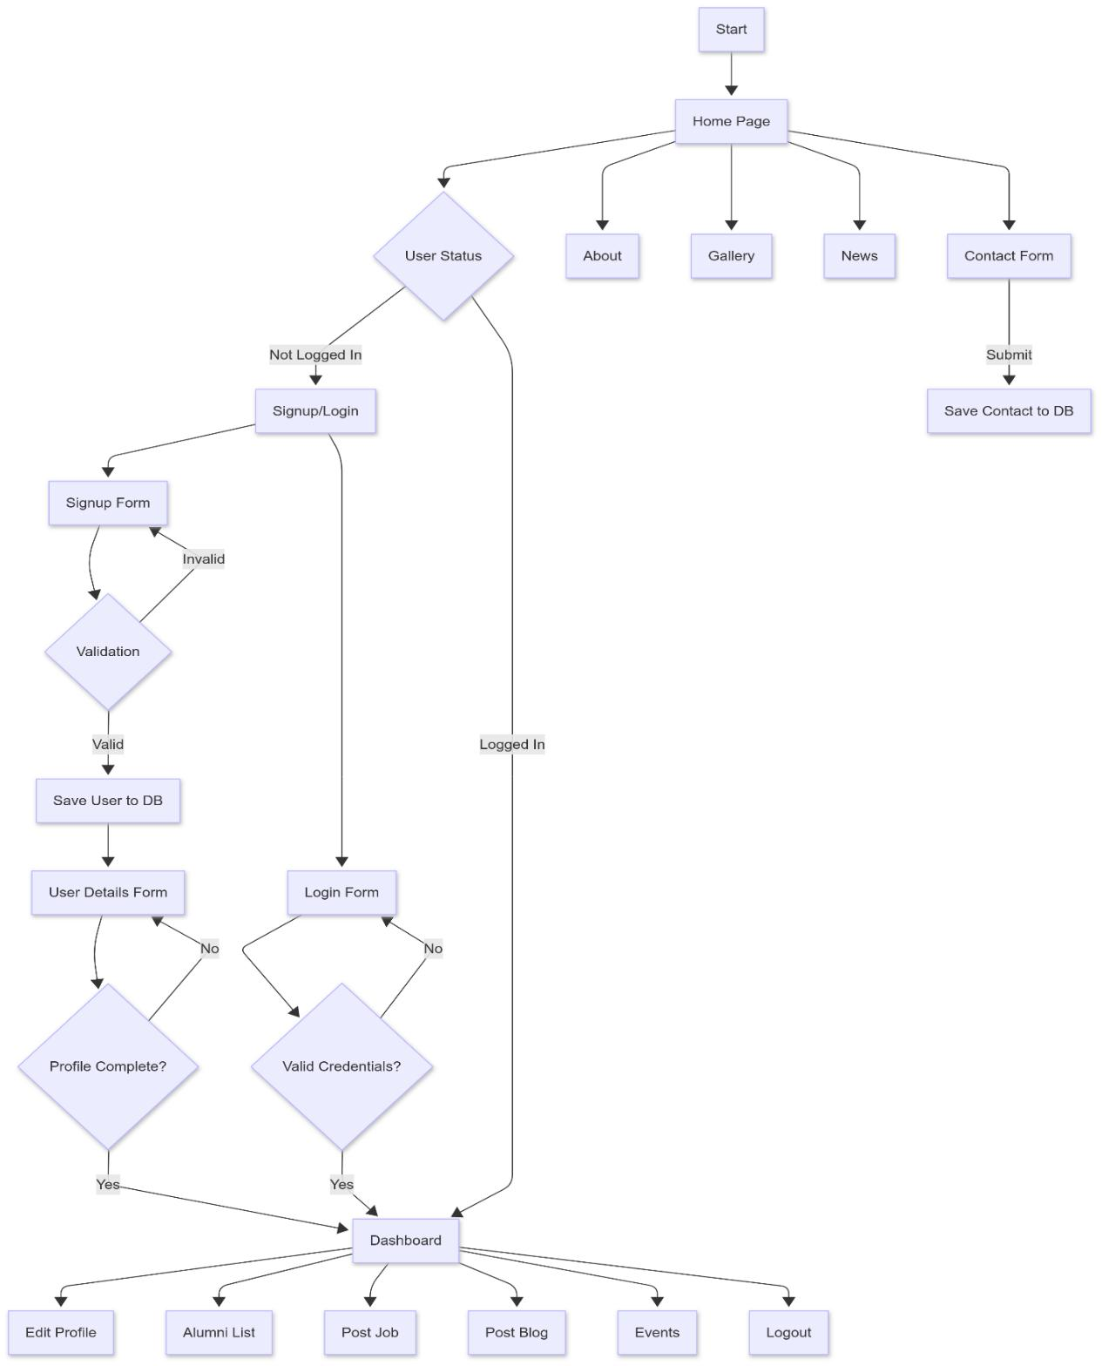

Figure 3.1: System’s Operational Flow chart

**Chapter 4**

**Implementation and Result**

Implementation is the phase in which the theoretical design is transformed into a fully functional system. It involves coding, testing, and deploying the system to ensure that it meets the spec-ified requirements. The implementation stage is crucial for ensuring that the system operates efficiently and effectively, allowing users to seamlessly interact with its features.

**4.1 Architectural Pattern**

A website architecture pattern is a general, reusable solution to a commonly occurring problem in website architecture within a given context. It provides a blueprint for how to organize the different components of a website and how they should interact with each other.

**4.2** **Used Tools and Technology**

* Platform: Web
* Front-End: HTML, CSS, JavaScript, Bootstrap(5.3.2)
* Back-End: Flask, MySQL
* Database: MySQL
* IDE: Visual Studio Code

10

|  |  |
| --- | --- |
| Chapter 4. *Implementation and Results* | 11 |

**4.3 Implementation Results**

The system interface is implemented for the web platform. It provides some services that are discussed in this section.

**4.3.1** **Home**

Following figure 4.1 shows the view of the homepage.

**4.3.2** **Sign Up Page**

Figure 4.2 shows the sign-up page. The sign-up page is used for Alumni sign-up.

**4.3.3** **Navigation Bar**

Navigation Bar has multiple characteristics in multiple scenarios. Figure 4.3 shows the naviga-tion bar for visitors. Figure 4.4 shows the navigation bar for Alumni’s logged in. Figure 4.5 shows the navigation bar for Admins logged in.

**4.3.4** **Event Page**

Figure **??** shows the event page having the upcoming and past events with there deadlines.

|  |  |
| --- | --- |
| Chapter 4. *Implementation and Results* | 12 |

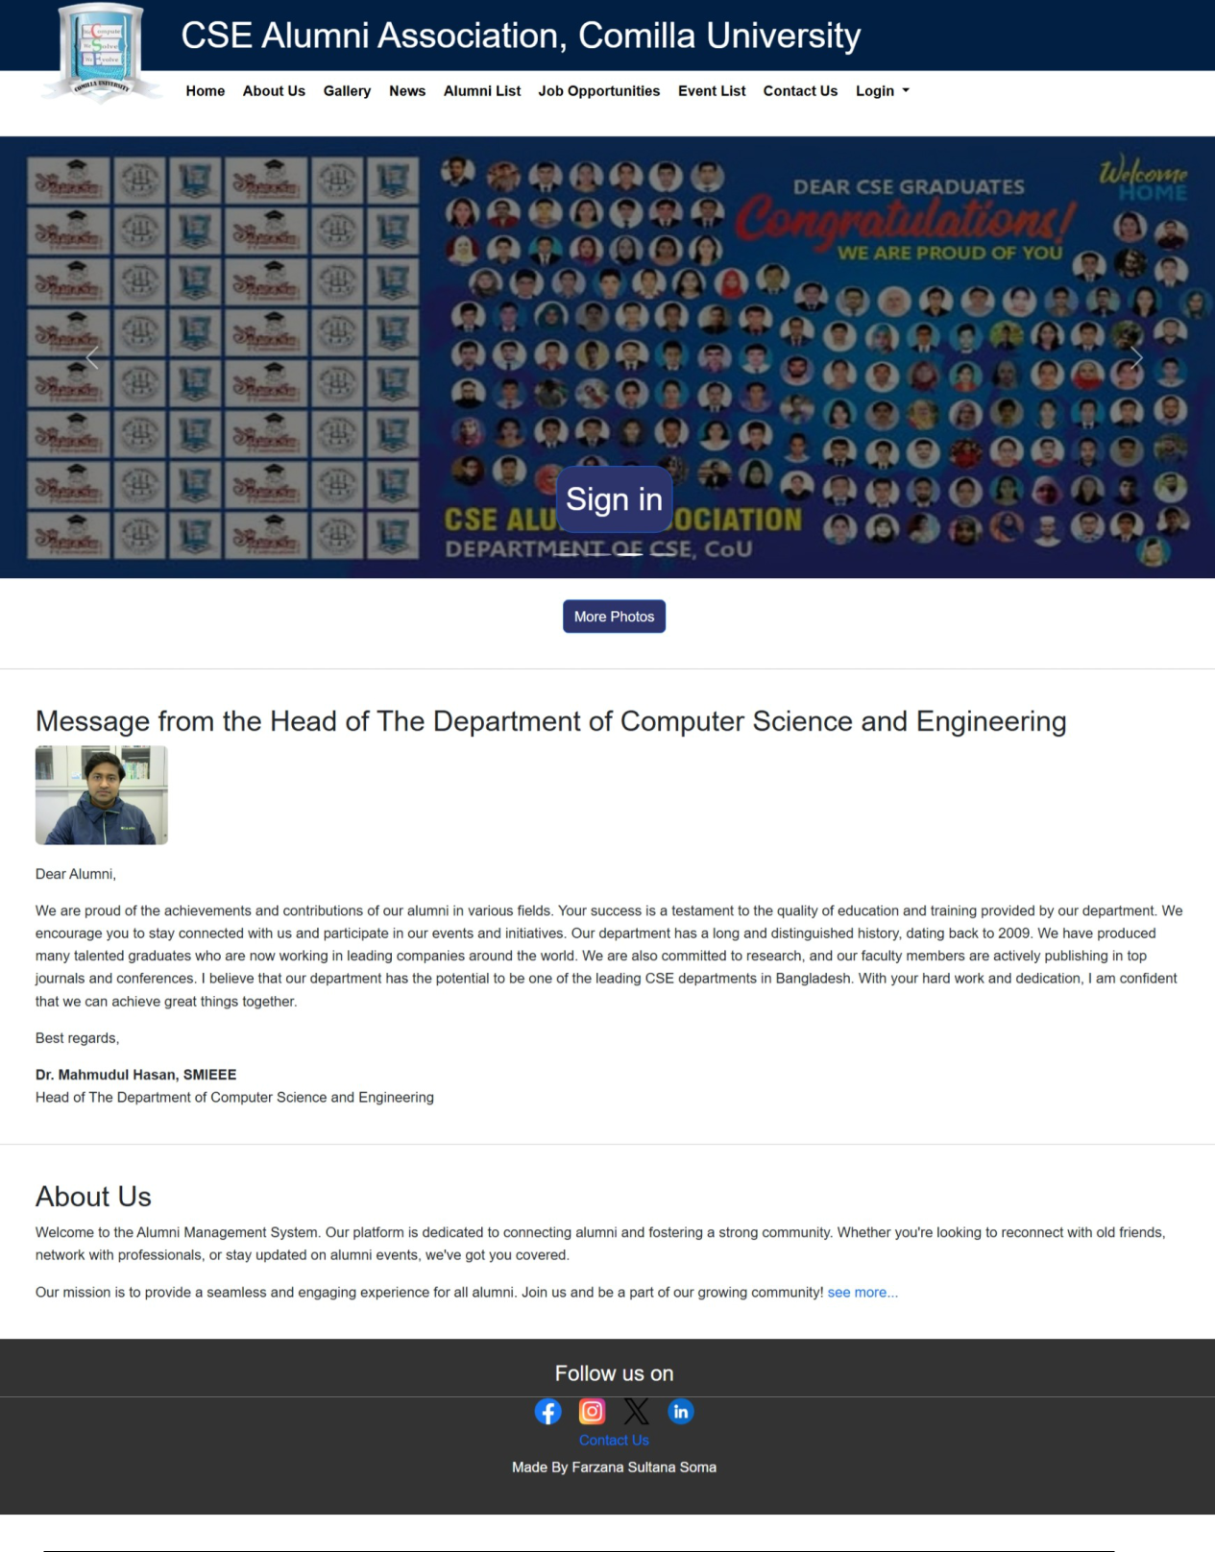

Figure 4.1: Home Page

|  |  |
| --- | --- |
| Chapter 4. *Implementation and Results* | 13 |

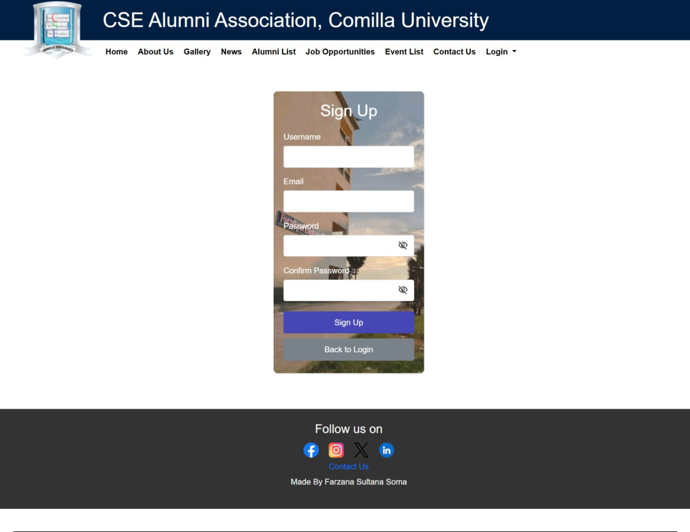

Figure 4.2: User Sign Up Page



Figure 4.3: Navigation bar for visitors



Figure 4.4: Navigation bar for logged in Alumnus



Figure 4.5: Navigation bar for logged in Alumnus

|  |  |
| --- | --- |
| Chapter 4. *Implementation and Results* | 14 |

**4.3.5** **Interface for MySQL Database**

**4.3.5.1 MySQL Database**

The figure shown in reference to Figure **??** displays the tables intended for storing all the user and admins data along with more necessary information.

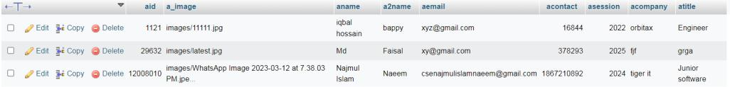

Figure 4.6: MySQL Server

**Chapter 5**

**Conclusion and Future Directions**

**5.1 Limitations**

While alumni and student management websites offer numerous benefits, they also have some limitations. These include cost, time commitment, technical expertise, user adoption, and most importantly, data privacy.

**5.2 Future Work**

Future plans include the development of alumni blog post, fund management and donation for scholarship. In order to create a strong network, we will also ensure that our instructors, alumni, and current students remain connected.

15